

Impact of Virtual Learning Environment; A Research Report

Module Name | Digital Skills and Research Methods
Module Code | BMSW4003
Lecturer | Koushik Modak
Assignment | Individual report
Student Number | 2009070
Student Name | Erika Mikolane Pinter
Deadline | 9 September 2021
Word Count | 1896 / 2000 words

Content page

1. Introduction | 3
2. Primary and Secondary research data | 3
3. Virtual Learning Environment (VLE) and Moodle | 3
4. Impact of Virtual Learning Environment – Secondary data | 4
5. Impact of Virtual Learning Environment – Primary data | 5
6. Conclusion | 7
7. References | 8
8. Appendices | 9

1. Introduction

The purpose of this report is to introduce and explain primary and secondary data research collection, Virtual Learning Environment and Moodle for better understanding. Furthermore, the paper will discuss collected and analysed primary and secondary research data on the impact of Virtual Learning Environment using research tools and by supporting the research with evidence.

2. Primary and Secondary research data

According to Hox and Boeije (2005) primary research data focuses on specific problems and is gathered by an individual or a company first-hand. It includes experimentation which is when the researcher is in complete control of how the experiment is being conducted, who participates in the experiment and manipulates the environment and set up of the experiment according to the structure they have previously planned. Social surveys such as interviews or web surveys are also primary research tools, where the researcher creates a questionnaire and gives it to a large, various sample of people to then analyse the collected data. Qualitative research which includes qualitative interviews, participant observations and focus groups are where the sample of people can express themselves more freely as it is not as closed as a standardised questionnaire such as quantitative data.

Hox and Boeije (2005) further states that once primary research data is used by someone who did not collect the data first-hand, it becomes a secondary research data. These can be data collected by other researchers, but it can also be statistics or records created by other organisations such as government or businesses.

3. Virtual Learning Environment (VLE and Moodle

Virtual Learning Environment (VLE) also known as Course Management System (CMS) or Learning Management System (LMS) is described by Oxford University Press (2016) as a system that provides learning materials through online tools. These tools include online assessments, lecture slides through systems such as Moodle, Blackboard, and bespoke, so tools that are available to students through the web, every day of the week, this way supporting them even when they are outside of campus or in another country.

Cambridge Dictionary (N.A.) explains that Moodle, also known as Modular Object-Oriented Dynamic Learning Environment, is a brand name of a Learning Management System for educational institutions to share learning materials with their students through the web. Bri et al. (2009) further explains that Moodle is a system that helps teachers communicate online support through the internet and has been developed by Martin Dougiamas.

4. Impact of Virtual Learning Environment – Secondary data

According to Sarkar (2016) online education has been present since the 20th century and the very first online course was created by University of Toronto in 1984. Since then, online learning has developed and is now available to not only students of higher education, but to primary schools too, and has become a very important part of learning.

Demian and Morrice (2015) discussed that VLE should be able to provide content that students might not be able to receive from a lecture, but if it is not delivered according to students’ needs, content- or format-wise, it becomes pointless. So, the structure of VLE is very important to be used effectively and efficiently, but its effectiveness will also depend on how students use their platform.

Demian and Morrice (2015) stated that Coventry University has concluded a study between 209 people regarding their online learning materials which showed that over half of the questionees had read and downloaded the materials, but only 14% of them decided to use external resources (Bromage, 2003). Which suggest that students using VLE believed the material was enough without further academic reading.

According to Von Kinsky et al. (2009) Curtin University decided to upload audio recordings to online servers to support students’ learning further then conducted a study which showed that although mostly students attended lectures, when they did not, over 40% of them accessed the recordings. Furthermore, over 22% of the students reported the recordings to be very useful and 31% reported them to be fairly useful. Although attendance was not affected by the usage of VLE, it showed that students who passed used the recordings more than failing students, but the results between how they used the platform varied. In conclusion, every student studied differently and there is not an established style for how students learn, but it is clear that those who passed used the recordings more.

The impact of Virtual Learning Environment had become even more important due to the recent situation with Covid-19. Torres Martin et al. (2021) concluded research on the perception of knowledge on virtual learning environment, digital technologies, and methods due to Covid-19 amongst 398 students. According to the results, students had a higher knowledge on using emails such as G-mail and social media chats such as Whatsapp, whilst learning platforms such as Moodle, and video conference platforms such as Google meet also showed good knowledge along with file storage platforms such as Google drive, searching tools such as Google and office tools such as Word. However, the research also showed that students believed teachers had a lack of knowledge on photo and video editors such as Photoshop and iMovie and tools creating presentations such as Prezi and academic databases such as Google scholar.

Torres Martin et al. (2021) also mentioned that though the research is impacted by students’ personal opinion on their teachers and their ability to use these technologies, it is important to support students and teachers in learning technological skills and techniques to acquire a new set of skills.

According to Barker and Gossman’s (2013) findings, using Virtual Learning Environments support independent learning from outside of campus and provides flexibility by being able to access the resources whenever students are in need to do so. According to the research, VLE and specifically Moodle had a positive impact on students’ learning and further supports individual learning. The report also mentions that VLE helps motivating students and encourages students to work together, however it is also shown that the least used tools are forums and chats rooms, therefore their importance need to be taught. However further research mentioned that improvements to the Virtual Learning Environment showed satisfaction amongst students and encourages individual learning as students can learn whenever and wherever they are which increases motivation and independence.

Bri et al. (2009) states that VLE had become not only important in higher education but in primary schools and secondary schools and is used all over the world. The study also discussed that Moodle in comparison to other VLE platforms performs better as it is faster, takes less time to load and even logging into the system is quicker. Though VLE systems have improved and provide help to both teachers and students, further improvements are necessary both for existing and new tools.

5. Impact of Virtual Learning Environment – Primary data

As per the first part of our assignment, we were asked to design a questionnaire, a kind of survey regarding Virtual Learning Environment focused on the experiences of our classmates. The questionnaire was created by me as it is shown in Appendix A and included Open-ended questions, Close-ended questions, Likert scale questions and Multiple-choice questions. The research focused on 20 participants, a small group and serves as a primary data collection in research methods.

Most of the participants answered to the first question “What did you like about virtual learning at UWTSD London Campus?” by saying it helped them save money and time and made their life easier. However, a smaller portion of the questionees said they didn’t like online learning and face to face learning was more comfortable for them.

The second question “Did you have any virtual learning experience before this course?” as per Appendix B, showed that 45% of the participants had previous experience with Virtual Learning, but 55% of them haven’t had any.

In the third question “Do you have enough computer skills for virtual learning?” half of students reported that they had enough computer skills for Virtual Learning, but the other half said their skills weren’t enough or that they only had a basic knowledge on how to use computers.

According to question four “How does virtual learning affect you?” most of the participants felt it had a positive effect on them because it helped them learn more about computer skills and recognised their lack of knowledge, whilst a smaller portion of them reported to find it difficult not to meet classmates and teachers face to face and often lose focus at the lectures.

Question five “How important is virtual learning for you?” showed that 65% of the questionee found Virtual Learning important, meanwhile only 20% thought it was very important and 15% of the participants found it to be nor important nor unimportant and had a neutral opinion as shown in Appendix C.

As seen in Appendix D, for question six “What device do you use for virtual learning?” students reported to use multiple devices when accessing Virtual Learning. 90% of the participants said to use laptops, whilst 55% reported to also use phones and 20% to use computers whilst no one said they used tablets.

In question seven “What are the modules you are studying at UWTSD?” 100%, therefore all the participants said they studied Academic and Employability Skills, and Digital Skills and Research Methods as the questionnaire was directed at classmates.

Once again 100% of the questionee replied to question eight “Do you have Digital Skills and Research Methods module?” as yes, they do have that module as the questionnaire was focused on classmates.

According to question nine “Digital Skills and Research Methods module is very important in online learning.” 40% of the students strongly agreed with the statement, 35% of the participants agreed with it and 25% of them stayed neutral as shown in Appendix E.

Therefore, it can be concluded that Virtual Learning is important to most students, and it impacted them positively as they found it to be useful regarding money saving, time saving and in acquiring technological skills, but a smaller portion of the participants found it to be more difficult and preferred in person studying.

6. Conclusion

In conclusion, Virtual Learning Environment according to Demian and Morrice (2015) is a very important part of learning, but it is essential to cater to what the students need regarding tools and formats available. Von Kinsky et al. (2009) also stated the importance of VLE but discussed that it also depends on the students and there is no specific style how students learn. Torres Martin et al. (2021) based their research on the technological tools students and teachers used and emphasised that further support is needed both for students and teachers. Barker and Gossman (2013) discussed that VLE is a very important system for students to not only learn what they are being taught in class but have additional knowledge that they can access every hour of every day outside of the campus. It is helping them save time and money whilst also helps further developing their technological knowledge. It is supporting both individual and group learning and helps motivate students. However, according to Barker and Gossman (2013) the importance of group learning and cooperating, the use of forums and chats are the least used tools, and their importance should be emphasised. Lastly, according to the primary data, most students find it both money and time saving to use VLE and feel it helps them improve their technological skills.

7. References
- Cambridge Dictionary (N.A.) ‘Moodle’. Available at: https://dictionary.cambridge.org/dictionary/english/moodle (Accessed: 4 September 2021)
- Barker, J. and Gossman, P. (2013) The learning impact of a virtual learning environment: students’ views. University of Cumbria. Available at: http://insight.cumbria.ac.uk/id/eprint/1455/1/146-574-1-PB.pdf (Accessed: 7 September 2021)
- Bri, D., Garcia, M., Coll, H. and Lloret, J. (2009) A Study of Virtual Learning Environments. Valencia; Polytechnic University of Valencia. Available at: http://citeseerx.ist.psu.edu/viewdoc/download?doi=10.1.1.522.2279&rep=rep1&type=pdf (Accessed: 7 September 2021)
- Demian, P. and Morrice, J. (2015) ‘The use of virtual learning environments and their impact on academic performance’, Higher Education Academy. Available at: https://www.tandfonline.com/doi/pdf/10.11120/ened.2012.07010011 (Accessed: 4 September 2021)
- Hox, J.J. and Boeije, H. R. (2005) Data Collection, Primary vs. Secondary. Ultrecht University; The Netherlands. Available at: https://dspace.library.uu.nl/bitstream/handle/1874/23634/hox_05_data+collection,primary+versus+secondary.pdf?sequence=1 (Accessed: 2 September 2021)
- Oxford University Press (2016) ‘Learn about Virtual Learning Environment/Course Management System content’, OUP Online Resource Centres. Available at: https://global.oup.com/uk/orc/learnvle/ (Accessed: 3 September 2021)
- Sarkar, S. (2020) ‘A brief history of online education’, Adamas University, 16 May. Available at: https://adamasuniversity.ac.in/a-brief-history-of-online-education/ (Accessed: 5 September 2021)
- Torres Martin, C., Acal, C., El Homrani, M. and Mingorance Estrada, A. C. (2021) Impact on the Virtual Learning Environment Due to COVID-19. Sustainability; MDPI. Available at: https://www.mdpi.com/2071-1050/13/2/582/pdf (Accessed: 4 September 2021)
- Von Kinsky, B. R., Ivins, J. and Gribble, S. J. (2009) Lecture attendance and web based lecture technologies:A comparison of student perceptions and usage patterns. Curtin University of Technology. Available at: https://ajet.org.au/index.php/AJET/article/view/1130/383 (Accessed: 5 September 2021)

8. Appendices
Appendix A – Primary data questionnaire
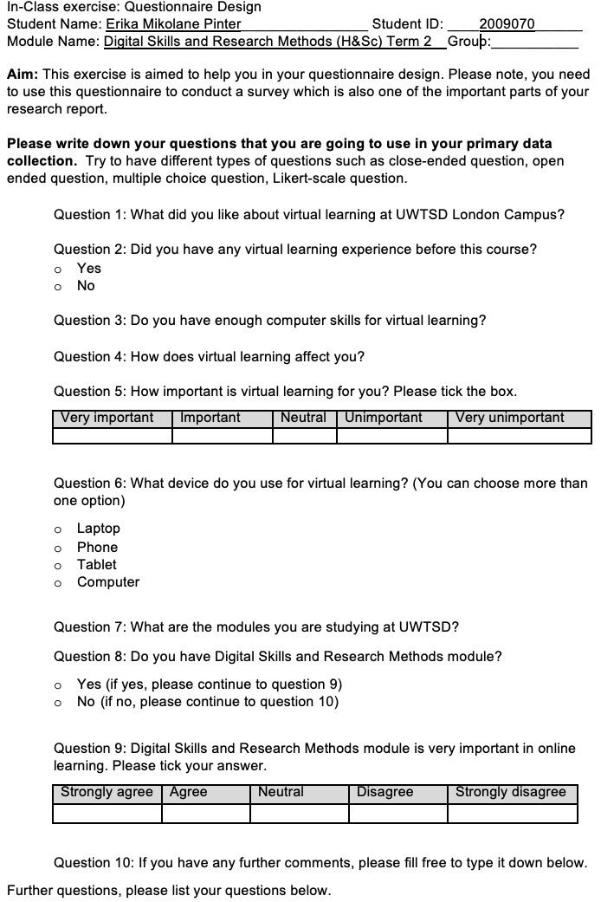
Source: Erika Mikolane Pinter, 2020
Appendix B – Question 2; Did you have any virtual learning experience before this course?
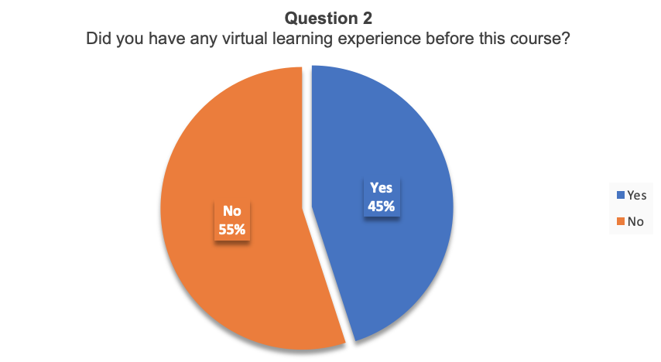
Source: Erika Mikolane Pinter, 2020
Appendix C – Question 5; How important is virtual learning for you? Please tick the box.
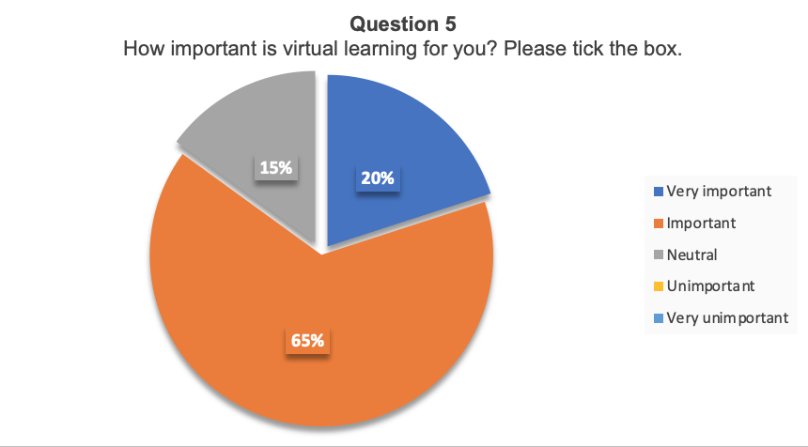
Source: Erika Mikolane Pinter, 2020

Appendix D – Question 6; What device do you use for virtual learning? (You can choose more than one option)
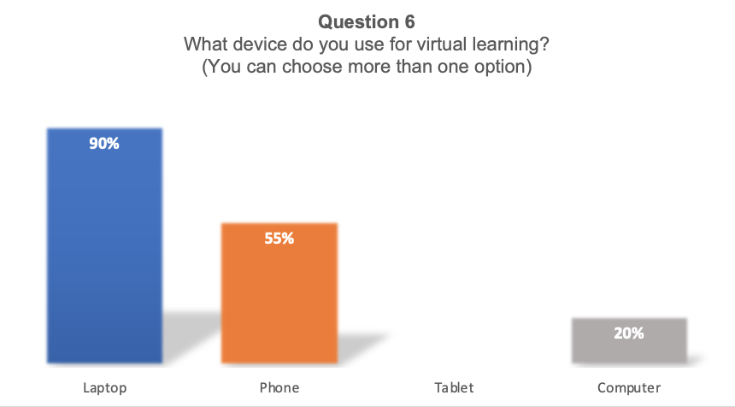
Source: Erika Mikolane Pinter, 2020
Appendix E – Question 9; Digital Skills and Research Methods module is very important in online learning
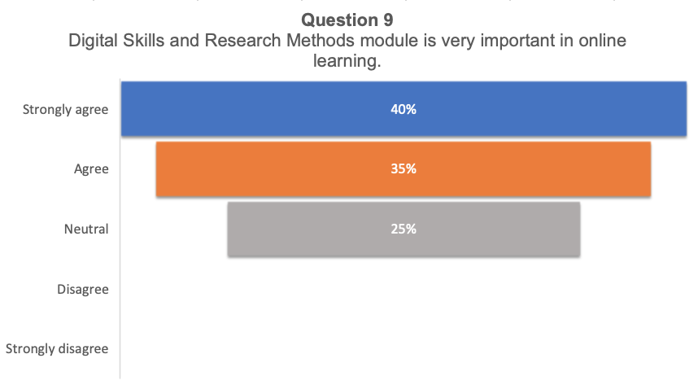
Source: Erika Mikolane Pinter, 2020

