Sallen and Key Assignment

1/31/2018
Robert Lucas (P151516)

Contents
Abstract 2
Intro 2
Problem 2
Solution 2
Conclusion Summary 2
Introduction 2
Background: What Are Filters? 2
Method 2
Results 4
Analysis 10
Conclusion 10
Bibliography 10

Table of Figures
Figure 1: High Pass Second Order Active Filter 5
Figure 2: Low Pass Second Order Active Filter 6
Figure 3: Frequency Graph of the High Pass Second Order Active Filter (Green Line is the Input, Red Line is the Output. Same Applies to all Graphs) 7
Figure 4: Frequency Graph of a High Pass Fourth Order Active Filter 7
Figure 5: Frequency Graph of a Sixth Order High Pass Active Filter. 8
Figure 6: Frequency Graph of an Eighth Order High Pass Active Filter 8
Figure 7: The Fixed Circuit of the High Pass Filter. Gain Changed Due to Resistor Value Change on R8 9
Figure 8: Frequency Graph of the Fixed High Pass Active Filter 9
Figure 9: Frequency Graph of a Second Order Low Pass Active Filter 10
Figure 10: Frequency Graph of a Fourth Order Low Pass Active Filter 10
Figure 11: Frequency Graph of a Sixth Order Low Pass Filter 11
Figure 12: Fixed Low Pass Active Filter. Gain Change due to R3 Value change to 2.1k 11
Figure 13: Fixed Frequency Graph of the Low Pass Active Filter 12
Figure 14: Alteration to Low Pass Filter: Turned Into First Order Filter to Reduce Attenuation 12

Abstract

Intro
This assignment revolves around signal filtering and the filtering methods used. Filtering allows circuits to get rid of unwanted noise in order to extract the signals that are needed. Filters need to be altered in order to acquire the optimum result.

Problem
This assignment involves investigating the background of the Sallen and Key method of filtering and filter a certain amount of noise out of a signal which is created from the student’s student number.

Solution
In order to do this, the resistance and capacitance values must be calculated first. In order to obtain this result the following method must be done: swap the resistance with a chosen frequency alongside a chosen capacitance (shown in further detail below in the Method sections.)

Conclusion Summary
The Sallen and Key method is an extremely effective and simple way of altering frequencies. Using some basic equations and some filter value changes, the resulting band pass filter has fulfilled the expected parameters.

Introduction
Filters are an important aspect of today’s technology. They are used in many types of technology, improving current and voltage or altering signals so that they are free of interference. This assignment employs the use of a band pass filter to remove high and low signal frequencies.

Background: What Are Filters?
Filters were designed to remove certain signals or enhance others. Filters are designed to remove certain signals, which is often noise, depending on their frequency[1]. The frequency response curve is attenuated until it reaches its cut off frequency, which has 70.7% or -3dB of the original signal value[2].
There are two types of filters, passive and active filters. Passive filters require no power source save for they signal they are given in contrast to active filters, they are usually composed of linear components such as resistors, capacitors and inductors while active filters possess nonlinear components. Active filters can use its amplifier to alter the filter’s response, mainly by changing ‘how quickly and how steeply it moves from its passband into its stopband[3].’

Sallen and Key Method
The Sallen and Key method is a simple way of implementing second order active filters. It’s exceedingly useful as it is very easy to select the gain and the rate of attenuation. Because of this it is one of the most highly used filter types. One of the reasons for its popularity is that it’s filtering ability does not rely on the op-amp’s performance as the op-amp is used as an amplifier instead[4].

Method
For this assignment there are three separate frequencies, measured in kilohertz (kHz), based on the student’s student number. There are two noise signals and one frequency with a 0.2 voltage root-mean-square (Vrms) value. The signals are as follows:
- 11kHz
- 29kHz
- 165kHz
Normally the equation in this scenario would be:
$$\frac{1}{2πRC}$$
However because the values for R (resistor) and C (capacitor) are unknown an alteration must be made. First a frequency must be chosen for the high pass filter. The number must be between 11kHz and 29kHz. Due to the fact that both signal levels are close together it would make choosing a proper signal a more difficult. It is best to choose a signal value close to the true signal which is 29kHz. To this end the value that was chosen is 24kHz. Afterwards a capacitor value must be selected, there are no real restrictions save for the value needing to be extremely small. To this end the value of 10nf was chosen.
Now to rearrange the equation so that a resistor value may be chosen. By exchanging the resistor value in the equation with the frequency value, the equation becomes this.
$$\frac{1}{2πfC}$$
With that in mind the equation amounts to this:
$$\frac{1}{2π×24×{10}^{3}×10×{10}^{-9 }}=663$$
In accordance to the E24 resistor series a resistor with closest value to the result on the equation above, so the resistor value is set to 680 ohms. Below is the resulting circuit.
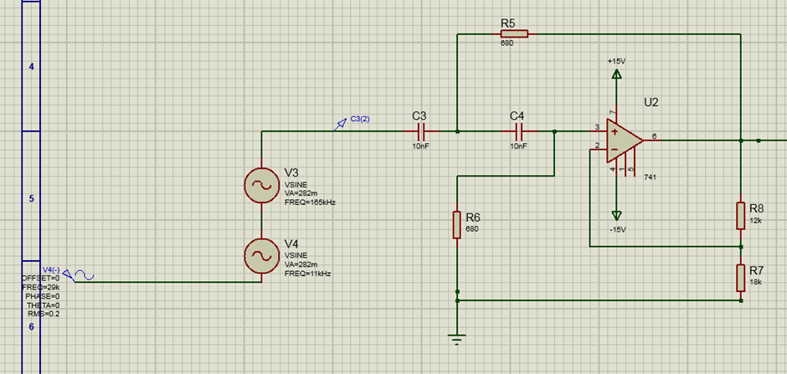
Figure 1: High Pass Second Order Active Filter
The filter is a second order due to the fact that there are two resistors and two capacitors. A first order filter would only have one of each. Second order filters attenuate signals more than first order filters at -40 dB per second rather than -20dB.
Now to do the same with the low pass filter. Because of the difference between the two signals (29kHz and 165kHz) there is more choice when it comes to selecting a frequency. In this case the signal chosen was 70kHz, resulting in this equation:
$$\frac{1}{2π×70×{10}^{3}×10×{10}^{-9}}=227$$
Once again the E24 resistor chart is consulted, and the closest resistor value to the equation’s answer is 220 ohms.
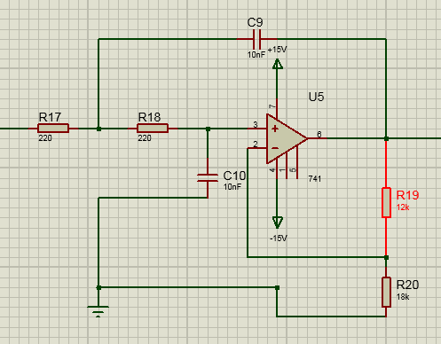
Figure 2: Low Pass Second Order Active Filter
Figure 2 shows a low pass filter. As seen when Figure 1 and Figure 2 are compared the difference between both circuit designs are the positions of the capacitors and the resistors.
In order to gain the required attenuation more filters needed to be added, therefore some experimentation was required in order to achieve the desired result, and the process is described in the results section below.
It is not a certainty that the perfect result will be attained, and as such the student will settle with the closest result they can achieve. Attenuation will have a ±3dB error margin while the gain will have an error margin of 1.

Results
As mentioned above it took some time before the correct results were produced, and the circuit required a lot of alterations before it could produce said result, the full circuit needed to be done in stages therefore the high pass aspect was completed first.

High Pass Filter
First the alterations to the individual filters were necessary so that they would reduce the correct amount of noise. Initially the filter only reduced the following amount of noise as shown in Figure 3.
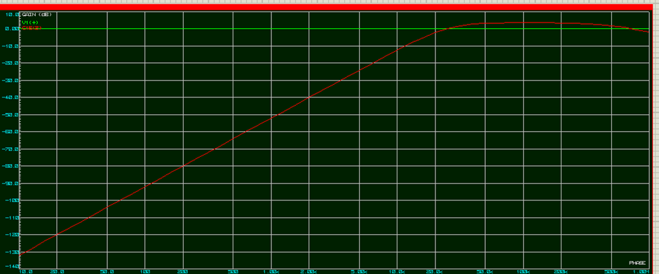
Figure 3: Frequency Graph of the High Pass Second Order Active Filter (Green Line is the Input, Red Line is the Output. Same Applies to all Graphs)
The attenuation on this graph amounts to -8.63 decibels (dB), this is not enough reduction. It is also important to keep an eye on the gain as well for reasons which will be soon made clear. This filter’s gain amounts to 3.04.
In order to increase the attenuation rate all that is required is to create another identical filter and connect it to the first filter, making a fourth order filter. The results of the Fourth Order Filter are shown in Figure 4 below.
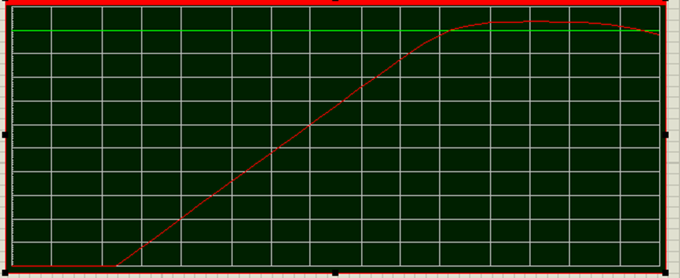
Figure 4: Frequency Graph of a High Pass Fourth Order Active Filter
As can be seen above the gradient of has deepened considerably and if one looks carefully it has also risen slightly higher above the input’s line, this is because alongside the signal attenuation the gain has also been affected by the additional filter. The attenuation has more or less doubled, becoming -17.5dB, and the gain has been affected in a similar manner, becoming 6.13. Once again however this is not enough.
Once again another filter is added, and the results are shown in Figure 5.
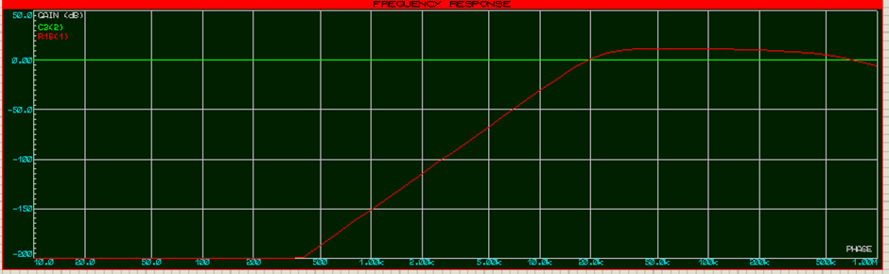
Figure 5: Frequency Graph of a Sixth Order High Pass Active Filter.
As shown in Figure 5, the attenuation has become even steeper. A pattern is beginning to emerge: as the attenuation is deepening in stages of approximately eight and the gain has risen by three with each second order filter added on.
The results for this graph are attenuation: -26.2dB and gain: 9.11.
The next filter is the final filter added to the whole high pass circuit, and the results are shown in Figure 6.
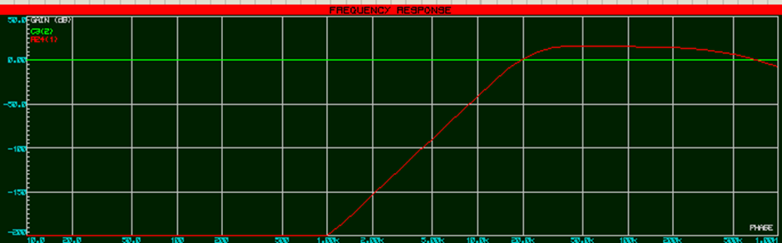
Figure 6: Frequency Graph of an Eighth Order High Pass Active Filter
The graph above in Figure 6 has an attenuation of -34.5dB and a gain of 12.1 This is where the issue becomes apparent. The gain is must not be present. And as such more alterations are needed. In order to achieve this result the resistor with the value of 12k shown on Figure 1 must be changed. After some changes the following result was shown, seen on Figure 8, and the fixed circuit on Figure 7.
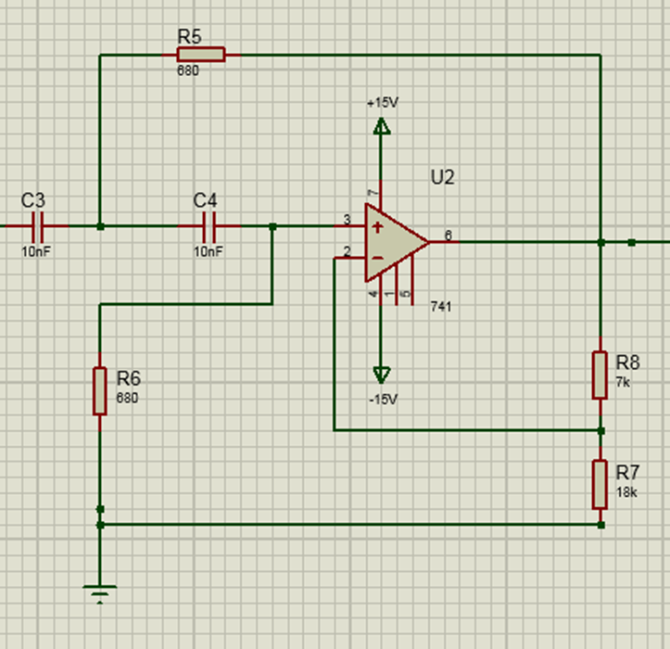
Figure 7: The Fixed Circuit of the High Pass Filter. Gain Changed Due to Resistor Value Change on R8
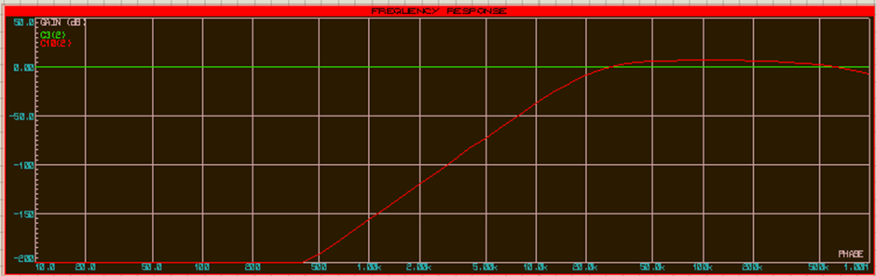
Figure 8: Frequency Graph of the Fixed High Pass Active Filter
Shown above on Figure 8 is a frequency with a gain of 0 and an attenuation of -32dB. It would be a borderline impossibility to attain a perfect result, however this will be acceptable for the finalized High Pass Filter. It should be noted that the filter was reduced to a sixth order variant because when the gain was reduced it resulted in the entire red line going down, meaning the attenuation grew, therefore in order to stay close to the -30dB line a filter needed to be removed.

Low Pass Filter
Like before the low pass filter follows the exact same procedure. The first filter shows the initial frequency result in Figure 9.
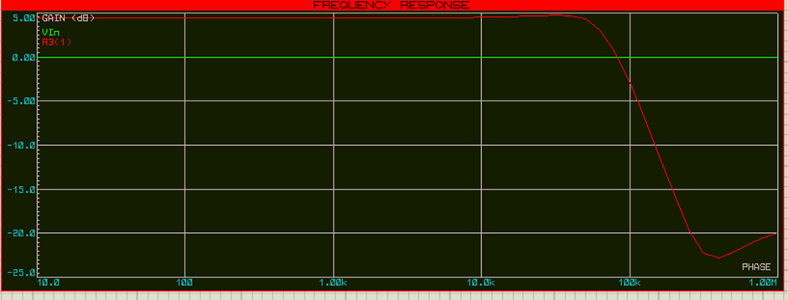
Figure 9: Frequency Graph of a Second Order Low Pass Active Filter
Figure 9 shows the attenuation and gain of the low pass filter. The gain is 4.17 and the attenuation is -11.9. It is unknown why there is a bump in the signal, but it doesn’t seem to affect the result in any problematic way so it will be ignored. As done before more filters are added until the -30dB limit is exceeded.
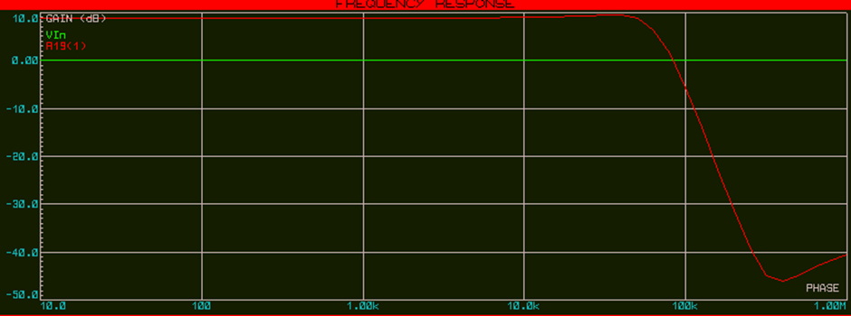
Figure 10: Frequency Graph of a Fourth Order Low Pass Active Filter
Same as with the high pass the low pass values have been doubled. The gain has increased to 9.45 and the attenuation has become -23.9dB. The graph lines themselves do not look different but the gain chart on the left reveals that compared to the highest gain value of 5 in Figure 8, the figure has become 11.
The next addition to the filter is the final one, and the results are shown on Figure 11 below.
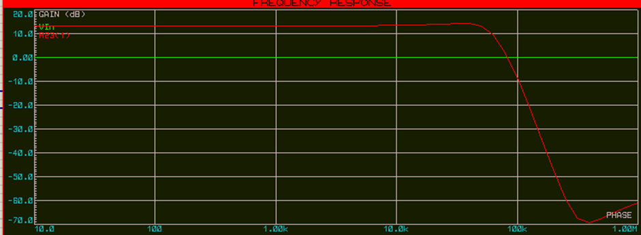
Figure 11: Frequency Graph of a Sixth Order Low Pass Filter
The gain on Figure 11 has risen by approximately five again, having become 14.2, the attenuation has also risen by approximately 10, becoming -36dB. This result is too much, both for the gain and the attenuation so once again the gain must be altered.
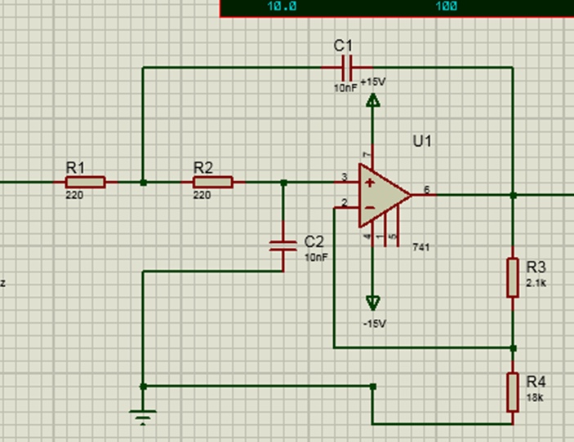
Figure 12: Fixed Low Pass Active Filter. Gain Change due to R3 Value change to 2.1k
Figure 12 shows the fixed circuit, and due to the changes the filter has been reduced to a fourth order filter.
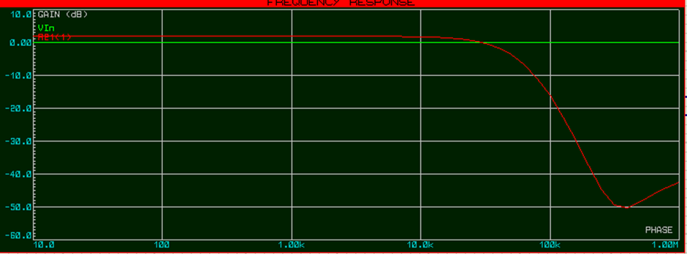
Figure 13: Fixed Frequency Graph of the Low Pass Active Filter
The low pass has been fixed so that the gain and attenuation are within tolerable levels. Gain has become -43.2m, and the attenuation has become -30.9dB.

Band Pass Filter
The final part was to combine the circuits to create a band pass filter. However there were some problems because when both filters were connected both of their respective gain and attenuation levels were altered, meaning that the process of altering gain levels needed to be repeated.
One primary change is shown in Figure 14.
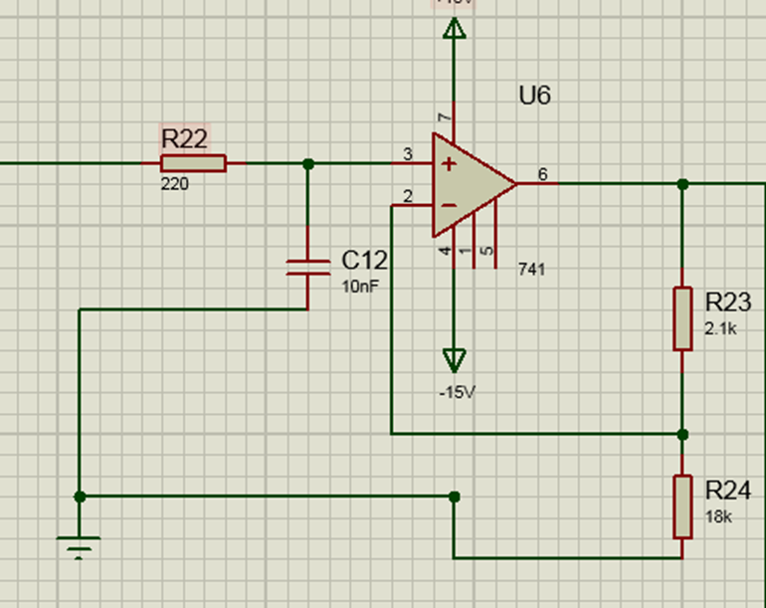
Figure 14: Alteration to Low Pass Filter: Turned Into First Order Filter to Reduce Attenuation
As seen above two of the components, a resistor and a capacitor, have been removed, which slightly lowers the rate of attenuation.
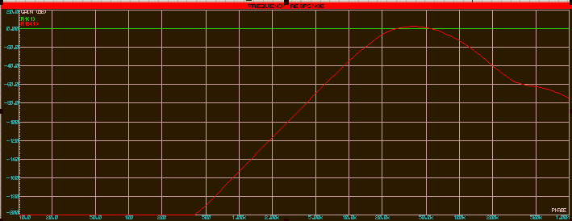
Figure 15: Frequency Graph of the Fixed Pass Band Filter
There are now two attenuation rates to monitor: the first is the 11kHz mark, where the attenuation is -30.7dB, and the 165kHz mark, where the attenuation is -21.3dB.
To further show the band pass’s success is an analogue signal result of the band pass, shown in Figure 16.
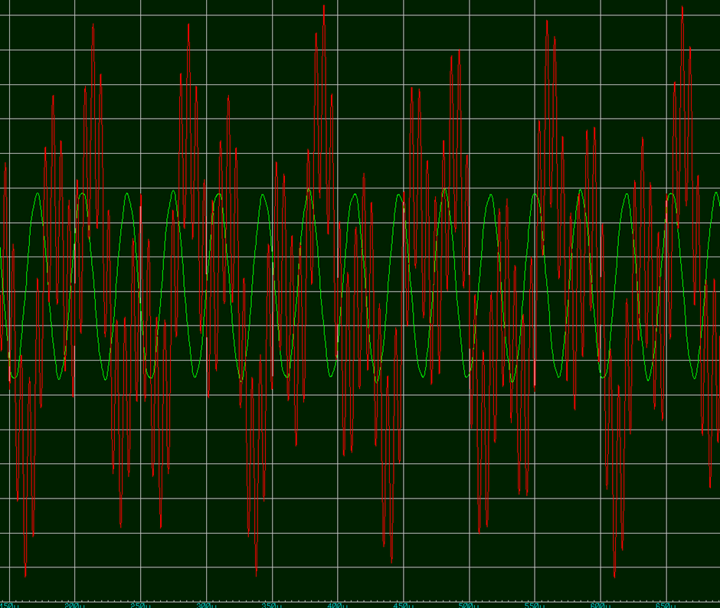
Figure 16: Analogue Result Graph of the Band Pass Filter. Red is the Initial Noise Filled Signal While Green is the Filtered Signal
As seen above the filter is indeed effective. Compare the noise filled frequency to the filtered frequency. While the filtered frequency is not entirely perfect if one looks closely enough, it is still far better than the initial signal.

Analysis
As seen by the results the Sallen and Key method of attenuating noise is an efficient method once the methods were understood. It was merely a matter of adding more filter orders and altering the gain to achieve the optimal result. It is clear why the Sallen and Key method is widely popular, as it is extremely simple to attain the desired results by altering the characteristics of the filter.
While there was no perfect result attained, all that matters is that the results are within the error margin, and that the filter removes the unwanted frequencies.

Conclusion
To conclude the assignment, the Sallen and Key method is definitely one of the more efficient ways of manipulating frequencies. It has a simple method and can be tuned very efficiently to suit the purposes of whatever objective that needs to be completed. The level of success at altering signals in this assignment has shown this. The objectives and error rates are satisfied and the band pass filter functions.

Bibliography
[1] K. Lacanette, “A Basic Introduction to Filters-Active, Passive, and Switched-Capacitor,” Natl. Semicond. Corp. Appl. Note, …, pp. 1–18, 2010.
[2] Electronic Tutorials, “High Pass Filter - Passive RC Filter Tutorial.” Electronics Tutorials, 2016.
[3] J. T. Rubin, “Passive Filter vs. Active Filter,” 2013.
[4] H. Zumbahlen, “Mini Tutorial Sallen-Key Filters MT-222,” pp. 5–7.

