DS 1 Template

My Screenshots/Photos
- Please add 4–6 screenshots or photos of your digital life.
- You can use your phone or laptop.
- For each screenshot, write one or two sentences explaining what it shows.

Screenshot/Photo 1
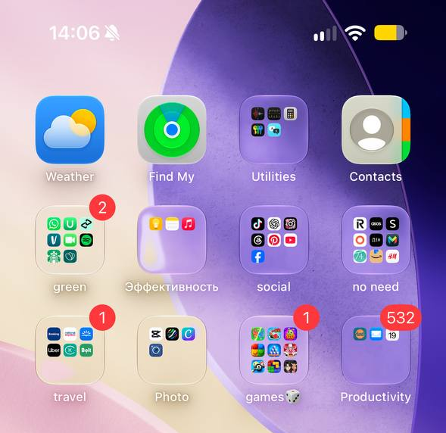
This screenshot shows my phone’s home screen, where I organise my apps into different folders. It helps me keep my digital life organised and find the apps I need quickly.

Screenshot/Photo 2
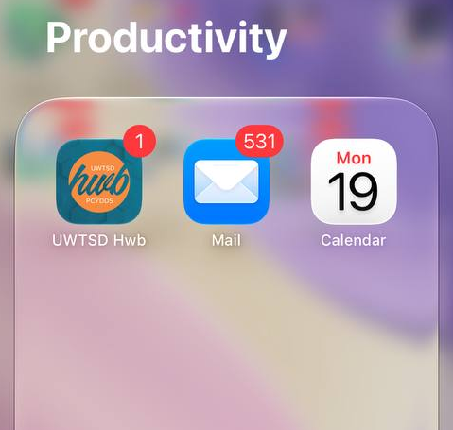
This screenshot shows my Productivity folder, which contains my calendar, university app and email. I use these apps to manage my schedule, check university information and stay updated with important messages

Screenshot/Photo 3
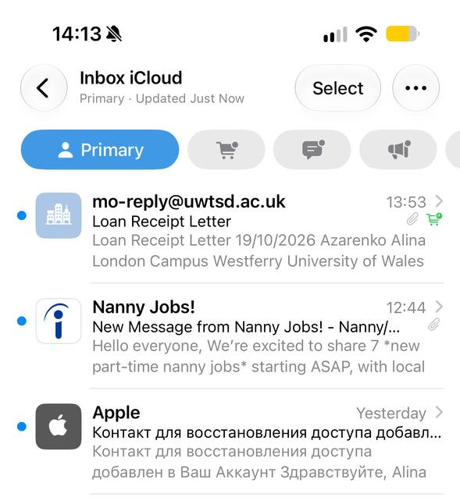
This screenshot shows my email inbox, where I receive messages and important updates. I use email to communicate with my university, check important information and manage my personal and academic responsibilities.

Screenshot/Photo 4
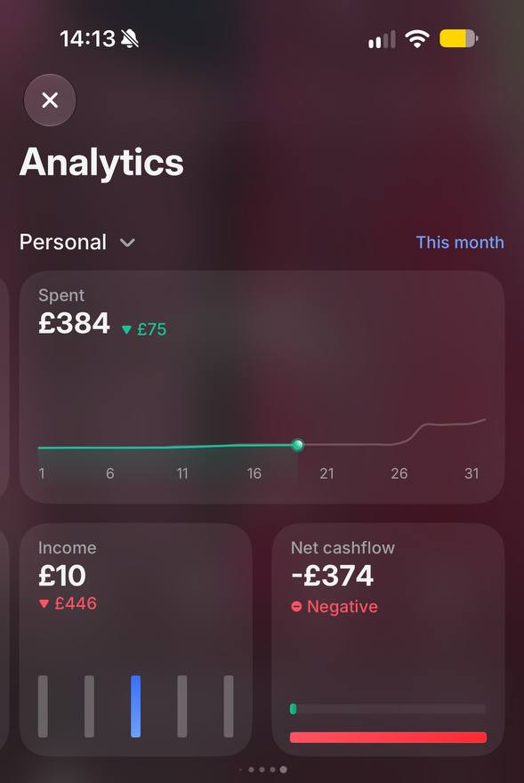
This screenshot shows my Revolut banking app and my spending statistics. I use it to check my balance, track my expenses and manage my money. It helps me understand my spending habits and keep control of my finances.

Screenshot/Photo 5
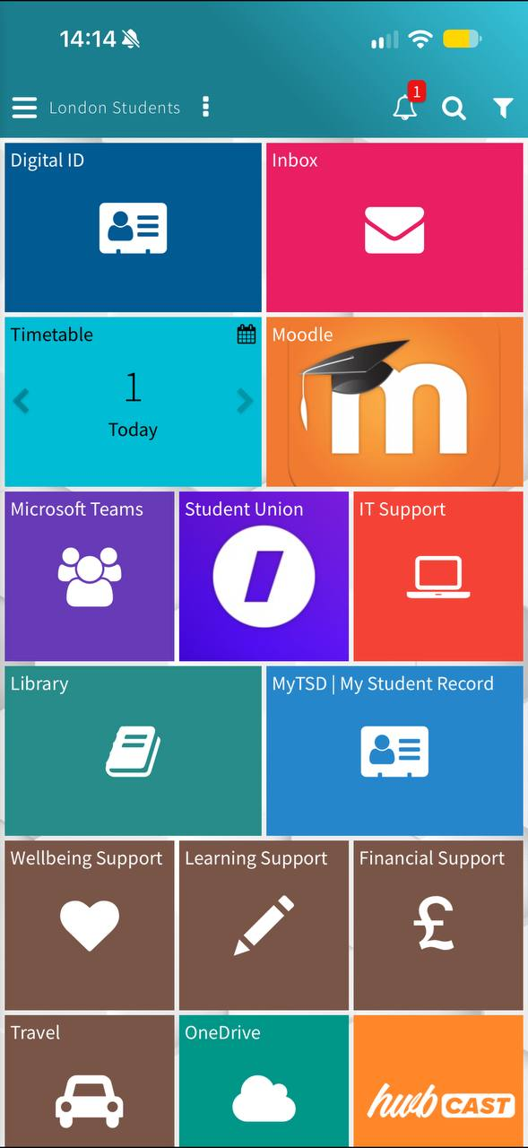
This screenshot shows my university app, which I use to access information about my studies. It helps me stay organised, check academic information and keep track of my university life.

My Short Reflection
- Write 5–8 simple sentences about your digital life.
- You can use the sentence starters below if helpful.
I use digital tools to organise my daily life, communicate with people and manage my university work. I feel confident when I use my smartphone, send emails and use apps such as Revolut. I want to improve my digital skills, especially when using Word and other tools for university assignments. I often use these tools: my calendar, email, university app, online banking and social media. I sometimes feel nervous about using new programmes or completing assignments online. I hope this module will help me become more confident and learn new digital skills. Digital skills are important for me because they help me with my studies, work and personal life. In my free time, I also use my phone to take photos, make video calls and watch videos.

Sentence starters
- I use digital tools to …
- I feel confident when I …
- I want to improve …
- I often use these tools: …
- I sometimes feel nervous about …
- I hope this module will help me …
- Digital skills are important for me because …
You can write more if you want.

Submission Checklist
Before you submit, please check:
​​​ ☒ I added 4–6 screenshots
☒ I wrote short sentences for each screenshot
☒ I wrote my short reflection
☒ My work is my own
☒ My file opens correctly
​​☐ My file opens correctly

