

NAME OF STUDENT: AESHANI SANJAYKUMAR PATEL

STUDENT ID: 2218148

MODULE NAME: INTERNATIONAL MARKETING (LCMB7006)

ASSIGNMENT TITLE: ASSESSMENT 1

Table of Contents

Introduction 2
Company Background 2
Analysis of Macro environment of Coca-Cola 3
PESTEL Analysis 3
HOFSTEDE’S Model of Cultural dimension 7
Advantages of Hofstede’s Model of Cultural dimension 11
Disadvantages of Hofstede’s Model of Cultural dimension 11
Analysis of industry attractiveness for Coca-Cola 11
Porter’s five forces 12
Threat from the new entrants: 12
SWOT Analysis 15
Similarities & differences in SWOT 17
Market Entry methods adopted by Coca-Cola 22
Advantages & Disadvantages Of chosen entry method 23
Directional development strategies 23
Ansoff Matrix 24
Recommendation 25
Conclusion 26
References 27
Appendices 33
Appendix 1 33

Introduction
The aim of the study is to conduct a cultural analysis of one of the leading soft drink manufacturers in the world, Coca-Cola that operates in different countries. This study sheds light on the marketing strategies used by Coca-Cola to sell its products in two different countries, the United States and India. Considering the cultural factors of both countries, the comparison has been drawn in terms of used marketing strategies by Coca-Cola. Relevant marketing strategies such as marketing mix, Ansoff matrix and others have been used to understand the similarities and differences of each country and the market of Coca-Cola.
According to Tien, Phu and Chi (2019), national culture can be considered one of the key factors that influence the development and integration of the marketing strategies of companies in international markets. Therefore, this study has the scope to evaluate the marketing strategies adopted by the American brand Coca-Cola to enter the Indian market and fulfil the cultural needs of Indian customers.

Company Background
Coca-Cola is one of the leading American multinational companies that is founded in 1982. The company manufactures, sells and markets non-alcoholic beverages in more than 200 countries across the globe. The aim of the company is to refresh the world in a different manner (coca-colacompany.com, 2023). It is found that the company sell multiple billion-dollar brands in multiple beverage categories in the world. The product portfolio of the company includes Coca-Cola, Fanta, and Sprite.
In addition, the company has other tea and coffee brands, water, juices and other value-added plant-based and dairy beverages. Coca-Cola reported sales of more than USD 10,980 million as compared to USD 10,491 million in last year (statista.com, 2023). The core values of the company include leadership, collaboration, integrity, accountability, passion, diversity and quality which help the company to become a valuable brand in most countries including emerging economies like India. In the US beverage market, Coca-Cola has a strong presence, however, the opportunities to grow are limited in this market due to the rapid shifting of preferences of customers towards healthy drinks. On the other hand, in India, the company has experienced notable growth opportunities due to the growing young population and rapid urbanisation.
It is also found that in the US, the company has a wide range of product portfolio including carbonated soft drinks, sports drinks, juices, bottled water and other others. In addition, considering the preferences of the US population, the company introduced healthier product options. Similarly, in the Indian market, the company introduced diverse products category that suits the taste bud of local customers (coca-colacompany.com, 2023). It is important to note that in both countries the company faces intense competition from other beverage brands. For instance, in the US, the company faces competition from Keurig Dr, Pepper, PepsiCo and other local brands and in the Indian market, the soft drinks manufacturers such as PepsiCo and other local brands give stiff competition to the company.
The macro-environment analysis is conducted for both countries (US and India) to understand the impact of external factors on the performances and marketing strategies of the company.

Analysis of Macro environment of Coca-Cola
PESTEL framework is used to analyse the macro environment of the US and India and compare the impact of external factors of both the countries on marketing strategies of Coca-Cola.

PESTEL Analysis

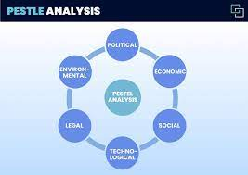

Figure 1: Pestle Analysis

Political factors:

US
The political factors of the country have a major impact on the strategic direction and performances of the Coca-Cola (refer to appendix 1). For instance, a fair and stable political environment helps the company to expand quickly (Nasir et al. 2021). In addition, the political stability also attracts foreign investors to invest in the business. The flexible trade agreements and good political relations with other countries help Coca-Cola to expand quickly in the international market (Whitehill et al. 2020). However, the recent changes in the tax rates have unfavourable impact on the pricing strategy of the company in the US market.

INDIA
Since India is the largest democratic country and maintains a good relationship with the other countries helps the business to grow quickly at the international level (Ullal et al. 2021). However, corruption is one of the significant political issues that has a negative impact on the growth of the companies like Coca-Cola and reduces their profitability.

Economic factors:

US
It is undeniable that the US is one of the most powerful and stable economies in the world. The presence of leading companies contributes to the development of the national economy (Inessa, Artem. and Wielki, 2019). However, the economic recession due to the outbreak of the pandemic significantly influences customer spending behaviours specifically soft drinks like Coca-Cola. It reduces the profitability and sales of the company in the US market.

INDIA
Indian economy and is one of the emerging economies and therefore, the multinational companies like Coca-Cola find it attractive for business and grow. In addition, the corporate tax rate of the company is lower as compared to other countries and therefore it attracts the foreign investors (Maiti, Castellacci and Melchior, 2020). Therefore, it imposes benefits on Coca-Cola. However, the outbreak of the pandemic slowed down the economic growth of every operating company in this country as consumer buying pattern has changed.

Socio-cultural factors:

US
It is evident that the US is a highly diverse and multicultural society that has the flexibility to adopt the new cultures (Abouk and Heydari, 2021). However, one of the major issues that Coca-Cola is facing over the past few years is related to the rapidly changing consumption patterns of customers as they switch to healthier drinking options as compared to the consumption of carbonated drinks offered by Coca-Cola. In addition, the rapidly growing ageing population reduces the market size of the brand in this market.

INDIA
India is one of a culturally diverse country and people from different cultural backgrounds live together. Therefore, the population has the flexibility to adapt to the new culture. However, the Indian population prefer to follow the tradition and culture, while keeping pace with the Western culture and influence (Mohan and Ali, 2019). Therefore, Coca-Cola has the opportunity to target a large number of customer base. In addition, the growing number of young populations increases the opportunity for the company to attain a huge customer base in this country.

Technological factors:

US
Technological advancement of the country provides a significant opportunity for Coca-Cola to improve its marketing strategies (Whitehill et al. 2020). For instance, the company increases its presence across digital and social media platforms to increase engagement with the customers and know about their needs and preferences (Chu, Chen and Gan, 2020). In addition, the company uses new technologies to improve its supply chain and distribution process.

INDIA
India is heading to become one of the most technologically advanced countries in the world (refer to appendix 1). Therefore, it provides opportunities to Coca-Cola to improve its operational activities using new technology and offer quality products to the customers (Nair et al. 2021). In addition, the growing number of social media users helps the company to adopt digital marketing strategies and increase brand awareness among the minds of customers.

Environmental factors:

US
Coca-Cola faces significant threats due to increasing environmental concerns among the stakeholders including government and customers (Widyawati, 2020). However, the company complies with the strict regulations of the country and focuses on the reduction of carbon emissions and using eco-friendly packaging and distribution strategies.

INDIA
The growing environmental concerns such as the generation of huge waste, and depletion of natural resources, pollution and others impose threats to the soft drink manufacturers like Coca-Cola (Fragouli. and Nicolaidou, 2020). The company needs to adopt sustainable business strategies in the Indian market to make people aware of their purpose and create a positive image in the minds of stakeholders in the Indian market.

Legal factors:

US
Coca-Cola complies with the food and beverage regulations of the country and ensures the use of the right ingredients for the manufacturing of products (Alzoubi et al. 2022). In addition, the food and beverage regulations of the US also ensure ethical advertising of the company. The Intellectual Property rights of the country provide a safeguard to the identity of the company and its products in the market.

INDIA
The companies’ act 2013 ensures protection to the employees from any kind of discrimination and exploitation (Singaram et al. 2019). In addition, the Industrial Disputes Act of the country restricts the business from any kind of harmful activities and business practices. Therefore, Coca-Cola must abide by the laws of the country and adopt the advertising and marketing strategies and ensure sustainable growth in the Indian market.

HOFSTEDE’S Model of Cultural dimension
Hofstede’s Model of cultural dimension is used to compare the cultural dimension of the US and India that influence Coca-Cola to adopt the marketing strategies accordingly to fulfil the needs and preferences of customers of different countries.
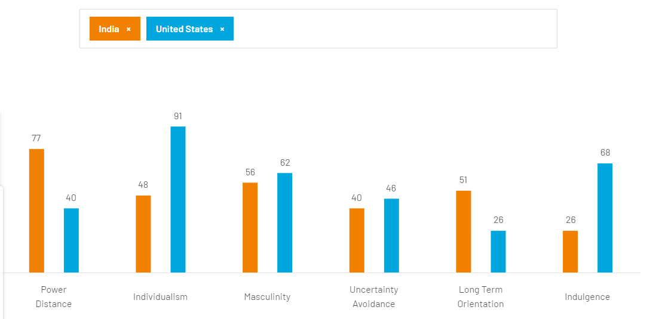
Figure 2: Comparison of the culture of the US and India using Hofstede’s cultural dimension
(Source: hofstede-insights.com, 2023)
According to Hofstede’s cultural dimension framework, there are six cultural dimensions such as power distance index, collectivism vs individualism, uncertainty avoidance index, femininity vs masculinity, short term vs long-term orientation and restraint vs indulgence that helps to understand the cultural preferences of the population of the countries (hofstede-insights.com, 2023). It helps the organisations to understand the strategies that are required to adopt to fulfil the cultural needs of customers and ensure sustainable growth in the international market. The six cultural dimensions proposed by Hofstede are discussed below:
Power Distance Index:
Power distance is the level of inequality between individuals and various groups of individuals within an organization according to the amount of power they possess. The populace accepts this disparity. Coca-Cola Enterprises The general culture is one of low power distance.
US
From the above diagram it is evident that the US has a low power distance as people of this culture believe in equal opportunities, rights and the organisations that operate in this country tend to follow the flat organisational structure. Therefore, the marketing strategies of Coca-Cola in the US market focus more on personal choices and individual empowerment that are appealing to a sense of freedom and equality (Mamatha and Geetanjali, 2020).

INDIA
On the other hand, India belongs to the high-power distance index as the society and the organisations follow a hierarchical structure. It is evident that in India, there is an unequal distribution of rights and power. Therefore, the marketing strategies of Coca-Cola in this country show more authorised figures, family values along with the respect for customs and traditions.
Individualism vs. Individualism:
This is referring to how work duties and activities are structured within an organization. Individualistic organizations place more emphasis on individual accomplishments, and workers prefer to compete with one another to complete difficult tasks and advance shared objectives. When possible, this is done with the goal of improving performance in addition to earning money. In contrast, collective organizations work more closely with teams and groups to reach a common objective that requires cooperation. Coca-Cola Enterprises The organizational culture of the maintains a good balance between individualism and collectivism to encourage workers' best work and to sustain business growth.

US
It is found that the culture of the US is characterised by individualism and therefore the people of this culture prioritise the personal desire, goals along with the individual achievements. Since the self-expression and personal achievements and goals are valued in this culture, therefore Coca-Cola emphasises on the personal enjoyment or individual experiences of this product in its advertising and promotional campaign (Chun et al. 2021).

INDIA
On the contrary, India is a collectivist society that emphasises more on the family values, societal values along with the needs of the community. Coca-Cola identifies that, unlike the US culture, India believes more in social networks and therefore the company opted for the marketing strategies emphasizing more on the group celebration, celebrating festivals and other such gatherings to enjoy the products offered by Coca-Cola.

Masculinity vs. Femininity:
This refers to how the organization's male and female employees have been assigned different employment positions and responsibilities. Coca-Cola Enterprises The organization has a low MAS score, which indicates that job duties frequently overlap between men and women and that job descriptions do not reflect gender bias or stereotypes.

US
According to Hofstede’s cultural framework, it is found that the US is a masculine society that believes in material success and competition. Considering the nature of the culture of this country, Coca-Cola also focuses on the sports partnerships and achievements to promote its products (Albinsson et al. 2019).

INDIA
Similarly, India also practices the masculinity culture as the majority of the population still follows the traditional roles of gender. Therefore, Coca-Cola in the Indian market targets a diverse audience to maintain a balance between the gender roles. It helps the company to provide social awareness among the youths of the country about gender roles.

Uncertainty Avoidance Index:
Organizations with strong uncertainty avoidance cultures may have a more controlling outlook, where there is a greater desire for control and thorough understanding. These cultures prioritize having stricter risk controls over encouraging innovation and creativity generally. A more laid-back and open culture is indicated by lower uncertainty avoidance ratings. Coca-Cola Company once more. The culture of uses a combination of both, with a tendency toward lower uncertainty avoidance ratings.

US
It is found that the US culture promotes innovation and risks taking abilities. Therefore, it helps Coca-Cola to feature innovative marketing campaigns and introduce new product categories to stay relevant and competitive in the market. It also helps the company to keep pace with the rapidly changing demands of the customers (Ruanguttamanun, 2023).

INDIA
On the other hand, in the uncertainty avoidance index, India scores moderately which shows its stability and loyalty towards the brand. Coca-Cola identifies that the Indian customers believe in tradition and reliability. Therefore, they can earn the trust of the customers by engaging them with the brand values and offering quality products considering their cultural preferences and needs.
Long-term orientation vs Short Term orientation:
Long-term-oriented cultures tend to be thriftier and more practical in approach. They demonstrate a long-term perspective on time that is well spaced out in the future. Cultures with a short orientation, in contrast, are more nationalistic and value-driven. Coca-Cola Enterprises In this strategic emphasis and development, the works with a long-term orientation, whilst execution and related operations of the same are more driven by a short-term orientation.

US
It is evident from the above diagram that the US scores low in the long-term orientation as the people of the US believe more in short-term goals. Therefore, to promote its products in the US market and attain competitive advantages, Coca-Cola must be aware of the new trends in the market, and change in the preferences of the customers. In addition, they also must focus on timely promotion to keep pace with the rapidly changing demands of the customers and stay relevant in the minds of customers (Escandon-Barbosa et al. 2022).

INDIA
On the other hand, India scores high in the long-term orientation. It states that the country values perseverance and persistence. The people in India believe in brand loyalty and expect good products and services from the brand and they tend to stick to the brand for the long term. Therefore, Coca-Cola has adopted their marketing strategies through customers' values, integrity and commitment. For instance, in India, the commitment and long-lasting presence of Coca-Cola shows the quality of its products and the ability to absorb the Indian culture quickly. It helps the company to sustain itself in the competitive yet attractive Indian market.
Indulgence vs Restraint:
A society is more tolerant of people's needs and happiness as well as their own pleasure if it has a higher indulgence score. On the other hand, a culture that is more constricting is one that is governed by social standards and laws. The organizational culture of Coca-Cola Company The is a harmonious blend of the two, with a tendency toward excess.

US
It is found that the culture of the US is indulgent in nature that promotes self-expression and leisure instead self-control. Therefore, Coca-Cola adopts the marketing strategies to promote its market emphasising more on the carefree experiences and enjoyment. Since the US is an indulgent society, therefore Coca-Cola promotes its products in this market as the symbol of enjoyment and pleasure (Nair and Selvaraj, 2021).

INDIA
On the other hand, India is a restrained society that believes in maintaining modesty and self-control. Therefore, unlike in the US market, Coca-Cola focuses more on the social values and responsible consumption. The Indian culture is more restrained as compared to the culture in the US. Therefore, the marketing strategies of Coca-Cola focus more on maintaining balance in life with enjoyment.

Advantages of Hofstede’s Model of Cultural dimension
- It helps in understanding different societies, societies, and diversity.
- The model helps in expanding business on an transnational platform by not facing any artistic obstacles.
- It encourages people to globalize and work together to stabilize the association.

Disadvantages of Hofstede’s Model of Cultural dimension
- Despite being a successful model, experimenters don't find the proposition to be accurate, as it doesn't pay attention to communities and their ethics.
- The proposition tends to be outdated, as the confines of power distance indicator, virility, individualism, short term vs. long term exposure, and query avoidance don't give sufficient knowledge on different social societies.
- A different group of artistic gets can be a loss to an association and can affect the director's decision- making due to social-artistic conflicts.

Analysis of industry attractiveness for Coca-Cola
The attractiveness of the industry in which, Coca-Cola operates in both the countries, US and India can be discussed using Porter’s five forces model.
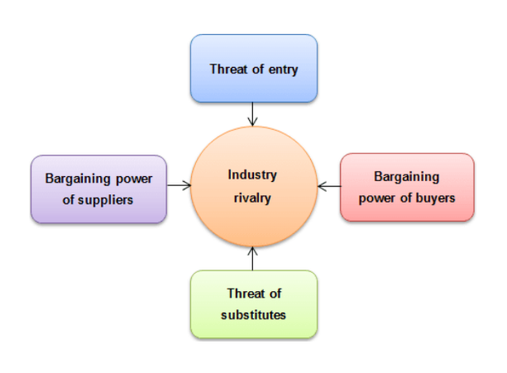
Figure 3: Porter’s Five Forces model
(Source: lecture slide)

Porter’s five forces

Threat from the new entrants:

US
Threat from new entrants in the US market for Coca-Cola is high due to low entry barriers for the new market players. In addition, the entire supply chain process of this industry is not complex as compared to other industries (Guo and Wen, 2021). Therefore, the local and international brands provide stiff competition to Coca-Cola. However, it is undeniable that Coca-Cola has already established a strong brand awareness along with a strong distribution network across the country. It may safeguard the competitiveness of the brand against the new entrants.

INDIA
The leading soft drinks manufacturers like Coca-Cola face low threat from the new entrants as the company has already established a strong brand recognition and distribution channels. In addition, entering the market for new entrants requires notable investment in both distribution and marketing (Fan, Tan and Zheng, 2022). Therefore, despite the regional appeal of the local brands, Coca-Cola faces a low threat from new entrants in the Indian market.

Bargaining power of customers:
US
It is found that the bargaining power of customers in the US market is high due to the availability of several beverage options. Therefore, the customers have the flexibility to switch to other options or brands that offer healthier beverage options as compared to Coca-Cola (Geng, Jiang and Liang, 2021). In this context, Coca-Cola needs to adopt a product differentiation strategy to attain customer loyalty in the market.

INDIA
It is found that the bargaining power of customers in the Indian market is comparatively low from the US market. The wide range of the brand product portfolio along with the taste of its products restrict the customers to switch to other brands (Dörnyei, 2020). In addition, Coca-Cola maintains a competitive pricing in the Indian market that helps the company to lower the bargaining power of customers.

Bargaining power of suppliers:
US
It is evident that the bargaining power of suppliers in US for Coca-Cola is low. The key ingredients used by the company for its products are available widely in both the market. In addition, the global presence of the company and its strong distribution network allows the company to be in the dominant position in terms of negotiating with suppliers (Fan, Tan and Zheng, 2022). It allows the company to maintain the prices of its products throughout the year in both the market and attain competitive advantages.

INDIA
It is evident that the bargaining power of suppliers in the Indian market is low for Coca-Cola. For instance, the key ingredients that are used by the company to manufacture the products are available widely across the Indian market. In addition, its strong distribution network allows the company to negotiate with the suppliers (Fan, Tan and Zheng, 2022). It allows the company to maintain the competitive prices of its products throughout the year in the Indian market and attain competitive advantages.

Threats from substitute products:
US
The threat from the substitute products is high for Coca-Cola in the US markets due to the presence of several regional and international market players. The rapidly changing preferences of customers towards the healthier beverage options flavoured juices and others impose notable threats to the marketing of Coca-Cola in the US markets (Li, 2022). It is found that a growing number of health-conscious customers tend to avoid the carbonated drinks offered by Coca-Cola. Therefore, to retain its position in the operating markets and attain brand loyalty, Coca-Cola needs to focus on the diversification of its product choices.

INDIA
The threat from the substitute products is high in the Indian markets for Coca-Cola with the presence of its key competitors. In addition, the company also faces threats to keep pace with the rapidly changing preferences of customers towards the flavoured juices and healthier beverage options (Li, 2022). Therefore, to retain its position in the Indian markets and attain brand loyalty, Coca-Cola needs to focus on the diversification of its product choices specifically for the Indian customers.

Rivalry among the existing firms:
US
In the US markets, the company faces intense competition from another multinational and other local and regional brands soft-drink manufacturers such as Dr Pepper, Tetra Pak, PepsiCo, Soylent and others (Hakhroo, 2020). Therefore, the company must focus on the product diversification and competitive pricing of its products to retain its market share in both the market.

INDIA
In the Indian markets, the company faces intense competition from multinational and local soft-drink manufacturer such as PepsiCo, Amul, Red Bull, Bisleri and others. It is found that in the Indian market, PepsiCo has a strong customer base and with the rapid innovation and aggressive marketing strategies. Therefore, PepsiCo imposes notable threats to the market share of Coca-Cola (Hakhroo, 2020). It is important for the company to focus on product diversification strategy along with competitive pricing to retain its market share in the Indian market.
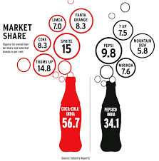
Figure 4: Market share of coco-cola
Similarities of market force analysis
Competition: Coca-Cola is up against a variety of beverage producers, including those that make carbonated soft drinks, juices, bottled water, energy drinks, and more. Coca-Cola's market share and price tactics are impacted by this rivalry. Consumer tastes: Coca-Cola's sales and product offerings may be impacted by shifting consumer tastes for healthier beverages and growing health awareness. To remain relevant, the business must make these changes. Economic Conditions: Consumer spending power and spending habits can be impacted by economic issues including inflation, unemployment, and disposable income levels. Economic downturns may result in a decline in the demand for luxuries like soft drinks.
Differences of market force analysis
Coca-Cola is an iconic and well-known brand on a global scale. This may affect consumer decisions and lessen some market factors like rivalry and price sensitivity. Distribution System: Coca-Cola has a huge distribution system in place all over the world. The company's capacity to respond to market shifts, roll out new goods, and effectively compete may be impacted by this network. The beverage industry is governed by a number of laws that include things like labelling, health claims, sugar levels, and environmental issues. The product compositions, marketing plans, and production procedures of Coca-Cola may be impacted by these rules. Product diversification: In addition to carbonated soft drinks, Coca-Cola also sells bottled water, juices, sports drinks, and other goods. With this diversification, the business can lessen the risks brought on by shifting consumer preferences. Global Presence: Coca-Cola is present in many nations.

SWOT Analysis
Strengths  - The company has a strong brand reputation in the both the US and Indian markets for its high-quality products and wide product portfolio.  - It helps the company to attain a competitive position over other soft drink manufacturers in the market.  - The diverse product portfolio is one of the key strengths of the company that helps the company to cope up with the rapidly changing preferences of customers (Chu, 2020).  - The extensive and well-structured distribution network of the company helps the company to reach customers from different parts of the world easily.  - The visually appealing marketing and advertising of the company to promote its products increase customer engagement with the brand. | Weaknesses  - With the rapidly increasing concerns about the health impact of the carbonated drinks offered by Coca-Cola in both the US and Indian markets reduce the profitability of the company.  - One of the major weaknesses of Coca-Cola is related to its product development and use of highly sugary content in its products (Singaram et al. 2019).  - The company is still not able to capture the local taste and incorporate them in its products.
Opportunities  - The growing use of several digital platforms and technological advancements in both the countries, US and India provides opportunities to Coca-Cola to reach more customers.  - In both the countries, the number of social media users are increasing day by day.  - The company has the opportunity to use the social media platforms to promote its products and interact with the customers easily (Dai, 2021).  - Considering the high demand of the healthy drinks, the company can diversify its product category with healthy product options such as low calories, zero sugary content drinks and others and retain its position in the market. | Threats  - The key threats that Coca-Cola faces in both the US and Indian markets are related to intense competition from the regional and international brands.  - The customers tend to switch to other brands (Rey-López and Gonzalez, 2019).  - The regulatory challenges in both the countries related to ingredients used in the products along with advertising elements impose notable threats to Coca-Cola.

Table 1: SWOT analysis
(Source: self-developed)

Similarities & differences in SWOT

Similarities
- Coca-Cola has a strong brand reputation in both the US and Indian market
- The company offers a diverse product range including soft drinks, energy drinks, juices and water in both markets (Wang, 2021).
- The company uses engaging content to promote its products in both the countries using online and offline platforms

Differences
- The number of health-conscious customers are growing more in the US market as compared to the Indian market (Guo and Wen, 2021). Therefore, the company faces more threats in sales of products in the US market.
- Lack of adaptability in preferences and local taste in the products (Mathews, 2021). For instance, in the US, Coca-Cola needs to produce more healthier beverage options, while in India, the company needs to offer flavoured drinks in line with the taste of customers.
- In the US, Coca-Cola has the opportunity by diversifying its products into more healthier options, while in India, the opportunity lies for Coca-Cola with the rapid urbanisation and changes in the lifestyle of people of the country (Chua et al. 2020).

Segmentation, Targeting & Positioning

Segmentation
Marketing Mix Market segmentation is the process of grouping potential customers into segments or groups based on their shared needs and how they would react to a given marketing initiative. With this strategy, businesses can reach out to a range of client segments whose perceptions of the absolute value of particular goods and services differ from one another.7Ps of Marketing Mix is used to analyse the marketing strategies adopted by Coca-Cola to tap into the US and Indian market.

Geographic:
Geographical, demographic factors make up Coca-Cola's market segmentation. Despite having its roots in the United States, Coca-Cola has over the years spread its brand to several nations around the world. The geographic segmentation used by the organization aims to divide the market into several geographic divisions, such as cities, regions, and neighbourhoods. Coca-Cola may concentrate on cities and suburbs, but it also maintains a nationwide network for product distribution. This is due to the corporation realizing that there is a demand from people in rural areas as it grows.

Demographic:
Based on a variety of factors including age, occupation, family life cycle, race, religion, generation, social class, and nationality, Coca-Cola's demographic segmentation is broken down into sub-segments. Coca-Cola uses these factors the most frequently to differentiate between different client segments. Based on lifestyle, personality, or values, the psychographic segment of the Coca-Cola market segmentation is divided into many groups.

Targeting
Coca-Cola's targeting strategy is more extensive due to their wide range of products as well as their global market presence. Additionally, there is a requirement to please a variety of clientele, from commoners to health-conscious ones. Coca-Cola's primary market is younger consumers in the age range of 10 to 25, with a secondary market made up of persons in the range of 25 to 40.

Positioning
Positioning examines how items will compare to rivals who provide the same goods and services in the marketplace and in consumers' thoughts. A product becomes distinctive thanks to strong positioning, which encourages customers to use it. An good positioning strategy lets the product stand out among others and piques clients' attention in a market with many cluttered products touting identical benefits.

Coca-Cola portrays its products as refreshing and thirst-quenching. They claim that their products make their target market happy. Coca-Cola beverages and other goods are linked to having a good time with loved ones and relishing everyday life.

Marketing Mix

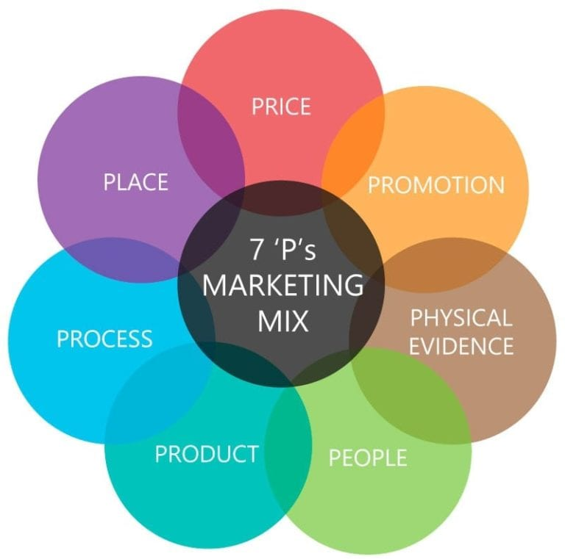
Figure 5: 7Ps of Marketing Mix
(Source: self-developed)
Product
In the US market, considering the growing preferences among the customers towards the more healthier beverage options, Coca-Cola introduces its new products. It includes Diet Coke, Zero Sugar Coke and others. In addition, its other non-carbonated beverage options for the US market include Minute Maid juices, Dasani bottled water and other sports drinks (Szolgayová, 2022). On the other hand, in India, based on the demands of customers of the local taste and traditional beverage options, the company introduced flavoured beverages such as Fanta, Maaza, Sprite, Limca and others. The diversification of the taste in beverages increases the popularity of the products across the country. In addition, to keep pace with the demands of customers the company also introduces Diet Coke, Zero Sugar Coke and other healthy food options.
IN US
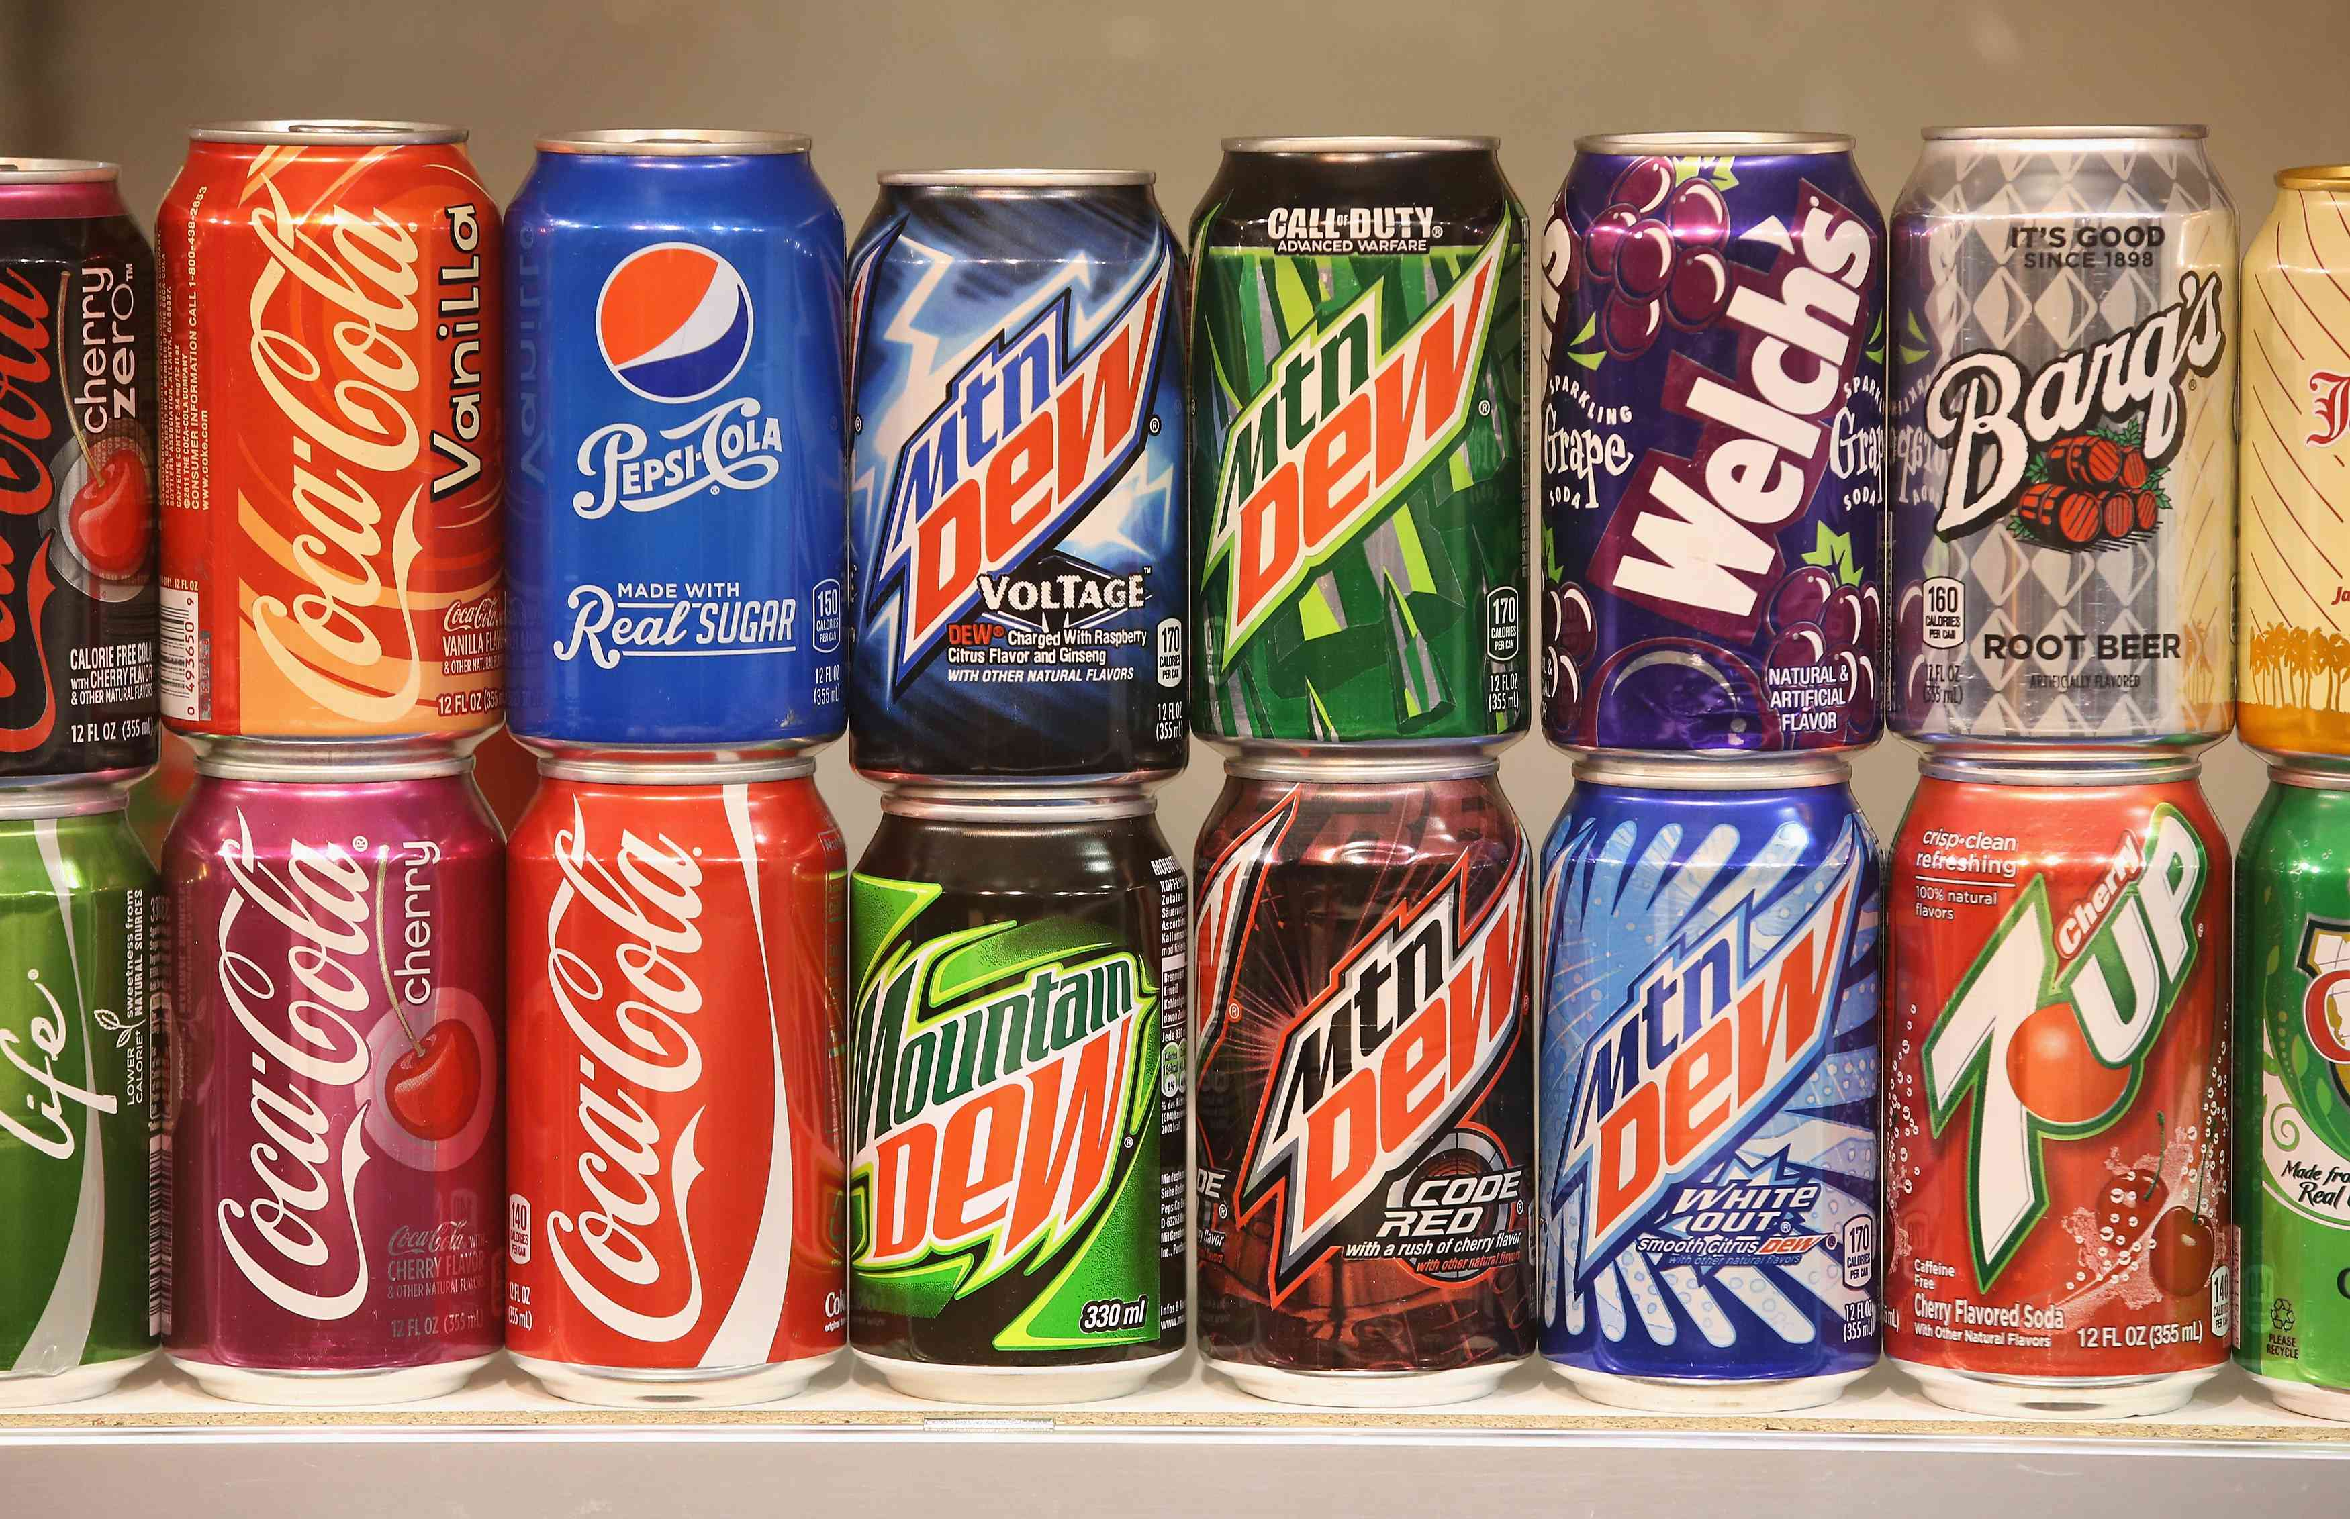

IN INDIA
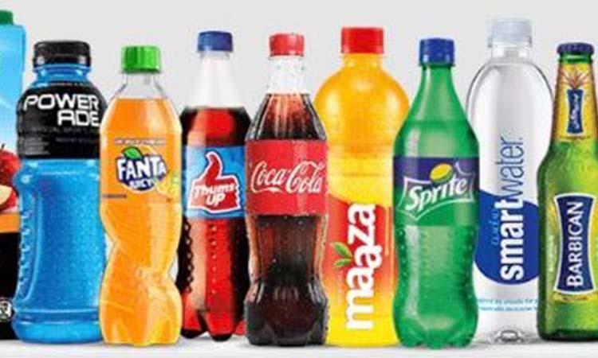

Place
In the US market, Coca-Cola uses its large distribution channels to ensure the availability of its products across the retail outlets, vending machines and restaurants in various sizes and options (Dörnyei, 2020). For the Indian market to reach both the rural and urban areas, the company uses both online and offline distribution channels. It ensures that its wide range of products is available in local markets, grocery stores, and supermarkets so that a vast population can get access to it.
Price
The pricing strategy adopted by Coca-Cola in the US market depends on the packaging and size of the products. In the US market, the company uses a premium pricing strategy. It helps the company to set higher prices for its every product as compared to its competitors. In addition, it also allows the company to position itself among the high-quality product category and help to fulfil the preferences of customers. In the Indian market, the company adopts a competitive pricing strategy based on the high demands of the customers (Sitanggang and Astuti, 2019). It allows the company to adjust the prices on the basis of the competitive situation in the market along with the regional preferences. In addition, this pricing strategy allows the company to offer quality products at affordable prices and even produce products at smaller packages for customers from every income group.
Promotion
In both the US and Indian markets, the company is trying to maintain its brand image through effective advertising and promotional strategy. For instance, in both the market considering the cultural preferences of the customers, the company uses social media platforms, celebrity endorsements, sports sponsorship and along with traditional promotional strategies such as TV commercials to promote its products. It helps the company to connect with the customers and provide them with a message about the brand (Alsharif et al. 2023). It is important to note that Coca-Cola identifies the value of festivals, events and social gatherings among the Indian people. Therefore, to connect the customers emotionally with the brand the company promotes its products during the festivals.

People
The purpose of the extra p was to emphasize the significance of the individuals delivering the messages to the audience. Professionals must here consider staffing and customer services. Training sessions and other exercises are the main methods used to achieve this.
Process
The distribution and delivery of your goods and services to customers are referred to as processes. Consumers eventually pay for how the service is provided to them as well. Consider ways to enhance your offerings and give your customers the best possible ease.
Physical Evidence
The last letter, "p," stands for "physical evidence," and it refers to all the tangible ways that customers will connect with your company. For instance, this may refer to the product's packaging, branding, design, and, of course, the general setting of the location where you sell your goods and services. The user experience will eventually be influenced by all of these factors.

Market Entry methods adopted by Coca-Cola
Market entry refers to the activities that are involved in bringing the new products and services to the new market. The Coca-Cola have opted for different market entry modes based on cultural differences in US and India.
Market entry mode for the US
In the US market, initially the company opted for Direct Investment, in which the company develops its presence in the foreign market with the help of wholly owned operations, subsidiaries or joint ventures. The company uses wholly-owned subsidiaries to penetrate in the US market and ensure sustainable growth (Huse et al. 2022). It allows the company to take full control of its entire marketing and operational activities across the country in line with the specific demands and preferences of customers in this market.
Market entry mode for India
On the other hand, the company entered in the Indian market through acquisition entry mode. The company acquired the local soft drink manufacturer, Thumsup and Limca to acquire knowledge about the soft drink market of India (Gómez, 2019). It helps the company to attain a detailed understanding of the needs and preferences of the customers along with the cultural values related to the taste and lifestyle. It helps Coca-Cola to not only enter in the Indian market but also attain brand loyalty.

Advantages & Disadvantages Of chosen entry method
Advantages and disadvantages of wholly-owned subsidiary
Using the wholly-owned subsidiary the company has a control over its entire business activities. It helps the company in making the right decisions (Tien and Ngoc, 2019). In addition, use of this entry mode helps Coca-Cola to adapt to rapidly changing preferences and market conditions. However, this market entry mode involves high investment and it increases the operational costs of the company.
Advantages and disadvantages of acquisition
This market entry mode helps the company to get easy access to the local companies and therefore they got to know about the specific preferences along with the regulatory conditions of the market (Qi et al. 2020). In addition, it helps the company establish an immediate market presence and improve profitability. However, it involved with the risks of damage of the reputation of the controversies of the acquired brand.

Directional development strategies
Directional Development strategies refer to the game plan adopted by the company to ensure growth of the business (Singaram et al. 2019). Ansoff Matrix is used to analyse the growth strategy adopted by Coca-Cola in the US and Indian market.

Ansoff Matrix
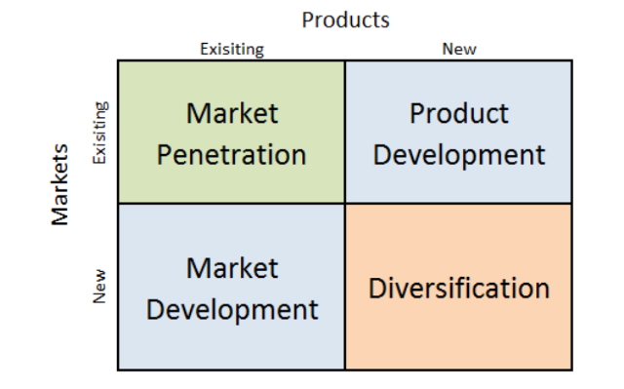
Figure 4: The Ansoff Matrix
(Source: lecture slide)
Market penetration
In the US market, the company emphasized on market penetration through the promotion of its existing products. In addition, the company invests adequately in brand promotions, advertising to strengthen its position. In the Indian market also the markets and promotes the existing products by focusing on the distribution network (Zafar and Habil, 2019). In addition, its localisation strategy allows the company to penetrate the Indian market successfully.

Product development
In this segment, the company introduced its new product category for the US market such as low-calorie beverages, zero sugar and other limited-edition brands targeting the health-conscious customers (Schlosser and Chenavaz, 2023). It increases customer attention towards the brand and increase the possibility of repeat purchase. For the Indian market, the company introduced flavoured beverages in line with the preferences of customers as part of its product development strategies.

Market development
It is found that in the US market, the market development strategy for Coca-Cola is less prominent as the market is already matured. Despite the company exploring opportunities for development through its non-carbonated beverages (Tien, Vu and Tien, 2019). However, in India, the company has extensive opportunities to grow in several regions and rural areas. Therefore, the company has diversified its product category for different target markets with localised flavours.
Diversification
In both the market, the company has adopted a diversification strategy. The company invested and acquired the beverage brands to produce new products that suit the taste of American health-conscious customers (Liu, 2021). Similarly, the company adopted an acquisition strategy for the Indian market to meet the local taste and preferences in its diversification strategy.

Recommendation
A set of recommendations is provided to Coca-Cola that can help the company to improve its marketing strategies in line with the cultural preferences of customers in different countries.
Promoting social responsibility: It is recommended to Coca-Cola to promote social responsibility by aligning its marketing campaigns with several social initiatives (Sharma et al. 2019). For instance, the promotion of health awareness and a healthy diet can help Coca-Cola to become a socially responsible corporation and improve its brand reputation in the targeted market.
Customisation of market entry strategies: It is recommended to the company to customise its market entry strategies with unique regulations and cultural elements of the country (Top-Oweh, 2019). For instance, developing partnerships with the local companies can help them to make awareness about the cultural trend and improve performances.

Conclusion
From the above discussion, it can be concluded that Coca-Cola is one of the leading multinational companies operating in multiple countries. In this study, the marketing strategies adopted by the company in the US and Indian market is analysed considering the cultural factors of both the countries. It is found that both the countries are culturally different from one another in terms of lifestyle, values, consumption of foods and other such aspects. Therefore, considering the differences in both the countries the company opted for different market entry modes, and marketing strategies including pricing, place and promotional strategies for its products. Based on the differences in preferences of customers in both the countries along with the consumption pattern, the company introduces new products, advertising and packaging strategies. The flexibility and adaptation of the company in marketing strategies help the company to attain customer satisfaction and customer loyalty in both the market and sustain its growth.

References
Abouk, R. and Heydari, B., 2021. The immediate effect of COVID-19 policies on social-distancing behavior in the United States. Public health reports, 136(2), pp.245-252.
Albinsson, P.A., Perera, B.Y., Nafees, L. and Burman, B., 2019. Collaborative consumption usage in the US and India: An exploratory study. Journal of Marketing Theory and Practice, 27(4), pp.390-412.
Alsharif, A.H., Salleh, N.Z.M., Abdullah, M., Khraiwish, A. and Ashaari, A., 2023. Neuromarketing Tools Used in the Marketing Mix: A Systematic Literature and Future Research Agenda. SAGE Open, 13(1), p.21582440231156563.
Alzoubi, H., Alshurideh, M., Kurdi, B., Akour, I. and Aziz, R., 2022. Does BLE technology contribute towards improving marketing strategies, customers’ satisfaction and loyalty? The role of open innovation. International Journal of Data and Network Science, 6(2), pp.449-460.
Chu, B., 2020, November. Analysis on the Success of Coca-Cola Marketing Strategy. In 2020 2nd International Conference on Economic Management and Cultural Industry (ICEMCI 2020) (pp. 96-100). Atlantis Press.
Chu, S.C., Chen, H.T. and Gan, C., 2020. Consumers’ engagement with corporate social responsibility (CSR) communication in social media: Evidence from China and the United States. Journal of Business Research, 110, pp.260-271.
Chua, J.Y., Kee, D.M.H., Alhamlan, H.A., Lim, P.Y., Lim, Q.Y., Lim, X.Y. and Singh, N., 2020. Challenges and solutions: A case study of Coca-Cola company. Journal of the Community Development in Asia, 3(2), pp.43-54.
Chun, D., Zhang, Z., Cohen, E., Florea, L. and Genc, O.F., 2021. Long-term orientation and the passage of time: Is it time to revisit Hofstede’s cultural dimensions?. International Journal of Cross Cultural Management, 21(2), pp.353-371.
https://homework.study.com/explanation/outline-advantages-and-disadvantages-of-dimensional-models-of-culture-assess-to-what-extent-they-only-provide-sophisticated-stereotypes-for-international-managers.html
coca-colacompany.com, (2023) Our company. About Us. Available at: https://www.coca-colacompany.com/about-us (Accessed: 22 July 2023).
coca-colacompany.com, (2023). Brands. Available at: https://www.coca-colacompany.com/brands (Accessed: 22 July 2023).
Dai, Y., 2021, March. Comparison of Emphasis Point Towards Marketing Strategies Between Pepsi & Coca-Cola. In 6th International Conference on Financial Innovation and Economic Development (ICFIED 2021) (pp. 79-83). Atlantis Press.
Dörnyei, K.R., 2020. Limited edition packaging: objectives, implementations and related marketing mix decisions of a scarcity product tactic. Journal of Consumer Marketing, 37(6), pp.617-627.
Escandon-Barbosa, D., Ramirez, A. and Salas-Paramo, J., 2022. The effect of cultural orientations on country innovation performance: hofstede cultural dimensions revisited?. Sustainability, 14(10), p.5851.
Fan, D., Tan, Z. and Zheng, Q., 2022, July. Financial and Strategies Analysis of Coca-Cola Company in the Period of COVID-19 Epidemic. In 2022 2nd International Conference on Enterprise Management and Economic Development (ICEMED 2022) (pp. 985-997). Atlantis Press.
Fragouli, E. and Nicolaidou, Z., 2020. Risk management of multinational companies (MNCs) in rising economies. International journal of information, business and management, 12(4), pp.238-268.
Geng, H., Jiang, N. and Liang, Q., 2021, December. Strategic Management and Financial Analysis in the Context of Epidemic--A Case Study of Coca-Cola Company. In 2021 3rd International Conference on Economic Management and Cultural Industry (ICEMCI 2021) (pp. 2396-2404). Atlantis Press.
Gómez, E.J., 2019. Coca-Cola’s political and policy influence in Mexico: understanding the role of institutions, interests and divided society. Health Policy and Planning, 34(7), pp.520-528.
Guo, X. and Wen, M., 2021, December. Research on Competitive Strategy of Coca-Cola Company. In 2021 3rd International Conference on Economic Management and Cultural Industry (ICEMCI 2021) (pp. 2879-2885). Atlantis Press.
Hakhroo, B.P., 2020. Review of rural marketing in India and innovations in rural marketing. International Journal of Engineering and Management Research, 10.
hofstede-insights.com, (2023) Country comparison tool. Hofstede Insights. Available at: https://www.hofstede-insights.com/country-comparison-tool?countries=india%2Cunited%2Bstates (Accessed: 22 July 2023).
Huse, O., Reeve, E., Bell, C., Sacks, G., Baker, P., Wood, B. and Backholer, K., 2022. Strategies used by the soft drink industry to grow and sustain sales: a case-study of The Coca-Cola Company in East Asia. BMJ Global Health, 7(12), p.e010386.
Inessa, S., Artem, S. and Wielki, J., 2019. Analysis of macroeconomic factors affecting the investment potential of an enterprise.
Li, M., 2022, December. Strategy and Financial Statement Analysis of the Coca-Cola Company. In 2022 2nd International Conference on Financial Management and Economic Transition (FMET 2022) (pp. 264-273). Atlantis Press.
Liu, S., 2021. A Report on Strategic Analysis and Recommendations of Coca-Cola. International Journal of Frontiers in Sociology, 3(17).
macrotrends.net. (2023) U.S. GDP growth rate 1961-2023. MacroTrends. Available at: https://www.macrotrends.net/countries/USA/united-states/gdp-growth-rate (Accessed: 22 July 2023).
Maiti, D., Castellacci, F. and Melchior, A., 2020. Digitalisation and development: Issues for India and beyond (pp. 3-29). Springer Singapore.
Mamatha, S.V. and Geetanjali, P., 2020. Founder leaders and organization culture: A comparative study on Indian and American founder leaders based on Schein’s model of organizational culture. IIM Kozhikode Society & Management Review, 9(1), pp.23-33.
Mathews, M., 2021. Winning Marketing and Business Strategies in a Highly Competitive and Globalized Economic Environment: A Case Study of Fortune 500 companies—Coca-Cola, Microsoft and Amazon. MS Ramaiah Management Review ISSN (Print)-0975-7988, 12(02).
Mohan, V. and Ali, S., 2019. Challenges faced by Indian MSMES in adoption of internet marketing and e-commerce. Academy of Marketing Studies Journal, 23(1), pp.1-9.
Nair, N. and Selvaraj, P., 2021. Using a cultural and social identity lens to understand pandemic responses in the US and India. International Journal of Cross Cultural Management, 21(3), pp.545-568.
Nair, R.K., Reddy, L.S., Verma, P., Pandey, R., Yuwono, S., Sin, L.G., Qi, W.Y., Kee, D.M.H., Gee, O.X., Ing, T.W.S. and Yu, T.P., 2021. The impact of COVID 19 towards international business strategy: A study of Coca-Cola company. International Journal of Accounting & Finance in Asia Pasific (IJAFAP), 4(2), pp.73-92.
Nasir, M.A., Shahbaz, M., Mai, T.T. and Shubita, M., 2021. Development of Vietnamese stock market: Influence of domestic macroeconomic environment and regional markets. International Journal of Finance & Economics, 26(1), pp.1435-1458.
Qi, X., Chan, J.H., Hu, J. and Li, Y., 2020. Motivations for selecting cross-border e-commerce as a foreign market entry mode. Industrial Marketing Management, 89, pp.50-60.
Rey-López, J.P. and Gonzalez, C.A., 2019. Research partnerships between Coca-Cola and health organizations in Spain. European journal of public health, 29(5), pp.810-815.
Ruanguttamanun, C., 2023. How consumers in different cultural backgrounds prefer advertising in green ads through Hofstede's cultural lens? A cross‐cultural study. Global Business and Organizational Excellence.
Schlosser, R. and Chenavaz, R.Y., 2023. Joint dynamic pricing and marketing‐mix strategies for revenue management applications with stochastic demand. International Transactions in Operational Research.
Sharma, A., Larkin, J., Fernandez, I. and Esteves, G., 2019. The Diversification of Coca-Cola: Globalization & Strategic Fit. Journal for Global Business and Community, 10(1).
Singaram, R., Ramasubramani, A., Mehta, A. and Arora, P., 2019. Coca Cola: A study on the marketing strategies for millenniums focusing on India. International Journal of Advanced Research and Development, 4(1), pp.62-68.
Sitanggang, C.M. and Astuti, S.R.T., 2019. The Effect Of Green Marketing Mix On Ades Consumer Purchasing Decision In Semarang. MADIC.
statista.com, (2023) Published by M. Ridder and 12, J. Coca-Cola Sales figures 2022, Statista. Available at: https://www.statista.com/statistics/264423/revenue-and-financial-results-of-coca-cola/ (Accessed: 22 July 2023).
Szolgayová, B., 2022. Adaption of Marketing Mix for Selected Country. In SHS Web of Conferences (Vol. 135, p. 01014). EDP Sciences.
Tien, N.H. and Ngoc, N.M., 2019. Comparative Analysis of Advantages and disadvantages of the Modes of Entrying the International Market. International journal of advanced research in engineering and management, 5(7), pp.29-36.
Tien, N.H., Phu, P.P. and Chi, D.T.P., 2019. The role of international marketing in international business strategy. International journal of research in marketing management and sales, 1(2), pp.134-138.
Tien, N.H., Vu, N.T. and Tien, N.V., 2019. The role of brand and brand management in creating business value case of Coca-Cola Vietnam. International Journal of Research in Marketing Management and Sales, 1(2), pp.57-62.
Top-Oweh, S., 2019. DIVERSIFICATION AND EARNINGS GROWTH-A MOTIVE FOR MERGER AND ACQUISITION STRATEGY.
tradingeconomics.com, (2023) India GDP2023 data - 2024 forecast - 1960-2022 historical - chart – news. India GDP - 2023 Data - 2024 Forecast - 1960-2022 Historical - Chart - News. Available at: https://tradingeconomics.com/india/gdp (Accessed: 22 July 2023).
Ullal, M.S., Spulbar, C., Hawaldar, I.T., Popescu, V. and Birau, R., 2021. The impact of online reviews on e-commerce sales in India: A case study. Economic Research-Ekonomska Istraživanja, 34(1), pp.2408-2422.
Wang, J., 2021, October. How Coca Cola and Pepsi use segmentation in consumer product industry. In 2021 International Conference on Public Relations and Social Sciences (ICPRSS 2021) (pp. 866-870). Atlantis Press.
Whitehill, J.M., Trangenstein, P.J., Jenkins, M.C., Jernigan, D.H. and Moreno, M.A., 2020. Exposure to cannabis marketing in social and traditional media and past-year use among adolescents in states with legal retail cannabis. Journal of Adolescent Health, 66(2), pp.247-254.
Widyawati, L., 2020. A systematic literature review of socially responsible investment and environmental social governance metrics. Business Strategy and the Environment, 29(2), pp.619-637.
Zafar, A. and Habil, H., 2019. The new semantics suggested for the marketing mix by millennials. International Journal of Recent Technology and Engineering, 8(2), pp.141-144.

Appendices

Appendix 1
Factors | Key Findings
Political | - The fair and stable political system  - Foreign Direct Investment  - Good trade relations  - Flexible trade agreements
Economical | - Powerful and stable economy  - Annual GDP 20.807 trillion (2020) (macrotrends.net. 2023)  - Leading companies such as Coca-Cola, Google, Microsoft, Amazon, Apple and others operate  - Economic recession due to the global pandemic
Social | - High ageing population  - It is a multicultural and diverse society  - Highly health-conscious population
Technological | - Technologically advanced country  - Flexible in terms of adopting new technology
Environmental | - Growing environmental concerns due to generation of waste and carbon emissions  - Strict environmental regulations of the country
Legal | - Food and beverage regulations of the US  - Intellectual Property Rights
Table 1: PESTEL of the US
(Source: self-developed)

Factors | Key findings
Political | - India is the largest democracies in the world with a relatively stable political environment  - The increasing corruption affects the business environment of the country  - Strict trade regulation with some countries
Economical | - It is considered the sixth largest economy with a national GDP of 2.59 trillion dollars (2020) (trading economics.com, 2023)  - The annual GDP declined by 7.7% due to the outbreak of the pandemic  - The corporate tax rate of the country is around 34.945
Social | - India has a huge and attractive consumer market  - It is a multi-religious, multi-ethnic and multi-lingual country  - Growing number of young populations
Technological | - The country improves its technological leadership position  - The number of social media and internet users is also increasing
Environmental | - Growing number of consumer waste, depleting natural resources increasing environmental concerns
Legal | - The Companies Act 2013  - Industrial Disputes Act 1947
Table 2: PESTEL analysis of India
(Source: self-developed)

