Appendix 1
APPLICATION FOR ETHICAL APPROVAL

In order for research to result in benefit and minimise risk of harm, it must be conducted ethically. A researcher may not be covered by the University’s insurance if ethical approval has not been obtained prior to commencement.

The University follows the OECD Frascati manual definition of research activity: “creative work undertaken on a systematic basis in order to increase the stock of knowledge, including knowledge of man, culture and society, and the use of this stock of knowledge to devise new applications”. As such this covers activities undertaken by members of staff, postgraduate research students, and both taught postgraduate and undergraduate students working on dissertations/projects.

The individual undertaking the research activity is known as the “principal researcher”.

Ethical approval is not required for routine audits, performance reviews, quality assurance studies, testing within normal educational requirements, and literary or artistic criticism.

Please read the notes for guidance before completing ALL sections of the form.

This form must be completed and approved prior to undertaking any research activity. Please see Checklist for details of process for different categories of application.

Delete the Guidance Notes at the end of the form BEFORE submitting your application

SECTION A: About You (Principal Researcher)
Full Name: |  | Samuel Chalmers
Tick all boxes which app | ly: | Member of staff: | ☐ | Honorary research fellow: | ☐
Undergraduate Student | ☒ | Taught Postgraduate Student | ☐ | Postgraduate  Research Student | ☐

Faculty/School/Centre: | ITE: Yr ATHROFA, UWTSD
Campus: | Carmarthen
E-mail address: | 1600649@student.uwtsd.ac.uk
Contact Telephone Number: | 07495 787 514
For students:
Student Number: | 1600649
Programme of Study: | BA Primary Education (QTS)
Director of Studies/Supervisor: | Dr Sioned V Hughes

SECTION B: Approval for Research Activity
Has the research activity received approval in principle? (please check the Guidance Notes as to the appropriate approval process for different levels of research by different categories of individual) |  | YES | ☒ | NO | ☐
 |  |  |  | Date
If Yes, please indicate source of approval (and date where known): Approval in principle must be obtained from the relevant source prior to seeking ethical approval | Research Degrees Committee |  | ☐
 | Faculty Research Committee |  | ☐
 | Other (write in) Module Lead |  | ☒ | 06/02/2020

SECTION C: Internal and External Ethical Guidance Materials
Please list the core ethical guidance documents that have been referred to during the completion of this form (including any discipline-specific codes of research ethics, and also any specific ethical guidance relating to the proposed methodology). Please tick to confirm that your research proposal adheres to these codes and guidelines.
UWTSD Research Ethics & Integrity Code of Practice | ☒
UWTSD Research Data Management Policy | ☒
Bera (British Educational Research Association) guidelines – Ethical Guidelines for Educational Research, (2018). | ☒
The research is within the bounds of the normal classroom and in accordance with the ATHROFA guidelines for parental consent as per ATHROFA letter. | ☒
Education Workforce Council (EWC) Research and Ethics Guidelines (2019). | ☒

SECTION D: External Collaborative Research Activity
Does the research activity involve collaborators outside of the University? |  | YES | ☐ | NO | ☒
If Yes, please provide the name of the external organisation and name and contact details for the main contact person and confirmation this person has consented to their personal data being shared.as part of this collaboration.
Institution
Contact person name
Contact person e-mail address

Has this individual consented to sharing their details on this form? |  | YES | ☐ | NO |  | ☒
Are you in receipt of a KESS scholarship? |  | YES | ☐ | NO |  | ☒
Is your research externally funded |  | YES | ☐ | NO |  | ☒
Are you specifically employed to undertake this research in either a paid or voluntary capacity? | Voluntary | YES | ☐ | NO |  | ☒
 | Employed | YES | ☐ | NO |  | ☒
Is the research being undertaken within an existing UWTSD Athrofa Professional Learning Partnership  (APLP) | If YES then the permission question below does not need to be answered. | YES | ☒ | NO |  | ☐
Permission to undertake the research has been provided by the partner organisation | (If YES attach copy) If NO the application cannot continue | YES | ☒ | NO |  | ☐

Where research activity is carried out in collaboration with an external organisation
Does this organisation have its own ethics approval system? | YES | ☐ | NO | ☒
If Yes, please attach a copy of any final approval (or interim approval) from the organisation

SECTION E: Details of Research Activity
Indicative title: | What effect does physical education in primary school have on participants attitudes and motivation to lifelong participation in physical activity?
Proposed start date: | 10/02/2020 | Proposed end date: | 01/07/2020
Introduction to the Research (maximum 300 words)
Ensure that you write for a Non-Specialist Audience when outlining your response to the three points below:
- Purpose of Research Activity
- Proposed Research Question
- Aims of Research Activity
- Objectives of Research Activity
Demonstrate, briefly, how Existing Research has informed the proposed activity and explain
- What the research activity will add to the body of knowledge
- How it addresses an area of importance.

Purpose of Research Activity

- To explore the opportunities that children have to take part in different physical activities during their time in primary education.
- To explore whether teachers are confident teaching children physical education in primary education.
- To develop understanding on physical education in the primary setting and its link to participation in physical activities.
- To further develop professional knowledge and understanding of future practice.

(this box should expand as you type)
Research Question

What effect does physical education in primary school have on participants attitudes and motivation to lifelong participation in physical activity?

(this box should expand as you type)
Aims of Research Activity

• The research aims to gather the views of current teachers and pupils within a primary education setting in order to contribute to an informed study regarding the impact that physical education has on children’s motivation and attitudes to lifelong participation in physical activity. Existing research suggests that primary physical education is in serious trouble despite many initiatives having been tried in throughout the primary sector (Kirk,

2012). Furthermore, the challenge is accentuated by a growing concern with the number of children and adults adopting sedentary lifestyles (Biddle et al. 1998, cited in Kirk, 2012).
• The primary research that I wish to undertake will provide an insight into how physical education may effect children’s participation in physical activity later in life and improve professional practice.

Kirk, K. (2012) ‘The Future For Primary Physical Education’, Journal of Pedagogic Development, 2(3), pp. 38-44.
(this box should expand as you type)2
Objectives of Research Activity

- To gather qualitative data on the delivery and variety of physical education lessons within primary school.
- To gather qualitative data on physical education lessons in different classes taught by a variety of teachers.
- To gather information from children to capture their opinions on physical education in and outside of school.
- To gather data from teachers to capture their feelings on their confidence and competence to deliver physical education.

(this box should expand as you type)
Proposed methods (maximum 600 words)
Provide a brief summary of all the methods that may be used in the research activity, making it clear what specific techniques may be used. If methods other than those listed in this section are deemed appropriate later, additional ethical approval for those methods will be needed.
Interviews – Children from the foundation phase and key stage two will be involved in semi-structed interviews where they will respond to key questions. For example, what types of physical activity do they take part in during physical education lessons? Do they enjoy physical education lessons? Would they like opportunities to take part in different activities during their physical education lessons? The interviews with children can take place in a group setting which Coheen, Manion and Morris (2012) suggest can be useful to encourage interaction between the group and ensure the environment is less intimidating. The interviews will take place in an informal setting and I will make notes of their answers. This type of interview increases comprehensiveness of the data and can make the data collection more systematic (Coheen, Manion and Morris, 2012). The children will not be forced to participate and no questioning will take place if a child does not wish to be involved. All children will be asked if they wish to take part. The children will be able to leave at any point during the interview or withdraw from the process at any point. I will check on children’s feelings regularly and no names will be used in writing. When utilising the interview data in my written response, no names will be mentioned and where applicable I may use pseudonyms to assist the discussion. Additionally, I will interview members of staff. However, with members of staff questions of a pedagogical and professional nature will be posed. Furthermore, I may interview other members of staff within the school that do not hold a teaching post; for example the head teacher or wellbeing coordinator. Staff participation will be voluntary and this notion will be expressed to staff participants from the outset. The staff will be informed that they can withdraw at anytime without providing notice.

Observation/Field notes – I will observe different groups undertaking physical education lessons with their teachers and this can enable me to observe good practice. I will also be able to make note of the children’s engagement during lessons and whether it varies with age or the activity. Making notes and colleting data through observation can also allow me to record non-verbal behaviour in a natural setting (Bailey, 1996 cited in Coheen, Manion and Morris, 2012). The children and the teacher will have access to my notes. Following the observation I will share my notes with the teacher and each child. Each child will have the opportunity to withdraw their personal notes from the observational notes to ensure their data will not be used.
Questionnaire – Depending on the children’s response throughout the research period I may create and administer a questionnaire if I believe this will assist me to gather quality data. Throughout the creation the questionnaire, I will adhere to and follow the training provided by the university during my second year of study when design and distribution of a questionnaire was necessary for a specific module. The questionnaire may focus on qualitative or quantitative data, or both, depending on its focus. Furthermore, the questionnaire may be administered to learners, staff and the general public. If a questionnaire is necessary then participants will not be required to list their name or personal information. However, they may be asked to share their status in the school if applicable (i.e pupil or teacher) if the questionnaire is completed by both learners and staff and a participants role is significant to the analysis.
A cover letter will accompany the questionnaire to explain to the participant the reasoning for the nature of the research questionnaire. The cover letter will also make reference to the confidentiality and anonymity of the respondents (Cohen, Manion and Morris, 2012). The questionnaire will be distributed via physical means and digital means. Once the participants have completed their questionnaire, their response will be gathered and placed within the response pool for analysis. For the questions posed within the questionnaire, there will be numerous ways for the individual to respond. This includes provided answers to questions to gather quantitative and qualitative data with the option, if necessary, for the individual to further comment their opinion or experience. Before the participants submit their response and it is added to the pool there will be no fair means of identifying their response in order to return it to them. This will be explained in the cover letter.

Learning walks – To support my research I may conduct a learning walk through the school to observe displays and discuss certain aspects of provision with members of staff or pupils. These learning walks may be self-directed or facilitated by a learner, group of learners or member of staff. Prior to conducting the learning walk I will obtain consent from a member of staff. Prior to evidencing the walk (by means of written or photographic methods) I will ask the participant who hosted the walk for their consent to use the information they provide in my research.

Talk with members of consortia – Within regional consortia individuals are assigned positions where their role is to supervise designated areas of education provision, curriculum, development and wellbeing. Members of consortia retain a wealth and breadth of knowledge which may relate to my area of research. Therefore, to support my research I may contact members of consortia to gain information. Methods to gain this information may include in person interviews, telephone interviews or written correspondence. Where research is sourced from members of consortia, the same procedure to ensure consent, confidentiality and data protection will be adhered to. Furthermore, if members of consortia wish to withdraw their response, then they will have the opportunity to do so at any time.

Cohen, L, Manion, L. and Morrison, K. (2007) Research Methods in Education. 6th ed. Oxon: Routledge.
(this box should expand as you type)

Location of research activity
Identify all locations where research activity will take place.
The proposed research activity will be conducted a Community School within the Athrofa.

What about online questionnaires? People not within the school

(this box should expand as you type)
Research activity outside of the UK
If research activity will take place overseas, you are responsible for ensuring that local ethical considerations are complied with and that the relevant permissions are sought. Specify any local guidelines (e.g. from local professional associations/learned societies/universities) that exist and whether these involve any ethical stipulations beyond those usual in the UK (provide details of any licenses or permissions required). Also specify whether there are any specific ethical issues raised
by the local context in which the research activity is taking place, for example, particular cultural and/or legal sensitivities or vulnerabilities of participants.
N/A

(this box should expand as you type)
Use of documentation not in the public domain: Are any documents NOT publicly available? | NO | ☒
 | YES | ☐
If Yes, please provide details here of how you will gain access to specific documentation that is not in the public domain and that this is in accordance with prevailing data protection law of the country in question and England and Wales

(this box should expand as you type)

SECTION F: Scope of Research Activity
Will the research activity include: | YES | NO
Use of a questionnaire or similar research instrument? | ☒ | ☐
Use of interviews? | ☒ | ☐
Use of diaries? | ☒ | ☐
Participant observation with their knowledge? | ☒ | ☐
Participant observation without their knowledge? | ☐ | ☒
Use of video or audio recording? (interviews) | ☒ | ☐
Access to personal or confidential information without the participants’ specific consent? | ☐ | ☒
Administration of any questions, test stimuli, presentation that may be experienced as physically, mentally or emotionally harmful / offensive? | ☐ | ☒
Performance of any acts which may cause embarrassment or affect self-esteem? | ☐ | ☒
Investigation of participants involved in illegal activities? | ☐ | ☒
Use of procedures that involve deception? | ☐ | ☒
Administration of any substance, agent or placebo? | ☐ | ☒
Working with live vertebrate animals? | ☐ | ☒
Other primary data collection methods, please explain in this box  For example, ‘focus groups’. Please indicate the type of data collection method(s) in this box and tick the accompany box. | ☐ | ☐
Details of any other primary data collection method:  (this box should expand as you type) | ☐ | ☐
If NO to every question, then the research activity is (ethically) low risk and may be exempt from some of the following sections (please refer to Guidance Notes).

If YES to any question, then no research activity should be undertaken until full ethical approval has been obtained.

SECTION G: Intended Participants
Who are the intended participants: | YES | NO
Students or staff at the University? | ☐ | ☒
Adults (over the age of 18 and competent to give consent)? | ☒ | ☐
Vulnerable adults? | ☐ | ☒
Children and Young People under the age of 8? (Consent from Parent, Carer or Guardian will be required) | ☒ | ☐
Prisoners? | ☐ | ☒
Young offenders? | ☐ | ☒
Those who could be considered to have a particularly dependent relationship with the investigator or a gatekeeper? | ☐ | ☒
People engaged in illegal activities? | ☐ | ☒
Others (please identify specifically any group who may be unable to give consent) please indicate here and tick the appropriate box. | ☐ | ☒
Other – please indicate here:  (this box should expand as you type) | ☐ | ☒

Participant numbers and source
Provide an estimate of the expected number of participants. How will you identify participants and how will they be recruited?
How many participants are expected? | About 400 participants from a Community School and the general public.  (this box should expand as you type)
Who will the participants be? | Approx. 300 pupils from a Community School.  1 head teacher, 15 teachers.  50 general public.  (this box should expand as you type)
How will you identify the participants? | Prior to conducting the research, I will discuss and seek advice from the head teacher or senior mentor in the school setting.  (this box should expand as you type)

Information for participants: | YES | NO | N/A
Will you describe the main research procedures to participants in advance, so that they are informed about what to expect? | ☒ | ☐ | ☐
Will you tell participants that their participation is voluntary? | ☒ | ☐ | ☐
Will you obtain written consent for participation? | ☒ | ☐ | ☐
Will you explain to participants that refusal to participate in the research will not affect their treatment or education (if relevant)? | ☒ | ☐ | ☐
If the research is observational, will you ask participants for their consent to being observed? | ☒ | ☐ | ☐
Will you tell participants that they may withdraw from the research at any time and for any reason? | ☒ | ☐ | ☐
With questionnaires, will you give participants the option of omitting questions they do not want to answer? | ☒ | ☐ | ☐
Will you tell participants that their data will be treated with full confidentiality and that, if published, it will not be identifiable as theirs? | ☒ | ☐ | ☐
Will you debrief participants at the end of their participation, in a way appropriate to the type of research undertaken? | ☒ | ☐ | ☐
If NO to any of above questions, please give an explanation
(this box should expand as you type)

Information for participants: | YES | NO | N/A
Will participants be paid? | ☐ | ☒ | ☐
Is specialist electrical or other equipment to be used with participants? | ☐ | ☒ | ☐
Are there any financial or other interests to the investigator or University arising from this study? | ☐ | ☒ | ☐
Will the research activity involve deliberately misleading participants in any way, or the partial or full concealment of the specific study aims? | ☐ | ☒ | ☐
If YES to any question, please provide full details
(this box should expand as you type)

SECTION H: Anticipated Risks
Outline any anticipated risks that may adversely affect any of the participants, the researchers and/or the University, and the steps that will be taken to address them.

If you have completed a full risk assessment (for example as required by a laboratory, or external research collaborator) you may append that to this form.
Full risk assessment completed and appended? |  | Yes | ☐
 |  | No | ☒
Risks to participants
For example: emotional distress, financial disclosure, physical harm, transfer of personal data, sensitive organisational information
Risk to Participant:  - May affect self-esteem through not being chosen as a participant in the research;  - Pupils may feel under pressure to give the ‘correct’ answer to the questions;  - Safeguarding issues could arise during the research; | How will you mitigate the Risk to Participant:  - All potential participants will give in consent forms. Pupils will be told that there will be a selection of children chosen at random. All pupils will be involved in the lesson.  - Pupils will be told that there is no consequence for anything that they say. We will make it clear that we want open and honest answers. We will make it clear that the answers they give will not affect their education in any way and there will be no repercussions for their actions and answers in regards to the research.  - If any safeguarding issues arise during the research, I will inform the safeguarding

• Anonymity;  (this box should expand as you type) | officer at the school immediately.  • Pupils will be made aware that all data will be anonymised and will remain confidential. They will be aware that no pupil will be able to be identified from the research.  (this box should expand as you type)
If research activity may include sensitive, embarrassing or upsetting topics (e.g. sexual activity, drug use) or issues likely to disclose information requiring further action (e.g. criminal activity), give details of the procedures to deal with these issues, including any support/advice (e.g. helpline numbers) to be offered to participants. Note that where applicable, consent procedures should make it clear that if something potentially or actually illegal is discovered in the course of a project, it may need to be disclosed to the proper authorities
N/A

(this box should expand as you type)
Risks to investigator
For example: personal safety, physical harm, emotional distress, risk of accusation of harm/impropriety, conflict of interest
Risk to Investigator:  - Allegations from pupils in the classroom whilst completing the research.  - Possibility of being accused of favouritism by pupils who are not part of the focus group.  - Accusation of fabrication or falsification of data.  - Possible power imbalance with myself as a teacher researcher.  (this box should expand as you type) | How will you mitigate the Risk to Investigator:  - The majority of the research is during a normal classroom activity. During the interview, there will be another researcher or multiple pupils in the room.  - All potential participants will give in consent forms. Pupils will be told that there will be a selection of children chosen at random. All pupils will be involved in the lesson.  - I will ensure that I follow the UWTSD and BERA ethical guidelines when conducting this research.  - Pupils will be made aware that participation is voluntary, they have the right to withdraw at any time, without consequence. Consent will be obtained from parents/carers.  (this box should expand as you type)
University/institutional risks
For example: adverse publicity, financial loss, data protection
Risk to University:  - The need to uphold the good name of the university.  - Not falsifying any data which could impact the representation and standards of the university. | How will you mitigate the Risk to University:  • I will make sure that I follow the UWTSD and BERA ethical guidelines when conducting the research task. I will behave in a professional manner at all times.
• Not behaving in a way that could impact the relationship between the school and university.  (this box should expand as you type) | (this box should expand as you type)

Disclosure and Barring Service
If the research activity involves children or vulnerable adults, a Disclosure and Barring Service (DBS) certificate must be obtained before any contact with such participants. | YES | NO | N/A
Does your research require you to hold a current DBS Certificate? | ☒ | ☐ | ☐

SECTION I: Feedback, Consent and Confidentiality
Feedback
What de-briefing and feedback will be provided to participants, how will this be done and when?
I will not be providing feedback to participants as it is not relevant for the research. If the participants request feedback from the response then I, as the author, will provide a summary of the data collected.

(this box should expand as you type)
Informed consent
Describe the arrangements to inform potential participants, before providing consent, of what is involved in participating. Describe the arrangements for participants to provide full consent before data collection begins. If gaining consent in this way is inappropriate, explain how consent will be obtained and recorded in accordance with prevailing data protection legislation.
Participation consent – children
I will converse with the class teachers and senior mentor and inform them of the research I will be undertaking, providing reason and rationale behind the research. However, I will verbally ask children identified to participate whether they wish to participate in person or by using a happy or sad face. If they show the happy face then they are willing, if they show the sad face then they are not willing to take part. This will be an individual exercise so that the children are encouraged to respond honestly with their interest and wellbeing in mind. Children will also be informed that they can approach me at any time and discuss their contribution to the research project and explain whether they wish to participate.

Participant consent – teachers
For the class teachers, I will ask them to sign a document if they agree to take part in the research. If they are not willing to sign the document, then I shall not use them in my research. The consent form will include a box for the participant to tick if they agree with the statements, e.g. I confirm that I have read and understand the information sheet dated “” for the above study. I have had the opportunity to consider the information, ask questions and had these answered satisfactorily. I understand that my participation is voluntary and that I am free to withdraw at any time, without giving any reason. I understand that any information given by me may be used in future reports, articles or presentations by the research team. I understand that my name will not appear in any report, articles or presentations. I agree to participate in the above study.

Participant consent – general public
For the general public they will be informed via the link provided before participating in answering any questions related to the study. The page prior to any questions will inform the participants that by completing the questionnaire they agree to participate and confirm that they have read and understand the information sheet for the above study. They have had the opportunity to consider the information, ask questions and had these answered satisfactorily. They understand that their participation is voluntary and that they are free to withdraw at any time, without giving any reason. They understand that any information given by themselves may be used in future reports, articles or
presentations by the research team. They understand that their name will not appear in any report, articles or presentations. They agree to participate in the above study.

(this box should expand as you type)
Confidentiality / Anonymity
Set out how anonymity of participants and confidentiality will be ensured in any outputs. If anonymity is not being offered, explain why this is the case.
I will ensure that no individual data (raw scores, individual identifiable performance outcomes) is made available to schools/parents etc. Only non-identifiable summary/aggregate data can be provided in this way.

I will also place a statement on the consent form indicating that ‘if you decide to remain anonymous, maintaining your anonymity will be a priority and every practical precaution will be taken to disguise your identity. If you prefer anonymity, there will not be any identifying information on audiotapes and transcripts without your consent. All materials generated from this or any interview will remain confidential.

(this box should expand as you type)

SECTION J: Data Protection and Storage
In completing this section refer to the University’s Research Data Management Policy and the extensive resources on the University’s Research Data Management web pages
(http://uwtsd.ac.uk/library/research-data-management/).
Does the research activity involve personal data (as defined by the General Data Protection Regulation 2016 “GDPR” and the Data Protection Act 2018 “DPA”)? | YES | NO
“Personal data” means any information relating to an identified or identifiable natural person (‘data subject’). An identifiable natural person is one who can be identified, directly or indirectly, in particular by reference to an identifier such as a name, an identification number, location data, an online identifier or to one or more factors specific to the physical, physiological, genetic, mental, economic, cultural or social identity of that natural person. | ☐ | ☒
If YES, provide a description of the data and explain why this data needs to be collected:
(this box should expand as you type)
Does it involve special category data (as defined by the GDPR)? | YES | NO
“Special category data” means sensitive personal data consisting of information as to the data subjects’ – (a) racial or ethnic origin,  (b) political opinions,  (c ) religious beliefs or other beliefs of a similar nature,  - membership of a trade union (within the meaning of the Trade  Union and Labour Relations (Consolidation) Act 1992),  - physical or mental health or condition,  - sexual life,  - genetics,  - biometric data (as used for ID purposes), | ☐ | ☒
If YES, provide a description of the special category data and explain why this data needs to be collected:
(this box should expand as you type)

Will the research activity involve storing personal data and/or special category data on one of the following: | YES | NO
Manual files (i.e. in paper form)? | ☒ | ☐
University computers? | ☐ | ☒
Private company computers? | ☐ | ☒
Home or other personal computers? | ☒ | ☐
Laptop computers/ CDs/ Portable disk-drives/ memory sticks? | ☒ | ☐
“Cloud” storage or websites? | ☒ | ☐
Other – specify: | ☐ | ☒
For all stored data, explain the measures in place to ensure the security of the data collected, data confidentiality, including details of password protection, encryption, anonymisation and pseudonymisation:
Confidentiality will be upheld by not requesting participant names on any piece of data collected. Data will be stored in a locked cupboard and be password protected on a computer. Any correspondence between my tutor and myself will be through a password protected e-mail account.

(this box should expand as you type)
All Data Storage
Will the research activity involve any of the following activities: | YES | NO
Electronic transfer of data in any form? | ☐ | ☒
Sharing of data with others at the University? | ☒ | ☐
Sharing of data with other organisations? | ☐ | ☒
Export of data outside the European Union or importing of data from outside the UK? | ☐ | ☒
Use of personal addresses, postcodes, faxes, emails or telephone numbers? | ☐ | ☒
Publication of data that might allow identification of individuals? | ☐ | ☒
Use of data management system? | ☐ | ☒
Data archiving? | ☐ | ☒
If YES to any question, please provide full details, explaining how this will be conducted in accordance with the GDPR and DPA (and/or any international equivalent):
Raw data will be available to the university module lead and external examiner, on request. All data will be stored until the relevant research assignment goes through the university exam board. After this point, the data will be destroyed.
All data will be archived on the university one drive and be password protected in line with the UWTSD data management guidelines.

(this box should expand as you type)
List all who will have access to the data generated by the research activity:
Samuel Chalmers
Iwan Ellis-Williams
Marker

(this box should expand as you type)
List who will have control of, and act as custodian(s) for, data generated by the research activity:
Samuel Chalmers

(this box should expand as you type)
Give details of data storage arrangements, including security measures in place to protect the data, where data will be stored, how long for, and in what form. Will data be archived – if so how and if not why not.
Any electronic data will be help on a password protected USB stick. Only I will have access to the USB stick. Any hard copies of work or data will be stored in a locked draw. Only I will have access to the key. All data will be stored until the relevant research assignment goes through the university exam board. After this point, the data will be destroyed. All data will be archived on the university one drive and be password protected in line with the UWTSD data management guidelines.

(this box should expand as you type)
Please indicate if your data will be stored in the UWTSD Research Data Repository (see https://researchdata.uwtsd.ac.uk/ ). If so please explain. (Most relevant to academic staff)
N/A

(this box should expand as you type)
Confirm that you have read the UWTSD guidance on data management (see https://www.uwtsd.ac.uk/library/research-data-management/) | YES | ☒
 | NO | ☐
Confirm that you are aware that you need to keep all data until after your research has completed or the end of your funding | YES | ☒
 | NO | ☐

SECTION K: Declaration
The information which I have provided is correct and complete to the best of my knowledge. I have attempted to identify any risks and issues related to the research activity and acknowledge my obligations and the rights of the participants.

In submitting this application I hereby confirm that I undertake to ensure that the above named
research activity will meet the University’s Research Ethics and Integrity Code of Practice
Signature of applicant: | Samuel Chalmers | Date:  06/02/2020
☒ | I have read the guidance notes supplied before completing the form.
For STUDENT Submissions:
Director of  Studies/Supervisor: | Dr Sioned V Hughes | Date:  07.02.20
Signature: | S.V.Hughes | Date:  07.02.20
For STAFF Submissions:
Head of School/Assistant Dean: |  | Date:
Signature: |  | Date:

Checklist: Please complete the checklist below to ensure that you have completed the form according to the guidelines and attached any required documentation:
☒ | I have completed ALL RELEVANT sections of the form in full.
☒ | I confirm that the research activity has received approval in principle
☐ | I have attached a copy of final/interim approval from external organisation (where appropriate)
☐ | I have attached a full risk assessment (and have NOT completed Section H of this form)  (where appropriate) ONLY TICK IF YOU HAVE ATTACHED A FULL RISK ASSESSMENT
☒ | I understand that it is my responsibility to ensure that the above named research activity will meet the University’s Research Ethics and Integrity Code of Practice.
☒ | I understand that before commencing data collection all documents aimed at respondents (including information sheets, consent forms, questionnaires, interview schedules etc.) must be confirmed by the DoS/Supervisor, module tutor or Head of School.
☒ | I have deleted the guidance notes before submitting the PG2 for consideration

Appendix 2
Childrens Interview Questions
- Do you enjoy PE lessons in school?
Yes x 11
No x 3
Sometimes x 2
- What do you think of when you hear/see PE?
Health
Sports
Indoors
Lots of hockey
Free Runnning
Outdoors
- Do you play sports after school?
If so, which sports?
Rugby
Football
Dance
Gymnastics
Boxing
Jujitsu
- Lack of free running opportunities
- Are you part of a team outside of school?
Yes – Teams are not involved with the school though
Dance and gymnastics teachers are not brought in to school.
- Are there any sports you would like to try in school?
Basketball
Tennis/Table tennis
Netball
Rounders
Dodgeball
Rugby – Tag rugby – more practice before tournaments
- Sports fair is really good
- Would like different teachers to take them for different sports
- Do you have any sporting role models?
Who?
Class teacher – overwhelming majority – supportive/interested/tries lots of sport/activities
Free running coach
- Does anyone in your family take part in exercise at home?
Yes
Majority No
Some of them
- Activities include: walking, running, exercise classes, sports day, rugby coach,
- parents do not tend to exercise much
- Have you been to watch any sporting events that have inspired you?
Yes – Ironman locally
- What sports do you think you might play when you’re older?
More activities, not sure what yet
Swimming
Group exercise classes
Tennis
- Do you understand why PE is important?
Yes – Healthy active lifestyles.
Notes: - Sports day is not enjoyed by all. Dislike the competitiveness.

Appendix 3

Teachers Interview Notes

- Do you feel confident teaching pe?
Designated member of staff for PE – Yes.
- Do you feel confident teaching other genders pe?
Designated member of staff for PE – Yes.
- Would you like training or professional development in future to enable you to deliver improved pe lessons?
Designated member of staff for PE – Yes, at aspects less confident at teaching.
eg. gymnastics
- Do you think a specialist pe teacher within a primary school to deliver pe is necessary?
It works with teachers PPA time
Provides children with someone who has a passion for that area of learning
Easier for PPA to cover PE than other subjects
- What do you think is important within a pe lesson?
Skill development
- How many times do you participate in physical activity a week?
Coordinators, and designated PE teacher are very active
Other members of staff are fairly active throughout the week
Staff share their active lifestyles with the children – promote physical activity
- What physical activities do you participate in?
Running
Triathlon
Weightlifting
Cricket
Dance
Netball
Hockey
- Could you offer children an extra curricular physical activity that the school doesn’t currently provide?
Yes – Teachers are not required to run extra-curricular clubs
Clubs are ran if and when suitable – eg. Athletics clubs prior to country sports.
- Do you think the school should support children who are MAT in physical activity more?
Yes – Athletics – county sports
difficult in other areas
- By teaching less PE, are children being deprived of active role models?
Teachers believe they are not as the teachers often discuss and praise children for their active achievements and participation. Teachers often share their active lifestyles with children.
Notes:
Teachers would like to teach PE. It offers a whole view of the child not just within the constrains of the classroom.
Could allow for improvement in cross-curricular physical activities as teachers understand children’s abilities for active learning.
CPD opportunities based on performance outcomes and school development plans.
Links with local clubs are poor. However, a sports fair is run once a year where local clubs are invited in to showcase what kind of activities are available to children.

Parent involvement can hinder opportunities for children with less confidence – Beginners rugby caused some parents to suggest children who already play should be picked.

Links with Sports Pembrokeshire to offer better opportunities with the children and improve parental engagement.
SKIP CYMRU- Teacher is trained to develop physical literacy within the foundation phase. Teacher provides training for other members of staff. Could be developed further into KS2.

Children take part in a 1km a day run/walk and daily yoga.
Links with the secondary school to ensure that opportunities offered to children remain linear and a smooth transition.

Appendix 4 - Questionnaire
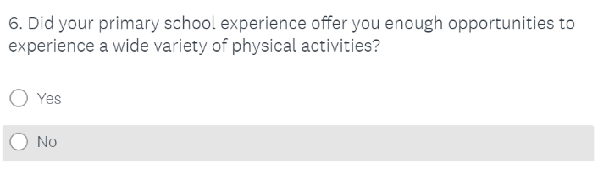
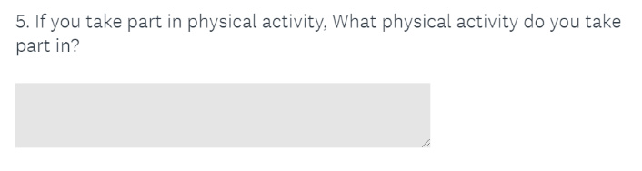
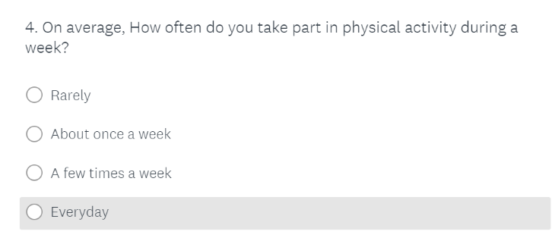
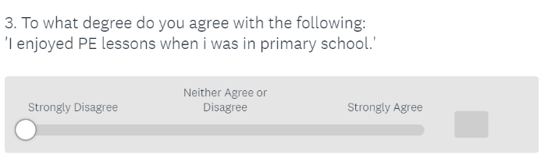
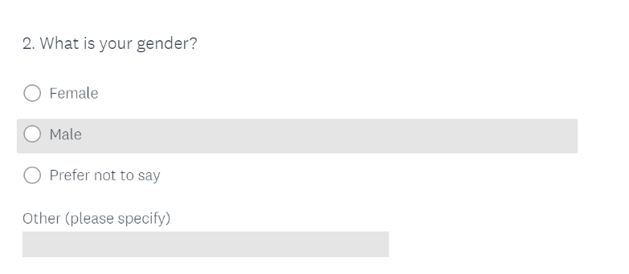
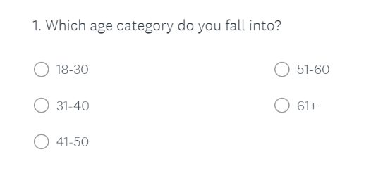

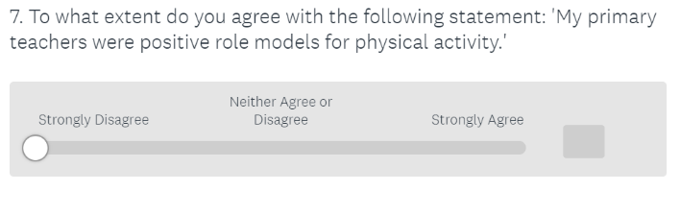

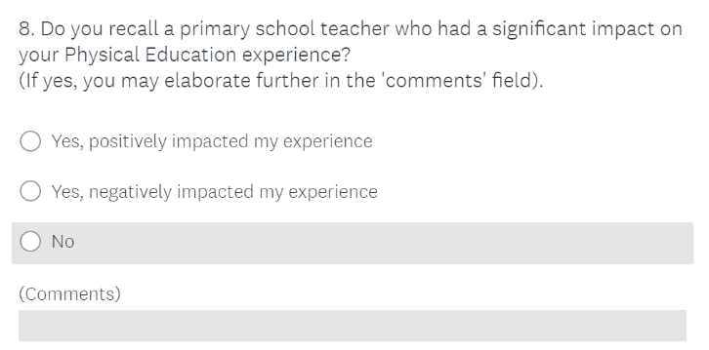

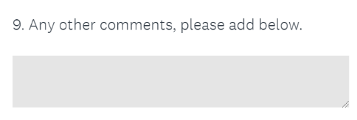

Appendix 5
Some responses to question 3.
Agreement shown as a percentage.

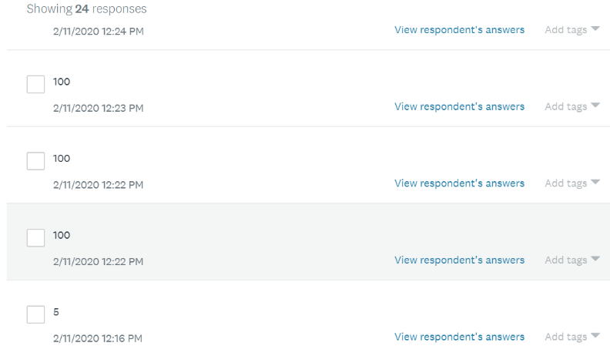

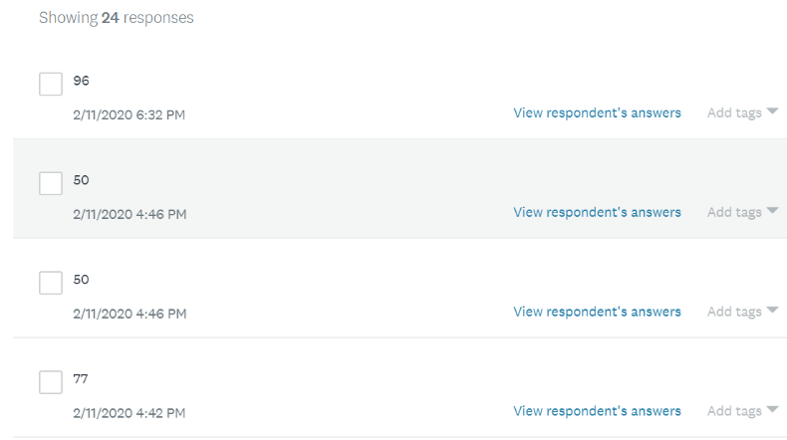

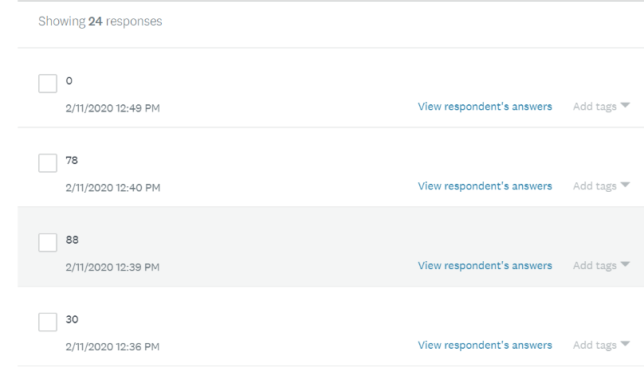

Appendix 6
Responses to Question 5

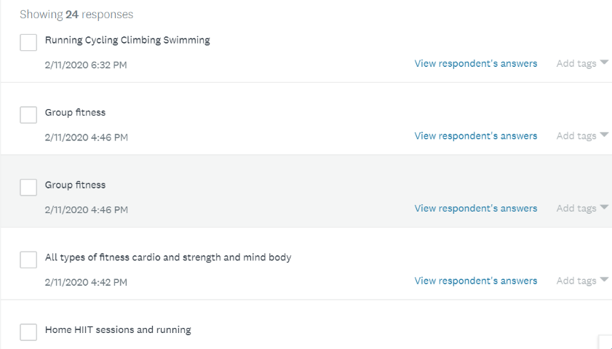

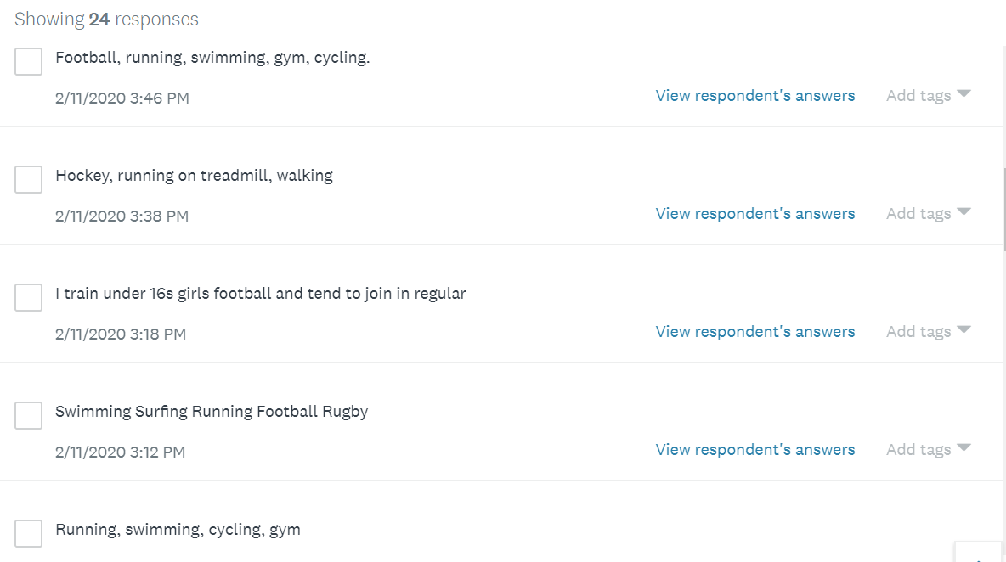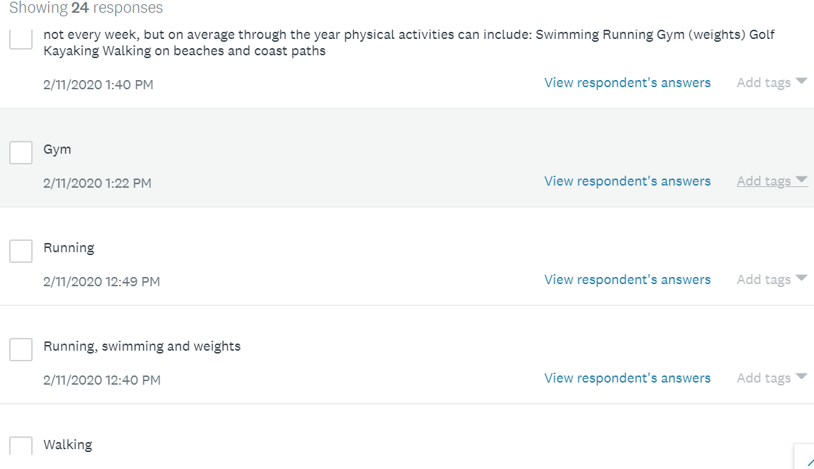
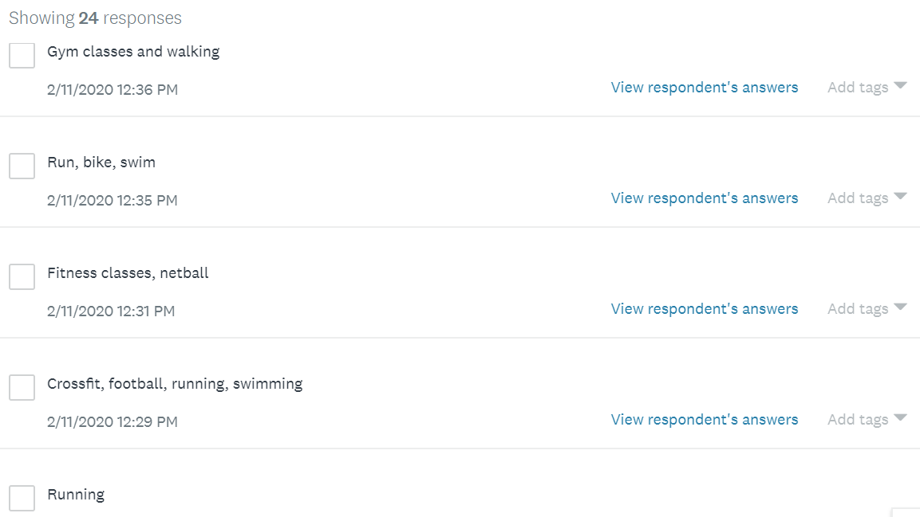
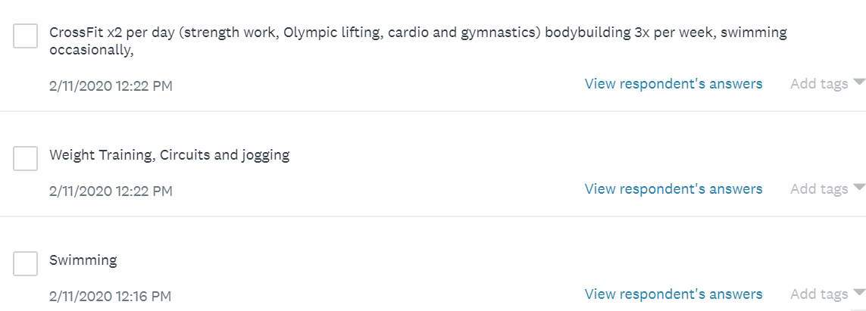

Appendix 7
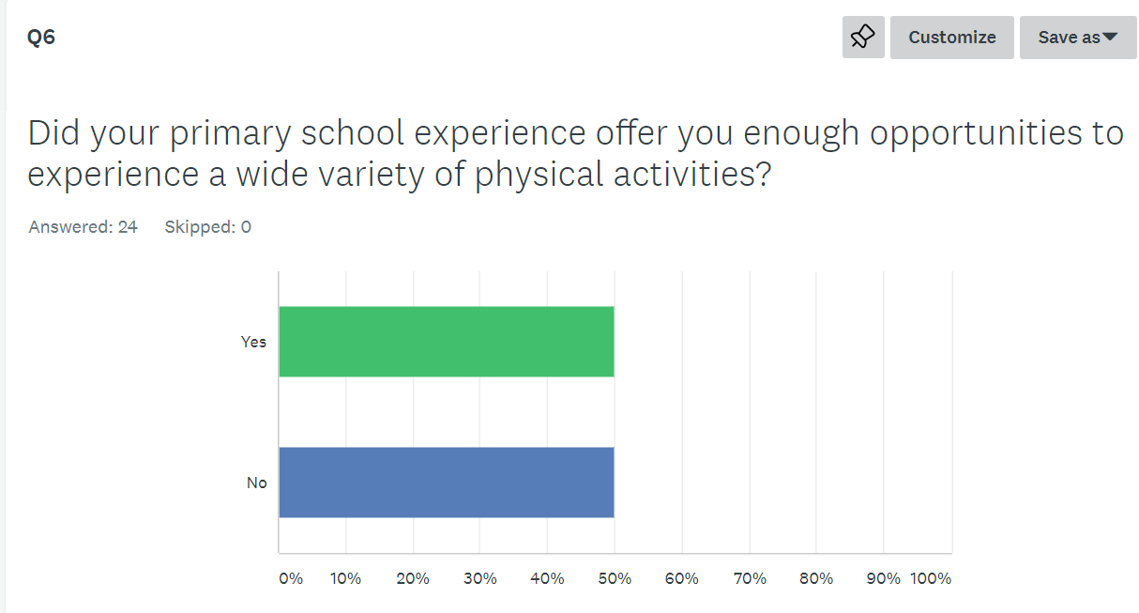

Appendix 8

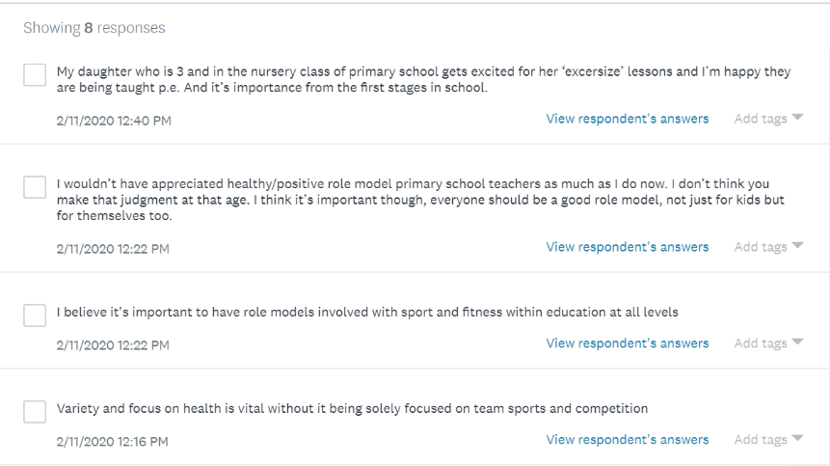

Appendix 9
Observational Notes
RIKA Shake:
KS2 only.
Less engagement than the free running sessions.
High intensity – induvial work
External Provider
Staff take part in RIKA shake after school
Free Running:
Children excited prior to taking part
Runs throughout the school – majority of ages taking part
Children all encouraging and motivating each other
Skills are broken up prior to trying whole routines
Children are grouped to try out different stations
Gymnastic elements used
Skills are able to support other physical activities
Equipment is utilised within the school
Provide it as an extra-curricular activity once a week
Child declared their love for free running.
Says it has improved confidence and allowed them to try other physical activities and sports.
SKIP CYMRU:
Welsh Academy for Health and Physical Literacy
Develops Key skills that aid other activities
Fine and Gross motor skills
Learning Walk:
The school celebrates pupils participation and success very well in different physical activities
Links to Ironman and learning
Physical activity tasks linked to health and well being/healthy confident individuals

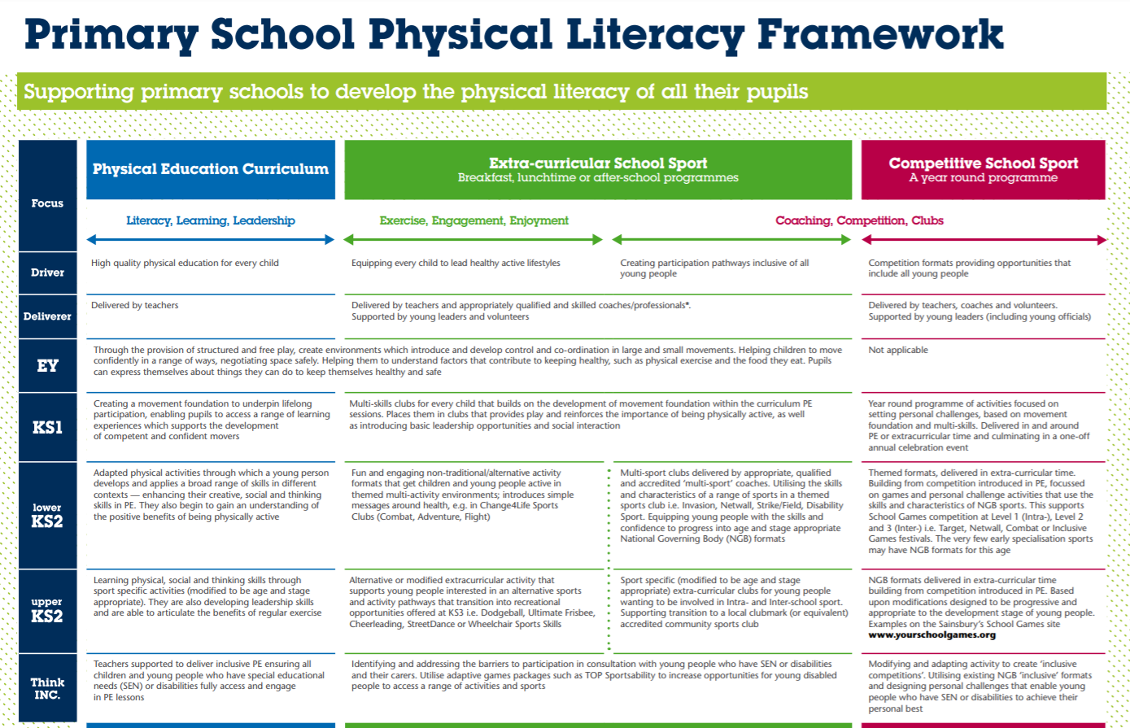
Appendix 10
https://sportengland-production-files.s3.eu-west-2.amazonaws.com/s3fs-public/physical-literacy-framework.pdf

