  Component One: Student Journal (Learning Log)  What are the key skills required when working in the housekeeping team?  Contribution to Overall Module Assessment: 25% | Student No: | 2209479
 | Module Title: | Operating Hotel Facilities
 | Module Code: | BMIH4006
 | Lecturer: | Lola Villard  Chris Wilkin  Lisa Bassler  Muhammad Cassamo  Lisa Knight
Housekeeping is an integral part of the hospitality and hotel industry where assigned people are responsible for cleaning and hygiene aspects (Raghubalan and Raghubalan, 2016). They also need to report their upline and manager if any sort of safety hazard is being assessed within the workplace. In general housekeeping staff are being assigned for sweeping, vacuuming, emptying trash cans and more. There are different skills that the housekeeping staff must have to execute the task positively. Personal initiative is one of the crucial aspects of the housekeeping job while working in a team as it helps in standing out from the other members of the team and further managing the task positively (Casado, 2012). Patience is also an integral trait and skill that an employee must have to remain calm in a stressful situation and positively manage each assigned task. It has been seen that in most hectic situations managing customer's constant needs and demands in terms of hygiene is a complex task. Therefore, housekeeping staff with a calm mind will be able to handle the situation in a far better way. Attention to detail is also a crucial aspect of the housekeeping job while working in a team as it helps in understanding the exact work needed by the manager and further executing that as directed. Effective teamwork is an important aspect of housekeeping services as it helps in improving the working culture of the organisation and makes the employees accountable for their own behaviour and services (Haupt, 2020). Flexibility is also a crucial skill that a housekeeping staff must have to collaboratively work in a housekeeping team. The hospitality sector is very vast and diversified. It has lodging, accommodation, food and beverage, travel and more in different sectors (Whiting and Symon, 2020). Each one of them has its own set of dynamics and customer preferences and that defines the flexibility of the job role that has been provided to the housekeeping staff. Therefore, housekeeping staff with more flexible traits will be able to manage the assigned task in a housekeeping team far better than others. Customer service skill is also one of the important and most needed skills that are required while working in a housekeeping team. Customers are an important element of organisational success as their satisfaction ensures higher sales and profitability of the organisation. Housekeeping staff with better customer service skills will be able to communicate well with the customers and further will be able to serve them with the utmost quality housekeeping services (Whiting and Symon, 2020). The control disc of the housekeeping service is the main facilitator of housekeeping services and excellent communication helps in building a good relationship with the stakeholders and improves the overall guest experience (Haupt, 2020).
Hotel and hospitality is Britain's fastest-growing industry. 2022 data shows 16.42 billion GBP in revenue and 81% occupancy (Statista, 2023). Premier Inn is the UK's largest hotel chain with great brand awareness. 93% of UK residents trust the brand (Premierinn, 2023). Data and client demand fluctuated throughout and after the outbreak. Thus, the hospitality business prioritises educated housekeeping managers. Premier Inn and other hotel brands have strict housekeeping requirements. Every hotel company relies on housekeeping to set the tone and boost client satisfaction. Housekeeping divisions are always needed in the hotel industry.
While I was going through the topic, I have analysed that having a theoretical knowledge of the above industry and housekeeping department will help me in grabbing professional opportunities in the future. For instance, as a supervisor, I will be able to better communicate with the team members about the requirements and further make them execute the task in an effective manner. In addition to that while working in a stressful situation I will be able to motivate the staff to be patient and handle the situation in a calm and peaceful manner. Moreover, I will be able to understand the requirement of the customers in a far better way and further manage my team to take care of the customers by focusing on minute details. Above all, I will be able to train the staff for the skills that are needed to manage time, be flexible and take personal initiatives. In this way, I will be able to contribute to the overall organizational success positively and further ensure higher professional growth in the hospitality sector of the UK.

Word Count | 727

Component Two: Practical Task - Scenario
Contribution to Overall Module Assessment: 25%
In this scenario – You have just been promoted to the team leader for a floor within the hotel. A guest complains that on their arrival, their room had not been properly cleaned. Create an action plan and answer the following questions.

Problem | Why did it happen? | What are you going to do? | How will you prevent this from happening in the future? | What measures would you introduce to improve team effectiveness?
The room was not properly cleaned | Staff has shown negligence in terms of doing their task properly and that has resulted in the above issues. | I will be conducting a team meeting and inquire about the issues that staff are facing while executing the task and further provide them constructive feedback as well. | In that meeting, tasks will be delegated properly and further strict punishment will be assured if any sort of negligence comes to from the staff. It will be a short term goal. | Task delegation and responsibility assignment will be ensured thoroughly. In this case, digital tools are also be used to effectively manage staff negligence aspect. A training of 1-2 weeks will be effective for solving the problem.
Staff negligence | The rules for not doing the task has not been defined properly and it has made the employees show negligence towards the assigned work. In general, in the hotel industry staff negligence is considered to be highly problematic for the overall growth and development of the hotel brand (Johnston et al., 2012). That is why, proper care should be taken. | In this case, also I will conduct a meeting about this and make the staff aware of the punishment that is going to be implemented if intentional negligence is been shown towards work. Moreover, the capacity of the employees should be improved. | A clear statement will be addressed in front of all the staff about what the deduction and termination aspects will be implemented while witnessing any type of work negligence. It will be a short term goal. | As a part of the measures, I will be revising the rule book for the housekeeping department and further make the staff to become aware of the above changes. A training of 1-2 weeks is also needed for the problem.
Poor time management | Lack of proper staff training is one of the leading reasons behind in the above-mentioned issues. In the case of the hotel sector time management plays a crucial role in maximising the overall customer satisfaction level (Jones, 2010). | As a team leader, I am going to assess the key strengths and weaknesses of the housekeeping staff. In addition to that I will be assessing the lacking areas of the staff which is resulting in poor time management skills. | I will be making sure that the task will be assigned properly. In addition to that I will make the staffs feel comfortable in terms of discussing the issues and challenges they are facing while managing the assigned task. | I will be designing a training and development program for the staff that are lagging behind in the assigned task and further will make them implement all the tools and techniques while handling the assigned task.
The communication gap between staff and management | Absence of a healthy relationship between the management and the staff has led to creating the above set of problems. In the hotel and accommodation organisation, it is very much important to have a minute or no possible communication gap in the team to manage the task in a fruitful manner (Buhalis and Cheng, 2020). | I will conduct one on one meetings with each of the staff and further listen to their issues and challenges. In this way, I will be able to develop a strong bond with each of the employees and further minimise the communication gap in a positive manner. | I will be focusing on conducting monthly and weekly meetings with each of the employees and making sure they communicate well with the managers regarding any support or discussion. This will be considered as a medium-term goal. | I will be designing a digital query section on our website where staff can share their challenges and issues while handling the housekeeping task which will be properly analysed and addressed in the weekly and monthly meetings. This will take 3-4 months to solve the problem.
Lack of monitoring | In the hotel sector several departments are there, which creates the chance for lack of monitoring. In this case, also the the above issues have cost low customer satisfaction level (Eid and Agag, 2020). | I will be taking the support of the supervisor and further taking advantage of the digital performance assessment tool. Digital tools are far more effective in minimising the performance of the housekeeping staff in the hospitality sector (Shin and Kang, 2020). Also, a monthly performance report will be introduced. Moreover, effective monitoring and team meeting will be conducted. | I will be continuously monitoring the performance of the staff and further providing the performance analysis report to the personal device of each staff. In this way, they will also be aware of the above aspects positively. This is going to be a long-term goal. | I will install performance management online digital tools where I will be able to see the exact areas and reason behind the lower quality of performance of the staff. This my take 7-8 months to solve the overall problem.
Table 1: Action Plan
(Source: Created by the learner)

Component Three: Presentation
Contribution to Overall Module Assessment: 50%
As the floor housekeeping manager and given the recent guest complaints you need to put together a basic training presentation for your colleagues within the housekeeping team to get the best out of them, ensure that brand standard is being achieved and that Health and Safety procedures are also being followed.

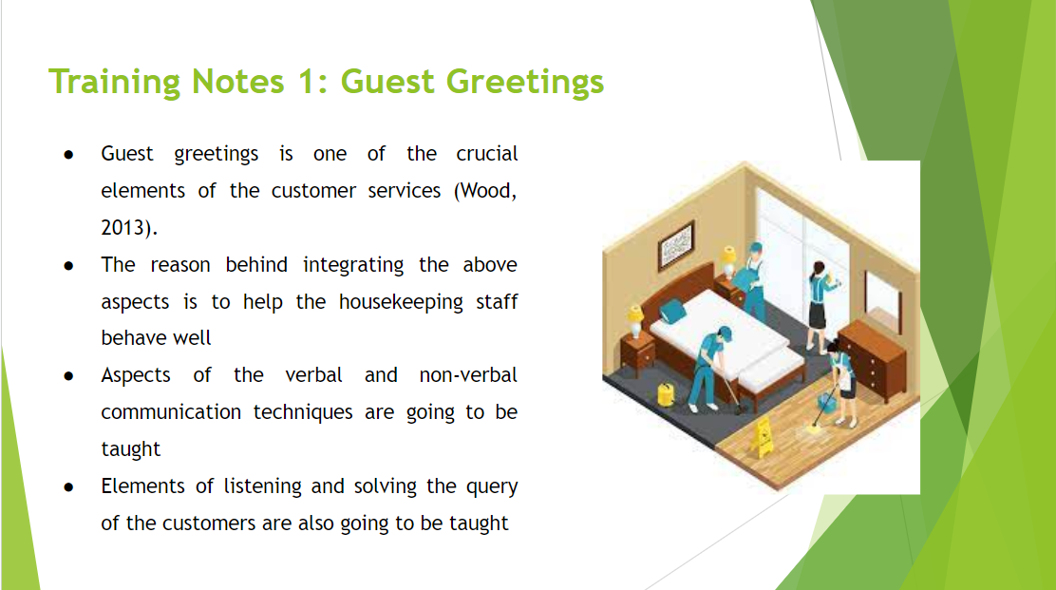

Training Notes: Guest greetings is one of the crucial elements of the customer services aspect of housekeeping (Wood, 2013). The reason behind integrating the above aspects is to help the housekeeping staff behave well with the customers. In this way, while providing housekeeping services staff will be able to maximise the overall consumer experience which will result in maximising brand recall value and brand reputation in a positive manner. In this case, aspects of verbal and non-verbal communication techniques are going to be taught to the staff in order to effectively communicate and provide industry-standard services to the customers. Moreover, different ways and aspects of greeting to customers are also going to be taught according to the different time frames of the day. Above all, elements of listening and solving the query of the customers are also going to be taught positively. It will lead them to better connect with the brand and come again for the relevant services. For example, Gloring Hotel in the UK is an independent property that has Incorporated a high standard of bedrooms and public areas that initiated a sound reputation through the maintenance of staff as well as the mechanical and electrical services (Core, 2018).
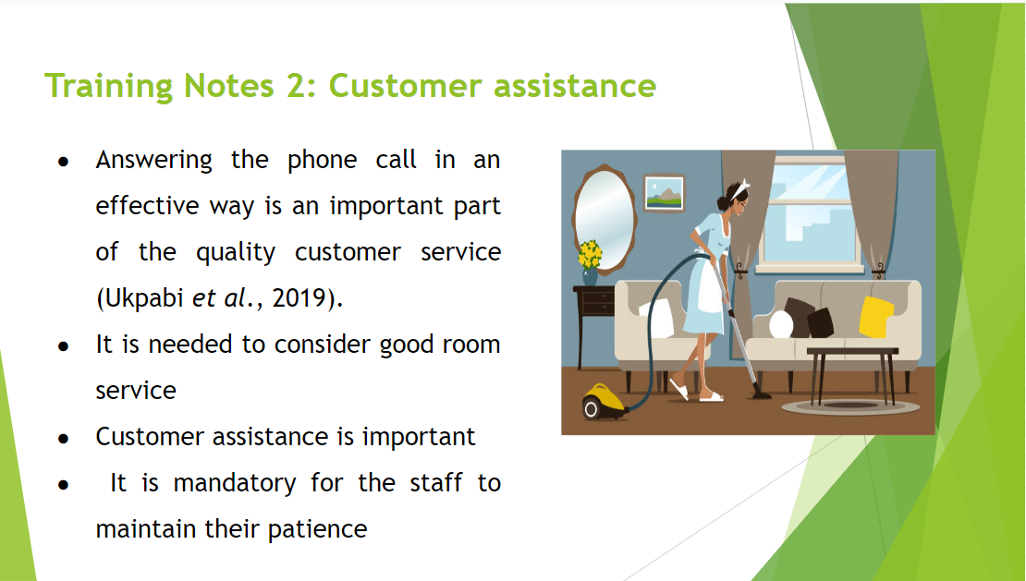

Training Notes: Answering the phone call in an effective way is an important part of the quality customer service (Ukpabi et al., 2019). For instance, when a customer in the hotel ask for room service it is important for the housekeeping staff to properly mention their name and department to the customers and further assist them with relevant solution to their problems. It again helps the customer to gain the required support from the hotels. It is mandatory for the staff to maintain their patience and calm while dealing with the customers as it will lead them to grab acknowledgement as well as better growth opportunities. Above all, it will result in maximising the brand awareness and brand recall v of the organisation in a positive manner in the highly competitive accommodation market. Moreover, the team leaders can develop monthly demonstrations about the customer services aspect to the staff so that they can get a practical exposure to the above customer services elements.
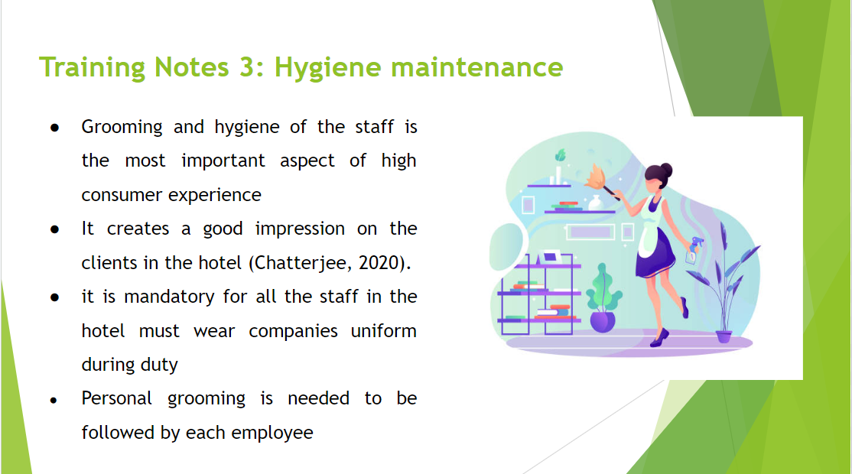

Training Notes: Grooming and hygiene of the staff is the most important aspect of high consumer experience in the hotel sector. It creates a good impression on the clients in the hotel sector and makes them revisit the space with their friends and families (‌Chatterjee, 2020). That is why, it is mandatory for all the staff in the hotel must wear companies uniform during the duty hour. Personal grooming is needed to be followed by each employee where proper haircut, facial grooming and other aspects will be considered. It has been seen that the clients have a complaint about the cleanliness and it is the responsibility of both the team leaders and staff to manage the clean environment in all over the floor. It will not only attract a higher number of visitors to the hotel but also will maximise the brand reputation of the hotel positively. This is also a specific issue related to the Hotel Trinity which might affect the overall task performance provided to the housekeeping employees and it also induces employee negligence that affects the overall productivity of the organisation.
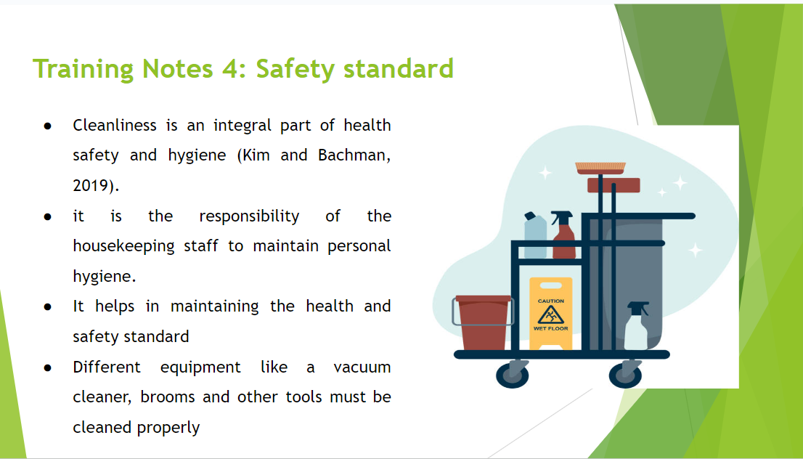

Training Notes: Cleanliness is an integral part of health safety and hygiene (Kim and Bachman, 2019). That is why it is the responsibility of the housekeeping staff to not only maintain personal hygiene but also try to manage cleaning-related housekeeping tasks in a positive way. It helps in maintaining the health and safety standard within the hotel. Therefore, different equipment like vacuum cleaners, brooms and other tools must be cleaned properly so that while using that for the above customer service aspect higher customer satisfaction will be achieved. It will indirectly enhance the effectiveness of the housekeeping staff in maintaining quality in the cleaning-related task within the organisation.
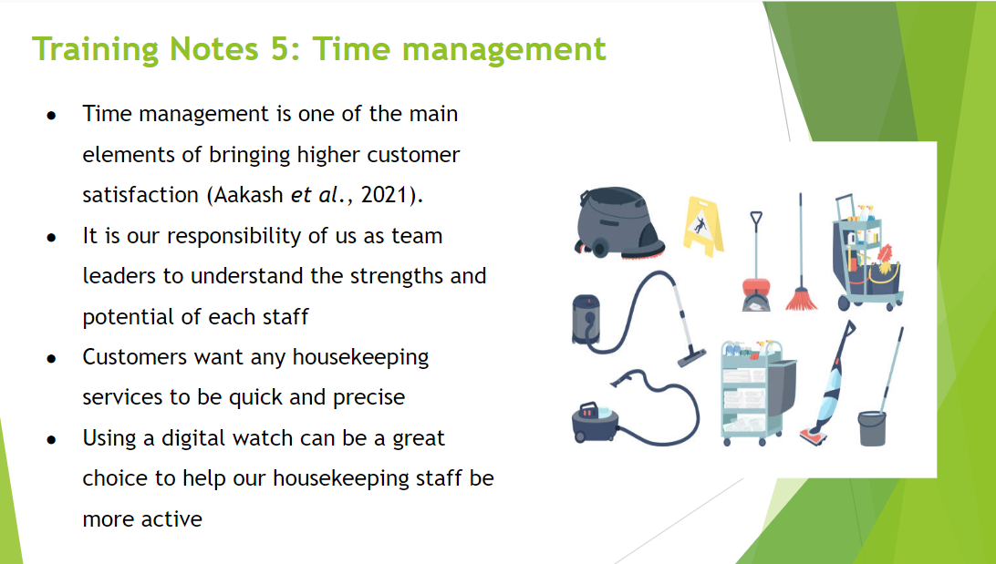

Training Notes: Time management is one of the main elements of bringing higher customer satisfaction in the hotel and other hospitality sectors (Aakash et al., 2021). That is why, it is our responsibility of us as team leaders to understand the strengths and potential of each staff in terms of finding time to execute the assigned work as per the given deadline. For instance, customers want any housekeeping services to be quick and precise with a higher focus on the attention to detail. In this way, staff will be able to focus on the relevant things and exclude any task that is time-consuming and does not add any value to the customers. Therefore, using a digital watch can be a great choice to help our housekeeping staff be more active towards the effective customer service task.

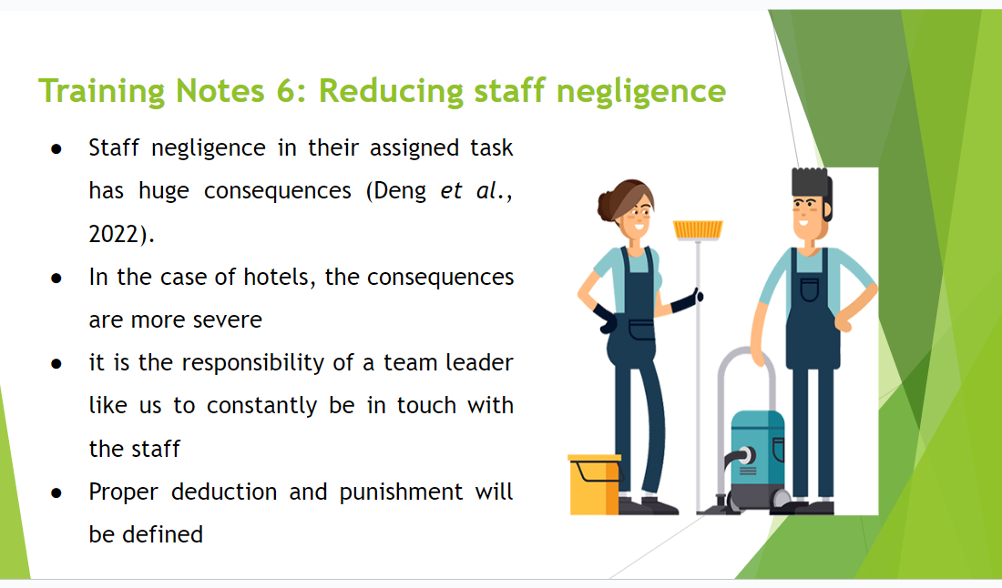

Training Notes: Staff negligence in their assigned task has huge consequences in terms of hampering the brand standard and reputation (Deng et al., 2022). In the case of hotels, the consequences are more severe. That is why, it is the responsibility of a team leader like us to constantly be in touch with the staff and make minimising any type of negligence towards their work. That is why, as a part of the solution proper deduction and punishment will be defined on the basis of the different negligence parameters. It will help the staff to become more attentive towards their job and show lower negligence towards their work. It is also important for us to communicate with the staff properly through personal and group meetings and further eradicate the above issues positively. For example, Lygon Arms in Worcester has suffered a critical level of staff turnover due to the insurance depreciation as well as the negligence in the training procedure of the staff that not only affect the return on capital investment but also the overall brand image of the organisation (Core, 2018).
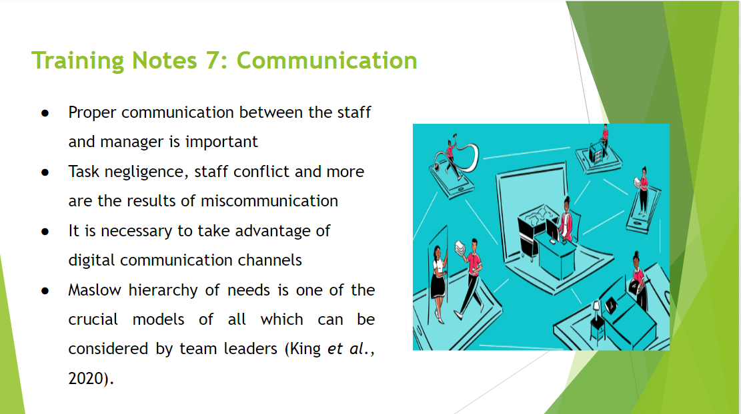

Training Notes: Proper communication between the staff and manager plays an essential role in executing any type of task in the different departments of the hotel brand. Any type of task negligence, staff conflict and more are the result of miscommunication among the staff and managers. That is why, it is necessary to take advantage of digital communication channels and tools so that both the managers, customers and staff will be connected throughout the housekeeping services regime. These will result in a higher level of productivity from the staff in the housekeeping space and further contribute to enhancing the brand reputation of the hotel brand. However, it is important for the team leaders to conduct meetings to analyse the exact areas which they need to be taken care of and further make the staff work as per the standard of the hotel. Above all team leaders can take the advantage of employee engagement model in order to extract maximum output from the house keeping staff. For example, Maslow’s hierarchy of Needs is one of the crucial model of all which can be considered by the team leaders. It will help them in acknowledging the basic and higher need of the staff and further increase the overall staff engagement level significantly (King et al., 2020).
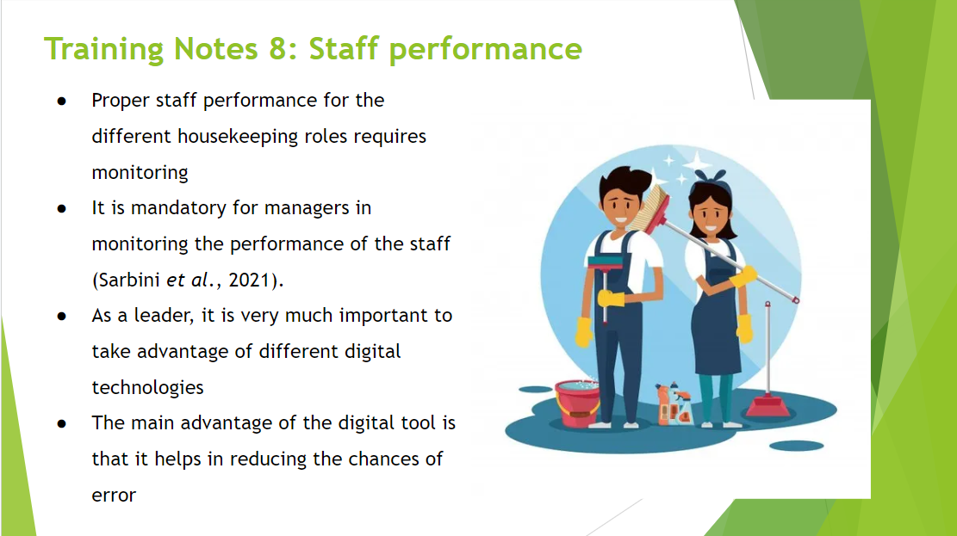

Training Notes: In order to minimise the challenges of proper staff performance for the different housekeeping roles, it is mandatory for the managers in monitoring the performance of the staff and further provide them with quality feedback to achieve perfection in their assigned job role (Sarbini et al., 2021). That is why, as a leader, it is very much important to take the advantage of different digital technologies and further track the performance of the staff effectively. The main advantage of the digital tool is that it not only helps in reducing the chances of error but also can help in providing real-time feedback to the staff. Moreover, the performance data entry procedure needs to be highly simple yet effective which will help the team leader in maximising the quality of the services as per the standard of the hotel.
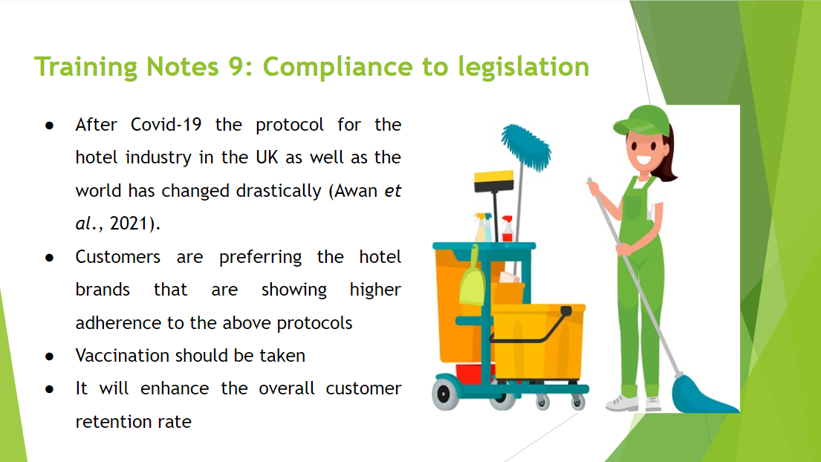

Training Notes: After Covid-19 the protocol for the hotel industry in the UK as well as the world has changed drastically (Awan et al., 2021). Customers are preferring the hotel brands that are showing higher adherence to the above protocol and concerning about the health and safety standards for the customers. That is why, team leaders of the housekeeping department need to ensure that all the staff including himself should have taken vaccination and use masks and sanitiser while providing services to the customers. It will not only help the hotel in providing optimum quality services to the staff but also will help in maximising the safety of the customers in the hotel sector. In the long run, it will enhance the overall customer retention rate and further improve the brand recall value and brand awareness of the above hotel brand in a positive manner. Compliances with legislation regarding the uses of chemicals and cleaning agents, personal grooming, maintaining effective customer consideration and health and safety measures are also some fundamental aspects for the organisation Hotel Trinity that are to be incorporated in the training module.
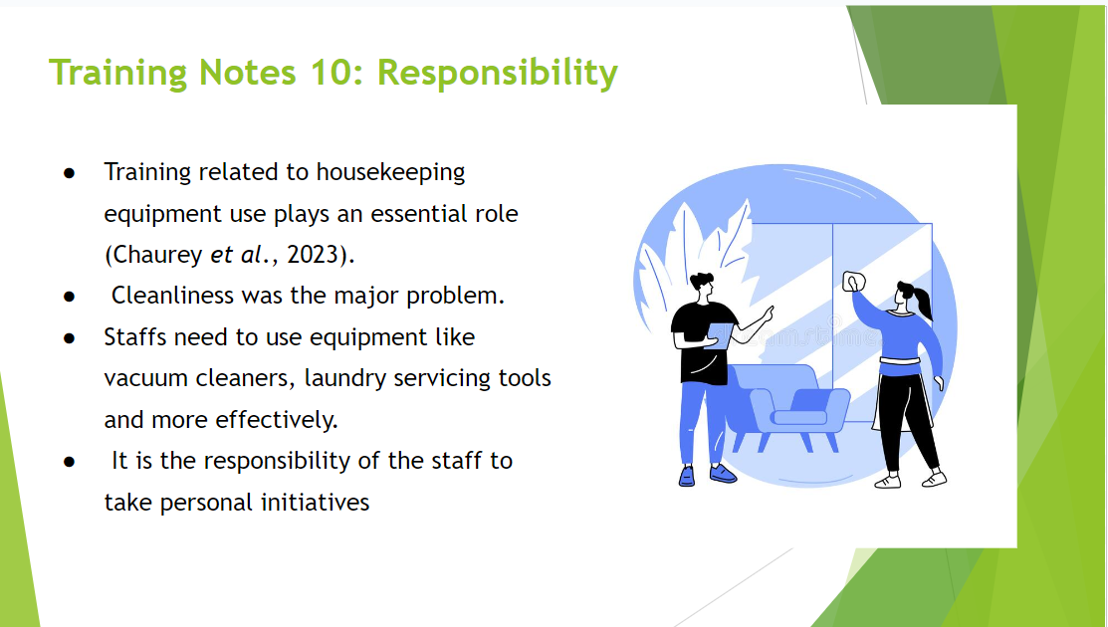

Training Notes: Training related to housekeeping equipment use plays an essential role in maximising the productivity and utility of the staff (Chaurey et al., 2023). As per the complaint of the client, cleanliness was the major problem he has faced. However, there are other areas as well, where staffs need to use the equipment like vacuum cleaners, laundry servicing tools and more in order to manage the above services positively. In this case, it is mandatory for the staff to go through a different set of relevant training and development programs about the technical and management staff so that they will not only greet the customers effectively but also will use the above equipment and tools to maintain the standards of hotel services. Above all, it is the responsibility of the staff to take personal initiatives towards learning new things related to their job role in order to generate maximum output through their services.

References

Aakash, A., Tandon, A. and Gupta Aggarwal, A., 2021. How features embedded in eWOM predict hotel guest satisfaction: An application of artificial neural networks. Journal of Hospitality Marketing & Management, 30(4), pp.486-507.
Awan, M.I., Shamim, A. and Ahn, J., 2021. Implementing ‘cleanliness is half of faith’in re-designing tourists, experiences and salvaging the hotel industry in Malaysia during COVID-19 pandemic. Journal of Islamic Marketing, 12(3), pp.543-557.
Buhalis, D. and Cheng, E.S.Y., 2020. Exploring the use of chatbots in hotels: technology providers’ perspective. In Information and Communication Technologies in Tourism 2020: Proceedings of the International Conference in Surrey, United Kingdom, January 08–10, 2020 (pp. 231-242). Springer International Publishing.
Casado, M. 2012. Housekeeping Management. London: Wiley.
‌Chatterjee, P., 2020. Role of Housekeeping Cleaning Equipment and Agent in the world of Hospitality Industry.
Chaurey, S., Kalpande, S.D., Gupta, R.C. and Toke, L.K., 2023. A review on the identification of total productive maintenance critical success factors for effective implementation in the manufacturing sector. Journal of quality in maintenance engineering, 29(1), pp.114-135.
Core. 2018. HOTELIERS AND HOTELS: CASE STUDIES OF THE GROWTH AND DEVELOPMENT OF U.K. HOTEL COMPANIES. [online]. Available at:https://core.ac.uk/download/pdf/266981846.pdf [Accessed 12 June 2023].
Deng, Y., Cherian, J., Kumari, K., Samad, S., Abbas, J., Sial, M.S., Popp, J. and Oláh, J., 2022. Impact of sleep deprivation on job performance of working mothers: Mediating effect of workplace deviance. International journal of environmental research and public health, 19(7), p.3799.
Eid, R. and Agag, G., 2020. Determinants of innovative behaviour in the hotel industry: a cross-cultural study. International Journal of Hospitality Management, 91, p.102642.
Haupt, B., 2020. 17 TEAM COORDINATION. Clinical Nurse Leader Certification Review, p.197.
Johnston, R., Clark, G. and Shulver, M. 2012. Service Operations Management. London: Pearson.
Jones, T. 2010. Professional Management of Housekeeping Operations. London: Wiley.
Kim, H. and Bachman, J.R., 2019. Examining customer perceptions of restaurant restroom cleanliness and their impact on satisfaction and intent to return. Journal of foodservice business research, 22(2), pp.191-208.
King, A.T., Gontarz, J. and Wei, H., 2020, July. Employee engagement and absenteeism: a step towards improving patient care. In Nursing forum (Vol. 55, No. 3, pp. 356-361).
Premierinn.com. 2023. Premier Inn hotels | Book direct. [online] Available at: https://www.premierinn.com/gb/en/home.html [Accessed 25 May 2023].
Raghubalan, G. and Raghubalan, S. 2016. Hotel Housekeeping - Operations And Management. 3rd ed. India: Oxford University Press.
Sarbini, N.N., Ibrahim, I.S., Abidin, N.I., Yahaya, F.M. and Azizan, N.Z.N., 2021. Review on maintenance issues toward building maintenance management best practices. Journal of Building Engineering, 44, p.102985.
Shin, H. and Kang, J., 2020. Reducing perceived health risk to attract hotel customers in the COVID-19 pandemic era: Focused on technology innovation for social distancing and cleanliness. International Journal of Hospitality Management, 91, p.102664.
Statista. 2023. Topic: Hotel industry in the UK. [online] Available at: https://www.statista.com/topics/3146/hotel-industry-in-the-united-kingdom-uk/#topicOverview [Accessed 25 May 2023].
Ukpabi, D.C., Aslam, B. and Karjaluoto, H., 2019. Chatbot adoption in tourism services: A conceptual exploration. In Robots, artificial intelligence, and service automation in travel, tourism and hospitality. Emerald Publishing Limited.
Whiting, R. and Symon, G., 2020. Digi-housekeeping: the invisible work of flexibility. Work, employment and society, 34(6), pp.1079-1096.
Wood, R. 2013. Key Concepts in Hospitality Management. London: Sage.

