

Databases and Application Development
(ACCA5026)

Component 1
Report Documentation

Name: Morsal Ali
Student ID: 22413056
Course: BSc (Honours) Applied Computing
Lecturer: Mohd Syafiq Bin Zolkeply
Assignment Title: Database Design & Implementation

Table of Contents

Introduction 3
2.0 Database Design 3
2.1 Entity Relationship Diagram 4
2.2 Database Desing Description 5
3.0 Database Implementation 6
3.1 Data manipulation Language (DML) 6
3.2 Data Definition Language (DDL) 7
4 Stored Procedure 11
5 Triggers 15
Performance Tuning 20
Conclusions and Reflection 24
References 25

Introduction

The purpose of the project was for me to assume the role of a Database Consultant for MedAssist Clinic, a small outpatient private clinic in the United Kingdom. It currently uses paper files and spreadsheet systems to manage many aspects of its operation. These systems can be effective for very small organizations; however, as an organization grows, they become increasingly difficult to manage and errors become more likely. Relational databases help solve these problems and improve efficiency.
I designed and built a functional relational database model to support the clinic’s daily activities. These include adding patients, matching doctors to departments, scheduling appointments, documenting treatment provided to each patient during consultations and enabling patients to provide feedback after their consultations.
Through the case study, I identified six key entities: Patient, Doctor, Department, Appointment, Treatment, and Feedback. I also created two supporting entities. The Addresses table stores patient and doctor address information, eliminating redundancy from storing multiple address fields in each record. The Audit Logs table tracks all system changes by each user and date/time stamps those changes.
I wanted the system to enforce its own rules and ensure consistency across the entire system, so I incorporated constraints. No physician can have double-booked appointments, patients cannot enter feedback about appointments that have not occurred, and all appointments must remain associated with a patient to prevent orphaned records. I also included features that track all activity within the application. If unauthorized access or data loss occurs because of technical failures or other reasons, it will be easier to identify where the issue occurred.
In the next sections, I will describe how I developed the database schema and normalized it into Third Normal Form (3NF), populated and tested the database using actual data from the clinic, handled transactions, and optimized the database for performance.

2.0 Database Design
The database reflects the daily work of the clinic. There are 7 main entity types in this database: Patient, Address, Doctor, Department, Appointment, Treatment and Feedback. Every one of these tables has an ID for the primary key that allows you to access all records. Doctors belong to Departments and they can also be assigned to attend on many Appointments. Patients have the option to make Appointments with various Doctors. Also, each Treatment or piece of Feedback is connected to a specific Appointments, which makes it easier to see how the doctor treated a particular patient through time and the treatment they had received. As well as having an address type for storing each customer's address, to avoid duplicate data being entered. Overall, the way that the Database Design has been created follows Third Normal Form, this will allow the clinic to maintain their records organized, correct and simple to manage [1].
.

2.1 Entity Relationship Diagram

The Entity Relationship Diagram shows how the seven main tables in the MedAssist Clinic database connect. The Patient table links to Address through AddressID, allowing patient and location details to be managed separately. Appointment connects each patient with a doctor using PatientID and DoctorID. Each doctor belongs to a department through DepartmentID, while one department can contain several doctors. Treatment is connected to Appointment so the outcome of each consultation can be recorded. Feedback also links patients to their appointments. These relationships make it easier to follow patient journeys while keeping the clinic’s information organised and reducing unnecessary duplication [2].
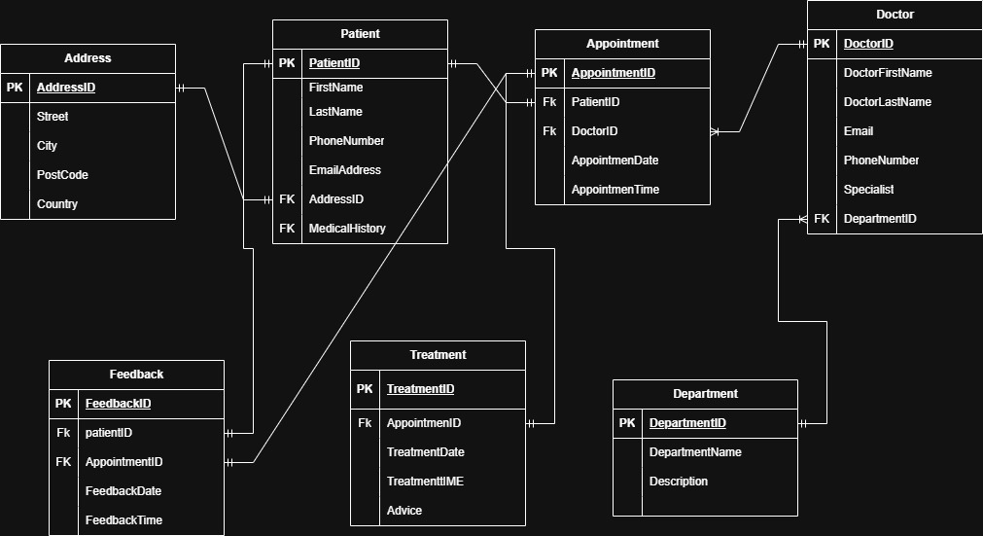

Figure 2.1: MedAssist Clinic Entity Relationship Diagram.

2.2 Database Desing Description

The MedAssist Clinic database was designed using the data collected in relation to MedAssist Clinic. There were 7 tables developed: Address, Patient, Doctor, Department, Appointment, Treatment and Feedback. Each of these tables contained relevant information. For example; the Patient table contained all the patient's contact details, address and medical history [3]. The Doctor table included contact information for each doctor as well as his or her specialty and department. A connection existed between the patient and doctor (via their respective ID numbers) within the Appointment table which recorded the date and time of each consultation. Additionally, a record of treatment administered to each patient existed in the Treatment table and this record referenced the original appointment that prompted the treatment. Finally, a record exists in the Feedback table referencing both the patient and the original appointment.
Each of the tables listed above have been structured to allow MedAssist Clinic to complete their main activities. In addition, the tables were structured so that it would be easier to enter, edit and locate patient information, appointment information and treatment information [4].

The Address table will include a description of each patient's address including street number, city, postal code and country. The Patient table will include information related to each patient such as contact information, contact history and medical history. The Department table will list each department at MedAssist Clinic along with a description of what services are offered by each department. The Doctor table will include the name of each doctor working at MedAssist Clinic as well as their contact information, area of specialty and department they work in. The Appointment table will connect a patient with a doctor and document the date and time of each appointment. The Treatment table will document any treatment rendered to a patient after an appointment has taken place. This documentation includes any advice or recommendations made to the patient. The last table, Feedback will document when patients wish to comment on their overall experience with MedAssist Clinic during an appointment [5].

3.0 Database Implementation
XAMPP was installed on my computer to run the local version of the MedAssist Clinic database. Using phpMyAdmin, I have been able to create all seven tables (Address, Patient, Department, Doctor, Appointment, Treatment, and Feedback) and use phpMyAdmin to manage the database. All tables contain primary keys to uniquely identify each table's entries [6]. Relationships were established among the tables based upon how the clinic uses this information. Sample data representing realistic clinic transactions has been entered into the tables to simulate patient registration, appointment scheduling, doctor assignment, treatment recording and submitting feedback [7].
A trigger was developed for several tables to enforce certain business logic or rules and maintain data integrity. An example is an application of triggers are to preclude the entry of duplicate address, department names and email addresses. Another example is that a trigger will prevent an appointment from being scheduled prior to today’s date. A trigger can also be applied to assure that no treatment date occurs prior to an associated appointment date. Indexes were added to specific columns within the address table (city, post code, country etc.) so that when searching through the database it is done in a timelier manner. Overall, XAMPP provides a convenient environment for developing and testing databases; however, phpMyAdmin makes executing SQL statements and reviewing the entries much simpler [8].

3.1 Data manipulation Language (DML)
Data Manipulation Language was used to add and manage information within the MedAssist Clinic database. The INSERT INTO statement populated the seven tables with realistic sample records. For example, patient records included names, contact details, addresses and medical histories, while doctor records included names, contact information, specialisms and assigned departments. Appointment data connected patients with doctors and stored the scheduled date and time [9]. Treatment and feedback records were also inserted to represent activities occurring after consultations. These sample records helped test whether the database structure could support the clinic’s daily operations correctly. Other important DML commands include SELECT, UPDATE and DELETE. SELECT retrieves information, such as a patient’s appointment history. UPDATE changes existing details, while DELETE removes records that are no longer required. Together, these DML commands allow authorised clinic users to enter, view and maintain accurate information without changing the overall structure of the database [10].

3.2 Data Definition Language (DDL)

The MedAssist Clinic's database structure was developed using Data Definition Language (DDL) within XAMPP. Seven tables were defined using the CREATE TABLE statement: Address, Patient, Department, Doctor, Appointment, Treatment, and Feedback. Each table had relevant column(s), and appropriate data type(s) based upon what information would be stored. For example, VARCHAR is typically used for names and other identifiers; DATE or TIME are usually used when storing appointment, treatment, and feedback records [11].
NOT NULL constraints were placed on all required fields to prevent leaving critical information blank. Unique identifiers for each table were designated as primary keys (PatientID, DoctorID, and AppointmentID).
After creating the tables, the ALTER TABLE statement was used to establish both primary key and index values. The design incorporates relational identifier values to link entries across the tables.
Overall, the DDL commands established an organized framework for storing and maintaining consistent and secure information about the clinic.

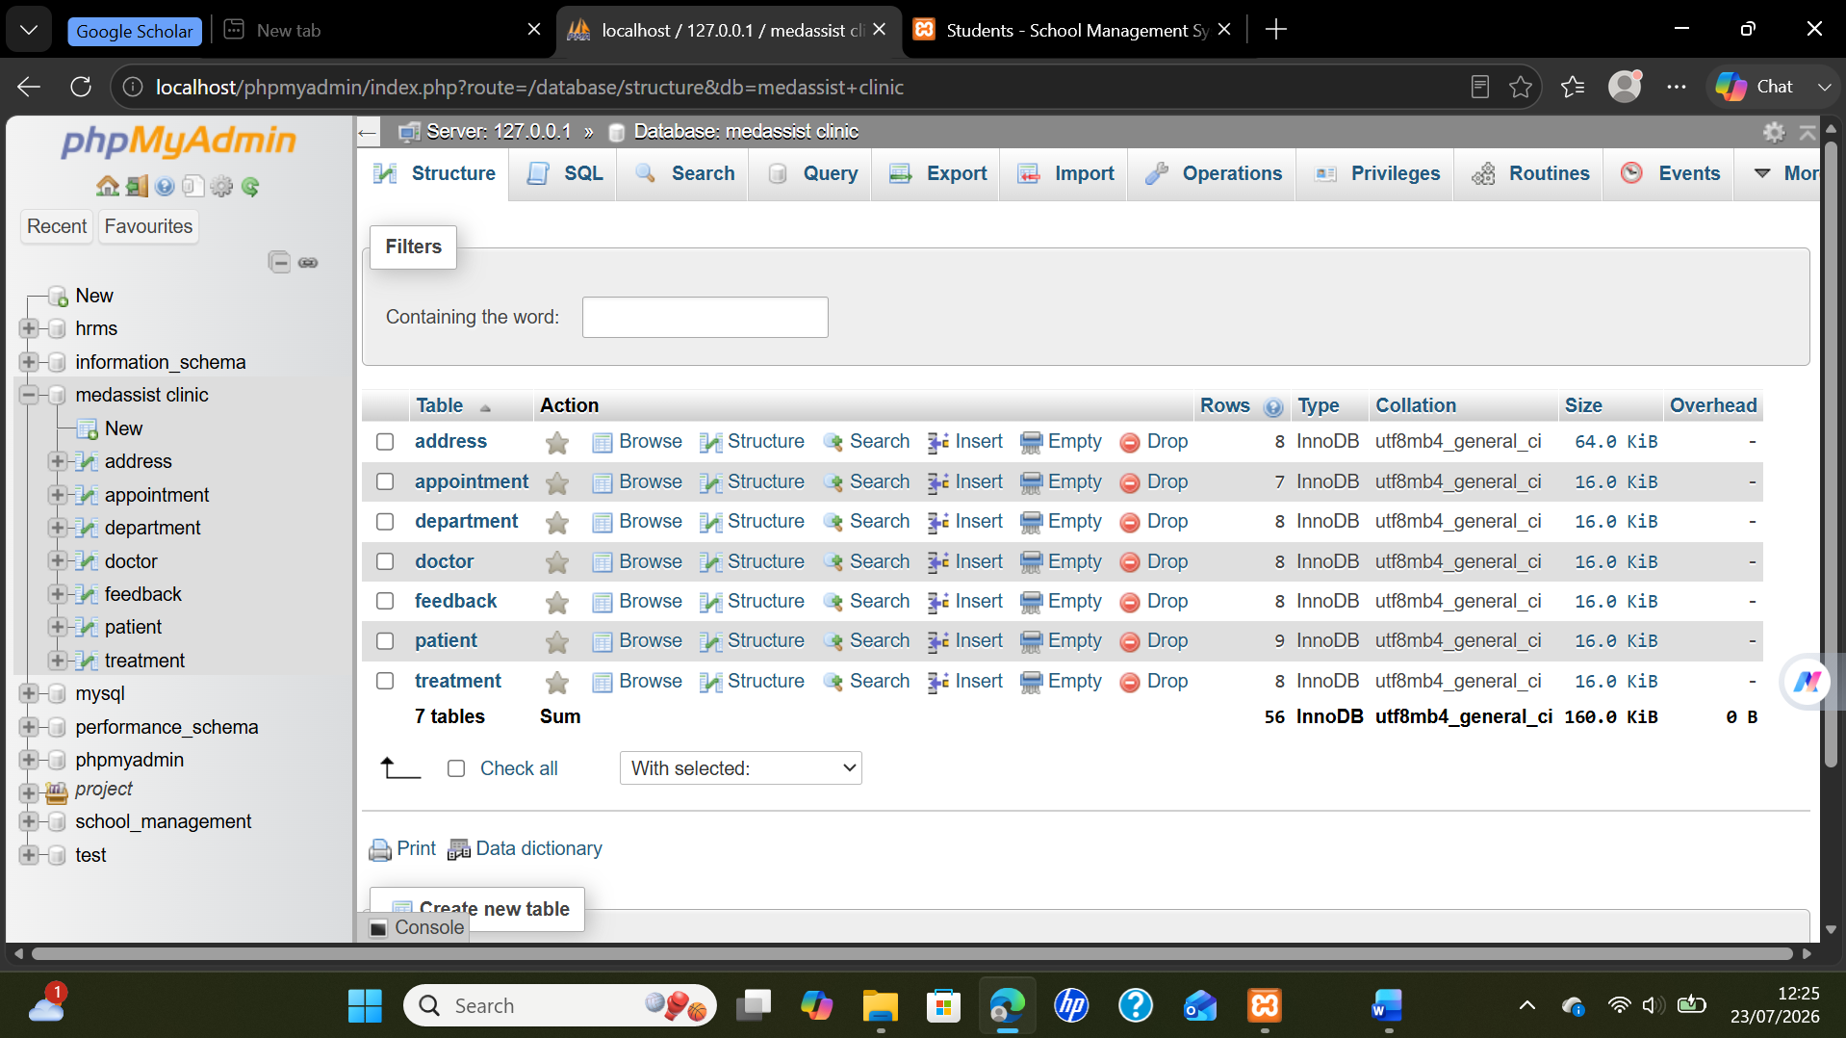

Figure 3.1: phpMyAdmin displays the MedAssist Clinic database structure, comprising seven healthcare management relational tables.

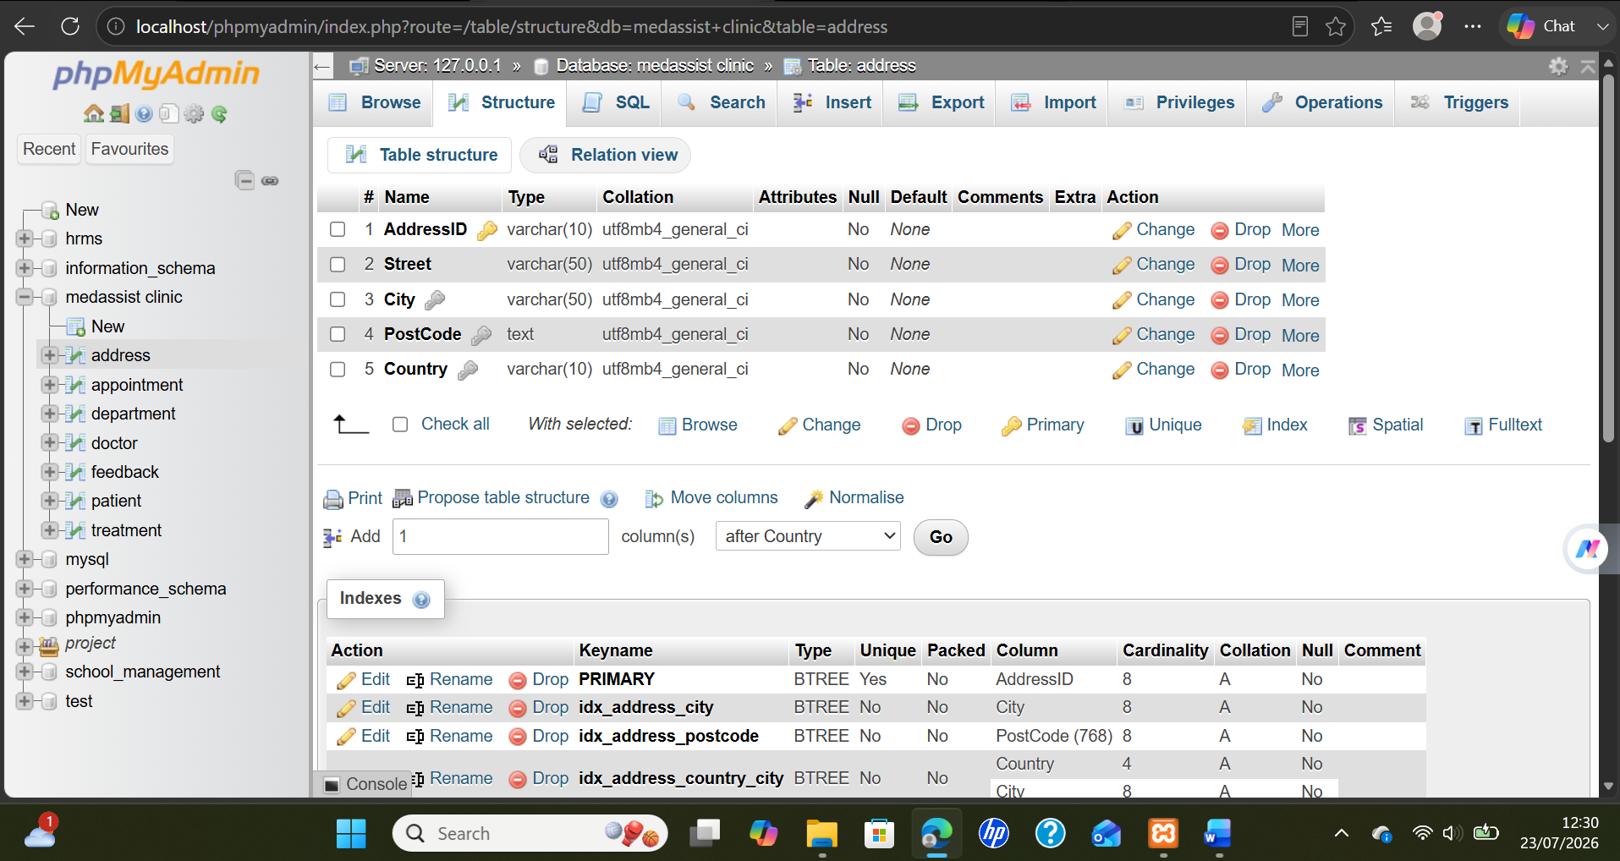

Figure 3.2: phpMyAdmin displays the address table structure, including fields, data types, keys, and indexes.

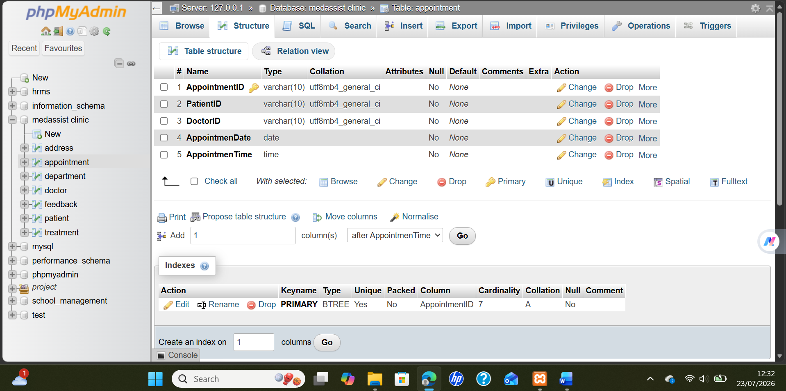

Figure 3.3: phpMyAdmin displays appointment table fields linking patients, doctors, dates, times, and primary keys.

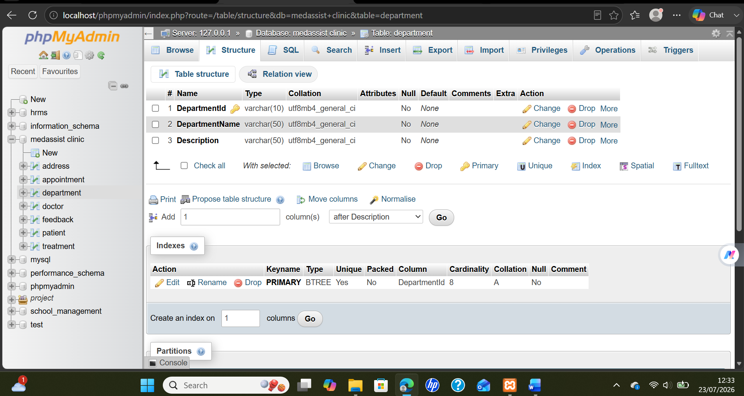

Figure 3.4: phpMyAdmin displays the department table structure with identifier, name, description, and primary key.

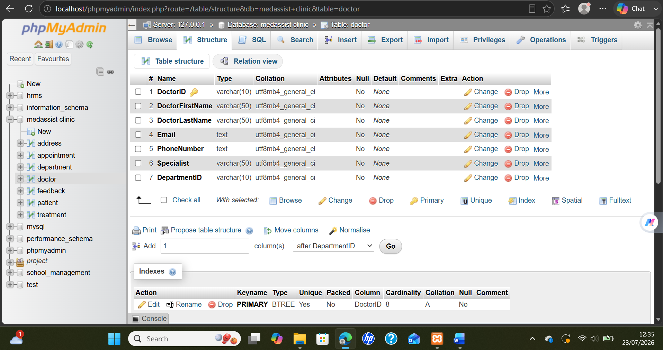

Figure 3.5: phpMyAdmin displays doctor table fields covering names, contact details, specialty, department, and identification.

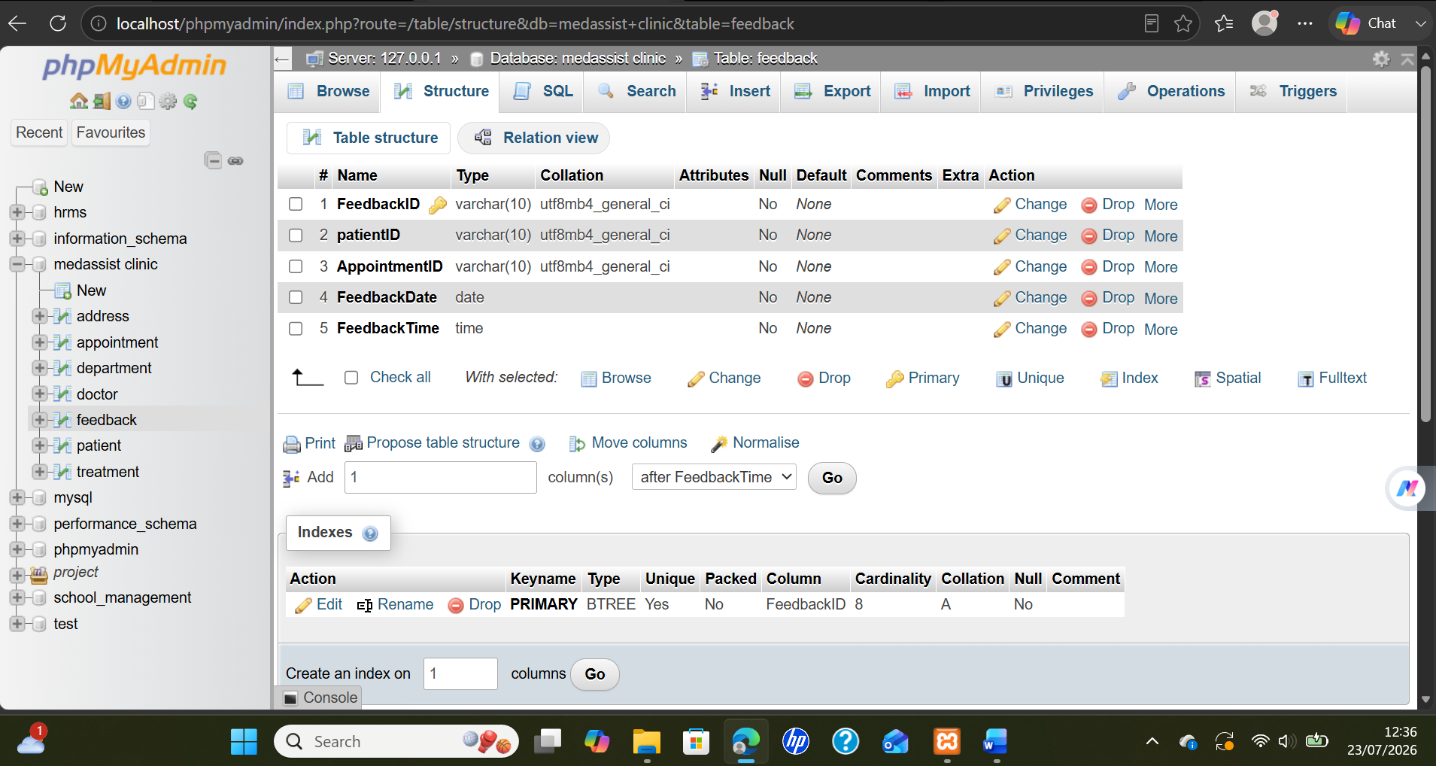

Figure 3.6: phpMyAdmin displays feedback table fields linking patients, appointments, dates, times, and unique identifiers.
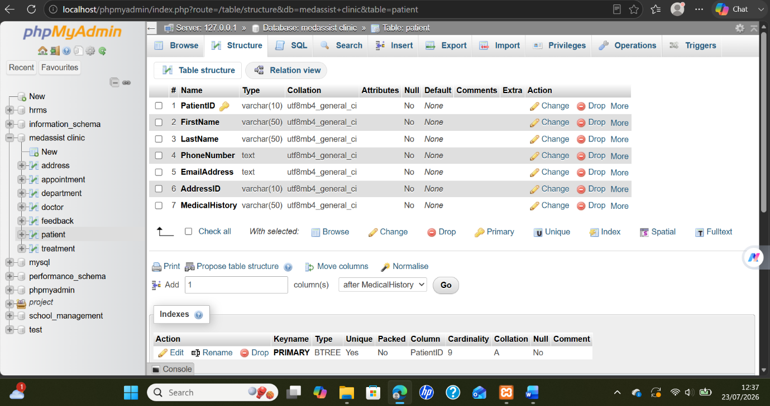
Figure 3.7: phpMyAdmin displays patient table fields including names, contact information, address, and medical history.
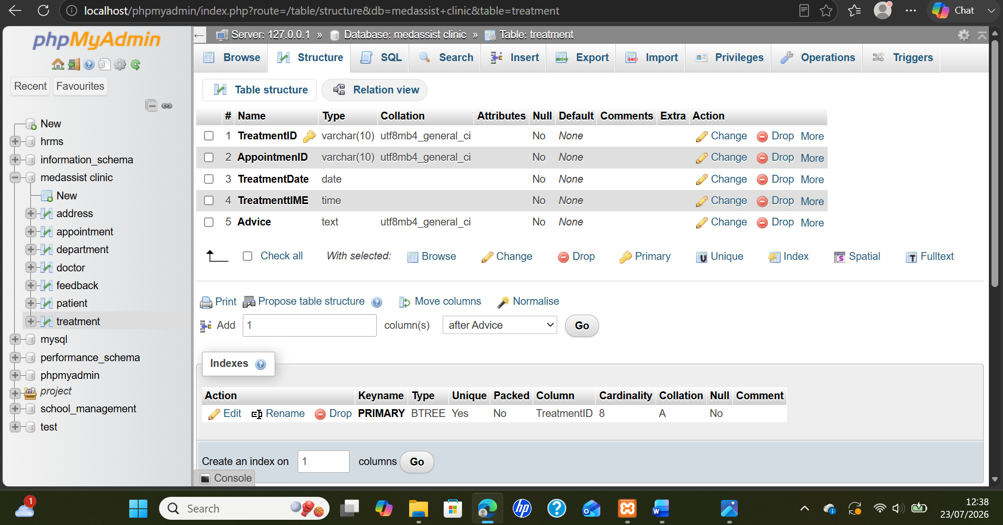

Figure 3.8: phpMyAdmin displays treatment table fields linking appointments, treatment dates, times, advice, and identifiers.

4 Stored Procedure
Stored procedures in MedAssist Clinic system are reusable SQL statements stored within the database. They handle common tasks such as registering patients, making appointments, updating contact information and removing incorrect records. This way users can perform tasks without repeatedly writing individual SQL commands and operations become more consistent and easier to control. For example, a registration procedure would accept details such as name, phone number, email, address and medical history [12]. Then it inserts that information into appropriate tables. An appointment procedure would accept ID for a patient and doctor along with date and time before creating an appointment. Validation checks that both patient and doctor exist and that the selected time is available. Each procedure should include handling transactions using START TRANSACTION, COMMIT and ROLLBACK. If all operations are successful, COMMIT permanently saves those changes. If something goes wrong during a transaction ROLLBACK undoes all changes made. This avoids situations like appointments created without valid patient information. Stored procedures improve reliability, reduce repetition of code and give controlled access to sensitive clinic data as well [13].

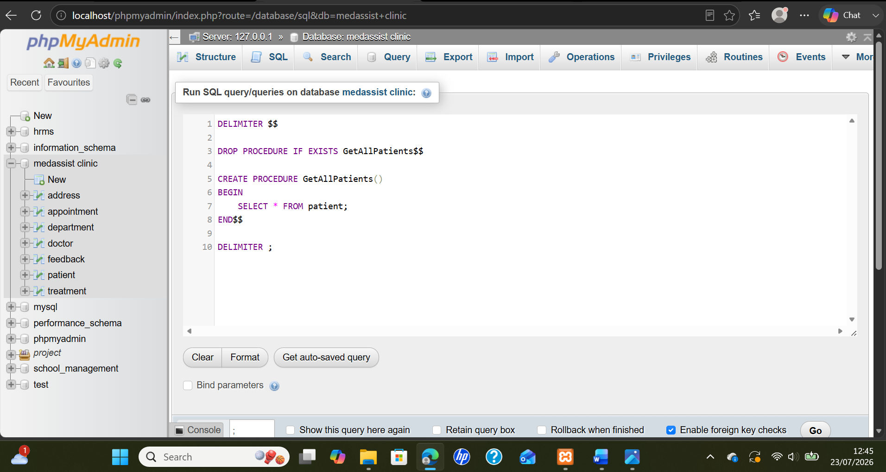

Figure 4.1: phpMyAdmin SQL editor showing the GetAllPatients stored procedure for retrieving all patient records.

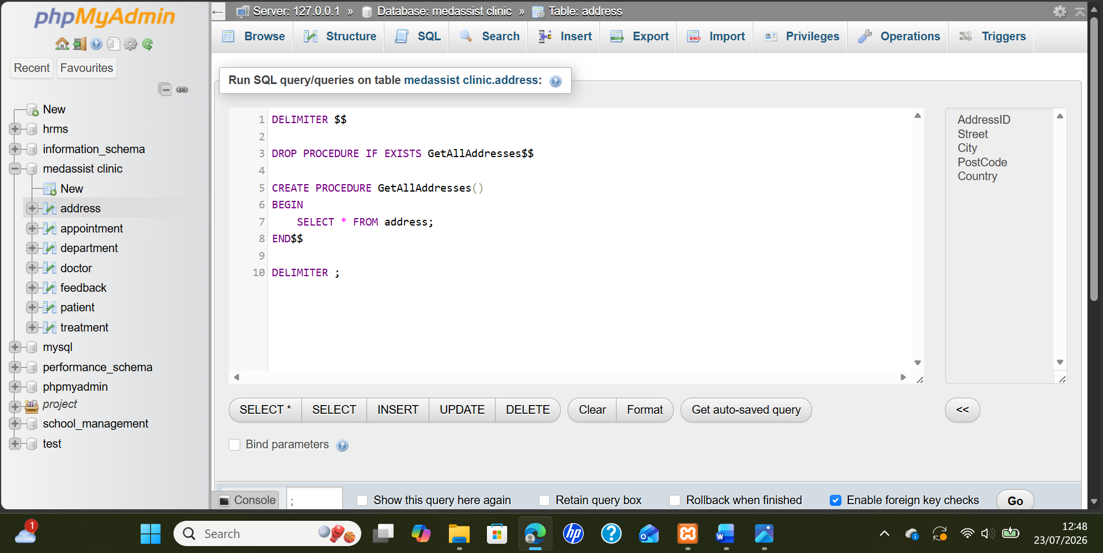

Figure 4.2: phpMyAdmin SQL editor showing the GetAllAddresses stored procedure for retrieving all stored address records.
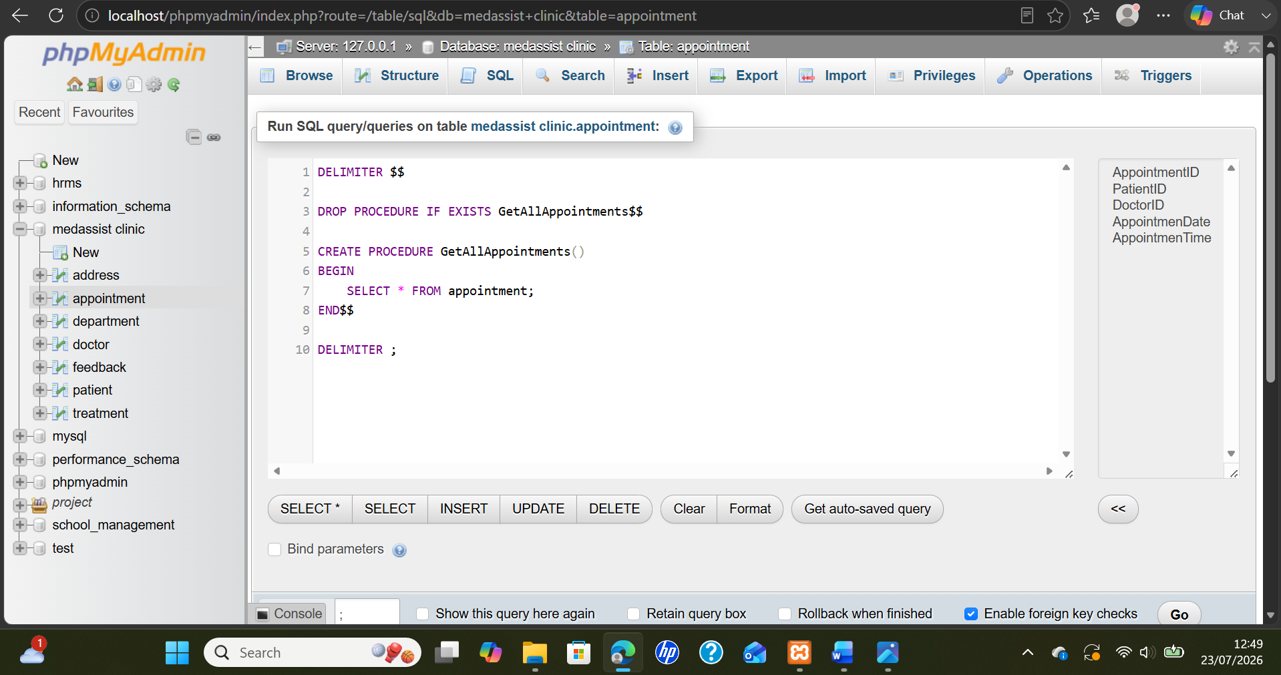

Figure 4.3: phpMyAdmin SQL editor showing the GetAllAppointments stored procedure for retrieving all appointment records.

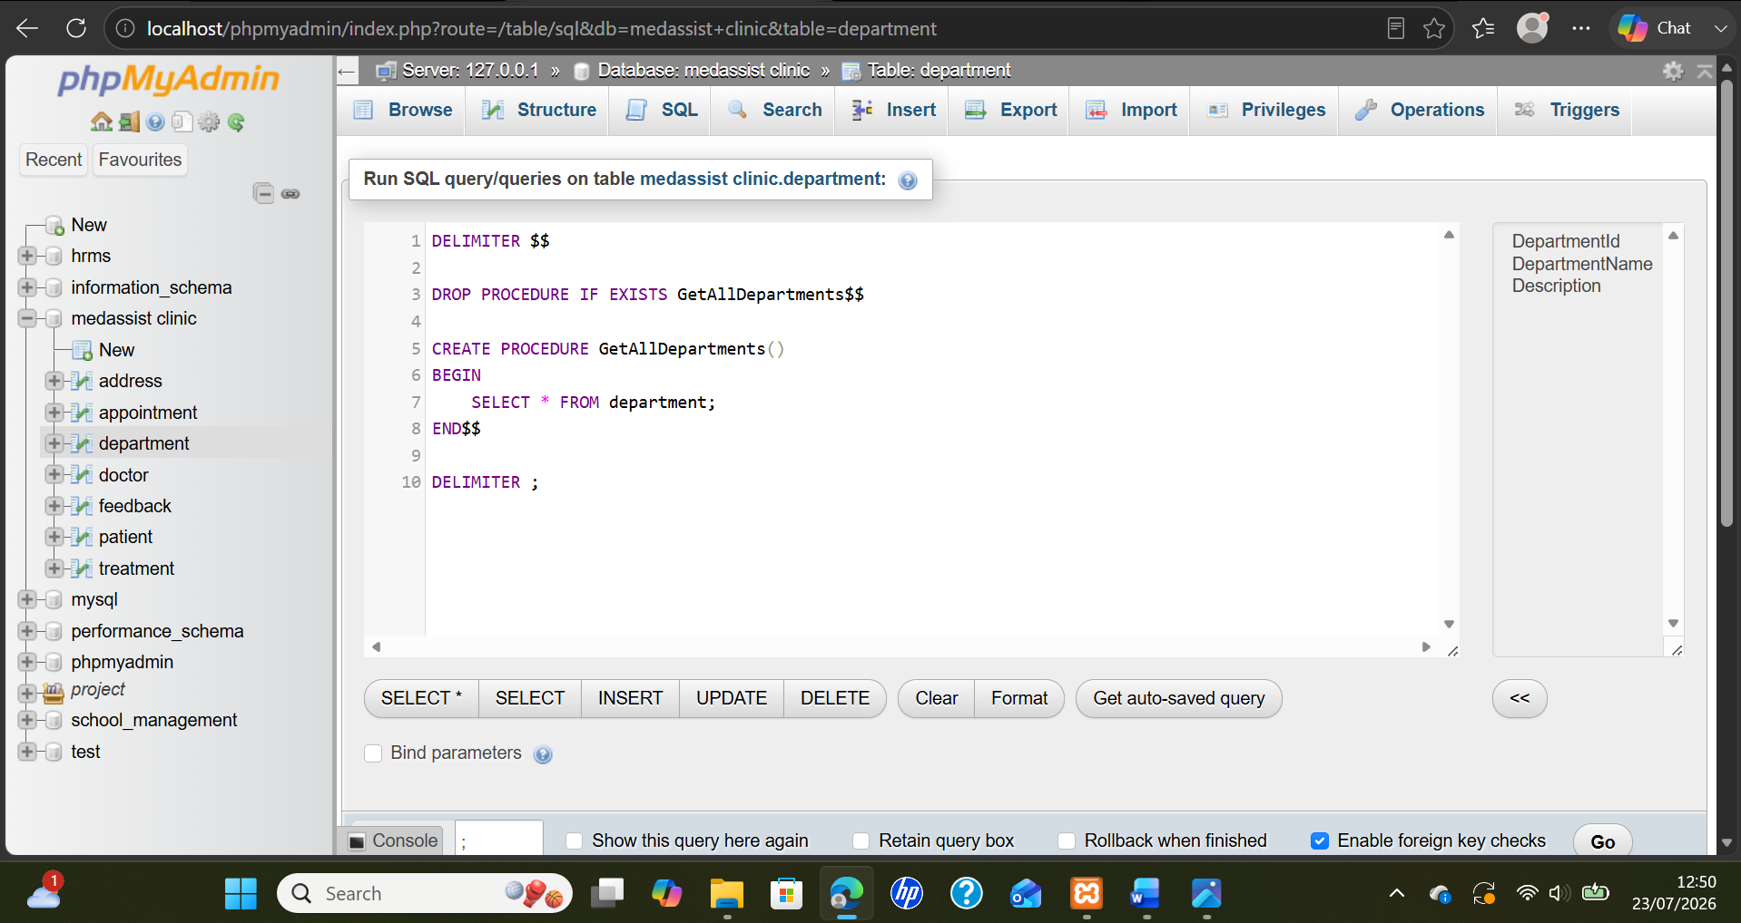
Figure 4.4: phpMyAdmin SQL editor showing the GetAllDepartments stored procedure for retrieving all department records
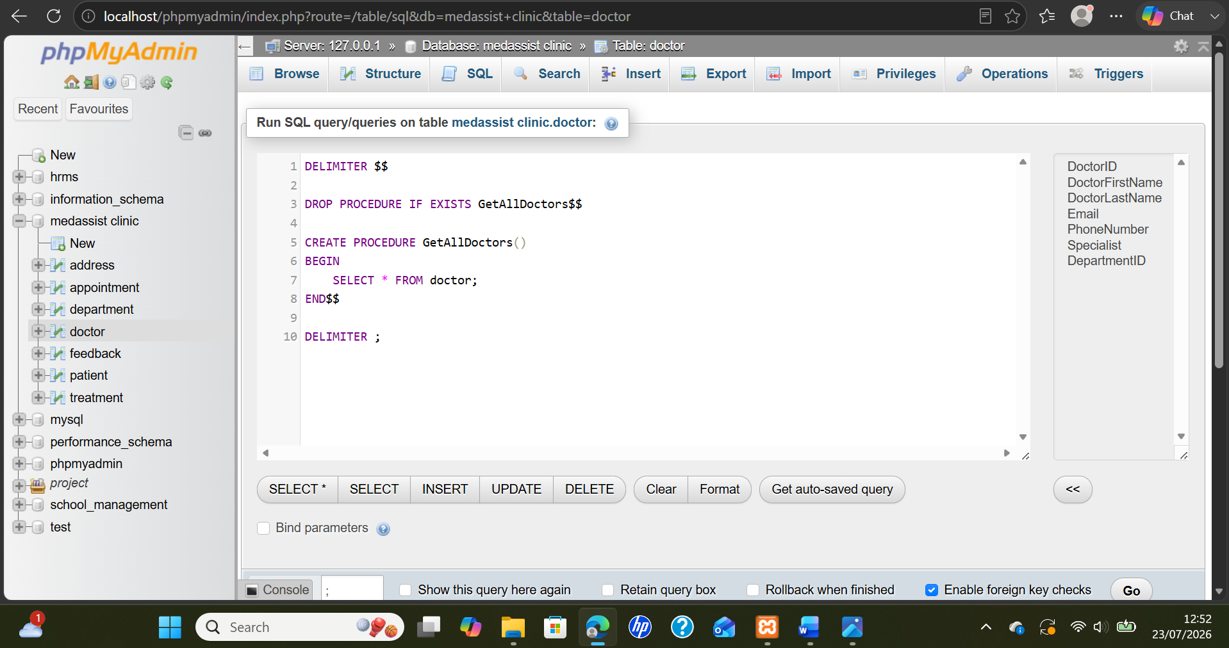
Figure 4.5: phpMyAdmin SQL editor showing the GetAllDoctors stored procedure for retrieving all doctor records.

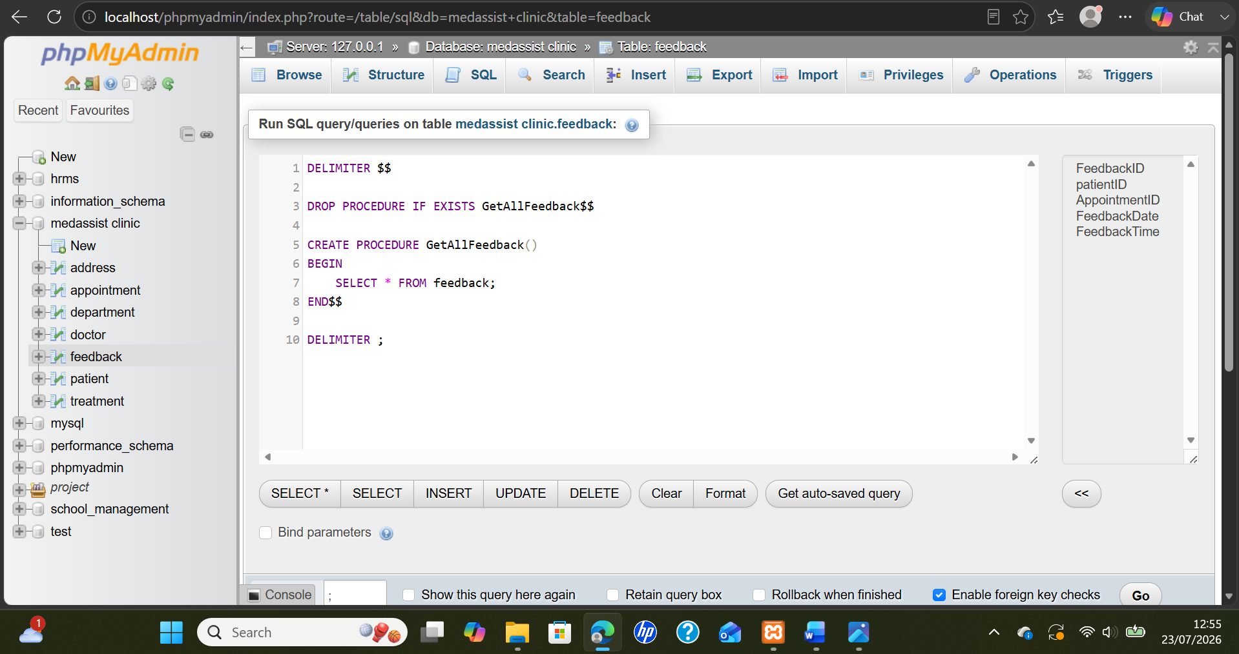
Figure 4.6: phpMyAdmin SQL editor showing the GetAllFeedback stored procedure for retrieving all feedback records.

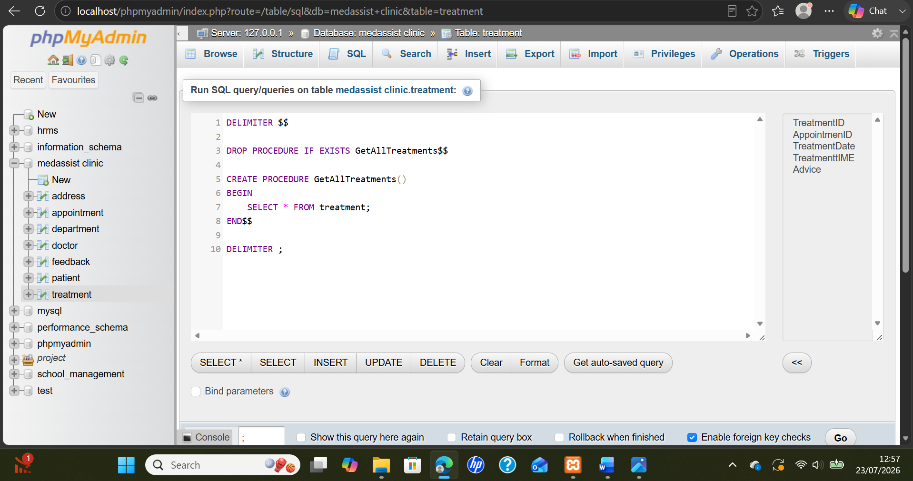
Figure 4.7: phpMyAdmin SQL editor showing the GetAllTreatments stored procedure for retrieving all treatment records.

5 Triggers

Triggers were built into the MedAssist Clinic database so that they would automatically verify data before adding it to any of the tables. A trigger will execute at the moment of occurrence of a specific type of database event, allowing users to avoid doing the same validations every time. Therefore, they support consistency while limiting incorrect or duplicate records from being added into the system.
The before_address_insert trigger performs validations on the information (street, city, post code and country) prior to inserting a new address. If an existing address is located, then the insert operation is cancelled and an error message is shown. The before_department_insert trigger validates similar data as the department names cannot be the same.
The before_patient_email and before_doctor_insert triggers validate e-mail addresses prior to adding new patient and/or doctor records. If an e-mail address is already present within the correct table, then those new patient/doctor records are denied as duplicate. Thus preventing unnecessary duplicates while allowing for each patient and doctor to be identified through their own unique e-mail address.
Validation of scheduling information was completed through the use of the before_appointment_insert trigger. The trigger validates the proposed date for the appointment against the current date. The trigger does not allow for appointments to be scheduled in the past. The before_treatment_date trigger identifies the date of the associated appointment and validates the treatment date. If the treatment date precedes the appointment date, the new treatment record will be rejected.
The before_feedback_insert trigger will automatically populate the "date" and "time" fields of feedback entries if this information has not been populated by the user. This allows for timely tracking of all feedback submissions. In general, all triggers automate important clinic policies, improve data integrity and help minimize errors during input. Additionally, the triggers provide clear error messages when invalid information is entered, thus increasing usability of the database for both administrative and clinical users.
staff to use. Future development could add audit triggers to record who changed sensitive information and when the change occurred.

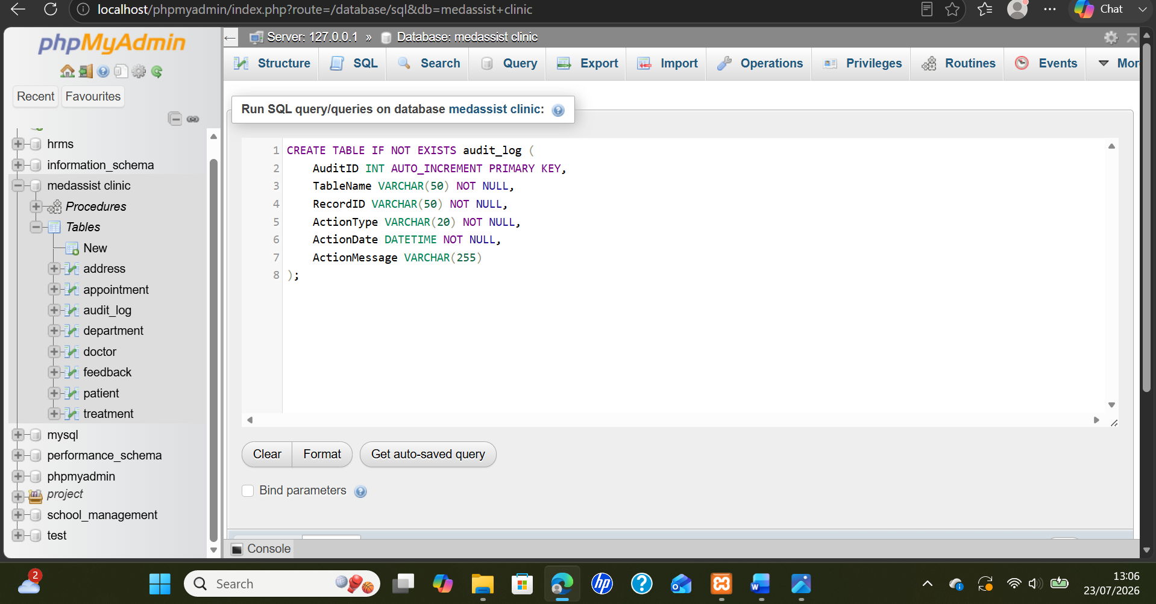
Figure 5.1: phpMyAdmin SQL editor showing creation of the audit_log table for recording database activities
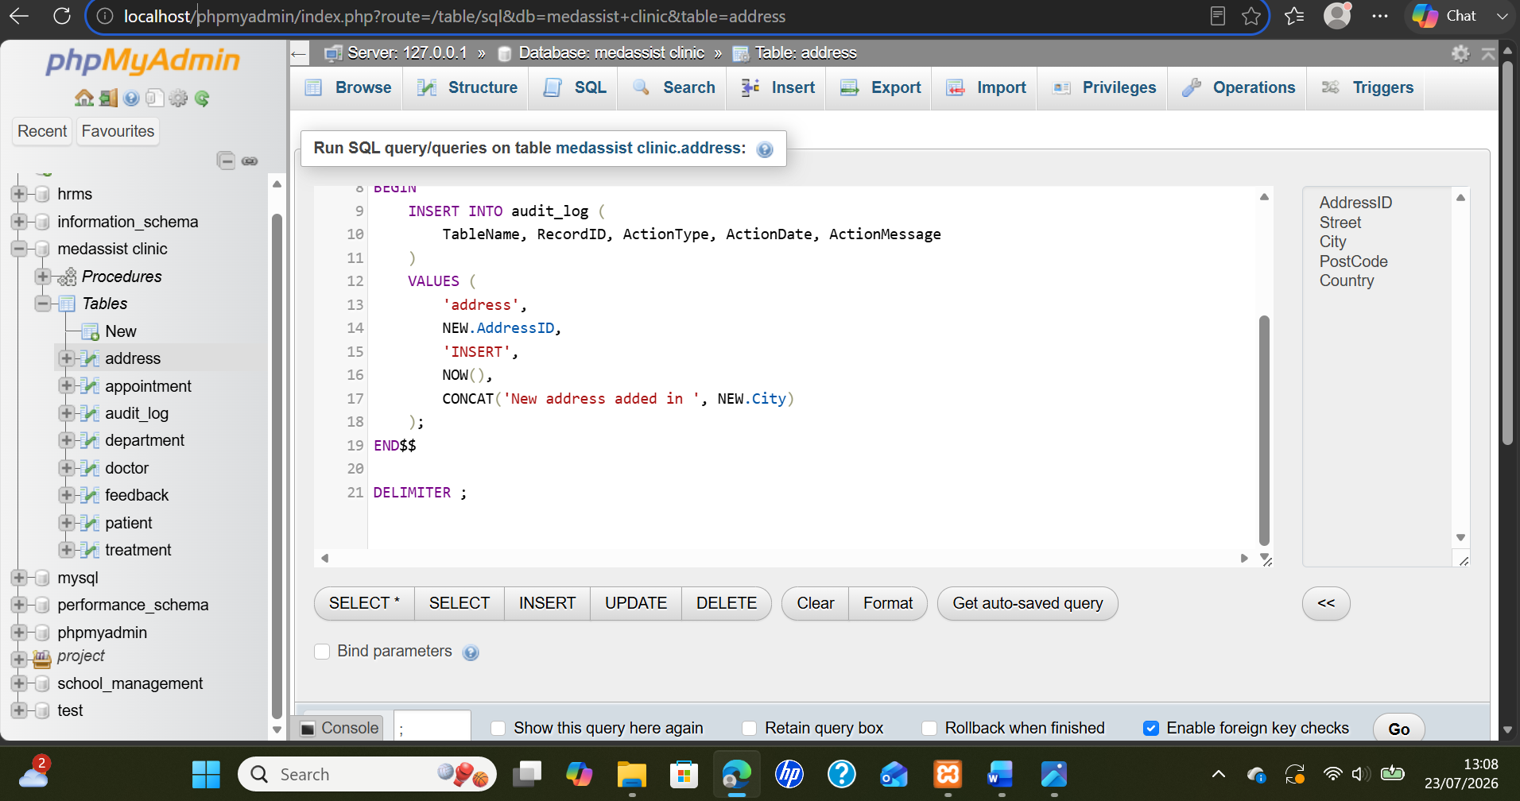
Figure 5.2: phpMyAdmin SQL editor showing the address trigger recording inserted address details in the audit_log.
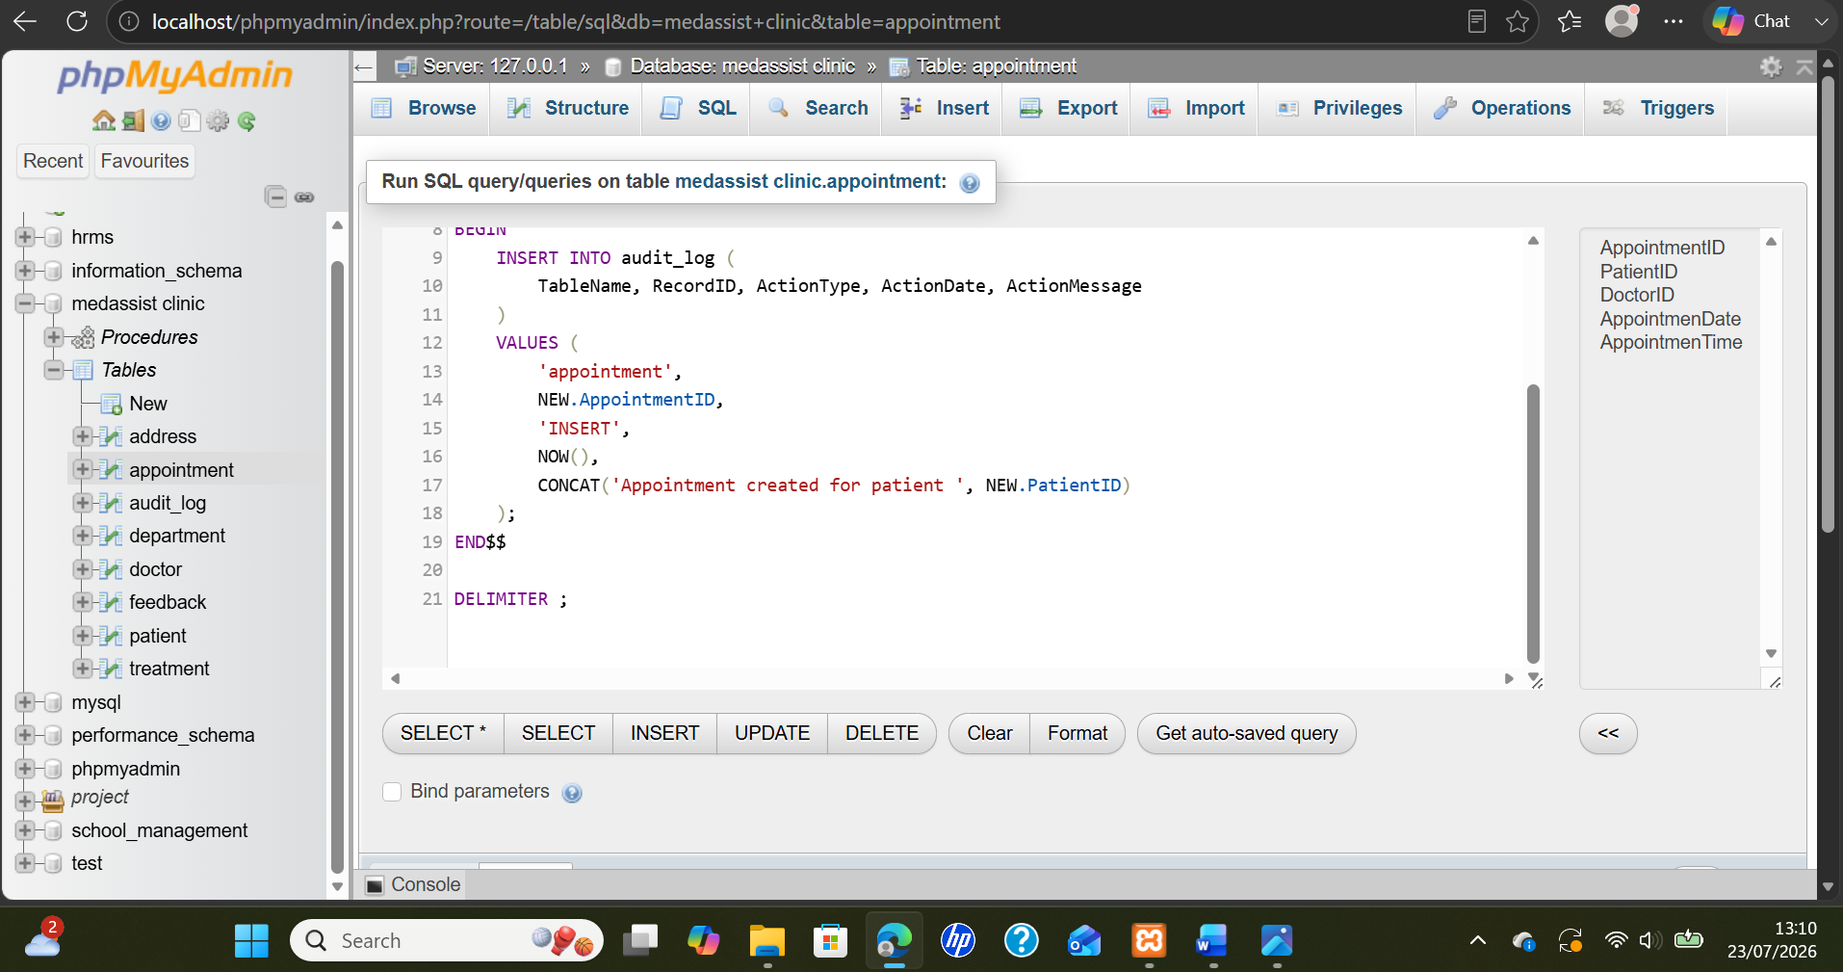
Figure 5.3: phpMyAdmin SQL editor showing the appointment trigger recording inserted appointment details in the audit_log.
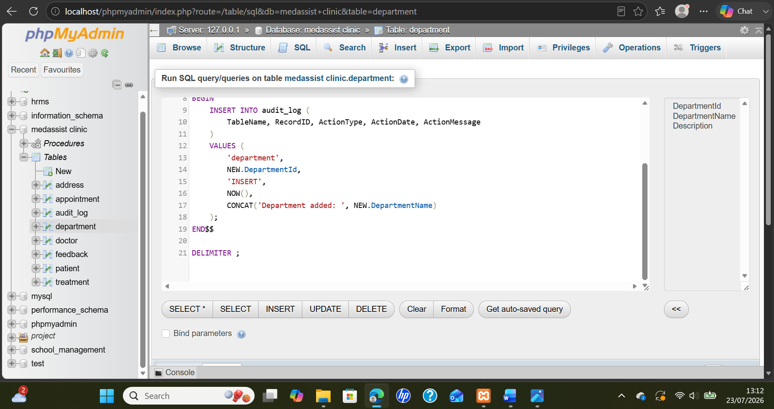

Figure 5.4: phpMyAdmin SQL editor showing the department trigger recording inserted department details in the audit_log.

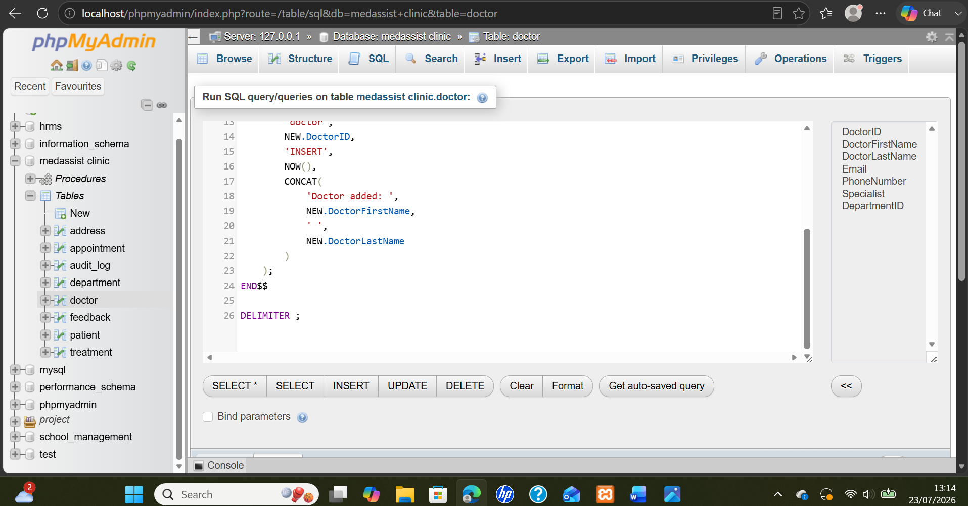
Figure 5.5: phpMyAdmin SQL editor showing the doctor trigger recording inserted doctor details in the audit_log.
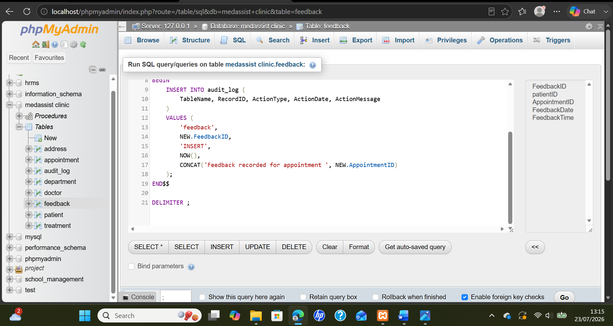
Figure 5.6: phpMyAdmin SQL editor showing the feedback trigger recording inserted feedback details in the audit_log.
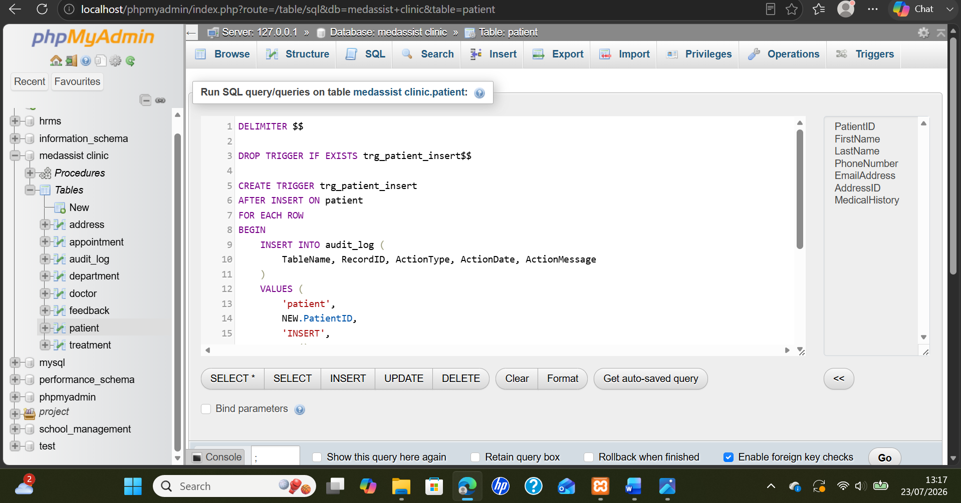
Figure 5.7: phpMyAdmin SQL editor showing the patient trigger recording inserted patient details in the audit_log.

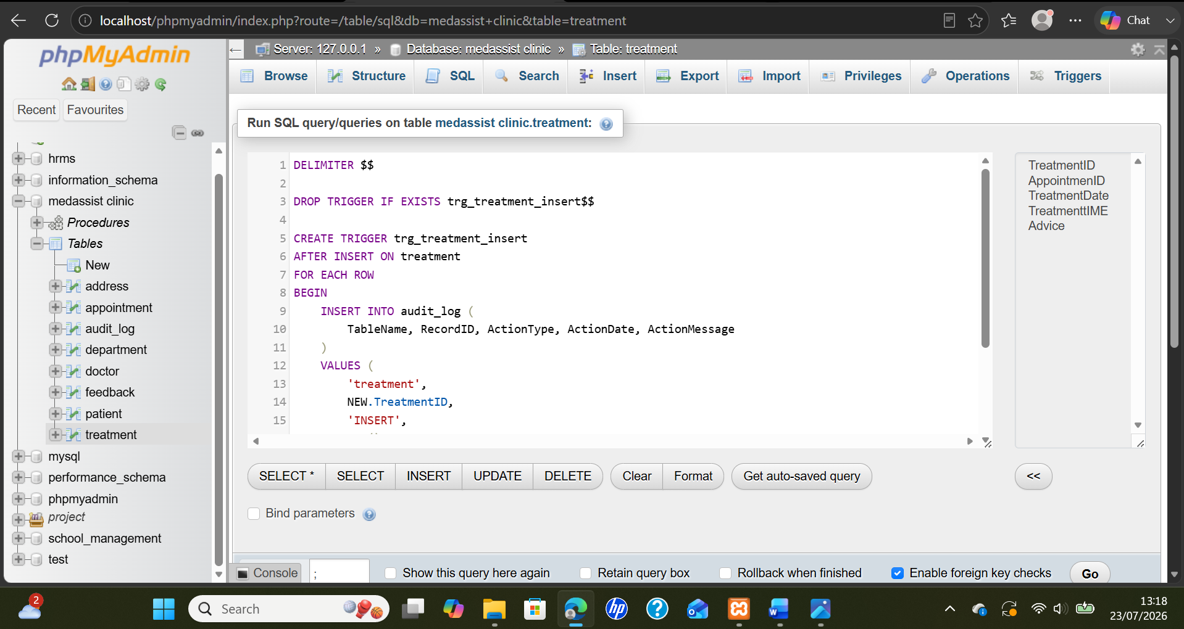
Figure 5.8: phpMyAdmin SQL editor showing the treatment trigger recording inserted treatment details in the audit_log.

Performance Tuning
The purpose of performance optimization will be to allow the MedAssist Clinic database to obtain data with ease as the quantity of data expands. An Index allows the database to look at data in an easier manner than having to scan each record in a table. It would greatly benefit the MedAssist Clinic by allowing employees to find specific items (patients, appointments, doctors, etc.) as they search through the database [14].
Currently, secondary indexes have been built upon two fields in the Address table; City and PostCode. The purpose of these indexes will allow users to find patient locations. Additionally, an index has been created on the fields of Country and City. This combined index will potentially aid in creating geographic reports or finding groups of patients who live in a certain area based off their addresses.
Primary keys (indexes) were created automatically on identifier fields; PatientID, DoctorID, AppointmentID, and TreatmentID. These indexes will enhance employee searches and enable the MedAssist Clinic to obtain individual records quickly. Primary Keys also assist in connecting tables based on common identifiers used to connect records.
Additional indexes should be developed on additional foreign-key columns that employees use to search for data (i.e., PatientID and DoctorID in the Appointments table, DepartmentID in the Doctors table, AppointmentID in the Treatments and Feedbacks tables). Furthermore, it would be beneficial to develop an index on the doctor, appointment date and time to enable employees to check doctor availability and identify scheduling conflicts [15].
Although this example uses a very small dataset, due to this size, employees may not notice a difference in processing speed. However, as thousands of patient and appointment records are input into the database, indexing will significantly decrease query execution times and improve overall system response times. Carefully select indexes as multiple indexes can hinder insert and update processes
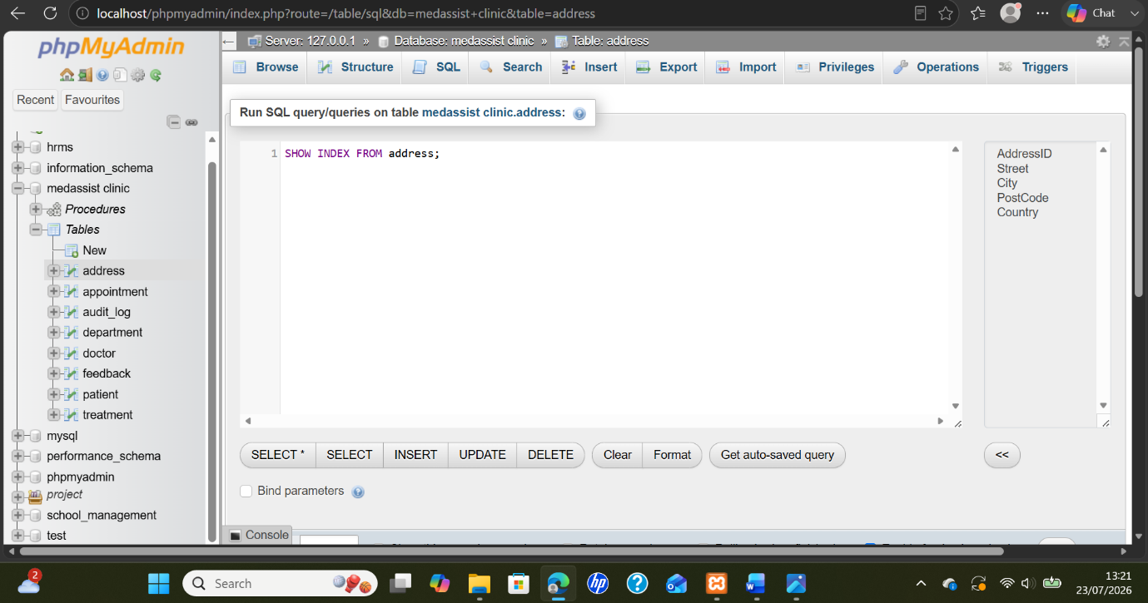

Figure 6.1: phpMyAdmin SQL editor showing the address index inspection query used for performance tuning.
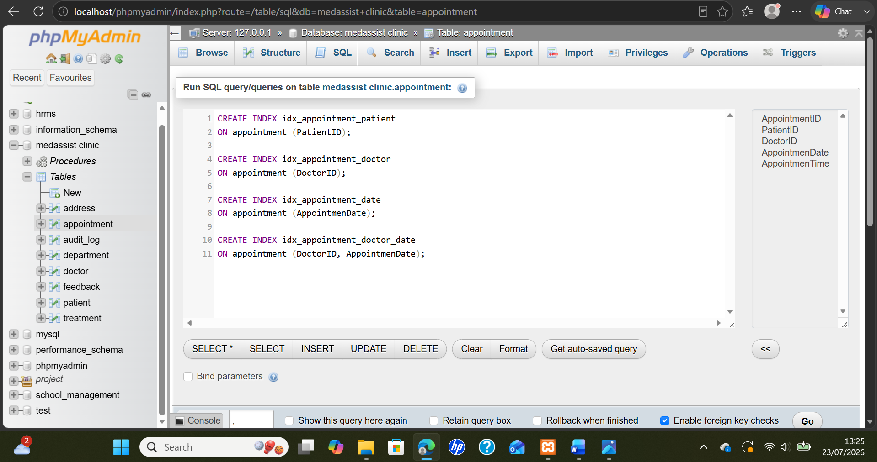
Figure 6.2: phpMyAdmin editor showing appointment indexes created to improve patient, doctor, and date searches.
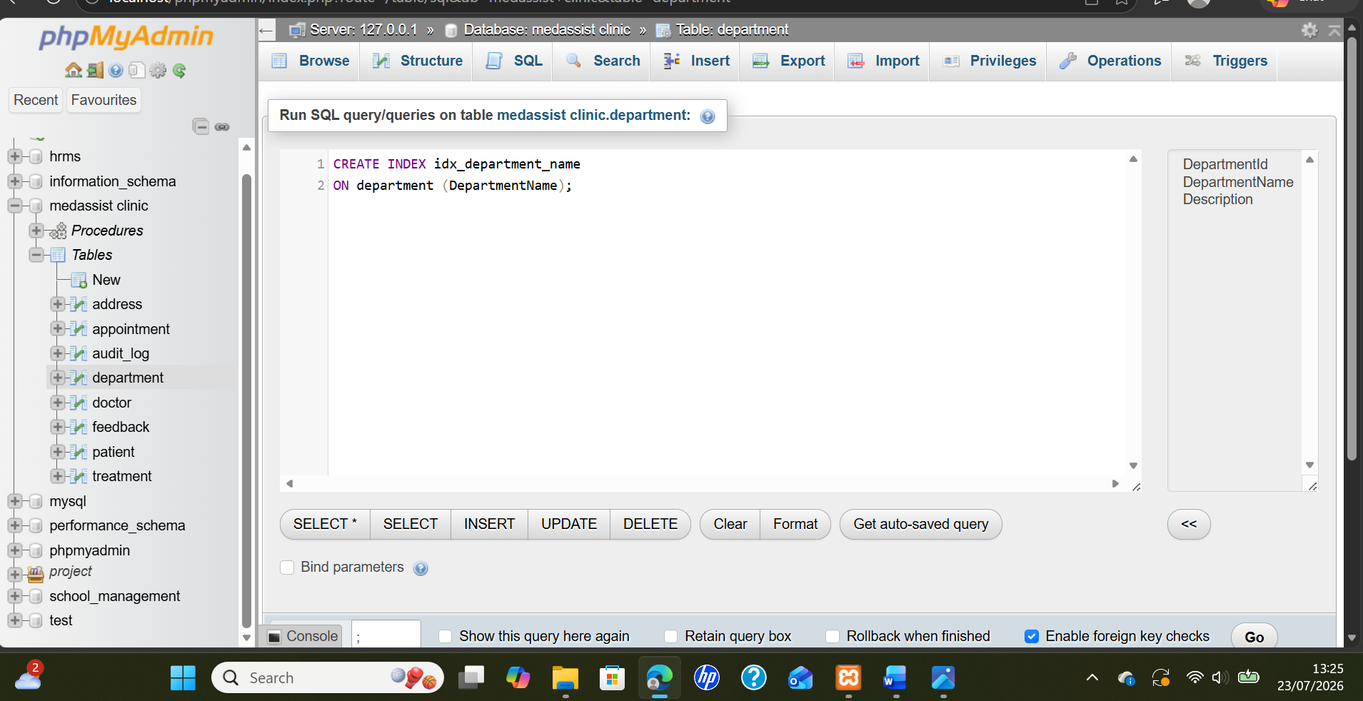
Figure 6.3: phpMyAdmin editor showing department index created to improve department-name search performance within the database.
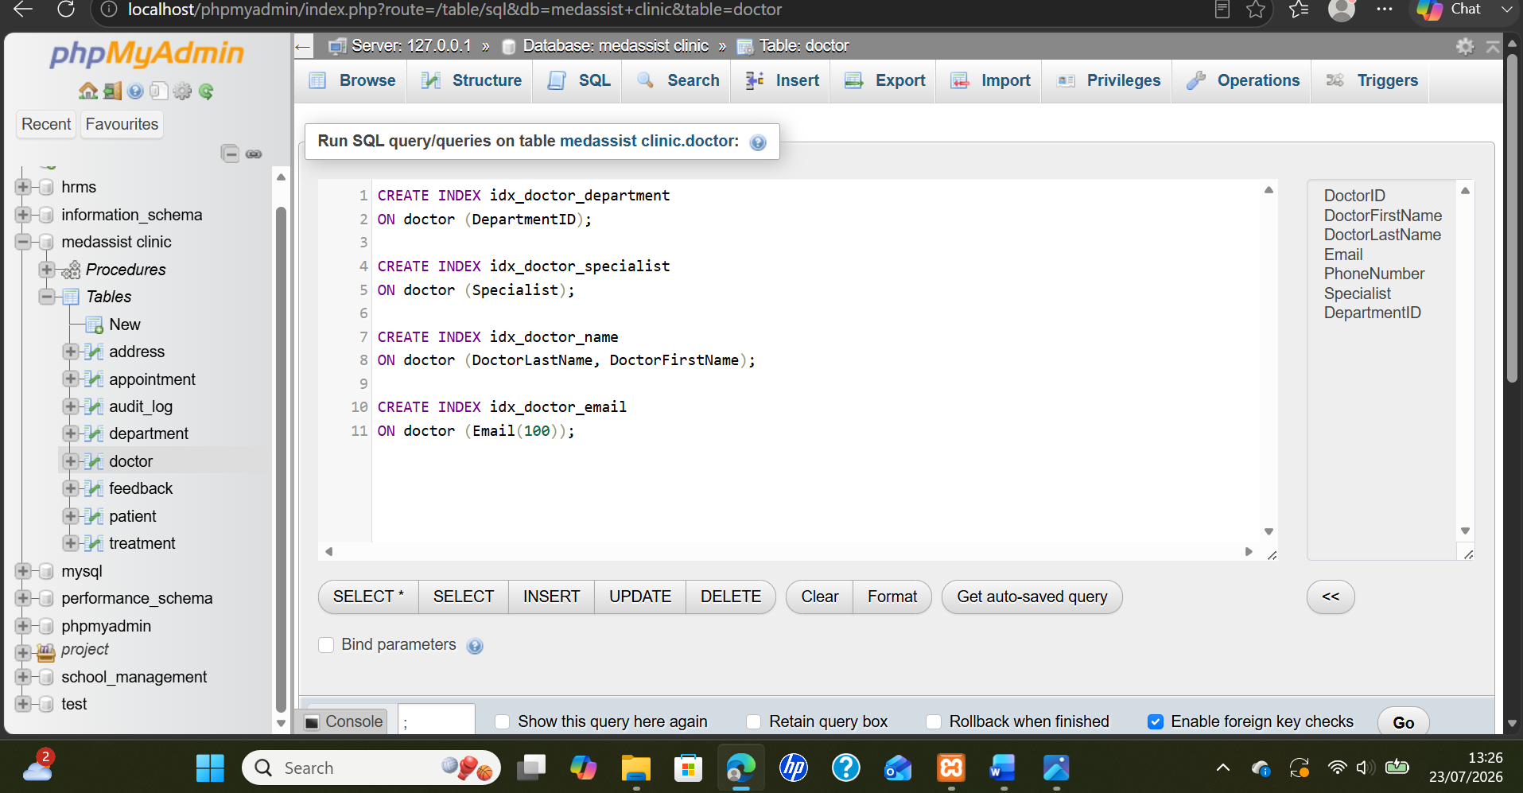
Figure 6.4: phpMyAdmin editor showing doctor indexes to improve department, specialty, name, and email searches.
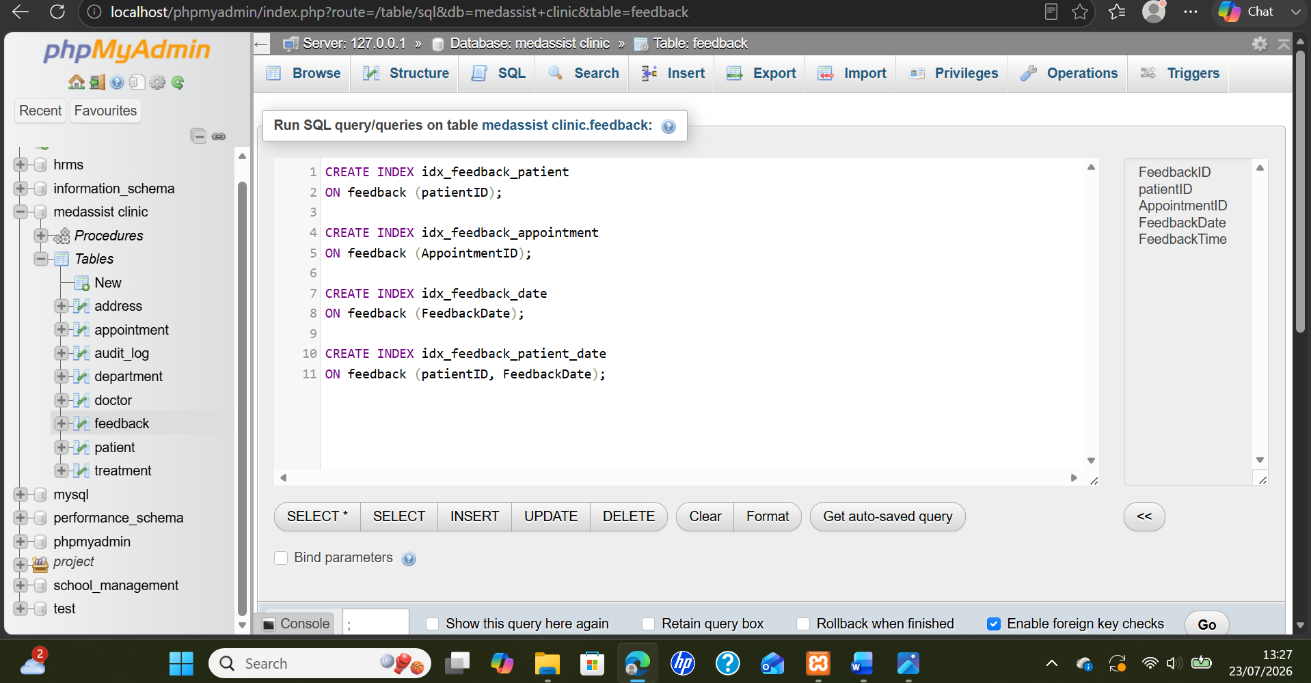
Figure 6.5: phpMyAdmin editor showing feedback indexes improving patient, appointment, date, and combined search performance.
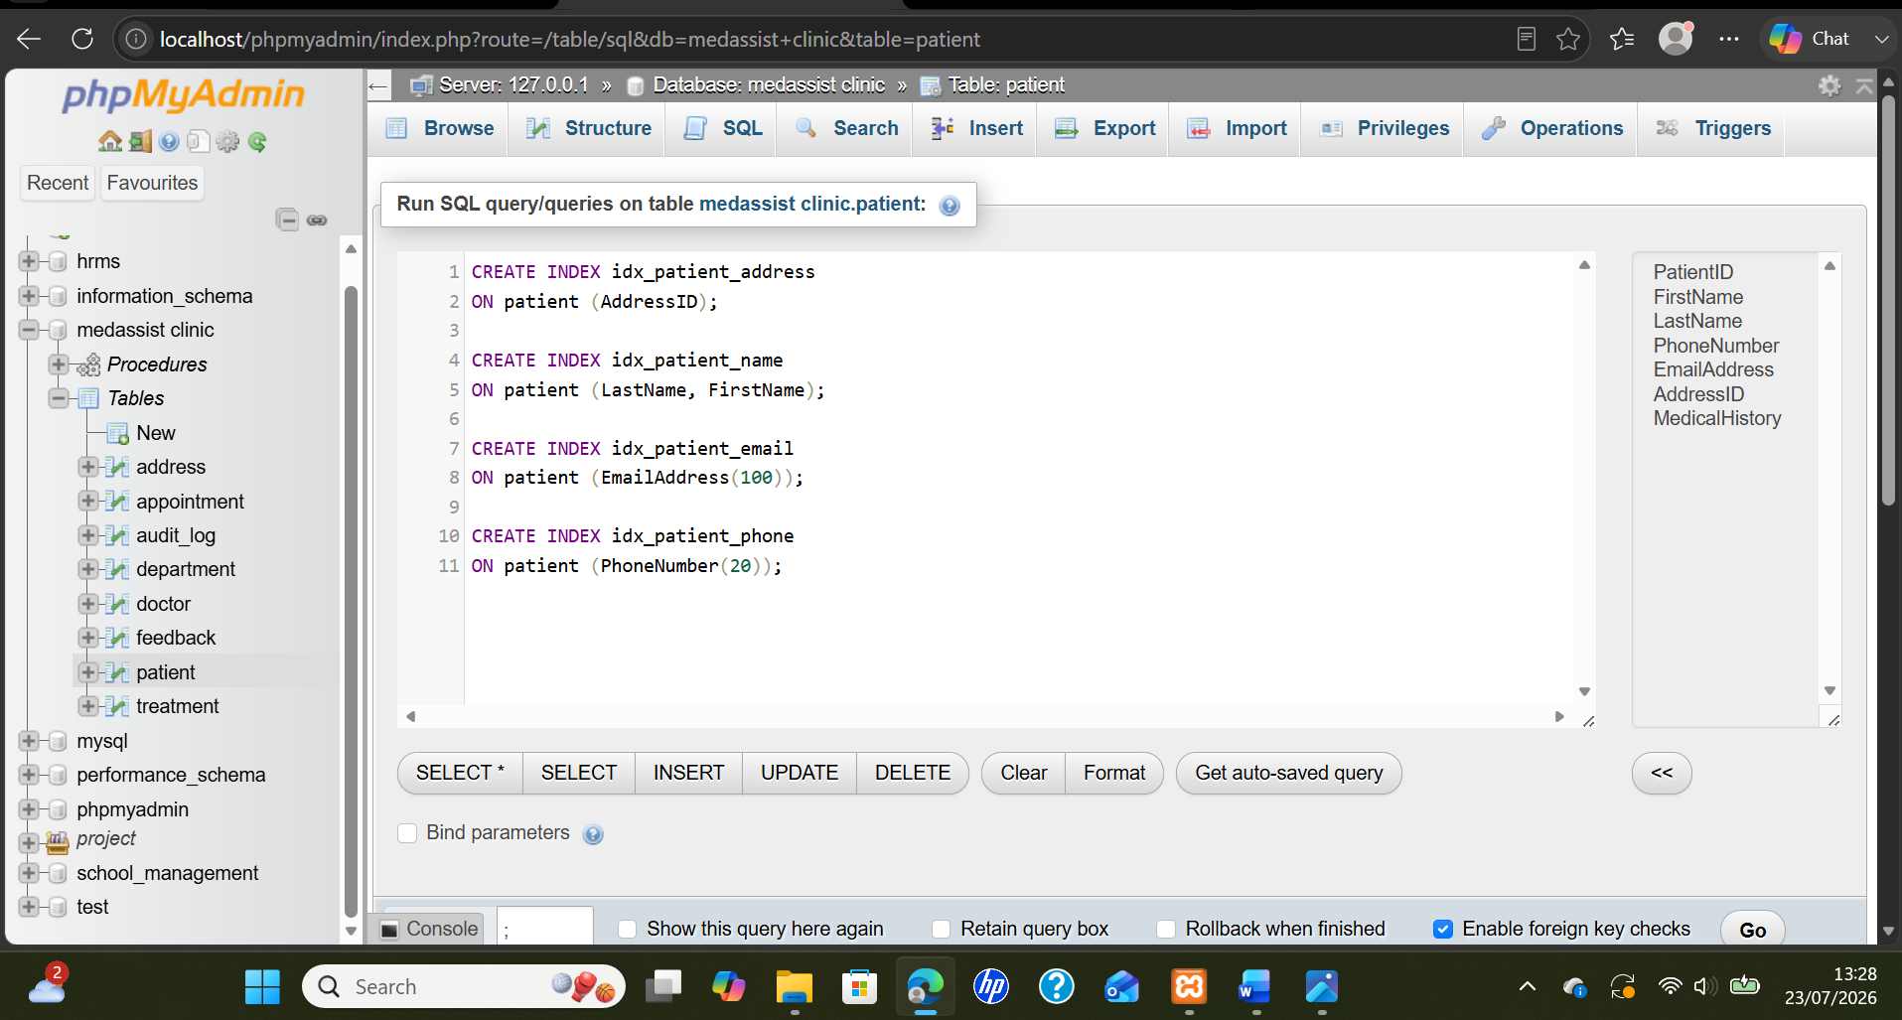
Figure 6.6: phpMyAdmin editor showing patient indexes improving address, name, email, and phone search performance.
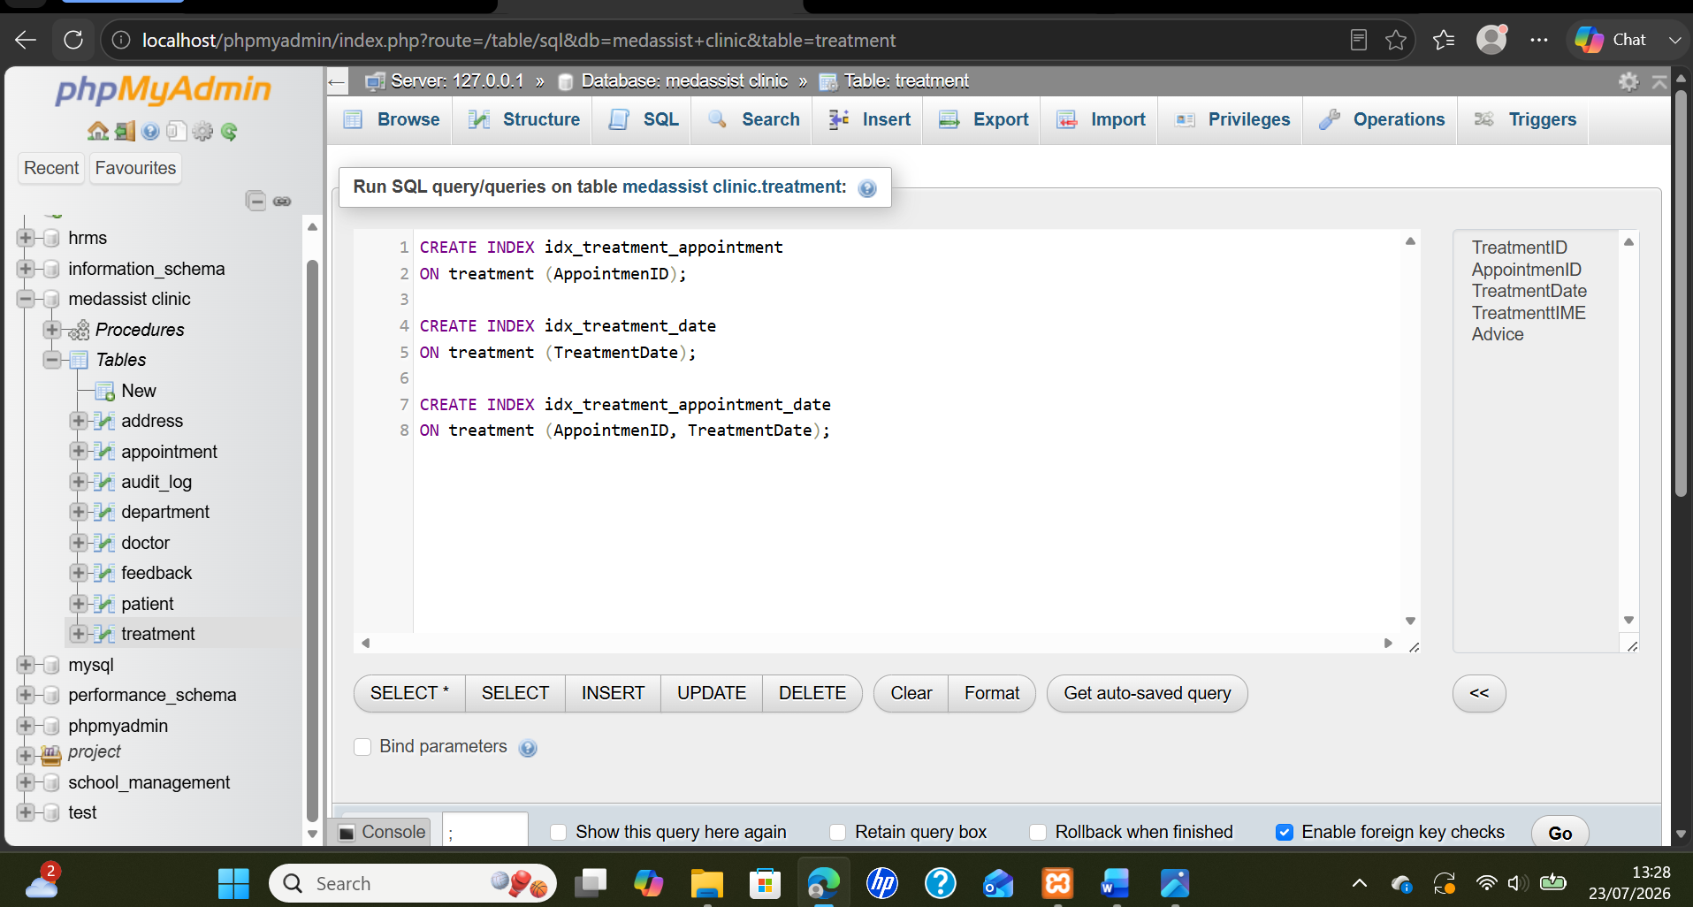
Figure 6.7: phpMyAdmin editor showing treatment indexes improving appointment, date, and combined database search performance.

Conclusions and Reflection
MedAssist Clinic is able to efficiently manage their patient's, physician's, department's, scheduling, treatments, address and customer service requests through the use of the MedAssist Clinic Database. The database design has been structured in such a manner that separate tables have been created for each type of information. In doing so, the database design eliminates any possible duplication of data; simplifies data storage, updating and retrieval. Each table in the database will contain primary keys which are used to identify specific entries in each table. Triggers may be used within the database to ensure critical rules or processes are followed (i.e., duplicate e-mail addresses from being entered as valid contacts; prevent past appointments from being entered into the system; treat date cannot precede the scheduled appointment time); index may be implemented to allow for faster searches throughout the database as the size of the database increases.
Experience gained from developing the MedAssist Clinic database within XAMPP included hands-on experience designing tables, populating sample data, testing sql commands through phpMyAdmin. A major difficulty experienced during the development process was determining how best to establish connections among tables in order to maintain simplicity and consistency. Establishing identifiers to create relationships among related records and adhering to normalization guidelines were two methods utilized to overcome this problem.
Although the current version of the MedAssist Clinic database prototype has met most of MedAssist Clinic's informational needs regarding management of its patients' and physicians', there are other areas of improvement which would provide security and reliability benefits. Some future enhancements might include adding additional foreign key constraints, stored procedures utilizing COMMIT and ROLLBACK statements, implementing user-level access control, and audit triggers which track changes made to sensitive pieces of information. Additional indexing may also need to be applied to commonly referenced columns including appointment and doctor.

References
[1] Z. F. Azzahra and A. D. Anggoro, “Analisis teknik entity-relationship diagram dalam perancangan database: Sebuah literature review,” Intech, vol. 3, no. 2, pp. 70–74, 2022.

[2] R. Ridwan, N. Kustian, and E. W. Ambarsari, “Peran data store dalam mempresentasikan hubungan data flow diagram SSADM dengan entity relationship diagram,” Jurnal Ilmiah Teknik Mesin, Elektro dan Komputer, vol. 2, no. 2, pp. 83–90, 2022.

[3] R. Rahutomo et al., “Database management system design improvement for child stunting data collection in multiple observation areas,” in Proc. ICIMTech, pp. 149–154, 2022

[4] M. Besta et al., “Demystifying graph databases: Analysis and taxonomy of data organization, system designs, and graph queries,” ACM Comput. Surv., vol. 56, no. 2, pp. 1–40, 2023.

[5] T. Taipalus, “Vector database management systems: Fundamental concepts, use-cases, and current challenges,” Cogn. Syst. Res., vol. 85, Art. no. 101216, 2024.

[6] S. Hao, Z. Wang, B. Bach, and L. Pschetz, “Design patterns for data-driven news articles,” in Proc. 2024 CHI Conf. Human Factors in Computing Systems, pp. 1–16, 2024.

[7] H. Laurenson-Schafer et al., “Description of the first global outbreak of mpox: An analysis of global surveillance data,” Lancet Glob. Health, vol. 11, no. 7, pp. e1012–e1023, 2023.

[8] M. Petrovich, M. J. Black, and G. Varol, “TEMOS: Generating diverse human motions from textual descriptions,” in Proc. Eur. Conf. Comput. Vis. (ECCV), pp. 480–497, 2022.

[9] L. M. Hoi, W. Ke, and S. K. Im, “Manipulating data lakes intelligently with Java annotations,” IEEE Access, vol. 12, pp. 34903–34917, 2024.

[10] Sutiyono, “Data Definition Language (DDL) dan Data Manipulation Language (DML),” CV Bravo Press Indonesia, 2025.

[11] A. Lusta, Ö. Demirel, and B. Mohammadzadeh, “Language corpus and data-driven learning (DDL) in language classrooms: A systematic review,” Heliyon, vol. 9, no. 12, 2023.

[12] M. T. J. Ansari, D. Pandey, and M. Alenezi, “STORE: Security threat oriented requirements engineering methodology,” J. King Saud Univ.–Comput. Inf. Sci., vol. 34, no. 2, pp. 191–203, 2022.

[13] K. M. Amelia, “Analisis penerapan standard operating procedure (SOP) pengambilan barang store di The Haven Bali Seminyak,” Ph.D. dissertation, Universitas Pendidikan Ganesha, 2025.

[14] H. Herodotou, L. Odysseos, Y. Chen, and J. Lu, “Automatic performance tuning for distributed data stream processing systems,” in Proc. IEEE 38th Int. Conf. Data Eng. (ICDE), pp. 3194–3197, 2022.

[15] P. Manda, “Leveraging AI to improve performance tuning in post-migration Oracle cloud environments,” Int. J. Res. Publ. Eng., Technol. Manage., vol. 6, no. 3, pp. 8714–8725, 2023.

