Contents Page

1.0 Introduction
- Issues and Sources of Aquatic Pollution
2.1 Global Concerns
2.2 Pollution Sources and Land-based Waste
3.0 Case Study: The Loughor Estuary
  - Background
  - Eutrophication: The Root Problem
4.0 Local, National and International Protection
  - Sewage overflow Protection
4.1.1 Land-based Collaborations
4.1.2 Marine Based Collaborations
4.2 Marina and Coastal Environmental Protection
5.0 Conclusion
6.0 References
7.0 Appendices

- Introduction
For many decades the world’s oceans have been treated as dumping grounds for human waste (ITV Report, 2019; Jones et al, 2018). It is only now the effects are being more intensely felt is humanity willing to act to make changes to better protect the marine environment. Several conservation zones exist globally but many lack focus on marine wilderness areas that are quickly declining due to over exploitation and habitat degradation. Several environmental commitments are implemented and monitored by the European Union (EU) including wastewater treatment which has become an increasingly common problem in Britain (Carrington, 2017; WWF, 2017; Gabbatiss, 2019; Herd, 2019; Welsh Water, 2019a). Untreated sewage is often released into waterways by water treatment companies during periods of intense rain to prevent flooding into homes. Environmental organisations like the WWF are concerned about the effect this is having on the biodiversity and call to have more efficient treatment facilities in place. Several Marine Protection Areas exist in Wales but with various protection zones overlapping, with differing priorities and management focuses, issues such as eutrophication is becoming far too common in Britain with 40% of rivers in England and Wales being polluted by sewage (CCW, 2012; Welsh Government, 2014; WWF, 2017). The following report will look at the issues surrounding sewage overflow into waterways in Britain, using the Loughor estuary South wales as a case study and asses the current level of protection in place and how to what extent the current level of protection is working.

- Issues and Sources of Aquatic Pollution
  - Global Concerns
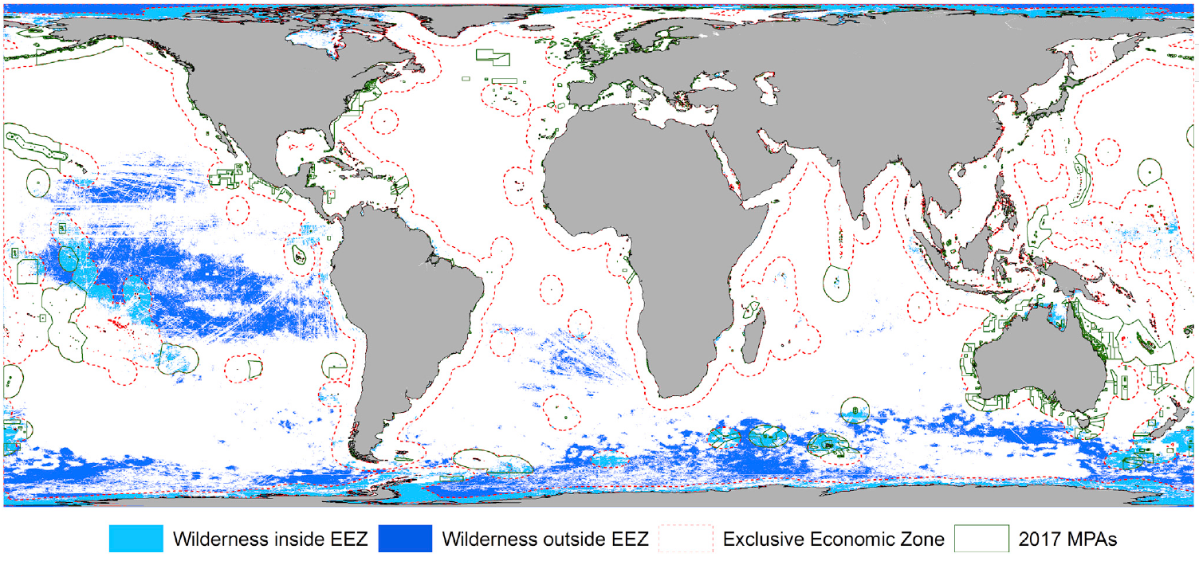
Anthropogenic pressures on the oceans are increasing and no part of the ocean remains untouched but human impacts (Jones et al, 2018). Strong currents and winds carry debris and pollutants over vast areas and into areas of remote marine wilderness. Jones et al (2018) research suggests that marine wilderness areas (MWA) cover approximately 55 million km² but only 4.9% of these are located in marine protected areas (MPAs; fig. 1). Protection is mainly focused within National waters and Exclusive Economic Zones (EEZs) like the Arctic but only 0.02% of wilderness protection occurs in high seas. In coastal areas wilderness protection focuses on soft bottom areas neglecting the vulnerable rocky and reef ecosystems but despite their low wilderness extent they have the highest proportional protection covered by MPAs (66% and 26% retrospectively; Appendix 1 and 2). Greater global efforts are needed to protect more remote marine ecosystems from the effects brought on by humanities activities if we are to slow the rate of species extinctions and habitat degradation.
(Jones et al, 2019)
Figure 1. Global Marine Wilderness Extent and Protection.

  - Pollution Sources and Land-based Waste
Sources of pollution can be ocean industry based but up to 80% of marine pollution comes from land-based sources through rivers, sewers and drains (ITV Report, 2019; Techera and Winter, 2019). Plastic debris has been getting most of the media attention for its prolonged presence within the environment for 100’s of years, but other sources of pollution can be just as profound, with its negative effect on the environment such as oil spills, nutrient dumping, light and noise pollution, commercial shipping, fishing industry and climate change to name a few (NOAA, 2019; Environmental Law, 2019a). Many attempts have been made to curve the amount of pollution entering the aquatic environment from land-based sources. In Britain, wastewater and sewage outlets contribute a large proportion of poor water quality.
  - Combine Sewage Overflows
Wastewater is a large contributor to aquatic pollution every year in the UK (Carrington, 2017; WWF, 2017; Gabbatiss, 2019; Herd, 2019; Welsh Water, 2019a). It originates from many sources including surface runoff, agricultural waste and sewage over-flow systems unable to cope surges in water levels following heavy rains and storms. Rain is a regular occurrence in Britain so why are treatment facilities not better equipped to deal with the increased water capacity? Herd (2017) states, in 2017, sewage pollution emptied into the sea and rivers over 30,000 times just in Wales. A million miles away from Welsh waters target of 155 incidents by 2014 set by the Environment Agency (Welsh Water, 2017b). To prevent flooding into homes the water company is forced to expel untreated sewage into rivers causing damage to aquatic ecosystems from the excess nutrients (Table 1 and 2; Appendix 3; Welsh Water, 2017a).
Table 1. Top Five Combine Sewage Overflow Releases Site by Region in Wales 2017.
Location | Number of Releases | Duration (in Minutes)
Pendine, Carmarthenshire | 317 | 208,950
Tintern, Monmouthshire | 245 | 25,230
Bethesda, Gwynedd | 179 | 197,910
Brecon, Powys | 157 | 6,735
Rhuddlan, Denbighshire | 97 | 7,965
(Adapted from: Welsh Water, 2017a)

Table 2. Top Five Combine Sewage Overflow Release sites for South and West Wales in 2017.
Location | Number of Releases | Duration (in Minutes)
Pendine / Pentywyn | 317 | 208,950
Clarbeston - Market Place | 298 | 138,810
Cwmfelin - Glan-yr-afon | 294 | 248,175
Johnston | 280 | 99,540
Cosheston | 278 | 164,490
(Adapted from: Welsh Water, 2017a)

- Case Study: The Loughor Estuary, South West Wales
  - Background
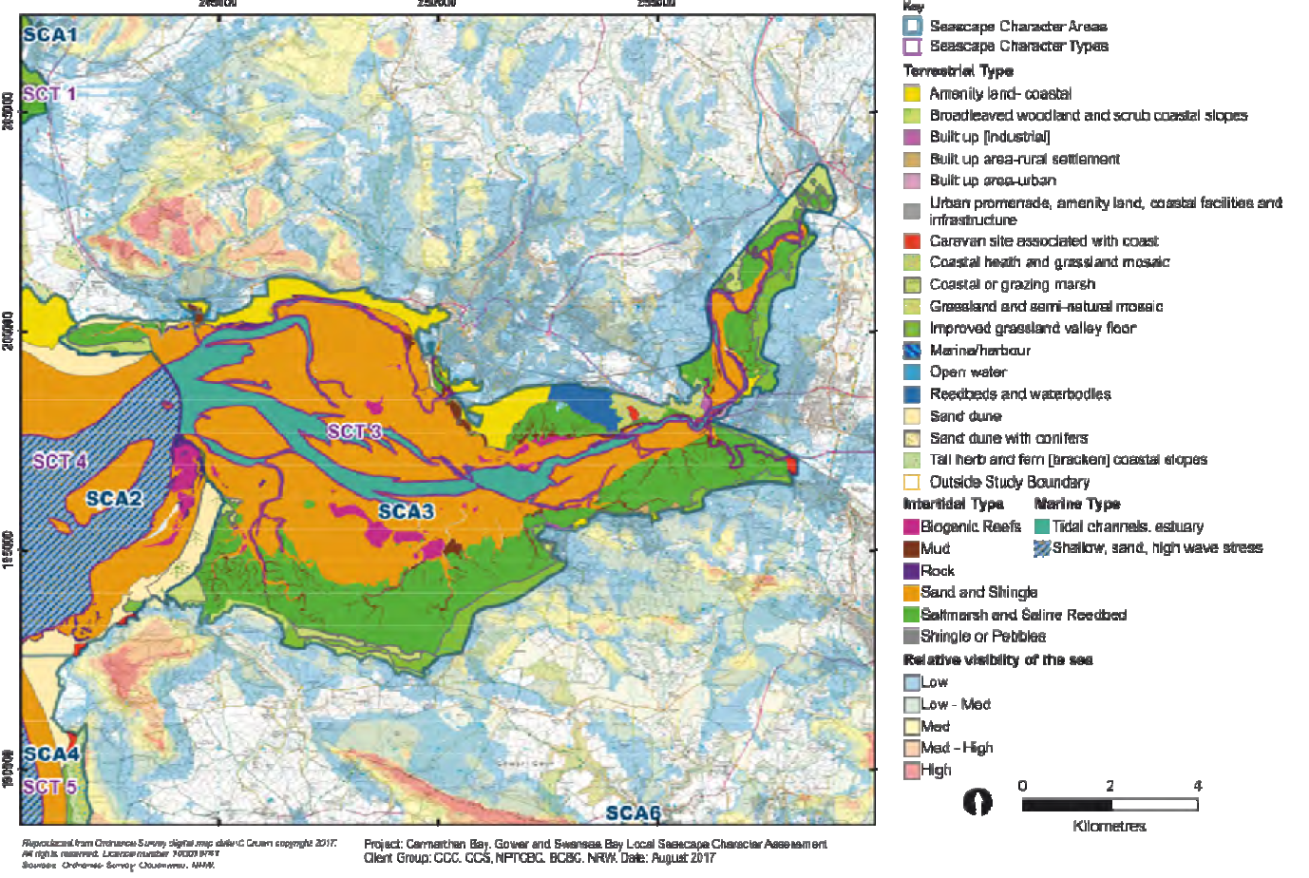
Loughor Estuary runs from Pontarddulais to the coast with a narrow tidal channel expanding in to large areas of sandbanks, saltmarsh and mudflats submerged during high tide (Figure 2 and 3; NPT, 2017; NRW, 2018). The Northern side is urbanised with industry and property developments whereas the southern side is part of the Gower AONB and Heritage Coast. Rich in wildlife it supports a variety food sources for many wintering birds and cockle and mussel beds.

Figure 2. Special Conservation Area 3: Burry Inlet and Loughor Estuary. Key indicated to the right of the map of the Estuary primarily dominated by sand and shingle in orange and saltmarsh in green (NPT, 2017)
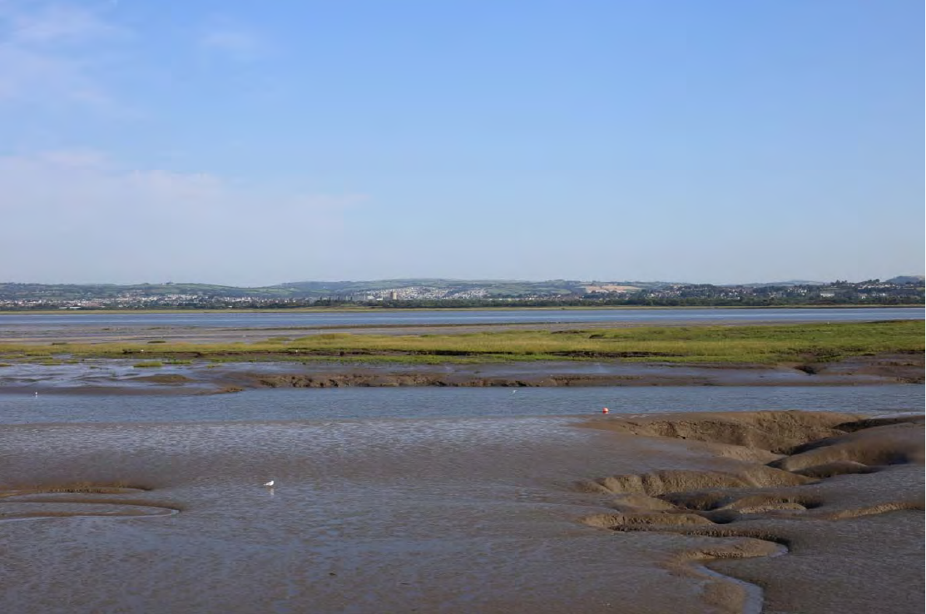
Figure 3. View of Burry inlet at low tide. Taken from Dalton’s Point looking towards Llanelli town (NPT, 2017).
  - Eutrophication: The Root Problem
Untreated sewage overflow and agricultural waste into the Loughor Estuary is causing a surge in nutrients in the water column affecting the growth of Seagrasses and other marine species (Jones and Unsworth, 2015; Pratt, Cullen Unsworth and Jones, 2016; Jones, Cullen-Unsworth and Unsworth, 2018). Seagrass in Britain is in decline despite water quality improving in Britain over the last 30 years thanks to legislation introduced by the EU (JNCC, 2012; Welsh Government, 2014; Neslen, 2016). Despite this, 40% of rivers in Wales and England are polluted with sewage (Carrington, 2017; WWF, 2017). Eutrophication causes surges in algae blooms starving the water and biodiversity of oxygen and light (Appendix 4; Dodds and Smith, 2016; Van Beusekom et al, 2017; Carrington, 2017; Europia, 2017; Blaettler, 2018; Nakate, 2018). Several studies have shown that the state on the locally found Zostera noltii is in decline due to the poor quality of the water and other contributing factors like Zostera wasting disease and climate change (Jones and Unsworth, 2015; Pratt, Cullen-Unsworth and Jones, 2016). As seagrass is a bioindicator of a healthy ecosystem increased monitoring and mapping could lead to better conservation efforts and protection.

- Local, National and International Protection
  - Sewage Overflow Protection
    - Land-Based Collaborations
National directives adopted from the EU linked to water quality include the Urban Waste Water Treatment Directive (1991) and the Bathing Water Directive (1992; DEFRA, 2002; EC, 2018:19; Environmental Law, 2019b). Evidence of frequent untreated sewage overflows (Appendix 3) highlight the need for better primary treatment facilities and increased carrying capacity to cope with excess water flow during storms and prolonged periods of heavy rains (Wasley,2017; Jones, Cullen-Unsworth and Unsworth, 2018; Welsh Water, 2017b). Current levels of production and directives are not doing enough to protect the natural environment from the effects caused by sewage overflow. Old and out dates treatment facilities either need to be decommissioned or undergo significant improvements needed to provide an acceptable level of environmental protection. Although organisations such as Natural Resource Wales and the Environment Agency are in place to monitor specific incidents and environmental testing, linking certain pollution events back to their original source such as agricultural slurry is particularly difficult (Wasley, 2017; Jones, Cullen-Unsworth and Unsworth, 2018). Better monitoring and control on a local scale will help to manage the conservation of specific areas and marine species such as Atlantic sea meadows.
    - Marine Based Collaborations
Several International agreements are available relating to pollution of the marine environment but many only relate to the shipping industry and oil pollution (Appendix 6; Environmental Law, 2019). The International Convention for the Prevention of Pollution from Ships, 1973, as modified by the Protocol of 1978 (MARPOL 73/78) is the only agreement that specifically mentions sewage as a wastewater substance for control under Appendix IV but this only relates to sewage expelled from ships and does not cover land-based sources (Environmental Law, 2019; IMO, 2019). None of these agreements are bound by law or have any enforceable penalties in place to deal with breaches in the agreements. Out on open water it is difficult for authorities to enforce and link waste and pollution back to its original source leaving a large gap in environment protection. Greater efforts are need to ensure ships are better equipment to safely dispose of waste or in increase their storage capacity until they return to land.

Nollkaemper (1994) states that sewage originating from land-based pollution sources are covered by national legislation or agreements but are clearly underdeveloped at an international level, essential for providing support, and there has not been much development on this issue to date. Global Wastewater Initiative (2013), launched by the United Nations (UN) can be considered an umbrella policy to protect international waters from a variety of pollution sources although sewage wastewater is not specifically mentioned (UN, 2017). As no penalties are in place for breaches or misconduct, governments are encouraged to freely enter the framework to work towards the common set targets to protect the environment but it could be argued that as there are no penalties in place governments could just sign up for the initiative but still not take any of the obvious actions towards improving water quality standards. Umbrella incentives like this many just provide the support and guidance needed for national governments to take charge of wastewater pollution by using the framework provided and adapting it to their countries current need. Regular re-evaluation and reports should also be incorporated to make any suitable amendments needed to ensure targets are met.
  - Marine and Coastal Environmental Protection
Currently there are 125 MPA’s designated in Wales but no Marine Conservation Zones (MCZ; Appendix 5; CCW, 2012; Welsh Government, 2014). In 2012, 10 sites were reviewed for MCZ’s in Wales but no further action was taken. Many of the MPA’s consist of overlapping zones of Special; Areas of Conservation (SAC’s), Special Protection Areas (SPA’s), Sites of Special Scientific Interest (SSSI), Ramsar sites and one Marine Nature Reserves (MNR) all with varying objectives and frameworks making protection and actions for conservation an organisational minefield. Overall assessment of the Loughor estuary as a SAC was determined to be in an unfavourable condition, in 2017, due to low quality water and assessments were carried out on the Atlantic sea meadows, mud flats and sand flats but fish were not assessed at this time (NRW, 2018). In 2012, the RSPB produced a report on the current status of the SSSI to be in a favourable condition based on the individual abundance and overall assemblage of wintering bird species but no report has been produced since (RSPB, 2012). Further efforts need to be made to better protect the estuary from the effects linked to untreated sewage in adequate treatment facilities.
Several other commitments are signed up for by Welsh Government and UK administrations on a National and International level ensuring the protection and conservation or marine areas into the future (Appendix 7; Welsh Government, 2014). However, following the UK’s withdraw from the European Union (EU) it is unclear going forward how the UK will react to less pressure being put on the UK to clean up and protect water ecosystems (Neslen, 2017; Gabbatiss, 2019). Tighter penalties and targets need to be set to better reduce the amount of released untreated waste and improved monitoring to link incidents back their sources including unchecked disposal of agricultural slurry into waterways (Wasley, 2017).
Despite research into various species, habitats and water quality investigations clearly establish a link in their decline due to poor water quality linked to wastewater as well as several other causes like disease, climate change, invasive species, changes in salinity and eutrophication (Pratt, Cullen-Unsworth and Jones, 2016; Longshaw, 2015). Cockle and mussel beds on the Loughor estuary make up a part of a much larger industry in Wales but since 2005 mass declines in the beds of the estuary have been recognised (Longshaw, 2016; Youle, 2017). Initial links to the poor quality of the water had been a small part of a potentially much larger problem, climate change. It was not until 2011 that a two year joint investigation in to their decline was led by the Environment Agency, Countryside Council for Wales (CCW), the Centre of the Environment, Fisheries and Aquaculture (CEFAS) and the universities of Hull and Swansea and still there is no one clear determining cause of the mass deaths. Individual species like cockles are afforded little protection from legislation, Aquatic Animal Health Regulation (2009) exists to protect biosecurity measures but does not extend to include wild aquatic animal harvested into the food chain.

- Conclusion
It is clear that despite the current levels of protection in place for UK waterways untreated sewage overflow is still a main contributing factor to declining biodiversity in the aquatic environment (Carrington, 2017; WWF, 2017; Gabbatiss, 2019; Herd, 2019; Welsh Water, 2019a). Priorities need to be focus on updating waste treatment facilities in the more intensively effected areas identified by regular EU and UK government reports. On a local scale greater efforts need to be made to monitor and link specific pollution events back to their source so that it does not happen again and ensure suitable penalties are in place to discourage illegal dumping of agricultural slurry into rivers and streams (Wasley, 2017). Monitoring of species vulnerable to sewage pollution such as Atlantic sea meadows is key to establishing the progress made by management plans and improved levels of protection (Pratt, Cullen-Unsworth and Jones, 2016; Jones, Cullen-Unsworth and Unsworth, 2018). Overall it can be concluded that water quality in the UK has been improved over the last 30 years due to pressure from EU legislation and commitments but Britain needs to continue to improve it water quality following Brexit to ensure marine environments are protected into the future (JNCC, 2012; Welsh Government, 2014; Neslen, 2016). UK authorities need to revisit the implementation of MCZ to contribute to a much larger global effort to protect MWA from the increasing effects of human activities such as fishing and marine debris pollution (Welsh Government, 2014).

- References
Blaettler, K. (2018) The Effects of Sewage on Aquatic Ecosystems. Available At: https://sciencing.com/effects-sewage-aquatic-ecosystems-21773.html (Accessed: 27 April 2019)
Carrington, D. (2017) Raw Sewage Flowing into Rivers Across England and Wales. Available at: https://www.theguardian.com/environment/2017/oct/16/raw-sewage-flowing-into-rivers-across-england-and-wales (Accessed: 27 April 2019)
CCW (2012) The National Assembly for Wales Environment and Sustainability Committee Inquiry into Marine Policy in Wales. Available at: http://www.senedd.assembly.wales/documents/s10704/Consultation%20response%20MP%2010%20-%20Countryside%20Council%20for%20Wales%20CCW.pdf (Accessed: 28 April 2019)
DEFRA (2002) Sewage Treatment in the UK. Available At: https://assets.publishing.service.gov.uk/government/uploads/system/uploads/attachment_data/file/69582/pb6655-uk-sewage-treatment-020424.pdf (Accessed: 28 April 2019)
Dodds, W., and Smith, V. H. (2016) Nitrogen, Phosphorus and Eutrophication in Streams, Inland Waters, 6(2), Pp, 155-154. Doi: Https://Doi.Org/10.5268/IW-6.2.909
Environmental Law (2017a) Law Search: International. Available At: http://www.environmentlaw.org.uk/rte.asp?id=276 (Accessed: 24 April 2019)
Environmental Law (2019b) Sources of Water Pollution. Available At: http://www.environmentlaw.org.uk/rte.asp?id=90 (Accessed: 24 April 2019)
EC (2018) Bathing Water Directive. Available At: http://ec.europa.eu/environment/water/water-bathing/index_en.html (Accessed: 29 April 2019)
EC (2019) Urban Waste Water Directive Overview. Available at: http://ec.europa.eu/environment/water/water-urbanwaste/index_en.html (Accessed: 29 April 2019)
Gabbatiss, J. (2019) UK Facing European Court After Government Fails to Stop Sewage Spills. Available at: https://www.independent.co.uk/environment/sewage-beaches-eu-court-uk-spills-waste-water-london-sunderland-river-thames-whitburn-a8757286.html (Accessed: 27 April 2019)
Herd, G. (2019) Sewage Pollution Empties into Seas and Rivers 30,000 Times. Available at: https://www.bbc.co.uk/news/uk-wales-47577865 (Accessed: 27 April 2019)
ITV Report (2019) ‘We Have to Stop Treating our Seas as a Sewer’: MPs Call for Protection for Oceans. Available at: https://www.itv.com/news/2019-01-17/out-of-sight-out-of-mind-attitude-to-oceans-must-change-mps-warn/ (Accessed: 16 April 2019)
IMO (2019) Prevention of Pollution by Sewage from Ships. Available At: http://www.imo.org/en/OurWork/Environment/PollutionPrevention/Sewage/Pages/Default.aspx (Accessed: 28 April 2019)
Jones, B., Cullen-Unsworth, L., and Unsworth, R. (2018) Sewage and Livestock Waste is Killing Britain’s Seagrass Meadows -New Study. Available At: http://theconversation.com/sewage-and-livestock-waste-is-killing-britains-seagrass-meadows-new-study-91805 (Accessed: 28 April 2019)
Jones, B., Cullen-Unsworth, L., and Unsworth, R. (2018) ‘Tracking Nitrogen Sources Using δ¹⁵N Reveals Human and Agricultural Drivers of Seagrass Degradation across the British Isles’, Frontiers. Doi: https://doi.org/10.3389/fpls.2018.00133
Jones, B., and Unsworth, R. (2016) ‘The Perilous State of Seagrass in the British Isles’, The Royal Society, 1(3). Doi: https://doi.org/10.1098/rsos.150596
Jones, K., Klein, C., Halpern, B., Venter, O., Grantham, H., Kuempel, C., Shumway, N., Friedlander, A., Possingham, H., and Watson, J. (2018) ‘The Location and Protection Status of Earths Diminishing Marine Wilderness’, Current Biology, 28. Pp. 1-7. Doi: https://doi.org/10.1016/j.cub.2018.06.010
JNCC (2012) European Community Directive in the Conservation of Natural Habitats and Wild Fauna and Flora (92/43/EEC): H1330 Atlantic Salt Meadows. Available at: http://jncc.defra.gov.uk/pdf/Article17Consult_20131010/H1330_UK.pdf (Accessed: 28 April 2019)
Longshaw, M. (2015) Unusual Cockle Mortalities in the Burry Inlet, South Wales. Available At: https://marinescience.blog.gov.uk/2015/08/14/unusual-cockle-mortalities-burry-inlet/ (Accessed: 28 April 2019)
Nakate, S. (2018) Sewage Water Pollution: A Deadly Treat to Biodiversity. Available at: https://helpsavenature.com/sewage-water-pollution (Accessed: 27 April 2019)
Neslen, A (2016) 95% of British Beaches Clean Enough to Swim, EU Tests Show. Available At: https://www.theguardian.com/environment/2016/may/25/95-of-british-beaches-clean-enough-to-swim-eu-tests-show (Accessed 29 April 2019)
Neslen, A (2017) UK Bathing Waters Ranks Next From last in EU Beach Table. Available at: https://www.theguardian.com/environment/2017/may/23/uk-bathing-water-ranks-next-from-last-eu-beach-table (Accessed 29 April 2019)
NPT (2017) Carmarthen Bay, Gower and Swansea Bay Local Seascape Character Assessment. Available at: https://www.npt.gov.uk/media/9034/local_seascape_character_assessment_2017.pdf (Accessed 27 April 2019)
NRW (2018) Carmarthen Bay and Estuaries Special Area of Conservation. Available at: https://cdn.naturalresources.wales/media/684382/carmarthen-bay-estuaries-sac-ica-2018.pdf (Accessed: 26 April 2019)
NOAA (2019) Ocean Pollution. Available at: https://www.noaa.gov/education/resource-collections/ocean-coasts-education-resources/ocean-pollution (Accessed: 18 April 2019)
Pratt, L., Cullen-Unsworth, L., and Jones, B. (2016) To What Extent id the Distribution of Zostera noltii in South and West Wales Changing? Available at: https://www.projectseagrass.org/BI9999%20PTY%20Report,%20C1308785,%20A1317.pdf (Accessed: 18 April 2019)
Quora (2016) What is Eutrophication? Available at: https://www.quora.com/What-is-eutrophication (Accessed: 26 April. 2019)
RSPB (2012) Designated Sites of Bird Monitoring Project: A Report on Bird Features on SSSI in Wales. Available at: https://infrastructure.planninginspectorate.gov.uk/wp-content/ipc/uploads/projects/EN010020/EN010020-001754-Core%20Docs%203.pdf (Accessed: 29 April 2019)
Techera, E. and Winter, G. (2019) Marine Extremes: Ocean Safety, Marine Health and the Blue Economy. [Online]. Available at: https://books.google.co.uk/books?hl=en&lr=&id=mPODDwAAQBAJ&oi=fnd&pg=PT170&dq=with+80%25+of+marine+pollution+coming+from+land+through+rivers,+sewers+and+drains.&ots=Y4i4rqpyzc&sig=Fu-nA9XkJvz_HLmtquckzhNBrU#v=onepage&q=80%25&f=false (Accessed: 16 April 2019)
UN (2017) Global Wastewater Initiative (GW21 Partnership). Available at: https://oceanconference.un.org/commitments/?id=14183 (Accessed: 28 April 2019)
UNESCO (2019) Marine Pollution. Available at: http://www.unesco.org/new/en/natural-sciences/ioc-oceans/focus-areas/rio-20-ocean/blueprint-for-the-future-we-want/marine-pollution/ (Accessed: 18 April 2019)
Van Beusekom, J., Bot, P., Gobel, J., Hanslik, M., Lenhart, H., Patsch, J., Peperzak, L., Petenati, T., and Reise, K. (2017) ‘Handbook on Marine Environment Protection: Eutrophication’, Springer, Pp, 429-445. Available at: https://link.springer.com/chapter/10.1007/978-3-319-60156-4_22 (Accessed: 27 April 2019)
Wasley, A., Davies, M., Adams, C., and Robbins, J. (2017) Dirty Business: The Livestock Farms Polluting the UK. Available at: https://www.thebureauinvestigates.com/stories/2017-08-21/farming-pollution-fish-uk (Accessed: 27 April 2019)
Welsh Government (2014) Report to the National Assembly for Wales on the Marine Protected Areas in Wales. Available At: https://llyw.cymru/sites/default/files/publications/2018-05/adroddiad-ar-ardaloedd-morol-gwarchodedig.pdf (Accessed: 27 April 2019)
Welsh Water (2017a) Combine Sewage Overflows. Available at: https://www.dwrcymru.com/en/devmap/CSO-Monitoring/South-West-Wales.aspx (Accessed: 27 April 2019)
Welsh Water (2017b) Sewage Pollution: What We’re Doing. Available at: https://www.dwrcymru.com/en/My-Wastewater/Your-Sewers/Sewage-Pollution/What-were-doing.aspx (Accessed: 27 April 2019)
WWF (2017) 40% OF Rivers in England and Wales Polluted by Sewage. Available at: https://www.wwf.org.uk/updates/40-rivers-england-and-wales-polluted-sewage (Accessed: 27 April 2019)
Youle, R. (2017) The Cockles Industry on the Brink? Life in an Ancient Trade Battling a Mysterios Crop Killer. Available At: https://www.walesonline.co.uk/news/wales-news/cockles-industry-brink-life-ancient-12864402 (Accessed 30 April 2019)

- Appendix
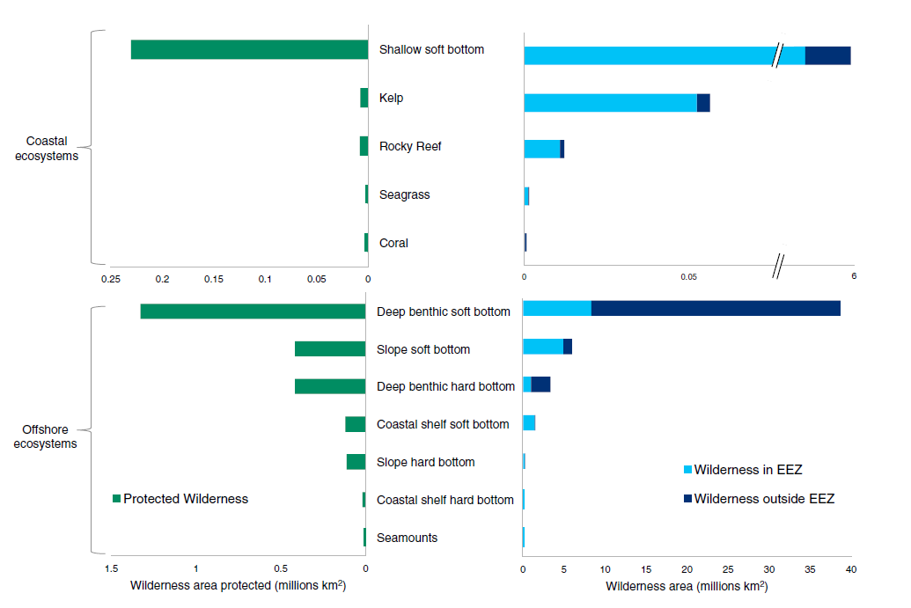
  - Appendix 1. Global Marine Wilderness Extent and Protection Across Coastal and Offshore Ecosystems
(Jones et al, 2019)

Figure 1. Global Marine Wilderness Extent and Protection Across Coastal and Offshore Ecosystems. Marine wilderness in EEZ indicated in light blue, areas outside in dark blue and MPAs in green.

  - Appendix 2: Wilderness Distribution Across Marine Ecosystems

Table 1. Wilderness Distribution Across Marine Ecosystems. Final ecosystem and wilderness extent within EEZ and outside EEZs and wilderness across coastal and offshore ecosystems. All values are in km² extent percentages in parentheses.
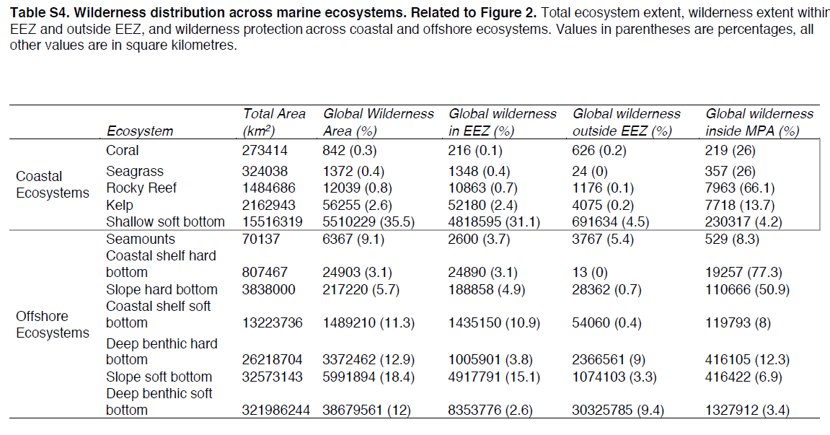
(Jones et al, 2019).

  - Appendix 3: Combined Sewage Overflow Releases in South West Wales 2017

Table 2. Combined Sewage Overflow Releases in South West Wales 2017. Only releases over 100 times are included. A full list of locations is available on the Welsh Water Website: https://www.dwrcymru.com/en/My-Wastewater/Your-Sewers/Sewage-Pollution/What-were-doing.aspx

Location | Number of Releases | Duration (in minutes)
Rhondda Clydach Vale Roundabout | 124 | 36285
Port Talbot Baglan (1) | 129 | 47850
Pont-Y-Rhyl Station Row | 123 | 44820
Port Talbot Abbey | 110 | 12345
Ystradgynlais Cwmtwrch | 104 | 48165
Seven Sisters / Blaendulais Dulais Farm | 116 | 52065
Maesteg Caerau Square Point | 103 | 11235
Cosheston | 278 | 164490
Pendine / Pentywyn | 317 | 208950
Johnston | 280 | 99540
Ammanford / Rhydaman Penybanc | 101 | 9285
Laugharne / Talacharn (3) | 164 | 85215
St Dogmaels / Llandudoch | 104 | 102855
Cardigan / Aberteifi Upper Mwldan | 102 | 16560
Milton | 151 | 99645
Treorchy Rhondda - Regent St | 137 | 54090
Dinas - Dinas Rd Station Road | 102 | 34890
Ferndale - Banana Tip | 160 | 116670
Boncath - Boncath | 181 | 150285
Clarbeston - Market Place | 298 | 138810
Cross Hands - Pontardulais Rd 1 | 144 | 65100
Cross Hands - Pontardulais Rd 2 | 101 | 21450
Ammanford - Cwmgwili | 150 | 160185
Crymych - Eglwyswrw | 111 | 113190
Hook - Pill Road | 105 | 30120
Kilgetty - Langdon | 178 | 196470
Maesteg - Llangynwyd | 183 | 159090
Haverfordwest - Spittal | 274 | 104655
Whitland - Tavernspite | 186 | 186435
Llandysul - Rhydlewis | 107 | 102705
Cymmer - Avon St | 106 | 9420
Gowerton - Pontycob Rd | 120 | 25470
Llanelli - Cwmgwili | 116 | 57435
Swansea - Penllergaer | 159 | 39780
Neath -Crynant | 123 | 18135
Llangeinor - Bettws Road | 186 | 137760
Maesteg - Heol Faen Garth | 151 | 42660
Ynystawe - Clydach Road | 142 | 35295
Port Talbot - Phoenix Wharf Harbour Rd | 267 | 195825
Tylorstown - Edmondes St | 111 | 39480
Ogmore Vale - Cemetery Rd | 160 | 98505
Ferndale - Fir Street | 101 | 35955
Cwmfelin - Glan-yr-afon | 294 | 248175
Llangynwyd - Parc Tynywaun | 152 | 50580
Maesteg - Bridgend Road | 147 | 132975
Swansea - Abercrave | 125 | 52575
Swansea - Clydach | 107 | 27180
Pontardawe - Dilwyn Arms | 123 | 28740
Fishguard - Dwrbach | 130 | 117030

(Welsh Water, 2017b)

  - Appendix 4: Eutrophication Diagram
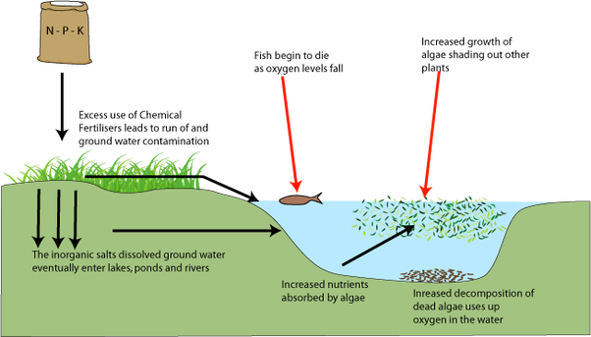
(Quora, 2016)
Figure 2. Eutrophication Diagram. Input of nutrients include nitrates and phosphates indicated by the brown sack, top left of image.

  - Appendix 5: Marine Protected Areas in Wales

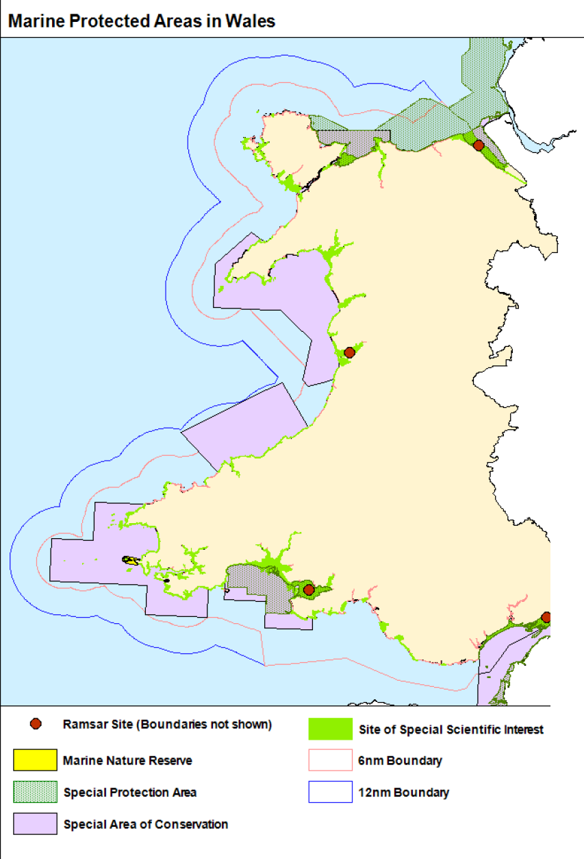

(Adadpted from: Welsh Government, 2012).

Figure 3. Map of Welsh Marine Protected Area’s. Loughor estuary indicated by black box on the bottom centre of the map.

  - Appendix 6: International Agreements on Pollution of the Aquatic Environment
Table 3. International Agreements on Pollution of the Aquatic Environment. These agreements are voluntary and not enforceable by law or penalties. The blue highlighted box is the only agreement that covers sewage pollution expelled from ships in Annex IV.
International | Description
International Convention for the Prevention of Pollution of the Sea by Oil 1954 | Common agreement. No penalties in place for breaches
International Convention on Civil Liability for Oil Pollution Damage 1969 | Common agreement. Signees agree to provide suitable compensation coverage to anyone effected by oil pollution
Convention on the Prevention of Marine Pollution by Dumping of Wastes and Other Matter 1972 | Convention agreement, no enforceable penalties in place
Protocol to the International Convention on Civil Liability for Oil Pollution Damage, 1976 | Convention agreement, no enforceable penalties in place
The International Convention for the Prevention of Pollution from Ships, 1973, as modified by the Protocol of 1978 (MARPOL 73/78) | This is the main convention covering several annexes beyond just oil pollution. Annex IV specifically relates to sewage pollution from ships following approved treatment systems. Regulations came into force in 2003:2005 requiring governments to ensure the provision of the standards outlined. Further regulations came into effect in 2013 preventing discharge in special areas (Baltic sea)
International Convention on Oil Pollution Preparedness, Response and Cooperation, 1990 (OPRC) | Global framework to tackle major incidents of marine pollution. Outlines parties to have measures in place for dealing with threats. Mostly relates to oil pollution events at sea
International Convention on Liability and Compensation for Damage in Connection with the Carriage of Hazardous and Noxious Substances (HNS) by Sea 1996 | Voluntary agreement. Not enforceable and no penalties
The International Convention on the Control of Harmful Anti-fouling Systems on Ships 2001 | Voluntary agreement. Relates to the use of toxic paints on ships that can cause harm to the aquatic environment. Not enforceable and no penalties
(Environmental Law, 2017; IMO, 2019)
  - Appendix 7: National, European and International Commitments
Table 4. National, European and International Commitments.
National
UK Marine Policy Statement (2011) | A framework for preparing marine plans and decisions affecting the marine environment, signed by the UK in an attempt to establish a coherent network of MPA’s in the UK
European
Wild Birds Directive (1979:2009) (Natura 2000) | A cross boarder collaboration to protect essential habitats for over 500 wild bird species in Europe (SPAs)
Habitats Directive (1992) (Natura 2000) | A cross boarder collaboration to protect over 200 essential habitat types for a range of biodiversity in Europe (SACs)
Marine Strategy Framework Directive (2008;2017) | Aims to achieve good environmental Status in EU marine waters by 2020. Aimed at the protection of marine biodiversity and whole ecosystems
International
Oslo-Paris Convention (OSPAR) (1992) | Convention established to protect designated marine protected areas in the North-Eastern Atlantic (Baltic sea)
Convention on Biological Diversity (1993) | Convention aimed at the conservation of biological diversity, sustainable use of components of biological diversity and fair and equitable sharing of benefits of genetic resources
(Welsh Government, 2014)

