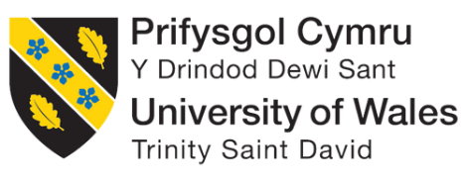
Programme: Master of Business Administration
Module: Human Capital Management
Module code: LCMB7023

Assignment Title: Integrated Human Capital Blueprint

Student Name: MD ASIF HOSEN
Student ID: 2506161
Group: 02

Lecturer: Dr Nerys Dosseh
Word Count: 2716

Table of Contents
Introduction 3
Part 1: Designing the Talent Ecosystem 4
2.1 Current Talent Ecosystem in Technology Companies 4
2.1.1 Talent Attraction Practices in Technology Firms 4
2.2 Strategic Talent Model: Build vs Buy Approach 6
2.2.1 Build Strategy – Developing Internal Talent 6
2.2.2 Buy Strategy – External Talent Acquisition 7
2.2.3 Integrating Build and Buy for Sustainable Talent Management 8
2.2.4 Benefits for Retaining Employees 8
2.3 Talent Development Mechanisms for Attracting and Retaining High-Potential Employees 8
2.3.1 Mentorship Programs 9
2.3.2 Leadership Development Paths 9
2.3.3 Lifelong Learning and Continuous Skill Development 10
Part 2: Reflective Practice and Future Readiness 11
3.1 Learning from Human Capital Management 11
3.2 Future career in AI era 13
Conclusion 15
References 16

Introduction
This is aimed at evaluating a human capital strategy that is integrated to Aether innovations, a technology firm experiencing flat growth, excessive staff turnover and decreasing customer satisfaction. In my case, as an HR consultant, I used the Human Capital Management theories to apply to the real-life problem, investigate the existing talent ecosystem, suggest a strategic model of building or buying strategy, and consider the efficiency of mechanisms (mentorship, leadership, and lifelong learning). The reflection section summarises my learning process based on Gibbs Reflective Cycle and proposes the way of how I intend to stay future ready in the era of artificial intelligence fostering innovation, engagement, and performance.

Part 1: Designing the Talent Ecosystem

2.1 Current Talent Ecosystem in Technology Companies
The modern talent system in the technology industry is experiencing a paradigm shift of strict, position hierarchy-based models to dynamic, ability-focused systems. The majority of modern tech ecosystems are currently not characterised by internal hiring but by an intricate network of internal mobility, incorporation of the gig-economy, and strategic alliances as Aether Innovations is going through flat growth and high turnover. Strategic talent attraction practises like employer branding, global recruitment networks, flexible work policy, career development are some of the new trends that modern technology organisations are employing in attracting high potential employees. The practises will empower organisational capacities and ultimately business expansion and customer satisfaction.

2.1.1 Talent Attraction Practices in Technology Firms
The top-technology firms have invented new methods to get quality talent within the very competitive labour market. According to World Economic Forum (2025), 59% of the global labour force requires reskilling by the year 2030. This is why major technologies companies are in need of talent attraction. Salesforce unveiled a new internal offering called Career Connect that will receive talent by offering a personalised career path. According to Jauhiainen (2025), can be applied during a three-month pilot in the first half of the year by almost one-third of workers in search of opportunities on the platform.
Similarly, Netflix applies a unique “Talent Density” strategy as part of its talent ecosystem (Garg, 2023). According to Jennings (2024), Netflix outpaces Apple and Meta, showcasing the power of prioritizing top talent and generates an astonishing $2.59 million in revenue per employee.
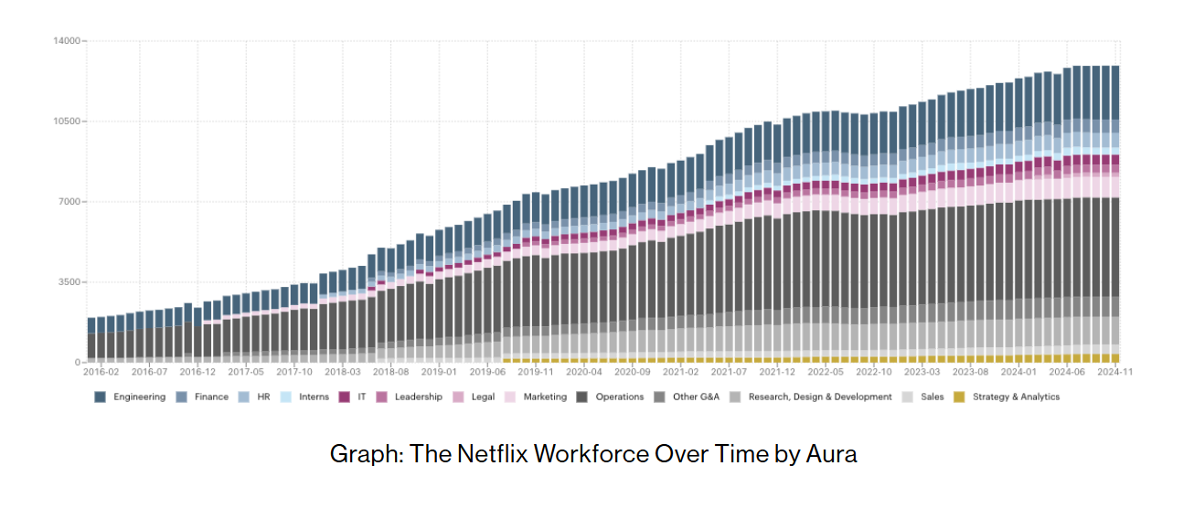
Figure 1 Netflix Workforce after Applying Talent Density Strategy; Source: (Jennings, 2024)
Another example is Adobe, which applies a real-time "Check-In" system to replace old-fashioned annual reviews, which helped them cut staff turnover by 30% (Latasha, 2026).
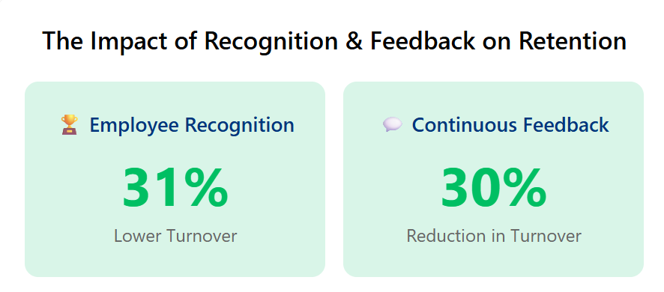
Figure 2 Impact of Adobe "Check-In" System; Source: (Latasha, 2026)
On the whole, these experiences show that effective technology companies develop their talent acquisition policies to produce beneficial organisational results. Through nurturing highly skilled workforce and the creation of favourable working conditions, these companies are increasing their innovation capacities, enhancing the engagement of the workforce and the end result being a strong organisational performance and competitiveness in the market.

2.2 Strategic Talent Model: Build vs Buy Approach
Talent management requires balancing the development of internal employees with the acquisition of external talent. The build versus buy model is a method of balancing the two which involve creating the skills within the company and recruiting them externally. Both methods are combined in a strategic model to be able to guarantee sustainability in growth, innovation and retention of high potential employees.
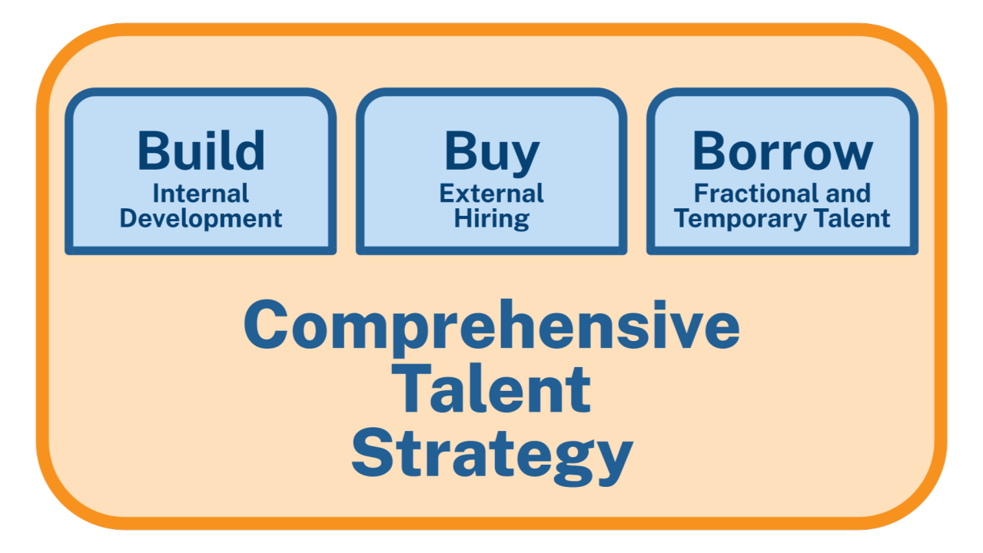
Figure 3 Build vs Buy Talent Approach; Source: Google

2.2.1 Build Strategy – Developing Internal Talent
The build strategy implies investing in individuals who are already employed by the company (Rehman, et al., 2022). It is the possibility of providing them with a chance to learn, develop, and advance their careers. Development of the internal skills may be organised by the training programmes, mentoring, and ongoing learning platforms. An example is IBM that launched its digital platform of training and reskilling, called ‘Your Learning’ that offers employees customised training and reskilling opportunities (Qin, and Kochan, 2020).
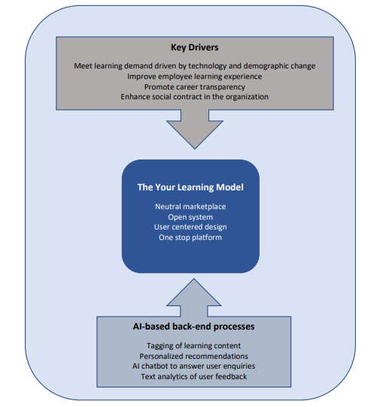
Figure 4 IBM ‘Your Learning’ Digital Platform; Source: (Qin, and Kochan, 2020)
Another significant feature of the build strategy is career progression opportunities. Employees are more motivated when they perceive that they have a way of moving up and becoming leaders. Employees feel appreciated by the leadership development programmes, succession planning and open promotion systems (Rehman, et al., 2022). This will develop loyalty and minimise turnover. The build strategy also reinforces the culture of the company as the employees develop within the company and take their values with them.

2.2.2 Buy Strategy – External Talent Acquisition
The buy strategy will involve the recruitment of new employees who are not within the company (Rehman, et al., 2022). This works well when the firm requires the skills that are not within it or whenever the firm wants to inject new ideas and views. Indicatively, Tesla often involves third-party professionals in battery technology and artificial intelligence to speed up its drive toward electric vehicle creation and autonomous driving (Li et al., 2024).
It is also necessary to recruit high potential external candidates. Graduate programmes, internship, and collaboration with universities allow companies to attract the young talents with novel ideas. Such employees are capable of introducing creativity and energy to supplement the abilities of the current employees. The buy strategy helps to make the company competitive by bridging gaps and creating diversity of thinking.

2.2.3 Integrating Build and Buy for Sustainable Talent Management
The most effective approach is to integrate both build and buy strategies. Building talent internally ensures long-term stability and cultural alignment, while buying talent externally provides immediate access to new skills. The workforce planning tools can assist managers in determining what roles are supposed to be created internally and which ones need to be recruited. The companies which integrate the two tendencies are more flexible and ready to face new challenges. To illustrate, Aether Innovations can retrain their workers with digital skills as well as recruiting external expertise in other areas such as artificial intelligence. This equilibrium will develop a sustainable talent ecosystem.

2.2.4 Benefits for Retaining Employees
A strategic build versus buy model supports employee retention in several ways. Internal development demonstrates that employees are valued in the company, and it makes them more engaged and loyal. Opportunities of career progression also provide the employee with the assurance that he/she is able to develop in the company. Meanwhile, outside recruits introduce new concepts and vigour that make a workplace dynamic and inspirational. The employees are easily retained, when they feel that they are supported and motivated. This directly improves customer satisfaction because engaged employees deliver better service.

2.3 Talent Development Mechanisms for Attracting and Retaining High-Potential Employees
To overcome the issues of flat growth, high employee turnover, and falling customer satisfaction in Aether Innovations, talent development processes should be developed to guarantee innovation, engagement, and performance. Three vital HR strategies that have direct links to enticing and keeping high potential workers are mentorship schemes, leadership growth tracks, and lifelong learning programmes.

2.3.1 Mentorship Programs
Mentorship programs are structured relationships where experienced employees guide less experienced colleagues (Ferguson, 2023). They can be considered an efficient means of knowledge transfer and assistance in professional growth. As an example, the Microsoft global mentorship programme unites staff members of different units and locations globally, allowing them to share knowledge and establish a sense of belonging (Microsoft, 2025). This will lower the turnover as the employee will feel happy and appreciated.
In the case of Aether Innovations, mentorship can deal with the issue of lack of turnover among the staff directly by making them more attached to the organisation. Innovation is another aspect that is developed with the use of mentorship; mentors push mentees to experiment and bring something new (Balinda, 2023).

2.3.2 Leadership Development Paths
Leadership development careers give orderly lines of career advancement and leadership in the future (Maduforo, et al., 2024). It is also common to see high potential employees being motivated by clear advancement opportunities and absence of such opportunities prompts them to quit to other competitors (Bristol-Alagbariya, 2024). The leadership programmes are also a guarantee that organisations are able to produce pipeline of leaders that are competent enough to be adopted to play strategic roles.
The best illustration is the Leadership Development Programme (LDP) at General Electric that has been known to generate the best in executive leadership across the world (Waters, 2009). On the same note, the Future Leaders Programme by Unilever also involves recruitment of graduates through fast-track leadership which has been used to keep the business in competitive markets (Unilever, 2026).
In the case of Aether Innovations, leadership routes would have a direct impact on the flat growth as it would equip the employees to be in charge of strategic projects. It would also help in minimising the turnover rate, since once employees get long term career and career prospects, they are less likely to turn over. Leadership development helps in increasing engagement and performance so that managers who are empowered and capable tackle the needs of the customers.

2.3.3 Lifelong Learning and Continuous Skill Development
Lifelong learning means continuous upskilling and reskilling possibilities of the employees during their professional journey (Lang, 2023). The rapidly changing technology environment requires one to be a perpetual learner in order to be competitive. Upskilling programmes enable employees to be familiar with new technologies, whereas the reskilling programme trains employees to be entirely new (Thwe, and Kalman, 2024). A more realistic case is Amazon Career Choice Programme, under which employees can have their tuition covered up to 95 percent to take courses in high-demand areas, even with Amazon (Kim, 2025). On the same level, the IBM platform named Your Learning offers custom-made digital learning where employees are able to constantly refresh their skills, including cloud computing and AI (Qin, and Kochan, 2020).
In the case of Aether Innovations, lifelong learning programmes would be a direct response to the flat growth as it would empower the employees to be innovative. They would also lower the rate of leaving their jobs as employees would feel confident that their job security into the future. Should there be a culture of constant learning, the engagement will be augmented since employees will feel at ease to be creative, and this will be passed to better customer satisfaction.

Part 2: Reflective Practice and Future Readiness

3.1 Learning from Human Capital Management
The reflection employed Gibbs Reflective Cycle (1988) to analyse my learning experience during the Human Capital Management and project formation of Aether Innovations.
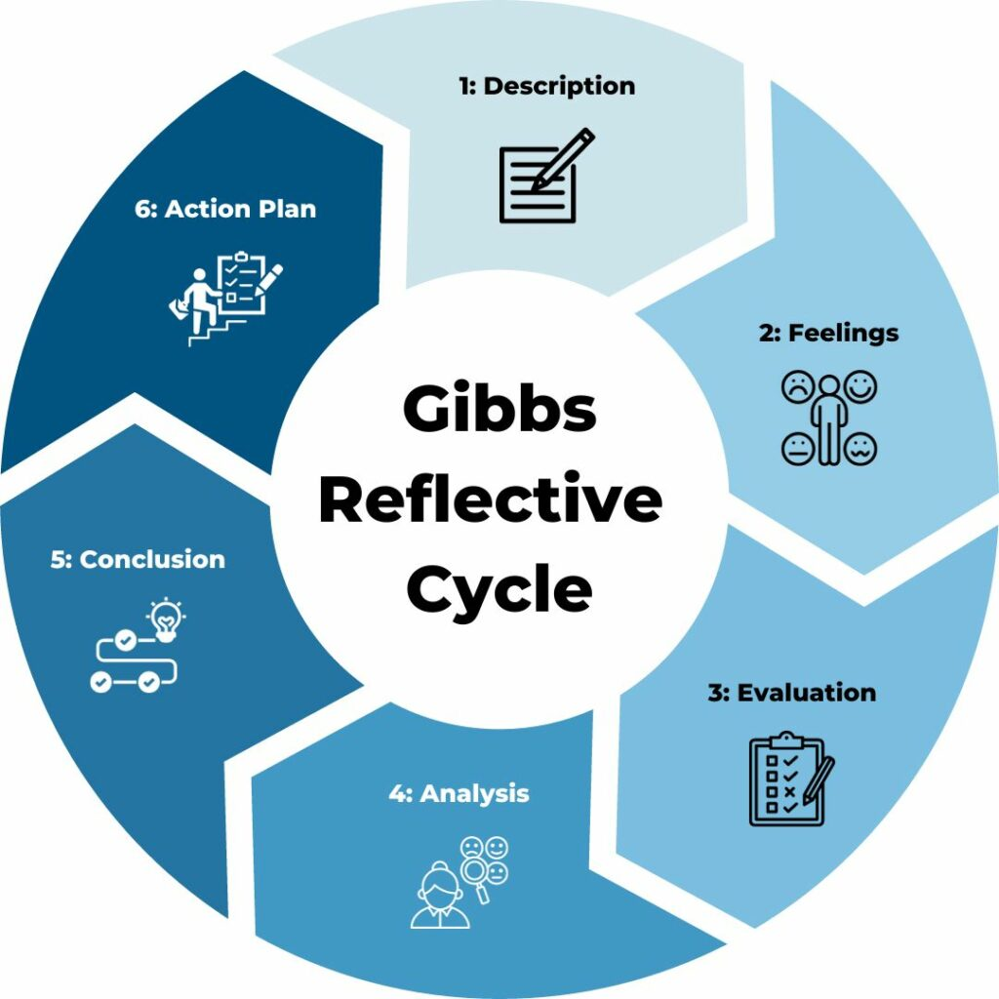
Figure 5 Gibbs Reflective Cycle; Source: Google
- Description
When I set about the case of Aether Innovations and the Human Capital Management module, I was required to work out the issues of flat growth, high turnover, and decreasing customer satisfaction. My work as a consultant meant that I should be able to develop an HR strategy that would lead to innovation, engagement, and performance. At first, I was too confused by the difficulty of the process of balancing between theory and practical solutions, but I understood that this was a chance to put HRM concepts to the test in a real-life context.
- Feelings
Initially, I was unsure of whether I would be able to relate the theoretical aspect of academics to real-world business issues. Nevertheless, when I started reading other models such as the build vs buy talent strategy and the talent development mechanisms, I became self-assured. I was inspired when I learned about the success of such companies as IBM, Tesla, and Amazon in applying these strategies. This made me optimistic that I would be able to create solutions which did not only have meaning theoretically but were practical and were also effective.
- Evaluation
It was not an easy but a satisfying experience. On the positive side, I got to know of how HR strategies directly impact organisational performance like innovation and customer satisfaction. An example is mentorship programmes at Microsoft where I learned how involvement can help minimise turnover. On the negative side, I occasionally had difficulties with the volume of words to use in narrowing the word count and yet providing a sufficient amount of detail. I also came to realise that I had previously overemphasised on generic examples, but had solidified my arguments by applying company-specific examples.
- Analysis
The project helped me realise that HRM goes beyond policies to providing ecosystems that empower people. The build vs buy model has enlightened me that talent management has to be balanced: talent development helps to create a sense of loyalty, whereas external recruitment brings innovative ideas. The leadership tracks demonstrated that career advancement models could be used to address the issue of flat growth as they equip the staff to assume responsibility in strategic projects. Lifelong learning programs proved that it is fundamental to develop skills continuously in rapidly evolving business fields. These lessons taught me to relate the issues of Aether Innovations to the real HR solutions.
- Conclusion
I inferred that my education process has provided me with the solid background to develop Learning and Development strategies myself. I now understand the need to develop a growth mentality and integrate innovation into daily activities. I understood that HR strategies are not the abstract theories but are the applicable instruments to address actual issues in organisations.
- Action Plan
To utilise these lessons within my career context, I would require a proper plan.
Action | Purpose | Expected Outcome | Timeline
Engage in mentorship (both as mentor and mentee) | To strengthen knowledge transfer and build relationships | Improved collaboration and reduced isolation | Ongoing, start immediately
Enroll in leadership development programs | To prepare for future leadership roles | Clear career progression and readiness for management positions | Within 6–12 months
Commit to lifelong learning through online platforms (e.g., Coursera, LinkedIn Learning) | To continuously upskill and reskill | Future-proof career and adaptability to new technologies | Quarterly, continuous
Apply HR strategies in real projects | To connect theory with practice | Enhanced problem-solving and innovation capacity | Next project cycle (3–6 months)
Reflect regularly using Gibbs Cycle | To evaluate progress and adjust plans | Continuous improvement and personal growth | Every 3 months

3.2 Future career in AI era
Artificial intelligence is evolving rapidly, changing most of the things related to the contemporary workplace. The AI technologies are becoming more and more able to automatize the routine administrative operations, to perform the analysis of a significant amount of information, and to aid the decision-making process (Patil, 2024). When I consider my future career, I understand that artificial intelligence is able to cope with a wide range of traditional jobs. Nevertheless, in my opinion, AI will not take my place in case I concentrate on other distinctive human abilities like creativity, empathy, and strategic thinking. I will apply AI as an aiding tool instead of a replacement. As an illustration, I will be able to analyse data, create insights and automate regular processes with the help of AI, though I will remain accountable when it comes to the results interpretation, decisions, and people leadership.
I have heard that AI can be applied to the HR practises to support the recruitment process, the performance management, and the learning systems. As an example, AI is able to assist in pointing out skill deficiencies, however, the human aspect of developing a meaningful development programme cannot be substituted. I will play the role of incorporating AI in HR strategies and at the same time uphold human values of fairness, inclusion, and engagement.
To remain applicable, I will be perpetually reskilling on those domains where human judgement cannot be substituted, including leadership, innovativeness, and ethical governance. I will also develop flexibility and growth mentality, thus being able to adopt AI as a co-worker. Together with human prowess and AI knowledge, I would be able to stay competitive and go on with my career flourishing in the digital age.

Conclusion
The results of this analysis indicate that the existing issues of Aether Innovations can be solved directly by an aligned talent ecosystem that incorporates both internal and outside acquisition. Innovation, leadership opportunities, and lifelong learning are mentorship and leadership and lower turnover, as well as customer satisfaction. Taking a reflection on this project, I got a clearer understanding of what such a learning and development approach should be designed and how to prepare to the age of AI. Finally, the assignment shows that strategic HR practises are formidable instruments in terms of sustainable growth and creating future-proof and robust organisations.

References
Balinda, J., 2023. The impact of mentorship programs on career advancement and satisfaction. International Journal of Human Resource, 1(1), pp.36-47.
Bristol-Alagbariya, B., Ayanponle, O.L. and Ogedengbe, D.E., 2024. Leadership development and talent management in constrained resource settings: A strategic HR perspective. Comprehensive Research and Reviews Journal, 2(02), pp.013-022.
Ferguson, C. and Davidson, P.M., 2023. Mentorship as a tool to facilitate global collaboration. In Mentoring in Nursing through Narrative Stories Across the World (pp. 855-863). Cham: Springer International Publishing.
Garg, G., 2023. Innovators unleashed: Strategies for industry domination. Gaurav Garg.
Gibbs, G. (1988) Learning by doing: A guide to teaching and learning methods. Further Educational Unit, Oxford Polytechnic, Oxford.
Jauhiainen, S. (2025). Training new professionals into the Finnish Salesforce ecosystem - A case study of ecosystem roles and entry-level employee profitability, onboarding and educational cooperation in a consultancy company. [online] Aalto.fi. Available at: https://aaltodoc.aalto.fi/items/b4cc1834-2551-48bc-9692-143386cc4747.
Jennings, M. (2024). Talent Density: Build High-Performing Teams. [online] Getaura.ai. Available at: https://blog.getaura.ai/talent-density.
Kim, E. (2025). Why Amazon paid for 2,000 employees to take classes in things like airplane mechanics and nursing. [online] Business Insider. Available at: https://www.businessinsider.com/amazon-career-choice-program-paid-for-2000-employees-2015-4.
Lang, J., 2023. Workforce upskilling: can universities meet the challenges of lifelong learning? The International Journal of Information and Learning Technology, 40(5), pp.388-400. https://doi.org/10.1108/IJILT-01-2023-0001
Latasha , R. ed., (2026). Employee Recognition and Continuous Feedback: Two Sides of the Same Coin. [online] Techclass.com. Available at: https://www.techclass.com/resources/learning-and-development-articles/employee-recognition-and-continuous-feedback-two-sides-of-the-same-coin [Accessed 15 Mar. 2026].
Li, C., Na, J., Nan, K., Qin, J. and Wu, M. (2024). Tesla’s product improvement strategies in the electric vehicle market. Advances in economics, Management and Political Sciences, 92(1), pp.177–185. doi: https://doi.org/10.54254/2754-1169/92/20231197.
Maduforo, A.N., Scott, S. and Scott, D., 2024. Leadership development for contemporary post-secondary academic leaders: Challenges, content and approach. Sage Open, 14(2), p.21582440241253647. https://doi.org/10.1177/21582440241253647
Microsoft (2025). Global Mentorship Initiative (GMI). [online] Global Mentorship Initiative. Available at: https://globalmentorship.org/.
Patil, D., 2024. Human-artificial intelligence collaboration in the modern workplace: Maximizing productivity and transforming job roles. Available at SSRN 5057414.
Qin, F. and Kochan, T. (2020). The Learning System at IBM: A Case Study. [online] Available at: https://mitsloan.mit.edu/sites/default/files/2022-06/Qin%20and%20Kochan%20The%20Learning%20System%20at%20IBM%2012%202020.pdf.
Rehman, S., Ullah, A., Naseem, K., Elahi, A.R. and Erum, H., 2022. Talent acquisition and technology: A step towards sustainable development. Frontiers in Psychology, 13, p.979991. https://doi.org/10.3389/fpsyg.2022.979991
Tayeb, Z. (2024). The great divide: business leaders are split on long-term remote working. This is what Spotify, Twitter, Goldman Sachs, and others have announced. [online] Business Insider. Available at: https://www.businessinsider.com/what-spotify-twitter-goldman-sachs-said-about-long-term-remote-working-2021-3.
Thwe, W.P. and Kalman, A., 2024. Lifelong learning in the educational setting: A systematic literature review. The Asia-Pacific Education Researcher, 33(2), pp.407-417.
Unilever (2026). Unilever Future Leaders Programme (UFLP) | Netherlands. [online] Unilever.com. Available at: https://careers.unilever.com/en/netherlands-early-careers-unilever-future-leaders-programme.
Waters, R. C. (2009). Evolution of Leadership Development at General Electric. Engineering Management Journal, 21(1), 42–46. https://doi.org/10.1080/10429247.2009.11431797
World Economic Forum (2025). The Future of Jobs Report 2025. [online] World Economic Forum. Available at: https://www.weforum.org/publications/the-future-of-jobs-report-2025/?gad_source=1&gad_campaignid=22152824089&gbraid=0AAAAAoVy5F4IOKtbdT953tc43WQUluC34&gclid=Cj0KCQjwwZDFBhCpARIsAB95qO1ZYuGf8mkprr6ZBSvsB7RbkmNjCauEhl3-RiGoVmkl-n2SIGI8IIgaAs7tEALw_wcB [Accessed 15 Mar. 2026].

