

Experimental simulation teaching platform based on Virtual Reality

by
Chenxi Yu

Supervisor: Tim Bashford & Joy Botu

Project submitted as part of the requirements for the award of MSc Software Engineering (Web Development)

November 2021
DECLARATION

I, Chenxi Yu declare that I am the sole author of this Project; that all references cited have been consulted; that I have conducted all work of which this is a record, and that the finished work lies within the prescribed word limits.

This work has not previously been accepted as part of any other degree submission.

Signed : ......Chenxi Yu..........

Date : ...... .November 11st, 2021............

FORM OF CONSENT

I , Chenxi Yu hereby consent that my Project, submitted in candidature for the M.Sc. Software Engineering (Web Development) degree, if successful, may be made available for inter-library loan or photocopying (subject to the law of copyright), and that the title and abstract may be made available to outside organisations.

Signed : .....Chenxi Yu...............

Date : ......November 11st, 2021..............

ABSTRACT

With the development of the information age, circuit experiment courses occupies an important position in the teaching of electronic information majors in colleges and universities. Through the real operation of the experiment box, students can learn and consolidate theoretical knowledge. However, with the development of science and technology and the enrichment of teaching methods, traditional circuit experiment teaching appears dull and boring.
The circuit experiment teaching itself is regarded as an aid and supplement to the theory class, so the time of experiment teaching is less than the theory class. This leads to the problem of low frequency and short period of equipment use. In addition, the aging of chip equipment will cause maintenance costs, requiring manual maintenance. These factors will affect students' learning enthusiasm and learning quality.
Nowadays, the application scope of virtual reality technology is becoming wider and wider. VR equipment and software platforms can restore the scene more realistically and enhance the experience. Many Internet companies have developed VR-related services. Therefore, in order to improve the learning efficiency of students and study easily, this research combines virtual reality technology to design an experimental simulation software to provide students with highly immersive circuit experiment teaching.
According to the characteristics of circuit simulation courses and virtual reality, this thesis uses 3ds Max to model the teaching environment and experimental equipment virtual simulation. Use Unity3D to build the framework of the experimental teaching simulation platform, and write the control and interaction code through C#. Import SteamVR Plugin and adapt HTC VIVE.Finally, through the exe file or HTC VIVE, the mouse or handle ray can be operated to select the experimental item, connect the line, and finally complete the experiment.
This paper uses questionnaires to allow students to evaluate the feelings of traditional experiments and VR experiments. Finally, we can know that VR experiments are indeed more novel and effective than traditional experiments. The experiment in exe format is convenient to use without HTC VIVE, and the mouse and keyboard work more smoothly, but the immersion is less. If the texture of the model is more similar to the experiment box, the immersion may be better.

CONTENTS PAGE
CHAPTER 1: Introduction 5
1.1 Purpose of the study 5
1.2 Research background 5
1.3 Project purpose and goals 8
1.4 Report structure 10
CHAPTER 2: Literature Review 10
CHAPTER 3: RESEARCH AND DEVELOPMENT METHODOLOGY 11
3.1 Selection of 3D modeling software 12
3.2 Selection of Virtual Reality Scene Development Platform 12
3.3 HTC Vive steamvr plugin 13
3.4 HTC Vive headset adaptation 14
CHAPTER 4: DESIGN AND IMPLEMENTATION 17
4.1 Design 17
4.2 Implementation 20
CHAPTER 5: RESULTS AND DISCUSSION 33
5.1 Main Menu 34
5.2 Classroom roaming interface 35
5.3 Preview the experiment box 36
5.4 Project selection 37
5.5 The operation 37
5.6 Experimental phenomena 38
5.7 Feedback of the questionnaire 41
CHAPTER 6: CONCLUSIONS AND RECOMMENDATIONS 42
CHAPTER 7: REFLECTION 43
REFERENCES 45
APPENDICES 46

CHAPTER 1: Introduction

1.1 Purpose of the study
With the advent of the information age, the demand for electronic information technology talents is increasing. At the same time, the professional skills requirements for such talents are getting higher and higher. Circuit experiment occupies an important position in the teaching of electronic information major in colleges and universities. It can provide students with a real operating environment and play a vital role in consolidating their theoretical knowledge. However, with the development of technology and the improvement of requirements, traditional circuit experiment teaching is increasingly unable to meet the rapidly increasing demand. In order to fit the development of modern science and technology, this research came into being. Moreover, the experimental courses in the school do not have VR experiments, so the purpose of this research is to design an experimental simulation software combined with virtual reality technology to provide students with highly immersive circuit experiment teaching.

1.2 Research background
1.2.1 Traditional circuit experiment teaching methods and existing problems
Circuit experiment teaching itself is regarded as an aid and supplement to theoretical courses, so the course duration of experiment teaching is usually very short and the class hours are very few. This leads to the problems of low frequency of equipment use, short cycles, and long idle time. In addition, the aging of equipment will cause maintenance costs and require manual maintenance. Sometimes one or two chips in an experiment box will have quality problems such as poor pin contact, which is not conducive to the overall experiment. In the meantime, the chance for students to participate in circuit experiment courses is therefore strictly limited, usually once every two weeks. Some students who do not have a good grasp of knowledge have no other way to make up. These factors will make students' learning enthusiasm and quality of learning decline.
1.2.2 The application and existing problems of two-dimensional circuit simulation in traditional teaching mode
From Wu [1] we find that in addition to eliminating the purchase of parts, materials, tools and equipment, circuit simulation can also possible to avoid the risk of damage to parts and equipment due to misconnection of parts, which is of great interest to researchers.
Two-dimensional circuit simulation software cannot solve all the problems faced by traditional experimental teaching methods, and its own application has also produced some new problems. Although it is effective to a certain extent, it cannot simulate components completely and accurately, and real circuits still need to be built. It is difficult for students to connect circuits with real objects, and there are some differences between simulation and reality. And virtual reality technology can be closer to the real circuit.
1.2.3 The development of virtual reality
The concept of virtual reality was formulated in the 1960s, and the first commercial virtual reality tool appeared in the late 1980s. Cipresso et al [2] states, in the past 20 years, 100 individual researchers have explored the process, effects, and applications of the technology, and published 1,000 scientific papers. Since then, multiple definitions of virtual reality technology have emerged. One of them is called, virtual reality is a technology based on an immersive, interaction-centric 3D computer-generated environment. Although they are slightly different, they all emphasize that virtual reality is a technology based on an immersive and interactive 3D computer-generated environment. VR can be accessed through different systems. The most prominent ones are desktop computers (or laptops with computers) and head-mounted displays (HMD). Like Oliver said in [4], head-mounted displays usually use two screens, one in front of each eye, to realize depth perception through stereo imaging. The first head-mounted display was developed by Filco, which can locate the user's head position to update the virtual image. Desktop virtual reality(executable file) usually refers to a virtual environment (VE) projected on a desktop computer screen, usually using a keyboard and a mouse for interaction.
Since the development of virtual reality technology, it has been applied to many different fields. Among them, games and surgery are the most common. In addition, there are applications to education, learning, architectural design, etc. People can break through the limitations of time and space to complete some experiential activities. The continuous development of 3D graphics simulation technology and computer technology enables VR equipment and software platforms to restore real scenes and real experiences more realistically. People's continued attention to virtual reality technology has also become its solid driving force for development.
HTC Vive is a virtual reality head-mounted display, jointly developed by HTC and Valve Corporation. HTC Vive realizes virtual reality in the room, and users can walk around in the area formed by two control base stations. There is a circular touchpad on each of the two handle controllers. The headset contains two display screens, which are combined into a display area. Users can experience VR games after connecting to steamVR. Figure 1 is the HTC Vive device used in this paper.
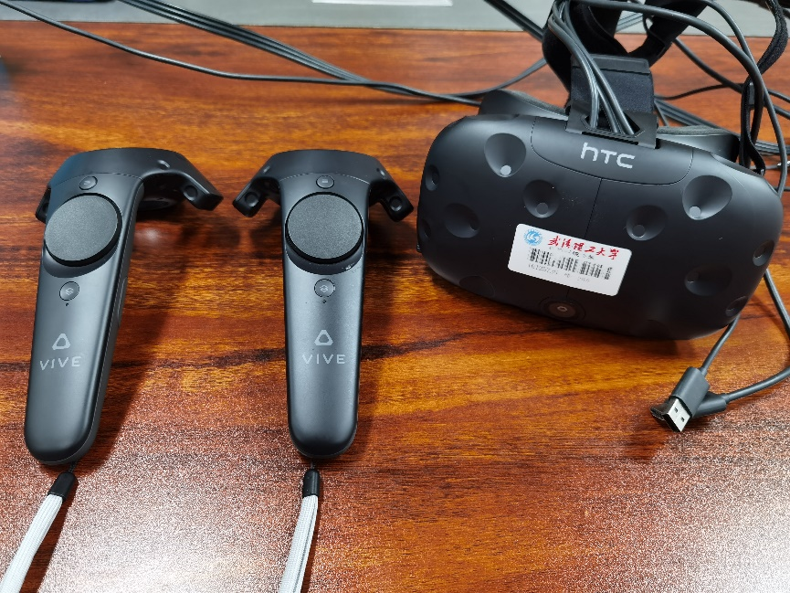
Fig. 1 HTC Vive hardware device used in this paper

1.2.4. Application status of virtual reality
In 2015, Google’s “Google Adventure Pioneer Project” cooperated with multiple schools to provide low-cost Google paper boxes, through which students can explore 120 locations. In 2016, Nearpod, an American educational technology company, provided publicly available VR education tools for the first time. It simulates Google Street View and incorporates its own teaching resources. Thanks to this technology, students can not only see some real pictures, but also interact with them during the learning process. In addition, virtual reality technology has great research significance in evaluating and treating mental illnesses, such as anxiety and depression. Replace virtual stimuli with real stimuli for an immersive experience. Cipresso et al [2] also states, for example, to problems arising from phobias. Or, simply, it is used like improvement of the traditional systems of motor rehabilitation, developing games that ameliorate the tasks. As Zhao said in [3], when studying the "Berlin Wall" lesson, students can use head-mounted displays to learn the history of the occupation of Germany like watching a movie, and make their own escape plan. To a certain extent stimulated students' interest in learning. Oliver said in [4] that, both the EU and USA launching initiatives for the large-scale implementation of digital technologies in the classroom (European Commission, 2018; U.S.Department of Education, 2017). VR in particular is expected to have widespread adoption within classrooms in the next two to threeyears (Freeman, Becker, & Cummins, 2017).
1.2.5. The advantages of using virtual reality in circuit experiment teaching
The powerful simulation ability of virtual reality technology can simulate the teaching scene of the circuit laboratory. Students can intuitively observe the experimental equipment and components in the simulated scene, providing a good immersion experience. Through the control and interactive code, the simulated experimental scene can give corresponding feedback to the student's operation. Until the actual experimental phenomenon is correctly reflected. The teaching simulation platform can effectively avoid the safety problems in the circuit experiment, and can also simulate the effect of the experiment teacher instructing the students through some prompt boxes. In terms of teaching costs, using the experimental teaching simulation platform, the school can save a lot of money for purchasing instruments and equipment, as well as daily maintenance costs. At the same time, thanks to the increasingly perfect simulation technology, the school can build new experimental scenes and launch new experimental projects more quickly, so as to truly keep pace with the times.

1.3 Project purpose and goals
The functional realization of the overall framework of the experimental simulation platform is mainly focused on the preview function and the script development of the experimental function. The paper will explore the important and difficult points of script development and provide solutions based on the functional design requirements.
1.3.1 Trigger scene jump
After students click the item button in the main menu to enter the laboratory scene, they can walk around in the scene at will from the first-person perspective to observe the experimental environment. The experiment box is placed on one of the experiment tables. In the functional design, it is considered that the first-person view camera is centered on the mouse pointer, and the pointer is hidden by default in the parameter options. Although the pointer can be enabled through code, it is not convenient to click the button with the pointer in the first person, so it was decided to only return to the main menu and reload the scene through buttons. The jump into the preview interface is achieved through triggers. In the design, a trigger collision area is added with the experiment box as the center. The code detects whether the label of the object entering the collision area is the player to detect whether the user has entered the collision area.
Since the code turns off the jump detection trigger during the process of jumping from the laboratory scene to the preview interface scene, it is impossible to jump through the trigger area again after exiting from the preview interface and returning to the laboratory scene. This paper intends to make changes to this problem when designing the trigger function.
1.3.2 Camera viewing angle control
The camera set up in the experimental teaching simulation platform acts as human eyes and provides users with an observable perspective. The camera used in the laboratory scene is the first-person view camera that comes with Unity3D. It provides comprehensive functions and does not need to be changed. However, the fixed-mounted camera is used in the preview interface and the experimental interface. In order to provide users with a more realistic perspective and operating experience in these two interfaces, a control code is added to the fixed camera in the functional design. Students can use the mouse to control the perspective translation, zoom, rotation, etc. to imitate human movement and observation Change of angle. The control code of the camera on the preview interface implements the functions of the mouse wheel to control the angle of view zoom, and the function of holding down the left mouse button and dragging to realize the rotation around the experiment box. The camera control code of the experiment interface intends to implement the function of zooming the view angle of the scroll wheel, and pressing the right mouse button to pan the view angle of the camera.
Write code to obtain the range of camera angle change through the rotation angle of the wheel, multiply it by the control coefficient, and finally use it as the camera's angle of view variable. The sign of the control coefficient controls the corresponding relationship between the wheel rotation direction and the angle of view zoom.
During the experiment, if the chip pin is outside the view zone during the connection operation, you need to use the right mouse button to move the view zone. After the right mouse button is pressed, the camera uses the obtained mouse X-axis and Y-axis movement values ​​and multiplies it by the speed coefficient to complete the translation operation of the angle of view. This function can help students perform wire connection operations well during the experiment.
A distance coefficient needs to be set in the code. It is used to control the distance between the camera and the experiment box, and obtain the position information of the experiment box in advance and store it in the system. By obtaining the mouse X-axis and Y-axis change values, the camera can rotate around the experiment box. With the scroll wheel zoom function, students can carefully observe the experiment box and the parts in the experiment box in the preview interface.
1.3.3 Realization of experimental project control function
After entering the experiment interface, students need to choose experimental items. In order to facilitate the operation, the experimental teaching simulation platform is prepared to add a right column in the design of the experimental interface. Used to hold experiment item selection buttons, help options, reselect buttons, and exit experiment buttons. After clicking one of the experiment item buttons, you need to temporarily disable other experiment item buttons to ensure that no problems will occur in the experiment due to the wrong click operation.
1.3.4 The realization of the port connection and the simulation of the logic function of the digital chip
The most important part of the experiment code is the realization of the analog and port connection of the logic function of the digital integrated chip. Only the correct logic function operation of the analog digital chip can obtain the correct experimental result.
According to the experimental schematic diagram, this paper needs to write a separate control script for all the pin ports used. Therefore, the script design of this part is very complicated.
1.3.5 Use HTC Vive headset
The whole set of equipment includes one hmd, two handle controllers and two positioners. First, the user needs to plan the play area. Make sure that the area is not blocked by other objects. Connect the two positioners to the power cord and install them on the bracket. The height of the stand is above one person's height. Place the two brackets on the diagonal of the play area, with a straight line distance of no more than five meters. Ensure that the positioner is tilted down by about 30 degrees. Second, connect the headset to the computer through the link box. The third step is to open the Steam VR installed on Steam. After all connected devices are displayed in the small Steam VR window, follow the prompts to complete the settings. At this point, you can begin to explore the virtual reality world.

1.4 Report structure
This paper is divided into seven chapters. In addition to the introduction of the first chapter, the second chapter serves as a summary of the previous inquiry data. Which briefly summarized several papers on the development of virtual reality technology. Find out their commonalities and characteristics, as the accumulation of technical background for their own development. The third chapter introduces the research content and methods to be adopted. Including the selection of the experimental content of the virtual simulation platform, the construction of the display platform, and the five major functions of the platform. The fourth chapter is the specific design and implementation, including the construction of the code and the display status of each component of the unity engine. And issues an objective questionnaire to compare the pros and cons of the real experiment and the VR virtual experiment. Chapter 5 shows the experimental results of the final virtual simulation platform, Regarding the sixth chapter, according to the designed questionnaire, let students evaluate the difference between the real operation and the VR experiment. In Chapter 7, I will reflect on the overall design and those areas that can be improved.
This chapter first introduces the situation of traditional circuit experiment teaching, and introduces the application of two-dimensional circuit simulation in traditional experiment teaching according to the problems it faces. By analyzing the characteristics of traditional circuit experiment teaching and two-dimensional circuit simulation-assisted experiment teaching, the problems and shortcomings that still exist at present are explained, and a way to establish a simulation platform for experimental teaching using virtual reality technology is proposed. Then it briefly introduces the concept and development background of virtual reality technology, and lists some domestic and foreign cases of applying virtual reality technology in the field of education and training. It provides a strong evidence for building an experimental teaching simulation platform based on virtual reality technology for circuit experimental teaching. The advantages of virtual reality technology applied to circuit experiment teaching are discussed through other documents. Finally, the chapter structure of the whole paper is briefly introduced. The next chapter will briefly analyze excellent papers of the same type.

CHAPTER 2: Literature Review
In [5], the author showed the four parts of the design system in detail, including the main menu, introduction, etc. The challenge section explains the detailed operations that players need to perform. In the evaluation part, the authors sent their system and questionnaires to 125 people. Every part received very real feedback. With detailed pictures and text to explain, and made improvements to some problems.
In [6],the author rely on Design-Based Research (DBR) as the basic method. The author studied that in the process of multiple iterations of intervention activities and design activities, this natural evolution can produce more insights into the design process of the system. The overall design and intervention itself follow the logic and consistent structure of the curriculum. Therefore, the flexibility of DBR is very suitable for introducing unified video game development into the classroom and conducting research in an appropriate manner. This paper is aimed at teenagers, so it pays more attention to fun, and the operation is relatively simple, which can attract teenagers' interest in learning. There are different operating terminals, such as Mac OS, PlayStation 4, Xbox One, etc. Among them, the range of questionnaire subjects is very wide, and the questionnaire forms are various. Sixty-three students from four different teachers and three different schools directly participated in the game development project. They completed specific questionnaires about classroom game development activities and their perceived results.
In the paper [7], the author introduced the process of creating a three-dimensional model in detail. The author uses 3ds Max software for polygon modeling. The modeling process includes modifying the position, rotation and scale values of vertices, polygons and line segments. Add texture, lighting and animation to design the final model. Finally export the 3D animation model to unity for use.
In the paper [8], a virtual simulation experiment teaching platform developed according to the characteristics of the professional course of surveying and mapping engineering, the content includes understanding the basic situation of the equipment, using various instruments and equipment, cognizing the structure of the equipment, and being familiar with the performance of the equipment. Through this virtual simulation teaching platform, undergraduate students can learn independently, use and master the design ideas, operating procedures and data processing of the same type of practical projects. The teaching platform integrates teaching, learning, practice, examination and other teaching functions, with vivid teaching resources, rich teaching activities, and accurate evaluation of student operations, which fully reflects the development direction of education informatization. The teaching platform has established an operation manual for the entire holographic virtual simulation equipment and an introduction to the holographic simulation system. Its teaching mode is a combination of demonstration and practice. If the user make a mistake, the project will not proceed until the correct answer is given.

CHAPTER 3: RESEARCH AND DEVELOPMENT METHODOLOGY
In this chapter, I will introduce in detail the research methods adopted in this thesis. This paper focuses on development, supplemented by investigation.
Regarding the development methodology, the design and development of the experimental teaching simulation platform based on virtual reality technology is mainly divided into two parts, namely three-dimensional modeling and platform function development. The first task is to determine the development platform used by each part.

3.1 Selection of 3D modeling software
At present, the most used modeling software in the field of 3D games is 3ds Max, Autodesk Maya, Zbrush, Blender, etc. These softwares have their own characteristics in modeling, animation, rendering, etc., and can basically be used as experimental teaching simulation platforms. Modeling platform. Considering the cost of software learning and the scale of application in similar fields in China, the paper initially selected 3ds Max and Autodesk Maya launched by Autodesk as the choice of modeling platform.
As relatively mature modeling software, both have powerful and relatively complete 3D modeling functions, but the two softwares have different emphasis on modeling methods and functions. Maya was born for animation, and its animation module is very powerful. The most commonly used modeling method is node connection, while 3ds Max belongs to a stacked architecture. The different modeling methods determine that the two can show their advantages in their respective fields. Maya's modeling method is more suitable for characters, so its hair and clothing simulation is very perfect, and it is more widely used in animation and film production. 3ds Max is more suitable for static architectural models, and is more used in architectural design and other fields.
The experimental teaching simulation platform of this thesis needs to build a three-dimensional model, mainly the laboratory environment, experiment box, digital integrated chip, etc. It does not need to model the characters, and the requirements for animation are not high. 3ds Max's embedded modeling method is more suitable for the requirements of design and development. In addition, 3ds Max has lower requirements for computer configuration than Maya, and learning materials are easier to obtain. Based on the above comparison and analysis, this paper determines 3ds Max as the modeling development platform of the experimental teaching simulation platform.

3.2 Selection of Virtual Reality Scene Development Platform
At present, the most used development software in the field of virtual reality includes Unity3D, Unreal Engine 4 (UE4), etc., both of which have the ability to develop complete virtual reality scene functions.
UE4 is currently the world's top and most well-known game development engine, with the industry's top texture editor. It provides the function of pre-built framework and adopts C++ as the development language. Its series of software has 80% of the global market share of commercial game engines. The shortcomings of UE4 are poor real-time processing capabilities and long scene loading time. The more important aspect is that C++ is not friendly to junior developers and code development is difficult. Unity3D is another game development platform that is widely used in addition to the UE series. Many mobile games on the market are developed based on Unity3D, including some web games. And it uses C# as the main script development language, which is more friendly to junior developers than C++. The Unity development platform includes visual programming tools and an IDE based on MonoDevelop, as well as a 3D compensation engine, scripting language environment, workflow system, and teamwork version control. Unity's UI interface is intuitive, development and operation are simple and easy to use, and there are many related tutorials and materials on the Internet for browsing and learning. Comparing the advantages and disadvantages of the two software, Unity3D is more suitable as a virtual reality scene function development software for experimental teaching simulation platform.

3.3 HTC Vive steamvr plugin
To use HTC vive for virtual reality based on unity, a teamVR plugin is required Virtual Reality development is nothing more than the camera function of the headset in the scene and the operation function of the handle. Download the latest steamVR plugin from the Unity Asset Store. After installation, the control method can be seen for development.
The operation of the camera is to hook the script SteamVR_Camera in the plug-in to any camera, and then click expand. For the controller handle, add the script SteamVR_ControllerManager, and then create two child game objects under the object. Add the script SteamVR_TrackedObject, set Index to None, and add the left and right handles in the SteamVR_ControllerManager script; finally add an object on each of the two sub-objects, add the script SteamVR_RenderModel to render the handle model and track the position of the handle. At this point, you can complete the settings and proceed with the project.
There are related methods for pressing each button in the SteamVR_Controller script. Take the trigger button as an example below.
if (device.GetTouchDown(SteamVR_Controller.ButtonMask.Trigger)){
Debug.Log("Pressed the "trigger button"");

}
if (device.GetTouchUp(SteamVR_Controller.ButtonMask.Trigger)) {
Debug.Log("Released the "trigger button"");
}

The file Assets/SteamVR/Plugins/openvr_api.cs directly encapsulates the support of the steamVR SDK. All the functions it provides are exposed by steamVR, and it is a necessary script.
Assets/SteamVR/Scripts/SteamVR.cs is the file that controls the initialization and shutdown of the system. Use SteamVR.instance to access.
Assets/SteamVR/Scripts/SteamVR_Camera.cs is the script to control the VR camera. The main function is to change the image of the Unity camera to form an imaging image in Vive. To combat the stretching caused by distortion correction, the scene is rendered at a higher resolution. Since all cameras in Unity are rendered sequentially, a static rendering texture is shared between each eye camera.
SteamVR provides a specific render target size to reduce distortion, however, rendering to a higher resolution will provide additional multi-sampling advantages at the associated cost. This can be controlled via SteamVR_Camera.sceneResolutionScale.
Assets/SteamVR/Scripts/SteamVR_TrackedObject.cs is to add it to any object you want to use tracking. HMD has a setting for automatic. For the controller, select the index of the object to map to. Generally speaking, these objects should be loaded into the "origin" object of the camera so that they can be tracked in the same space.
Assets/SteamVR/Scripts/SteamVR_RenderModel.cs is the model used to render the handle and track the position of the handle.
Assets/SteamVR/Scripts/SteamVR_Utils.cs is a variety of event interfaces for using SteamVR API in Unity, including a simple event system, RigidTransform class for handling vector/quaternion pairs, matrix transformation and other useful Function.
Assets/SteamVR/Scripts/SteamVR_PlayArea.cs is used to display the player's play area.

3.4 HTC Vive headset adaptation
After downloading the steamVR Plugin, drag the player from Assets to the scene. Create empty objects and uncheck their Mesh Renderer properties to make them invisible. Add the Box Colider property and set the collider for it. Adjust the size of the collision body to ensure that when the handle is used to push the trigger, the ray placed on the collision body can produce an effect. Add the corresponding script code to set the left and right hand ray attributes. Write the corresponding ray trigger code or trigger code.
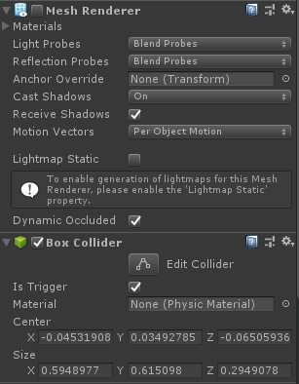
Fig.2 Set collider parameters and invisible properties

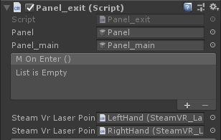
Fig.3 Set the left and right hand ray properties
Some code examples are as follows.
public UnityEvent mOnEnter = null;
public SteamVR_LaserPointer SteamVrLaserPointer;
public SteamVR_LaserPointer SteamVrLaserPointer1;
public UnityEvent mOnClick = null;
public UnityEvent mOnUp = null;

void OnEnable()
{
SteamVrLaserPointer.PointerClick += SteamVrLaserPointer_PointerClick;
SteamVrLaserPointer.PointerIn += SteamVrLaserPointer_PointerIn;
SteamVrLaserPointer.PointerOut += SteamVrLaserPointer_PointerOut;
SteamVrLaserPointer1.PointerClick += SteamVrLaserPointer_PointerClick;
SteamVrLaserPointer1.PointerIn += SteamVrLaserPointer_PointerIn;
SteamVrLaserPointer1.PointerOut += SteamVrLaserPointer_PointerOut;
}
void OnDestroy()
{
SteamVrLaserPointer.PointerClick -= SteamVrLaserPointer_PointerClick;
SteamVrLaserPointer.PointerIn -= SteamVrLaserPointer_PointerIn;
SteamVrLaserPointer.PointerOut -= SteamVrLaserPointer_PointerOut;
SteamVrLaserPointer1.PointerClick -= SteamVrLaserPointer_PointerClick;
SteamVrLaserPointer1.PointerIn -= SteamVrLaserPointer_PointerIn;
SteamVrLaserPointer1.PointerOut -= SteamVrLaserPointer_PointerOut;
}
private void SteamVrLaserPointer_PointerOut(object sender, PointerEventArgs e)
{
if (e.target.gameObject == this.gameObject)
{
if (mOnUp != null) mOnUp.Invoke();
}
}

private void SteamVrLaserPointer_PointerIn(object sender, PointerEventArgs e)
{
if (e.target.gameObject == this.gameObject)
{
if (mOnEnter != null) mOnEnter.Invoke();
}
}

private void SteamVrLaserPointer_PointerClick(object sender, PointerEventArgs e)
{
if (e.target.gameObject == this.gameObject)
{
if (mOnClick != null) mOnClick.Invoke();
}
}

public void OnButtonEnter()
{
panel_main.SetActive(true);
panel.SetActive(false);
//Debug.Log("111");
}
This chapter mainly discusses the research methods adopted in the whole thesis. After comparing and selecting several existing development tools, 3ds Max was determined as the 3D simulation modeling platform and Unity3D as the function development platform. And made a simple explanation and adaptation scheme for the plugins used by HTC Vive headsets.

CHAPTER 4: DESIGN AND IMPLEMENTATION

4.1 Design
The flow and framework of the entire experimental teaching simulation platform are shown in the figure below.

Fig.1 The framework of the experimental teaching simulation platform
Although the digital circuit experiment has fewer circuit components than the analog circuit, the digital integrated chip has many pins, and the number of ports and wires that need to be connected is obviously more than that of the analog circuit experiment. The experimental teaching simulation platform is more difficult to design the circuit connection. In order to facilitate the design, development and debugging, the experimental teaching simulation platform puts the three experimental chapters into different scenarios. Students can select through the buttons on the main menu. In different experimental scenarios, students can connect different chips according to the experimental requirements. And experimental operations. The main menu, each experimental scene and the interactive interface use buttons and triggers to complete jumps and calls.
4.1.1 Select experiment content
The electronic information professional courses of the university include courses such as the basics of analog electronic technology and communication principles. Each course is equipped with experimental teaching.
Analog electronic technology and high-frequency electronic technology mainly study analog electronic circuits. Its main feature is that the circuit transmits continuously changing electrical signals. The main functional circuits include basic amplifying circuit, oscillating circuit, basic modulation and demodulation circuit and so on. Experiments often involve the adjustment of component parameters such as variable resistors and variable capacitors, and subtle changes in all parameters will directly affect the final output waveform. This puts forward very high requirements on modeling and simulation technology. Considering the development cycle and difficulty, the analog electronic circuit experiment is not suitable for the development of this experimental teaching simulation platform.
The most important feature of digital circuits is that discrete electrical signals are transmitted in the circuit, which is also the biggest difference from analog circuits. The functional circuits can be divided into two categories: combinational logic circuits without memory function and sequential logic circuits with memory function. Digital circuits mainly rely on integrated chips to complete binary logic operations. Compared with analog circuit experiments, digital circuit experiments use fewer types of components, and experimental teaching is more inclined to use chips. The relationship between experimental phenomena and input is relatively fixed, and the development difficulty is moderate. The traditional digital circuit experiment integrates the power supply and the chips and components required for each experiment into an experiment box. Students can directly complete the circuit connection and experiment test operations on the experiment box through the wires. This experimental mode is also more conducive to the construction and function development of the experimental teaching simulation platform model.
Considering the development cycle, development difficulty and experimental methods, the digital circuit experiment is more suitable for the development of this experimental teaching simulation platform.
4.1.2 Framework design of experimental teaching simulation platform
With reference to the traditional circuit experiment teaching process, the experimental teaching simulation platform selects a data selector for design and development, and designs the overall framework of the experimental teaching simulation platform.
Although the digital circuit experiment has fewer circuit components than the analog circuit, the digital integrated chip has many pins, and the number of ports and wires that need to be connected is obviously more than that of the analog circuit experiment. The experimental teaching simulation platform is difficult to design the circuit connection. In order to facilitate the design, development and debugging, the experimental teaching simulation platform puts the three experimental chapters into different scenarios. Students can select through the buttons on the main menu. In different experimental scenarios, students can connect different chips according to the experimental requirements. And experimental operations. The main menu, each experimental scene and the interactive interface use buttons and triggers to complete jumps and calls.
4.1.3 Function design of experimental teaching simulation platform
The functional design of the experimental teaching simulation platform determines the fidelity of the simulation of traditional experimental teaching scenes. This paper puts forward the following requirements for the development of the experimental simulation platform:
(1) The simulated scene has a sense of immersion and a good interactive experience. Through 3D modeling to simulate real laboratory teaching scenes, a more real environment can enhance students' immersion and help enhance students' interest and enthusiasm. Refer to the real experimental teaching scene, and the internal environment of the classroom, experiment table, experiment box and other elements should be added to the simulated teaching scene. After entering the main scene of the laboratory, students can use the keyboard and mouse to control the first-person camera to walk in the laboratory, and observe the entire laboratory environment by adjusting the camera's perspective.
(2) The experimental scenes and projects are clearly divided, and there are relatively complete operation prompts and guidance. The experimental simulation platform designed in this paper refers to the digital circuit experiment of the electronic experimental textbook, and selects the data selector as the experimental project of the simulation platform. It includes testing the logic functions of CT74LS153, CT74LS151, and CT74LS138 chips. Students select experimental items in the main menu of the software and enter the corresponding different scenarios. After entering the scene and clicking to start the experiment, there will be a right column that provides options for the experimental items. Students must select the experimental items in the right column before they can actually enter the experimental connection stage.
(3) The experiment box preview function. The experiment box is the most important instrument in the digital circuit experiment. All the chips, power supplies, trigger switches, and light-emitting diodes used in the experiment are integrated on the digital experiment box. Therefore, it is necessary to be familiar with the experiment box, chip model and pins. The experiment teaching simulation platform should be designed with a preview function, so that students can observe and familiarize the experiment box in more detail before the experiment. Students can change the preview perspective through the mouse buttons and scroll wheel.
(4) Simulate circuit connection operation. After students select specific experimental items, they enter the experimental operation section and use the mouse to connect the circuits. The circuit design of the experimental teaching simulation platform refers to the circuit schematic diagram and experimental requirements of the digital circuit experiment part in the electronic experiment textbook. Students can only connect to the circuit by clicking the chip port of the corresponding item, and can connect to the next pair of ports only after the connection of a pair of ports is completely completed. After connecting a pair of ports correctly, a wire will appear to connect the two ports. The specific wire needs to be modeled in advance, and the display of the wire is controlled according to the port connection identifier in the script during operation.
(5) Feedback and display of experimental results. The real digital circuit experiment box has trigger switches, light-emitting diodes, power switches and other operable or displayable parts. These parts will correspond to different operations, different circuit connections, different input and output controls, and logic operations. status. The experimental simulation platform should restore these parts and design the corresponding interactive codes and animations. For example, the main power switch controls the material of the corresponding main power light-emitting diode through the status indicator in the script, simulating the situation that the indicator light of the power switch is turned on in the real environment, and the indicator light of the power switch is also turned off when the power switch is turned off. When using C# language to design and develop scripts, it is necessary to accurately simulate the logic functions of the chip to ensure the correctness of the circuit functions and experimental results.
(6) Operation feedback and prompts. As a software platform, the experimental simulation platform requires a well-designed and user-friendly interface. Adding necessary prompts and operational feedback pop-ups to the interface of each scene can guide students to correctly perform experimental operations and ensure students' enthusiasm for participating in the experiment.
4.1.4 Design of the questionnaire
This questionnaire is intended to evaluate the characteristics and differences between virtual reality technology and real scene activities. The key factor to measure virtual reality is to evaluate whether a person has a sense of presence in the virtual reality environment. Specifically refers to the degree of personal feeling related to or participating in the virtual environment. The sense of existence includes three dimensions of spatial existence, participation and authenticity. Compared with desktop virtual reality, head-mounted displays can provide a higher sense of presence, and they can also be interacted with through the handle.
This questionnaire is roughly divided into three modules, namely, perception enjoyment, simulator sickness and professional knowledge. Each question in this questionnaire takes the form of scoring, with a minimum of 1 point and a maximum of 10 points. From low to high, it means "not in line with me at all" to "very in line with me". After the students complete the experiment, the questionnaire will be sent to them. After they finish the evaluation, they collect all the data and analyze the data.
Perceived enjoyment Score(1-10)
1. I find using this kind of simulation enjoyable.
2. I think this way of learning can make me remember more firmly.
3. The laboratory scene makes me feel real and comfortable.
4. I feel the perspective switching is very smooth.
5. I can move freely in the scene.
Simulator Sickness
After finishing the experiment, I feel …
1. General discomfort
2. Finger Pain
3. Headache
4. Eyestrain
5. Nausea
6. Vertigo
Prior Knowledge
1. After the experiment, I have a good understanding of the experimental principle and process of the chip
2. After finishing the experiment, I can still remember the whole experiment process very clearly.
3. Until now, I can still remember the way the wires connect to the chip.

4.2 Implementation
This chapter corresponds to the 1.3 project difficulties in Chapter 1, and provides the final implementation plan.
4.2.1 Trigger scene jump
This function is mainly implemented in desktop virtual reality. After students click the button to enter the classroom scene, they can use the mouse and keyboard (WASD key or four arrow keys) to roam the scene. When walking near the experiment box, the collision area is triggered, and then it is judged whether the object entering the collision area is a player. If it is, use the classroom scene camera and canvas, and start the camera and canvas of the preview interface. The specific implementation code is as follows.
public class Cameraswitch : MonoBehaviour
{
public GameObject camera0;
public GameObject camera1;
public GameObject canvas0;
public GameObject canvas1;
public GameObject trigger;
public GameObject triggerrecheck;

// Start is called before the first frame update
void Start(){}

// Update is called once per frame
void Update(){}
private void OnTriggerEnter(Collider col)
{
if(col.gameObject.tag == "player")
{
camera0.SetActive(false);
camera1.SetActive(true);
canvas0.SetActive(false);
canvas1.SetActive(true);
trigger.SetActive(false);
triggerrecheck.SetActive(true);
}
}
}
A trigger area is added around the jump trigger area to restart the jump trigger. This detection area takes the jump trigger trigger.activeInHierarchy and the first-person view camera status camera1.activeInHierarchy as conditions. When the student exits from the preview interface and re-controls the first-person view camera to move out of the detection area, the function will determine that the experimenter has left. Jump area. The internal timer of the function starts timing. After a few seconds, the jump area will restart for the next interface jump. The specific implementation code is as follows.
using System.Collections;
using System.Collections.Generic;
using UnityEngine;

public class Trigger_recheck : MonoBehaviour
{
float timer = 0.0f;
public GameObject triggerrecheck;
public GameObject trigger;
public GameObject camera1;

// Start is called before the first frame update
void Start(){}

// Update is called once per frame
void Update(){}

private void OnTriggerEnter(Collider col)
{
if (!trigger.activeInHierarchy && camera1.activeInHierarchy && col.gameObject.tag == "player")
{
timer += Time.deltaTime;
if (timer >= 1)
{
trigger.SetActive(true);
timer = 0.0f;
}
triggerrecheck.SetActive(false);
}
}
}
So far, the problem that the trigger can only be used once is effectively solved. It also improves the students' experience in using this experimental teaching simulation platform.
4.2.2 Camera viewing angle control
(1)In desktop virtual reality, students can use the mouse wheel to zoom in and outwhich can facilitate student experiments without requiring a lot of experimental equipment. The zoom function of the scroll wheel view angle mainly depends on the control code of the camera in the experiment interface and the function of the right mouse button to translate the view angle of the camera. The code to control the viewing angle zoom by the mouse is as follows.
using UnityEngine;
public class Camera_YLQ : MonoBehaviour
{
void Start()
{
Cursor.visible = true;
Cursor.lockState = 0;
}

void Update()
{
Camera.main.fieldOfView = Camera.main.fieldOfView + Input.GetAxis("Mouse ScrollWheel") * -20;
}
}
(2) In the preview mode, in addition to the right mouse button to realize the angle of view translation, it also need the left button to rotate the angle of view. CameraTarget = target.position is to obtain the position information of the experiment box.
using UnityEngine;
public class Camera_1 : MonoBehaviour
{
public Transform target;
private float normalDistance = 2;
private float xSpeed = 250.0f;
private float ySpeed = 120.0f;
private int yMinLimit = -20;
private int yMaxLimit = 80;
private float x = 0.0f;
private float y = 0.0f;
private Vector3 CameraTarget;
void Start()
{
Cursor.visible = true;
Cursor.lockState = 0;
CameraTarget = target.position;
var angles = transform.eulerAngles;
x = angles.y;
y = angles.x;
}
void Update()
{
Camera.main.fieldOfView = Camera.main.fieldOfView + Input.GetAxis("Mouse ScrollWheel") * -20;
if (Input.GetMouseButton(1))
{
x += Input.GetAxis("Mouse X") * xSpeed * 0.02f;
y -= Input.GetAxis("Mouse Y") * ySpeed * 0.02f;
y = ClampAngle(y, yMinLimit, yMaxLimit);
var rotation = Quaternion.Euler(y, x, 0);
var position = rotation * new Vector3(0.0f, 0.0f, -normalDistance) + CameraTarget;
transform.rotation = rotation;
transform.position = position;
}
}
static float ClampAngle(float angle, float min, float max)
{
if (angle < -360)
angle += 360;
if (angle > 360)
angle -= 360;
return Mathf.Clamp(angle, min, max);
}
}
The distance coefficient -normalDistance is used to control the real-time distance between the camera and the experiment box. Get the position information of the experiment box in advance and store it in CameraTarget, and realize the function of rotating the camera around the experiment box by obtaining the mouse X-axis and Y-axis change values. At this point, students can carefully observe the experiment box in the preview interface.
(3)During the experiment, if the chip pins are outside the view zone during the connection operation, this experiment needs to realize the function of using the right mouse button to move the view zone. After the right mouse button is pressed, the camera uses the obtained mouse X-axis and Y-axis movement values and multiplies it by the speed coefficient to complete the translation operation of the angle of view. The offset of the camera position is Vector3 type. Its realization principle is the addition of vectors. And need to limit the Y axis offset. The specific implementation method to realize the perspective shift is as follows. This function can help students perform wire connection operations well during the experiment.
using UnityEngine;
public class Camera_control : MonoBehaviour
{
public GameObject camera1;
public float speed ;

// Start is called before the first frame update
void Start()
{
Cursor.visible = true;
Cursor.lockState = 0;
}

// Update is called once per frame
void Update()
{
float _mouseX = Input.GetAxis("Mouse X") *speed;
float _mouseY = Input.GetAxis("Mouse Y") *speed;
Camera.main.fieldOfView = Camera.main.fieldOfView + Input.GetAxis("Mouse ScrollWheel") * -20;
CameraMove(_mouseX, _mouseY);
}

/// <summary>
/// </summary>
/// <param name="_mouseX"></param>
/// <param name="_mouseY"></param>
public void CameraMove(float _mouseX, float _mouseY)
{
if (Input.GetMouseButton(2))
{
Vector3 moveDir = (_mouseX * -camera1.transform.right + _mouseY * -camera1.transform.forward);
moveDir.y = 0;
camera1.transform.position += moveDir * 0.5f;
}
}
}
4.2.3 Realization of experimental project control function
After entering the experiment interface, students need to select an experiment item. For the convenience of operation, a column is prepared on the right side of the interface. Used to display experiment item selection buttons, “Help” options, “Reselect” buttons, and “Exit” experiment buttons. When students click on one of the experimental item buttons, the platform needs to implement the function of temporarily disabling the other experimental item buttons to ensure that there will be no problems in the experiment due to wrong click operations.
When clicking the button to select the experimental chip, the three chips all use the same logic. After clicking the "Test CT74LS153" button, the script attached to the button will call the CS_153 function. Send a request to set the identifier to the "Reselect experiment" button, and disable all the click functions of the remaining experiment item buttons, and all the buttons will be grayed out. Take the selection of 153 chip as an example, the code show as below.
using UnityEngine;
using UnityEngine.UI;
public class CESHI_153 : MonoBehaviour
{
public GameObject prefab;
public GameObject box;
public GameObject CXXZ;
public GameObject CTYingyong;
public GameObject CT153;
public GameObject CT138;
public GameObject CT151;

// Start is called before the first frame update
void Start(){}

// Update is called once per frame
void Update(){}

public void CS_153()
{
GameObject BOX_Clone = Instantiate(prefab) as GameObject;
CXXZ.SendMessage("Set_Flag_153");
BOX_Clone.SetActive(true);
CT138.GetComponent<Button>().interactable = false;
CT153.GetComponent<Button>().interactable = false;
CT151.GetComponent<Button>().interactable = false;
CTYingyong.GetComponent<Button>().interactable = false;
box.SetActive(false);
}
}
After clicking the "Reselect Experiment" button, the button will clear the identifier it has obtained and re-enable all button click functions.
public void Cxxz_button()
{
Flag = 0;
box_clone = GameObject.Find("实验箱_导线版本_1(Clone)");
Destroy(box_clone);
box.SetActive(true);
CT153.GetComponent<Button>().interactable = true;
CT151.GetComponent<Button>().interactable = true;
CT138.GetComponent<Button>().interactable = true;
CTYingyong.GetComponent<Button>().interactable = true;
ResetFlag();
}
Considering that students may perform different experimental operations, only providing an experimental box model may cause some parameters not to be restored. As a result, follow-up experiments have incorrect experimental results. In order to effectively solve this problem, try to introduce two versions of the experimental box model into the scene of the experimental teaching simulation platform.
They are the experiment box model (experiment box_wire version_1 (1)) that can do any processing, and the experiment box model (experiment box_wire version_1) that only mounts scripts and triggers.
The experimental box model that can be processed in any way is always kept disabled as a cloned sample of the experimental interface. In the laboratory scene and the preview interface, the experimental box models that cannot be operated are displayed. In this way, it is ensured that some parameter identifications in the experiment box will not be recorded incorrectly due to clicking on these interfaces. As shown in the figure, every time you click the experiment item button, a new experiment box model will be generated to carry the subsequent experiment connections and operations (experiment box_wire version_1 (Clone)); click "reselect experiment" "Project" button will destroy the cloned experimental box model and restore it to the state before the selection.

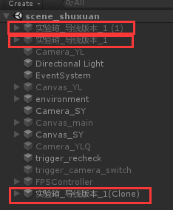
Fig.4 About the three versions of the experiment box
4.2.4 The realization of the port connection and the simulation of the logic function of the digital chip
The most critical part of the circuit experiment in this paper is the chip connection. The proficiency and correctness of the connection operation represent the students' mastery of the chip experiment. In the development of code writing, the realization of the analog and port connection of the logic function of the digital integrated chip is the most important. Only with the correct logic function calculation of the analog digital chip, students can obtain correct experimental results that are the same as real experiments when performing experimental operations. The operation of designing and providing port connection can make students have a more realistic experience when using the experimental teaching simulation platform.
When designing and writing code in this paper, according to the experimental schematic diagram, a separate control script was written for all pin ports that need to be used. When a student performs a connection operation and clicks on one of the ports used in the experiment, the code will check whether the port has been connected or whether it has accepted the connection request. If it is not connected and has not received a connection request, it will send a connection request to the corresponding other port. If the connection request has been received, the corresponding ports will uniformly set the connection identifier to 1, indicating that the port connection has been completed, and the wires in the disabled state between the corresponding ports will be enabled under code control.
Take the 153 chip as an example. Because the 16th port of the 153 chip needs to be connected to the "+5V" power supply. First make sure to add collision bodies to all ports on the model. Then add script components on the 16th port of the 153 chip and the "+5V" power supply.
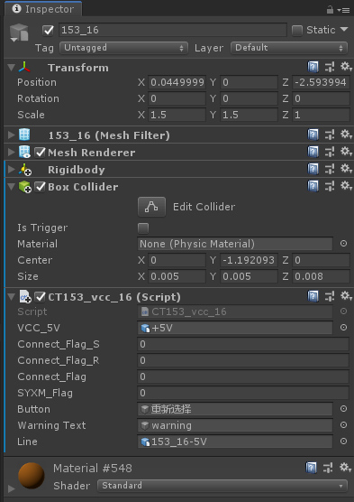
Fig.5 Port 16 of the 153 chip contains components
The specific code is shown below.
using UnityEngine;
public class CT153_vcc_16 : MonoBehaviour
{
public GameObject VCC_5V;
public int connect_Flag_S;
public int connect_Flag_R;
public int connect_Flag;
public int SYXM_Flag = 0;
public GameObject button;
int request_Flag;
public GameObject warningText;
public GameObject line;
void Start()
{
SYXM_Flag = button.GetComponent<CXXZ>().Flag;
}
void Update()
{
request_Flag = button.GetComponent<CXXZ>().request_Flag;
}
public void OnMouseDown()
{
if (SYXM_Flag == 1)
{
connect_Flag_R = VCC_5V.GetComponent<Control_5V>().connect_Flag_S;
if (connect_Flag == 1)
{
Debug.Log("Connected, invalid operation ");
}
if (connect_Flag == 0)
{
if (connect_Flag_R == 0)
{
if (request_Flag == 0)
{
Debug.Log("No power port connection request, jump to initiate connection request function ");
Connect_try_S();
}
else
{
warningText.SetActive(true);
}
}
if (connect_Flag_R == 1)
{
Debug.Log("There is a power port to send a connection request, and jump to receive a connection request function ");
Connect_try_R();
}
}
}
else
{
warningText.SetActive(true);
}
}

// Request connection function
public void Connect_try_S()
{
connect_Flag_S = 1;
Debug.Log("Send a request to establish a connection ID ");
button.SendMessage("SetFlag");
}

// Function to receive connection request
public void Connect_try_R()
{
Debug.Log("Connection establishment request received ");
connect_Flag = 1;
if (SYXM_Flag == 1)
{
Debug.Log("The connection is successfully established, and now the VCC of 153 is connected to +5V ");
VCC_5V.SendMessage("Set_Flag");
line.SetActive(true);
}
}
// Unified flag status after successful connection
public void Set_Flag()
{
connect_Flag = 1;
button.SendMessage("ResetFlag");
line.SetActive(true);
}
}
After the logic of port 16 is completed, the following is the power logic. Because there are many kinds of chips that need to be connected to the "+5V" power supply, the script of the power supply needs to write code according to the situation. When the experimental chip is 153, the code is as follows.
if (SYXM_Flag == 1)
{
connect_Flag_R = CT153_16.GetComponent<CT153_vcc_16>().connect_Flag_S;
if (connect_Flag == 1)
{
Debug.Log("Connected, invalid operation ");
}
if (connect_Flag == 0)
{
if (connect_Flag_R == 0)
{
if (request_Flag == 0)
{
Debug.Log("No chip connection request, jump to initiate connection request function ");
Connect_try_S();
}
else
{
warningText.SetActive(true);
}
}
if (connect_Flag_R == 1)
{
Debug.Log("A chip sends a connection request, and jumps to receive the connection request function ");
Connect_try_R();
}
}
}
In actual teaching scenarios, students are prone to connection errors during the connection operation. As a result, the experiment cannot be completed or the results are wrong. This paper adds an auxiliary prompt function when designing the experimental simulation teaching platform. To ensure the effectiveness of teaching, it is only a vague reminder. When a student connects incorrectly, a warning prompt box for incorrect connection will pop up. And use the script to control the activation/deactivation of the warning box to help students complete the correct connection. The specific implementation method is as follows.
if (connect_Flag == 0) // The port is not connected
{
if (connect_Flag_R == 0) // Port did not receive connection request
{
if (request_Flag == 0)
{
Debug.Log("No power port connection request, jump to initiate connection request function ");
Connect_try_S();
}
else
{
warningText.SetActive(true); // If the wrong connection identifier is 1, a warning box will pop up
}
}
if (connect_Flag_R == 1)
{
Debug.Log("There is a power port to send a connection request, and jump to receive a connection request function ");
Connect_try_R();
}
}
The logic of the above code is that when a port is clicked and a connection request is sent, the request_Flag error connection identifier in the "reselect experiment" button will be set to 1, only when the clicked other port is the correct port The connection is successfully established. If the wrong port is clicked, the request_Flag error connection identifier in the "reselect experiment" button is still 1. Then the condition of the warning code is established, a warning box pops up to remind students that there is an error in the connection, and the port needs to be reselected to connect. A script containing a timer is mounted on the alert box. When the alert box pops up, the timer starts to count. After a short interval, the alert box will automatically disappear under the control of the timer. Students can continue the connection operation without being affected. The prompt box rendering and simple logic code are shown below.
void Update()
{
if (text.activeInHierarchy)
{
timer += Time.deltaTime;
if (timer >= 1)
{
text.SetActive(false);
timer = 0.0f;
}
}
}
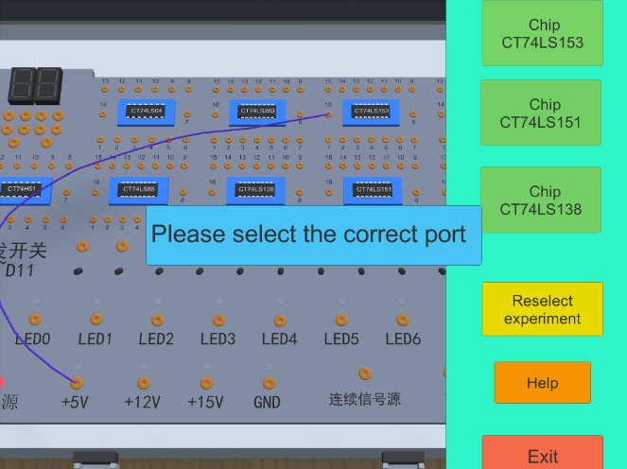
Fig.6 Schematic diagram of the effect of warning frame
At this point, the connection function of the experimental simulation teaching platform is basically completed. The analog development of the logic function of the digital integrated chip is realized through a state script, and each digital integrated chip is mounted with a logic function state script of the chip. The function of this state script is written according to the truth table of the chip (the truth table is introduced in Chapter 5, section 5. 5 experimental operation and section 5.6 experimental phenomenon), and through the Update () function to obtain real-time chip each pin Status, and calculate the output result according to the logic. The following figure 3.12 shows the parameter interface of the state script of the 153 chip in Unity3D. During the operation, all the parameter values in the list will change in real time with the change of the chip pin state and logical operations.
This chapter describes the model design process and function realization process of the experimental teaching simulation platform. Explained in detail the difficulties encountered in the development process and the final solution, such as the wire modeling display program, auxiliary teaching warning frame design, viewing angle control, experimental project control functions, etc. Using virtual reality technology and relatively complete code writing control technology, a relatively complete experimental teaching simulation platform has been successfully developed.

CHAPTER 5: RESULTS AND DISCUSSION
In this chapter, I will show the results in next seven parts. First of all, the following shows the effect of the experimental simulation platform exe program and the use of HTC Vive. Sections 1-4 are the experimental procedures. Section 5 is the experimental operation. Section 6 is an experimental phenomenon, and it is compared with the correct chip phenomenon to verify whether the design of this paper is wrong. If the result of the experimental teaching simulation platform conforms to the chip logic, it means that the development has already achieved the function.
After verifying the correctness of the platform, discuss the feedback results of the questionnaire in section 7.

5.1 Main Menu
The figure below shows the home page of the experiment platform for desktop virtual experiments. Click the “Data selector” for experiment selection. With reference to the digital circuit part of the exprimental textbook, three experimental items in the data selector are designed. This interface contains three buttons, namely the button to enter the data selector, the help button and the button to exit the program.
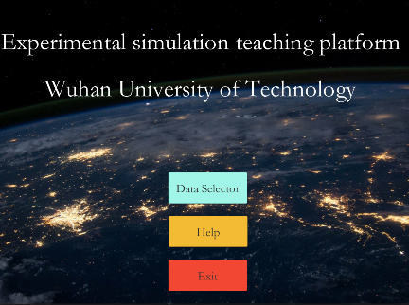
Fig.7 The main menu interface
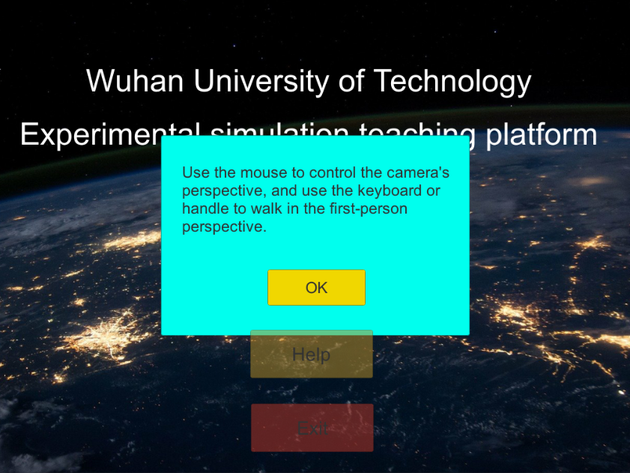
Fig.8 The main menu interface
The code for clicking the “Data Selector” button is actually implemented by SceneManager.LoadScene.
public void Goscene0(string sceneName)
{
SceneManager.LoadScene(1);
}
The code of the “Help” button displays the help page through SetActive().
public void Tips_out()
{
SXQ.GetComponent<Button>().interactable = false;
JFQ.GetComponent<Button>().interactable = false;
BJQ.GetComponent<Button>().interactable = false;
TIP.GetComponent<Button>().interactable = false;
EXIT.GetComponent<Button>().interactable = false;
panel.SetActive(true);
}
The “Exit” button code is as follows.
public void Quit()
{
#if UNITY_EDITOR
UnityEditor.EditorApplication.isPlaying = false;
#else
Application.Quit();
#endif
}

5.2 Classroom roaming interface
The classroom scene is built according to the real classroom. In desktop virtual reality, students can use the keyboard (WASD key) to control the characters to walk in it. Find the experiment box and click Preview or start experiment. Use the handle trigger button to achieve teleportation in virtual reality.
Use keyboard: Realize character roaming through FPSController.
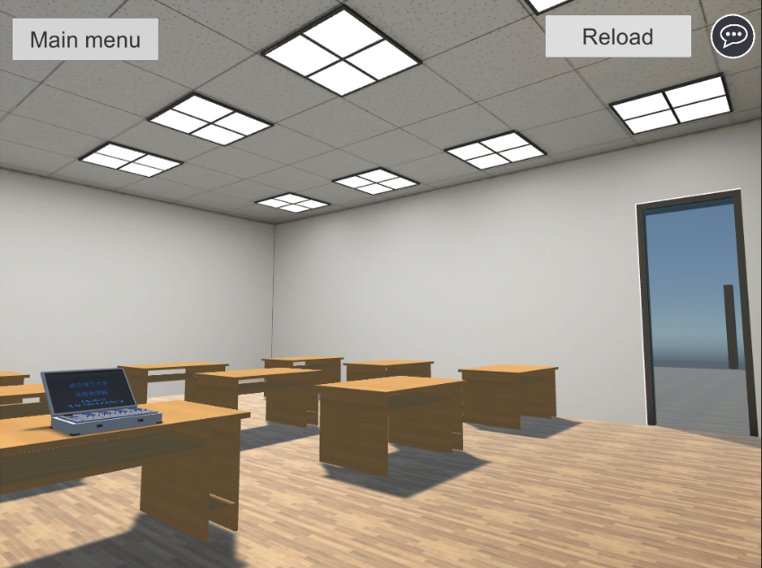
Fig.9 Use the arrow keys to roam the scene in the classroom
Use the handle: For handle operation, add a collision body for each button, and add a Teleport Area component. In this way, the ray can also complete the operation when the button is clicked. The picture shows the collider under editing.
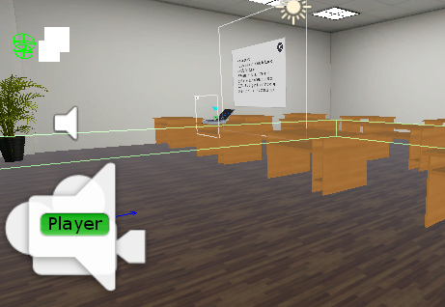
Fig.10 Edit the collider size
The picture below shows using HTC Vive controller to roam in the classroom.
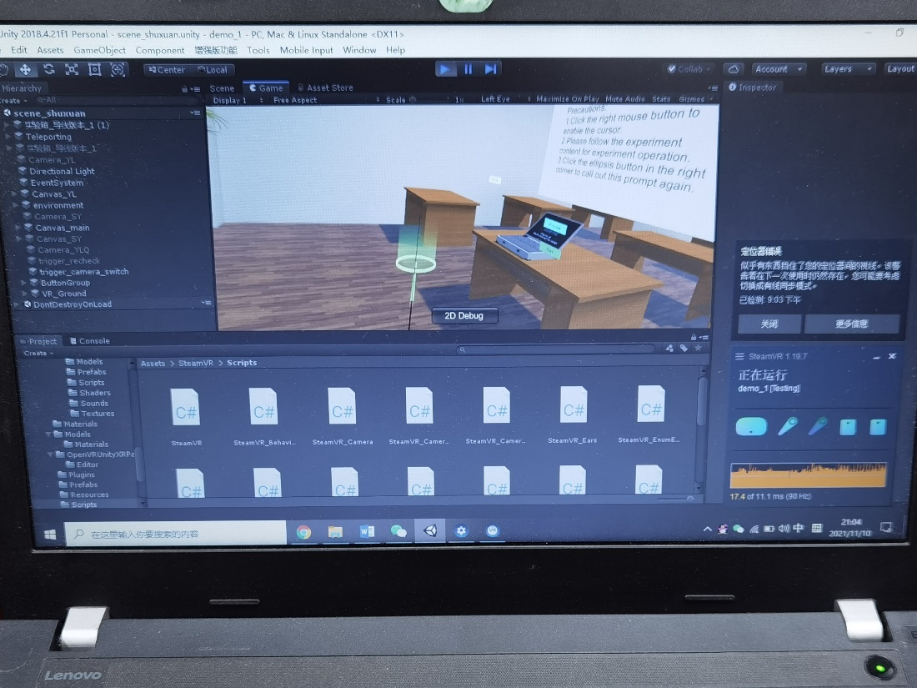
Fig.11 Use the handle to roam the classroom scene

5.3 Preview the experiment box
Students can control the mouse to adjust the angle of view, observe the experiment box, chip and other components at close range. The mouse wheel controls the viewing angle zoom, and the left button drags the experiment box. After the preview is over, click the "Exit Preview" button to return to the previous page.
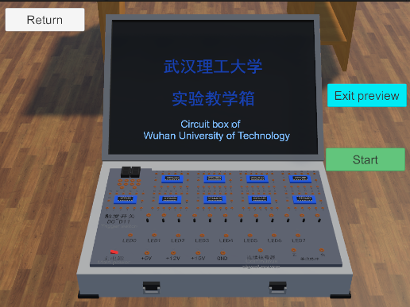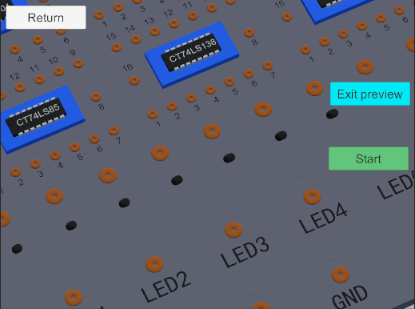
Fig. 12 Experiment box in preview mode

5.4 Project selection
On the right side of the experiment platform is the selection sidebar, where students can select experimental items or restart the experiment. Once the experiment item is selected, all the buttons will be grayed out except for the "Reselect experiment item" button. If the student wants to reselect the item, after clicking the button, all the buttons will be restored to their original state. The following picture shows the panel for selecting experimental items.
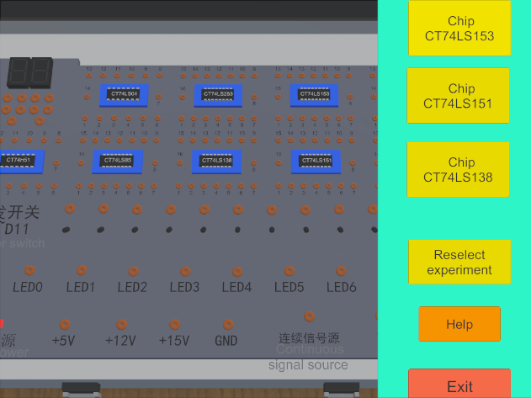
Fig. 13 Interface for selecting experimental items

5.5 The operation
In this area, students can make circuit connections, experiment operations, and observe the results of phenomena.
After selecting the corresponding experiment, students can start the experiment. Connect the circuit according to the experiment manual or chip pin diagram.
The principle of this experiment refers to the digital electronic circuit experiment set in the "Engineering Practice and Training Course", the electronic and electrical experiment textbook of Wuhan University of Technology. The function of the data selector is to select one channel from multiple input data to the output according to the address selection code. The following formulas are the logical expressions of chips 153, 151, and 138 , respectively.
$Y=\overline{A_{1}}\overline{A_{0}}D_{0}$+ $\overline{A_{1}}A_{0}D_{1}$+$A_{1}{\overline{A_{0}}D}_{2}$+$A_{1}A_{0}D_{3}$ (1)
$Y=\overline{A_{2}}\overline{A_{1}}\overline{A_{0}}D_{0}$+$\overline{A_{2}}\overline{A_{1}}A_{0}D_{1}$+
${\overline{A_{2}}A}_{1}{\overline{A_{0}}D}_{2}$+${\overline{A_{2}}A}_{1}A_{0}D_{3}$+$A_{2}\overline{A_{1}}\overline{A_{0}}D_{4}$+$A_{2}\overline{A_{1}}A_{0}D_{5}$+${A_{2}A}_{1}\overline{A_{0}}D_{6}$+$A_{2}A_{1}A_{0}D_{7}$ (2)
$Y=AC+B\overline{C}$ (3)
The following figure is the corresponding pin diagram of the three chips, which are 153, 151, and 138 respectively.
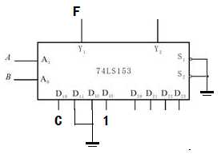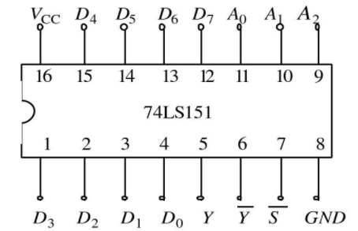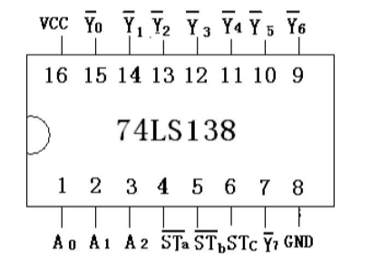
Fig. 14 Pin diagrams of the three chips
After the connection is completed, click on the main power source to make the experiment box energize. According to the table in Section 1.4, adjust the paddle switch, and then can judge whether the experiment is correct by the lighting condition.
The complete wiring diagram is shown below, respectively 153, 151, 138.
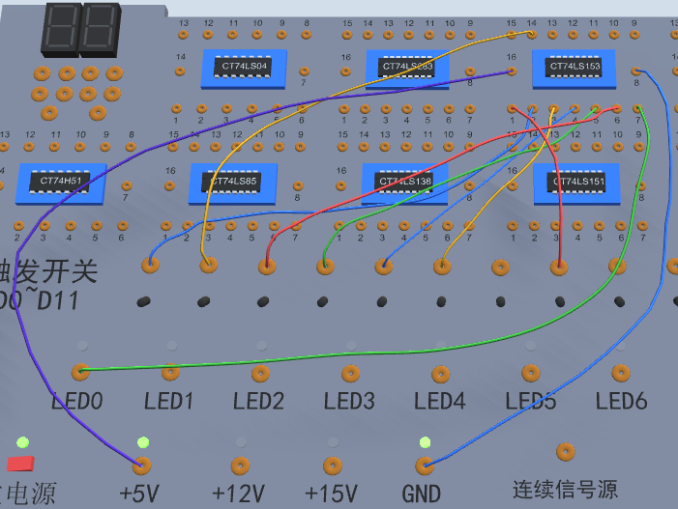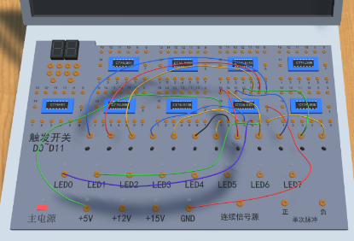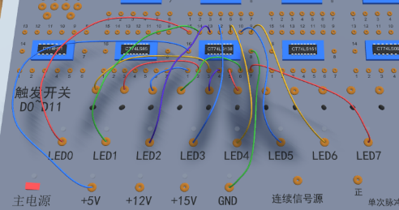
Fig. 15 Wiring diagram of the three chips

5.6 Experimental phenomena
As shown below, section 5.6.1 introduces the correct experiment lighting phenomenon. Section 5.6.2 verify whether the experimental teaching simulation platform meets the requirements. If the result of the experimental teaching simulation platform matches the lighting result of the chip, it means that the function has been realized in this development.
5.6.1 Logical function diagram & Lighting phenomenon
The final experimental results of the simulation platform, take the experiment of "testing the logic function of CT74LS153" as an example. When the input address A1A0 is "HL"( A1 A0:High Low), the chip output is the state of the third pin. The third pin of the 153 chip in the experimental circuit is connected to the D2 port of the trigger switch. At this time, the D2 port status is H, the chip output LED0 status is H, and the light is on.
Table 1 CT74LS153
A1 | A0 | D0 | D1 | D2 | D3 | LED0
L | L | L | L | L | L | L
L | L | H | L | L | L | H
L | H | L | L | L | L | L
L | H | L | H | L | L | H
H | L | L | L | L | L | L
H | L | L | L | H | L | H
H | H | L | L | L | L | L
H | H | L | L | L | H | H

Table 2 CT74LS151
A2 | A1 | A0 | D0 | D1 | D2 | D3 | D4 | D5 | D6 | D7 | LED0 | LED1
L | L | L | H | L | L | L | L | L | L | L | H | L
L | L | H | L | H | L | L | L | L | L | L | H | L
L | H | L | L | L | H | L | L | L | L | L | H | L
L | H | H | L | L | L | H | L | L | L | L | H | L
H | L | L | L | L | L | L | H | L | L | L | H | L
H | L | H | L | L | L | L | L | H | L | L | H | L
H | H | L | L | L | L | L | L | L | H | L | H | L
H | H | H | L | L | L | L | L | L | L | H | H | L

Table 3 CT74LS138
A2 | A1 | A0 | D0 | D1 | D2 | LED0 | LED1 | LED2 | LED3 | LED4 | LED5 | LED6 | LED7
L | L | L | H | L | L | L | H | H | H | H | H | H | H
L | L | H | H | L | L | H | L | H | H | H | H | H | H
L | H | L | H | L | L | H | H | L | H | H | H | H | H
L | H | H | H | L | L | H | H | H | L | H | H | H | H
H | L | L | H | L | L | H | H | H | H | L | H | H | H
H | L | H | H | L | L | H | H | H | H | H | L | H | H
H | H | L | H | L | L | H | H | H | H | H | H | L | H
H | H | H | H | L | L | H | H | H | H | H | H | H | L

5.6.2 The lighting phenomenon of the experimental simulation teaching platform
In section 5.6.1, I briefly introduce the logic functions of CT74LS153, CT74LS151, and CT74LS138 chips. And the lighting phenomenon of the final experiment. As shown in the table, different phenomena are highlighted. The dip switches corresponding to these three types of chips are different. Take 153 as an example, the trigger switch once from left to right is: A1, A0, D0, D1, D2, D3, as shown in the figure 16.
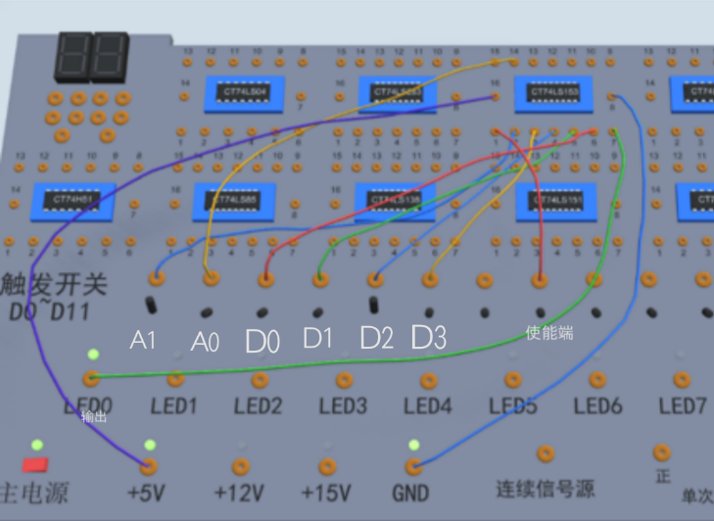
Fig. 16 Schematic diagram of CT74LS153 chip trigger switch port
After the line is connected, turn on the red button of the main power supply, and then correspond to different lighting conditions according to the toggle of the trigger switch. If it is the same as the experimental result in Section 5.6.1, the test is successful.
The figure 17 below shows the lighting conditions of various chips when flipping different trigger switches, which can be observed by comparing the three tables in 5.6.1. Take 152 chip as an example, when A1A0 is set to 00 and D0D1D2D3 is set to 1000, LED0 lights up. When A1A0 is set to 01 and D0D1D2D3 is set to 0100, LED0 lights up. When A1A0 is set to 10 and D0D1D2D3 is set to 0010, LED0 lights up.

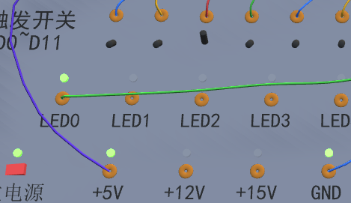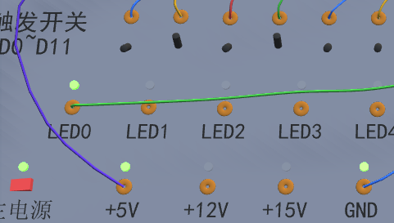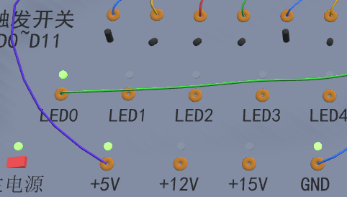
Experimental phenomenon of CT74LS153 Chip
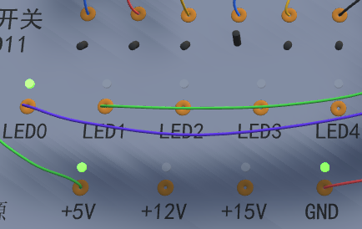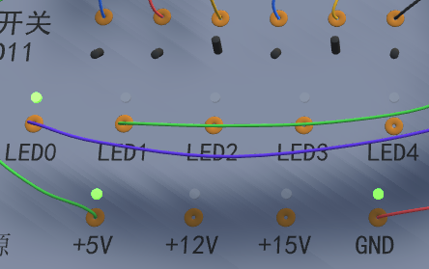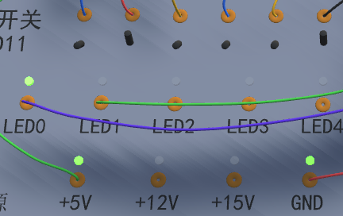
Experimental phenomenon of CT74LS151 Chip
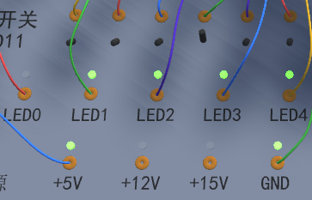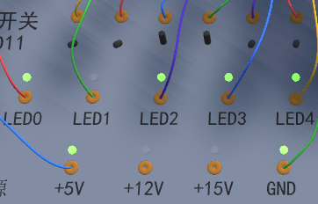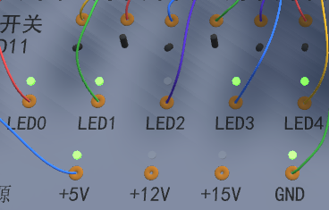
Experimental phenomenon of CT74LS138 Chip
Fig. 17 Some experimental phenomena of the three chips
The figure 18 shows students using HTC Vive to complete the experiment.
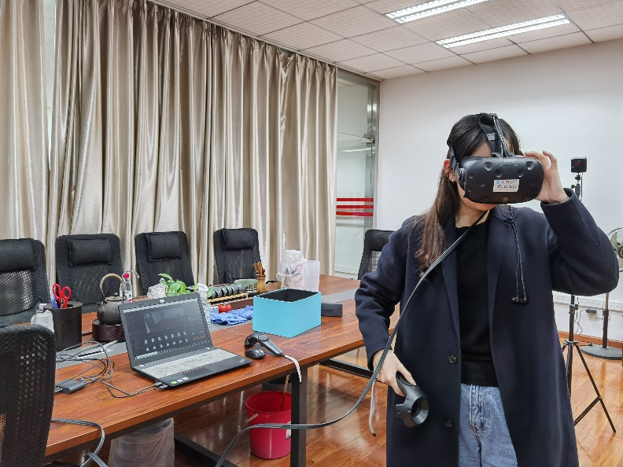
Fig.18 Student is completing the experiment

5.7 Feedback of the questionnaire
From the perspective of perception and enjoyment, in the first and second questions, the virtual simulation teaching platform is more attractive to students than the actual operation experiment box. As we all know, the new technology of virtual reality has not yet been put into teaching work on a large scale, so students have a strong curiosity about it. This is of great help to increase the interest in learning. In addition, there are a few students whose actual test box scores are very low. They said that the connections were all right, but the result was wrong. After changing the chip several times, the correct result appeared. From this point of view, the actual experimental operation has the possibility of objective problems, that is, experimental errors caused by hardware failures. However, for experiments using virtual reality technology, as long as the logic is correct during the development process, there is no such problem. Thereby greatly improving the learning efficiency. In the third question, some students' scores are not very high, which reflects that there are still some differences between the scene model and the reality. Therefore, when making models, how to get closer to reality and how to further increase immersion needs to be strengthened. Some students responded to the fourth question, using the exe program to do the experiment, the operation is very smooth. Indeed, using a computer and keyboard and mouse to do experiments is more convenient and quicker than inserting the chip connection line in the experiment box. This method is especially suitable for situations in which students cannot attend school together during the epidemic and need to take online lessons. Only an exe file is needed to simulate a real experimental scene. Improve the learning efficiency of distance learning. For the fifth question, several students scored very high on the HTC vive device. They said that the way the head-mounted device moves is very interesting, that is, where is the circle cast by the ray on the ground collision body, and where the field of view is after releasing the disc key. This type of teleportation enhances the interest of the experiment.
Regarding the simulator disease, it can be summarized as follows. First, students are more prone to finger pain under the experimental method of actual operation. That's because the actual chip has many sharp pins. If the student is not careful when picking it up, it may get hurt. And if the chip is inserted in the experiment box upside down, the chip will heat up and even explode, which greatly increases the risk. Although the teacher will emphasize it many times during class, the chip heats up due to the reverse insertion. Second, using the desktop virtual experiment method, because students stare at the computer screen for a long time, and the interface of the chip is much smaller, the mouse will click the wrong one if you are not careful, so eye pain inevitably becomes a problem. Third, some students will experience strong dizziness and 3D reactions during the experiment while wearing the head-mounted display, such as dizziness, nausea and other symptoms. One part is due to its own reasons, and the other part may be the problem of the recognition delay between the HTC vive locator and the helmet, causing the picture in the head-mounted display to not keep up with the changes in the student's field of view, and the student feels dizzy. And during the test, sometimes steamVR can't recognize the locator.
In the professional knowledge part, I mainly want to investigate the actual effect of the three experimental methods on students' learning. Judging from the feedback from students, most students can obtain knowledge efficiently through virtual reality learning methods, and have a deep memory. This is very conducive to student learning.

CHAPTER 6: CONCLUSIONS AND RECOMMENDATIONS
In this thesis, the functional test is carried out after completing the basic development of the experimental teaching simulation platform. The test scope covers three logic chip experiments in the data selector experiment project that has completed all the development work so far.
1. During the operation of the experimental teaching simulation platform, all triggers and interface jump switching functions operate normally and respond quickly. Students can easily control the first-person perspective and handle to observe the environment in the laboratory scene and walk around at will.
2. The preview interface and the camera control during the experiment run well and meet the design requirements.
3. During the experiment, the code that controls the wire connection operation can meet the demand. Students can successfully complete the connection of the experimental circuit. When there is a connection error, the warning box prompts normally. By observing the state script parameters, experimental operations, and experimental phenomena of each chip, all experiments can smoothly complete logical operations and output results in accordance with the logical relationships reflected in the truth table. Students can change the address and initial value received by the chip by flipping the trigger switch to complete the test task set by the experimental project.
The feedback from the students’ questionnaire is summarized as follows:
1. As an emerging teaching method, virtual reality technology is very popular among students, making everyone more motivated and easier to accept new knowledge.
2. Although the scene and operation panel can meet the basic experimental needs, there is still room for improvement in UI design, including the color matching of panel buttons and click interaction, etc.
3. Desktop virtual reality is more convenient than helmets in the case of group teaching. Students only need to use their own computers to run exe files, but the teaching effect is not as good as helmets. Considering that virtual reality devices such as helmet handles are relatively expensive. In order to meet the actual situation of collective teaching, and the digital circuit experiment is not only the three mentioned in this paper. If virtual equipment can be successfully introduced into the actual teaching environment, students can experience the effects of helmets in different classes in batches, combined with desktop virtual reality. Perhaps this method is more suitable for the initial stage of introducing virtual devices into the teaching environment.
4. During the epidemic, if you can't come to the classroom to have an experimental class as a group, you can learn and complete the experimental class through desktop virtual reality.
5. There is another advantage to using virtual reality technology to do course experiments. Because once the experimental platform is developed, if the logic of the compilation can be guaranteed to be correct, then the experimental results will not change, and other objective factors will not affect the experimental results and cause misunderstandings. If it is an actual chip, due to the aging of the experiment box circuit or poor chip pin interface, it will cause the experiment result to be wrong, which is not good for the students' study.
6. Discussion on the cost of three experimental methods
Discussion on the cost of three experimental methods
Real experiment boxes are used to complete the digital and electrical experiment courses, and experiment boxes are purchased collectively. An experiment box on the market is about 1,500 yuan, and the collective wholesale price will be lower. The chips are all wholesale from the factory.
The cost of desktop virtual reality should be the lowest among the three methods, only a computer is needed. The venue uses the school’s computer room. If you cannot meet the situation of group attendance, send the exe file to all students, and you can complete the experiment on the student's own computer. Very convenient and fast.
Because a set of HTC Vive equipment is more expensive, it will cost about 3,500 yuan. In addition, the experimental class can only be used by one student in an empty space of five square meters, while other students wait. Considering this practical problem, students can be arranged to experience HTC Vive devices in batches for experiments, and other students can complete them through real experiments or desktop virtual reality experiments. This ensures that as many students as possible can experience this technology.

CHAPTER 7: REFLECTION
Nowadays, the development of virtual reality technology is becoming more and more extensive. It has great potential in the field of scene simulation, education and training. If it is applied to experimental teaching in colleges and universities, it can make up for many problems encountered in traditional experimental teaching, such as time, funding, teaching land, and remote education of the epidemic. This thesis selects professional-related circuit experiment teaching as the research object, and analyzes in detail the existing problems in current traditional circuit experiment teaching and two-dimensional circuit simulation software.
This paper develops and builds an experimental simulation teaching platform, and discusses the significance and advantages of applying virtual reality technology to circuit experiment teaching and building a virtual experimental teaching simulation platform. The reference design requirements of the thesis determine the circuit type of the digital electronic circuit experiment as the experimental teaching simulation platform, and analyze in detail the specific application of virtual reality technology in the experimental teaching simulation platform. Combining the characteristics of digital electronic circuit experiments and virtual reality technology, the paper explores the logical thinking and operation methods of digital circuits. And the successful realization method in the virtual reality platform restores the experimental operation and experimental effect in the traditional circuit teaching. A virtual simulation experimental teaching platform with relatively complete functions and good interactive experience has been developed, which solves the problem of traditional circuit teaching limited by time and space, and creates a new teaching mode. Under the premise of ensuring the quality of teaching, it can effectively Improve students' enthusiasm for learning.
The main results of the thesis are as follows:
1) Combine virtual reality technology with teaching practice courses. The characteristics and implementation methods of virtual reality technology are studied, the overall framework of the experimental teaching simulation platform is built, and the functional design is deeply explored.
2) Using the modeling software 3ds Max to build experimental boxes and other models, and strive to make a more realistic restoration of the traditional teaching scenes, and pursue the immersion that the experimental teaching simulation platform brings to users.
3) Successfully developed and constructed an experimental teaching simulation platform with strong interaction and complete functions. Including desktop virtual reality and virtual reality using HTC Vive. Through scenario design and script development, the restoration simulation of the digital circuit logic function and the real experimental operation has been completed.
Due to its own ability and workload, the experimental teaching simulation platform built only allows exactly the same wire connections according to the circuit schematics, and cannot display corresponding experimental phenomena for other similarly correct connection methods. This is the current experimental teaching simulation platform function My biggest regret. In addition, in the simulation of the experimental equipment, since the trigger button of the handle is not particularly sensitive when pressed, the ray is changed to trigger the buttons and switches by moving in during development. Therefore, it is less interactive than the trigger button in operation.
In general, the development of the experimental teaching simulation platform is a relatively successful attempt in digital circuit experiments. And it laid the foundation for the virtual reality of other circuit experiment teaching. This also proves that virtual reality technology has a relatively outstanding potential for development and application in the field of circuit experiment teaching. As the world moves toward a high degree of informationization, electronic information talents will be desired by all sectors of society. In the future, its application will not only be limited to student groups, but can also be extended to the scenes of circuit education or training in all sectors of society. Really maximize its economic, safety, and high-efficiency advantages.

REFERENCES
[1] Exploring the Skill Retention of Circuit Simulation Learning from the Perspective of Sustainability (Open Access) Wu, Wen-Chuan (Krirk University, Khet Bang Khen, Krung Thep Maha Nakhon; 10220, Thailand); Guo, Shu-Ying; Cai, Ai-Ting Source: IOP Conference Series: Earth and Environmental Science, v 576, n 1, November 11, 2020, International Conference on Sustainability Management
[2] Cipresso Pietro,Giglioli Irene Alice Chicchi,Raya Mariano Alcañiz,Riva Giuseppe. The Past, Present, and Future of Virtual and Augmented Reality Research: A Network and Cluster Analysis of the Literature.[J]. Frontiers in psychology,2018,9:
[3] ZHAO J, LAFEMINA P, WALLGRUN J O, et al. iVR for the geosciences [C]//IEEE Virtual Reality Workshop on K-12 Embodied Learning Through Virtual & Augmented Reality. [S.l.]: IEEE,2017:1-6. [2020-05-28]
[4] Oliver A. Meyer, Magnus K. Omdahl, Guido Makransky,Investigating the effect of pre-training when learning through immersive virtual reality and video: A media and methods experiment,Computers & Education,Volume 140,2019,103603,ISSN 0360-1315,https://doi.org/10.1016/j.compedu.2019.103603.
[5] E. Kučera, O. Haffner and R. Leskovský, "Multimedia Application for Object-oriented Programming Education Developed by Unity Engine," 2020 Cybernetics & Informatics (K&I), 2020, pp. 1-8, doi: 10.1109/KI48306.2020.9039853.
[6] O. Comber, R. Motschnig, H. Mayer and D. Haselberger, "Engaging Students in Computer Science Education through Game Development with Unity," 2019 IEEE Global Engineering Education Conference (EDUCON), 2019, pp. 199-205, doi: 10.1109/EDUCON.2019.8725135.
[7] J. S. Ortiz, B. S. Guevara, E. G. Espinosa, J. Santana, L. R. Tamayo and V. H. Andaluz, "3D Virtual Content for Education Applications," 2020 15th Iberian Conference on Information Systems and Technologies (CISTI), 2020, pp. 1-5, doi: 10.23919/CISTI49556.2020.9140822.
[8] Q. Qi and T. Wang, "Application of Virtual Simulation Technology in Teaching of Surveying and Mapping Engineering," 2020 International Conference on Urban Engineering and Management Science (ICUEMS), 2020, pp. 380-384, doi: 10.1109/ICUEMS50872.2020.00087.
[9]D. C. C. Crisóstomo, A. A. F. Moura, E. P. Rocha, F. M. Cruz and A. P. Moura, "Educational Software For Simulation Of Power and Voltage Control In Power Systems Connected With Wind Farms," in IEEE Latin America Transactions, vol. 16, no. 6, pp. 1603-1609, June 2018, doi: 10.1109/TLA.2018.8444155.
[10]A. Z. Sampaio and L. Viana, "Educational model based on virtual reality: Simulation of the construction of a bridge deck," 2013 2nd Experiment@ International Conference (exp.at'13), 2013, pp. 52-57, doi: 10.1109/ExpAt.2013.6703029.
[11]A. Wang and W. Biu (2014). The Use of Game Development in Computer Science and Software Engineering Education. Available: http://www.idi.ntnu.no/~alfw/publications/Use_of_Games_In_SE_and_CS_Education.pdf (2018, August 2).
[12]V. Andaluz, J. A. Pérez, C. P. Carvajal, J. S. Ortiz, Virtual Environment for Teaching and Learning Robotics Applied to Industrial Processes, international Conference on Augmente Reality, Virtual Reality and Computer Graphics, pp. 442-455, 2019
[13]J. Romero, W. Quero, J. Sánchez and V. H. Andaluz, Training assistant for Industrial Processes through Aumented Reality, International Conference on Education Technology and computers, pp 308-315, 2019.
[14]J. Majernik, M. Madar, and J. Mojzisova, “Integration of virtual patients in education of veterinary medicine,” in 2017 Federated Conference on Computer Science and Information Systems (FedCSIS). IEEE, 2017. doi: 10.15439/2017F134
[15] K. Zhang, J. Suo, J. Chen, X. Liu, and L. Gao, “Design and implementation of fire safety education system on campus based on virtual reality technology,” in 2017 Federated Conference on Computer Science and Information Systems (FedCSIS). IEEE, 2017. doi: 10.15439/2017F376
[16] Austrian Agency for International Cooperation in Education and Research (2018). Sparkling Science - a programme of Federal Ministry of Education, Science and Research. Available: https://www.sparklingscience.at/en (2018, August 11).
[17] D. Topalli and N. E. Cagiltay, "Improving programming skills in engineering education through problem-based game projects with Scratch," Computers & Education, vol. 120, pp. 64-74, 2018.
[18] The GIMP Team (2018). GIMP - The GNU Image Manipulation Program. Available: https://www.gimp.org (2018, August 8).
[19] O. Comber, D. Haselberger, M. Hörbe, H. Mayer, R. Motschnig, and D. Unterweger (2019). learn2proGrAME Grundlagentutorial Tutorial - Let’s make a Bouncy Fant Game! Available: https://learn2programe. github.io/ learn2proGrAME - Grundlagen/ (2019, March 3).

APPENDICES
using System.Collections;
using System.Collections.Generic;
using UnityEngine;
public class CT153_gnd_8 : MonoBehaviour
{
public GameObject GND;
public int connect_Flag_S;
public int connect_Flag_R;
public int connect_Flag;
public int SYXM_Flag;
public GameObject button;
int request_Flag;
public GameObject warningText;
public GameObject line;
// Start is called before the first frame update
void Start()
{
SYXM_Flag = button.GetComponent<CXXZ>().Flag;
}
// Update is called once per frame
void Update()
{
request_Flag = button.GetComponent<CXXZ>().request_Flag;
}
public void OnMouseDown()
{
if (SYXM_Flag == 1)
{
connect_Flag_R = GND.GetComponent<Control_GND>().connect_Flag_S;
if (connect_Flag == 1)
{
Debug.Log("Connected, invalid operation ");
}
if (connect_Flag == 0)
{
if (connect_Flag_R == 0)
{
if (request_Flag == 0)
{
Debug.Log("No power port connection request, jump to initiate connection request function ");
Connect_try_S();
}
else
{
warningText.SetActive(true);
}
}
if (connect_Flag_R == 1)
{
Debug.Log("There is a power port to send a connection request, and jump to receive a connection request function ");
Connect_try_R();
}
}
}
else
{
warningText.SetActive(true);
}
}
public void Connect_try_S()
{
connect_Flag_S = 1;
Debug.Log("Send a request to establish a connection ID ");
button.SendMessage("SetFlag");
}
public void Connect_try_R()
{
Debug.Log("Connection establishment request received ");
connect_Flag = 1;
if (SYXM_Flag == 1)
{
Debug.Log("The connection is successfully established, and now the GND of 153 is connected to the GND of the power area ");
GND.SendMessage("Set_Flag");
line.SetActive(true);
}
}
public void Set_Flag()
{
connect_Flag = 1;
button.SendMessage("ResetFlag");
line.SetActive(true);
}
}

using System.Collections;
using System.Collections.Generic;
using UnityEngine;
public class Control_GND : MonoBehaviour
{
public int connect_Flag_S;
public int connect_Flag_R;
public int connect_Flag;
public GameObject CT153_8;
public GameObject CT151_8;
public GameObject CT138_8;
public int SYXM_Flag = 0;
public GameObject button;
int request_Flag;
public GameObject warningText;
public int connect_Flag_R_151;
public int connect_Flag_R_138;
public int connect_Flag_S_151;
public int connect_Flag_S_138;
public int connect_Flag_138;
public int connect_Flag_151;
public GameObject line4_151;
public GameObject line4_138;

// Start is called before the first frame update
void Start()
{
SYXM_Flag = button.GetComponent<CXXZ>().Flag;
}

// Update is called once per frame
void Update()
{
request_Flag = button.GetComponent<CXXZ>().request_Flag;
}
public void Connect_try_S()
{
connect_Flag_S = 1;
Debug.Log("Send a request to establish a connection ID ");
button.SendMessage("SetFlag");
}
public void Connect_try_R()
{
Debug.Log("Connection establishment request received ");
connect_Flag = 1;
if (SYXM_Flag == 1)
{
Debug.Log("The connection is successfully established, and now the GND of 153 is connected to the GND of the power area ");
CT153_8.SendMessage("Set_Flag");
}
if (SYXM_Flag == 2)
{
Debug.Log("The connection is successfully established, and now the GND of 151 is connected to the GND of the power area ");
CT151_8.SendMessage("Set_Flag");
}
if (SYXM_Flag == 3)
{
Debug.Log("The connection is successfully established, and now the GND of 138 is connected to the GND of the power area ");
CT138_8.SendMessage("Set_Flag");
}
}
public void OnMouseDown()
{
if (SYXM_Flag == 1)
{
connect_Flag_R = CT153_8.GetComponent<CT153_gnd_8>().connect_Flag_S;
if (connect_Flag == 1)
{
Debug.Log("Connected, invalid operation ");
}
if (connect_Flag == 0)
{
if (connect_Flag_R == 0)
{
if (request_Flag == 0)
{
Debug.Log("No chip connection request, jump to initiate connection request function ");
Connect_try_S();
}
else
{
warningText.SetActive(true);
}
}
if (connect_Flag_R == 1)
{
Debug.Log("A chip sends a connection request, and jumps to receive the connection request function ");
Connect_try_R();
}
}
}
if (SYXM_Flag == 2)
{
connect_Flag_R = CT151_8.GetComponent<CT151_8_GND>().connect_Flag_S;
if (connect_Flag == 1)
{
Debug.Log("Connected, invalid operation ");
}
if (connect_Flag == 0)
{
if (connect_Flag_R == 0)
{
if (request_Flag == 0)
{
Debug.Log("No chip connection request, jump to initiate connection request function ");
Connect_try_S();
}
else
{
warningText.SetActive(true);
}
}
if (connect_Flag_R == 1)
{
Debug.Log("A chip sends a connection request, and jumps to receive the connection request function ");
Connect_try_R();
}
}
}
if (SYXM_Flag == 3)
{
connect_Flag_R = CT138_8.GetComponent<CT138_8_GND>().connect_Flag_S;
if (connect_Flag == 1)
{
Debug.Log("Connected, invalid operation ");
}
if (connect_Flag == 0)
{
if (connect_Flag_R == 0)
{
if (request_Flag == 0)
{
Debug.Log("No chip connection request, jump to initiate connection request function ");
Connect_try_S();
}
else
{
warningText.SetActive(true);
}
}
if (connect_Flag_R == 1)
{
Debug.Log("A chip sends a connection request, and jumps to receive the connection request function ");
Connect_try_R();
}
}
}

if (SYXM_Flag == 4)
{
connect_Flag_R_138 = CT138_8.GetComponent<CT138_8_GND>().connect_Flag_S_GND;
connect_Flag_R_151 = CT151_8.GetComponent<CT151_8_GND>().connect_Flag_S_GND;
if (connect_Flag == 1)
{
Debug.Log("Connected, invalid operation ");

}
if (connect_Flag == 0)
{
if (request_Flag == 0 || (request_Flag == 1 && (connect_Flag_R_151 == 1 || connect_Flag_R_138 == 1)))
{
if (connect_Flag_151 == 0) {
if (connect_Flag_R_151 == 0)
{
Debug.Log("151 chip not connected request, jump to initiate a request to connect 151 chip function ");
Connect_try_S_151();
}
if (connect_Flag_R_151 == 1)
{
Debug.Log("151 chip has sent a connection request, jump to receive chip 151 request connection function ");
Connect_try_R_151();
}
}
if (connect_Flag_138 == 0)
{
Debug.Log("The GND port of chip 138 is not connected to the GND of the power supply area ");
if (connect_Flag_R_138 == 0)
{
Debug.Log("138 chip is not connected to the request, jump to initiate a request to connect to the 138 chip function ");
Connect_try_S_138();
}
if (connect_Flag_R_138 == 1)
{
Debug.Log("Chip 138 has sent a connection request, jump to receive chip 138 request connection function ");
Connect_try_R_138();
}
}
if (connect_Flag_R_138 == 1 && connect_Flag_R_151 == 0)
{
connect_Flag_S_151 = 0;
button.SendMessage("ResetFlag");
}
if (connect_Flag_R_138 == 0 && connect_Flag_R_151 == 1)
{
connect_Flag_S_138 = 0;
button.SendMessage("ResetFlag");
}
}
else
{
warningText.SetActive(true);
}
}
if (connect_Flag_138 == 1 && connect_Flag_151 == 1)
{
Set_Flag();
}
}
if (SYXM_Flag != 1 && SYXM_Flag != 2 && SYXM_Flag != 3 && SYXM_Flag != 4)
{
warningText.SetActive(true);
}
}
public void Set_Flag()
{
connect_Flag = 1;
if (SYXM_Flag != 4)
{
button.SendMessage("ResetFlag");
}
}
The following is the scoring situation of students completing the questionnaire.

