

Assessment 1 – Reading Task Template
PART 1: Upload your photo of your A3 in-class notes here:
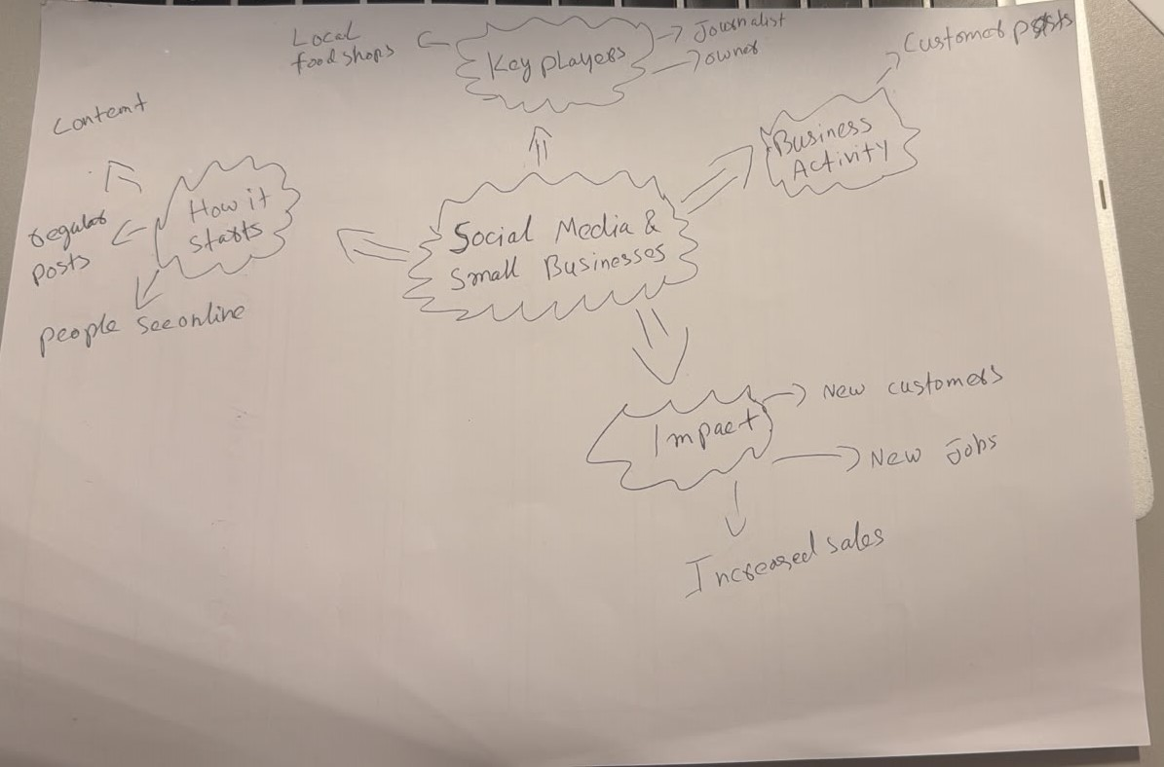

PART 2:
- Answer every question below in 1-3 full sentences.
- Use your own words. Do not use generative AI to answer these questions.
- Include a specific detail from the text when asked.
REMINDER
- The main idea is the overall message of the whole text.
- A key point helps to explain the main idea.
- A specific detail or example from the text shows that the key point is true.

- What is the main idea of the whole text?
Social media helps small businesses become popular and attract more customers. Increases the sale and make more job
- What is one key point that supports the main idea, and which specific example from the text shows this?
When a business goes viral on social media, it can get more sales. For example, Binley Mega Chippy's sales increased a lot after its videos became popular online.
- What is a different key point that supports the main idea, and which specific example from the text shows this?
Social media attention attracts customers from long way. For example, people travelled long distances to visit businesses after seeing them on TikTok.

- Which part of the text do you think is most important, and why?
I think the most important part is that social media gives small businesses a chance to be seen by many people. This is important because it helps them grow and attract new customers.

Reflection:

- What did you find difficult in this task (including in-class components), and why was it difficult?
I found it difficult to identify the main idea because there were many examples in the text

- What helped you with this difficulty, and how did it help you?
The checklist helped me focus on the main idea and choose the best examples from the text.

