Contents
1. Proposed Dissertation Title 1
2. Dissertation Brief 1
3. My Aims and Objectives 1
4. What is a Senior Civil Engineering Surveyor 1
4.1 What is Civil Engineering Surveying 1
4.2 What purpose does this role have 1
5. What is the Importance of this Position 2
6. How do you achieve this Position 2
6.1 What Qualifications can get you here 2
6.2 What Experience and Skills do you have to have 2
6.3 What further development would you need 2
7. Chartership 2
8. Methodology 3
9. Timetable 3
10. Bibliography 3

Proposed Dissertation Title

How to Become a Senior Civil Engineering Surveyor

Dissertation Brief
The purpose of this paper is to highlight the need for Senior Civil Engineering Surveyors and the need for people to gain Chartership to improve the expertise and experience in the Industry.

My Aims and Objectives
My aims are to explain what is a Senior Civil Engineering Surveyor, its importance ,explaining how you reach this position and importance and how you reach chartership. My objectives are to identify the qualifications, experience, competencies and roles of the position. Also, to demonstrate how you can reach Chartership.

What is a Senior Civil Engineering Surveyor

What is Civil Engineering Surveying
Civil Engineering is “Civil engineering is everything you see that’s been built around us.” (ICE, n.d.)
A Surveyor is “Surveyors shape the way we live. From our towns and cities to our streets and homes, they help create safer, better, happier communities.” (RICS, n.d.)
A Civil Engineering Surveyor is the both combined and more as they done setting out, surveying, record keeping, design, planning, management and various other tasks. The roles differ depending on project and tasks.
The position of Senior/Chief is used for one who’s reached this position not due to age but Skill, Experience, Competence and Recognition. The purpose of the role is to teach the next generation of engineers and to improve and develop the industry.

What is the Importance of this Position
The position holds lots of importance to the industry as they’re looked up at as Mentors to younger engineers due to their expertise, experience and skill. They teach and guide next generations into the future pushing for newer and better ways of doing things in the industry making it better for the new generation. From 50 years ago setting out with Inverse Levels and Theodlites to now 3D Machine control, Drones and GPS. They are the ones who have authority and power to change the industry as to get this position requires recognition from the industry, Institutions and respect from others.

How do you achieve this Position

What Qualifications can get you here
The qualifications for this position depend on the route you taken from when you first leave school. Either through 6th form or Apprenticeship or Vocational course routes are the first step into this position.

The 6th From route is the longer route of the 2 as you have 2yrs in school, then the next step after that is degree, masters and PhD if you want to go that far.

Figures 1 and 2 are showing the qualifications route to get into the industry.
As you need these qualifications as these are fundamental skills you need.
As next step after these is Experience and variety of work.
(ICE, How can I become a Civil Engineer, n.d.)

Figures 3 and 4 show the route through Apprenticeships as vocational route is similar to this as one is full-time and the other part-time.
Apprenticeships are the best way as you learn on the job and in the class room gaining knowledge and experience at the same time. Bettering yourself. (ICE, How can I become a Civil Engineer, n.d.)

What Experience and Skills do you have to have
In engineering and surveying you are always looked at for your thinking, planning and management skills and more.
You need to be able to do maths and problem solving as to be able to think on your feet and make decisions there and then. As in the industry nothing always goes to plan so being able to show creative thinking, quick judgement and taking action shows your confident and competent.
As a surveyor you need to be able to use technology as when surveying, design work and managing data. Same goes for engineers as they aren’t Peg Bashers like they were their Data managers now.

Chartership
The best way for becoming a Senior Civil Engineering Surveyor is through Chartership.
Chartership is gaining Recognition from the industry and peers of your skill and expertise. This title is recognized worldwide as it “is one of the most recognisable international engineering qualifications” (ICE, How to become a professionally qualified civil engineer, n.d.).
Getting this title is a huge and life changing achievement to people. As this grants worldwide opportunities and benefits to them.
To get this title you have to go through the ranks and constantly better yourself with CPD. As you can start as a Student Member as its free to join, next step is EngTech which is having “”approved level 3 diploma or an HND or foundation degree or above” as achieving this title shows your competence and commitment to professional standards. (ICE, How to become a professionally qualified civil engineer, n.d.).
After EngTech its IEng which requires an accredited bachelors degrees or having HNC/HND and working towards it in the industry due to experience. This is seen by others in the industry that you’re a competent engineer and committed to the profession.
Chartership is the final title and to get here you have to go through all of these and proving your constantly improving yourself and competence. All the titles from IEng to Charted are protected by law.

Timetable
The research will start in the new year and spread across 3 months to gain and ask others of their and mine own experiences.

References
ICE. (n.d.). How can I become a Civil Engineer. Retrieved from ICE: https://www.ice.org.uk/what-is-civil-engineering/how-can-i-become-a-civil-engineer
ICE. (n.d.). How to become a professionally qualified civil engineer. Retrieved from ICE: https://www.ice.org.uk/careers-and-training/graduate-civil-engineers/how-to-become-professionally-qualified
ICE. (n.d.). What is civil engineering. Retrieved from ICE: https://www.ice.org.uk/what-is-civil-engineering
RICS. (n.d.). What surveyors do. Retrieved from RICS: https://www.rics.org/uk/surveying-profession/what-is-surveying/what-surveyors-do/

Appendix

Figure 1- A Level and Highers 2
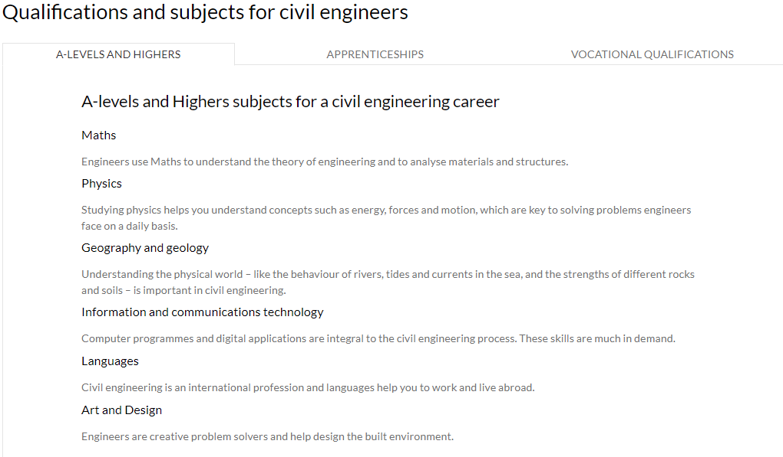
Figure 2- University 3
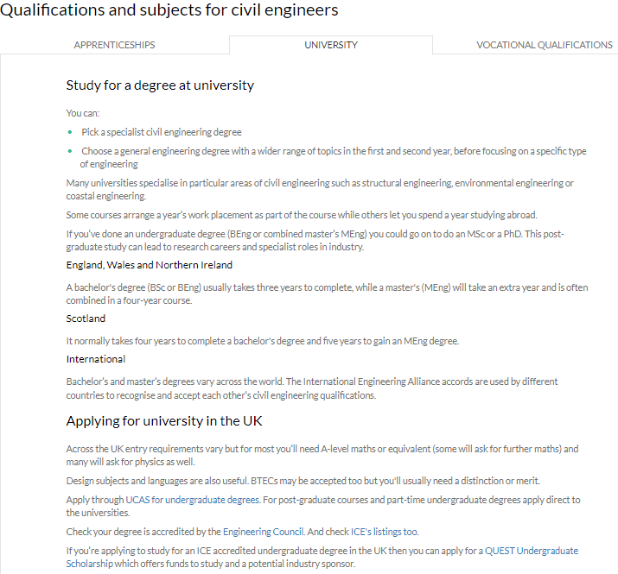
Figure 3- Apprenticeship Route 3
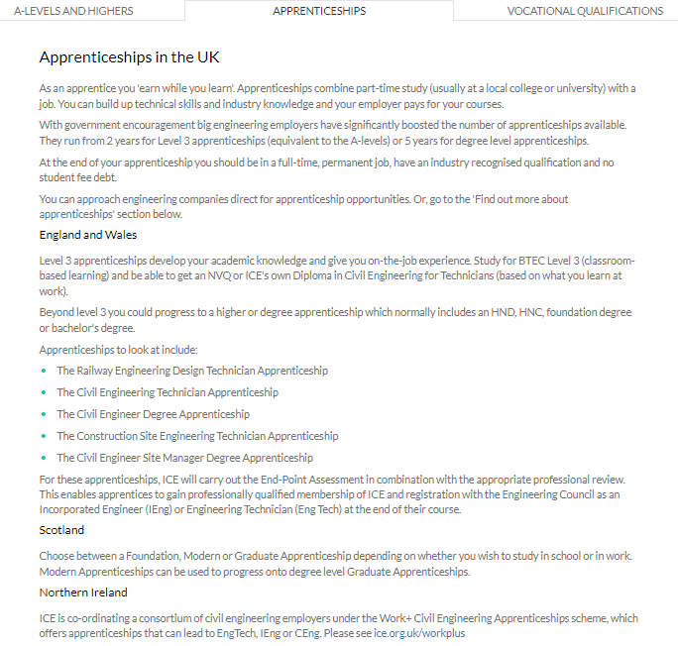
Figure 4- Vocational Route 4
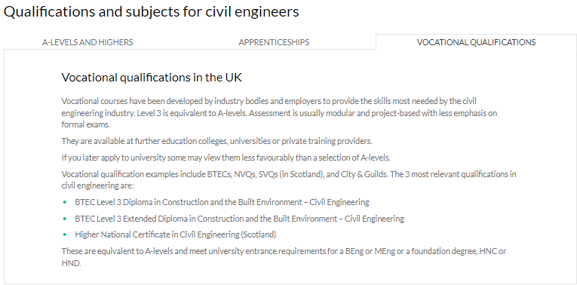

Chapter 2

Over the last few months I’ve been working to my goal of becoming a Senior Engineering surveyor. Since working for Griffiths, its helping me achieve my goal and gain the experience, training and knowledge to become a Senior Engineering Surveyor. As being on the A40 Bypass Project in Llanddewi Velfrey I’ve learnt many and done lots of new things. My role on site is as a Section Engineer, this means I’m in charge of a portion of the scheme. With this role I’m doing all forms of work from management, supervision, surveying, setting out and record keeping. I’ve been helping with doing RAMS, Permits to Dig and supervising workforce as well as a Graduate engineer as he’s green to the industry. These are helping me gain confidence and more responsibility as I’m becoming more able to confidence in speaking to Agents telling them information I’ve gotten from site and the workforce giving them orders and telling them what they need to do and how to do it safely. One of the other roles I carry out is taking records such as photographs of the work being carried out, pre-conditional photos and just general records and storing them on the site SharePoint and managing the photos everyone puts on there as organizing them into year, month and weekending .
Furthermore, on the project I’ve been using and gaining more experience on the engineering equipment we have and drawing up surveys and sending them off to the Senior Engineering Surveyor on site or Design Manager. Also, asking the right questions and working with Topcon and Sealand Survey who supply us with our equipment and software. As been having one to one training with them on the software and then having time to play with it and trying out the different functions on it. I’ve also been making my own Code Library on the software to suit the coding we use when we are surveying rather than Topcons as its general. The purpose of this is to make uniformity with all the engineers and graduates on site so that we are all using the same codes and can read any survey or drawings the other has produced.
On the project, we hired 2 graduates to be Chainpersons for the engineers. As I’ve been teaching them about the equipment how to use them, the functions and modes on them which we can use. Then showing them what to survey and pick up and that as a surveyor your drawing a map for someone else to look at and read as that’s the many role of a surveyor creating a map of what you see for someone else. I’ve also, talked to them about what there goals are and about going into ICE either going up the ranks or going straight to chartership. As for myself I’ve started my application for the Engineering Technician aka EngTech so then can start my journey to Chartership.
Outside of Griffiths, I’m on the Graduate and Student Committee of South West Wales ICE. So I’ve taken part in meetings and carried out talks with a few of the members and now organizing an event in University of Wales Trinity St David for my fellow peers. I’ve also now taken the role of Sponsorship Lead for the Engineering Team Challenge which is an event that ICE’s Graduate and Student Committees carry out for schools and colleges to take part in and compete for a prize. My role is to get in touch with companies to sponsor the event and help us run it and make it successful as covid has stop it from happening the last 2 years. This is helping me get better understanding of budgeting, expenses and overheads. Being part of the committee now has taught me new skills and improved my current ones as how to take lead of my own talks/events, managing cost and organisation skills.

