


Research Proposal
Smart buildings and Internet of Things (IoT)
Project’s supervisor: Dr Mabrouka Abuhmida
Student Name: Mohamad Wael Baghdadi
Student Number: 1708309
Course: Software Engineering
Due Date: 3rd May 2019

Table of Contents
Table of Contents 1
Table of Figures 2
Abstract 3
1. Introduction / Background to the proposed 3
1.1 Introduction 3
1.2 Research and project title 3
1.3 The background to the subject 3
1.4 Why smart building 5
1.5 Field of study 5
1.6 Aims and Objectives 5
1.7 Expected outcomes and/or deliverables 6
➢ Minimum expected 6
➢ Expectations 6
➢ Expanded 6
1.8 Conclusion 6
2. RESEARCH & DEVELOPMENT METHODS 7
2.1 Introduction 7
2.2 Research Methodology 7
2.2.1 Research philosophy 7
2.2.2 Approach 7
2.2.3 Strategies 7
2.2.4 Generalisability, reliability and validity 7
2.3 Data collection methods 8
2.4 Development methods 8
2.5 Risks analysis 9
2.6 Conclusion 9
3. Resources and planning 10
3.1 Introduction 10
3.2 Resources required 10
3.3 Project planning and management 10
3.4 Conclusion 12
4. References: 13
5. Bibliography 14
Appendix I 15

Table of Figures
Figure 1: IoT vs. IoE vs M2M vs others[4]. 4
Figure 2: Control smart building via smartphone[9]. 6
Figure 3: Research choices and the research process "Onion"[10]. 8
Figure 4: Waterfall in development method[14]. 8
Figure 5: The heading of the Project planning Gantt chart 10
Figure 6: The whole project planning schedule Gantt chart. 11
Figure 7: Gantt chart graph1 11
Figure 8: Gantt chart graph2 12

Abstract
In this report, the author has defined the project proposal for the final year project, including the aim and objectives and what he expected to deliver. In addition, the research and development methodology has been included, along with the expected risks that might occur during the project’s implementation. In the final section, the project report’s author has included the required resources that would be important in getting the project delivered. As detailed planning is an important step, the author has included his planning section with creation of Gantt chart for each section in the project.

Introduction / Background to the proposed

1.1 Introduction
In this section the author has highlighted to the background of the project proposal in a few steps starting from the history and why this project is important, then the aim and the objectives have been defining for the project with the expecting outcomes in the final step which the author has defined them to be as minimum expected, expectant and expanded

1.2 Research and project title
The title of this research and project is: Smart buildings and Internet of Things (IoT)

1.3 The background to the subject
The name ‘smart building’ seems like a modern idea but, in fact, the concept’s origins go far back in history, most likely to the 17th century when Cornelis Drebbel invented the automated heating, ventilation and air conditioning (HVAC) system. One of Drebbel’s innovations was a mercury thermostat that was able to maintain the space around it at a constant temperature automatically. This invention was the forerunner of the modern-day air circulatory system, as it relied on a feedback-controlled machine to set a building's environment. Drebbel also developed the first known system of air conditioning, as he used salt as a cooling instrument. Furthermore, based on Drebbel's ideas and his projects relating to the thermometer, a French scientist named René Antoine Ferchault de Réaumur invented a temperature-controlled incubator in the 18th century. In the 20th century, the invention and development of digital computers, which were an important element of the progress made in the technology of modern buildings, prompted a wide-scale integration of technologies (heating units, lift compressed air) into a building and at its core. This is what produces a smart building and the automation of modern buildings that we see today[1][2][3].
The definition of the Internet of things (IoT) is: actuators and Sensors embedded in physical objects are connected through wired and wireless networks, and usually, it uses the same internet protocol(IP) to connect to the internet[4].
The Internet of Things considered as new innovations as well, The expression the “Internet of Things” has existed for around 20 years, but the real concept of connected devices was first developed in the 1970s. The concept was called "pervasive computing" or "embedded internet", but the actual expression "Internet of Things" was termed by Kevin Ashton in 1999, while he was working for Procter & Gamble.
In the summer of 2010, the concept of the Internet of Things began to become more popular when some information was leaked that Google's Street View service had stored massive amounts of data relating to people's WIFI networks and had not just made 360-degree pictures. In addition, in the same year, the Chinese government declared that they would make the Internet of Things a strategic priority in their Five-Year-Plan.
in 2011, the market research company Gartner, Inc. invented the famous "Hype Cycle for Emerging Technologies" in which they included a new phenomenon on the list, called the Internet of Things. In the following year, the Internet of Things was the main subject at the biggest internet conference in Europe, called LeWeb. At the same time, the famous and popular tech-focused magazines, such as Wired, the Fast Company and Forbes, began to use the Internet of Things as their vocabulary to describe the phenomenon. Furthermore, at the end of 2013, a report was published by the International Data Corporation (IDC) stating that the Internet of Things market would be an $8.9 trillion by 2020. In 2014, Google announced that it was buying Nest for £3.2bn, whereby the Internet of Things reached mass market awareness[4][5].
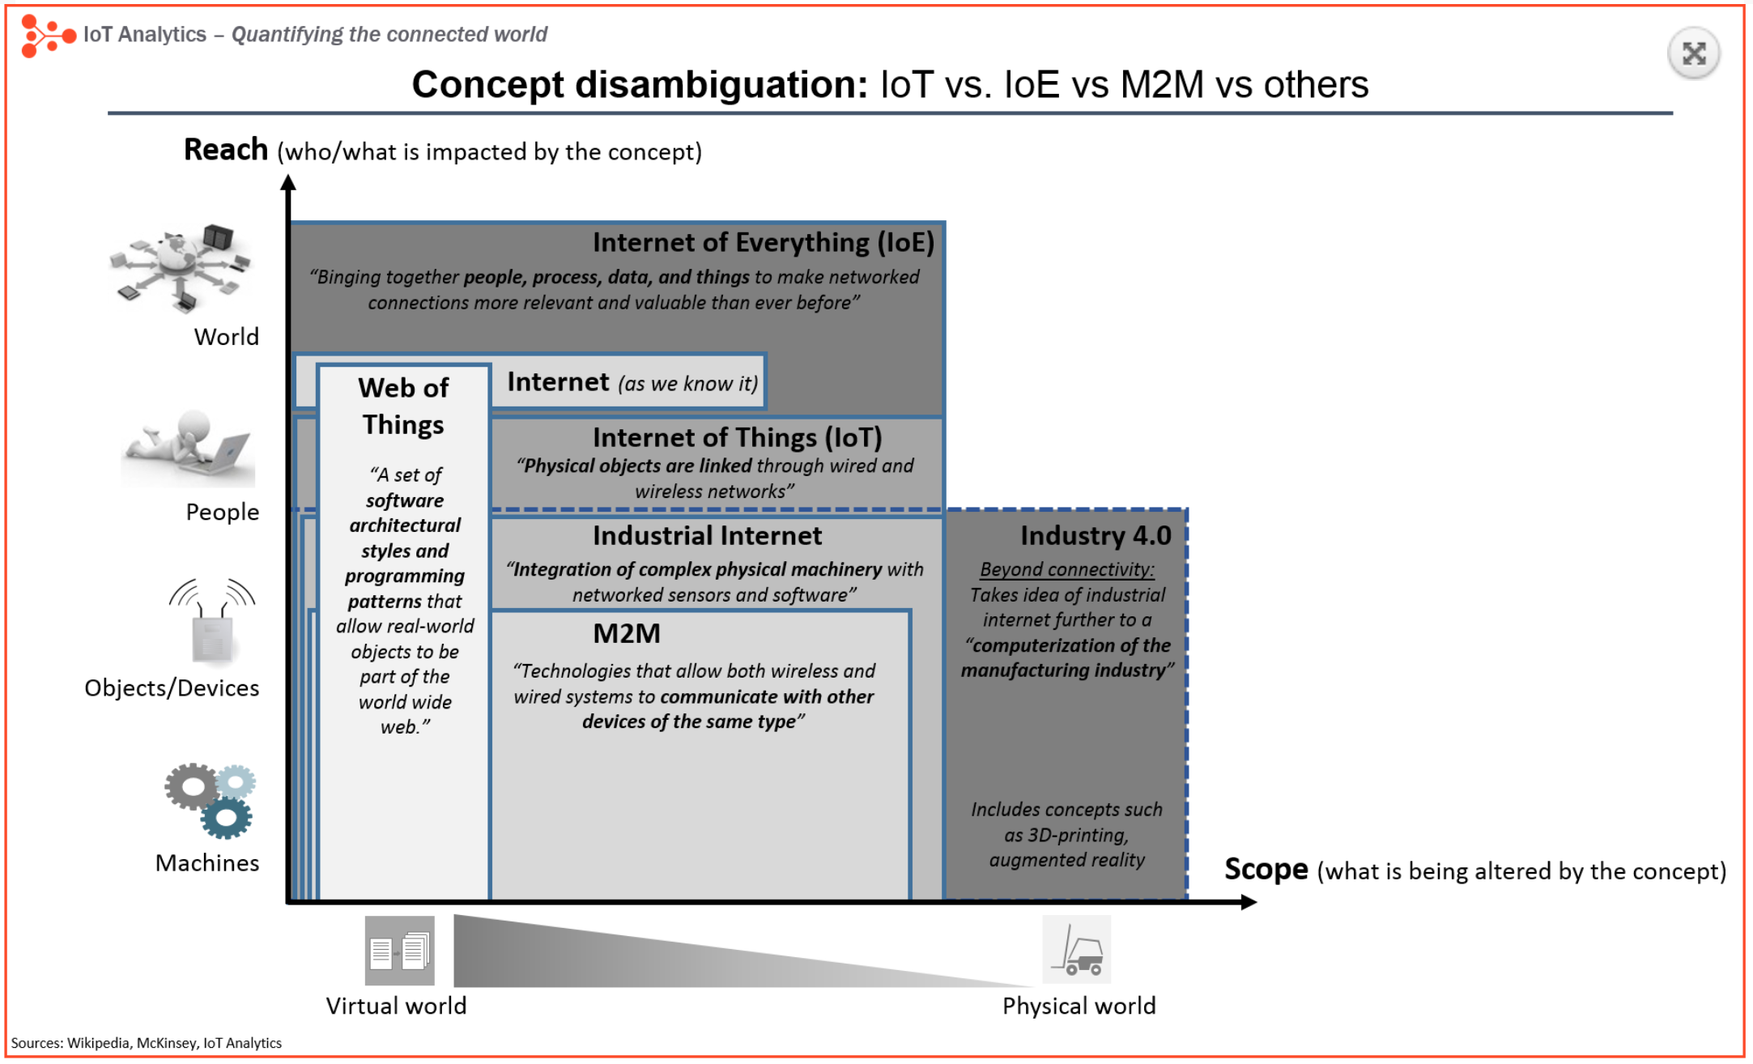
Figure 1: IoT vs. IoE vs M2M vs others[4].
If we go back again to the smart buildings, we can notice that, currently, some of the most amazing innovations in the field of smart building technology have to do with the ways in which the Internet of Things, data mining and even data-driven management are being inserted into the current systems. All those things can be cost-effectively retrofitted to old buildings, which can allow the owners to make a safe and welcoming environment to meet the users' requirements. The systems and devices are connected to the internet across buildings by the Internet of Things, which can transform previously inefficient collections of objects into an effective information system. The smart building technology is like the central nervous system of humans, whereby this technology can localize into a building automation system (BAS), which can be connected and monitored, in order to optimize total performance. This system is responsible for controlling and monitoring the buildings' facilities systems, from electricity to mechanical systems, to plumbing, lighting, water and HVAC [1].
At the beginning of the 21st century, the technology for smart buildings and building automation has risen significantly. The market in building automation and smart building technology has continued to increase, meaning that more homeowners and businesses have seen the benefits of adding sustainable and energy-efficient system to their construction. The smart building field today ranges from intelligent and automated HVAC systems, to identification security systems and, also, many of these features today can be operated remotely and controlled from smartphones and tablets or even from computers [3][6].

5 success smart buildng in the world:
- The Gates’ Home, Washington
- Capital Tower, Singapore
- The New York Times, New York
- The Edge, Amsterdam
- Beijing Airport, T3 Terminal[7].

1.4 Why smart building
The smart building is a technology and service that allows PSPC to monitor, track and reduce energy use and improve the overall building effectiveness. It reduces greenhouse gas emissions and lowers operational costs and even identifies the building’s operational problems so that they can be solved quickly.
The smart building continuously gathers raw data from devices that control a building’s ventilation, heating, hot water, air conditioning, lighting and heating systems. The information collected is then transferred to a cloud and the service provider analyzed and provides recommendations to solve potential operational and reduces greenhouse gas emissions with lowering operational costs and even it identifies the building operation problems so they can be solved quickly, the smart building constantly gathers raw data from devices that control a building’s ventilation, heating, hot water, air conditioning, lighting and heating system, and the information collected is then transferred to a cloud and the service provider analyzed and provides recommendations to solve potential operational issues[8].

1.5 Field of study
This project’s aim is to discuss the benefits of the smart building with the Internet of Things in the technological revolution with an analysis of its mechanism of action at the industrial level. Building and implementing a sample of a smart building using the Internet of Things and an Arduino kit will provide greater opportunity for the user to identify the smart building’s importance and how this technology will affect our daily lives, from reducing energy bills to security, to helping the environment and even highlighting the effect of the Internet of Things on sustainability.

1.6 Aims and Objectives
The study’s aim is to provide and implement a sample of a smart building with the Internet of Things that can be used in homes, businesses, universities or any type of building that wishes to:
- Preserve more energy that negatively impacts the environment.
- Reduce wasted energy in unused or unnecessary situations.
- Save users time and effort in controlling energy.
- Facilitate security systems by using the application in smartphones.

The study’s objectives are:
- To investigate what the smart building is and the impact of the Internet of Things.
- To analyse and evaluate the benefits of using the Internet of Things in the smart building.
- To design and build a basic scenario of a smart building based on Raspberry Pi or Arduino.
- To introduce a security system that can use with smartphone applications.
- To automate energy and HVAC based on a schedule.

1.7 Expected outcomes and/or deliverables
The expected outcomes at the end of the project will be an investigation of the importance of the Internet of Things, with a basic scenario of a smart building that will meet the users' requirements and needs, through which the author has divided the project into several parts:

Minimum expected
The minimum expected from this project will be a complete research work that investigates and analyses the benefits of smart buildings and the Internet of Things in terms of how they work in our lives

Expectations
The outcome will be building and designing a smart building, including some functionality, such as controlling lighting and heating systems, security systems and others that will link and be controlled by a smartphone.

Expanded
The extended means that if the author has more time and completes all the minimum expected tasks and the expected outcome, he will add more functionality such as face recognition or opening the door lock using the QR system

1.8 Conclusion
In this section, the author has discussed the project’s background and the history of the smart building and the Internet of Things, providing the benefit of this project and what the aim and objectives of implementing this project are by dividing the study into several steps and what the expected outcomes are at the end of this project.
In the following section, the author discusses the research and development methods and what the risks will be in this project.
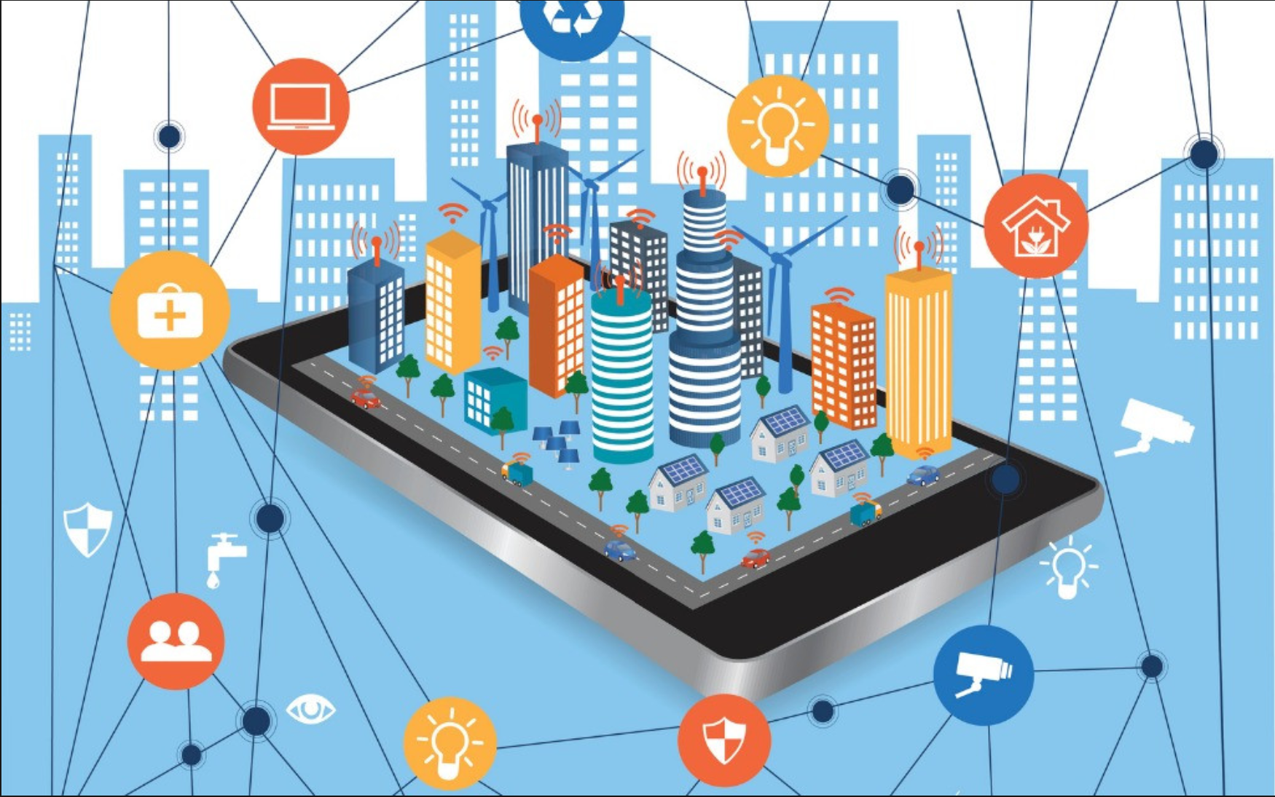
Figure 2: Control smart building via smartphone[9].

RESEARCH & DEVELOPMENT METHODS

2.1 Introduction
In the first section, the background for the project proposal has been defined with the aim and objectives of the project. and in this section, the author has set the research methodology of this project and what the development methodology needs to follow, also the expected risks have been locating to be considered to avoid it and to work out for the project more smoothly.

2.2 Research Methodology

2.2.1 Research philosophy
It is very important for the project’s author to identify and decide upon the appropriate research methodology to follow while implementing his project. the common research methodology is positivism and phenomenology whereby this method is focused more on facts in a systematic way and measures and evaluates phenomena to present a rational explanation. In addition, positivism considers that human behaviour can be explained as a straight system by studying the factors that affect them. Examples of the positivistic method are experimental studies or software development.
The alternative philosophy in the research methodology is the phenomenology, which is considered human behaviour, which is unpredictable. In addition, phenomenologists consider that human behaviour cannot be measured due to different factors that motivate them. The phenomenological research counteracts by affirming that variables affecting an individual are really wide ranging that interact at the same time with others. Enormous numbers of factors cannot be arranged or predicted, and the example of the phenomenology method is like a case study or survey.
According to that the above, the author has decided that the best philosophy in the research method that meets his project's aim is positivism, as this project will lean more towards software development, which will include the design, development and testing of the smart building with the Internet of Things.

2.2.2 Approach
The author has decided that the approach in the research methodology is deductive, as this approach specifies testing a theory by locating a hypothesis and then aggregating the data to test that hypothesis, while the inductive approach allows the building and evaluation of generic theories based upon particular examples.

2.2.3 Strategies
For the strategies section in the research methodology, the author has decided that the appropriate research strategy for this topic is the software development, as this strategy covers developing novel software and testing that it works effectively, Furthermore, this project will design and build a database that will link it to the system to act as a scheduling system, and the other strategy that related to this project document review which this strategy indicates to the literature review that the author of the project need to do it through implementing the project and also this strategy identifying the main theories and positive and negative of using the IoT with smart building and in the field of the project.

2.2.4 Generalisability, reliability and validity
In relation to the generalisability, the project will be able to be applied at any time and anywhere and will be implemented according to analysing the data and converting and testing the data in relation to an actual project. In terms of reliability, the project would deliver and provide the same results once it has finished even if it was run again or by a different researcher, unless the programming codes have not changed,
and for the validity, the project will be more ley to software development where the project’s success lay in testing and validating the code to programme the kits.
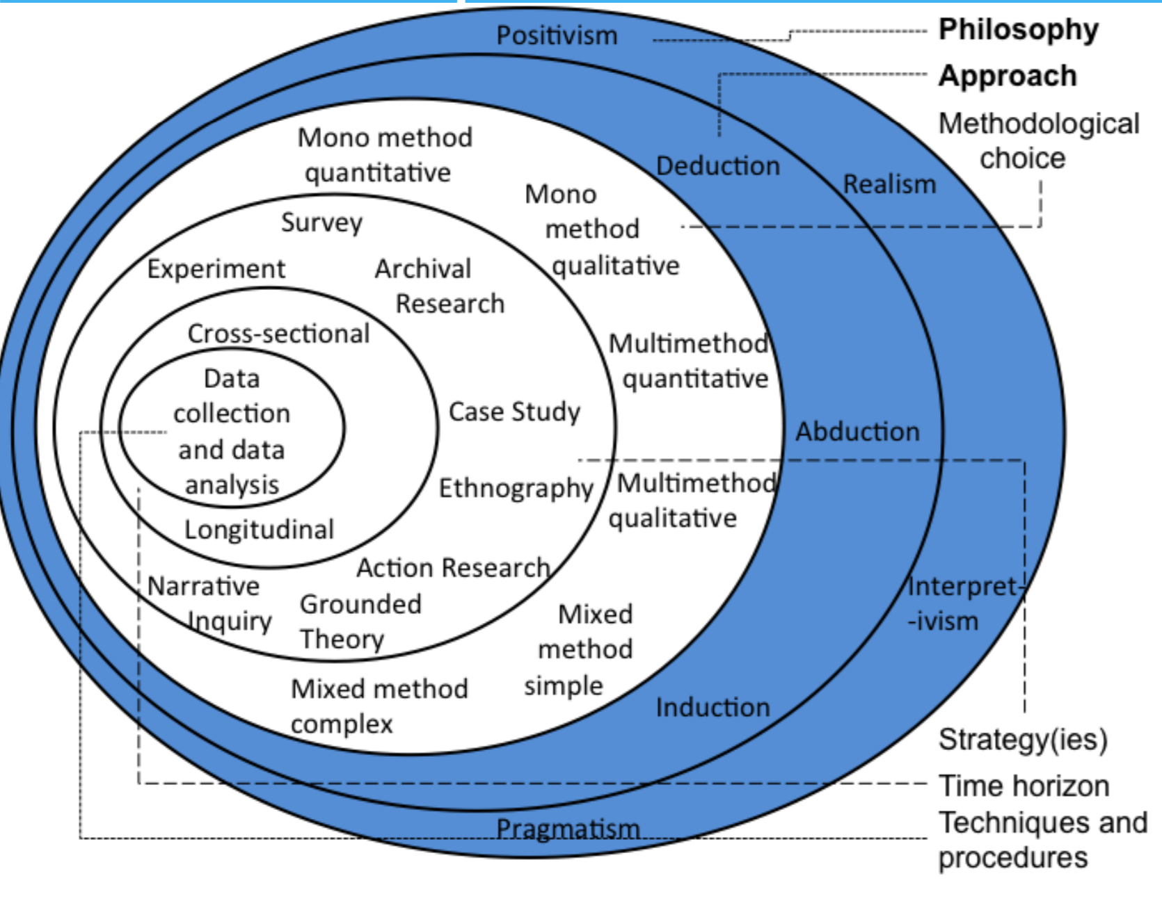
Figure 3: Research choices and the research process "Onion"[10].

2.3 Data collection methods
In terms of the data collection methods for this project, the author has identified that this project was more inclined to quantitative data collection research, which is used to quantify the issue by creating numerical data or transforming the usable statistics from data. In addition, the quantitative research was used to discover patterns and to formulate facts in research using measurable data which the quantitative collection data research are considered much more organized rather the qualitative data collection method, which this one is considered as an exploratory research and used to discover trends in opinions and thoughts[11].

2.4 Development methods
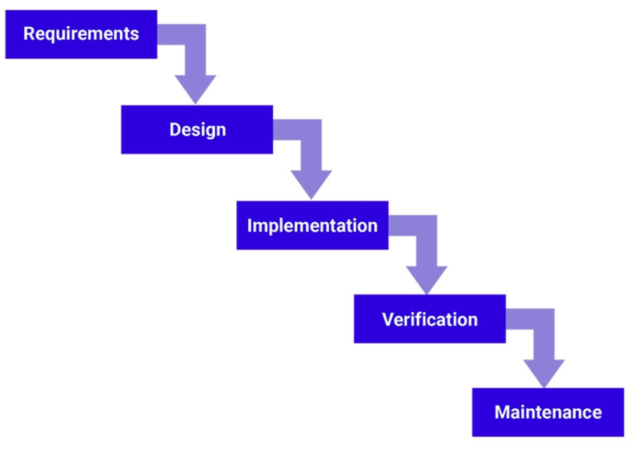
According to the author’s research, the best development methodology for this project is the Waterfall Method in which it is considered a traditional software development method and is a sequential development approach as it starts with analysing the project, then determining what the software requirement specifications are to implement the software design and once the software design has done the testing take the second part will be testing for the software, Therefore, the pros of this approach are that the linear and rigid nature of this method makes it easier to understand and manage. In addition, this method can save a significant amount of time for the project’s author[12][13][14].
Figure 4: Waterfall in development method[14].

2.5 Risks analysis
As with any project, there are several issues that faced the authors during the implementation of their projects. However, by identifying these risks and analysing how they will affect the project, and with the expectation of the occurrence the become less risk to the project and more possible to avoid. So, the author has identified the risk of this project as follow:
- Not finding lots of resources as it's a nearly new topic
- Achieving different results due to electronic or programming errors
- Lack of time and time management due to other responsibilities and assignments
- Not achieving all the requirements due to unrealistic plans
- The limitations of the knowledge in this topic
- Personal emergency or illness in the implementation time
F or these risks, there are many ways to avoid as much as we can, which for the lack of time and time management, the author will work more over the summer to finish at least the researches and as he mentioned there are not lots of resources because this topic is nearly a new topic, he decided to use as much as he can from the internet and YouTube and other related projects.
and when considering the limitation for the project, the most considerable would be not having the skills and management to be able to create the project due to lack of knowledge, it may over time be likely to gain the skills through self-learning.

2.6 Conclusion
As a result, in this section, we can see that the author has identified the philosophy in the research methodology to be positivism with a deductive approach and for the project’s strategy step the project lean to be software development with a document review In addition, a quantitative research method was chosen for the data collection and the author has located in this section several risks that need to be considered during the project term.

Resources and planning

3.1 Introduction
The important way to succeed in any project is by planning and the main element in this section is the planning and setting what the required and important resources are that are needed by the author to implement the project and to define the timescale by creating a time management sheet to follow during the implementation time.

3.2 Resources required
The author has identified the required resources to implement and achieve success in this project in the following:
- Arduino Development Boards & Kits - to implement a smaller scenario of smart building
- Laptop/PC – to be used to program the Arduino kits
- Arduino IDE software programme – to programme the Arduino kits
- Access to internet – to be used for researches
- Books in the same field area – to be used for researches
- Smart phone – to download some specific application to be used for the project
- SQL server/MySQL – might need to hold the database
The project might need other resources during the implementation time

3.3 Project planning and management
In this section, the project planning and management has been defined which the author will be starting his project from June to get more ideas over the summer and to research more field subject, and even give more time for the implement the template, so here some screenshots of the planning steps with starting and finishing dates.
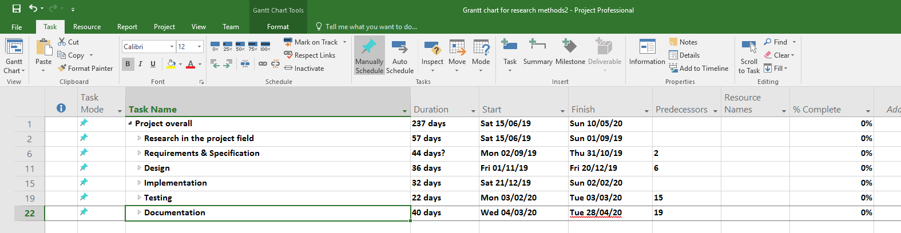
Figure 5: The heading of the Project planning Gantt chart

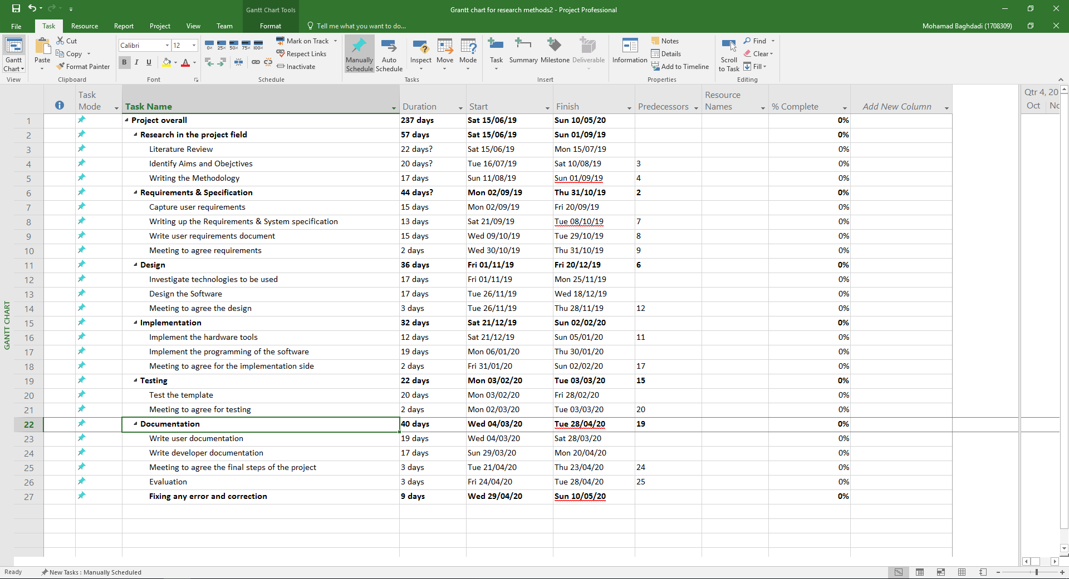
Figure 6: The whole project planning schedule Gantt chart.


Figure 7: Gantt chart graph1

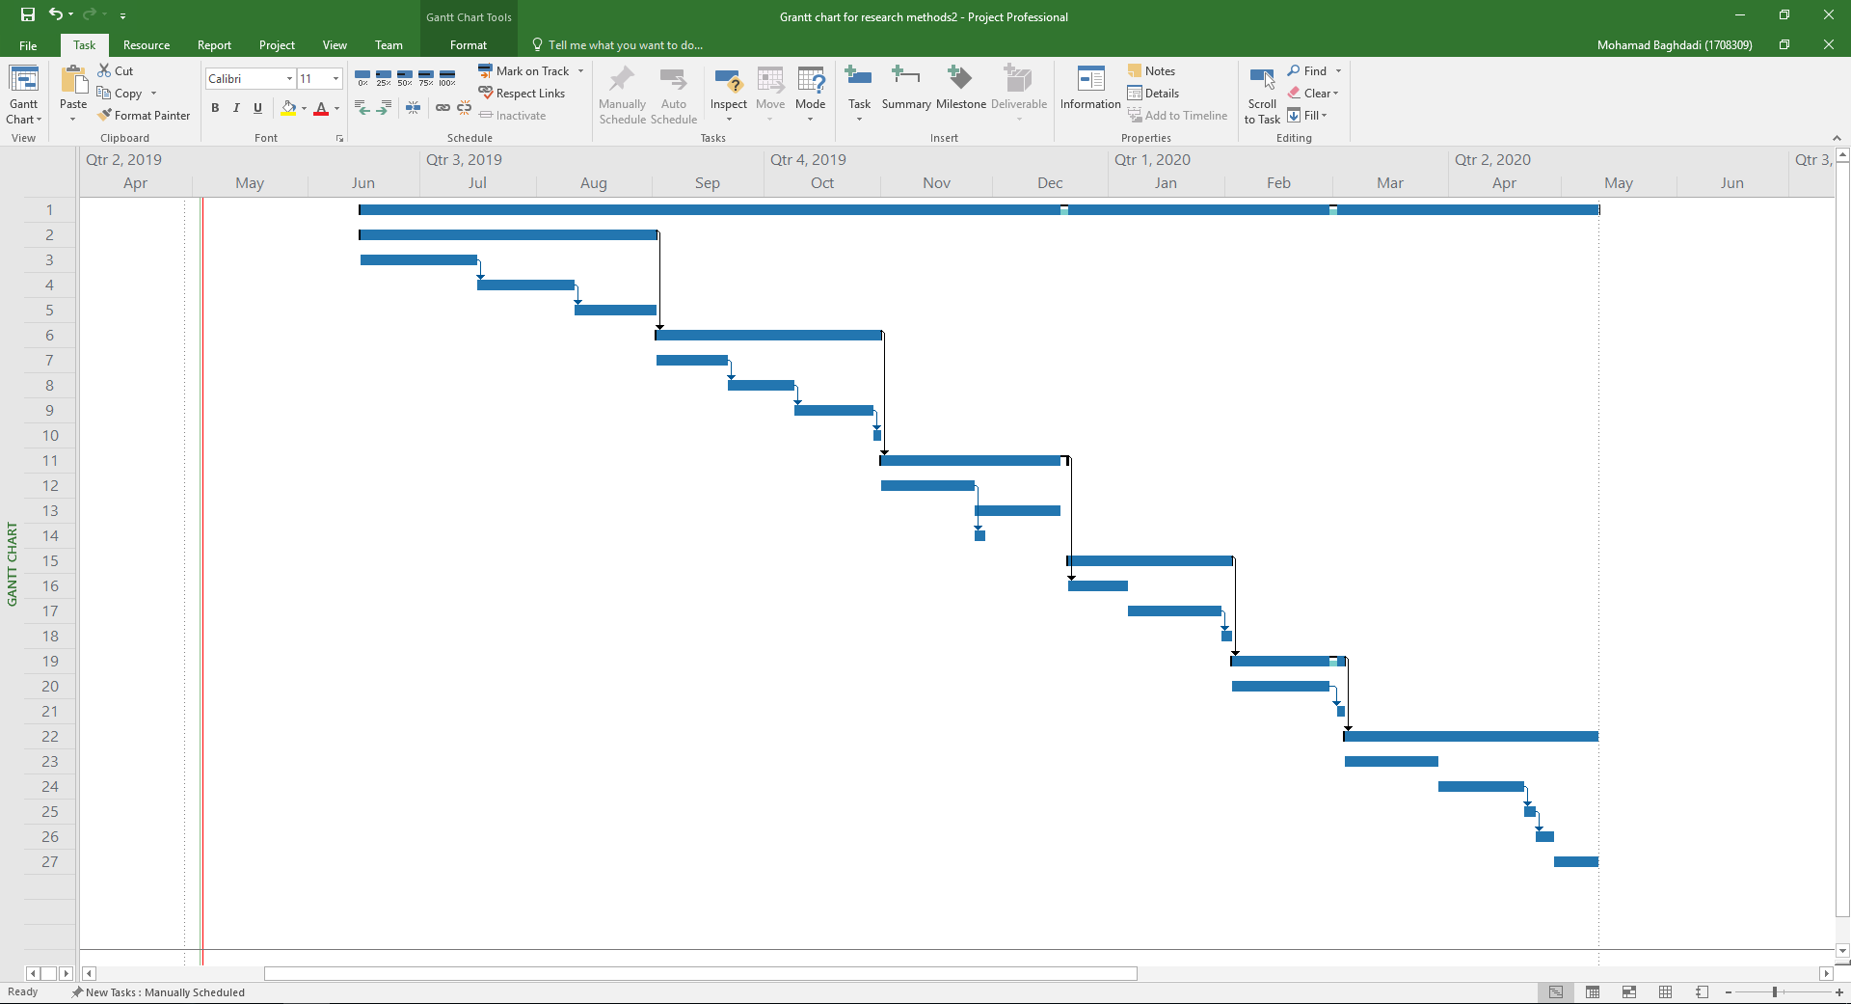
Figure 8: Gantt chart graph2

3.4 Conclusion
In the conclusion of this section, the author has defined what resources are required for his project but, in the same as any other project, the author might need to use other unexpected resources, which will be required for the projects’ In addition, he defined the project planning using the project management tool to set the Gantt chart and to create a timescale for the project; however the Gantt chart and timescale are hypothetical and they might vary, due to unexpected things happen during the implementation time.

References:
[1] W. B. Spillman, “The evolution of smart structures/materials,” in Control Solution Inc, 2017, p. 21.
[2] M. Rouse, “What is smart home or building (home automation or domotics)? - Definition from WhatIs.com,” IoT Agenda, 2018. [Online]. Available: https://internetofthingsagenda.techtarget.com/definition/smart-home-or-building. [Accessed: 26-Apr-2019].
[3] “A Brief History of Smart Buildings – acs smart buildings.” [Online]. Available: https://acssmartbuildings.com/a-brief-history-of-smart-buildings/. [Accessed: 24-Apr-2019].
[4] Knud Lasse Lueth, “Why the Internet of Things is called Internet of Things : Definition , history , disambiguation Internet of Things definition Why Google ’ s Internet of Things definition is inaccurate,” IOT Anal., vol. 1, no. 9 Dicember 2014, p. 1, 2015.
[5] B. M. Leiner et al., “A Brief History of the Internet,” Baseline, p. 1, 1999.
[6] A. H. Buckman, M. Mayfield, and S. B. M. Beck, “What is a smart building?,” Smart Sustain. Built Environ., vol. 3, no. 2, pp. 92–109, 2014.
[7] “5 success smart buildings in the world | BIMCommunity.” [Online]. Available: https://www.bimcommunity.com/news/load/710/5-success-smart-buildings-in-the-world. [Accessed: 27-Apr-2019].
[8] “Smart buildings initiative – Greener federal buildings – How the federal government manages property – Federal properties and buildings – How government works – Canada.ca.” [Online]. Available: https://www.tpsgc-pwgsc.gc.ca/biens-property/intelligents-smart/index-eng.html. [Accessed: 27-Apr-2019].
[9] “IoT and the energy ecosystem - key smart utility challenges to consider | Engerati - The Smart Energy Network.” [Online]. Available: https://www.engerati.com/smart-infrastructure/article/utility-communications/iot-and-energy-ecosystem-key-smart-utility. [Accessed: 28-Apr-2019].
[10] 抱井尚子, “Mixed methods researchの新たなる夜明け,” 看護研究, vol. 47, no. 3, pp. 183–193, 2014.
[11] L. Slevitch, “Qualitative and quantitative methodologies compared: Ontological and epistemological perspectives,” J. Qual. Assur. Hosp. Tour., vol. 12, no. 1, pp. 73–81, Feb. 2011.
[12] Synopsys Editorial Team, “Top 4 Software Development Methodologies | Synopsys,” Synopsys, 2017. [Online]. Available: https://www.synopsys.com/blogs/software-security/top-4-software-development-methodologies/. [Accessed: 30-Apr-2019].
[13] I. Korkishko, “Top 6 software development methodologies,” DEV, 2017.
[14] K. Jasmeer, “12 Best Software Development Methodologies with Pros and Cons,” Acodez, 2018. [Online]. Available: https://acodez.in/12-best-software-development-methodologies-pros-cons/. [Accessed: 30-Apr-2019].

Bibliography

[15] S. Drewer and D. Gann, “Smart Buildings,” Facilities, vol. 12, no. 13. pp. 19–24, 1994.
[16] H. Barzilai, “Finiteness properties for handlebody mapping class groups,” 1997.
[17] A. M. Cornelius Pieper, João Maciel, Romain de Laubier, Marius Wunder, “A Guide to the Revolution in Smart Buildings,” 2018. [Online]. Available: https://www.bcg.com/en-gb/publications/2018/guide-revolution-smart-buildings.aspx. [Accessed: 01-May-2019].
[18] “Building Whisperers Aid Digital Transformation of Buildings - Building Automation Coverage.” [Online]. Available: https://www.facilitiesnet.com/buildingautomation/contributed/Building-Whisperers-Aid-Digital-Transformation-of-Buildings--42006. [Accessed: 01-May-2019].
[19] R. L. Mitchell, “The Rise of Smart Buildings - Computerworld,” Computerworld, 2005.
[20] G. I. Fântână and S. A. Oae, “Evolution of Smart Buildings,” in Proceedings of the 2013 International Conference on Environment, Energy, Ecosystems and Development, 2013, pp. 223–225.
[21] “Smart Building Automation Evolution-Timeline.” [Online]. Available: https://www.tiki-toki.com/timeline/entry/929813/Smart-Building-Automation-Evolution/#vars!date=1985-04-03_07:44:48! [Accessed: 01-May-2019].
[22] R. M. Davidson and C. Lindner, “Chapter Three : Research Methodology,” City University of Hong Kong, no. June. pp. 1–20, 2004.
[23] L. Koskela, G. Howell, G. Ballard, and I. Tommelein, “The foundations of lean construction,” in Design and Construction, 2007, pp. 211–226.

Appendix I
The author has read and used other resources to implement his project proposal from[15],[16],[17],[18],[6],[19],[20],[21],[22],[23],

