Student Name : Rebecca Erin Herbert

P Number :1902294

Programme of study : Photojournalism & Documentary

Module : M4X01560

Tasks in the order I received them in:

Task one Ryan Moule task semiotic analysis of an image= 433

Task two Julia Lockheart manifesto = 302

Task three Jon Pugh -reflective writing =297

Task one Ryan Moule task semiotic analysis of an image
Semiotics means that you can have one picture with multiple meanings depending on the person that is looking at the picture's outlook on life.
Semiotics tries to get you to change your opinions regarding your reality on life, for example in the picture described above, most of the images have a double meaning.
There is another good example called Plato Cave, where the prisoners are chained facing a wall all their lives and watching shadows been cast on to the wall from objects passing in front of the ‘fire’, when they break free they find out that their reality wasn’t a reality, it was just objects been casted as shadows, hence breaking their version of reality.
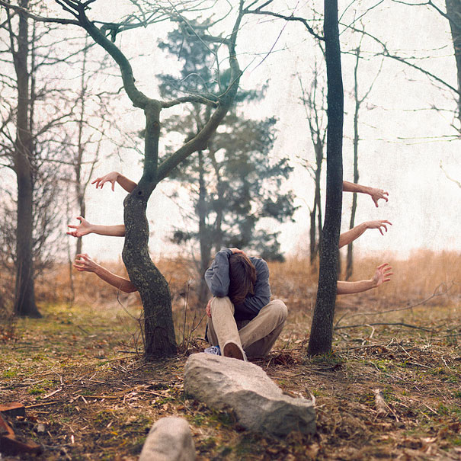

This is a semiotic analysis of a photo by Kevin Corrado. In this image I see a young person sitting in a forest with one hand on their head and the other on their knee. He is surrounded by trees and two of the trees have arms and hands coming out of them and then the other trees are mostly bare apart from one in the background. There are also two rocks in front of them.

There are many things that the image could mean or it could lead back to a mental health problem. He is sitting in a position that could suggest that he is sad or he is feeling alone, and with the hands coming out of the trees, it could suggest that they are their inner demons trying to come out and mess with their head. In the photo the trees are bare and this could represent the fact that they feel like they are alone and have no-one in their life, but the tree in the background could be hiding them as it's not bare. It could mean there is someone he doesn’t know about looking out for him and is seeing what is happening to him. There are two rocks in front of him, that is how he could get to where he is now, or it could be the fact that he keeps tripping over in life and he can’t find his way so he keeps stumbling.

The way the person is hiding their head could mean that they are hiding their real self or it could mean they are hiding from the world. If you see rocks in your dream then it could be associated with your ‘stability, steadiness and

firmness’ (https;//www.auntyflo.com/dream-dictionary/stone) It could also mean the exact opposite of those feelings as well.

Bibliography
https://mydreamsymbolism.com/
Access the 22 of december
Website name my dream symbolism
Date unknown
https://www.auntyflo.com/dream-dictionary/stone?fbclid=IwAR339-qccldRMFNtHNQvgWNd9QKY_f-C71yx9vLj697YXrDESRiqXwkYrRg
Access the 1st of january
Website name auntyflo
Date unknown

Task two Julia Lockheart manifesto

1) Always make sure that you have people’s permission before you take their picture because they may be insecure, and it would affect their mental health.

2) I will always try to tell the truth through my pictures, because in the age of fake news and false images, I would like to stand out as the beacon of truth.

3) I will try and tell a story through my images, as the more emotion I put into an image the more the onlooker will hopefully feel.

4) I will try and be as creative as possible, because the more creative the more appealing the image will be.

5) I will always try and put my prospective into my pictures.

6) I will try not to rush my photos.

7) I will accept constructive criticism and try not to take it to heart.

8) I want to change the world for the better through my pictures.

The first statement I want to talk about is number 2
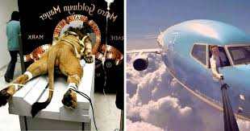
Keywords “fake images /fake news”
“I will always try to tell the truth through my pictures, because in the age of fake news and false images, I would like to stand out as the beacon of truth”

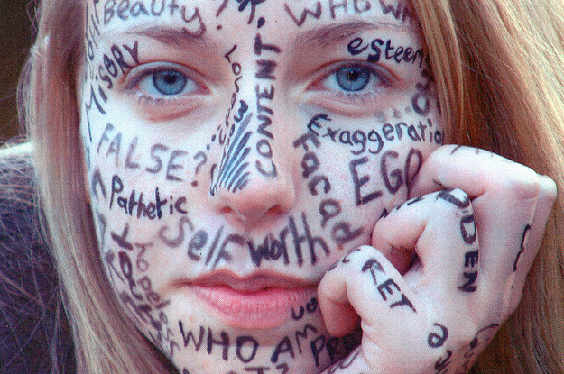
Because we are in an age of false news and fake adverts, we have become numb to seeing children in poverty and neglect as it splashed on our screens constantly, I would like to get people to realise that for us as onlookers then its just an image, but to the people going through it then it is real and I would like to make people more aware of it.
Keywords (insecure)

“Always make sure that you have people’s permission before you take their picture because they may be insecure, and it would affect their mental health”

This one is important to me because I know that I don’t like my photo being taken without my permission, upon seeing that image, it has affected my mental health a lot and I don’t want to put anyone else though that.
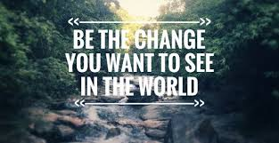
Keywords ( save the world / change)

“I want to change the world for the better through my pictures”

I would like to change the world through my pictures as there is too much emphasis put on the bad news cases in the media, I want to put the good news in the public focus for once, and as we have seen a good ‘bad’ photo go viral, I want to get a good ‘good’ image go viral as well. Another thing I want to point out to the world in my pictures is that there is more going on in the world, for example last year the amazon rain forest was burning at the same time as Notre Dame was burning and nobody reported the amazon rainforest.

Bibliography
https://www.elitereaders.com/30-fake-viral-photos-that-we-believed-were-real/
Access the 4th of janary
Website name elitereaders
Date unknown
https://zarawall.com/2017/08/09/handbook-of-the-insecure-2/
Access the 4th of jan
Website name zarawall
Date 9th of august 2017

https://www.solon.eco/right-here-right-now-solon-is-just-beginning-to-change-the-world
Access on the 4th of jan
Website name solon.eco
Date May 24, 2019
The sources of the images

Task three Jon Pugh -reflective writing

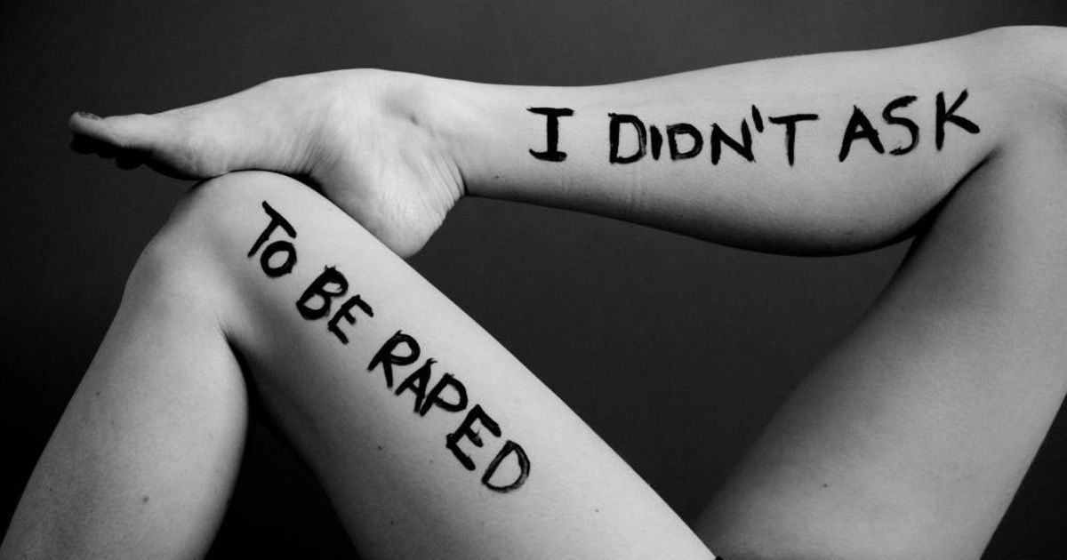
In this photo I can see a pair of legs with “ I didn't ask to be raped” on them. They are also in a seductive position. This picture is very powerful for me because it is something every woman and girl has to be constantly aware of. We are constantly being taught that men are superior to women and that we need to “ cover up” so that boys don't get distracted by girls for example a 5 year old girl got told to “cover up because her summer dress too revealing” - https://www.thesun.co.uk/fabulous/8917151/girl-told-cover-up-teachers-dress-revealing/
This so wrong and stupid in many ways, and that is what Liora K thinks too, she belives that
“I’m a feminist because I can’t live in a world where I am defined, limited, and categorized by my genitalia, where women are objectified beyond reason, where rape culture thrives, and where these injustices (and more) are so blatantly ignored and denied by so many people”
- Liora k
This is why I chose this image because it is so powerful yet so simple.
After discovering more about this photo I saw that she wanted to see an “artistic response” to the
“ all the attacks on birth control, abortion rights, equal pay, and retractions of protections for survivors of domestic violence”
- Liora K
Which she did herself and what is interesting is that she got most of the words and phrases from talking to the models themselves and doing this had helped her realize how much of a fenminsit she is. Now looking back at the images after doing the research on them has just boosted the power of it all for me and it has inspired me to do something along these lines to help raise awareness for it.

Bibliography
https://www.liorakphotography.com/feministphotos
Access on the 5th of jan
Website name liora k photography
Date unknown

https://www.thesun.co.uk/fabulous/8917151/girl-told-cover-up-teachers-dress-revealing/
Access on the 5th of jan
Website name The sun
Date 23 april 2019

