University of Wales Trinity Saint David School of Engineering

Analysis of Power Generation Cycles & Application of Compression-Vapour Cycle

Thermofluid Mechanics
ACMA5011

Nathan Scott Morgan (1902731)
10th of January 2021

Table of Contents
1 Introduction 1
2 Part A 2

13
3 Part B 14
3.1 Reheating 14
3.2 Reheating Steam Turbine 14
16
3.3 Water Injection Gas Turbine 16
4 Part C 18
19
5 Conclusion 19

Introduction
In today’s times, travel is especially for almost everyone. Whether you’re on your way to work or whether driving is part of your job. It has almost become essential, with cars owned for each individual on the rise across the U.K. It is increasingly important that we know and understand the importance on making efficient and reliable vehicles as well as other systems that may require an engine or turbines. The more challenged engineers become over solving issues such as thermal efficiency, the more engineers will try and find alternative solution, which provide a new outlook, this can lead to breakthroughs which can change the course for an entire industry or for cars…the entire world.

Part A
- Air at a temperature of 32 °C and at standard atmospheric pressure is drawn into a cylinder of a spark ignition engine. The heat energy added to the air per cycle is given as 1650 kJ/kg.
- Assuming an air standard Otto cycle, determine the pressure and temperature at all points of the cycle.
(Ans) Given Values:
T₁ = 32 + 273 = 305K
P₁ = 101,325Pa
Qin or Q23 = 1650kJ/kg
r_{v} = 8.5:1
c_{v} = 718 J/kg K
Note: That the compression ratio (r_{v}) is equal to V1:V2 and V4:V3
Therefore, V₁ = 8.5
V₂ = 1
V₃ = 8.5
V₄ = 1
So, using the equation.
$$\frac{T_{2}}{T_{1}}={\left(\frac{V_{1}}{V_{2}}\right)}^{γ-1}$$
Transposed to make T₂ the subject and substitute values in.
$$T_{2}= {\left(\frac{8.5}{1}\right)}^{1.4-1}\text{ x }305$$
$$T_{2}= 717.9057134K = 717.91K$$
Now that T₂ and V₂ are known, P₂ can be found using the combined gas law equation as shown below.
$$\frac{P_{1}V_{1}}{T_{1}}=\frac{P_{2}V_{2}}{T_{2}}$$
This can be transposed to make P₂ the subject and substitute the values provided/calculated in.
$$P_{2}=\frac{101,325 \text{x} 8.5 \text{x} 717.91}{305 \text{x} 1}$$
$$P_{2}= 2027230.392Pa = 2.03MPa$$
Now, to find T₃, use the following equation.
$$Q = c_{v}ΔT$$
This can be transposed to make $ΔT$ the subject and substitute the values in.
$$ΔT = \frac{{1650\text{x}10}^{3}}{718}$$
$$ΔT = 2298.050139K = 2298.05K$$
T₃ will then equal $ΔT+T_{2}$ as shown in the equation below.
$$T_{3}= 2298.05 + 717.91$$
$$T_{3}= 3015.955853K = 3015.96K$$
Now that T₃ and V₃ are known, P₃ can be found using the combined gas law equation as shown below.
$$\frac{P_{2}V_{2}}{T_{2}}=\frac{P_{3}V_{3}}{T_{3}}$$
This can be transposed to make P₃ the subject and substitute the values provided/calculated in.
$$P_{3}=\frac{{2.03\text{x}10}^{6} \text{x} 3015.96}{717.91}$$
$$P_{3}= 8516490.746Pa = 8.52MPa$$
Now, to find T₄, use the following equation.
$$\frac{T_{4}}{T_{3}}={\left(\frac{V_{3}}{V_{4}}\right)}^{γ-1}$$
Transposed to make T₄ the subject and substitute the values in.
$$T_{4}= {\left(\frac{1}{8.5}\right)}^{1.4-1}\text{ x }3015.96$$
$$T_{4}= 1281.319424K = 1281.32K$$
The denominator is switched as the calculation is considering decompression.
Now that T₄ and V₄ are known, P₄ can be found using the combined gas law equation as shown below.
$$\frac{P_{3}V_{3}}{T_{3}}=\frac{P_{4}V_{4}}{T_{4}}$$
This can be transposed to make P₄ the subject and substitute the values provided/calculated in.
$$P_{4}=\frac{{8.52\text{x}10}^{6} \text{x} 1281.32}{3015.96 \text{x} 8.5}$$
$$P_{4}= 425671.1168Pa = 425.67KPa$$
All values for pressure and temperature are now all known.
- If the compression ratio for the cycle is 8.5:1, calculate the air standard thermal efficiency using the four temperature points for the cycle and compare with that found from knowing the compression ratio.
For air, γ = 1.4 and c_{v} = 718 J/kg K
(Ans) The equation below will be used to calculate the air standard thermal efficiency using the temperature points.
$$η = 1 - \frac{{(T}_{4 }- T_{1})}{{(T}_{3}-T_{2})}$$
Substitute the values in.
$$η = 1- \frac{1281.32 - 305}{3015.96 - 717.91}$$
$$η = 0.5751531234 = 57.52\%$$
Comparing this to the equation below which uses the value for the compression ratio (r_{v}).
$$η = 1 - \frac{1}{r_{v}^{γ-1}}$$
$$η = 1 - \frac{1}{{\left(\frac{8.5}{1}\right)}^{1.4-1}}$$
$$η = 0.5751531234 = 57.52\%$$
These two equation compare equally and give the same answer which shows that they both can be used to determine the thermal efficiency.
- At the start of the compression process in an ideal diesel cycle, the pressure and temperature of the air are 1.05 bar and 50 °C respectively. If the compression ratio for the cycle is 17.5:1, and the heat energy added at constant pressure is 1400 kJ/kg, determine the cut-off ratio for the cycle and theoretical cycle efficiency.

For air, γ = 1.4 and c_{p} = 1005 J/kg K
(Ans) The following equation is used to calculate the cut-off ratio.
$$Cuttoff Ratio=\frac{v_{3}}{v_{2}}$$
As V₃ is unknown, another equation can be used to calculate the cut-off ratio, which is as followed.
$$Cuttoff Ratio=\frac{Q_{23}}{c_{p}\text{x }T_{1}\text{x }{{(r}_{υ})}^{γ-1}}+1$$
Firstly, review the values provided:
P₁ = 1.05bar = 105000Pa
T₁ = 50℃ = 323K
r_{v} = 17.5:1
Qin or Q23 = 1400 kJ/kg
For air, γ = 1.4 and c_{p} = 1005 J/kg K
r_{v} = 17.5:1
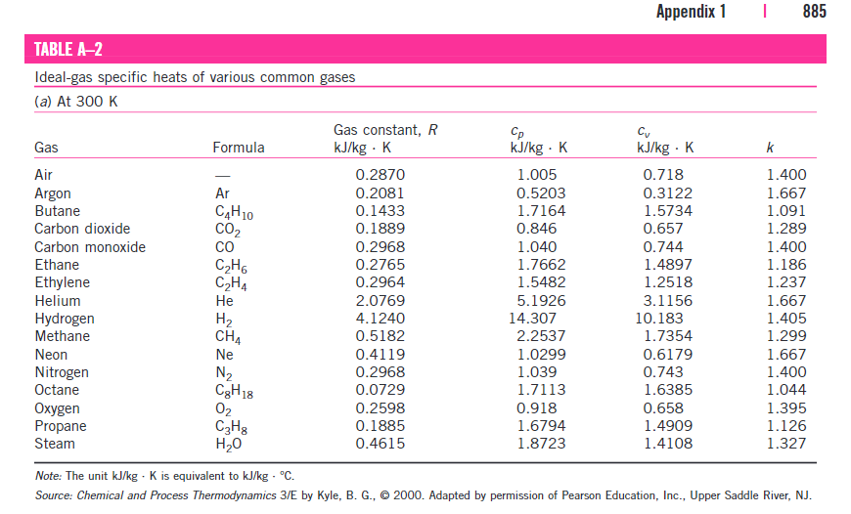
Figure 1-Thermodynamic Table

Using this table, we know the c_{v} = 0.718 kJ/kg K and the gas constant, R = 0.287 kJ/kg
Now, by using the 2nd equation for cut off, substituting each value into the equation.
$$Cuttoff Ratio=\frac{1400\text{x}{10}^{3}}{1005 \text{x }323 \text{x}{\left(\frac{17.5}{1}\right)}^{γ-1}}+1$$
$$Cuttoff Ratio=2.372600751=2.37$$
The following equation is used to calculate the cycle efficiency
$$ηCycle= 1-\frac{Q_{41}}{Q_{23}}$$
Q₄₁ is the constant volume heat rejected also expressed as $Q_{41}= c_{v}ΔT$
Q₂₃ is the constant pressure heat supplied also expressed as $Q_{23}= c_{p}ΔT$
This can also be written as,
$$ηCycle=1-\frac{mc_{v}\left(T_{4}-T_{1}\right)}{mc_{p}\left(T_{3}-T_{4}\right)}$$
By looking at this equation above, we can cancel and simplify it. The mass has no effect as it is equal to 1. Also, c_{p} over c_{v} is equal to γ as shown in the equation below and can be placed in the dominator.
$$γ=\frac{c_{v}}{c_{p}}$$
This results in a simplified equation as shown below.
$$ηCycle=1-\frac{T_{4}-T_{1}}{γ(T_{3}-T_{4})}$$
However, as the temperatures are not provided, another equation can be used as shown below.
$$ηCycle=1-\left(\frac{1}{{{(r}_{v})}^{γ-1}}\right)\text{x} \left(\frac{r_{c}^{γ}-1}{γ\left(r_{c}-1\right)}\right)$$
Substituting the values provided and calculated into this equation will equal.
$$ηCycle=1-\left(\frac{1}{{\left(\frac{17.5}{1}\right)}^{1.4-1}}\right)\text{x} \left(\frac{{\left(\frac{2.37}{1}\right)}^{1.4}-1}{1.4 \text{x} \left(\left(\frac{2.37}{1}\right)-1\right)}\right)$$
$$ηCycle = 0.610562455 = 61.06\%$$

- The following diagram depicts an actual marine engine dual combustion cycle. Show that the thermal cycle efficiency of 62.56 % (2 dp) as given for the experimental data provided is correct. What assumptions have you made in your calculations?
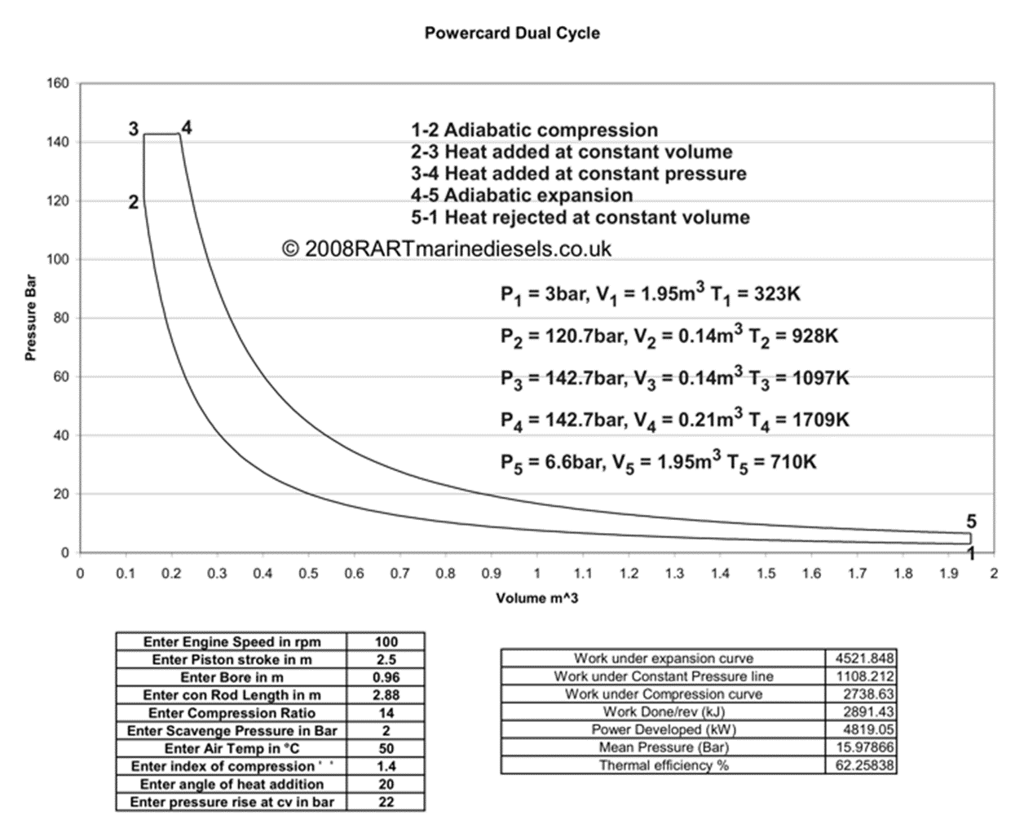
(Ans)
The following equation for finding the thermal efficiency shown as
$$η=1-\frac{Heat Rejected}{Heat Supplied}$$
Heat rejected and heat supplied can both be solved using their own equations.
The following equation is used for finding heat rejected.
$$Heat Rejected=mc_{v}\left(T5-T1\right)$$
The following equation is used for finding the heat supplied.
$$Heat Supplied=mc_{v}\left(T3-T2\right)+mc_{p}\left(T4-T3\right)$$
Using the equations and the values provided by the image above, we can solve for thermal efficiency. Firstly, review the values given.
T2 = 928K
T3 = 1097K
T4 = 1709K
T5 = 710K
Noticeably, the mass (m), specific heat at constant pressure (c_{p}), and specific heat at constant volume (c_{v}) aren’t provided. However, assuming that the weight of air within the system is 1kg, we can also assume that the c_{v} is equal to 0.718kJ/kg. K and c_{p} is equal to 1.005kJ/kg.K
The table below, presents these values for air. Alongside other specific heats for various common gases.
Note: Realistically, air wouldn’t be the only gas within the system. Other gases will also be present, but we assume that air takes up the majority in percentage.
Figure 2-Thermodynamic Table
Secondly, by using the equation for heat rejected and substituting the values provided and the values assumed.
$$Heat Rejected= 1\text{x}718\text{x}\left(710-323\right)$$
$$Heat Rejected=277866 J/kg=277.866 kJ/kg$$
Thirdly, by using the equation for heat supplied and substituting the values provided and the values assumed.
$$Heat Supplied=1\text{x}718\text{x}\left(1097-928\right)+1\text{x}1005\text{x}(1709-1097)$$
$$Heat Supplied=736402 J/kg=736.402 kJ/kg$$
Finally, using the equation for solving thermal efficiency.
$$Thermal Efficiency=1- \frac{277866}{736402}$$
$$Thermal Efficiency=0.62267$$
$$Thermal Efficiency=62.26\%$$
How does this compare with the value of thermal efficiency provided on the dual cycle image?
The thermal efficiency value provided was 62.25838%. Rounded up, and the value provided is equal to 62.26% which compared to the value calculated through the thermal efficiency equation is accurate. With this information, the values from the table image above, for air, the mass (m), specific heat at constant pressure (c_{p}), and specific heat at constant volume (c_{v}) can be assume as the correct values.
- The temperature of a gas entering a turbine is 725 °C. The gas leaves the turbine at a temperature which is 35 % lower than the inlet temperature, and the mass flow rate of the gas through the turbine is 3.25 kg/s. Calculate the power developed by the turbine for the ideal Joule cycle (c_{p} = 980 J/kg K). If the power output was required to be increased to 800 kW, what would be the necessary inlet gas temperature (assuming that the exiting gas temperature does not change)?
(Ans)
The following equation will determine the power developed by the gas turbine.
$$W= \dot{m}c_{p}(T1-T2)$$

The values that have been provided:
T1 = 725℃
T2 = 725x0.65 = 471.25℃
ṁ = 3.25 kg/s
c_{p} = 980 J/kg K
W = Unknown

As we substitute these values in, the answer is given as
$$W=3.25\text{x980x((725-(725x0.65))}$$
$$W= 808193.75W=808.19kW$$

If the power output was increased to 800kW, and the outlet temperature remained the same, then the previous equation for power will need to be transposed to make T1 the subject.
Firstly, review the new values that have been provided:
T1 = Unknown
T2 = 725x0.65 = 471.25℃
ṁ = 3.25 kg/s
c_{p} = 980 J/kg K
W = 800x10³ kW

Secondly,
$$\frac{W}{\dot{m}c_{p}}=T1-T2$$
Thirdly,
$$\frac{W}{\dot{m}c_{p}}+T2=T1$$
As we substitute these values in, the answer is given as
$$T1 =\frac{\left(800\text{x}{10}^{3}\right)}{3.25 \text{x 980}}+471.25$$
$$T1=722.427394℃$$
$$T1=722.43℃$$

- In a steam turbine plant, the steam supply to the turbine is 44 bar dry saturated, and the exhaust steam is at 0.04 bar after isentropic expansion. Sketch a suitable temperature-entropy diagram for the cycle (including at known data) and calculate the ideal Rankine efficiency of the cycle.
(Ans) Values Provided: 44bar = 4.4MPa
0.04bar = 0.4MPa
By using the thermodynamic tables, we can determine the h₃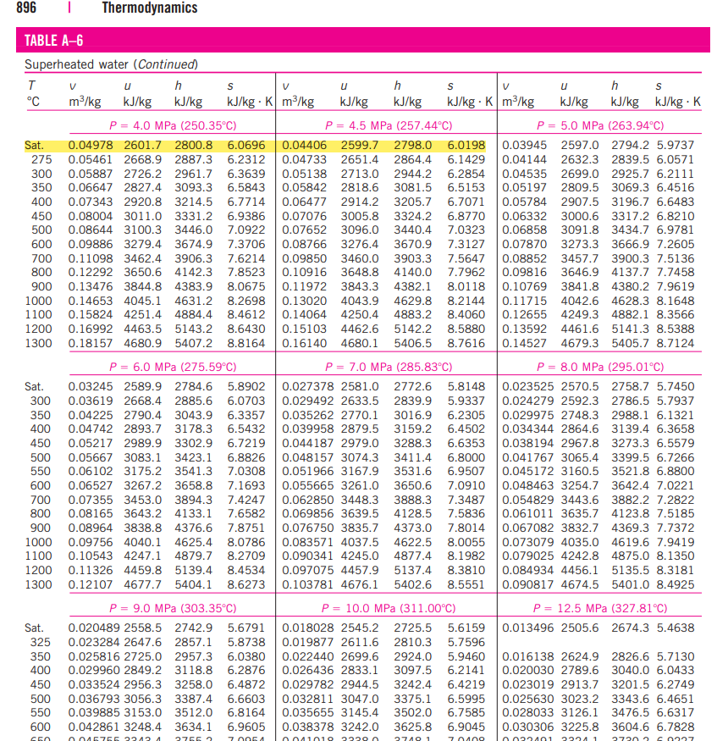
Figure 3-Thermodynamic Table
The equation for h₃ is shown below.
$$h_{3}= 2800.8-2798 = \frac{2.8}{5}=0.56kJ/kg$$
$$h_{3}= 2798+0.56 = 2798.56kJ/kg$$
Taking the difference between 4.0MPa and 4.5MPa, enthalpy column. Then dividing by 5 to get the value for 0.1MPa give 0.56kJ/kg.
Now taking the difference between entropy and applying the same process.
$$s_{3}= 6.0696-6.0198=\frac{0.0498}{5}=9.96x{10}^{-3}$$
$$s_{3}= 9.96x{10}^{-3}+6.0198 = 6.02976$$
$$s_{3}=6.02976kJ/kg=6.03kJ/kg$$
Note: s₃=s₄

Now, by using the dryness fraction using the entropy values calculated. For 0.4bar using thermodynamic tables (Table A-5)
$$s_{x}=s_{f}+s_{fg}$$
So,
$$6.02976= 0.4224+x8.0510$$
$$x = \frac{6.02976-0.4224}{8.0510}$$
$$x = 0.6964799404 = 0.69$$
Now by using the dryness fraction above and enthalpy for 0.4bar, h₄ can be calculated.
$$h_{4}=h_{f}+xh_{fg}=121.39+0.69 x 2432.3$$
$$h_{4}=1815.438159kJ/kg = 1815.44kJ/kg$$
Finally, Rankine efficiency can be used shown in an equation below.
$$η_{R}=\frac{h_{3}-h_{4}}{h_{3}-h_{1}}=\frac{2798.56-1815.44}{2798.56-121.39}$$
$$η_{R}=0.367224857 = 36.72\%$$
Below is the graph that represents the data calculated above with known data added.

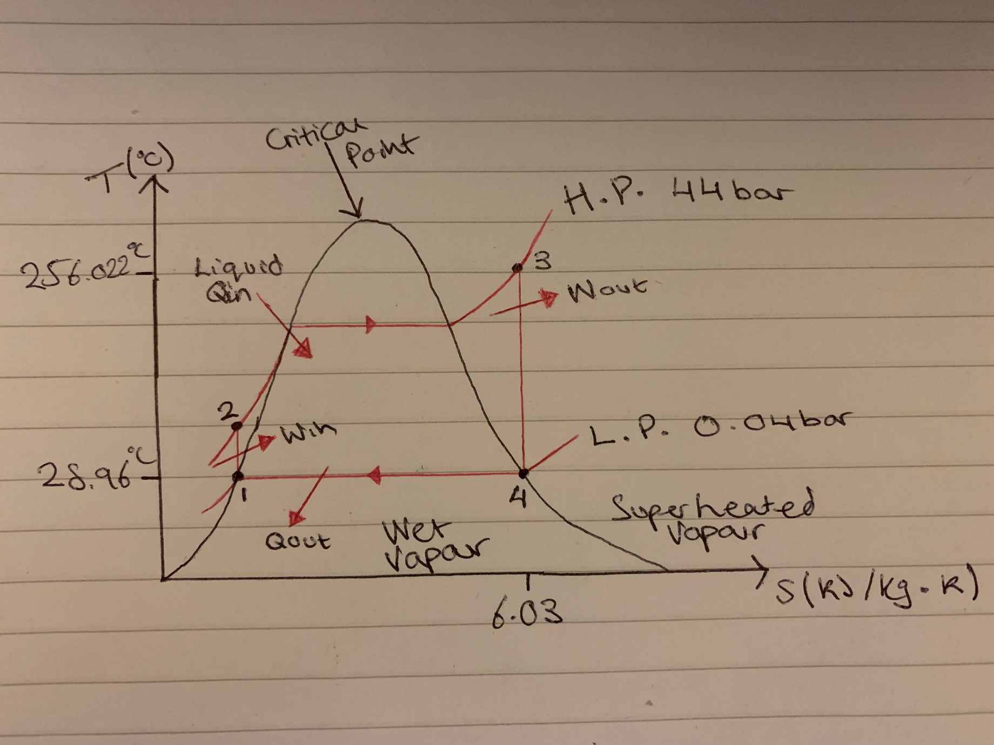

Part B
In the power generation cycles we have dealt with this far, ideal processes have been assumed and analysed in order to determine fluid properties and cycle efficiencies. Describe what practical methods may be employed to improve the efficiency for a gas turbine plant and a steam turbine plant. Include in your discussions appropriate schematic layout diagrams and power cycle diagrams to aid your explanations.

Reheating
Reheating is a practical method which can be used to improve the thermal efficiency of a gas and steam turbines.

Reheating Steam Turbine
There are several way to reheat the steam after its route through the initial high-pressure turbine. The first option is to link the post stage of the high-pressure steam back through the boiler, which could have a secondary chamber that uses the already provided heat from the first chamber (Boiler).
The second chamber could be positioned around the boiler like a hollow tube or a conductive material such as a copper coil could be wrapped around the boiler, stealing the wasted heat from the first stage. On this second stage, an option to add more fuel to increase the temperature as a lot of the energy will have already been used which will increase the pressure into a second high pressure turbine, however the choice to not add more fuel and to solely rely on the initial heat provided is an option for a low press turbine.
This extra stage will take advantage of the already high steam temperature from the post stage of the high-pressure turbine as it will be heated from the initial boiler and will also take advantage of the existing heat being provided from the first stage.
Here is a diagram below of the process described above.
Condenser
L.P Turbine
HP Turbine
Boiler
Figure 4 - Reheated Steam Turbine
The picture below is a temperature-entropy diagram, which highlight the process and how reheating has an effect overall. As the graph shows, the temperature drops after the high-pressure turbine. Then once it passes through the reheater, its temperature increases which will make its way to the low pressure turbine. The temperature then drops, and the wet vapour is then condensed through the water pump and condenser.

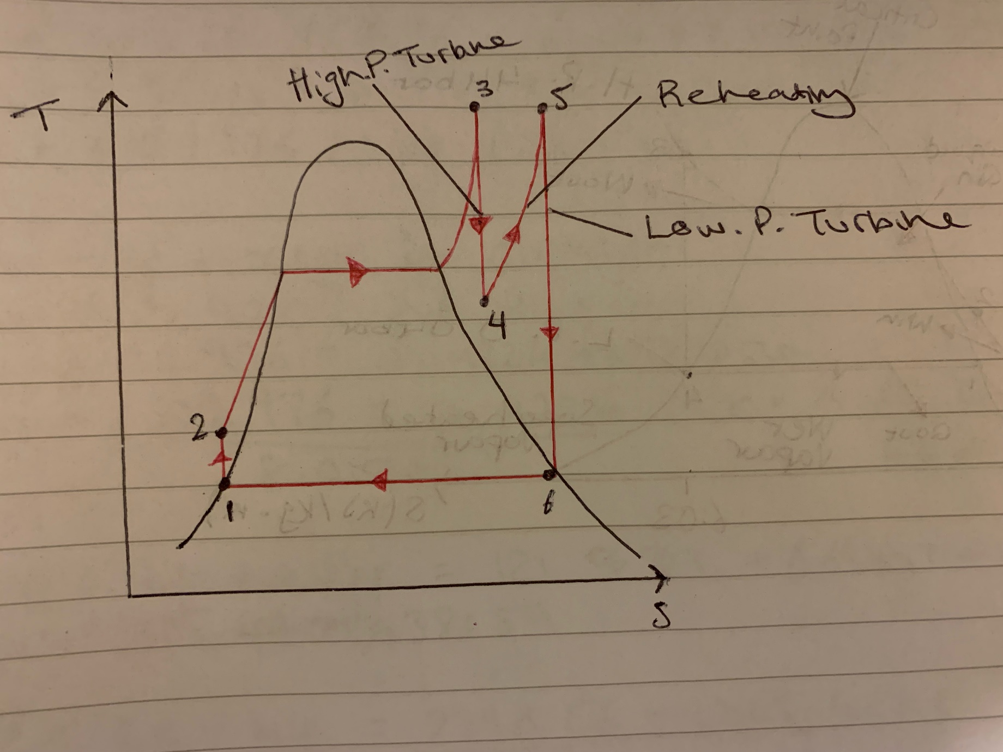

Water Injection Gas Turbine
Water injection is a process in which water is injected into the area before and after compression to cool the air circulating. This greatly drops the power absorbed during compression, meaning that it becomes more efficient. This can be used continuously or seasonally as it is usually used in the summer as temperatures within the system usually exceed and absorb a lot of power.

Part C
A refrigerator or heat pump contravenes physics when we consider the second law the of thermodynamics. These practical devices are possible however and are operated using a vapour-compression cycle. Explain the practical vapour-compression cycle, with particular reference to the following points;

• refrigeration cycle
• heat pump cycle
• coefficient of performance (for refrigeration and heat pumps)

For your discussions above, include suitable schematic diagrams and process/cycle diagrams, as well as explanation of the particular mathematical models applied to the various processes and cycles.
The following graph represents the vapour-compression cycle. The graph shows that enthalpy increases as heat is increased. Pressure also increases as temperature increases as particles become more kinetic in the finite volume. Then, enthalpy decreases as the heated water is condensed through a refrigeration cycle. Pressure also decreases as temperature drops.

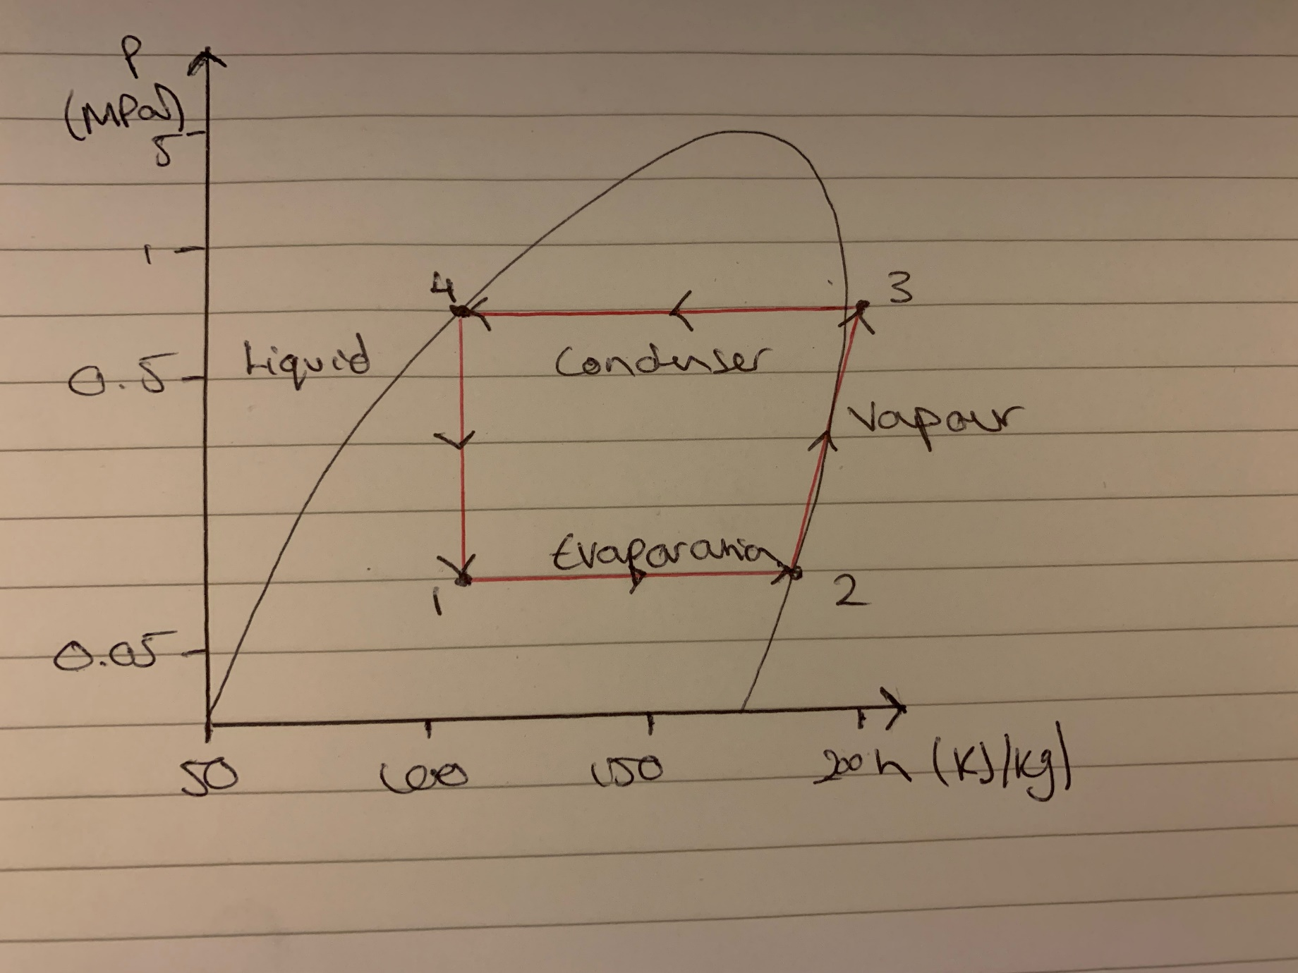

Conclusion
The main findings throughout were that gas and steam turbines can be improved and made more thermal efficient in many ways, whether that is through adding more processes or influencing the way heat interacts with cooler elements.

