
Reflective Review of Learning journey


Bettina Silsby
1905229
November 3, 2019
University of Wales Trinity Saint David

Table of Contents
Introduction 2
Relevant Career Development Disciplines 2
Personal SMART Career Goal 3
SWOT and TOWS Analysis Related to Career Goal 4-5
Time management matrix 5
Go Mad Thinking Framework 6
Learning Styles: Honey and Mumford, VARK Learning Styles Questionnaire 7-8
Personal Development Plan 8-9
Conclusion 9
Bibliography………………………………………………………………………………….10
Appendices………………………………………………………………………………… 11

Introduction

I have prepared this report as a reflective statement of my learning journey through my personal development. It will in turn also be considered as my personal statement as it highlights my learning experiences. The report covers information about my smart goal, my strengths, my weaknesses, all my opportunities and my threats. My assignment also discusses the challenges I have faced as a student, the time management skills I have achieved, and the group discussions that I have participated in furthering my communication skills. The report also highlights my ability to refine my areas of expertise. The review then highlights my learning experiences and the knowledge I have gathered during my learning journey.

I have always had a keen interest in business studies, when I was a teenager I chose to study at a business and marketing college in Hungary. I find business studies really interesting and I feel it is the most suitable career that I can have for myself. Recently I started running my own business as a childminder in 2018 and find running my own business really beneficial. I can see that obtaining a business qualification will most certainly improve my business ideas. Since I started this course, I have learned a great deal about the concept of business, the marketing strategies and numerous other concepts implemented to ensure the success of a business. I will carry out a SWOT analysis to reflect my smart goal, and I will apply a GO MAD work frame to show what I have learned and how I can put ideas and strategies into practise.

Smart goal

Having now learned how a professional career development is carried forward I have come to realise that I am making the correct decisions with what I would like to do for my future. I have found the course has highlighted lots of gaps in my knowledge which I can now use to make me an accomplished businesswoman. I have set a Smart goal for myself to obtain a business degree. In order to achieve my SMART (Doran, 1981) goal I am performing a SWOT (Humphery, 1960-1970) (Strengths, Weaknesses, Opportunities and Threats) analysis on myself. While there is a myriad of variants, SMART translates to: S – Specific (or Significant), M - Measurable (or Meaningful), A – Attainable (or Action-oriented), R - Relevant (or Rewarding), and T – Time-bound (or Trackable) (Hettema and Deary, 2013). This approach is an effective way of identifying where my development needs to be improved. While SWOT analysis is fundamentally used by the management, it can also be efficiently used in evaluating an individual as in my case. The analysis tends to focus on recognizing both the external and internal influences that may affect the impending performance of a business. The four primary factors that are focused in SWOT analysis tend to assess the balance the internal possessions and abilities and external potentials and threats (Pahl, Richter 2007).

SWOT

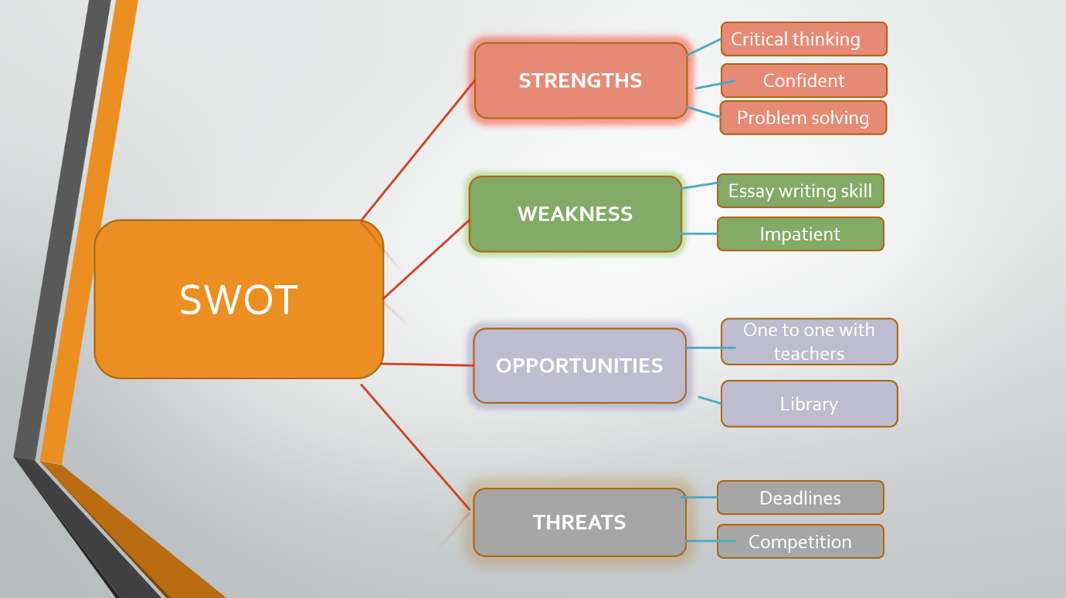

Strengths: Being a critical thinker is helping me to achieve a better academic performance. this is a very strong and usable skill in business as it helps me to identify issues, look for evidence and assess the strengths for the reasons of my actions. I am a very confident person, and this will help me when I need to do a presentation in front of a large public audience. My problem solving and quick thinking will also help me to find a quick solution to problems.
Weakness: My academic writing skills in English is not the best, I am aware that my English grammar needs to be improved upon. I am inclined to be very impatient as I have tendencies to rush everything.
I am very aware of my weaknesses, I will convert my weakness to strengths through TOWS analyst. I saw the need for me to obtain this business degree to enable me to further my career here in the UK. I know through my studying here in the UK that all the assignments and report writing that I am required to do, with the presentations that my grammar and command of the English language will only improve and further my confidence. Being impatient can work in my favour as it will push me to meet deadlines and make decisions to achieve high results.
Opportunities: I have wonderful helpful teachers who are always there to support me in and are offering one to one session which are the most helpful. Also having people with many different backgrounds in my class I find bring a lot of different skills which offers us all a great opportunity to learn from each other. I also have 24/7 online access to the library.
Threats: Like every other student my biggest threat is meeting the deadlines, to produce good work in the short amount of time available and try to produce a better standard of work than anybody else. I will convert my biggest treat the deadline through TOWS analyst an I will plan a head; organise my time and I will do drafts for my assignment.
I can measure myself by the marks that I get for my works to ensure I am in the right direction to achieve my goal. I will also stay in my Time management matrix ( S. Covey 1989) within the important but not urgent level. It is necessary to keep this level, otherwise I will start rushing, panicking and I cannot produce work good work and I cannot get the best marks what I am aiming for.
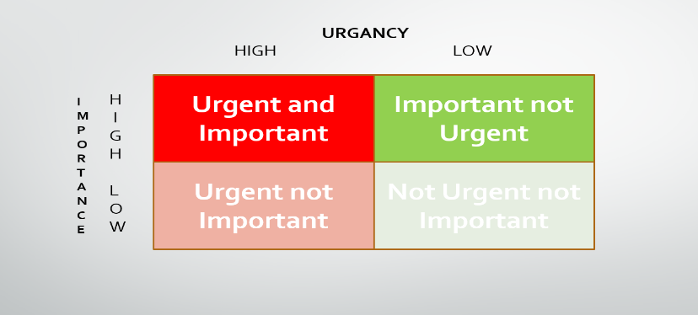
With all this skill I can say confidently my goal is realistic, as I can clearly see how I can convert my weaknesses to be my strengths.
I have set myself 3 years to complete university and achieve my business diploma.
Go MAD

The go M.A.D. (making different) model was published 1999. Andy Gilbert and Ian Chakrovothy come up with this system. I will put this model in use, and this help me increase my performance trough study and help me develop better leader skills.
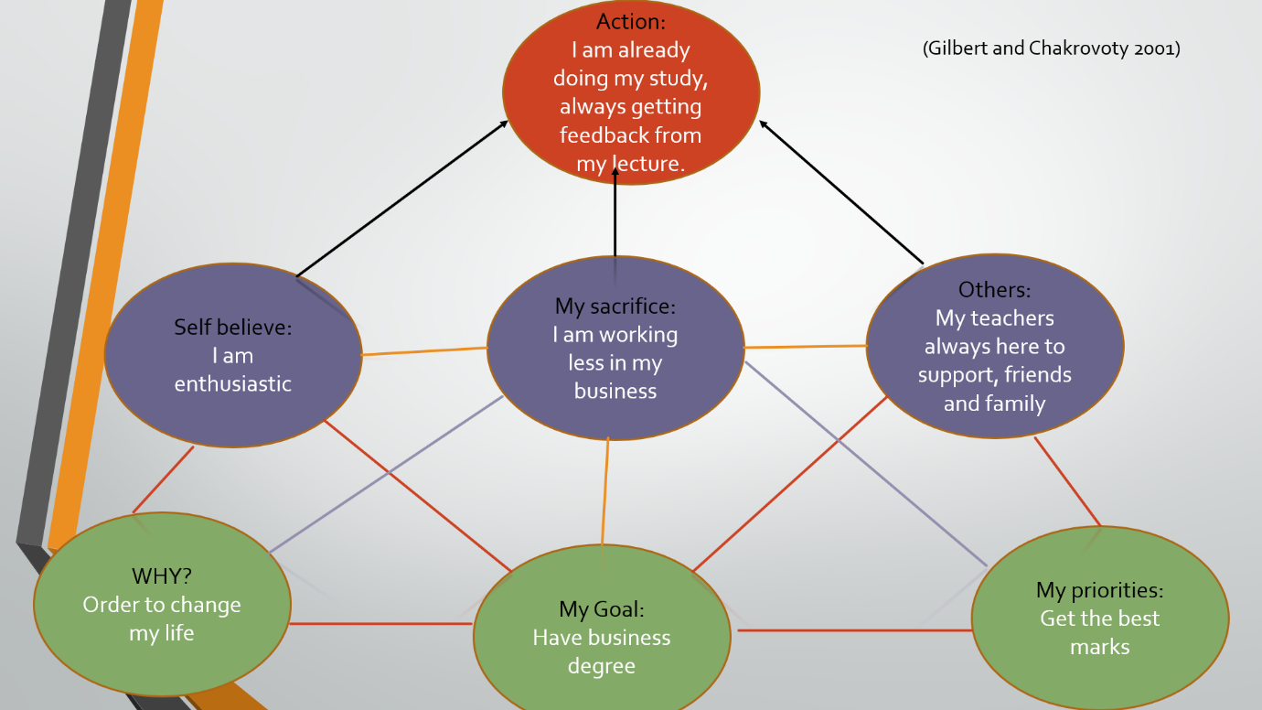

I have set my goal to obtain a business degree, this work frame helps me to understand what I need to do and what is around me to help me succeed. To achieve my goal, I enrolled into this course to enable me to have a better future. I recognise the need to achieve the highest marks that I can and will have the support of my fellow students, family and lecturers during this time. To be able to study I have had to decrease the development of my business which in turn reduces my income. I am aware of this sacrifice, but it is a small one to endure knowing that I can achieve more in the future by getting my degree.

Learning Style

It is important to be true to yourself, and not to just recognise your strengths and weaknesses but what you can learn from them. A clear way of succeeding with this is to carry out some tests.
- The Honey and Mumford learning style test was first published in 1992. This test helps some people to identify themselves. Some people learn from experience (Activist) and others learn from reflection (Reflectors). Some develop their own ideas and how the world is working (Theorist) and others take in information plan and investigate “what if” (Pragmatist). Within this capacity, I will collect data first hand as well as from others and I will think about this data thoroughly before making any conclusions (Honey and Mumford, 2006). According to the Honey and Mumford learning style I am a Pragmatist, which means I am a more practical person as I am always seeking out new ideas and how I can improve my work and how I can put my work into practice. When I do get new ideas, I am eager and impatient to put them into practice as I prefer to act on things as soon as I can. This test is really similar to Kolb’s learning cycle, according to Kolb I am always planning my next step and testing out new ideas.
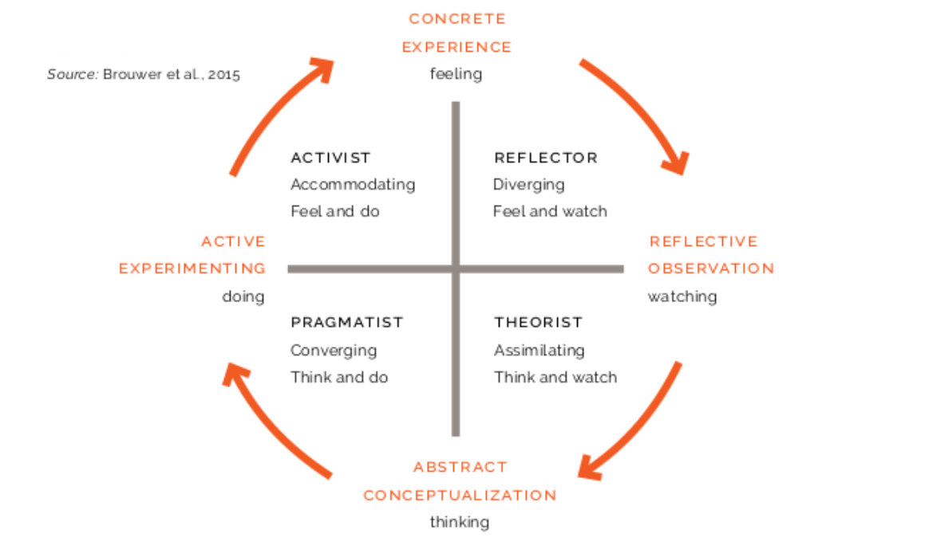
- The second learning style which I find really useful is the VARK test, this model of learning style was developed in early 1990’s (Fleming and Mills 1992). This style is based on the fact that every human is different, and everyone uses different methods to study. The VARK test puts people into four study strategy groups. Which are: Visual, Aural, Reading/Writing and Kinaesthetic study strategies. According to this learning style test I am a Visual learner, I prefer to symbolise or convert my lecture notes into pictures making it easier for me to understand and learn.

Personal Development plan

These two results are key points to plan my pdp (personal development plan). A personal development plan is essential in identifying ways to move forward with your career. It highlights the areas that are requiring development. I have chosen three objectives to concentrate on in my pdp.

My first objective is to improve my attitude towards other people as according to my Honey and Mumford test I am pragmatists, I am more likely to be orientated on the task, not on the people around me. I need to be more open towards people and listen to their point of view. I need to show more interest in the people around me. For support I will socialise more often with my fellow students and work associates. The achievement of this will show when I have a greater understanding of people’s needs and how this will help my business grow.

My second objective is to improve my essay writing. I will need to read more books and take up English lessons. According my VARK learning test I am a visual learner, could be make it easier if I use symbols through my study. It will be hard to find the time to do this as everyday time I am working or in University, so I will have to set time aside in the evenings to achieve this. I will get support from my lecturer and feedbacks from her when she marks my work. My writing will become more fluent.
My third objective is to be more creative. According to Kolb’s learning cycle I am always seeking out for new ideas and visiting art gallery’s or became involved in drama groups can be very inspirited. To find the time to do this will be extremely difficult at the present time. Family will need to be involved to assist in looking after my daughter. Ideas should come easier to me.

Conclusion

In order to achieve my goal, I will follow my SMART plan, I will convert my weaknesses to strength and my treats to opportunities. I will use my learning style all the way through in my study, and I will make sure I will up to date with my personal development plan.

Bibliography

- Morgan, P. (2017) Business Student's Guide to Study and Employability. London: Sage Publications.

- Maund, S.K. et al. (2017). Certificate in Higher Education : Skills for the Workplace Student Yearbook. London: Sage, 2017.

- Covey, S. R. (1999) The 7 Habits of Highly Effective People : Restoring the Character Ethic. London: Simon & Schuster.

- Hensher, P. (2018) "'What's Your Type? The Strange History of Myers-Briggs and the Birth of Personality Testing', by Merve Emre - Review." The Spectator

- BBc Learn English, Academic writing, The language of argument (2019). Available:www.bbc.co.uk/learningenglish/english/course/go-the-distance/unit-3/session-4 (access November, 2019.)

- Deckers, L. (2018). Motivation: biological, psychological, and environmental. London; Routledge

- Cottrell, S. (2010) Skills for Success: Personal Development and Employability, Red globe.

- Learning cycles (2019) Available: http://www.managingforimpact.org/tool/kolbs-learning-cycle-and-learning-styles ( access November, 2019)

- Honey, P. and Mumford, A., (2006). Learning styles questionnaire: 80-item version. London, Maidenhead

- Pahl, N., Richter, A., University of Applied Science (2007). SWOT analysis: idea, methodology and a practical approach. GRIN Verlag

Appendices



