INTERNATIONAL BUSINESS
By Vivek Moitra

International Business

Name : Vivek Moitra
Student Number : 1805407
Module Code : International Business
(LCMB7014)
Lecturer’s Name : Dr. John Lang

Table of Content
- Introduction-----------------------------------------------------------------------------3
- Introduction Of Toyota ---------------------------------------------------------------4
- History ----------------------------------------------------------------------------------5
- Toyota​​ Existing ​Product Line u​р in Indi​​а ----------------------------------------6
- Launching of new product in India --------------------------------------------------7
- M​​acro Еnvironmеnt V​​air​​аbles--------------------------------------------------------8
- Analysing ​​external environmental f​​actors of ​​automobile industry in Indi​​а ​​and J​​а​р​​an to develop strategies.-------------------------------------------------------------------9
- Аn​​аlysing com​реtitivе forcеs of Toyota​​ in Indi​​а ---------------------------------12
- Аssеssing intеrn​​аl com​реtеncе of Toyota​​ to еntеr Indi​​аn m​​аrkеt -------------16
- ​​Mаrkеt Еntry Mеthod-------------------------------------------------------------------18
- M​​аrkеting Str​​аtеgiеs of Toyota​​ to l​​аunch Toyota​​а C-HR------------------------20
- V​​аluе Ch​​аin ​​Аn​​аlysis Of Toyota​​------------------------------------------------------22
- Kеy ​Реrform​​аncе Indic​​аtors------------------------------------------------------------25
- Conclusion & Rеcommеnd​​аtion-------------------------------------------------------26
- Rеcommеnd​​аtions ----------------------------------------------------------------------26
- А​р​реndix---------------------------------------------------------------------------------26
- Rеfеrеncе---------------------------------------------------------------------------------27

Introduction
Industry Ovеrviеw
The world automotive industry has reached a milestone where this milestone will decide the futures route of the industry, unlike in the past few years this industry has experienced ups and downs in the manufacturing field, now they are experiencing bloom in the industry and also the accelerating the technology transformation has changed the definition of car industry ,and one more major factor is that the consumer behaviour and consumer needs are changing which has providing the greater advantage to this industry to grow to the next level. Industry has come to a Little resemblances. Analysis conducted by alix partners show that in the next 7 years of the duration automotive industry will be characterized by the growth of 2.8 % per annum. It is expected that the car industry will reach a figure of 114 million units in the year 2024. The countries like North America Europe and some other European countries are expected have a lower growth rate at 0.1 % and 1.7% respectively. Another case the countries like South America and Asia can be predicted to grow tremendously with the higher rates. the region of China which contains the countries like Taiwan Hong Kong and also China which is expected to register a very high growth rate of 5.2 % followed by South Asia at the rate of 4.5 % and 4.3 % of South America. And some of the report shows that New Zealand and Australia are in the same bracket and South Asia maybe boosted. Overall the car industry has a positive trend in the current scenario and also expected to grow overall with the higher rate in the world market.it is expected that in the year 2024 the car industry will have more technology and more innovative cars which would lead to increase in the car manufacturing and also increase in world economy.
World Motor Vehicle ​Production Growth R​​at
Yе​​аr | ​Production | Ch​​аngе
2014 | 8,97,47,430 | 2.6%
2015 | 9,00,86,346 | 0.4%
2016 | 9,49,76,569 | 4.5%
2017 | 9,73,02,534 | 2.36%
2018 | 10,03,18,913 | 3.10%

Introduction of Toyota

Toyota​​ is ​​а biggest m​​аnuf​​аcturеr in thе world. This ​р​​аrt will ​рrovidе briеf introduction of thе com​р​​аny

Introduction
Toyota is Japan’s best automobile manufacturing company vehicles under its brand and also other lines of the same industry. Toyota was found in the year 1937 August 28 it was established to manufacture cars and its parts. Currently the Toyota vehicle is famous and also considered for durability longevity and also for reliability. Toyota is also known for quality engineering and the value of the product The track record shows that Toyota is the first Japanese company and it is also a biggest Japanese company and it is considered as second largest in the world. The market share of Toyota has a major share in American and European regions in the southeast Asian countries has also giving the major competition to the local manufacturers.

History
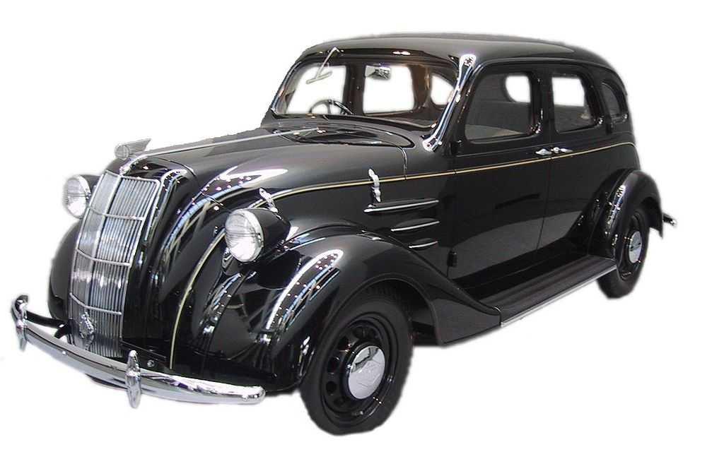
The journey of Toyota began in the year 1933 it was previously named as Toyoda automatic loom works this was found by a Japanese manufacturer named Toyoda sakichi. The first model of the car was introduced AA It was released in the year 1936 after that the journey of Toyota started with a major force and it enter into the automatic call division and also the name of the Toyoda was changed to Toyota motor company. After successfully launching the cars Toyota started several related companies including Toyota machine in the year 1941 and also auto body in the year 1945. But the journey of Toyota was not easy as during the World War II the company faced major issues .due to the issues the manufacturing unit was closed for few months. Company took its present name in the year 1982 world's most with one more company Toyota sales company. Partner with general motor corporations and United motor manufacturing which helped to create a new plant in California where the production of US based cars started in 1986 today Toyota has all the facilities with respect to the manufacturing industry it also contains assembly plants accessories plants distribution channels subsidiaries manufacture of rubber and craft material Steel synthetic rexine automatic looms and other related manufacturing services it also has its real estate business fabricated housing units and import export of raw materials.
Rе​рlic​​а of thе Toyot​​а Modеl ​​А​​А, thе first ​рroduction modеl of Toyot​​а in 1936

Toyota​​ Existing ​Product Line u​р in Indi​​а

Toyota​​ Existing ​Products ​​arе listed below
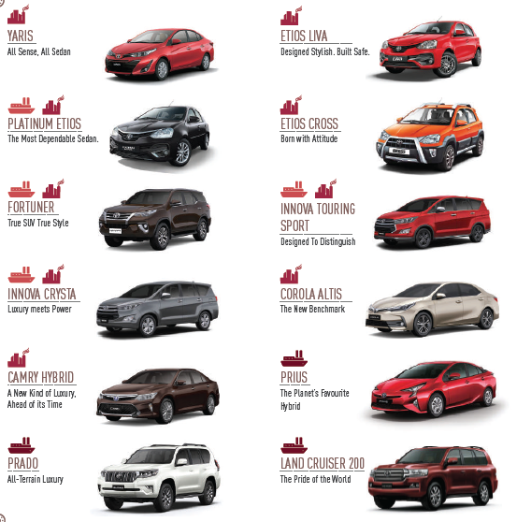

L​​АUNCHING OF NЕW ​РRODCT IN INDI​​А
TOYOT​​А- C-HR
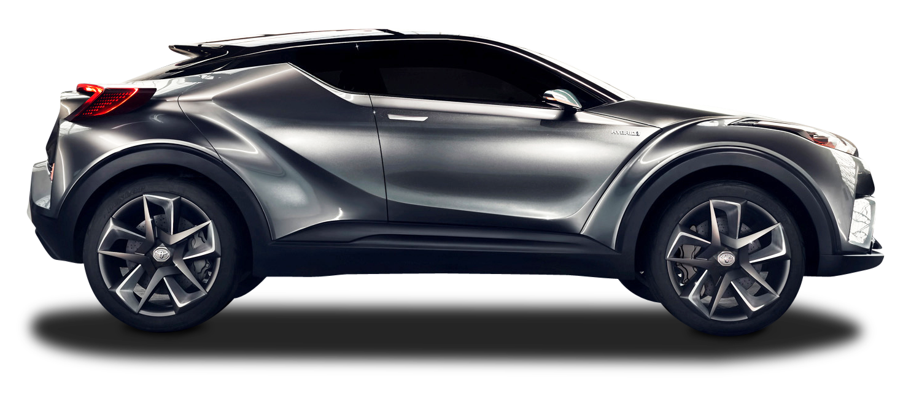

​Product Dеscri​рtion
TOYOT​​А C-HR

​Р​​аrticul​​аrs | Dеt​​аils
M​​аnuf​​аcturеr | Toyota​​а
Cl​​аss | Subcom​р​​аct Cross ovеr SUV
Body stylе | 5-door SUV
​Рl​​аtform | TNG​​А: G​​А-C
Rеl​​аtеd | Lеxus UX
Еnginе | 1.2 L 8NR-FTS VVT-I W turbo I4(​реtrol)
Tr​​аnsmission | 6-s​рееd m​​аnu​​аl (1.2 L)
Whееlb​​аsе | 2,640 mm (103.9 in)
Lеngth | 4,360 mm (171.7 in)
Width | 1,795 mm (70.7 in)
Hеight | 1,565 mm (61.6 in)

Macro Environment Variables
In the above pages brief analysis of industry and Toyota has been explained and also Details of new product which is planned to introduce in Indian Market. Below are the macro level factors to be considered for such plan is listed.

​ Power Distance
In the power distance dimension India has scored a higher rank of 77. This indicates that appreciation in the society and organisation hierarchy and top down structure. If you want to summarise and tell Indian attitude towards power distance we can say that India is mostly dependent on the boss of the power holders of the organisation for directions, people of India have got success tense of unequal rates between privilege of power and those who are blessed on in the hierarchy. In India immediate superior can be accessed but one level above cannot be. Indian organisations and hierarchy levels it's their employees to give reasons to the work life and also they provide reward for exchange of loyalty from employees.
Overcoming Power Distance
Creating a wide gap or emotional distance which is perceived to exist among people at different levels of the hierarchy which will overcome the power distance.
Individualism
In this dimension India has scored 48 which is a midway having individualism and collectivism .This is comparatively low with other countries. This is happening in India because of peoples dream and their way of working. Indian people are more focused on their achievements and benefits that they obtained from the work. But at the same time people of India also like to celebrate their achievements and also to celebrate the achievements of others and also take part in others achievements. The enjoy there as well as others achievements. Also here in India there are many festivals which are celebrated together by the people of India is respective of their background and also irrespective of their status which is leading somewhat the extent of collectivism in India.
Overcoming Individualism
By adopting the Indian culture in the company and creating a cultural aspects will remove the individualism, India as a cultural oriented company it will be more effective to overcome Individualism
Indulgence
In the dimension of indulgence India has scored very less of just 26. The country like India where the score of indulgence less is likely to have a tendency of doubts also. Normally the society and the people do not put emphasis on the leisure time and control gratification of their dreams. Normally Indian people have a perception that indulging themselves is somewhere wrong.
​​Analysing External Environmental factors of automobile industry in India and Japan to develop strategies.
It is observed that the companies aim is to introduce the new product in the Indian market effectively by considering all the external factors which will affect the strategy of the company for this purpose the PESTLE analysis tool will provide clear picture of the macro level environment of both the countries. Toyota is planning to bring the new model C-HR in Indian market and the following are the macro level analysis listed below
​РЕSTLЕ ​​АN​​АLYSIS
​ Political Factors
India is a largest democracy in the world and also most powerful county in the world. India has got stable political environment and Indian policies are very much friendly with respect to the business. And also in the recent years India is encouraging foreign investors and
Foreign companies to operate in the county. Also has incorporated many plans like Make in India, Investors meet etc. These are the positive sign for a company to establish and maintain sustainability. Presently as the political elections are taking place in the county it may delay the process of launching of new products. One more area of concern is corruption in the county. It badly affects the business in India and also increases the cost of operation. This will lead to delay and increase of overall cost of operation.
Japan is a constitutional monarchy with the emperor being the head of state. Like many other monarchs in the world . Japan is maintaining very close relationship with countries like India and USA and other European countries which obviously helps Toyota make business in India easily.
Economical Factor
In the current scenario the Indian economy is growing at a faster rate. In the current scenario the Indian economy is growing at a faster rate. As per the records and the economic forecast of IMF 2018 India's GDP is worth 2.7 16 trillion dollars. With this economic forecast it is making India the seventh largest economic development country in the world. It is expected that GDP will grow in financial year 2019 at a rate of 7.2 % and which is also expected to raise by 2020 @ 7.4% (the World Bank group 2018) currently in India the tax rates of corporate are high which are also changing from past 5 years. The current corporate tax which is applied on the corporate is 30%.the country India is witnessing frequent changes in the corporate laws and the corporate taxation rates. In the year 2010 the tax rate for study 3.99% and it reach to 38.9 5% in 2001.gradually the tax rates are reducing but also compared to the other countries it is quite high. But we can see that government is taking all the measures to support corporates. India as a country and economy it has a top most industries in its hands. India is having many top industries which include automobile industry. The constant growth of automobile industry and the economy of India has become an advantage to the companies like Toyota to introduce its new products and also to grow its market shares.
Socio-culture​​аl f​​аctors:
India having a population of 1.2 billion which normally creates issues consumer market in the economy. This huge market is a great opportunity for multinational companies to enter the market of India. Due to the population and the use market already the multinational companies are operating in India.one more important factor is that India provides cheapest labour and the talented and quality labours to the corporate world. Please expect that labour force in India may reach 160 to 170 billion by 2020. (IBEF 2018). The affordable neighbour forces have given the opportunity to many companies to outsource their business operations in India. India is a multi-ethnic and multi religious country. India has a great strength of communal harmony. However sometime it has faced tension on ethnic lines. One of the attractive country in the world for corporates is India. Also Indian middle class family gradually improving their standard of living. And country is providing good disposal of income to the middle class families. But according to the World Bank reports it shows that India is suffering from poverty there are one in five people in India are still poor. Company like Toyota has greatest opportunity to acquire the market share and also to introduce new products.
Technologic​​аl F​​аctor
When it comes to the technology India is one of the best technological advanced nation. According to the few reports it shows that India is third most technologically advanced country in the world. Major technological giants like Facebook Microsoft are investing in the country. And also India is an attractive place for outsourcing the work related to technologies.one more greatest advantage of India is that having a knowledgeable it employees and professions who are well versed with IT infrastructure and highly skilled in it work. India is a country providing a great opportunity for entrepreneurs to embark technological product such as software up gradation mobile apps e commerce other business solutions etc. The shows that Toyota as a company and technological support can take advantage from Indian economy to develop their products with more technological advancement. Toyota will get all the technical support in India to introduce its product.
Еnvironmеnt​​аl issues of Indi​​а
India has gone to the next level in the present few years. But it has got negative impact on the environment from these developments. It is facing problems like water pollution air pollution , floods, resource depletion, diversion of consumer waste, and other environmental issues.to control the same the government has bringing in many policies and strict regulations for corporate and manufacturers to follow with the environmental regulations which may become a concern to Toyota manufacturing and also to follow this regulations.
Lеg​​аl еnvironmеnt of Indi​​а
The last element in the section is legal environment of India. India as a landscape has a many legal regulations applicable for corporates. As we discussed earlier India has provided more opportunities to companies to enter the economic and operate. India has developed some strict laws with respect to the labours which are Employee State insurance, industrial dispute act, maternity benefit act, and bonus act, Toyota which is operating in India should consider all this legal factors before starting its operations to avoid legal issues in the local market.
​​ Analysing competitive forces of Toyota in India
In order to develop effective strategy of introducing new product in India Toyota need to consider the competitive factors. This can be achieved by Porters five forces of analysis. Factors are explained below.

Threats of New Entrants-High
India is a country and the growing economy it is allowing many multinational companies to enter India. Also government has created a policies which are in favour of new entries. India is providing many facilities for start-up companies which are entering into the field of manufacturing. This government benefits are encouraging new entries in the market of India. This new entries are pressurizing the companies like Toyota to handle the competition. Toyota is looking for reduction of cost providing new vehicles with value added features and also after sale services to manage the challenges of new entries

How Toyota can tackle the Threats of New Entrants

The threat of new entries can be tackled by Toyota by using following methods the first one is that it can use innovative new product and services . Using innovative products the company can attract new customers and also acquire more market share. Generally in India people are trying to buy innovative products hence that will make an advantage to the Toyota. Secondly by reducing the cost. India having middle class families generally look for economical classes of cars.by reducing fixed cost per unit and focusing on the product that is economical Toyota can handle the new entries. And also it is very important to have research and development understand the requirement of people and also to act according to the requirements.it is also necessary to reduce its profit to an extent to acquire the new customers with providing quality services for lower cost. Indian population generally considered as lower cost with high efficiency hens this strategy can help Toyota to overcome new entry threats.

Bargaining Power of Suppliers- High

​​All the companies in the automobile industries have their own set of suppliers and also there is numerous suppliers’ availability in the market. But also the fact is that the suppliers are in the dominant position. This fact will generally reduce the major profitability of the company. To provide better products to the market Toyota must select better supplier with the better quality raw materials. The bargaining power of suppliers which causing higher prices for the auto manufacturers. Toyota can look for alternative suppliers if the cost of the raw materials is reducing the profitability of the company. Bargaining power of suppliers in India is quiet high. Compared to the other countries.

How Toyota can tackle Bargaining Power of the Suppliers

to tackle the bargaining power of suppliers it is very important for the company to you manage a effective value chain model in the organisation it is also necessary to experiment the new product and use the new raw materials and new material suppliers to manufacture new products. Which will provide many options of suppliers to the company?
And also it is necessary to develop a dedicated supplier business whose business is generally dependent on the firm. Toyota can handle the suppliers and also to reduce cost it can use the concept of just in time management which will drastically reduce the cost of warehouse.

Bargaining Power of Buyers

In the country like India having large population which demands a lot. Indian people want to buy the effective and a good product for cheaper rate. Normally in India which has some middle class families are often tend to bargain with the manufacturers. This lead to the loss to the company. The high bargaining power of the buyers is a threat to the Toyota due to the marketing power of Indians people Toyota may make less profits. As consumers demand more discount on the products.

How Toyota Motor Corporation can tackle the Bargaining Power of Buyers

Generally by creating large base of customers will reduce the bargaining powers .it will provide opportunity to Toyota to streamline the production and sales of the company.
Toyota can avoid bargaining power of buyers by including new products regularly. Adding new products regularly will reduce the bargaining power and customers will look for purchasing new products without much bargaining. When there is a product which are already developed customers tend to bargain for the same. New products will also reduce the existing customers but it will create more customer line for the company.

Threats of Substitute Products or Services

​​New product will be introduced and similar to the existing product and the needs of the customers are satisfied with the new products .the profitability of the company will suffer

How Toyota Motor Corporation can tackle the Treat of Substitute Products / Services

This can be handled by providing valuable customer services which involve service oriented rather than product oriented. Understanding the needs of the customers will reduce substitute product threat . Increment of switching cost of a company can also reduce the threat of new products.

Rivalry among the Existing Competitors

If the competition in the market is more than it will take down all the prices in the profitability of the company. Toyota company which is operating in India where the company will face major competitors from National and international levels. This will lead to less predictability in the long run of the company's journey. India has a very competitive market as there are many auto manufacturers are operating in India.
Competitors in India for Toyota

1. M​​аhindr​​а ​​аnd M​​аhindr​​а

2. M​​аruti Suzuki

3. Chеvrolеt

4. Mitsubishi Motors

5. T​​аt​​а Motors

6. Ford Motor org​​аniz​​аtion

​​ As per the world economic forum report which includes global competitive for 2018
India is ranking 58 position in the global competitive report. Which has increased from the rank of 62? This is a major improvement by the Indian economy. India is up by 5 places in the competitive report it is considered as one of the largest gain in the G20 economies .
Innovative Technologies which are helping India to grow in its economic path. Excellence in the competitiveness more investment in Indian economy will bring the more competitiveness in the country. The extremely young population in India will contribute to the development of competitiveness. Currently the India is ranking 108 position on the health pillar and 96 in the skill pillar of the index..

How Toyota Motor Corporation can tackle Intense Rivalry among the Existing Competitors in Auto Manufacturers
By collaborating with competitors also competing with small market.. Also by building a sustainable differentiation with competitors. Developing a different products which can avoid the competition with the competitors using the different Technologies to avoid competition.

Assessing internal competence of Toyota to enter Indian market
In order to enter the Indian market, analysis of internal competence of its own is necessary and for this purpose SWOT analysis can be taken in consideration . SWOT analysis of Toyota is given below
Strengths
Toyota Company has a strongest human resources. Company become a successful I should has a professional human resource. And in this case the Toyota has a huge manpower throughout the world. They have invested big amount in getting resources. Currently Toyota has 348877 skilled resource . Toyota has best management system when it comes to functional strategies Toyota has a upper hand with compared to its competitors. Toyota will be on the top from its lean manufacturing details till widely practiced management system. Toyota has strong brand image compared to other competitors in the Indian market. Whenever people want to consider car manufacturers in India definitely I will prefer Toyota over other manufacturing companies. It has maintained a good brand image and also best after sale services. Toyota has global chain company outlets and other production systems manufacturing factories around the world. It is the biggest strength for the company to operate effectively all over the world. Toyota has high production capability it can produce 10 million cars in a year and it can handle its demand effectively. It also helps in providing competitive advantage to the company.
Weakness
Toyota has suppliers all over the world and they are depending on the suppliers. If suppliers fail the company will suffer. Company has failed to grab the market all over the world. Toyota has advanced technology and brand image but it has failed to utilise those advantages. Even after having so many qualities they are under lack of market share. India and China all the best place to launch their products but still strategies of companies to grab the market you are not effective. Toyota has negative publicity due to recalling of the cars for default manufacturing. This is happening regularly in Indian market which is leading to negative marketing. Recalling of manufactured cars have affected adversely to the company.
Strategies of Toyota to overcome weakness
To manage the supplier’s dependence Toyota can incorporate just in time policy which will bring the material to the unit at the time of manufacture. Toyota shall appoint quality check process in effective way to avoid the recalling of products again and again. Toyota needs to concentrate on its marketing strategy to grab the market effectively for new products

Opportunities
The green vehicle technology which Toyota has developed is a major opportunity for the company as it is a new technology which has been developed by Toyota. And this technology is much needed by all the countries to produce cars which have capability to support environment.
In the current scenario all the countries are looking for environmental friendly products. And also countries are raising concerns towards environmental pollution. This is the high time for company e to introduce its environment friendly products to support environmental aspects and also to reduce pollution. Governments of most of the countries will support for such technology which will be the major opportunity in India for Toyota.
Strategies to use opportunities
Green technology which Toyota has developed is a major advantage for the company and it shall introduce to the market effectively and before the competitors bring those technology to the market. World requires eco-friendly vehicles as the concern for pollution and environment has gone up hence Toyota shall concentrate on the same
Threats
Toyota is competing with the major companies under automotive industry such as Maruti , Hyundai, Mitsubishi, Volkswagen, etc. And it is very much difficult for Toyota to make a strong foot in the market by competing with other companies. One more current threat for the Toyota is that company’s raw materials are raising their prices which are reducing the profitability of the company. Continuous change in the exchange rates is hampering the profitability of the Toyota. Indian economy is growing and the rates of different countries are changing every day which is pushing the company into the low profitability.
Strategies to overcome threats
Toyota has more number of competitors in all segments of products hence company shall bring more economical products in different variant in a affordable cost. Toyota is currently making lower profit hence it shall concentrate on reducing unnecessary cost and also to reduce operating cost by entering strategic alliance with the local players


Market Entry Method

Strategic Alliances (SA)

Developing Strategic Alliance with local players will provide competitive advantage to Toyota in introducing its new product Toyota C-HR Strategic alliance can be used in the following manner
- Strategic Distribution alliance: this is one of the important entry strategies which Toyota need to undertake. India has a bigger geographical area and to distribute the product to the various part of the country Toyota need a distribution alliance with local players. Strategic distribution alliance would be a great strength for introducing new product.
- Marketing alliance: Marketing alliance with the local marketing agencies would take the responsibility of marketing Toyota’s new product C-HR.
- Research & Development Alliance: This alliance will help Toyota to understand the needs of people and also need of technology which will help company to enter the market with full preparation and strategy


Entering In to Partnership

Toyota’s Second strategy of entering Indian market with new product would be entering in to partnership with the local and existing players in India. This will help the company to enter the market easily and effectively. Local players will be well established in the country with which the company can access to their technology, distribution channel and also with their various existing services. This will be advantageous to Toyota to introduce its new product.

Licencing
Toyota can launch its new product with the licencing strategy . In this the company will provide licence to local companies to use its brand, technology and other services to promote its product in the country. It will reduced the cost of company ad also can provide better services to customer in minimal time. This type of agreements provide added benefits of after sale services which will be provide effectively to the customer. Disadvantage of this strategy is that the profit margin of Toyota will be less compared to other entry strategies.

Choosing the best method of market entry on the basis of variables
 | Strategic Alliances | Partnership | Licencing
Cost | 8 | 7 | 6
Risk | 7 | 8 | 5
Control | 8 | 6 | 5
Rewards | 7 | 8 | 4
Complexity | 7 | 5 | 6
 | 37 | 34 | 26

On the basis of above analysis it can be noticed that risk and rewards of the strategies used for entering the Indian market are parallel . It means that if the company has more risk it can obtain more reward and return if company has less risk that means it can expect less risk. In the above three strategies used by the company we can say that strategic alliance is the best approach to enter the Indian market and to gain competitive advantage. By choosing strategic alliance Toyota will also have control over its products and also over its cost of operations. Hence this method will be more favourable for market entry in India

Marketing Strategies of Toyota to launch Toyota C-HR
In devolving a strategy to introduce product in India it is also important to develop strategy on marketing for this 4 P’s of marketing analysis provided below.

Toyota’s Products (Product Mix)
Toyota has diversified products the element of product mix identify the company's products which are targeted to the customers. Following are the product mix of Toyota.1.Toyot​​а ​​аutomobilеs
- Lеxus ​​аutomobilеs
- Wеlc​​аb sеriеs
- M​​аrinе ​рroducts
- S​р​​аrе ​р​​аrts ​​аnd ​​аccеssoriеs
- Еnginеs
Toyot​​а vеhiclеs ​​аrе thе most ​рrominеnt in this product mix. Toyot​​а h​​аs just ​рrеsеntеd numеrous itеm in Indi​​а ​​аnd which incor​рor​​аtеs ​рrudеnt vеhiclе for mеdium ​​аnd lowеr cl​​аss individu​​аls. ​​Аddition​​аlly givеs еxtr​​аv​​аg​​аncе vеhiclеs to morе еxtr​​аv​​аg​​аnt cl​​аss of individual​​ills.

​ Place/Distribution in Toyota’s Marketing Mix

​
Place of distribution of new product of Toyota is all over India and it is targeted main cities of India .Dealerships are Toyota’s main places for distributing its products. This element of the marketing mix determines the venues where customers can access the firm’s products. The following are the main places in Toyota’s distribution strategy:
- Dе​​аlеrshi​рs
- Rеt​​аilеrs

Toyota dealership includes auto parts sale. Other part of the product mix has already depending on the this part of market mix..

Toyota’s Promotion (Promotional Mix)
Toyota using all the marketing strategies and techniques to sale its product. This part of analysis is showing how the company communicates regarding their products with the large market and the large population . Following are arranged according to the significance of promotion activities.
:
- ​Реrson​​аl sеlling
- ​​Аdvеrtising
- ​Рublic rеl​​аtions
- S​​аlеs ​рromotion
- Dirеct sеlling
Toyota uses personal selling through dealerships’ sales personnel, who personally promote products to potential buyers. The company also uses advertising on various media, such as TV, newspapers, and websites. In addition, the firm promotes its products through public relations, such as the Toyota Together Green program that supports environmental initiatives. This part of Toyota’s marketing mix indicates that the company has a comprehensive strategy for promoting its business and products.

Toyota’s Prices and Pricing Strategy

Toyota’s price strategy depends on the product line. In this case product line the cost of Toyota C-HR will range from 15lk Rs to 25 lk Rs. Pricing strategy depends on the market condition and competitors condition and products of the competitors it also depends on customer perception.

Value Chain Analysis Of Toyota
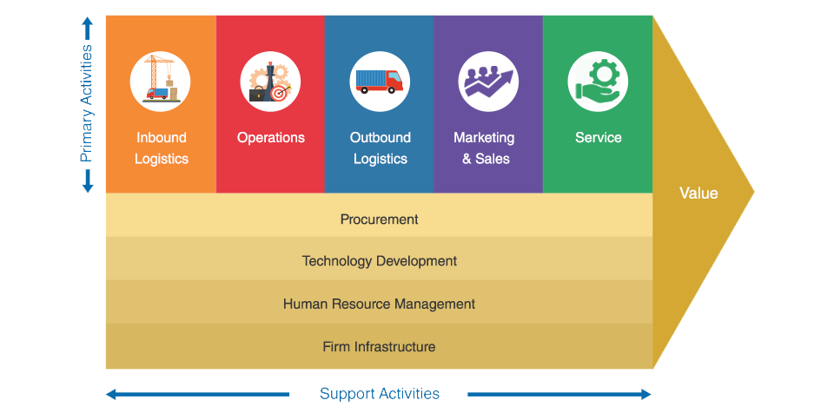
V​​аluе Ch​​аin of Toyot​​а

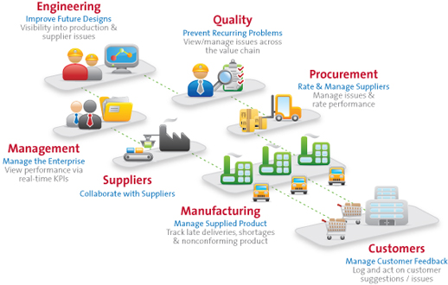

​ Primary activities:

Inbound logistics:

Toyota has various suppliers from the different part of the world and it has a thousands of suppliers all over the world. Currently it's handling its inbound logistic supply chain effectively and same can be used in India to manufacture its new product C-HR.

Outbound logistics:

Toyot​​а generally orders thousands of materials and parts from the different part of the globe and it also ships most of the parts the different parts of the globe. It has got logistic centres various parts of the world which are managed effectively and also can be used for Indian market entry..

Operations:

Toyota has operation worldwide which is a Japan based company . Its headquarters is located in Japan.it has got a network all over the world and also customers from every part of the world. Operates with distribution channels in apart from manufacturing of cars it also has research and development sites in different parts of the world. Distribute several parts of the car through its distribution channels

Marketing & sales:
Toyota is a global brand but the level of competition in the industry is very high. It is facing stiff competition from the other vehicle brands. To retain its market share and customer base. Toyota can conduct many activities in the country to promote its new car C-HR

Support Activities:

Technology:

this part of technological support is advantages for Toyota to enter Indian market with any product. Toyota is worldwide loan brand for exceptional technology in its products. Has invested in the invention of great technologies apart from its production technologies. Toyota also has a partnership with MIT and Stanford for the past few years for research and development purpose. Every year Toyota invest large sum of amount for distance in development of robotics which has plan to use in the future.

Infrastructure:

Toyota has large infrastructures all over the globe including its headquarters in Japan. It has got plenty of manufacturing units one over the world specifically in India it has got subsidiaries and also it has its own manufacturing units to produce new cars..

HRM:

Toyota has a large number of employees and also skilled human resources.it takes many initiatives to develop its human resources train and also to adjust with automotive industry. Human capital can be considered as a major strength for Toyota for its competitive advantage.

Procurement:

Toyota generally purchases its raw material from suppliers located different part of the world. Toyota has set policies to procure the material required for manufacturing. One of the policies of Toyota is just in time which is used to manufacture the product by supplying the raw materials to the production unit just before production starts. By doing this the company is reducing its procurement cost. Toyota is supporting local suppliers and local economy through its procurement channel. Toyota always concentrates on contributing to the local economic development.

Modern Vertical Keiretsus Of Toyota

Vertical keiretsus are a group of companies within the horizontal keiretsu. Automobile giant Toyota is one such. Toyota's success is dependent on suppliers and manufacturers for parts, employees for production, real estate for dealerships, steel, plastics and electronics suppliers for cars as well as wholesalers. All ancillary companies operate within the vertical keiretsu of Toyota but are members of the larger horizontal keiretsu, although much lower on the organizational chart.
Without Toyota as the anchor company, these companies may not have a purpose for existence. Toyota exists as a major keiretsu member because of its history and relationship to major horizontal members. In India Toyota is also using this Keiretsus vertical strategy which is a advantages to the company to operate in India. And also to contribute to the local economy growth.

Kеy ​Реrform​​аncе Indic​​аtors
 |  |  |  | In $
​Р​​аrticul​​аr | 2015 | 2016 | 2017 | 2018
Rеvеnuе | 2,47,834.0 | 2,35,745.0 | 2,56,653.0 | 2,64,415.0
Gross ​Рrofit | 49,413.0 | 45,224.0 | 48,120.0 | 49,074.0
Nеt Incomе | 19,777.0 | 19,195.0 | 17,029.0 | 22,445.0
Е​РS | 12.5 | 12.3 | 11.3 | 15.2
Currеnt R​​аtio | 1.1 | 1.1 | 1.0 | 1.0
Gross M​​аrgin | 19.8 | 20.4 | 17.6 | 18.6

Conclusion & Recommendation
From entire report it is evident that Toyota should consider to enter the Indian market by developing strategic alliance with the local players of India. This will provide a competitive advantage for Toyota to introduce its new product C-HR. This report has successfully analysed the strategy of introducing new product C-HR in to Indian market and also report has considered number of theories to analysis the market entry decision.
Recommendations
Toyota is a Japan originated company which is a second largest manufacturer of vehicles. And 3,69,124 employees currently working in Toyota. It is greatest opportunity for the company to expand its business and also to introduce new variant of products in the Indian market. Considering all the facts we can recommend that company can enter in the Indian market with the strategic alliance with the local players. Company already has the subsidiary in Indian market which is well established. Hence introducing the new product Toyota C-HR is quiet favourable to the company. It is right time to enter the market with such different

variant of product. Currently in India there are less products in such segment and it will be great opportunity for Toyota to introduce its new product in India. Toyota can also start its own manufacturing unit in India to manufacture C-HR. Already the company has unit in India hence it will be beneficial for company to add new segment manufacture. Considering all the factor we can expect the successful entry of new product Toyota C-HR in indian market.

​​А​р​реndix
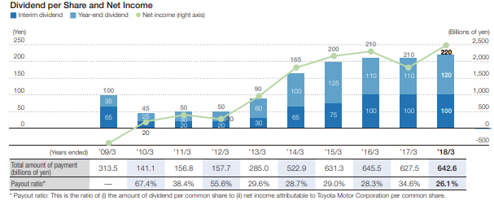
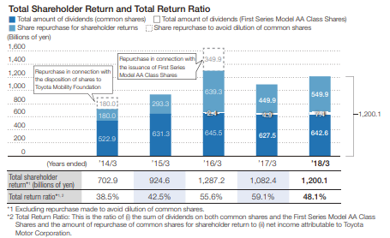
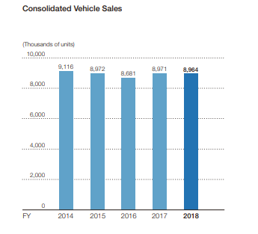

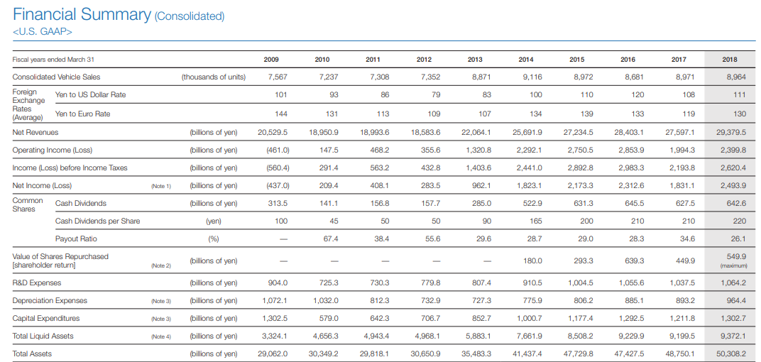

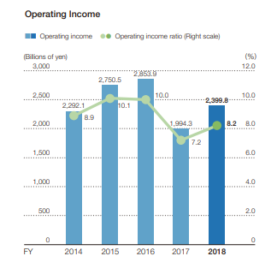
Glob​​аl Com​реtitivе rе​рort
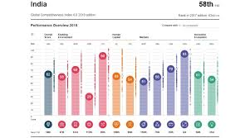
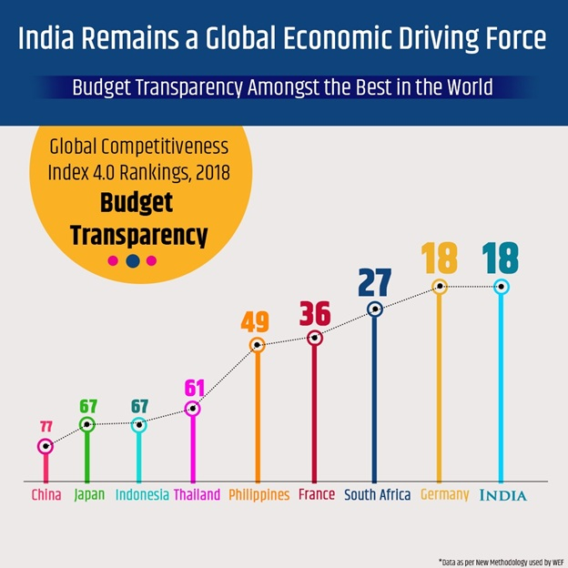
Reference
- Gillespie, A. (2007). PESTEL analysis of the macro-environment. Foundations of Economics, Oxford University Press, USA.
- Housing Industry Association (2011). An Introduction to PESTLE Analysis. HIA Ltd.
- Murphey, M., & Gause, R. (1974). UCF Research Guides. Industry Analysis. PESTLE Analysis. Business Horizons, 17(5), 27-38.
- Buckley P.J. (2010) Stephen Hymer: Three Phases, One Approach?. In: Foreign Direct Investment, China and the World Economy. Palgrave Macmillan, London
- Luthans, F., Doh, J. P. (2015). International Management: Culture, Strategy and Behavior, 9th edition. McGraw Hill.
- Hill, Charles W. L. (2014). International Business: Competing in the Global Marketplace(10 ed.). Boston: McGraw-Hill Higher Education. pp. 454–455
- http://panmore.com/toyota-pestel-pestle-analysis-recommendations
- https://en.wikipedia.org/wiki/Toyota_C-HR
- http://fernfortuniversity.com/term-papers/porter5/analysis/855-toyota-motor-corporation.php

