3/24/2025
University of Wales Trinity Saint David
London campus
E-Portfolio Link:
Module Name: Learning In the Digital Era
Module Code: ACCA 4025

Student Name:
Student ID:
Group: 1

Lecturer’s Name: Koushik Modak

LDE Assignment 1
E-Portfolio
Table of Contents
Introduction 2
Main Body 2
Task 1: Essential Academic and Employment Skills for the future career Path 2
Task 1 (a): Report on Essential Academic and Employment Skills 2
Task 1 (b): Evaluation of Task 1 (a) based on Similarity report 4
Task 2: Collaborative Mind Map and Individual Poster 4
Mind Map (Collaborative) 4
Poster (Individual) 5
Task 3: Virtual Collaboration and RefWorks 5
Report on Virtual Collaboration 6
Step-by-step process of using RefWorks with visuals 7
Task 4: E-Portfolio Creation and Evaluation 7
Task 4 (a): E-Portfolio Creation 7
Task 4 (b): Illustrative Review of E-Portfolio tool Selection 7
Conclusion 7
References 8
Task 1 References: 8
Task 3 References: 9

Introduction
To progress in my journey, I will need to develop certain skills that will help me in my career for me I want to improve my communication skills is an essential skill for the study and employment environment. This skill is very good and useful as it’s used everywhere and all the time with excellent communication skills you can understand others as well as formulating your words correctly, it includes body language, listening and talking it’s important because you want to be a professional and be taken seriously etc. Time management is important to me because it helps me to use my time effectively to help me do my assignment before its deadline and essentially as soon as possible to help me be organized and plan for my next assignment instead of using that time to do my first one. This way I will manage my time effectively and avoid missing assignments. Leadership skills is good to have so that you can help, motivate and to solve conflicts there’s more but I think this is the most important for me you don’t need to be a manager to have or develop leadership skills. Problem solving and self-reflection these two skills is also crucial to help me stay focused in my journey and help me reach success which is the goal

Main Body

Task 1: Essential Academic and Employment Skills for the future career Path

Task 1 (a): Report on Essential Academic and Employment Skills

Essential skills for study and employment can mean different things for everybody and has been around for decades it is normally described as technical skills and is use by everyone and everywhere, it gets improved by using it and by improving your own skills you become better. Everyday skills like for example communication, leadership skills and problem solving is normally defined as technical skills and is used in study and employment but there are also generic skills that would normally be thinking skills, critical thinking and computer use but there are a lot of skills and skills can be described different for everyone. Flexibility can also be a skill, but it is often used in everyday bases for example how people change between skills for everyday use, for study and for workplace it can be the same or it can differ [1]. Skills are important and different varieties like hard skills and soft skill, because for example IT is broad in India but and could offer a lot of opportunities in in employment but many lack communication skills and language skills which leads to less employability [2].

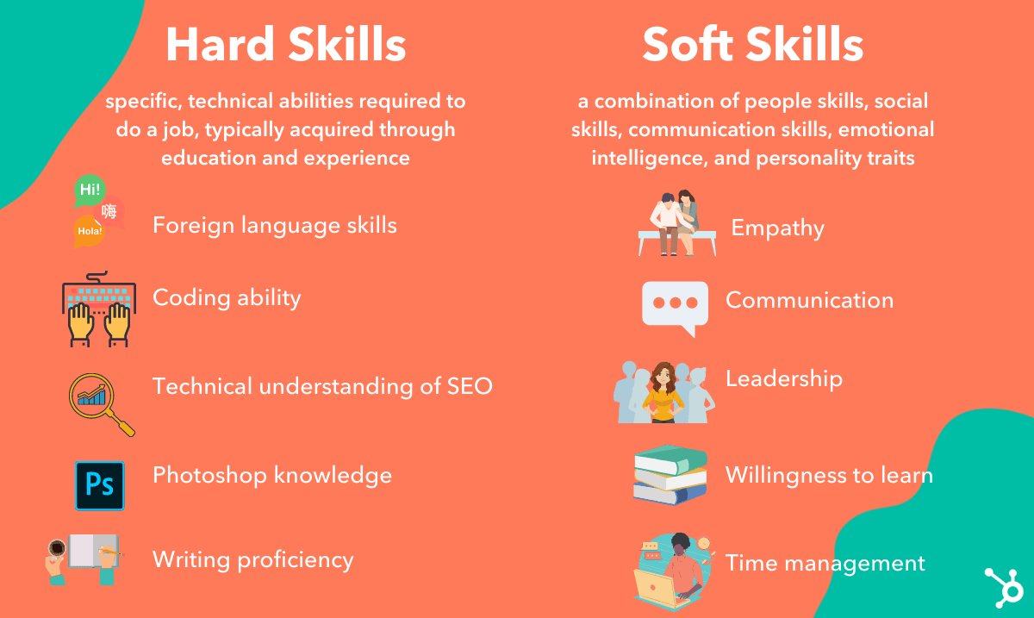
Figure 1: Hard vs Soft Skills. Applied from source [3].

“Every day, for instance we are faced with deciding upon whether something is ‘fake news’.” This is what critical thinking is about and is used every day and it’s a skill that allows us to think if it’s worth trusting someone’s word or to think about it and make your own judgement similar to source criticism [4].

Task 1 (b): Evaluation of Task 1 (a) based on Similarity report

Task 2: Collaborative Mind Map and Individual Poster

Mind Map (Collaborative) MindMap Link: Click Here
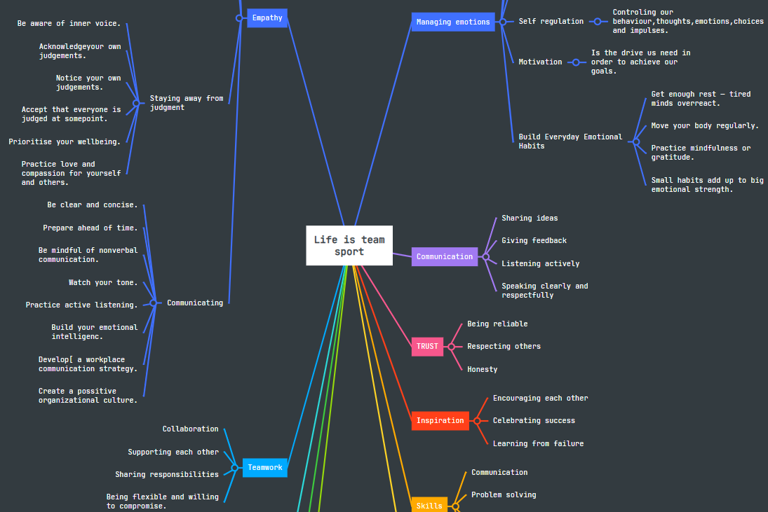 [5]

Poster (Individual) Canva Academic A3 Poster Link: Click Here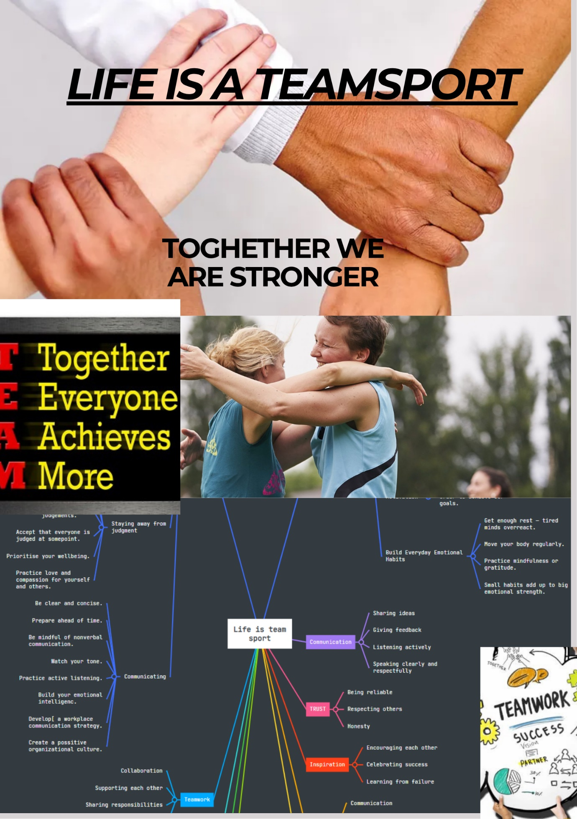

Task 3: Virtual Collaboration and RefWorks

Report on Virtual Collaboration
The New Norming
The term "New Norming" describes a new phase of group formation for example when teams reinterpret norms to fit contemporary circumstances, particularly in increasingly digital and hybrid workplaces. The stages of group development identified by Bruce Tuckman—forming, storming, norming, performing, and adjourning—have historically been used to explain how teams advance toward cohesiveness and efficacy. However, because teams now have to deal with organizational, cultural, and technological changes in addition to interpersonal expectations, the norming stage has changed (Tuckman, 1965; Tuckman & Jensen, 1977). The New Norming's emphasis on inclusivity is another feature. Teams have to make sure standards support equal engagement and understand cultural variations as workforces grow more diverse and international. This involves putting in place procedures including switching up meeting times, promoting organized turn-taking, and applying accessible communication formats (Maznevski & Chudoba, 2000). Team standards are made to clearly and deliberately in "The New Norming." Teams must define expectations for responsiveness, role boundaries, accountability, and psychological ensurement considering remote collaboration technologies, and virtual communication. Teams increasingly agree through shareable documents and charters or communication protocols rather than conventions developing naturally. Despite geographical and temporal distance, this deliberate strategy promotes coherence (Ferrazzi, Keith 2014). “Norms and de-individuation in a lean(er) virtual environment” The two most important factors in virtual environment are considered, virtual environment and anonymity. Virtual environment is considered much less of use than face to face, nonverbal environment and also less of room for feedback cues which leads to harder to complete task. And for anonymity leads to less awareness of possibly less inhibition which leads to antinormative behaviour this specifies how different groups relate to social norms(KS Moser, CM Axtell 2013).

Step-by-step process of using RefWorks with visuals
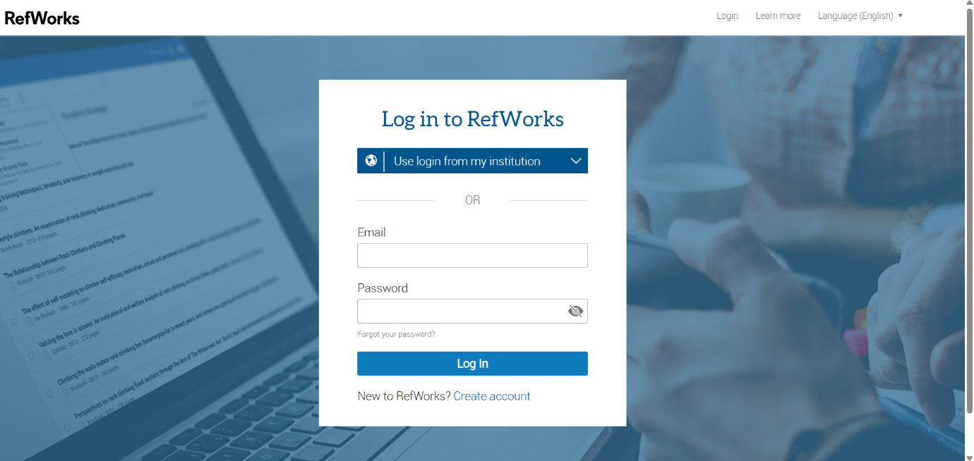

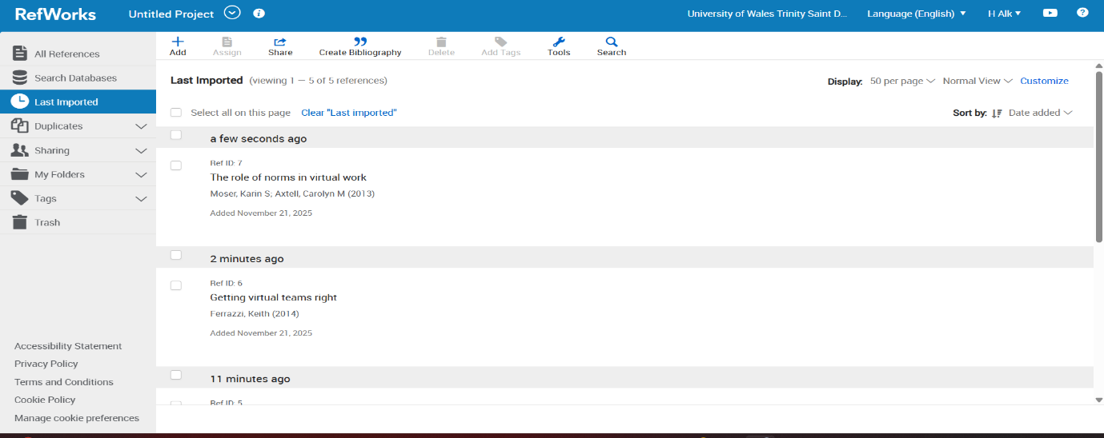
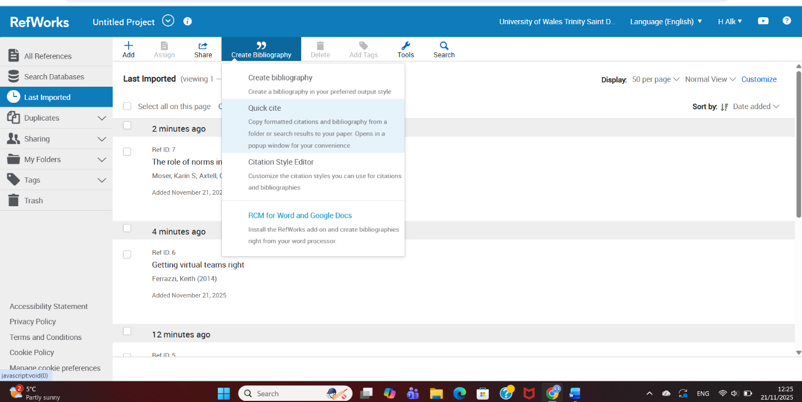
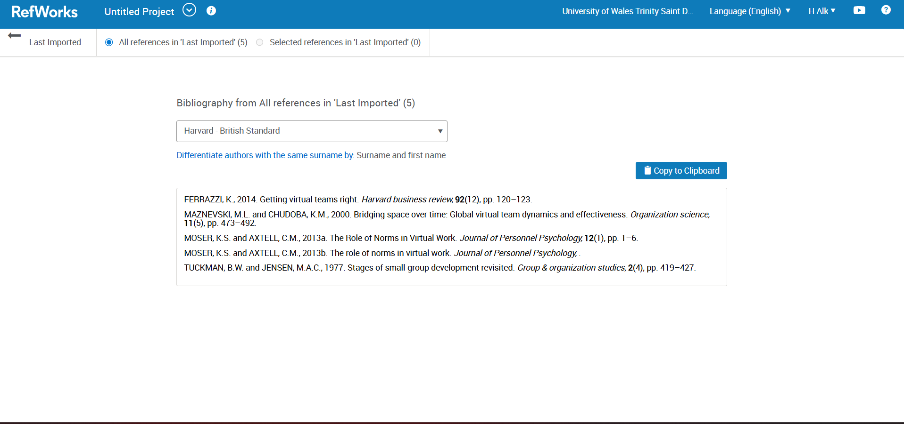
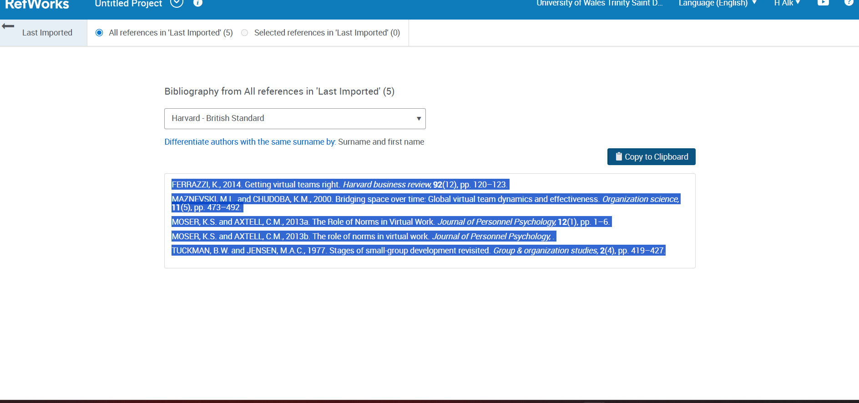

Task 4: E-Portfolio Creation and Evaluation

Task 4 (a): E-Portfolio Creation
https://www.canva.com/design/DAG5VHZDifY/2NvK7sR9YamW_33pnBhFyg/view?utm_content=DAG5VHZDifY&utm_campaign=designshare&utm_medium=link2&utm_source=uniquelinks&utlId=h2da9c84553

Task 4 (b): Illustrative Review of E-Portfolio tool Selection
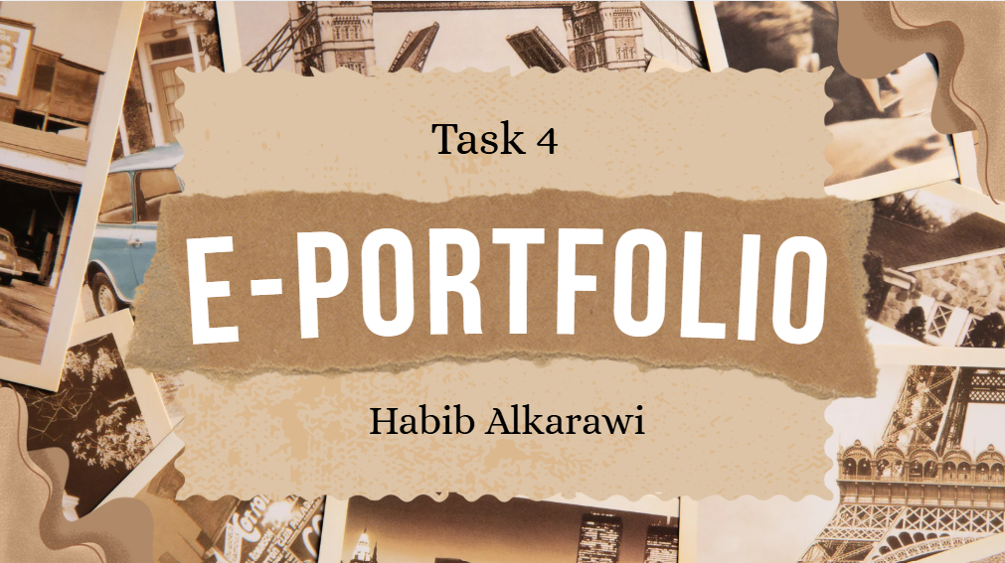first page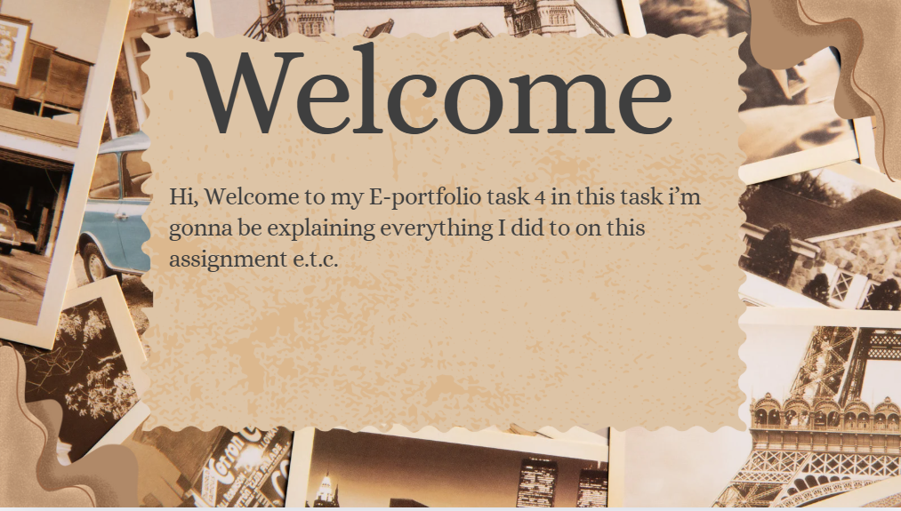Second page
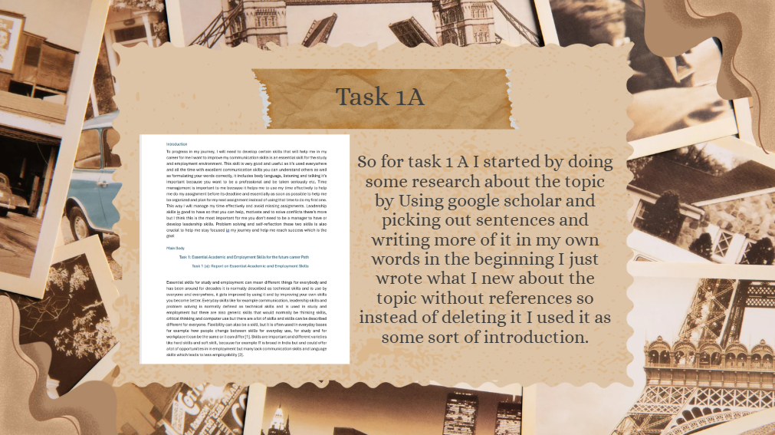Third page 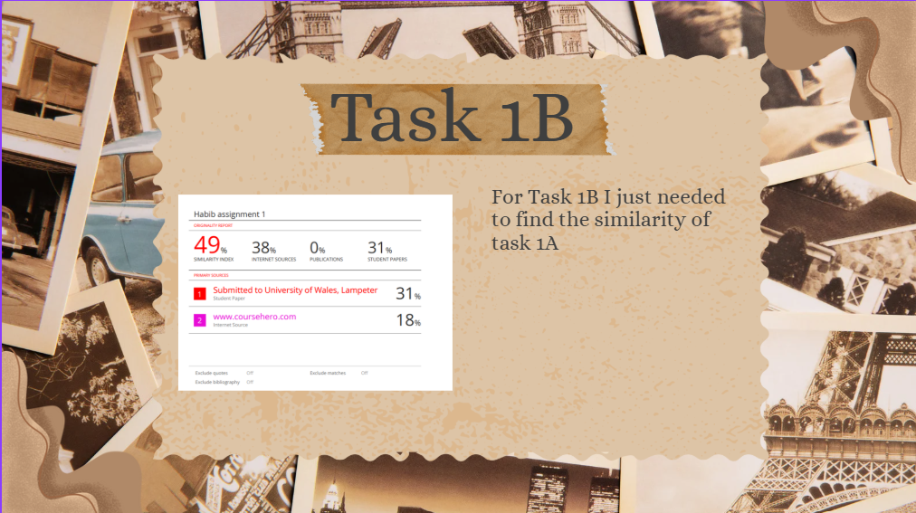Fourth page

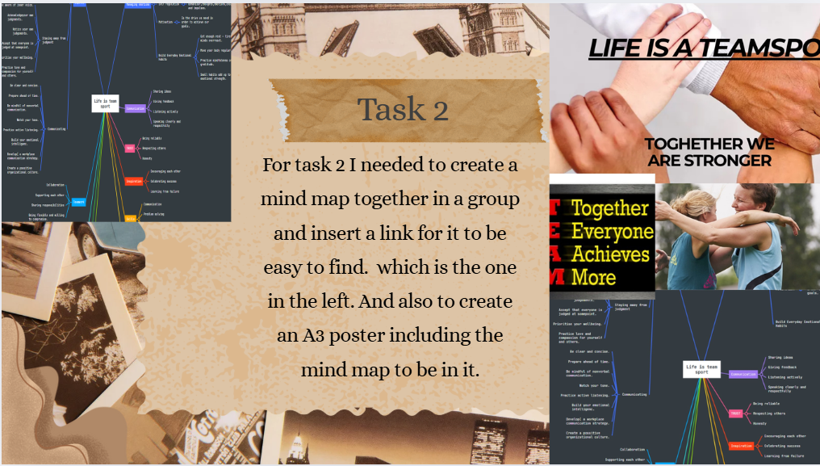Fifth page 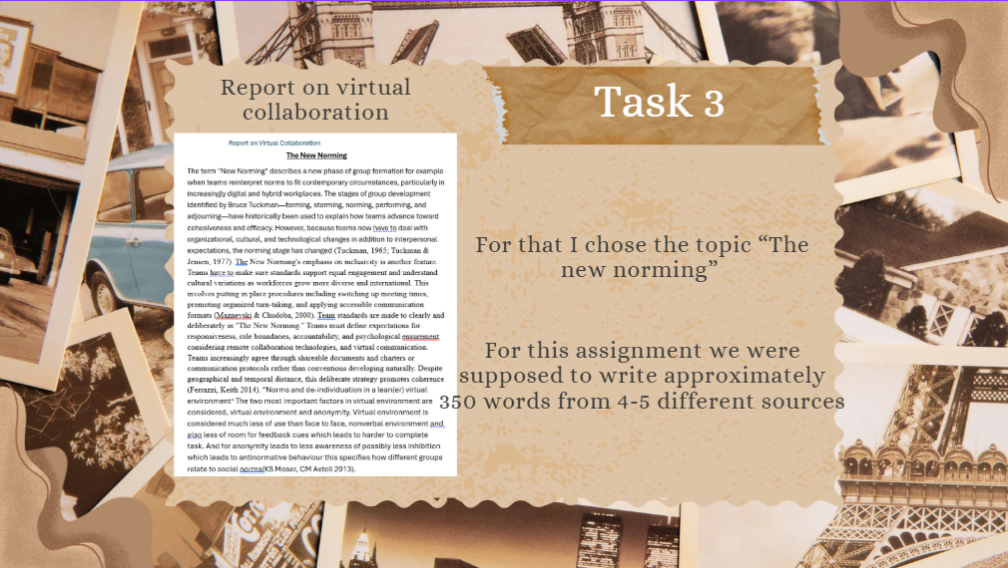Sixth page
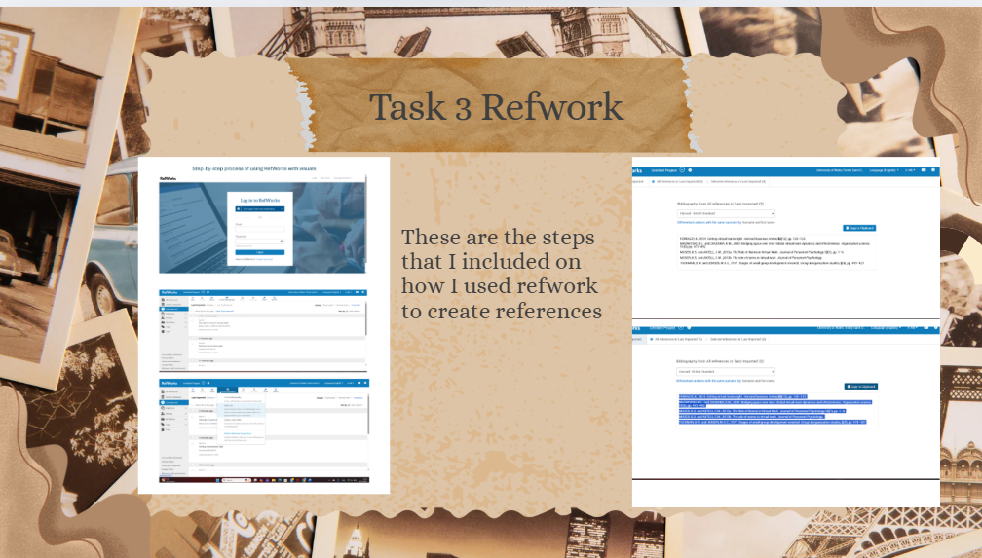Seventh page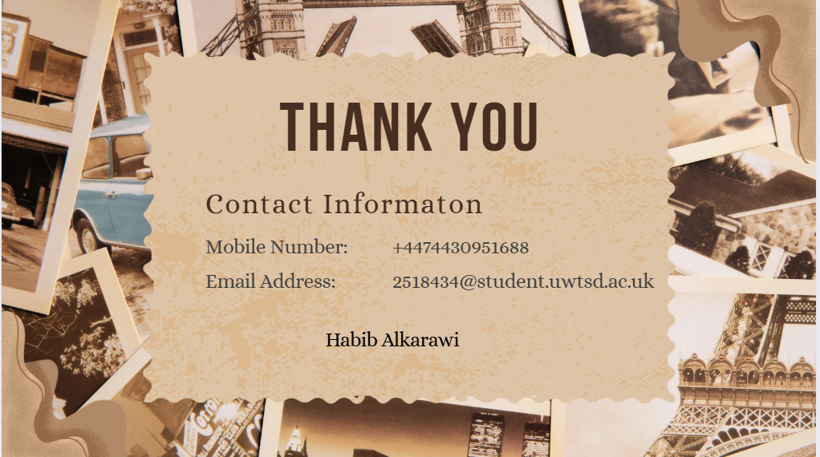Eighth page

Conclusion
For conclusion I want to say I’m happy with the work I’ve done and proud of my self that I did it on time. For next time I would start the assignment a lot earlier and try to complete it ASAP. For this assignment I feel like a could probably add a little bit more information but I also feel like it’s good so I would probably say 75% out of 100.

References

Task 1 References:

References

[1] | N. Jackson, “Essential skills: Essential confusion,” p. 6, 2005.
[2] | 2. N. U. K. S. R. 1T.Vidyullatha, “www.ijmms.in,” INTERNATIONAL JOURNAL OF MULTIFACETED AND MULTILINGUAL STUDIES, 1 10 2016. [Online]. Available: https://www.researchgate.net/profile/Tata-Llatha/publication/334273372_Fundamental_Elements_of_Employability_Skills/links/5d2042d8458515c11c156072/Fundamental-Elements-of-Employability-Skills.pdf.
[3] | A. Yeh, “Hubspot,” Hubspot inc, 19 11 2021. [Online]. Available: https://blog.hubspot.com/marketing/hard-skills-soft-skills. [Accessed 03 11 2025].
[4] | K. Gallagher, Essential Study and employment skills, Oxford: Oxford university Press, 2022, 2022.
[5]
[6]
[7] | Habib, “Mindmeister,” Mindmeister, 17 11 2025. [Online]. Available: https://www.mindmeister.com/app/map/3844884777. [Accessed 17 11 2025].

Task 3 References:
FERRAZZI, K., 2014. Getting virtual teams right. Harvard business review, 92(12), pp. 120–123.
MAZNEVSKI, M.L. and CHUDOBA, K.M., 2000. Bridging space over time: Global virtual team dynamics and effectiveness. Organization science, 11(5), pp. 473–492.
MOSER, K.S. and AXTELL, C.M., 2013a. The Role of Norms in Virtual Work. Journal of Personnel Psychology, 12(1), pp. 1–6.
TUCKMAN, B.W. and JENSEN, M.A.C., 1977. Stages of small-group development revisited. Group & organization studies, 2(4), pp. 419–427.

/

