Marketing Fundamentals
Assessment-02
Student ID: Cristian Mihail Grigore
Student Id: 1920733

Table of Contents
Introduction: 3
Role of marketing 3
Process of creating customer value 5
Impact of Stakeholders involvement on marketing activities 7
Conclusion: 11
References: 12

Introduction:
Marketing refers to creating demand among the target market by informing them regarding a particular product and service features through the different communication channel and selling them to generate revenue. A business organization conduct marketing activities to promote the updated customer-oriented features of a good or service provided by them to meet the demand of the target market. Unilever is a multinational business organization that conducts worldwide marketing strategy to meet customer demand. So, this report will discuss the role of Unilever marketing in creating customer value and ensuring customer satisfaction, as well as the impact of Unilever stakeholder’s involvement on marketing activities, also will discuss here.

Role of marketing
Marketing is a way of communicating the right customer with the right communication channel to increase the sales volume of an organization (Xu, 2015). Unilever is a multinational business organization which attracts international customer regarding their product and service features through maintaining the strategy of international marketing to meet customer needs. Marketing has some roles to enhance the brand value of an organization like Unilever, create demand among the target customer, increasing sales volume and earning revenue which is describing below-
Building customer relationship: Marketing plays a great role to establish a relationship between a customer and a business organization (Kozlenkova, et al., 2015). Effective marketing enhances confidence among customers to get and try a new product and service of an organization. As a multinational business organization, Unilever can conduct a proper marketing strategy to attract the target customer and by selling a product it can build a relationship with the customer. After that with maintaining promise and product quality, Unilever can retain customer-business relationship for a long time.
Meeting customer demand: The key purpose of marketing is meeting customer demand and requirement. As a multinational business organization, Unilever conducts marketing activities for informing the customer demand about the product and service features to meet their needs and wants.
Enhancing brand value: Marketing helps to obtain the objectives of a business organization like Unilever and by this way market share and customer retention also can ensure which can enhance the brand value of an organization ultimately.
Informing customer regarding competitive product and prices: Marketing is the way of attracting the attention of target customers and customers pay attention when they found competitive facilities to meet the demand (Tarka, 2018). As a reputed business organization, Unilever can inform the customer regarding the competitive features of their product and service which will be able to attract the customer demand. Moreover, the price of a product and service may change from time to time considering fair price or competitive price which can communicate to the target customer with proper marketing.
Creating utility: Marketing can create utility among the customers to satisfy their needs regarding a product or service. Place, time, possession, information and formation utility can create by marketing. For example, Unilever can innovate a body spray for resisting coronavirus.
Managing demand: A good role of marketing is managing demand based on the situation (Cheung, 2019). The demand for a product or service of a business organization like Unilever can fall or increase after a certain time which needs to manage properly and marketing activities work for such demand management.
Growth of economy: An indirect role of marketing is economic growth. For example, Unilever conducts marketing in the UK for a particular product or service which increases the demand for that product or service. For meeting the increasing demand Unilever manage an outlet and hires some employees as well as manage an increasing number of raw materials for producing that product. So, this hiring of employees, managing raw materials enhances the economic growth indirectly.
Attracting global market: A vital role of marketing is attracting the global market by conducting advertising and promotional activities (Cortez, 2019). Today’s promotional activities are conducted offline and online where online and social media promotional strategy is more effective to attract international attention. As a multinational business organization, Unilever can attract the attention of the global customer through an effective marketing strategy.
Hence, those are the role of marketing to create customer value and influence of marketing for an organization includes attracting customer mind towards a product or service, selling that product to that customer and ensuring quality and promise for making a sustainable relationship with customers.

Process of creating customer value
Customer value is a perception of the customer regarding the competitive benefits and advantages of the customer for a particular product or service against their cost (Kumar, 2016). The customer always thinks about the highest benefit competitively with their limited cost and in that case, an organization like Unilever need to ensure customer value by maintaining the process of creation of customer value. A good customer value creation management process can ensure a sustainable relationship with customers which are describing below-
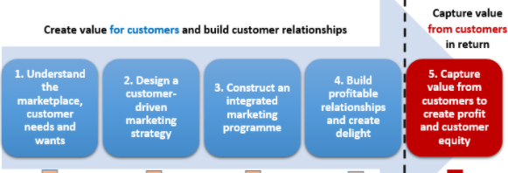
Figure: Process of creating value for Unilever customers
Sources: (Rantala, 2019)
Understanding the marketplace and demand of customer: Creating customer value requires understanding the marketplace and customer mind. Good and reliable research can ensure the actual condition of the marketplace and the actual needs and wants of the customer (Heinonen, 2019). So, a business organization like Unilever can conduct market research to get actual data and information regarding customer tastes, changing condition of demand, present requirements and prospect as well as customer’s perception towards a particular product or service. This data and information will assist to design a product or service for a particular market segment with proper customer value.
Designing a customer-oriented marketing strategy: For ensuring effective customer value, it is required to select the right customer with the right screening strategy (Davis, 2015). Segmenting the customers is the proper strategy to design and formulate a product to meet the demand. Then targeting the right customer makes the marketing process easier. As a multinational business organization, Unilever can differentiate in product and services features to ensure an effective value proposition for their customers. In that case, Unilever needs to segment the market based on customer tastes, attitude, behaviour, changing demand and demographic profile then targeting the best segment will be effective for ensuring customer value.
Constructing an interactive marketing strategy: Marketing strategy includes product, place, price and promotion to ensure a competitive customer value for a particular target market segment. And in this stage, a business organization like Unilever can enhance their brand value by designing and establishing strong brands, can conduct a competitive and feasible product or service price for customers, distribution process and system can make it easier for any customer from the UK and form other countries, as well as Unilever, can maintain a customer-oriented communication and promotional strategy for spreading the features of product and service among the target customers.
Building profitable relationships: Customer always thinks about competitive advantages with a particular cost which means they expect the highest service or best products with a limited amount (Åslund, 2017). This is a good scope for a business organization to attract a customer with ensuring competitive advantages. When a customer will find the competitive benefits from an organization, he will be loyal towards that organization which will ensure sustainable and profitable business-customer relationship. A business organization like Unilever need to maintain a good relationship with marketing partners besides customers for spreading the product features positively towards target customer.
Capturing value from customers to ensure profit and customer equity: Meeting customer needs and delighting them with required product and services can build a sustainable relationship with them. A business organization like Unilever can capture the lifetime customer value by maintaining customer-oriented product and services as well as competitive and promised product quality at a competitive price. This customer lifetime value will ensure higher market share and growth for a long time by increasing the level of business profit.
Therefore, marketing a crucial thing to spread product and service features among the target customer to attract their attention, to purchase and to provide feedback for further improvement. Effective management of the customer value process is highly required to build a sustainable customer relationship to ensure a higher market share and growth.

Impact of Stakeholders involvement in marketing activities
Stakeholders are the people who are directly or indirectly involving the activities of a business organization during making a decision or implementing a formulated plan or strategy (Bourne, 2016). Every business organization like Unilever has stakeholders influence to conduct the business operation within and outside the UK. Stakeholder includes customers, suppliers, competitors, investors, employees and managers of a business organization. For a business organization like Unilever, the stakeholder can be categorized in three ways like internal, external and connected stakeholders. Internal stakeholders include employees and managers of a business organization. External stakeholder includes government, pressure group, local communities, media and professional bodies surrounding a business organization. However, connected stakeholder of a business organization like Unilever includes customers, suppliers, investors, shareholders and distributors.
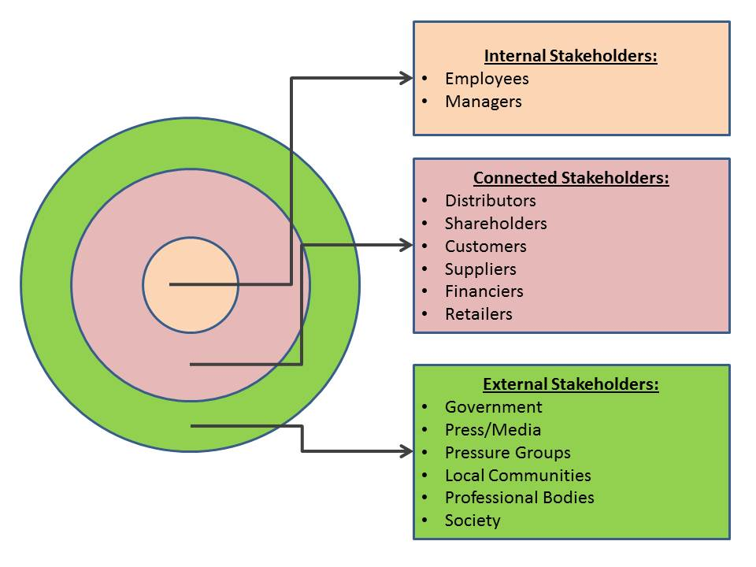
Figure: Stakeholders impact on marketing strategy of Unilever
Sources: (Goodman, 2017)
Impact of internal stakeholders involvement on marketing activities:
Employee: Employee of an organization like Unilever play a vital role in marketing activities. An employee of Unilever know the actual gap of customer demand and marketing strategy and they can formulate the best-suited plan, strategy and communication formula for attracting the target customer to get their required product to meet their demand (Taghian, 2015). Effective cooperation and integration among the employees are highly required to accomplish marketing activities undertaken by an organization like Unilever to get the expected outcome.
Manager’s: The engagement of managers are highly essential in marketing activities due to their power and authorization ability. Managers of a business organization like Unilever formed by shareholders and owners who keep the actual power of formulating an effective and customer-oriented marketing strategy for communicating the target market. Understanding the customer mind, formulating marketing strategy and conducting an effective distribution process are the key responsibilities of managing the body of a business organization like Unilever.

Impact of external stakeholders involvement on marketing activities:
Government: Government is a key external stakeholder who has much power to influence the marketing activities of a business organization like Unilever (Buyucek, 2016). Government is the actual regulatory body of a country that can influence the decision making strategy of a business organization like Unilever. Governmental rules and regulation can impact the policies and planning of a business organization and in this way, the marketing activities can be influenced by an organization like Unilever.

Media: Media and press are works as a mirror of a society where they can positively influence the marketing activities of a business organization (Viglia, 2018). As a reputed business organization, Unilever conducts its operation around the world including the UK and this organization usually spread the updated news of a product or service features through media to communicate to the actual customer. Online, social or press media plays a role to inform the potential and existing customer about the competitive features of a product of a business organization like Unilever that can increase the sales volume of that organization.
Local communities: Local communities of a business organization plays a good role to conduct the word of mouth marketing strategy. In the UK, any business organization like Unilever can build and maintain a good relationship with local communities so that they positively share the product and service features with others. Local communities positive perception and response can enhance the image of the business organization that will assist to convert potential customers to actual customers.
Pressure group: A pressure group is a group of people who comes from the surrounding environment of a business organization (Yang, 2017). As a multinational business organization, Unilever conducts its operation around the world and they have a worldwide pressure group. A key concern of this group includes environment, employee rights and equity, child labour, safe and secure workplace as well as recycle able packaging materials. These factors are highly relevant to formulate and implement the marketing strategy of a business organization like Unilever.
Society: Society is a group of people and surrounding environment where a business conducts its operation. As a business organization, Unilever conducts its activities within the UK and it has a particular society in the UK that has high influencing power on this business organization. Maintaining social beliefs, values, norms and customs appeared as a key concern during formulating and implementing the marketing strategy of a business organization like Unilever.

Impact of connected stakeholders involvement on marketing activities:
Customers: Customers are the king of a business organization and the main focuses of marketing strategy conducted by a business organization includes requirements and satisfaction of customers (Cui, 2016). A business organization like Unilever first think about the customer needs and wants, then formulate the marketing strategy and finally implement a particular marketing strategy by incorporating the customer communication channel. Customer satisfaction is the prime concern and for measuring the customer satisfaction level a business organization like Unilever can conduct a customer feedback strategy to understand the gap of marketing strategy to improve to ensure better customer satisfaction. So, customer engagement plays a good role in marketing strategy considering the purchasing and bargaining power as well as competitors existence where it is required to maintain a customer-centric marketing strategy.
Suppliers: Suppliers are the key back supporters to maintain a business operation smoothly (). If it thinks about a production-oriented business organization like Unilever, raw materials are the prime concern before going production. Getting supply in the right time can ensure to maintain a good production process which is highly related to delivering the required products timely. For example, Unilever can take a big order of soap from a wholesaler of the UK based on the raw materials and current production process. So, based on the supplier's condition, a business organization like Unilever need to plan and conduct a marketing strategy.
Investors: Investors engagement can highly impact the marketing strategy of a business organization (Ormiston, et al., 2015.). Investors invest a huge amount of money in a business organization like Unilever and they expect a rate of return after a certain period. Managing capital from investors is a key task of a business organization to continue the operation and in that case, investors can play a good role in the decision making step of a business organization like Unilever. For example, Unilever is thinking about expanding its business operation in the UK where it is required a big amount of capital and in that case, investors can influence the planning, designing, formulating and implementing a marketing strategy.
Shareholders: Shareholders are the owner of a business organization who is highly responsible for planning and managing marketing strategy (Mishra, 2016). As the largest and reputed business organization, Unilever has shareholders who are involving with the managing body of this organization. Shareholders of Unilever think about the customers present and future perception, current and potential customer demands return from shares as well as the potential growth of a market and potentiality of a customer segment for a long time to conduct a business operation successfully. That thinking comes from the market survey and customer opinion evaluation that helps the shareholders to determine to purchase the share of a business organization like Unilever.
Retailers: Retailers engagement can also play a good role in the marketing strategy of a business organization considering their proper movement and customer-oriented business communication. For example, Unilever has some retailers in the UK who deals with a large number of products with Unilever on regular basis from where Unilever gets a good cash flow. Suddenly these retailers decrease their dealing with Unilever and switching to competitors considering the competitive advantages which decrease the cash flow of Unilever. So, retailer involvement has a high impact on the marketing strategy of a business organization.

Conclusion:
Marketing is an essential task of a business organization like Unilever to attract the target market by providing information regarding the features of a product and service of a business. Ensuring competitive customer value can enhance the loyalty of customers and build a sustainable customer relationship which ultimately ensures a high return from customers that assists to enhance the market share and growth. However, a business organization like Unilever has strong stakeholders including internal and external who are involves to influence the decision-making process of the business. These stakeholders direct and indirect engagement can highly impact the marketing strategy of a business organization in the long run.

References:
Åslund, A. and Bäckström, I., 2017. Management processes and management’s role in customer value creation. International Journal of Quality and Service Sciences.
Bourne, L., 2016. Stakeholder relationship management: a maturity model for organisational implementation. CRC Press.
Buyucek, N., Kubacki, K., Rundle-Thiele, S. and Pang, B., 2016. A systematic review of stakeholder involvement in social marketing interventions. Australasian Marketing Journal (AMJ), 24(1), pp.8-19.
Cheung, L. and McColl-Kennedy, J.R., 2019. Addressing vulnerability: what role does marketing play?. Journal of Services Marketing.
Cortez, R.M. and Johnston, W.J., 2019. Marketing role in B2B settings: evidence from advanced, emerging and developing markets. Journal of Business & Industrial Marketing.
Cui, A.S. and Wu, F., 2016. Utilizing customer knowledge in innovation: antecedents and impact of customer involvement on new product performance. Journal of the academy of marketing science, 44(4), pp.516-538.
Davis, M.M., Field, J. and Stavrulaki, E., 2015. Using digital service inventories to create customer value. Service Science, 7(2), pp.83-99.
Goodman, J., Korsunova, A. and Halme, M., 2017. Our collaborative future: Activities and roles of stakeholders in sustainability‐oriented innovation. Business Strategy and the Environment, 26(6), pp.731-753.
Heinonen, K., Campbell, C. and Ferguson, S.L., 2019. Strategies for creating value through individual and collective customer experiences. Business Horizons, 62(1), pp.95-104.
Kozlenkova, I.V., Hult, G.T.M., Lund, D.J., Mena, J.A. and Kekec, P., 2015. The role of marketing channels in supply chain management. Journal of Retailing, 91(4), pp.586-609.
Kumar, V. and Reinartz, W., 2016. Creating enduring customer value. Journal of Marketing, 80(6), pp.36-68.
Mishra, S. and Modi, S.B., 2016. Corporate social responsibility and shareholder wealth: The role of marketing capability. Journal of Marketing, 80(1), pp.26-46.
Ormiston, J., Charlton, K., Donald, M.S. and Seymour, R.G., 2015. Overcoming the challenges of impact investing: Insights from leading investors. Journal of Social Entrepreneurship, 6(3), pp.352-378.
Rantala, T., Ukko, J., Saunila, M., Puolakoski, H. and Rantanen, H., 2019. Creating sustainable customer value through digitality. World Journal of Entrepreneurship, Management and Sustainable Development.
Taghian, M., D’Souza, C. and Polonsky, M., 2015. A stakeholder approach to corporate social responsibility, reputation and business performance. Social Responsibility Journal.
Tarka, P., 2018. The views and perceptions of managers on the role of marketing research in decision making. International Journal of Market Research, 60(1), pp.67-87.
Viglia, G., Pera, R. and Bigné, E., 2018. The determinants of stakeholder engagement in digital platforms. Journal of Business Research, 89, pp.404-410.
Xu, C., Peak, D. and Prybutok, V., 2015. A customer value, satisfaction, and loyalty perspective of mobile application recommendations. Decision Support Systems, 79, pp.171-183.
Yang, Y., Asaad, Y. and Dwivedi, Y., 2017. Examining the impact of gamification on the intention of engagement and brand attitude in the marketing context. Computers in Human Behavior, 73, pp.459-469.

