MARKETING MANAGEMENT
SBMA7138
Rohit Agrawal
1605867

LECTURER
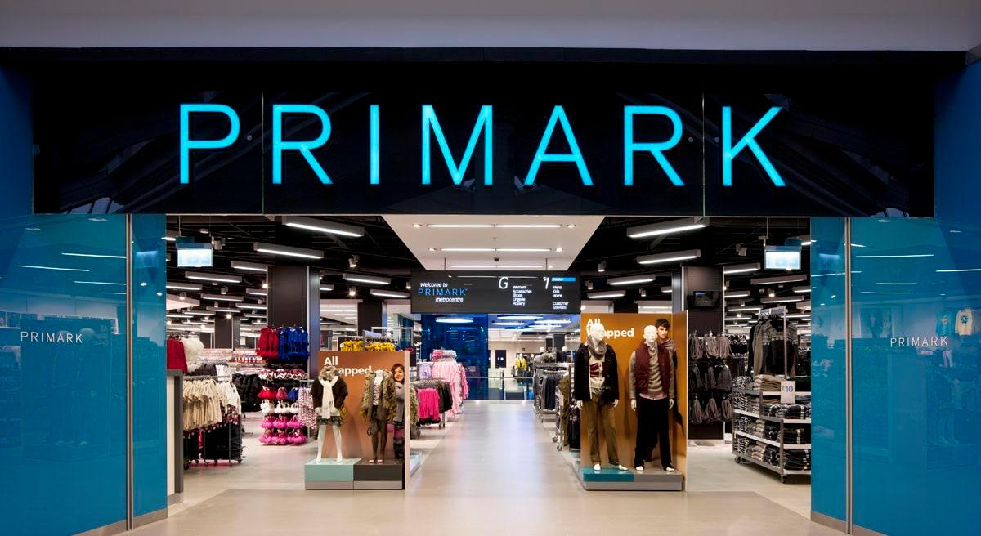
RICHARD SMALL
Table of Contents
Introduction 3
Company Overview 3
Brand Marketing Strategy 4
SWOT Analysis 8
PESTEL Analysis 10
Competitor Analysis 12
GAP Analysis...............................................................................................................................................12
Customer End to End Journey....................................................................................................................14
Conclusion..................................................................................................................................................15
References..................................................................................................................................................16

INTRODUCTION

In this era of globalization companies are keen to expand their business worldwide. This has not only increased the company's customer base but also increased the competition. There are a lot of brands in the market competing to provide the best products and customer services. This has increased the difficulties in retaining customers, as the customers easily shift to the brands which provide them with better products and services as per their needs. Because of irrelevant changing expense starting with one organization then onto the next, the unsatisfied customers effortlessly change to various brands on the off chance that they are not happy with the items or administrations of the present brand (Kotler, 2012). The major reasons for the customers shifting to another brand can be the low level of customer satisfaction. The company's keen to improve customer satisfaction concentrate on the touchpoints, however it is equally important to focus on the customer end to end journey. Due to the improved competition in globalization and a changing business environment the companies are facing many challenges like rise of digitalization, increasing brand awareness and competitiveness, managing reputation, information management and rising expectations of customers. The increase customer satisfaction and gain a competitive advantage the companies are following different marketing strategies. The objective here is to critically analyze way in which 'Primark" can create innovative marketing strategies for raising awareness of the brand as well as managing and evaluating the customer journey across a variety of communication channels to ensure current and future stakeholders' expectations are fulfilled.

COMPANY OVERVIEW/ SITUATIONAL ANALYSIS

Primark first established by Arthur Ryan in June 1969 in Dublin, is an Irish clothing and accessories brand. it is a subsidiary of AB Foods. the headquarter of Primark is in Dublin Ireland. The CEO of the company is Paul Marchant and it has around 68000 employees. The revenue generated by Primark in 2016 was £5,949 millions. Primark offers a diverse range of products including beauty products, home ware, accessories, footwear, children's clothing, men's clothing and women's clothing. Primark's fruitful plan of action, which gives the 'latest looks without breaking the bank' (Primark, 2014) has empowered the organization to keep extending quickly. Primark now has over 350 stores in eleven nations in the world.
Riding the undeniable increment in the prevalence of the value segment, which has evidently 'outflanked whatever remains of the dress market' (Ross, J and Harradine, R. 2010), this quick design spending organization has moved from quality to quality, giving a triumphant combination of 'on-trend' item at low value focuses. Regarding the retail life cycle (Findlay, A and Sparks, L. 2002).
Primark is toward the start of the 'growth' stage. The retailer should now investigate in the case of influencing these changes will allow them to come to the 'maturity' stage more rapidly.

BRAND MARKETING STRATEGY

Primark is an amazing and net worthy organization with a mission statement to enhance the life of everyone with fashionable clothing paying little regard to monetary prosperity. It created as critical power in the British retail industry, contributing through it low price value and amazing quality for everyone form items for everybody in the public eye overall and leaves wonderful effect on social, ecological and moral conduct of individuals. Primark does not rip off its customers and presents incredible instance of it maxim which states "look good, pay less" Primark.

MARKETING MIX

The idea of showcasing relies upon distinguishing the correct need of the customer that isn't satisfied by the contenders exhibit into the market or reckoning the future need of the customers and create item and fulfill the needs of the customers. Marketing Mix reflects mix of components used to advertise the associations product. it comprises of 4 components which will help in promoting the organization's item in a fitting way. This strategy consists of product, price, place, promotion by following this system, the organization can end up being effective to build up its item in the market.
- Pricing
Holdin to a "cost-based pricing" strategy Primark has developed a reliably wandered value design (Jackson and Shaw, 2009) to speak to those fashion conscious customers who desire value for money. However, Primark is able to do it because they focus on simple designs and purchasing the popular sizes in volume. As the facts state Primark may have lower quality products from its competitors but it competitive advantage is the pricing strategy (Drapers, 2013). Customers of Primark have a "impulse purchasing behavior" as the prices are too low.

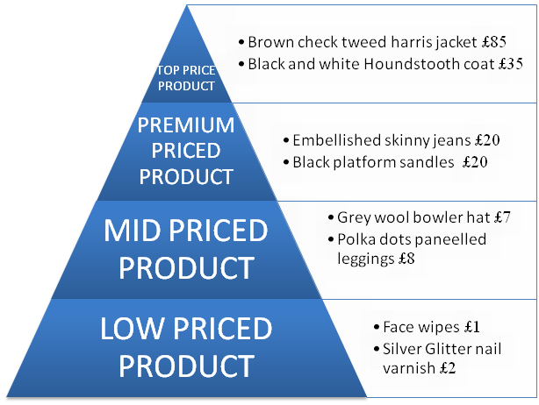

If you look at how it operates on a category level it is an extraordinarily professional retailer which takes a very detailed approach to each category –
not just getting the right price but also getting the right fashionability” (Jobling, A. 2013).
- Product
Primark follows a product strategy of making large quantity of attractive and fashionable products at low price. Other strategy which Primark follows is to put new products on the shelf every week. A season in Primark is defined by summer winter or spring but by a six-week gap. The company focuses on the target markets with their "wide and shallow" products with limited sizes. Primark's major focus is the women's section. Jackson and shaw (2009) reports that the annual clothing expenditure of women, men and children is 4:2:1 and it is profitable. Primark includes sub brand like Atmosphere, Cedarwood State, B&W, Denim Co., Love to Lounge, Young Dimension, No Secret, Ocean Club, Secret Possessions.
‘We offer a diverse range of products, stocking everything from baby and kids, to womens, mens, home ware, accessories, beauty products and con - fectionery’ (Primark.com, 2014)
- Place
Apart from price, proximity and convenience is the major concern for the customers. Suitable places for Primark could be the industrial surfaces and big malls as the rent is cheaper in industrial surfaces and the big malls have major foot falls. The major target group of Primark are the teenagers who might not have their own transportation so a place accessible to public transport is better for Primark. Over the years Primark has invested to improve the efficiency of their logistic strategy and capacity of their warehouse, this has helped them reduce their overhead cost and resulted positively for Primark.
- Promotion
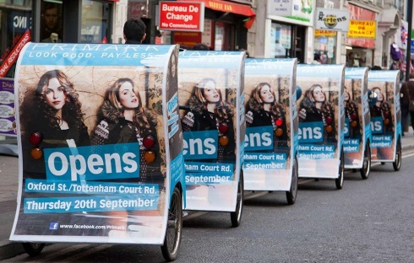
As the cost of television advertisements, celebrity endorsements and newspaper advertising are too high, Primark relies on word of mouth and marketing communications including social media to promote their products and reach their target customers. Primark's social media activities (actively posting on Facebook, Instagram, Pinterest etc.) enhance word of mouth, reaching to the public. Though most of the brands have an online selling platform Primark uses its website for the promotion purposes only. The "Primania Blog" is an effective tool in promotion of Primark, which enables the customers to upload their looks in the blog wearing Primark products. The store at Tottenham Court Road itself offers a lot of promotion with impressive flagship.

SWOT ANALYSIS

Strengths
- Provide latest, current fashion at low price.
- Offer a extensive range of things including children's wear, clothing for men and women, embellishments, confectionary and home wear, stocking enormous volumes of the most generally perceived sizes for the goal advertise.
- Active through online systems administration media post as regularly as conceivable on Facebook, Instagram, Twitter, Google+ and Pinterest. Save money on restricted time practices in view of the verbal trade made by their social media philosophy.
- The precisely advanced Tottenham Court road pioneer store, is attracting a lot of customers because of its location, size and displays.
- In support of current customer lifestyle designs: Recently developed an extent of wellbeing dress adjacent the dispatch of a wellbeing campaign (excluding the Primark name), addressing new markets and following in the steps of contenders H&M.
- Primark has overtaken the Arcadia Group, which has made it the largest footwear and clothing retailer in the UK.
Weakness
- The atmosphere of the Primark store is not very relaxing. The store is sometimes messy and there are long lines so the customer has to wait alot.
- The facilities in all the stores of Primark are inconsistent, as far as advanced development and visual promoting. Their Tottenham Court street and Edinburgh store give an all the more stylishly satisfying, and invigorating background (with extensive plasma screens and innovatively promoted item shows) than a portion of the more scattered and seemingly unattractive smaller stores.
- Customers are not ready to purchase Primark items on the web (will conceivably impact the organization's future development rate, as it was accounted for by ONS that 'the sum spent online expanded by 12.4% in February 2014 contrasted and February 2013 and by 2.5% contrasted and January 2014' proposing that they may need to start offering by means of their site, with a specific end goal to remain pertinent.
- Not carefully aggressive: Perhaps because of current evaluating methodology and the emphasis on global development, Primark might not have the expected spending plan to give customers a carefully progressed, in store involvement.
- Certain items seem poor in quality.
- Due to broadly wide item run, the objective market isn't well defined.
- It is heavily reliable on UK market.
Opportunities
- Market penetration- The rising obesity level provide opportunity for expanding to plus size products and also for the growing age.
- Growth of ecommerce offers opportunities for Primark to sell products online.
- Availability of option to customers to get their product delivered to their door step.
- Improve visual merchandising and general layout of store.
- Installing more digital technologies in the store for a more competing instore experience.
- The company should consider celebrity endorsements.
- Developing a Primark mobile app will help promotion and better knowledge of the products to customers.

Threats
- Brands offering higher quality items at also or similarly low value focuses
- Supermarket brands-offering extreme convenience "The blend of low costs, convenience and solid brand trust, implies that the general stores should keep on gaining piece of the overall industry".
- Brands with higher spending plans ready to give an additionally captivating, carefully progressed in store involvement, for instance Topshop furnishing an individual shopping administration with iPads and so on.
- There are competitor brands who are willing to invest on broad limited time battles, fusing TV adverts and big-name support.
- Brexit is likely to cause adverse effects on profit margin.

PESTEL ANALYSIS

Political
- In June 2016 Britain voted to leave EU which created a major political turmoil.
- Due to Brexit the market got uncertain both financial and business.
Economic
- Following Brexit the pounds reduced to its lowest, this has put pressure on the business.
- It has also been found that though the falling UK sterling created financial and market uncertainties it also created some positive effects too.
Social
- There is a rising obesity in UK which provides opportunities for growing in the plus size clothing for Primark.
- Primark should also start focusing on its ageing customers. Over the 40-year period between 1974 and 2014," the median age (that is the age at which half the population is younger and half the population is older) of the UK population has gone up from 33.9 years in 1974 to 40.0 years in 2014 (ONS 2015)"
Technological
- In this period of globalization technology offers major oppurtunities to Primark. It can start a mobile app, improve its digital marketing. Primark has to step into ecommerce and start selling its products online like its competitors do.
Environmental
- The industry is getting more ethical and environment friendly and so do the customers. They are asking firms to use paper packings and recyclable materials. Some brands like H&M are making clothings organic cotton which is environment friendly.
Legal
- The most regulation which is affecting the UK cloth industry was the new Workplace Pension Legislation that makes compulsory for the companies to contribute 3% of their employee's workplace pension for eligible UK workers. (Department of Business, Innovation & skills 2016)

COMPETITOR ANALYSIS

'Industry Competitors-Rivalry among existing firms'
According to Porter's five forces model (Jackson and Shaw, 2009) Topshop, H&M, New look poses major threats to Primark. These brands use celebrity endorsements, digital merchandising to dominate the markets. Most of the competitors of Primark have an online as well retail presence which offers their customers with better services as compared to Primark.
'Threats of New Entrants'
There are competitors in the market who are selling on an online platform online (for example Boohoo.com) pose a major threat to Primark's traditional retail practices. Indirect competitors like Tesco, Lidl are taking advantage of their location and they too pose a major threat. However, the clothing section in these supermarkets are smaller than Primark.
Cost leadership Strategy
Primark has always followed the cost leadership strategy but in the future to gain competitive advantage Primark should consider following 'differentiation' strategy alongside (Kotler, P.2012). As Darwin said for the survival evolution is a necessity.

GAP ANALYSIS

Customer expectation consists of what a customer believes or what will happen. The customer gap refers to the gap between the expected service and the perceived service. It important for improving the customer service that the gap should be low. The customers will be satisfied when they receive a serivice as per their expectations. The gap analysis for the customer gap is as follows:
Step 1: Primark now has a online website for promotions only. It also has a Primania blog where the customers can upload pictures wearing Primark products. It offers on trend fashionable products.
Step 2: the specific improvement areas for Primark can be, start selling products online, the in-store service as the store is sometimes messy. Primark can invest more in advertisement. It follows a cost leadership strategy only. Customers do not consider it as a style statement.
Step 3: the targets of Primark are, improvement in ecommerce. Enhance in store experience of customers. Make customer change their mindset about its product. Moreover, Primark also has a need to follow differentiation strategy alongside cost leadership strategy. Collectively, enhance customer satisfaction.
Step 4: the current state of customer satisfaction in Primark is not very high. As the instore services are poor and the customer think that the products are disposable. Moreover, the customers also have a notion that Primark's products are not a trend setter. The only thing keeping customer satisfied are the lower price point.
Step 5: the action plan for Primark to achieve its target and enhance customer satisfaction is by improving the in-store experience for customer, by keeping the store tidy. Primark should invest in celebrity endorsements especially when entering a new market. It should start selling its products online which may increase the customer satisfaction as they will be getting their products at their door step. It can also launch a mobile app.

CUSTOMER END TO END JOURNEY

Customer's journey starts when they have a need to purchase the product of an organization. The customers journey does not end with the purchase of the product rather it continues to the next purchase from the same organization or from a different organization resulting from the satisfaction gained by the customers. Primark has achieved a distinctive customer satisfaction, not on the basis of its service but by it lower cost point. Major part of Primark customers shows 'impulse buying behavior' due to lower price products. The customer end to end journey of Primark is as follows:
- Awareness: the first step is to make the customer aware of your brand. Primark uses its website to promote its products. It also uses different social media platforms like Facebook, Instagram, Pinterest etc. for the promotion of its products. Primark has also started a blog 'Primania' where the customers can upload their looks wearing Primark products. The company also carries out promotion activities like posters on rickshaws and individual standing with the posters. The flagship store on Tottenham court road is itself a promotion platform.
- Consideration: before going to a store customers need to reseasch and compare the products offered by the competitors. The company needs to communicate its value to the customer and build confidence in the customer regarding its brand. The most important communication channel for Primark is 'word of mouth', customers who purchase from Primark will mostly speak to others about its low price fashionable products.
- Purchase: the 'on-trend' fashionable products with low price has made Primark successful in attracting customers. The customers are already motivated as they have a need to buy a product the companies just have to build up confidence in them. But in case of Primark decision making for the customer is not an issue as they mostly go with impulse buying due to low prices.
- Post-Purchase: customers want to purchase from to purchase from a brand which provides good post purchase services. Primark allows a return and refund policy in UK except some items. They mostly work on 'wide and disposable' range of products. So, the customers generally come back due to the low price.
- Advocacy: although Primark does not provide very good instore service it does get a major promotion from word of mouth as the products in Primark are changed every week. And as mentioned earlier the lower price factor.

CONCLUSION

It can be concluded that Primark is following a cost leadership strategy that is, selling the products at lower price. the customer services provided by Primark are not very efficient, they can improve in their services to enhance the customer satisfaction. The company can improve their services by following strategic options like, developing a mobile app like its other competitors, starting to sell its product online, perhaps expand into new market and also improve the in-store customer experience. By using its strengths to grab the opportunities, reduce weakness and eliminate Primark can prosper and enhance its customer satisfaction.

REFERENCES

Kotler, P., 2012. Marketing Management, millenium edition: Custom Edition for University of Phoenix.
Jackson and Shaw, (2009). Mastering Fashion Marketing. Basingstoke: Palgrave Macmillan.
Ross, J and Harradine, R. (2010). Value brands: cheap or trendy?. Journal of Fashion Marketing and Management. 14 (3), 350-366.
Findlay, A and Sparks, L (2002). Retailing: The evolution and development of retailing. London: Routlege
Associated British Foods plc. (2014). Interim Management Statement. Available: http://www.abf.co.uk/media/news/2014/interim-management-statement_july_2014. Last accessed 15th Oct 2014.
Primark.co.uk Available: http://www.primark.com/en/about-us/about-primark. Last accessed 13th January2018
ONS . (2014). Internet Access Quarterly Update, Q1 2014. Available: http://www.ons.gov.uk/ons/rel/rdit2/internet-access-quarterly-update/q1-2014/stb-ia-q1- 2014.html#tab-Age. Last accessed 12 January 2018
Edelman, D.C. and Singer, M., 2015.Competing on customer journeys. Harvard Business Review, 93(11).
Kotler, P., Keller, K.L., Ancarani, F. and Costabile, M., 2014. Marketing management 14/e. Pearson.
Rawson, A., Duncan, E. and Jones, C., 2013. The truth about customer experience. Harvard Business Review, 91(9).
Drapers - Editions: (April, (2013), October 4th, 11th, 18th, 26h, 27th (2014)
Jobling, A. (2013). Primark: hitting new heights. Available: http://www.wgsn.com/content/board_viewer/#/122876/page/1. Last accessed 14 January 2018
Megaw, N (2016). Primark: looks to benefit from Brexit. Available: https://www.ft.com/content/032d7b42-05d2-3263-bcb0-9ad3950f86be. Last accessed 14 January 2018
Gap analysis. Available: https://www.investopedia.com/terms/g/gap-analysis.asp. last accessed 13 January 2018.
Zeithaml, V.and Bitner, M. Services marketing, 4/e.

