Jac Cromwell – 2401039

L4 - Network and Cybersecurity Essentials (ACCA4024)

L4 - Network and Cybersecurity Essentials (ACCA4024)
Table of Contents
L4 - Network and Cybersecurity Essentials (ACCA4024) 1
Introduction 1
Modern Threats And How to Spot Them 2
Zero Trust Security Model 2
Modern Security Policies 2
Technical & Administrative Mitigation Measures 3
Proactive Monitoring & Incident Response 4
Continuous Training & Security Awareness 4
Business Impact & Board-Level Perspective 4
Conclusion 5
References 5

Introduction
Cybersecurity has become a significant issue globally and increasing exponentially in recent years, and a large part of it being within the finance sector, which consistently ranks within the most targeted industries since they deal with high value assets and sensitive data. In Jan 2023 – June 2024 ENISA reported that lower maturity level companies were more affected within the period. And 38% of the cases of ransomware caused financial loss, 35% being the sale of data and 20% being operational disruption to the company [1]. In CISO’s report for 2025 it states how cloud based environments where the data and users are located outside of the usual network perimeter has expanded the organisation attack surface and reduced the effectiveness of the older robust security models[2] And now business owners within the finance sector need to prioritise targeted investment to improve their cybersecurity resilience, such as managing supply chains and incident response and ensure their compliance with frameworks and GDPR as a result of this, I will be doing the same here at VTAM.

Modern Threats And How to Spot Them
One of the most prevalent modern threats to cyber security is Ransomware as a Service, abbreviated as RaaS. RaaS is a model where people who develop Ransomware will sell the code or malware they produce to other hackers, who will then use it to initiate their own attacks, they are handing over a loaded gun, which enables the buyer to deploy and launch an attack with minimal skill. You can imagine how this is dangerous because now individuals with limited technical experience can now initiate these attacks [3].
The four main ways that we can mitigate against RaaS attacks are to frequently perform data backups, this ensures that data is able to be recovered in case of deletion. Keeping software regularly updated, especially antivirus and protection. Cyber criminals take advantage of outdated software because the bugs there are known. It is also important to train employees to know how to identify things such as phishing emails, suspicious messages and prevention of social engineering. Lastly is endpoint protection and technology to detect threats [4]. As a result of the recent Phishing campaign at VTAM, I will primarily be focusing on Training our employees, this is affordable and addresses a primary human related vulnerability.

Zero Trust Security Model
The Zero Trust Model, being to never trust and always verify has become very popular in modern cyber security. There are three main principles to this model, verifying explicitly which is to always authenticate and authorise, To use the least privilege access, to where users are only given access to what they explicitly need, nothing more. And Assume Breach, which means designing your security as if an attacker has already breached into your environment rather than trying to keep everyone out with a strong border, this reflects a layered defence approach, accepting that you will likely be breached the focus on Assume Breach is to limit the impact and scope of compromise [5].

Modern Security Policies
There are many modern security policies we can use as Cyber Security, one being the Identity and Access Management Policy. This policy also ties back into Zero Trust, it means to have Strong authentication, least-privilege access models and credential lifecycle. As the security manager of VTAM, I will implement an IAM Policy following NIST’s model. Making Multifactor authentication mandatory, identity proofing and review credentials regularly. This follows the NSA best practice for lifecycle management, SSO and central IAM auditing [6]. Another is having a Remote and Hybrid work policy. Using ZTNA which is the zero trust network access model, again is a modern policy, instead of having a VPN and giving general access to the entire network it’s to have explicit least privilege access and only allow workers to connect to the specific applications that they use. I will implement a Remote/Hybrid working policy at VTAM and ensure that connections are reverified, identity is checked and the connections are encrypted via a gateway [7]. And lastly another policy is the incident response policy.
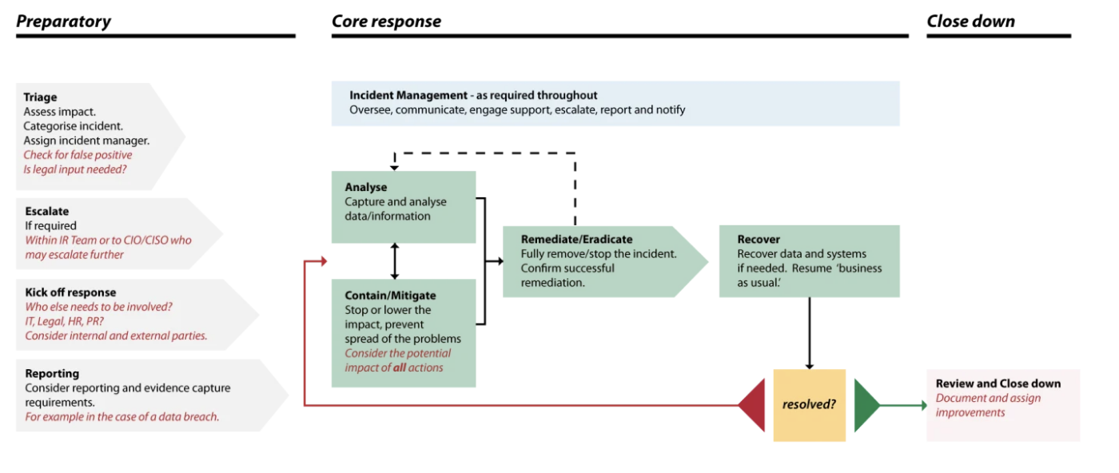
As seen in the above diagram, it’s to have a clear-cut plan for incident response. Make sure that escalation paths are clear. I will implement a policy at VTAM so that we have the benefit of damage control and ensure that if we are breached that we can prevent escalation by using these principles.

Technical & Administrative Mitigation Measures
For technical administration and mitigation measures, there are many methods that we can use. One of the main ones being multi-factor authentication. At VTAM I will aim to implement this across all critical systems including email, VPN Access, and financial SaaS platforms. I will also implement a SIEM solution, to help detect security threats and analyse data such as our network, hardware and software in real time. This provides a centralised view of our data and security activities, reducing the average time to detect and respond. [8].
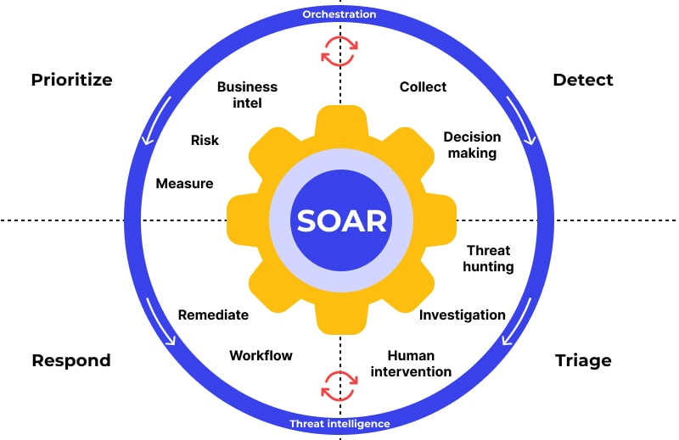
We can also use SOAR which as seen in the diagram above is process for Security Orchestration, Automation and Response technology. I will ensure we use this at VTAM so that we can respond to cybersecurity attacks and understand how they happened and how we can prevent future incidents, by analysing the alert data and to prioritise automated incident responses if we see similar incidents in the future. This will be significantly more efficient by automating the repetitive incident response tasks.[9] I will also ensure that in future we use immutable backups, which is known as the Write Once Read Many formats. Therefore, our backups will not be able to be edited, deleted or encrypted. This will ensure that our customers’ financial data has integrity and stays untampered and will also prevent attackers from encrypting our own backups to prevent us from accessing them in a ransomware situation [10].

Proactive Monitoring & Incident Response
Under Incident response also comes the SOAR model, using it to monitor data from incidents and trying to prevent similar incidents in future. I will ensure to implement an automated alert triage using the SOAR model so that we are always monitoring and not late to react, continuously analysing logs from our email platforms and our customer endpoints and requests looking for any suspicious logs, metrics to try and detect threats whilst they’re happening not after a threat has succeeded. Using one SIEM tool for logging and metrics will allow us to have a centralised location for tracking things such as unauthorised access attempts and credential compromises and attach correlation ID’s to any related requests allowing us at VTAM to better understand who the threat actor is and what they are attempting so that we can figure out how to mitigate it.
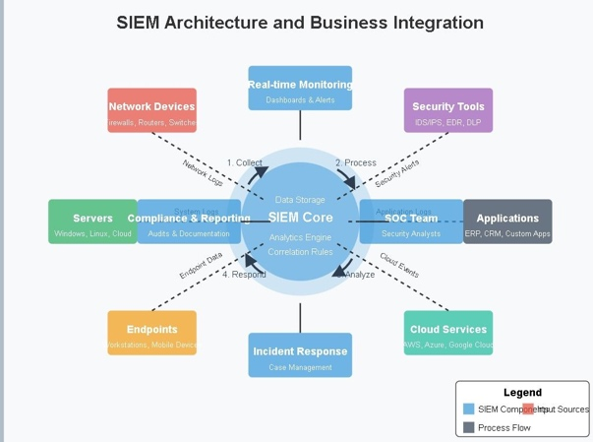
[11]

Continuous Training & Security Awareness
I will need to implement better training than the typical annual compliance-driven training that people see as just a checklist. I will need continuous and meaningful training.[14] Some of the examples that I will implement at VTAM are Monthly phishing simulations and emails. AI generated and fake calls attempting social engineering. And more specifically training targeted at different roles at VTAM, for example for IT and Tech Staff they will be provided with intriguing incident response drills from relevant attack methods. For the finance and payment, they will be focused on things like payment diversion and fraud, because it’s a waste of resource having generic training that some staff will not benefit from. I will also attempt to enforce a security first environment where people can see something and say something, encouraging a strong reporting culture for anomalies to be reported to increase early detection of threats.

Business Impact & Board-Level Perspective
As Cyber Risks are a huge threat to VTAM because of things like ransomware, downtime and damaging brand reputation and customer trust. Investing in principles like Zero Trust isn’t just spending money on our IT department. It’s a calculated investment in making us more secure and resilient. Because it mitigates security breaches it will help us at VTAM build trust with our customers, ultimately this will drive more revenue and benefits to us at VTAM [12].

Conclusion
As a summary, here at VTAM we will be implementing a zero-trust approach along with a better threat landscape visibility using a SIEM tool and a SOAR model. This will allow us to be a more resilient and proactive rather than reactive in our cyber security. Not only will we be more secure by doing this, but we will also build a better client relationship driving our profits. By keeping our staff trained and motivated, we hope to seek issues before or while they’re occurring not after.

References
[1] M. Theocharidou, I. Lella, R. Naydenov, and A. Malatras, “ENISA THREAT LANDSCAPE: FINANCE SECTOR ABOUT ENISA AUTHORS,” doi: https://doi.org/10.2824/5410466.
[2] “The CISO Report.” Accessed: May 05, 2026. [Online]. Available: https://edu.arrow.com/media/32yhrv03/3_ciso-report-2025.pdf
[3] J. Holdsworth and M. Kosinski, “Ransomware as a service,” Ibm.com, Sep. 05, 2024. https://www.ibm.com/think/topics/ransomware-as-a-service#1238298323

[4] “What Is Ransomware-as-a-Service (RaaS)? How Does it Work?,” Fortinet. https://www.fortinet.com/resources/cyberglossary/ransomware-as-a-service-raas
[5] Microsoft, “Zero Trust implementation guidance,” learn.microsoft.com, Apr. 12, 2024. https://learn.microsoft.com/en-us/security/zero-trust/zero-trust-overview
[6] D. Temoshok, “Digital Identity Guidelines,” Jan. 2025, doi: https://doi.org/10.6028/nist.sp.800-63-4.
[7] C. Kidd and C. Kidd, “ZTNA and Remote Access: A Security Model for the Future of Work,” Cisco Blogs, Dec. 15, 2025. https://blogs.cisco.com/insidervoices/ztna-remote-access
[8] C. Kidd, “What’s SIEM? Security Information & Event Management Explained,” Splunk, Jan. 03, 2025. https://www.splunk.com/en_us/blog/learn/siem-security-information-event-management.html
[9] Palo Alto Networks, “What is SOAR?,” Palo Alto Networks, 2024. https://www.paloaltonetworks.com/cyberpedia/what-is-soar
[10] Licdn.com, 2026. https://media.licdn.com/dms/image/v2/D4E22AQF5Mh3fPY-b-g/feedshare-shrink_1280/B4EZYieAi4HgAo-/0/1744335014666?e=2147483647&v=beta&t=CcehUZE170EXU3UA6IejrnXNdIo6Qv6iwlOS66Ln208 (accessed May 05, 2026).

[11] “Common Causes of Training Failure and How to Overcome Them • PubAdmin.Institute,” Public Administration Institute, Feb. 03, 2025. https://pubadmin.institute/human-resource-management/common-causes-training-failure-overcome
[12] S. Balaouras, “​Zero trust security: The business benefits and advantages​,” Forrester. https://www.forrester.com/zero-trust/

