DVP Assisgnment

Report Title: Developing Professional Practice as a HR Professional

Name: Courtney Drew Mariah Morgan

CIPD Membership Number: 5343295X

Date: 14th November 2018

Word Count: 2,730

I declare that this assignment is my own work and that any information obtained from books and other sources have been appropriately referenced.

Signed Courtney Morgan Date 14th November 2018

Contents
1. Introduction 3
2. Understanding of a HR professional 4
2.1 What is a HR Professional? 4
2.2 The CIPD Map 4
3. PDP Plan Self Assessment 6
4. Group Dynamics and Conflict Resolution 12
5. Project Management 15
6. References 18
7. Appendices 19

1. Introduction

This report captures what is required to be an effective and efficient HR professional. This report understands what a HR professional is and how the professional is to perform effectively amd efficiently no matter what problems they face. This report also demonstrates how a HR professional is to apply CPD techniques to their role and how to construct, implement and create a personal development plan. This allows HR professionals to identify their position on the map and plan any further training needed. As I professional working in the recruitment sector I have tailored this report to my role discussing my personal development role, team working and how I have faced any arisen challenges.

2. Understanding of a HR professional

2.1 What is a HR Professional?

A HR professional is a qualified person who is a member of a professional Body. The professional updates their knowledge continuously and confident to practice this knowledge and apply this in their role. This person is underpinned to a code of conducts or ethics, such as ones set out by the CIPD. The HR Professional also has a recognised qualification and is an individual who is able to challenge, commercially aware, proactive and a decisive thinker (Taylor and Woodhams, 2016). Cited in Taylor and Woodhams (2016) there a four circles of HR professionalism that underpins the HR Professional:
- Managing self
- Managing Teams
- Managing upwards
- Managing across the organisation
The CIPD (Charted Institute for Personal Development) was founded in 1993, it’s a professional body and also experts in people within employment. The CIPD are worldwide recognised and set professional standards for HR and people development professionals CIPD(2018).

2.2 The CIPD Map
The CIPD map was issued in 2009 and sets out competencies which HR professional’s should work to. This captures all aspects of the HR role and underpins the behaviours of which CIPD member’s should abide by. Following this framework will add value to the HR professional and the organisation working within by setting standards and adding knowledge needed.
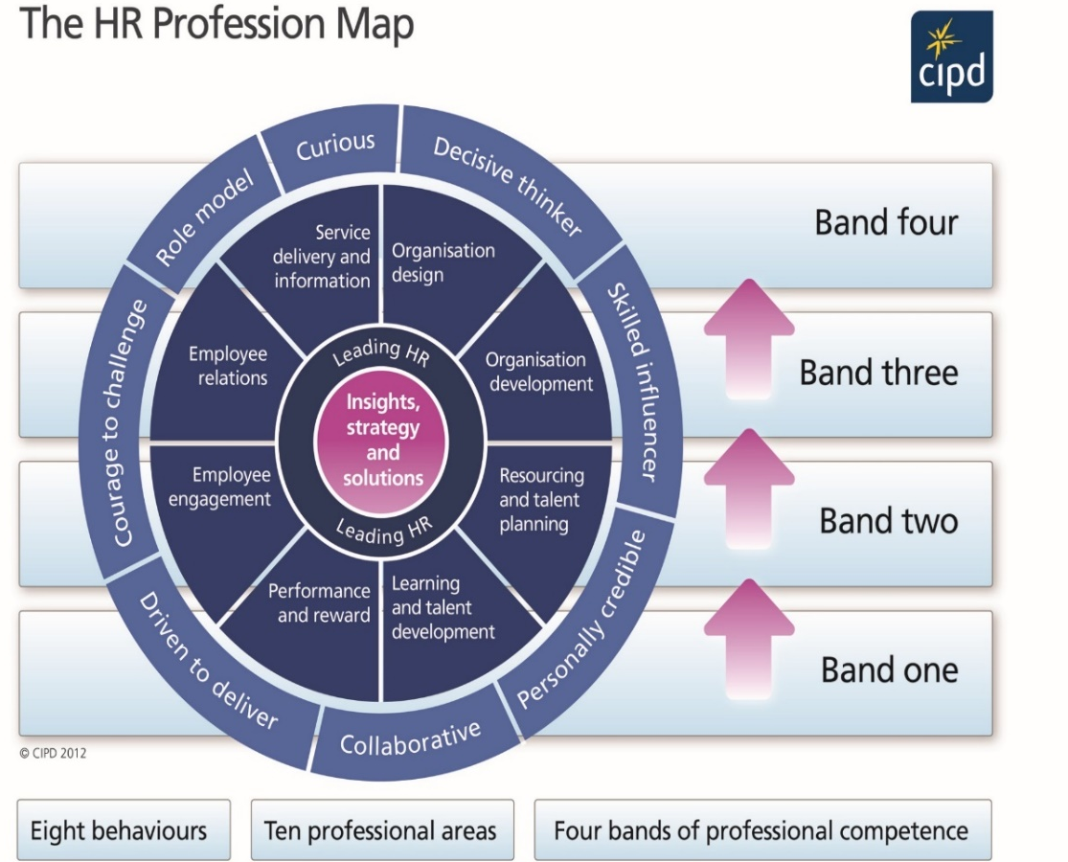
The CIPD map illustrates ten professional areas, Eight behaviours and four bands of professional competence. Please see below Diagram 1.0:

1.0– CIPD – The
HR Professional
Map (CIPD 2018)

As demonstrated in the above map all HR professionals situated in the core of the Map are Leading HR and Insights, Strategy and Solutions. These two core circles are applicable to all HR professionals, situated around those are roles within the HR profession. In Each of these areas the HR professional could highlight what area they are working in and using the competencies with their knowledge and skills are, this can be used in comparison with the banding- one to four. This is a great way which individuals can focus on how they would like to improve or need further training, for example developing knowledge, skills and development as a HR Professional. This is also a way which professionals can measure their success in the profession. Finally, on the outer circle these are the eight behaviours which are needed as a professional in how to act and carry out the activities within the role. These eight behaviours are applicable to all HR Professionals, these are also banded and allows professionals to compare themselves against these indicators and contrast how they can improve. I am now going to discuss 3 of the competencies and behaviours from the above map.
- Curious
According to the Cambridge Dictionary (2018) being curios is being interested in learning about the things or people around you. Being curious as a HR professional is being open minded, curious and focused adding value to the organisation. This is important as being a curious HR professional you are constantly learning and developing in your role while asking questions, it can also be good for the organisation as its HR team is knowledgeable and up-to-date.
- Employee Engagement
Employee Engagement encompasses the relationship HR professionals have with all aspects of their work, colleagues and position. This adds value to the organisation if employees are fulfilled and enjoying their roles this can contribute to working output of the staff within a business. This is important as a HR professional also the organisation. A happy workforce makes a happy organisation this can also add value to the company by showing they support their staff.
- Courage to Challenge
Having the courage to challenge as a HR professional allows them to speak up and speak their mind within their role. This could involve controversy within the organisation, having the courage to challenge individuals in different situations. These are important to HR professionals and organisations e.g. while having the courage to challenge ideas of company stake holders sometimes daunting to people due to the status of these people. Challenging ideas could add additional ideas to the table and potentially be more successful if implemented.

PDP Plan Self Assessment

As a HR professional working within the recruitment talent planning are of the map, I have taken a self-assessment to understand my position on the map. By doing this I am able to position my current banding and also identify areas or behaviours that could be developed within my role at Fieldbay. As an individual who is keen to learn and keep developing within the role to advance knowledge this is a great tool to identify these points to build my own PDP (Personal Development Plan) to show potential development stages. Diagram 2.0 below illustrates the results my own map:
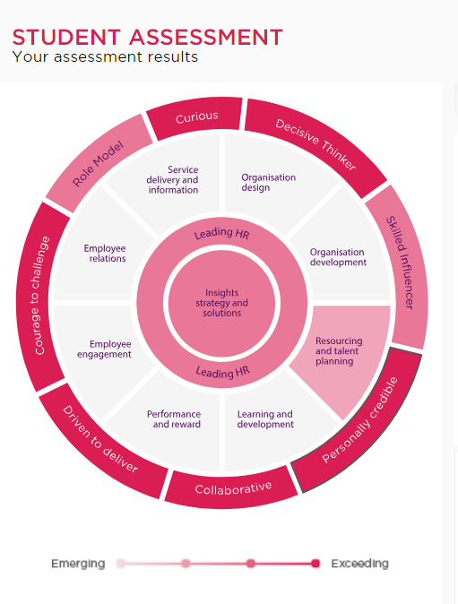

Diagram 2.0 Student
Assessment CIPD
Map

Using the map, I have assessed myself across the 3 centre competencies and across the behaviours. A HR professional should portray all of these behaviours, I thought it would be an advantage to review all of these, as a result of this I can then put together a PDP plan for my development and then action these points. I am now going to discuss three of the areas above that I have been reviewed against and not exceeding in and also my plan to develop in these:
- Role Model
Within my role and being a HR professional, I believe being a role model for Fieldbay is essential. Being the first face candidates meet and being involved in the forefront of the recruitment process its vital to represent Fieldbay and portray a good image. Diagram 3.0 below shows my development actions for this are.
Diagram 3.0 - Role Model- Development Actions
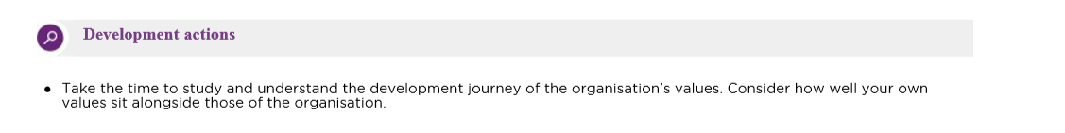
Table 1. – Role Model – Action Plan
Table 1.0: Role Model – Action Plan
Objective: | To be more aware of Fieldbay’s organisational values.
Action: | To meet with Fieldbays management team and my fellow HR team and discuss the company’s values to have an understanding of the companies aims and objectives. By knowing these I consider how my values sit along side the companies and compare these.
Resources/Support needed: | I think this could be done by having a focus group or coached by member of the senior team, this will be a way to be interactive and communicate with the team to discuss and learn from each other.
Target Date: | Jan 18

- Leading HR
Leading HR is all about contributing to HR in Fieldbay by supporting and leading other members of the team. This could be supporting the HR advisors with the recruitment co-ordination at allocated r homes a sharing my ideas. This could also be providing advice, looking at external ways and creating a plan to do so. This is essential as without staff we are unable to operate within the homes and the skilled staff that we need. This could also be looking at external ways outside of the recruitment sources we use at present as we are finding it difficult to resource the number of skilled workers needed and finding costings for these as a plan. Diagram 4.0 below illustrates the development actions that are needed for Leading HR.
Diagram 4.0: Leading HR- Development Actions
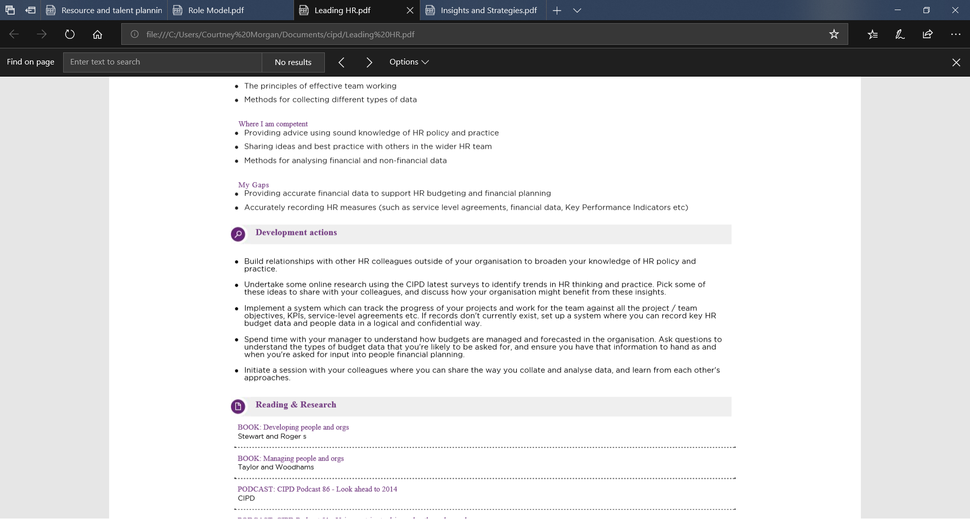
Table 2.0 below- Leading HR – Action Plan:
Table 2.0: Leading HR- Action Plan
Objective: | Seek prices for other recruitment platforms to help us find skilled workers needed in readiness for new care home opening next summer.
Action: | Spend time with managers to understand and discuss the budget for recruitment and ask questions about potentially pricing up different recruitment platforms.
Resources/Support needed: | Arrange a confrence with Financial Controller and HR Manager to discuss budgets. Further on I could then arrange another meeting with the HR Advisors and seek their advice if any or network with other care companies in the area for advice.
Target Date: | Feb 19

- Resourcing and talent planning
Being a HR professional working as a Recruitment Assistant with in Fieldbay, looking at my current role I would band myself at banding one in relation to the map. There are some aspects of banding 2 that are involved in my role but not all. Diagram 5.0 below shows my development actions:

Diagram 5.0: Resourcing and talent planning- Development Actions
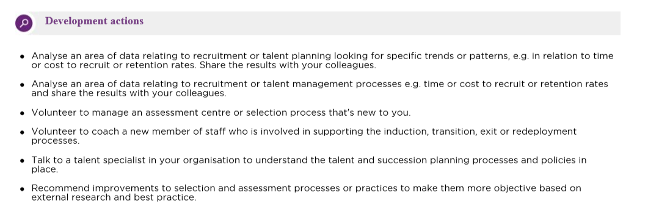
Table 3.0- Resource and Talent Planning – Action Plan:
Table 3.0: Resourcing and Talent Planning – Action Plan
Objective: | Recommend Improvements to selection process or assessment process
Action: | To create a scoring chart for candidate interviews
Resources/Support needed: | Researching assessment methods and looking at other companies in the care sector and how they recruit. This could also be used as benchmarking. This could also include looking at online courses into successful ways into finding talent and assessment methods.
Target Date: | January 2019

I have chosen the above areas to develop as these are close to my area of work within my role at Fieldbay and could progress me within the CIPD map and advancing or widening my knowledge in HR. This knowledge and skills is beneficial to me, also for me to move up the banding in the role and also give me the knowledge to eventually progress into HR advisor role. Being an individual who likes to be to be taught and find being taught as a more hands on approach a better style of learning for me. Having experienced doing online course, this is not the best learning method as I prefer the more interactive approach. For this reason, I find the above areas for self-development and the resources I will use to meet these will meet my preferred learning style.
In 1974 David Kolb made the learning theory which sets out 4 different types of learning styles. This is also based on the 4-stage learning cycle also by Kolb, Kolb identifies 4 learning style preferences:
- Diverging - Feel and Watch - Watching and taking in information
- Converging – Think and do – Being able to solve problems using their learning
- Accommodating– feel and do – More hands-on approach to learning
- Assimilating – Think and watch – Having a more logical approach with ideas
(Kolb 1976)
Following on from Kolbs theory there are lots of ways an individual can learn for example E-learning, attending conferences and coaching. These examples are tailored to the way personally I find I learn efficiently and are linked to my PDP plan. Please see below Table 4.0 illustrating the advantages and disadvantages of these:
Table 4.0- Advantages and Disadvantages of Learning Styles

E- Learning
Advantages  - Can do in your own time and space  - Can be relatively cheap  - can be interpreted in other types of learning  - Efficiency | Disadvantages  - Can sometimes be too broad  - No person interaction  - All online access  - All results are marked by a computer
Attending a conference
Advantages  - Interactive  - Tailored to the subject  - Flexible in terms of time as you can arrange as and when needed  - Being able to network with other attendees | Disadvantages  - Cost- sometimes can be expensive
Coaching
Advantages  - On the job training  - Flexibility  - Cost effective as learning from someone within the business  - Learning in specific things related to the subject | Disadvantages  - Picking up bad habits  - Maybe time consuming if other priorities take over within the business  - Could be hard to monitor the development stages

There are other theorists who have different beliefs in which people learn best, Peter Honey and Alan Mumford were also ones who identified learning styles based on the theory of Kolb. These are
- Activist – more hands-on approach
- Theorist – more theory based
- Pragmatist – putting learning into practice
- Reflector – observing and thinking
University of Leicester (2018)
Honey and Mumford in 1986 created the learning styles questionnaire. Its pieced together of 80 questions. You have to simply tick or mark a cross by situations you agree or disagree too. You generate a score from the amount of questions you have marked with a tick and use this score to compare against the scoring chart. I had a score of 48 which scored as an activist, someone who has a more hands on approach and learns by doing things. This could be implemented in different ways e.g. brainstorming and group discussions who are willing to get their hands dirty, is open minded who are willing to try anything once. From a personal perspective with my result and find this is the way I learn best.

4. Group Dynamics and Conflict Resolution

A group consists of 2 or more people which members interact and share the same end goal, This could be the group interacting face to face or using technology to interact (Forstyth 2018). There are many types of groups - professional or personal. For example, being part of HR team in my current role or on a personal side with my various group of friends. Forstyth (2018) states that group dynamics is the process in which influential interaction takes place between the groups. The word Dynamic is Greek and means to being strong also powerful which influences the group work.
Huczynski & Buchanan (2016) identified that there are various types of teams, and can professionals can be involved in more than one for example:
- Advice teams
- Action Teams
- Project Teams
- Production Teams
Myself being part of the admin team, being part of the HR team, Christmas party team and also being part of the well-being team at work. also various outside of work from a social perspective. Bruce Tuckman in 1965 created the Forming - Storming - Norming – Performing-Adjourning model of teamworking. The Team Building Company (2018). This model focuses on how teams initiate the task from receiving the initial information of what is need then to the completion of the task using the five steps in relation to my recent team working experience:
- Forming – Assembling the team together such as
- Storming- Addressing the task and presenting ideas together as a team
- Norming – Moves on to working towards the task and agrees on rules
- Performing – Where the team works well together and reaches results
- Adjourning- evaluating their work and networking together as a team
Mind Tools (2018)
During these 5 stages there are many ways which teams can result in conflict and can result in teams breaking down this could be due to Personality clashes, communication skills, culture, leadership skills, time restraints and effort of those involved in the team and also differences in background and gender. There are many ways in which conflict can be addressed in these situations, The Center for Creative Leadership (2016) identified that active listening could be used Diagram 6.0 illustrates these:

Diagram 6.0: 7 Key active listening skills
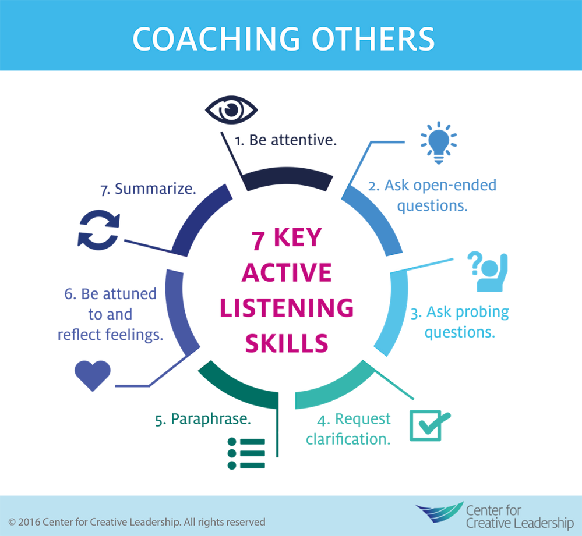
Center for Creative Leadership (2016)
These 7 key listening skills are engaging with the members of team asking questions- being attentive. This could also be being curious where the behaviour can come in and asking probing questions to the result of the conflict. It can also incur being respectful of the team members feelings . E.g. team members are not happy about a members effort with regards to the input of work to the team Dissolving deeper into the issue it could personal issues at home, being sensitive to their feelings and have an understanding.
Kenneth Thomas and Ralph Kilman created the Thomas/Kilman conflict chart “How do I manage differences?”. This tool shows options on how to handle conflict when it arises and also creates 5 types of response on how to deal with this. The tool gives 30 statements and you are to pick either A or b for each statement on how you would respond. Using these answers, reflect these answers on the score chart and a score of 6 or above for any conflict styles on the chart indicates the preference mode of conflict. These are measured in the following conflict resolution styles in Table 5.0 below:

Table 5.0 – Thomas and Kilman Conflict Resolution Styles
Conflict Style: | Summary: | Example in HR Context:
Competing | When a person his or her concerns over anyone else’s | When a member of the team is not taking into any consideration views of anyone else into why this person should be not employed for the position.
Cooperating | This is the reverse of compromising. Working with others to try and find a solution together. | The company is struggling to find nurses, so the team come together and brain storm ideas on how to find staff
Compromising | To find a medium between all parties of the team so all members | When there is conflict between members of the team. 50% agree he should have the job and 50% disagree so it is come to a solution that he will be given a chance on a 6th month probationary period
Avoiding | When a person does not take into account any of their own views or anyone else’s and avoids the situation. | When a person stays out of the debate of if a person should be hired or not. This person leaves the decision to everyone else to decide.
Accommodating | The reverse of competing- when someone disregards their own views and concerns just to meet the views of others | This person does not believe a person should not have the job having been dismissed from his last 3 positions for breaching confidentiality. Other members of the team want to give him a chance, regardless of this person views he goes with the flow of others just to keep them happy.

Kilmann Diagnostics (2018)
Having completed the tool and calculated my score, my preference for conflict are cooperating and avoiding.

5. Project Management

While at Fieldbay I have been involved in various projects, for example I have been involved working as part of a team to recruit staff for a new care home Cwm Gwendraeth we recently opened. The team involved myself, members of the HR team and senior management team. This involved attending various meetings discussing staffing numbers needed to run the home and how we are going to recruit this pools of staff. This project was started in April 18 and is still on going. For the project the main objective was set clear at the start and that was to find a team of staff, we identified resources in our meeting about how we could recruit these for example using indeed and further down the line we brainstormed on how we could recruit further afield, we set time lines that we would be holding 2 slots of interviews each week and time lines on how we would be holding a meeting every week to monitor and evaluate the staff we were bringing in for trial shifts which was part of the recruitment process. These processes are many of which are to be undertaken in a project management role within HR. It is understood that there are principles and practice of time and project management is necessary for HR professionals.
There are ways in which you can monitor project management to setting deadlines to maintain the focus of the project. If the project is not monitored and sustained this may have an impact on the report and lose the main aim of the teams end goal. If a maintained plan is in place this allows the project to be efficient and the team is driven to deliver. This also allows any risks that could be incurred is easy to manage, any issues that do arise can be identified early on in the planning phase, any additional costs can be identified and agreed on, a time line can be scheduled and a structure put in place as well as team members having key responsibilities. UpstartHR (2018)
The main problem was having recruited the main influx of staff form indeed, the number of candidates applying were slowly decreasing. We brainstormed on how we would look for staff on other platforms, indeed was the main source for recruitment and also referrals from other staff. By having this meeting we were able to have a problem solving plan as shown below in Table 6.0 :
Table 6.0 – Cwm Gwendraeth Staffing Plan
Stages to Solve the Problem: | In Reference to Staffing project:
1-Identify the problem | Understanding the lack of candidate applying for positions needed
2-Manage the problem | Brainstorming as a team for other ideas on how to recruit staff
3-Decide what action to take | As a team we decided on using social media, holding open mornings and open afternoons, putting an advert in the local newspaper
4-Implement this action | We sent out invites to candidates on indeed to attend an open afternoon and also advertised this on social media. We also priced up how much it would be to advertise our positions in the Llanelli Star and this then went into the post.
5-Monitor the results | We were able to record the number of interviews booked using our Fieldbay interview tracker. This then shows how many positions have been offered, we are also able to see these results using an hours tracker which shows the available hours within the home in which needs to be recruited for.

Using the idea of Brainstorming as a problem-solving technique to us as a team was highly beneficial, it was cost effective as its free and also is not time consuming. It was an efficient way of bringing all ideas to the table where all members of the team got involved. Having members of the team having different backgrounds and experiences in recruitment helped in bringing these ideas together to create a robust plan. This also could be used in relation to the theory of Edward de Bono theory and his six thinking hats. This theory allows you to look from different people’s perspectives and also can avoid confusing from over thinking at one time. These hats are different colour coded and each at looks from a different perspective for example Mind Tools (2018). These are showed below in Diagram 7.0:
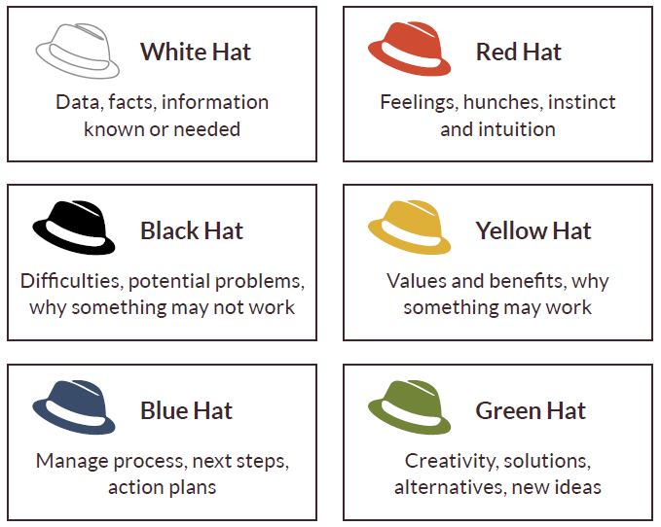

Diagram 7.0:
Edward de Bono – 6 Thinking
Hats Theory

Reading Graphics (2018)

Another method of conflict resolution method is Influencing, Persuading and negotiating. These 3 techniques are used in all situations of conflict when trying to find a solution. As a HR professional I use these techniques in my role. I am now going to discuss these and refer them to an example I have been involved in: Table 7.0 Below explains:
Table 7.0 Influencing, Persuading and Negotiating
Influencing: | this is changing someone’s attitudes or opinions- this is a mix of negotiating and persuading. An example of this is while we are looking for staff in our care home, the moral of the staff was pretty low due to staff shortages. I used this still to influence the staff to get the moral back up and ensured them that we are in the process of taking on more staff which were due to start within the next few weeks
Persuading: | this is helping someone to agree with something- For example many of the staff in Cwm Gwendraeth were transferred over from the care home we took over. We used persuading techniques for many of them stay with us and not leave the home
Negotiating: | this is where you come to a compromise with someone. These results could be affected by pressure on budgets, timescales or resources. An example of this is again relating to the transferred staff from the existing care home a lot of staff we negotiated things such as Pay rates and annual leave in order for them to come across onto our contracts.

6. References

Buchanan D.A and Huczynski, A (2016) Organisational Behaviour . 9th Edn. Harlow: Pearson Education Limited
Cambridge Dictionary (2018) Curious. Available at: https://dictionary.cambridge.org/dictionary/english/curious (Accessed: 12th November 2018)
CIPD (2018) About. Available at: https://www.cipd.co.uk/about . (Accessed: 10th November 2018)
Community Cengage (2018) 7 Key Active Listening Skills . Available at : https://community.cengage.com/t5/Management-In-the-News-Blog/7-Key-Active-Listening-Skills/ba-p/5236 (Accessed: 12th November 2018)
Forsyth, D.R (2014) Group Dynamics . 7th Edn. USA: Cengage Learning
Kilmann Diagnositcs (2016) Overview Thomas Kilman Conflict Mode Instrument. Available at : http://www.kilmanndiagnostics.com/overview-thomas-kilmann-conflict-mode-instrument-tki (Accessed 13th November 2018)
Kolb, D. A. (1976). The Learning Style Inventory: Technical Manual. McBer & Co, Boston, MA
Leicester University (2018) Honey and Mumford. Available at: https://www2.le.ac.uk/departments/doctoralcollege/training/eresources/teaching/theories/honey-mumford (Accessed : 12th November 2018)
Mind Tools (2018 ) Six thinking hats. Available at :https://www.mindtools.com/pages/article/newTED_07.htm . (Accessed 11th November 2018)
Mind Tools (2018) Forming, Storming, Norming, and Performing. Available at : https://www.mindtools.com/pages/article/newLDR_86.htm .(Accessed:12th November 2018)
Reading Graphics (2017) Six Thinking Hats- The 6 Hats. Available at : https://readingraphics.com/uploads/2015/06/Six-Thinking-Hats_The-6-hats.png .(Accessed 13th November 2018)
Team Building (2018) More Forming, Storming, Norming ,Performing. Available at : https://www.teambuilding.co.uk/theory/more-forming-storming-norming-performing.html (Accessed: 12th November 2018)
UpstartHR (2018) HR Project Management Ultimate Guide . Available at : https://upstarthr.com/hr-project-management-ultimate-guide/ .(Accessed 12th November 2018)

7. Appendices

