James Forder CLCS4011 Art Analysis: Augustus of Prima Porta
The statue of Augustus of Prima Porta, (fig. 1) is a prime example of the deification of the Roman Emperors in the imperial period. In contrast to earlier, more realistic portrayals of Roman leaders, (fig. 2) the Augustus statue gives a more idealistic representation, as a supplement to the imperial cult, showing Augustus as a divine figure, descended from the Roman deities, justifying his position of authority.
The statue shows Augustus possibly addressing a crowd, as indicated by his raised right arm, (fig. 3) although he may have been holding something, such as a military standard, portraying the recapture of the standards from the Parthians. This pose gives the impression of a powerful, inspiring figure, whose presence as a divine leader led to victory over the Parthians. The possible inclusion of the standard would further promote this impression, showing Augustus claim the responsibility for this victory. In his right hand, it is debated as to whether he is holding a spear, or a baton.
The face of the statue (fig. 4) is an idealistic depiction of a youthful man, in contrast to earlier facial depictions (fig.2). This is particularly interesting, considering that prior to Augustus, leaders of the Roman Republic were generally older men, with Augustus taking a departure from this tradition. This representation could both be a depiction of eternal youth, again showing his divinity, a show of power to his subjects, always showing him in peak physical condition, and represents a newer, younger system of governance, in the form of the imperator.
The breastplate is perhaps the most interesting portion of the statue. (Fig. 5) This breastplate was almost definitely not based on a real piece of armour. The centre of the plate depicts a Parthian returning a Roman legionary standard to a Roman figure, accompanied by either a dog or a wolf. If accompanied by a wolf, this could be a possible depiction of Romulus, but is more likely simply a personification of the Roman Military. If it is a depiction of Romulus, it may infer that Augustus is a descendant or a successor to the founder of Rome, further placing him within the mythology of Rome. The inclusion of this scene increases the probability of his right hand once containing a legionary standard, as previously mentioned. The rest of the breastplate depict a series of divine figures, such as a god of the sky and goddess of earth at the top and bottom, respectively. This could be a hint to Augustus’ divine heritage, or to show the defeat of the Parthians as a divine event, with Augustus being responsible. Other depictions of divinity are the inclusion of Cupid, (fig. 6) which alludes to Augustus’ supposed descendance from Venus and his bare feet, which were previously reserved for depictions of deities. (fig. 7).
Overall, the Prima Porta statue represents Augustus as a divine ruler, who represents a new age for Rome. Through his conquest of the Parthians and ascension to the position of Imperator, the statue indicates he was responsible for the period of Roman dominance.
Word Count: 524

Appendix
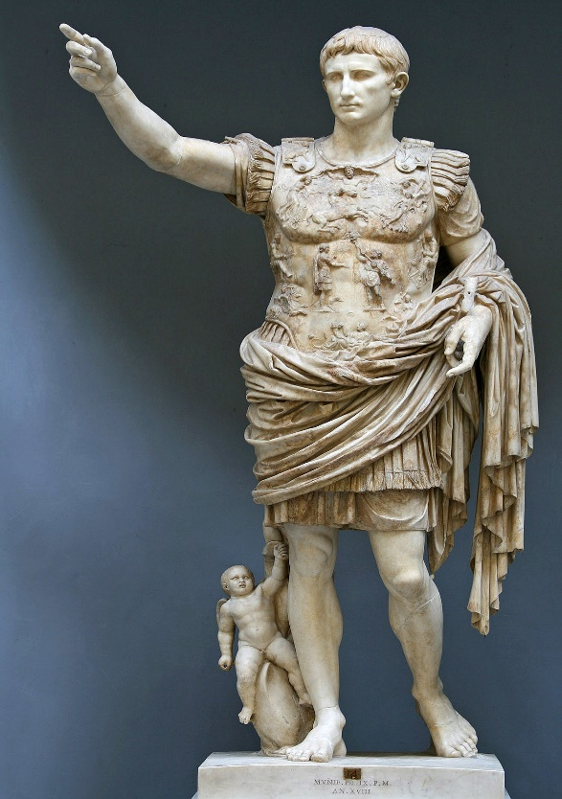
Figure 1: Augustus of Prima Porta,1st C. CE. Vatican Museum.
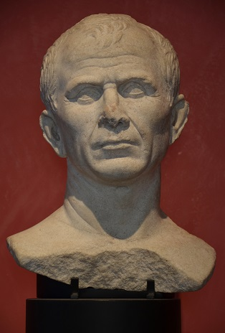
Figure 2: Marble bust found in the Rhone River near Arles, debated as a possible portrait of Julius Caesar, Musée de l'Arles antique, by Carole Raddato from FRANKFURT, Germany [CC BY-SA 2.0 (https://creativecommons.org/licenses/by-sa/2.0)], via Wikimedia Commons.
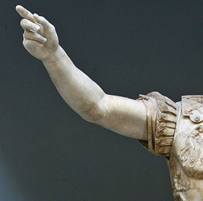
Figure 3: Detail of raised arm, Augustus of Prima Porta, 1st C. CE., Vatican Museum.
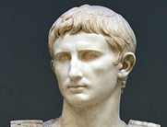
Figure 4: Detail of face, Augustus of Prima Porta, 1st C. CE., Vatican Museum.

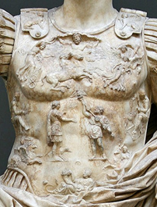
Figure 5: Detail of breastplate, Augustus of Prima Porta, 1st C. CE., Vatican Museum.
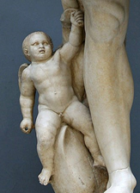
Figure 6: Depiction of Cupid, Augustus of Prima Porta, 1st C. CE., Vatican Museum.
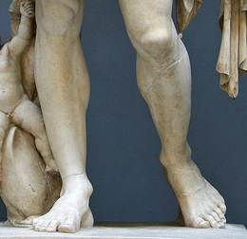
Figure 7: Detail of feet, Augustus of Prima Porta, 1st C. CE., Vatican Museum.

Bibliography
Barchiesi, A., 2005. Learned Eyes: Poets, Viewers, Image Makers. In: K. Galinsky, ed. The Cambridge Companion to the Age of Augustus. Cambridge: Cambridge University Press, pp. 281-305.
Holliday, P. J., 2015. Roman Art and the State. In: B. E. Borg, ed. A Companion to Roman Art. Chichester: Wiley Blackwell, pp. 195-213.
Zanker, P., 1988. The Power of Images in the Age of Augustus. Ann Arbor: University of Michgan Press.

Zanker 1988: 189.
Zanker 1988: 189; Holliday 2015: 204.
Barchiesi 2005: 299.
Holliday 2015: 205.

