References
Dewey, J. (1933). How We Think: A Restatement of the Relation of Reflective Thinking to the Educative Process. Boston: D. C. Health
Dr mani (2021) Time Management Theory & Time Management Research. [online] Dr.Mani’s Productivity Tips. Available at: https://drmani.com/productivity/time-management-theory/.
HCPC (2021). What is reflection? [online] www.hcpc-uk.org. Available at: https://www.hcpc-uk.org/standards/meeting-our-standards/reflective-practice/what-is-reflection/
Macmilllan, S.S., Pedro morago, Linda Bruce and Malcom (2017). Reflective Practoce. [onlime] Reflectove Practice. Avaliable at: https://content.iriss.org.uk/reflectivepractice /what.html.
Njagi, L.K. and Malel, J. (2012). Time Management and Job Performance in Selected Parastatals in Kenya. Australian Journal of Business and Management Research, 02(05), pp.19–29.
UCL (2018). Develop academic reflection skills. [online] Short courses - staff resources. Available at: https://www.ucl.ac.uk/short-courses/staff-resources/course-design/design-learning-activities/develop-academic-reflection-skills.
www.dictionary.com. (2019). Definition of time management | Dictionary.com. [online] Available at: https://www.dictionary.com/browse/time-management.

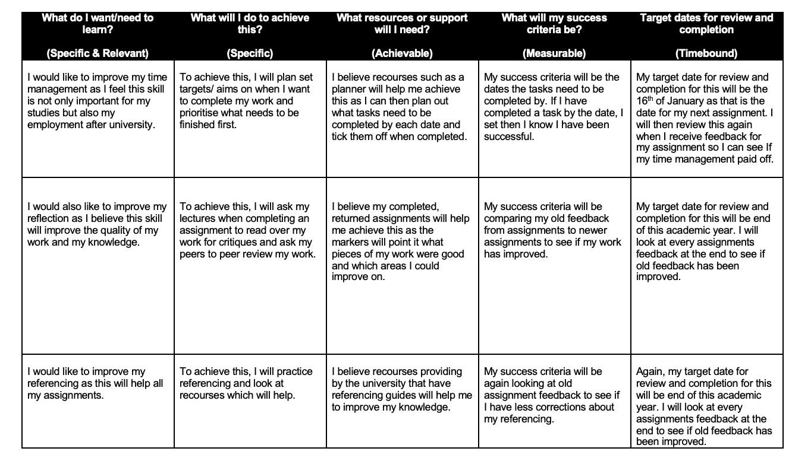
Action plan

