

Student name: Aminata Sinayoko
Student ID: 2310293
Module name: Empowering the Older Person
Module code: BMHP6027
Lecturer’s name: Laila Surani
Submission on 20th March 2026

Empowering older Adults

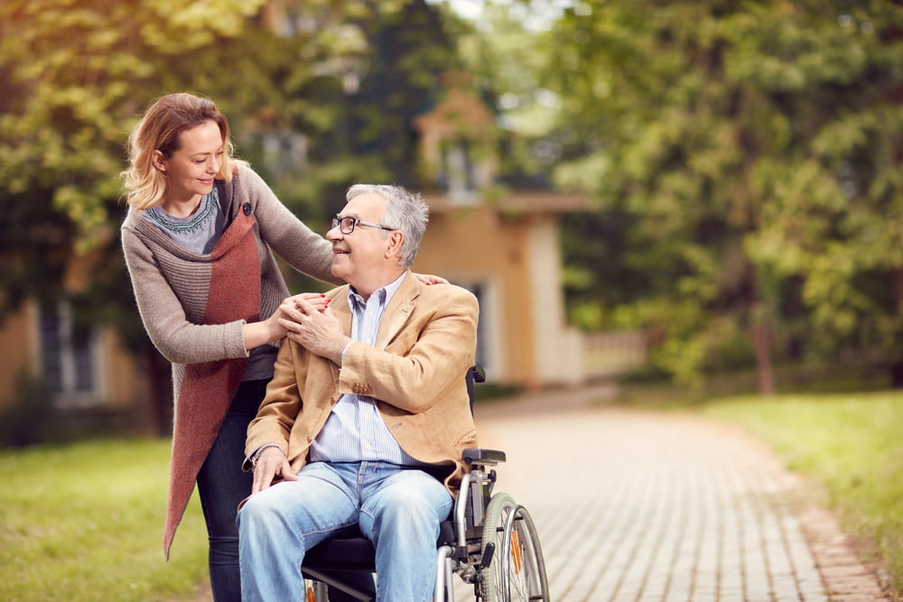  (Oneclickinfo21, 2022) |  | Care, Empowerment and Support Needs  Physical Health Needs  - Chronic illness management  - Nutrition  - Falls prevention  - Mobility support  (National Institute on Aging, 2022)  Social Needs  - Loneliness (NHS, 2023)  - Social isolation  - Build and maintain relationships  Psychological Needs  - Depression  - Cognitive decline  - Dementia (Jang et al., 2026)  Emotional Needs  - Empathy (Jang et al., 2026)  - Listening. |  | 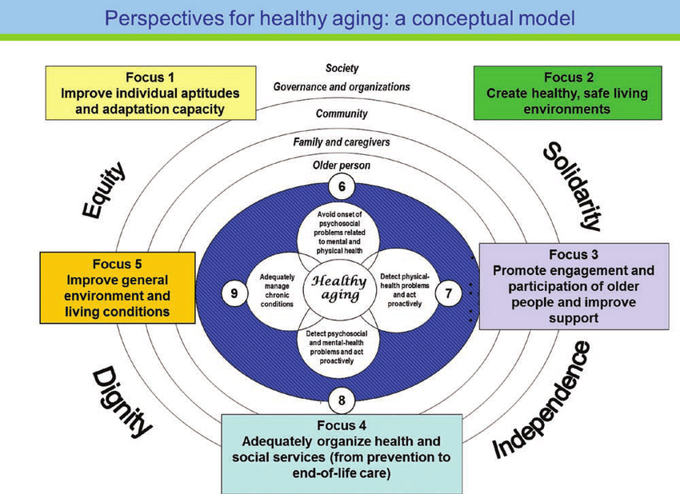  (ResearchGate, 2024)
Introduction  The demand for health and social care services for older individuals is rising due to the UK's rapidly aging population. According to Barton et al (2024) , 19% of the UK population was aged 65 or over in 2022, and this proportion is projected to rise to 27% by 2072.  - According to the World Health Organization (2024), healthy aging is defined as preserving the functional capacity that permits wellbeing as one age.  - The World Health Organization (2020) Promoting independence and functional ability supports dignity, autonomy, and quality of life, while lowering dependency on health and social care services.  - This poster evaluates the care, empowerment and support needs of older adults and explores policies, theory and interventions that support healthy ageing in the UK. |  |  |  | Challenges to Maintaining Independence  - Physical frailty (Gill et al., 2002)  - Housing quality  - Poverty  - Cognitive decline  - Digital literacy  - Service fragmentation  Example, cognitive decline and reduced physical capacity can limit participation in social activities, reflecting aspects of Disengagement Theory (Sirizi et al.,2025). However, modern policy increasingly supports Activity Theory, which emphasises continued social engagement to maintain independence.  Recommendations  Improve access to integrated care services (Kam, 2023).  Develop adaptable assistive technologies  Increase trained Staff in older adult care (NHS England, 2025).  Expand social and community activities (Yardley et al.,2007).  Increase funding for community-based rehabilitation.  Improve digital literacy programmers for older adults.  Conclusion  - Ageing populations increase pressure on care services.  - Policies and services provide support but face challenges.  - Technology offers opportunities but may increase inequality.  - Promoting independence is essential for dignity, wellbeing and sustainable care systems.

Effectiveness of Interventions: UK Policies and Theoretical Perspectives
Theory
- Activity Theory of Ageing 1961
- Disengagement Theory 1963 (Science Direct, 2016)
Activity Theory suggests that staying socially and physically active improves wellbeing in older age (Adams et al., 2011).This theory supports policies that promote community participation and independent living.
Policies
- Care Act 2014
- Equality Act 2010 (Sargeant, 2012)
The Care Act 2014 promotes wellbeing and independence by requiring local authorities to assess individua care needs and appropriate support (Marczak, 2017). However, rising demand and limited funding mean services sometimes struggle to meet the needs of the ageing population.
References
ADAMS, K.B., LEIBBRANDT, S. and MOON, H. (2011) ‘A critical review of the literature on social and leisure activity and wellbeing in later life,’Ageing and society, 31(4), pp. 683–712. Available at: https://doi.org/10.1017/S0144686X10001091 (Accessed: 6 March 2026).

Barton, C., Sturge, G. and Harker, R. (2024) The UK’s changing population. Available at: https://commonslibrary.parliament.uk/the-uks-changing-population (Accessed: 3 March 2026).

Gill, T.M. et al. (2002) ‘A Program to Prevent Functional Decline in Physically Frail, Elderly Persons Who Live at Home,’ The New England journal of medicine, 347(14), pp. 1068–1074. Available at: https://doi.org/10.1056/NEJMoa020423 ( Accessed: 6 March 2026).

Jang, Y.J., Chang, J.H., Moon, D.U. and Jeon, H.J. (2026). Cognitive Impairment, Dementia and Depression in Older Adults. Journal of Clinical Medicine, 15(3), p.1198. doi:https://doi.org/10.3390/jcm15031198 (Accessed: 5 March 2026).

Kam, P.K., 2023. Empowerment in old age: A ladder of user participation in social services for older people. Journal of Social Work, 23(4), pp.677-691 (Accessed: 9 March 2026).

Marczak, J. (2017) “The Care Act 2014 in England,” Zeszyty Naukowe Ochrony Zdrowia, Zdrowie Publiczne i Zarządzanie, 15(3), pp. 217–226. Available at: https://doi.org/10.4467/20842627OZ.17.023.7803 (Accessed: 6 March 2026).

National Institute on Aging (2022) Falls and fractures in older adults: Causes and prevention. Available at: https://www.nia.nih.gov/health/falls-and-falls-prevention/falls-and-fractures-older-adults-causes-and-prevention (Accessed: 5 March 2026).

‌NHS (2023) Introduction to care and support - Social care and support guide. Available at: https://www.nhs.uk/social-care-and-support/introduction-to-care-and-support/ (Accessed: 5 March 2026).

NHS England (2025) Improving Care for Older People. Available at: https://www.england.nhs.uk/ourwork/clinical-policy/older-people/improving-care-for-older-people/ (Accessed: 9 March 2026).

Oneclickinfo21 (2022) Empowerment in Elderly Home Care Beverly Hills In Home Caregivers. Available at: https://abetterwayinhomecare.com/how-empower-elderly-home-care.html ( Accessed: 16 March 2026).

ResearchGate (2024) Michel RAÎCHE | PhD | Université de Sherbrooke, Sherbrooke | UdeS | Center for Research on Aging | Research profile. Available at: https://www.researchgate.net/profile/Michel-Raiche (Accessed: 16 March 2026).

Sargeant, M. (2012) ‘Justifying Age Discrimination,’Business law review (London), 33(Issue 8/9), pp. 204–205. Available at: https://doi.org/10.54648/BULA2012049 (Accessed: 6 March 2026).

‌Science Direct (2016) Disengagement Theory - an overview | ScienceDirect Topics. Available at: https://www.sciencedirect.com/topics/psychology/disengagement-theory (Accessed:12 March 2026).

Sirizi, D. et al. (2025) ‘Robotics and Independent Living: Insights from Older Adults with Cognitive Impairment and Their Caregivers,’ Alzheimer’s & dementia, 21(S4). Available at: https://doi.org/10.1002/alz70858_102316 (Accessed: 6 March 2026).

‌World Health Organisation (2020) Healthy ageing and functional ability. Available at: https://www.who.int/news-room/questions-and-answers/item/healthy-ageing-and-functional-ability (Accessed:3 March 2026).

World Health Organization (2024) Ageing and health. Available at: https://www.who.int/news-room/fact-sheets/detail/ageing-and-health (Accessed: 3 March 2026).

Yardley, L., Beyer, N., Hauer, K., McKee, K., Ballinger, C. and Todd, C. (2007) Recommendations for promoting the engagement of older people in activities to prevent falls. Quality and Safety in Health Care, 16(3), pp.230–234. doi:https://doi.org/10.1136/qshc.2006.019802 (Accessed: 9 March 2026).
‌

