
New business choice - Self Employed or Limited Company?
Jason Locker (2106946)

March 30, 2023
University of Wales Trinity Saint David

Executive Summary
The purpose of this report is to analyse the differences between a company as a sole trader and a company that is registered as a limited company, looking at the benefits and disadvantages of both, using the different forms of taxation each side has to deal with as a strong driving point for effectiveness and then coming to my own personal conclusion about which business structure I believe to be more effective for a new company.
Whilst looking at sole traders it was evident that the more successful the business is the more tax the owner will have to pay as the companies’ profits are entirely belonging to the owner of the company making this a decision that would need to be made based on how much income the individual already has and what tax they already pay on it.
When looking at limited companies it was evident that there is a lot more protection offered to the owner as they are separate from the company, there is more work involved in running a limited company but there is a break point on a business’ profits which suggest that once they hit this point a limited company becomes a more profitable structure for the owner of the business.

Table of Contents
Executive Summary 1
Introduction (average of 10% of the word count) 2
Main Findings 3
Conclusion 7
References 8

Introduction (average of 10% of the word count)

In this report I will be looking at the differences in being self employed or a limited company, focusing on the implications of these choices in regard to setting up a new business.
Self employed also known as a sole trader is a person that runs a business for themselves, they take on all the responsibilities and rights associated with its success or failure. They are not paid through PAYE, and they do not have the same responsibilities or rights as someone who is employed through a company (gov.uk, 2023).
You can also enter into a partnership but this would still classify you as a sole trader, but this normally entails a joint business venture with at least one other person as a partnership requires a minimum of two people before it can be classed as one.
A limited company is a business that is a separate legal and financial entity than those that own it such as the CEO or company directors. This means that a limited company pays its own tax has its own bank accounts and can be bought and sold via shares and must be registered publicly at companies’ house. This also means that a limited company has limited liability so should the business fail then those owning it are only liable for the value of their share in the business (Green, 2023).

Main Findings
Self Employed/Sole Trader
A sole trader is one of the easiest ways to structure a business as there are fewer legal regulations meaning the business can be set up quicker, once you inform HMRC that you’re self employed you can start trading almost immediately. You work and get paid as an individual and pay tax on the profits that you make. You can become a sole trader whilst also still being employed this can help offset the financial burden that the business may have, or it can work as a supplementary form of income whilst the business is growing it can be a way to get the best of both worlds if your able to manage running a business and being employed at the same time (Your company formations, 2019).
When it comes to taxation as a sole trader the rules are similar to being employed the amount of tax you pay is based off of the income you receive from the profits that your business makes. Your personal allowance stays the same and anything earned over that is eligible for tax with the same tax brackets as someone whose employed.
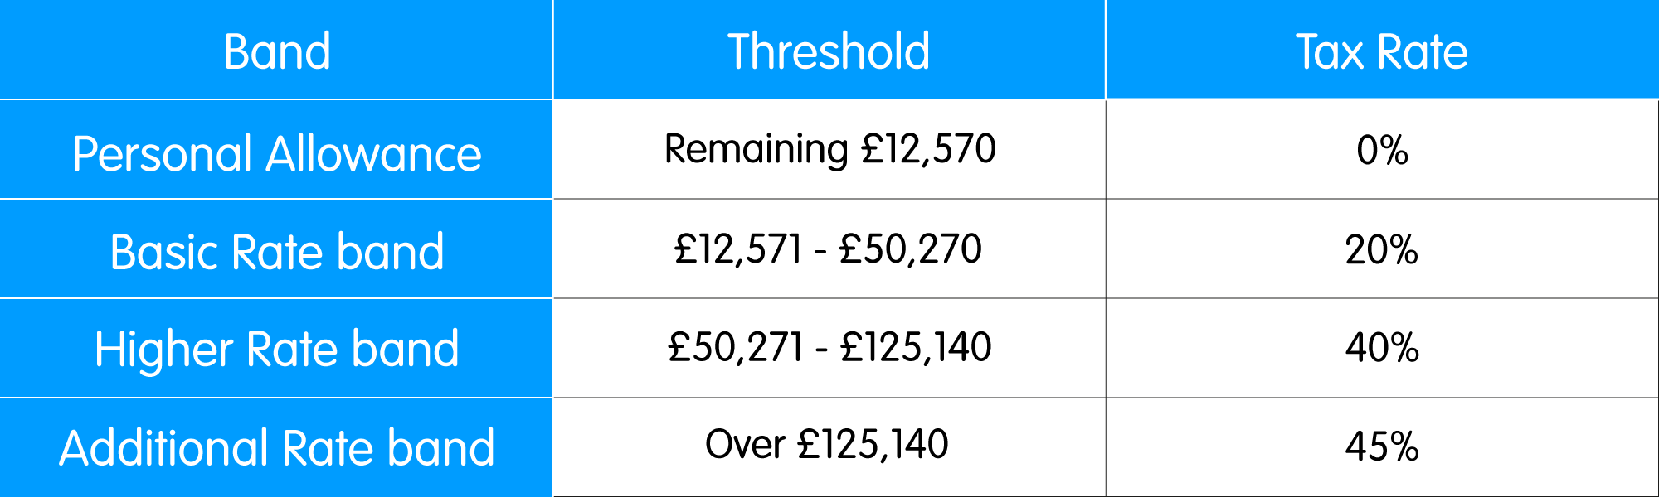
There is also a trading allowance that can be used for income tax and national insurance contributions up to one thousand pound per tax year however eligibility for this is not automatic and you can be entitled to claim it if you either use the cash basis of accounting or use the accruals basis of accounting but are still eligible to use the cash basis. This allowance is still available to be used even if you have only been trading for part of the year for example if you had only been trading for the first six months of the tax year you can claim the allowance as if you had been trading for the full year.
There are times in which you may not want to claim this allowance as your business expenses are deducted from your taxable profit so if your expenses exceed the allowance then you would pay less tax that way, you cannot claim from both so working out which one is more beneficial is important, you also cannot claim this if you have made a trading loss (Watkinson, 2022).
You can however make a claim for losses against other income there are several different ways to do this the first being sideways loss relief where you can set the loss from the business against other forms of income that you have within the same tax year or one year prior this would reduce the tax that you pay on your other sources of income the loss needs to be calculated using the accrual basis of accounting system. You can also do this with capital gains however you must first offset any loss you have from other income in the tax year first before being able to do this. For a new business the offset you can use can be up to three years before the loss was made this can be especially useful as most businesses expect a loss when they are first starting up.
You can also offset the loss against a future years profits and this can be calculated using either accruals or cash basis, this is normally only used if the loss cannot be offset by any other means and is used as soon as possible so the first year in which the business makes a profit the loss is used against that and if there is any remaining balance it is carried forward to the next year where there is a profit (LITRG, 2022).
Being a sole trader does come with some disadvantages the main one being that the business assets and the owners’ personal assets are one in the same, if the business is sued for any reason, then financial damages can be claimed from the owner such as their personal savings, car or possibly even their home. Most sole traders will use insurance companies to help them cover these costs should they arise, but business insurance isn’t an umbrella policy and it could turn out that the insurance a business has might not cover them for everything they need it to.
As a sole trader the business cannot raise capital by itself meaning that if money needs to be raised for the business then it is down to the owner to do so due to there being no separation between the business assets and personal assets. This means that sole traders often have to put up their own collateral if they wish to raise money it creates an increased risk to owner as if the business were to fail and money borrowed cannot be repaid then the lender is able to claim personal assets if needs be to recover payments owed to them (Reuters, 2023).
Partnerships
A partnership is essentially two or more sole traders coming together to form a business together, this can be advantageous in the fact that the business is easier to start up and costs to establish it become lower as more capital can be made available through multiple owners, this structure also affords you more borrowing flexibility as the collateral can be split between partners. It can be beneficial financially as profits and income would be split between partners it can result in greater tax savings if worked out correctly. As opposed to a limited company the private affairs of the business partners remain private as the business follows similar guidelines to that of a sole trader company, the partners that start the business together do not need to be there for the entirety of the businesses life as long as there are always at least two partners within the company partners can move into or out of the business as they see fit.
The downside to having a partnership just like being a sole trader the liability of the business is entirely on the owners, they are liable not only for their own debts but also being liable for the debts of the other partners within the business. Depending on the agreements made surrounding the partnership having several owners of one business venture can cause chaos and friction between its members which could harm the business, and when partners join or leave the business everything needs to be revalued between the partnership assets and this can end up being costly and time consuming (Gard&Co, 2023).
Limited Companies
Setting up a limited company is a little more complexed than trading as a sole trader, but it can have some advantages that make it a more lucrative opportunity than sole trading. By registering your company as a limited company, you create shares in the business which effectively means that the shareholders are the owners of the business as they have an equity stake within the company, these shares can create dividends that can be collected on each year.
Dividends are taxed separately to personal income so normally in a limited company the director of the business is paid a salary which is taxed as personal income and then collects dividends from shares, which means that you have the potential to have more income through a mix these two different incomes as they are taxed differently. There is a personal allowance of two thousand pound on dividends meaning with someone’s personal allowance you can get close to fifteen thousand pounds worth of income tax free.
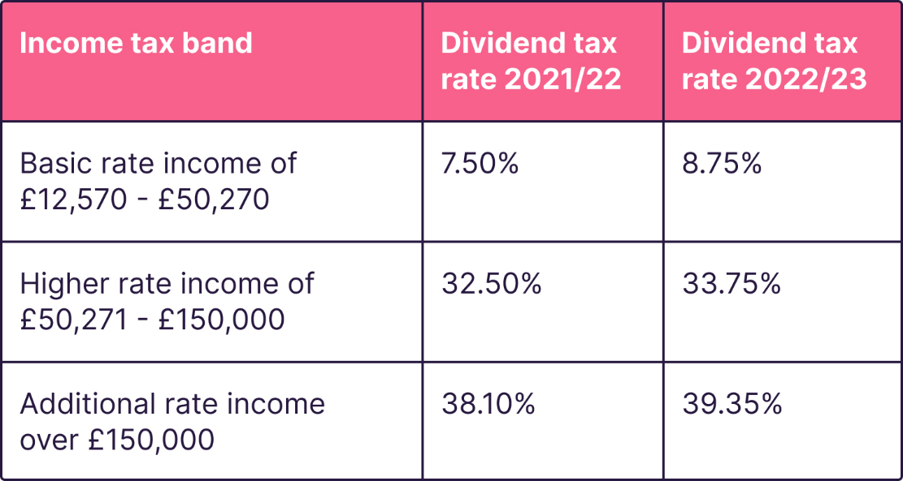
Another benefit that can be had in a limited company is the ability to claim tax relief on several different business expenses. Some examples of these are computer equipment and business software, travel, and subsistence costs if you are having to work away from your normal location.
There’s more protection to your personal assets in a limited company, the limited refers to limited liability. This is due to the company being legally separate from your personal affairs so that if a claim is made against the company you have no personal liability and your personal assets are not put at risk.
Working as a limited company can also offer more credibility to your business as it gives suppliers and customers more confidence in the business as some companies prefer not to deal with non-limited companies. It also protects your company name as once you have registered the name of your company it can’t be used by anyone else and is protected by law this can help protect your companies IP and can solidify your brand (SJD, 2023).
However, there are points to be made as to why a limited company may not be financially beneficial. There are several different expenses that limited companies have to pay the first being corporation tax. This is a flat rate no matter the size of your business and currently stands at nineteen percent, depending on the size of your business and the revenue it makes you could end up paying more in tax than a sole trader as the company doesn’t have a personal allowance against tax.
There is more paperwork involved in running a limited company which can be time consuming and costly if an external company is used to cover the paperwork, you have to file your accounts every year as a company tax return to HMRC this is mandatory even if the company makes a loss in that year. If you employ any staff, you also have to pay national insurance contributions on employees wages and also on the majority of employee benefits such as company cars, insurance and other expenses that employees may claim.
It also becomes easier to sell your business as a limited company should you wish to leave the business and not close it down, because the company exists on its own legally all you need to do is sell your shares over to a new or existing shareholder and that’s it. As a sole trader the company does not exist without you so it takes a few more steps to be able to pass the company on to other hands and having the hassle of making sure everything in the company that’s being sold is correctly valued and not tied to your personal assets (Business4beginers, 2023).

Conclusion

As to whether you should start your business as a sole trader or a limited company is going to differ between different peoples circumstances. The main attributing factor that I can see is that it will depend on how much income you have already and how much income you foresee the business generating in the first few years of operation.
Should the business be a low profit easy to run company that’s mostly used as an extra source of income to run along side other projects then it would seem more profitable to run the company as a sole trader, you may end up paying more in income tax but should the business have poor results one year that can come off of its own tax the following year or off your own tax for the current or previous year. The same goes for partnerships especially if you have a smaller share in the business as this will likely not be your only source of income.
If the business is going to be a long-term investment and main source of income then a limited company may be more suited to what would net more income, with a flat tax rate and the ability to claim back on multiple different expenses it can sometimes be more cost efficient. You can also split your income between a salary and dividends making it more tax friendly by combining the personal allowances both of those give you. There is extra protection in a limited company and should you wish to sell the company it is an easier process to complete.

References

Business4beginers. (2023). Business4beginers. Retrieved from https://www.business4beginners.co.uk/from-sole-trader-to-limited-company/
Gard&Co. (2023). Gard&Co. Retrieved from https://www.gardandco.com/what-we-do/business-law/business-articles/sole-trader-partnership-or-limited-company-2/#:~:text=Effectively%20a%20partnership%20is%20like,other%20than%20liability%20for%20tax).
gov.uk. (2023). gov.uk. Retrieved from https://www.gov.uk/employment-status/selfemployed-contractor#:~:text=A%20person%20is%20self%2Demployed,and%20responsibilities%20of%20an%20employee.
Green, N. (2023). Unbiased. Retrieved from https://www.unbiased.co.uk/discover/tax-business/running-a-business/setting-up-a-private-limited-company#:~:text=A%20limited%20company%20is%20a,a%20company%20has%20limited%20liability.
LITRG. (2022). litrg. Retrieved from https://www.litrg.org.uk/tax-guides/self-employment/what-business-expenses-are-allowable/what-if-i-make-loss#toc-1-set-loss-off-against-other-income-of-the-same-year-and-or-the-previous-year
Reuters, T. (2023). FindLaw. Retrieved from https://www.findlaw.com/smallbusiness/incorporation-and-legal-structures/what-are-the-disadvantages-of-a-sole-proprietorship.html#:~:text=The%20biggest%20disadvantage%20of%20a,car%2C%20or%20even%20their%20home.
SJD. (2023). sjaaccountancy. Retrieved from https://sjdaccountancy.com/resources/limited-company/advantages-disadvantages/
Watkinson, L. (2022). Crunch. Retrieved from https://www.crunch.co.uk/knowledge-tax/tax-rates-thresholds-and-allowances-for-current-tax-year#personal-allowance
Your company formations. (2019). Your company formations. Retrieved from https://www.yourcompanyformations.co.uk/blog/starting-your-own-business-while-still-employed/#:~:text=There%20is%20absolutely%20nothing%20stopping,the%20business%20or%20relocate%20it

