Andra-Loredana Bobonica
2211879
E-portfolio report
Learning in the Digital Era – BMPL4007/BMPS4009

Table of Contents

Task 1 – Written summary 2
Task 2 – Mind map 3
Task 3 – Presentation 4
Task 4 – Reflection 5
Reference list 6


(Task 1 – Written summary

Preparing for higher education

As a quick summary Studying for higher education is different comparison with college/school and I say that from my past experience were in my opinion school/colleges i’'s more easy to “complete. Higher education comes as a package with lots of assigments and lots of activities (such as teamwork activity were you must communicate with the other students from your class or to do a quick prezentation) From this information that I’ve mentioned above I can state that the main skills that you must have before starting a higher education is communication and IT skills which is very necessary. Even From the beginning , before you start studying you must improve your perfectionism level due to the fact that as a higher education student you will have a range of documents and you must be organised so these documents don’t get wasted and ready when you search for them (You must know where exactly is each of your document). As I mentioned above you must have a basic IT skills such as knowing how to use PowerPoint , Word document and teams (R1)Even from the starter you have to start managing your time effectively because by having different module were you must work effectively it’s very beneficial to manage and plan your activities. As a higher education learner you will be asked too write the essays in academic style and what I am trying to say is that you must improve your vocabulary with complex words also to start knowing how to write a reference which is very important in an assignment or essay. Because in university you will have a lot of assignment to complete and you must keep the level with the other students , it’s very important to put all your skills into practice.(R2,R6)

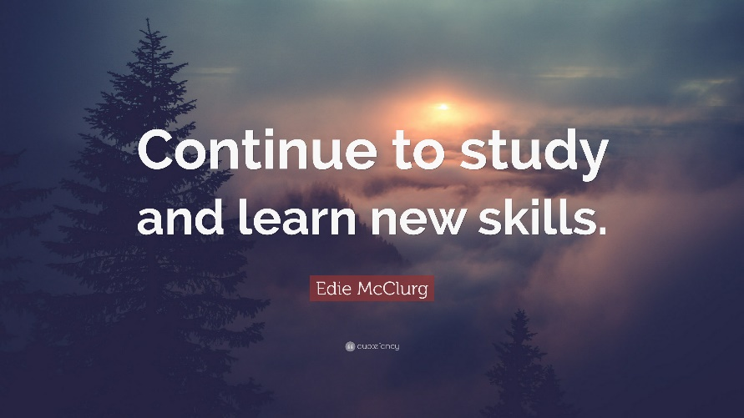

Task 2 – Mind map

Please follow this link to view my mid map : mind map assigment.pptx

Task 3 – Presentation
Please follow this link to view my presentation: https://uowtsd-my.sharepoint.com/:p:/g/personal/2211879_student_uwtsd_ac_uk/Eb325y1HlZ1IghcE-de-s1QBpH-uoskYx9EqHpcuAruqng?e=wv5Szf

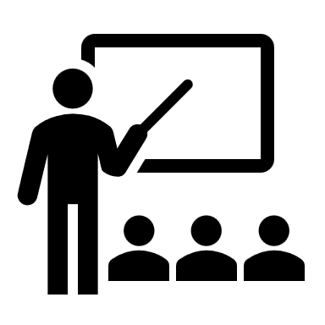

Task 4 – Reflection

Reflection starting university
Borton’s reflective tool- the purpose of Burton’s reflective model is to have a good structure and make the people think about their situation not having too much structure in front of them.
WHAT?(what was I trying to achieve , what happened )- reflecting on starting university what I was trying to achieve a day before I was thinking about leaving a positive impression for the teachers and trying to be less nervous.
SO WHAT?(What did I feel at the time, what were the effects of what I did /did not)- When we first meet we the teachers I will started to be less nervous and also I start engaging with the environment. The only negative aspects that I had is that I didn’t interact with the other students in that day.
NOW WHAT?(What would I do in this situation again) – if I will meet this situation again I will be less nervous at the day before the first day of university ,also I will interact more with the other students. Furthermore I will participate more verbally in lessons.
This reflection model it will help me to see what I must improve in my personality skills. From this Reflection model I can infer that this is beneficial for all students who have a situation where they must change something at their attitudes or personal skills.(R7.R8)
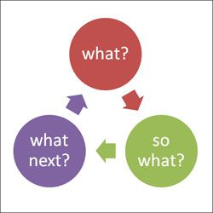

Reference list

(BOOK)R1-Dr Penny Grubb. (2019). Preparing for higher education. London: fantastic book publisher. p.160.
R2- Sabrina colier. (2021). Study Skills: Preparing for Higher Education. [Online]. Top Universities. Last Updated: 13 April. Available at: https://www.topuniversities.com/blog/7-tips-prepare-starting-university#:~:text=7%20Tips%20to%20Prep [Accessed 9 March 2023].
R3-Heather. (2021). 5 Ways to Be the Best Digital Learner. [Online]. My digital lesson. Last Updated: 28 January. Available at: https://www.mydigitallesson.co.uk/onlinecourses/5-ways-to-be-the-best-digital-learner/ [Accessed 9 March 2023].
R4-Not author provided. (2022). Digital learning. [Online]. CIPD. Last Updated: 9 December. Available at: https://www.cipd.co.uk/knowledge/fundamentals/people/development/digital-learning-factsheet [Accessed 9 March 2023].
R5-Author not provided. (.). Don’t judge a book by its cover. [Online]. Grammatist. Last Updated: 2021. Available at: https://grammarist.com/proverb/dont-judge-a-book-by-its-cover/#:~:text=The%20expression%20don%27t%20 [Accessed 9 March 2023].
R6-Gemma stevens. (2016). Student transitions in higher education: concepts, theories and practices. [Online]. Research Gate. Last Updated: august. Available at: https://www.researchgate.net/publication/318947997_Student_transitions_in_higher_education_concepts_ [Accessed 9 March 2023].
R7-Jane B. (2022). Borton’s Model of Reflection. [Online]. Toolshero. Last Updated: 9 September 2022. Available at: https://www.toolshero.com/personal-development/borton-model-of-reflection/#:~:text=Borton%27s%20mode [Accessed 9 March 2023].
R8- Johndabell. (2015). Borton’s Model Of Reflection. [Online]. Johndabell. Last Updated: 5 august 2015. Available at: https://johndabell.com/2018/08/05/models-of-reflection/ [Accessed 9 March 2023].

