Video Link:
https://uowtsd-my.sharepoint.com/:p:/g/personal/2539026_student_uwtsd_ac_uk/IQA4u_T0J4p2SafKbZuFEw9dAeF9YG89nUgW0FMLj2-LDIA?e=qVhHDA
Module Name: Learning in the Digital Era
Module Code: ACCA 4025

Student Name: Olamide Akintunde-Jimba
Student ID: 2539026
Group:1

Lecturer’s Name: Lecturer’s Name: Koushik Modak
Assignment 2
Learning in the Digital Era
Table of Contents
Introduction 1
Body 2
Slides 2
Slide 1: Cover Page: 2
Slide 2 : Content 3
Slide 3: Introduction 3
Slides 4: GIBB's Reflective Model 4
Slide 5: Self-Evaluation 5
Slide 6: Traits Gained from Self-Evaluation 6
Slide 7: Professional Development Plan 7
Conclusion 8
References 8

Introduction
This presentation summarises my self-assessment, professional growth plan, and my Unit 4 topic. My goal was to use this opportunity for genuine self-discovery as a learner and to strategise for a career in cybersecurity.

I utilised Gibbs' Reflective Cycle to evaluate my experiences, emotions, successes, and challenges. This honest reflection helped identify my strengths and areas for improvement. Additionally, I applied the SMART criteria to create a professional growth plan with specific, attainable goals.

In this presentation, I will share insights from my self-reflection, outline my development objectives, and summarise the Learning to Learn topic, providing an overview of my progress and future direction.

Body

Slides

Slide 1: Cover Page:
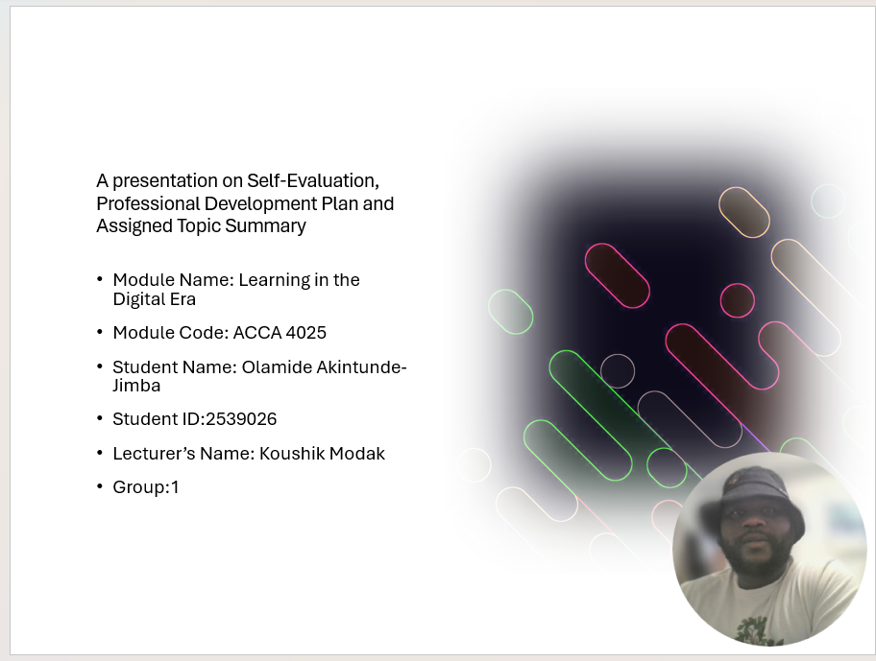

Slide 2 : Content
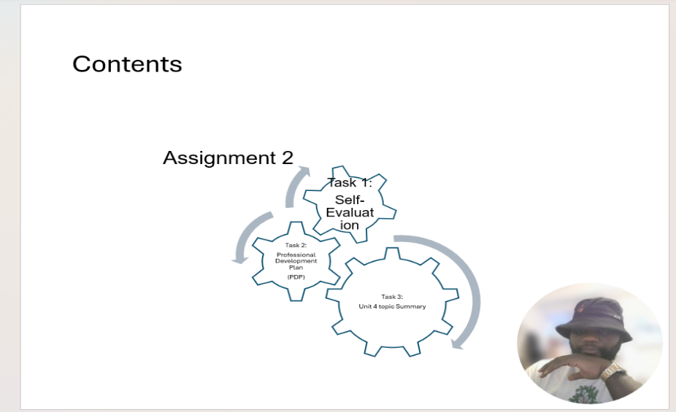

Slide 3: Introduction
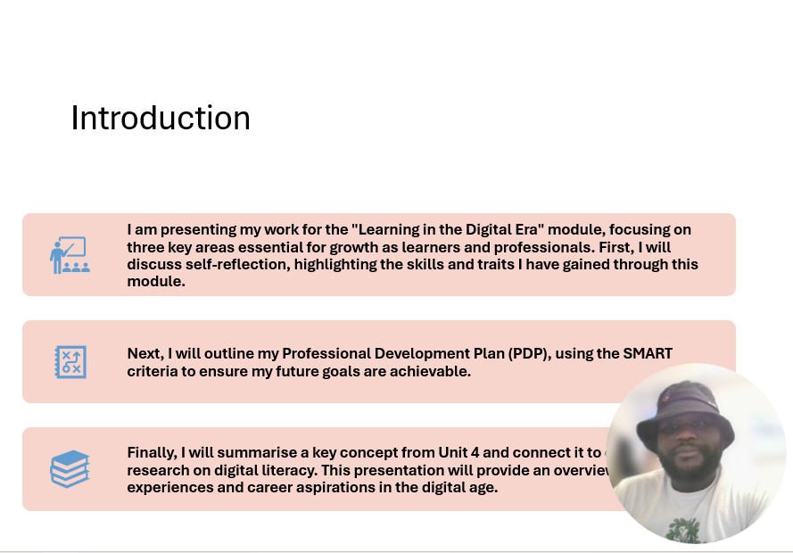

Slides 4: GIBB's Reflective Model

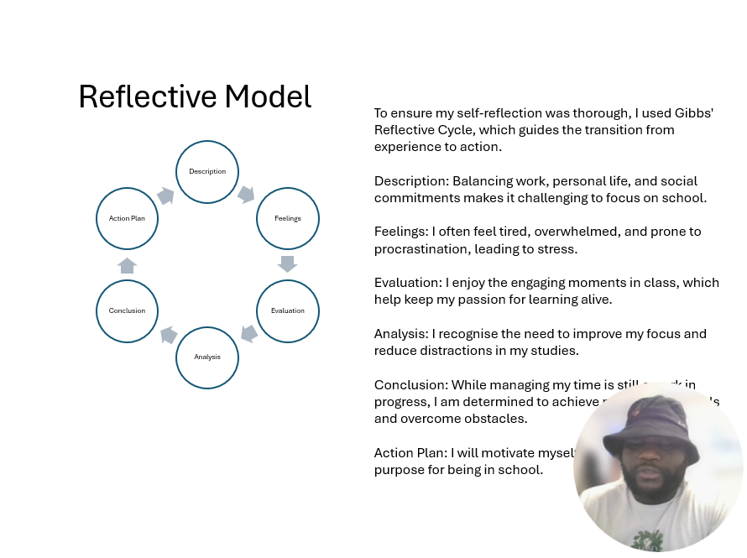
To ensure my self-reflection was structured, I used Gibbs' Reflective Cycle [1] . This model helps individuals systematically reflect on experiences, turning them into meaningful learning steps [2]. It includes six stages: Description, Feelings, Evaluation, Analysis, Conclusion, and Action Plan.

In my reflection, I described the challenge of balancing work, personal life, and social commitments, which made it difficult to concentrate on my studies. This led me to explore feelings of fatigue, overwhelm, and procrastination that contribute to stress. I noted that engaging moments in class helped maintain my passion for learning, which was positive. In my analysis, I recognized the need to improve my focus and reduce distractions. I concluded that while time management is still a work in progress, I am determined to achieve my academic goals. Finally, I created an action plan to motivate myself and stay focused on my educational purpose.

I plan to use this model in Assignment 2 to reflect on my learning throughout the module and identify successes and areas for improvement. Adhering to Gibbs’ cycle will ensure my reflections lead to genuine personal and academic growth [2].

Slide 5: Self-Evaluation
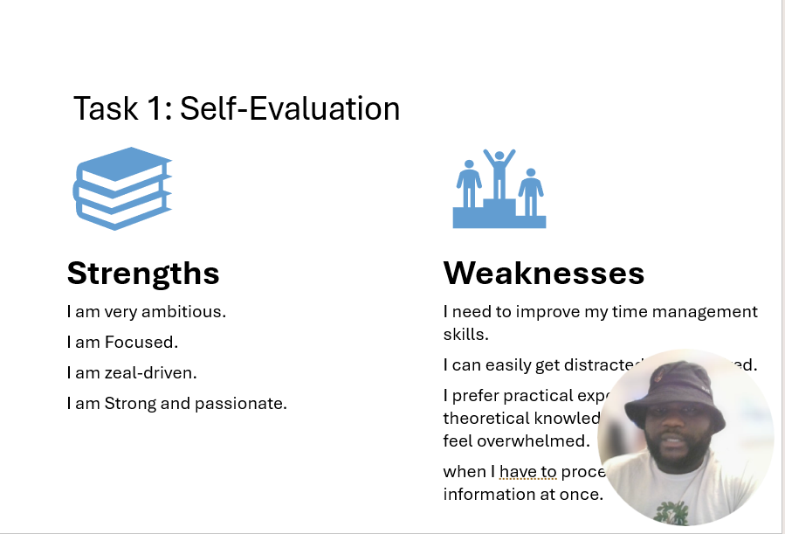
Based on my SWOT analysis, I've identified key strengths and weaknesses that shape my learning experience.

- Strengths:
My ambition drives me to set high goals and persevere through challenges. I'm focused and give my all to my passions, which helps maintain my motivation throughout my academic journey.

- Weaknesses:
I struggle with time management, balancing work, personal life, and studies. Distractions and fatigue affect my productivity, and I prefer practical experience over theoretical knowledge, which makes it challenging to engage with abstract content. At times, I feel overwhelmed, leading to stress and procrastination.

Understanding these strengths and weaknesses has been eye-opening. It helps me identify areas for improvement and develop strategies, like planning shorter study sessions and finding practical applications for theoretical concepts.

Slide 6: Traits Gained from Self-Evaluation
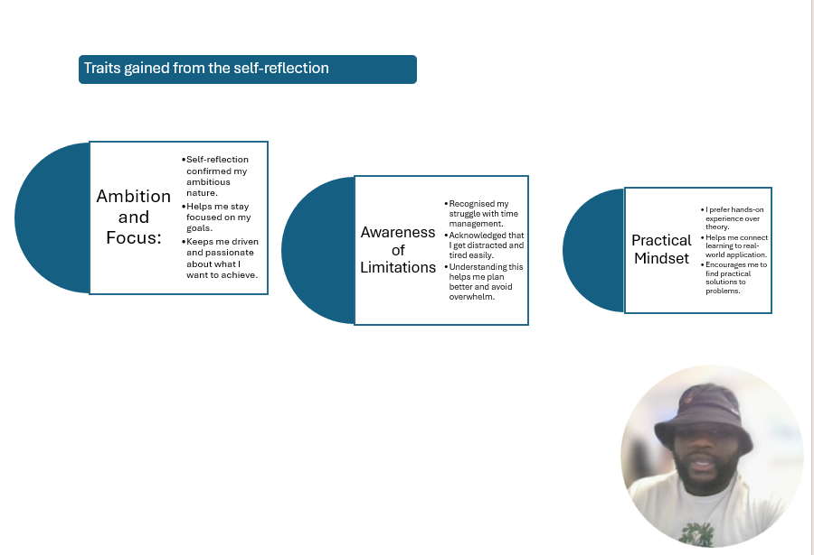
Through introspection, I've gained insights into my learning characteristics.

I recognize my ambition, which helps me stay focused, but I also see my time management limitations. This encourages me to create effective study plans with regular breaks.

My pragmatic mindset drives me to prefer hands-on experiences that relate to my goal of becoming a cybersecurity expert.

This reflection has clarified my identity as a learner and highlighted areas for improvement.

Slide 7: Professional Development Plan
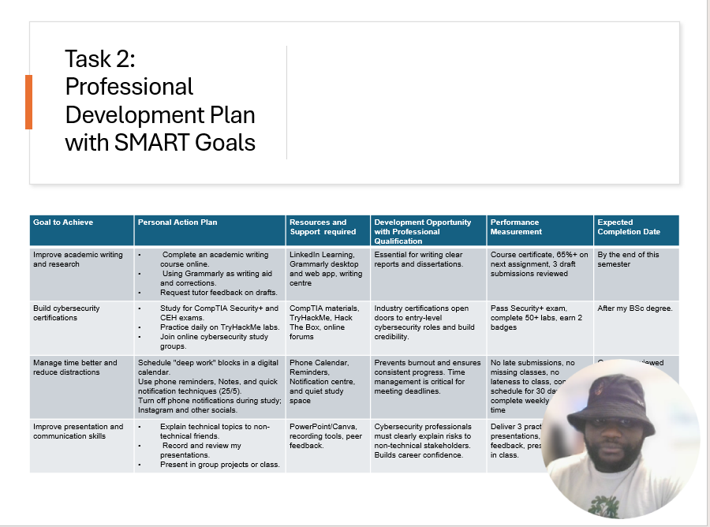

I have developed a professional development plan using SMART goals.

- Enhance Academic Writing and Research
I will take an online writing course and use Grammarly, aiming for a certificate, a score of 85% or higher on my next assignment, and three drafts reviewed by my tutor by semester's end.

- Pursue Cybersecurity Certifications :
I plan to become a cybersecurity specialist by preparing for the CompTIA Security+ and CEH exams using resources like CompTIA, TryHackMe, and Hack The Box. Success means passing the Security+ exam, completing 50+ labs, and earning two badges after my BSc.

- Improve Time Management :
I will schedule "deep work" sessions and create a quiet study space, and I will track submissions to avoid late assignments for 30 days.

- Enhance Presentation Skills:
I will explain technical topics to non-technical friends for feedback, measuring success by delivering three practice presentations and one in class next semester.

Slide 8: Topic Summary
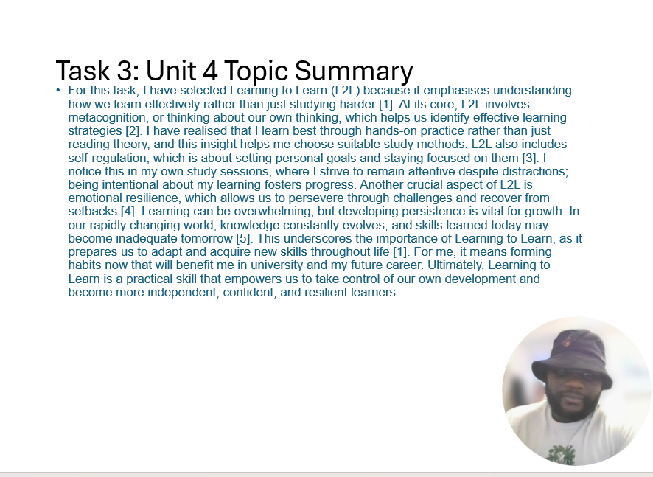
I have chosen Learning to Learn (L2L) because it focuses on effective learning strategies rather than just studying harder [3]L2L emphasizes metacognition, helping us reflect on our thinking to identify beneficial learning methods [4]I've realised that hands-on experience enhances my learning efficiency more than theoretical reading. Another key aspect is self-regulation, which involves setting personal goals and staying focused [5]. I strive to maintain attention during study sessions despite distractions. Additionally, L2L fosters emotional resilience, enabling us to overcome challenges and recover from setbacks [6]. In an ever-changing knowledge landscape, L2L prepares us for lifelong learning [7]. For me, this means developing habits that will support my university studies and future career. Ultimately, L2L empowers us to take control of our growth as independent and resilient learners.

Conclusion

Slide 9 Conclusion
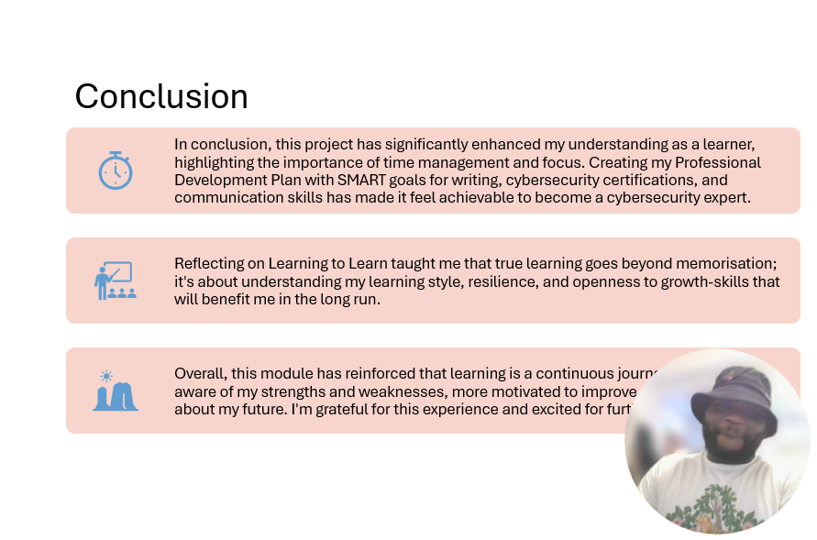
In conclusion, this project has significantly enhanced my understanding as a learner, emphasising the importance of time management and focus. By creating my Professional Development Plan with SMART goals for writing, cybersecurity certifications, and communication skills, I now feel it is achievable to become a cybersecurity expert.

Reflecting on the concept of Learning to Learn taught me that true learning extends beyond mere memorisation; it involves understanding my learning style, building resilience, and being open to growth. These skills will benefit me in the long run.

Overall, this module has reinforced the idea that learning is a continuous journey. I feel more aware of my strengths and weaknesses, more motivated to improve, and more confident about my future. I am grateful for this experience and excited for further growth.

References

Slide 10: References
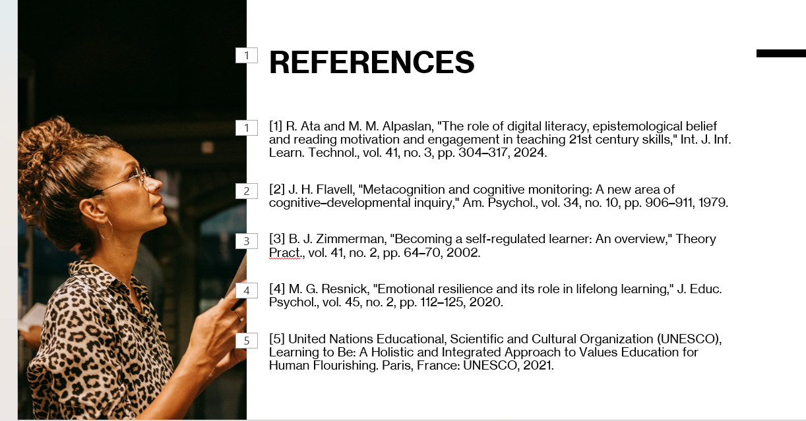

References

[1] | G. Gibbs, Learning by Doing : A Guide to Teaching and Learning Methods, Oxford: Further Education Unit,Oxford Polytechnic,, 1988.
[2] | N. Trimasse, “The use of reflective reports in higher education,” Reflective Pract., p. 1–17, 2024.
[3] | R. Ata and M. M. Alpaslan, “The role of digital literacy, epistemological belief and reading motivation and engagement in teaching 21st century skills,” vol. vol. 41, p. 304–317, 2024.
[4] | J. H. Flavell, “Metacognition and cognitive monitoring: A new area of cognitive-developmental inquiry Am. ., vol. 34,,” Psychol, vol. 34, p. 906–911, 1979.
[5] | B. J. Zimmerman, “Becoming a self-regulated learner: An overview,” Theory Pract, vol. 41, pp. 64–70,, 2002.
[6] | M. G. Resnick, “Emotional resilience and its role in lifelong learning,” J. Educ. Psychol., vol. 45, pp. 112–125,, 2020..
[7] | S. a. C. O. (. United Nations Educational, Learning to Be: A Holistic and Integrated Approach to Values Education for Human Flourishing., Paris, Paris: UNESCO, 2021.

