L4 - Learning in the Digital Era (BA GAMES/ANIMATION STUDENTS)
E-Portfolio
Daniel Thomas
2003824
BA Computer Games Design

Table of Contents
E-Portfolio 3
Task 1 – Written Summary 3
Task 2 – Academic Poster 4
Task 3 – Automatic Citation 5
Task 4- Illustrative Review 6

E-Portfolio
Link: Daniel Thomas E-Portfolio
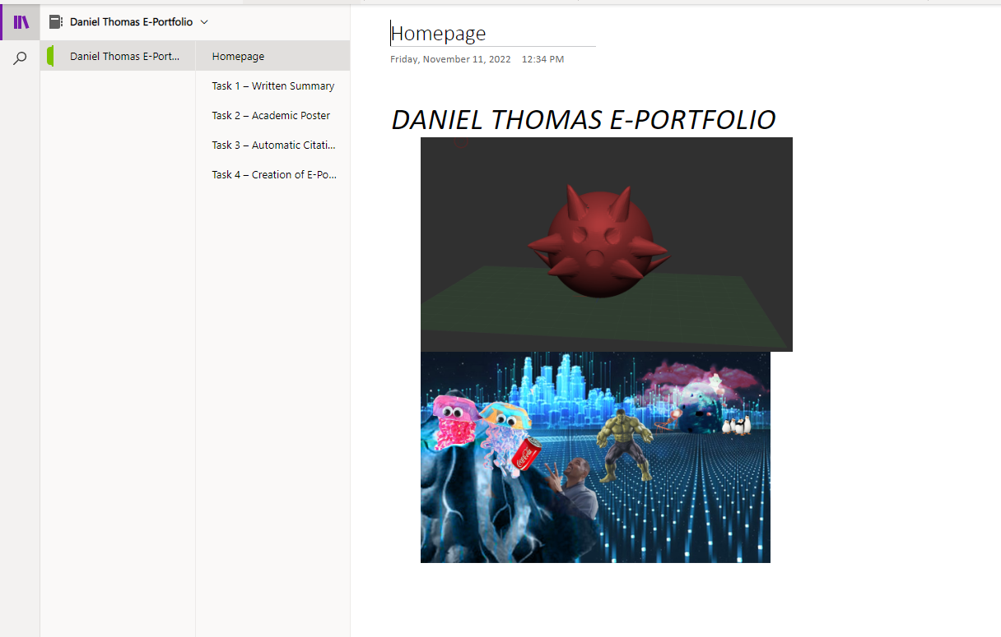

Task 1 – Written Summary
Link: Task 1.docx
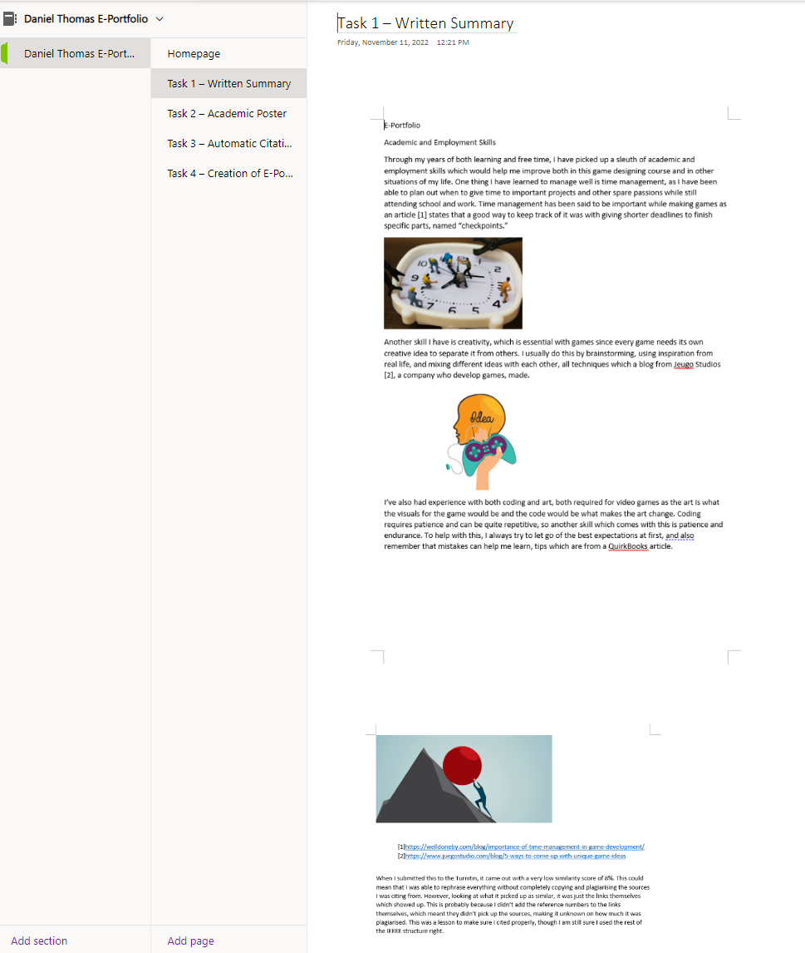

Task 2 – Academic Poster
Link: poster.pub
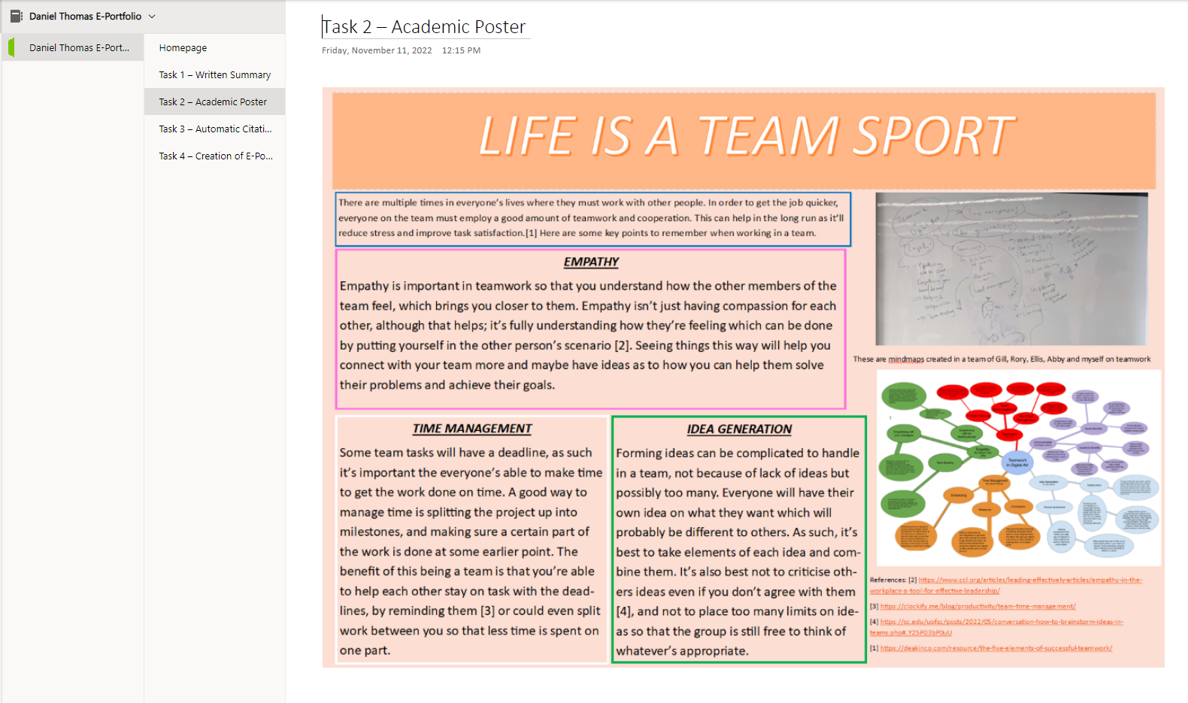

Task 3 – Automatic Citation

Link: Forming a Team.docx
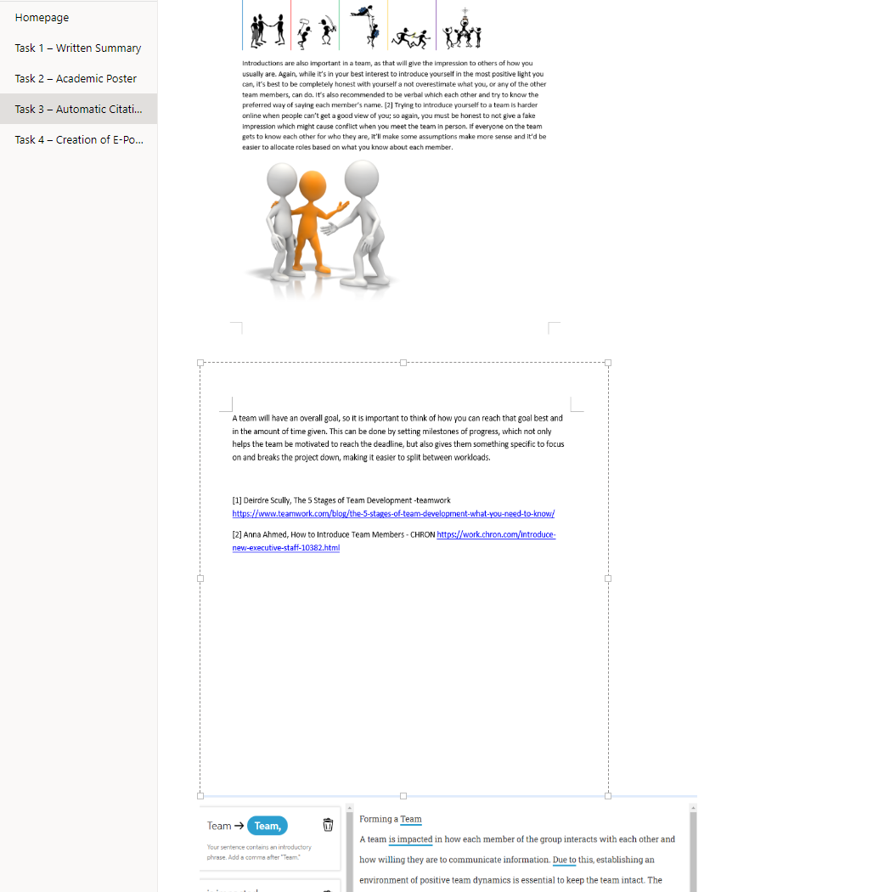

Task 4- Illustrative Review


