Changemakers: Building Your Personal Brand for Sustainable Employment
BMHP5015
Student Name: Diana Constantin
Student ID: 2331926
Lecture Name: Tsiwani Khumalo

Table of Contents
Task 1 – Personal Brand 3
Task 2 - Network Map and Rationale 4
Task 3- Blog 6
Task 4- NHS Equality, Diversity and Inclusion Quiz 8
Task 5- A Letter to Yourself 10
Task 6- GANTT Chart 11
Task 7- Making Changes- Report 12
Task 8- Self-Reflection 13
Reference List 14
Table of Figures
Figure 1: Network Map 4
Figure 2: Percentage change in FTE staff 7
Figure 3: Gantt Chart 11

Task 1 – Personal Brand
The values of compassion, responsibility, and person-centred care are the personal brand that I have developed based on my aspiration to become a Health and Social Care Manager. I would like to position myself as a confident, responsible and supportive professional who is concerned about the well-being and dignity of the service users and is efficient in handling healthcare services. Professionals in the health and social care sector are supposed to show empathy, leadership and excellent communication in order to offer quality care. Personal branding helps people to convey their values, strengths, and professional identity to improve career opportunities (Nuzilawati, 2025). Thus, my personal brand is based on professionalism, cooperation, and the desire to make care services better for people and communities.
To continue my personal brand development and to reach my employment objectives, I will pay attention to the constant development of my profession and the acquisition of the necessary practical experience. Enrolling in the training programmes connected with leadership, safeguarding, and care management will also enhance my professional competence. Moreover, on-the-job placements and volunteering in healthcare facilities will contribute to the building of confidence, problem-solving skills, and knowledge of the practical care settings. The contemporary workforce demands employability, where graduates need to be in reflective practice and in continuous learning in order to achieve adaptation to the evolving professional requirements (Asiedu et al., 2024). Moreover, building a professional online profile and networking with the representatives of the health and social care industry will enhance exposure to prospective employers. Through a strong and believable personal brand, I will be able to build a solid and reliable reputation within the sphere of health and social care by making sure to be professional, empathetic, and accountable.

Task 2 - Network Map and Rationale

Figure 1: Network Map
Source: (Author, 2026)
The network map above is a hybrid network that I have, comprising offline and online relationships that will help me with my academic experience and future career in the health and social care field. The hybrid network is a blend of personal and online connections that will provide me with more opportunities to find professional opportunities and support networks (Andrade and Andrade, 2023).
The people in my professional network are lecturers, placement supervisors, and mentors who give guidance, industry knowledge, and constructive feedback. These people are significant in assisting me to acquire the professional skills that I need to become a Health and Social Care Manager. My support system, comprising family members and university career advisors, will offer emotional support and guidance during my coursework and career planning.
Moreover, my social circle, friends, and classmates facilitate team learning and knowledge exchange in academic processes. My community network, including volunteering groups and local health organisations assist me in acquiring practical experience and having a more realistic idea of the real-life health and social care settings.
Studies indicate that networking is a vital career development strategy since it enables individuals to access information, resources and job opportunities through professional associations (Faizan, 2025). Moreover, employability and career success may be enhanced through the appropriate networking behaviours that increase professional visibility and network (Tomlinson and Jackson, 2021). Hence, having a balanced hybrid network is significant to my future career growth.

Task 3- Blog
Title: Growth of the NHS Workforce: What It Means for the Future of Health and Social Care
Introduction
The NHS workforce has witnessed a massive increase in the number of staff in most staff groups in the last 10 years (Hemmings, Buckingham, and Palmer, 2021). The chart shows the percentage change in the various NHS staffing positions between 2010 and 2025. It records a significant increase in the number of doctors, scientific and technical employees, and support workers in healthcare organisations. The purpose of this blog is to enlighten health and social care students and future professionals about the emerging trends in the workforce within the NHS and how the trends will impact future job opportunities in the sector.
Why This Issue Matters
The significance of learning workforce trends is that it shows how healthcare systems react to the growing demand for services. According to the chart, a number of staff groups, especially the doctors and scientific, therapeutic, and technical staff, have increased by more than 40 - 50% since 2010. This is an indication of the NHS trying to enhance the healthcare services and patient outcomes. Nonetheless, the growth in the workforce is also an indicator of the increasing needs of healthcare because of population ageing and rising chronic illnesses. These trends indicate that the field of health and social care is still growing and needs a variety of skilled professionals to work in it, especially for students entering the sphere.
Key Challenges Include:
- Inequalities in the growth of the workforce, with some positions growing faster than others.
- The growing service demand, which still exerts pressure on healthcare personnel.
- Retention issues, in which healthcare organisations have a problem retaining experienced professionals.
- Workload stress, particularly in the frontline healthcare activities like nursing and ambulance services.
Moving Forward
The NHS should invest in staff wellbeing, recruitment, and training to facilitate the development of a sustainable workforce. To strengthen the workforce, more students should be encouraged to take up careers in health and social care, and opportunities to progress their careers should be improved. Also, building leadership and management capabilities will be significant for the future professionals joining the sector.
Conclusion
The NHS labour force is increasing in various categories of staffs and this is due to the increasing complexity and demand of the healthcare services in the UK. Although this growth offers some new opportunities to students and future professionals, it also demonstrates the necessity of continuous workforce planning and support. The awareness of these trends will enable people to plan good and sustainable careers in the field of health and social care.

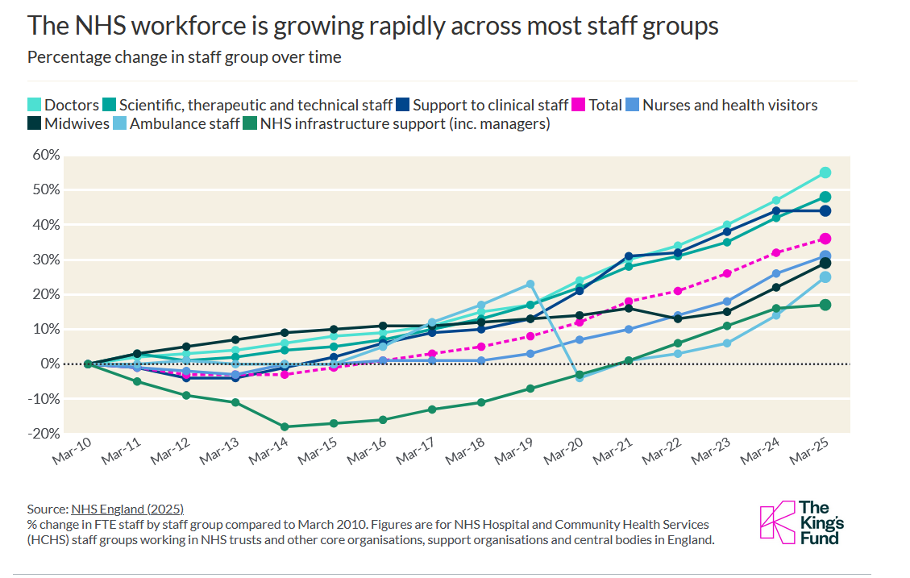
Figure 2: Percentage change in FTE staff
Source: (The King’s Fund, 2025)

Task 4- NHS Equality, Diversity and Inclusion Quiz
1. What is the primary goal of the NHS Equality, Diversity, and Inclusion Improvement Plan?
The main aim of the NHS EDI Improvement Plan is to establish a workplace that is fair and inclusive and where every employee is treated with dignity and respect, irrespective of their background (Bolster and Jameel, 2024). It will minimise discrimination, enhance staff experiences, and guarantee equal opportunities among the NHS workforce.
2. How does the NHS EDI Improvement Plan propose to tackle the gender pay gap?
The plan will focus on the gender pay gap through enhancing pay transparency, tracking pay data, and ensuring equal career progression opportunities for women. It also promotes equal recruitment and leadership between both sexes.
3. What is meant by the term ‘intersectionality’ as used in the NHS EDI Improvement Plan?
Intersectionality is a concept that states that a person can be discriminated against or disadvantaged in more than one way depending on the various dimensions of identity, including gender, ethnicity, disability, or age (Christoffersen, 2021). The NHS acknowledges that all these overlapping factors can have some impact on workplace experiences.
4. Why is it important for the NHS to create a psychologically safe work environment?
The psychologically safe environment also enables staff to raise the issues, errors or ideas without the fear of being punished or discriminated. This assists in the enhancement of staff wellbeing, teamwork, and patient safety.
5. How does the NHS EDI Improvement Plan suggest improving the experience of internationally recruited staff?
The plan suggests that it should offer superior induction, pastoral care, and career development to internationally recruited employees. This will enable them to fit well in the workplace and feel appreciated in the organisation.
6. What role does leadership play in advancing EDI objectives according to the NHS Improvement Plan?
Leadership has a major role to play because it facilitates inclusive practices, defines organisational standards, and makes teams responsible towards the accomplishment of EDI objectives (Kuknor and Bhattacharya, 2022). Leaders should establish a culture of equality and respect.
7. Identify one way the NHS EDI Improvement Plan aims to reduce health inequalities within the workforce.
One of them is to enhance the accessibility of training, development, and promotion of employees who represent an underrepresented or disadvantaged group.
8. Why does the NHS EDI Improvement Plan emphasise the importance of collecting and analysing data on protected characteristics?
Data collection assists in the detection of disparities in the workforce and enables organisations to come up with specific measures to tackle discrimination and enhance equality.
9. Explain how flexible working policies can contribute to equality and inclusion in the NHS workforce.
Flexible working policies facilitate employees who might have caring obligations, health, or other personal obligations. This assists in establishing a more accommodating and conducive working environment.
10. What is one strategy mentioned in the NHS EDI Improvement Plan to combat bullying and harassment in the workplace?
One of them is to have a clear reporting mechanism and make staff members feel free to report bullying or harassment and have complaints addressed accordingly.

Task 5- A Letter to Yourself
Dear Younger Me,
At one point, you experienced a feeling of being overwhelmed by difficulties, lack of clarity, and self-doubt, particularly when you attempted to juggle between academic and personal life and future career expectations. At that time, it appeared to be a hard task to cope with stress and be sure that you are able to do anything. In retrospect, I can see that I would have benefited greatly by having better emotional intelligence and resilience, which would have helped me deal with those situations.
Emotional intelligence refers to the capacity to appreciate, comprehend and control your feelings as well as to be conscious of the feelings of other people. Then, you should have learned to stop and consider your emotions and react to the stressful situations with more relaxed emotions than with frustration and fear. Knowing how you feel would have also enabled you to be more open with other people and get support when necessary.
Instead, resilience is the skill to adjust to changes and overcome failure. The difficulties that you had to go through were not failures but chances to get stronger. Had you also taken those challenges as learning opportunities, you could have become more confident and resilient. Resilience would have assisted you in being focused on your long-term objectives rather than being disheartened by short-term challenges.
On your way, keep in mind that difficulties are the normal aspects of personal and professional growth. With the help of improving emotional intelligence and resilience, you will be able to cope with pressure better, stay positive, and keep working towards achieving your goals in life, as well as your future profession.
Stay patient with yourself and keep growing.
Sincerely,
Your Future Self

Task 6- GANTT Chart
Tasks / Activities | Week 1 | Week 2 | Week 3 | Week 4 | Week 5 | Week 6
Career research on the Health and Social Care Manager role and required skills
Self-assessment of employability skills and identifying gaps
Enrolling in relevant online training (leadership, safeguarding, care management)
Networking with professionals (LinkedIn, lecturers, healthcare staff)
Volunteering or gaining practical experience in health/community services
Developing CV and LinkedIn profile
Applying for internships/placements in health and social care organisations
Reflection and improvement of professional skills
Figure 3: Gantt Chart
Source: (Author, 2026)

Task 7- Making Changes- Report
Introduction
One of the changes that I would like to make as the manager of a care home is the implementation of a systematic staff wellbeing and stress management programme. Health and social care can be a stressful and challenging field to work in, and staff wellbeing is a key element to ensuring high-quality care to residents. Enhancing staff wellbeing also has the capability of reducing burnout, enhancing job satisfaction and improving staff retention.
Proposed Change and Implementation
The change that would be proposed would include the implementation of routine well-being programs like stress management courses, availability of counselling services, and well-being check-ins among the staff members. Lewin's Change Management Model can be used to guide the implementation of this change, and it comprises three stages, namely unfreezing, change, and refreezing (Santos et al., 2023). During the unfreezing phase, employees would be educated about the significance of wellbeing and the way the programme will be helpful to the employees and residents. At the change stage, wellbeing programs like workshops and support sessions would be implemented. Lastly, during the refreezing phase, the practices would be integrated into the workplace culture of the care home.
Skills Required and Potential Barriers
The implementation needs good leadership, communication and empathy in order to be successful. Managers should be able to hear the employees and promote the idea of discussing stress and well-being. Nevertheless, possible obstacles can be the lack of time, budget limitations, or the unwillingness of the staff to talk about the problems of personal well-being. Mwamba (2023) argues that to ensure successful organisational change, effective communication and employee engagement will be necessary in order to minimise resistance.
Conclusion
A staff wellbeing programme can be introduced to boost the morale of the employees, decrease stress, and eventually improve the quality of care given to the residents. This change can be made to provide a healthier and more supportive working environment with effective leadership and planned action.

Task 8- Self-Reflection
This module has helped me to understand my own strengths, professional identity, and the skills I need to be successful in the health and social care field better. Applying the Reflective Cycle (1988) by Gibbs as a framework, I am able to reflect on my learning experience and how it will impact my professional development in the future.
Regarding description, the module entailed several activities concerning personal branding, networking, communication, and resilience. These activities prompted me to reflect on my employability competencies and on the ways in which they match the demands of the health and social care profession.
In terms of feelings, in the first stages of the module, I was unsure of how to be a professional and how to structure my future career. Nevertheless, by doing the portfolio assignments, I gained more confidence in recognising my strengths and learning about the relevance of professional networking and self-growth.
Evaluation and analysis allowed me to understand that the skills that are important in health and social care settings include communication, emotional intelligence, teamwork, and resilience. The module made me understand the necessity to develop a solid personal brand and have a professional presence online in order to enhance employability.
To sum everything up, the module has made me more conscious of my personal and professional developmental needs. I have come to realise that reflective practice can be used to promote continuous improvement.
Lastly, my action plan is to enhance my communication, leadership, and networking skills by engaging in additional training, experience, and self-reflection to be ready to work in the health and social care profession in future.

Reference List
Andrade, D.L. and Andrade, S.W., (2023). Developing the global career network: The benefits of promoting effective remote and hybrid work models. International Journal for Digital Society, 14(1), pp.1816-1824.
Asiedu, E., Malcalm, E., Boakye, A.N. and Amoah, C.K.K., (2024). Graduate employability skills of business students: the moderating role of reflective practices. Higher Education, Skills and Work-Based Learning, 14(2), pp.352-371.
Bolster, A. and Jameel, L., (2024). Evaluating the experiences of a staff equality, diversity and inclusion reflective space. Reflective Practice, 25(2), pp.227-250.
Christoffersen, A., (2021). The politics of intersectional practice: competing concepts of intersectionality. Policy & Politics, 49(4), pp.573-593.
Faizan, R., (2025). The importance of professional networking: A pathway to career success. Scientific Societal & Behavioral Journal, 1(1), pp.59-65.
Hemmings, N., Buckingham, H. and Palmer, W., (2021). Attracting, supporting and retaining a diverse NHS workforce. London: Nuffield Trust.
Kuknor, S.C. and Bhattacharya, S., (2022). Inclusive leadership: new age leadership to foster organizational inclusion. European journal of training and development, 46(9), pp.771-797.
Mwamba, J., (2023). Effective Leadership in Change Management: Ensuring Success in Organizational Transformation. Journal of Policy Options, 6(1), pp.28-38.
Nuzilawati, L., (2025). Personal Branding Strategies for Building a Strong Self-Image in the Digital Era. Journal of Applied Science and Engineering Management Research, 1(1), pp.57-63.
Santos, E., Queiroz, M., Borini, F.M., Carvalho, D. and Dutra, J.S., (2023). The journey of business transformation: unfreeze, change and refreeze–a multiple case study. Journal of Organizational Change Management, 36(1), pp.47-63.
The King’s Fund (2025) NHS Workforce nutshell | The King’s Fund. Available at: https://www.kingsfund.org.uk/insight-and-analysis/data-and-charts/nhs-workforce-nutshell (Accessed: 06 March 2026).
Tomlinson, M. and Jackson, D., (2021). Professional identity formation in contemporary higher education students. Studies in Higher Education, 46(4), pp.885-900.

