
effective team-working and communication within the workplace
Case study

December 10, 2021
University of Wales Trinity Saint David

CORNELIA BUF
2028303
UNIVERSITY OF WALES TRINITY SAINT DAVID
10th of DECEMBER 2021
Word count: 2250

Executive Summary

The report was made to emphasize the importance of building teams, developing effective communication within a team, and highlighting the importance of effective teamwork by applying the theories and models of communication that have been studied in this module.
Also, the report will highlight the problems within Andrea Jones`s online business and will try to advise her on how to create a proper environment to increase effectiveness and productivity, to form relationships within the company, to form effective teams and better work balance the workforce. All the theories and models mentioned in this report are meant to bring an important contribution to Andrea`s decisions.
It shows the importance of working in teams which is more effective and leads to higher performance and productivity. Having a common goal and working together increase the effectiveness of a business, improve communication and relationships between individuals, release stress, build trust, create a balance within the teams.
These theories help us develop and implement the best strategies suitable to grow a business, make it more profitable, increase markets, expand.

Table of Contents
Executive Summary 1
Terms of Reference 3
Procedure 3
Introduction 3
Findings 4
Conclusion 10
Recommendations 10
Bibliography/References 11

Terms of Reference

This report has been requested by Melanie Squires to be submitted by the 10th of December 2021. The purpose of this report is to highlight the importance of two-way communication and why verbal and non-verbal communication is important in this case study as well as how teamwork theories can improve teamwork in this case study.
This report has been compiled by Cornelia Buf, student number 2028303 and it will outline the importance of communication and teamwork in the case study and will identify some of the problems which might prevent the good development of the business.

Procedure

To complete this report, has been used and applied some of the teamwork theories and ways of communication that have been studied in the module Effective team-working and communication along with other books, journal articles, websites where these theories have been highlighted in different situations.

Introduction

The case study used for this report is about Andrea Jones`s small retail store from Swansea which shifted to permanent online shopping with home delivery and has grown rapidly in the last few years becoming a medium-size store after the Covid 19 pandemic.
Problems found within this business that might prevent it from growing more are poor employee organization and possible poor experience, lack of teamwork and communication between staff, between staff and management, lack of steering groups for each department, inappropriate training for employees, more part-time employees than full time.
By applying to this case study teamwork theories as Tuckman`s, Belbin`s, Kilmann`s, and communication ways as Berlo`s model, Shannon & Weaver`s model, or Schramm`s model studied in this module will try to advise Andrea on how to re-organize and expand the workforce within her business and ensure it runs smoothly, how to prevent small problems becoming big problems.

Findings

A quick SWOT analysis (Helms, M.M & Nixon, J., 2010) on this case will bring up a few things which have to be taken into consideration.

STRENGTHS  -strong online presence  -delivery service  -existing a customer base  -online ordering | WEAKNESSES  -staff training  -no steering groups for each department  -lack of employees  -poor or no communication  -lack of full-time employees  -relationship between employees
OPPORTUNITIES  -hire more full-time experienced staff  -expand services  -larger product variety  -new markets | THREATS  -customer choice  -online market competition

As you can see there are few weaknesses which can affect the development of the business. A good start to prevent that is for Andrea to apply Tuckman`s model (Tuckman, B.W., 1965), who identified five stages of development for a group of people which are Forming, Storming, Norming, Performing and Adjourning.

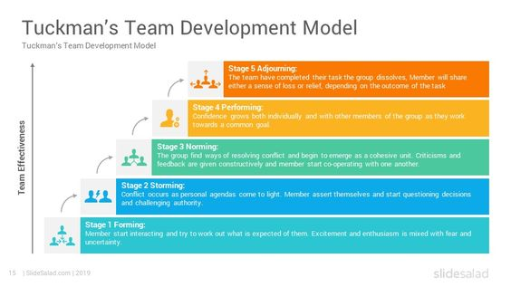

The Forming stage will give the employees the opportunity to meet and know each other, a stage which in this case study looks like is missing. Working in different shifts, different hours, most of them working part-time and from home, the employees have not had the chance to meet.
The Storming stage is the stage where they can see their strengths and weaknesses, is the stage where conflict might occur, and in this situation, conflicts can arise anytime as there is a lack of communication already between staff, they have no regular meetings, and a lot of information is lost. Conflicts can be also positive according to Thomas - Kilmann Conflict Model Instrument (1977). The conflicts bring together employers and employees and give them the opportunity to communicate and find what the problems are and provide solutions, to know each other, to learn about their strengths and weaknesses, to learn from other experiences. Also, conflicts can have a negative impact on productivity and efficiency and can lead to misunderstandings and low morale.
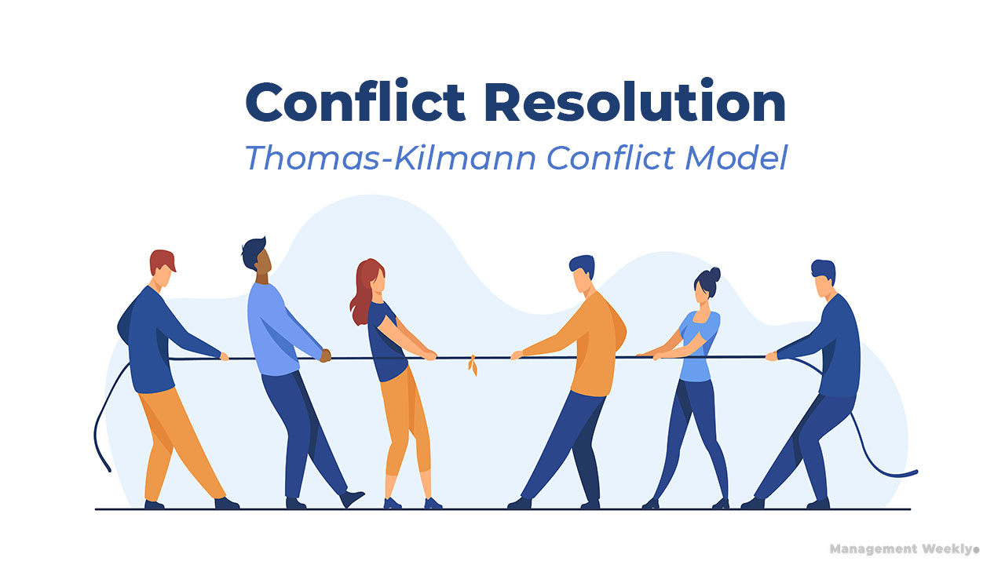

The Norming stage is identified as the stage where the employees accommodate each other and establish work relationships.
The Performing stage is the stage where everyone knows exactly what they must do individually and everyone contributes efficiently to the business development and productivity, they all work together to achieve a common goal.
The Adjourning stage is the stage where the goal has been achieved, people have made connections and good relationships.
As you can see Tuckman`s theory will help Andrea to form teams for her business. But like any other team, they will need to have leaders and each individual specific role to make the team effective. A team shares roles and responsibilities to achieve a common goal. Advising Andrea to apply the 9 Belbin team roles model (2010) in the first three stages of Tuckman’s model will give her the opportunity to form good and strong teams for her business.

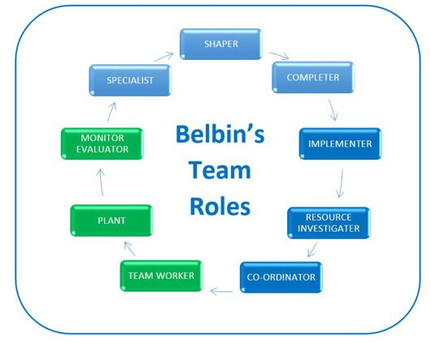

Andrea has already three managers which they can be allocated one on each shift and go from there all roles and responsibilities within the team can be shared between the employees. A team led effectively will be more successful for Andrea`s business.
Why these two models/theories are good for Andrea’s business?
First, they will help Andrea to have a clearer vision of her business, of what weaknesses they have, and how to improve or correct them. It is very important for Andrea`s business to have steering groups for each department because this will eliminate the lack of communication and loss of information within teams and between teams.
Secondly, these models will help Andrea to form effective teams which are very important for her business. An effective team will have a common goal which in this case will be the development of Andrea`s business, shared roles, and responsibilities, good communication which at this moment is almost null within the workplace, mutual trust, and respect, knowing the abilities and skills of the team, commitment, listening to the others, clarity around accountability, empowering, increased self-awareness, and openness, giving and receiving feedback. All these will contribute to developing team working behaviours within Andrea`s company.
Why communication is important for Andrea`s business?
Let’s see first what is communication? Communication is critical for all living ones. The exchange of thoughts and ideas with the goal of conveying information is referred to as communication. Communication is a two-way street that involves both vocalization and gesticulation. The goal of communication is to clearly communicate one's beliefs, ideas, thoughts, or needs to reach a consensus or a mutually acceptable solution. Communication does not only refer to the ability to articulate words. Sign language and the sense of touch are also important modes of communication for expressing and feeling. Finally, communication must be effective. The goal of communication will be met if there is clarity in communication.
Every aspect of a business is built on communication. Effective communication is communication between two or more people with the goal of successfully delivering, receiving, and comprehending a message. It's the process of exchanging information among team members while keeping in mind what you want to say, what you actually say, and how your audience interprets your words.
When one person is the sender and sends a message to another person who is the receiver, this is known as two-way communication. When the recipient receives the message, they respond with an acknowledgment that it was received.
In the business world, two-way communication is critical. Employers, employees, consumers, and other stakeholders provide messages, and feedback is essential to ensure that the message was received and comprehended.
Regarding this case study, there is a breakdown in communications, and information is not shared effectively. Currently, in Andrea`s business, they are having occasional meetings online and sometimes organized ad hoc meetings on a particular shift with whoever is working at that time. This type of communication in Andrea`s business looks like the theoretical communication model described by Shannon-Weaver (1949) which says there is someone who sends the message, there are messages sent via different channels, in this case, Microsoft Teams or ad hoc meetings at the workplace messages which might be misunderstood by the receiver as there is the chance that some noise to be involved and the final message to be slightly different than the original message, which leads to a piece of information shared ineffectively. This is one-way communication, and it is not efficient for the business. Having no feedback, the sender will never know if the receiver got the message, or it is the right message.
Shannon and Weaver's model has been criticized in several ways. However, the model is not a communication model. Instead, it is an incomplete and unfair model of the flow of information through a medium. The model implies that communication within a medium is frequently direct and unidirectional, but communication in the real world of media is almost never unidirectional and is frequently indirect. (Foulger, D., 2004)

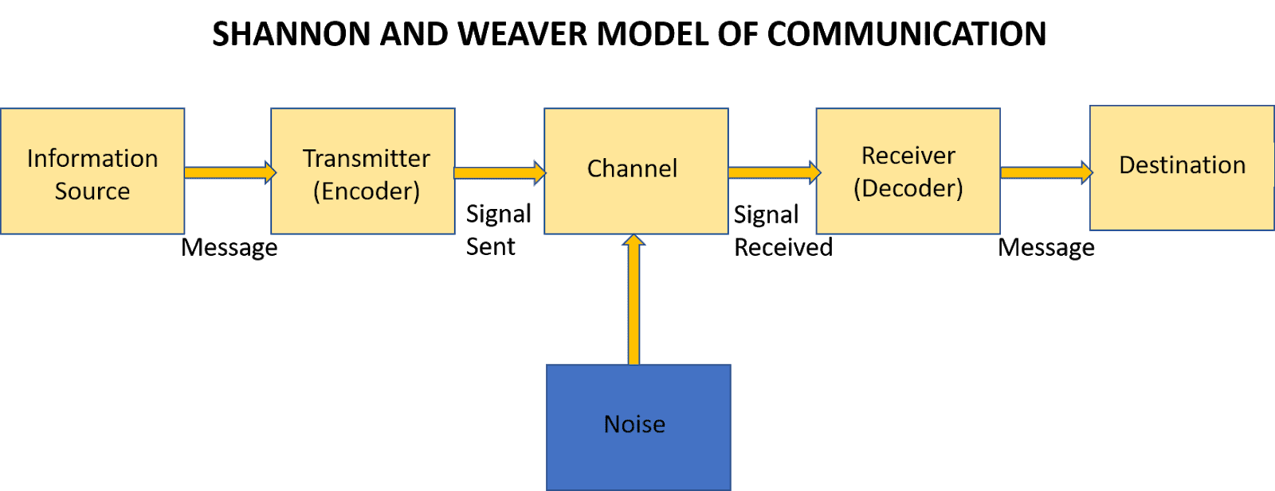

David Berlo`s SMCR model (1960) it is another model of communication. According to Berlo's model, for effective communication to occur, the source and the receiver must be on the same level. Only then will communication occur or take place properly. So, if the source's communication skills are good, the receiver should have equally good listening skills. However, in everyday life, this is rarely the case. This model is not suitable for this case study as there is a lack of feedback, does not mention the barriers to communication, it is a one-way communication, it has no room for noise and it omits the fact that there are humans involved and their ability to think, understand, analyse, etc. Also, in this case, study not all employees are working at the same time, and they are not in the same place, some are working from home. Therefore, they need a better way to share information effectively to make sure everyone got the message.

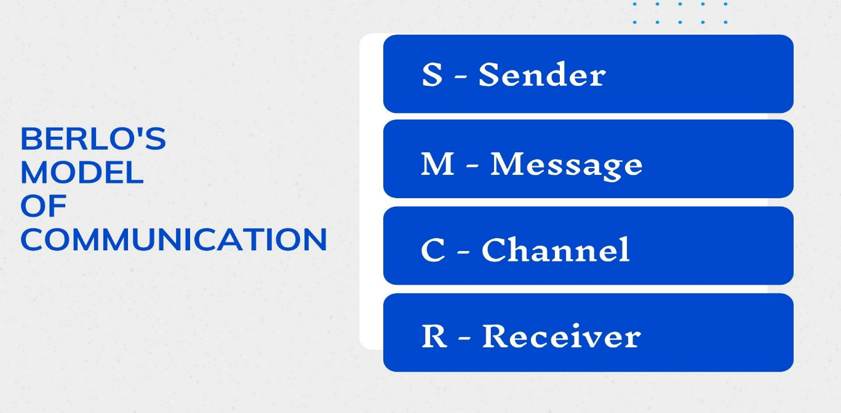

To get through the barriers of communication successfully, Andrea will need to use a two-way communication model to help her business to grow.
Schramm's model (1948) says that the two essential processes of effective communication are coding and decoding.
He also emphasises that communication is not complete until the sender receives feedback from the recipient.
According to this communication model, when a sender transmits information to a receiver, the receiver must interpret it in the form desired by the sender and provide feedback or respond accordingly. Any communication in which the sender does not receive feedback is incomplete and thus ineffective.
SENDER
M M
RECEIVER
M=message
Teamwork is required for a business to run smoothly and efficiently. It enables the workforce to divide difficult tasks into simpler ones, then collaborate to complete them faster and develop specialized skills so that the best person for each task can complete it more efficiently and quickly.
Teamwork entails sharing leadership and responsibilities. It has effective communication, which enables a team to bring together diverse opinions and points of view for positive and healthy brainstorming. A positive attitude can also foster trust and enthusiasm among members of a team. It is critical to deal with a conflict as soon as possible to prevent it from escalating.
There are numerous benefits to working effectively together as a team. Positive team spirit, increased productivity, high-quality work completed, and objectives met are examples of these. Finally, effective teamwork leads to success.
For Andrea to have a successful business it is important to build effective teams, to help her employees to connect and interact even they are not working together all at the same time. She can use the three managers one on each shift and create the proper environment for them to develop effective communication within the teams and between the teams.
Also, it would be a great advantage if they could bring to the business more full-time experienced employees. However, having a designated person to provide training for all employees will help them eliminate the eventual knowledge gaps which they have at this time when the training is provided by a different person for everyone.

Conclusion

This report was meant to highlight the problems within Andrea`s business and help her to develop a better strategy to increase productivity and grow her online business. Also, the report advises her on how to build effective teams using what she already has in her company and what she can bring more to help them develop a better relationship and communication between her employees, between them and the management team.
The report also comes up with useful theories and communication models which can be very helpful for Andrea to make sure they allocate the right person to the right role and have the possibility to give and receive feedback from all her employees and even from customers.

Recommendations

Few recommendations for Andrea`s business would be re-organized, form steering groups for each department, reduce costs and better work balance the workforce, provide the appropriate environment for regular meetings and handovers with all employees, designate one qualified person to provide training for everyone, remove barriers and help employees to build relationships and trust, discover new skills for team members that they are better at comparing with what they do at this point. To be open-minded and accept different ideas with different solutions.

Bibliography/References

Al-Fedaghi, S., 2012. A conceptual foundation for the Shannon-Weaver model of communication. International Journal of Soft Computing, 7(1), pp.12-19.
Belbin, R. Meredith, Management Teams: Why They Succeed or Fail. Butterworth Heinemann, 3rd ed., 2010
Berlo, D.,1960. The Process of Communication. Holt, Rinehart and Winston Inc., New York, p. 329.
Blythe, J., 2009. The Schramm Model of Communication. In: 2009. Key Concepts in Marketing, SAGE Key Concepts, London: SAGE Publications Ltd. pp. 178-180 Available at: <http://www.doi.org/10.4135/9781446221617.n46> [Accessed 8 Dec 2021].
Foulger, D., 2004. Models of the Communication Process, February 25. http://davis.foulger.info/research/unifiedModelOfCom munication.htm
Helms, M.M., & Nixon, J., 2010. Exploring SWOT analysis – where are we now? A review of academic research from the last decade. Journal of Strategy and Management, 3(3), 215-251
Kilmann, R.H. and Thomas, K.W., 1977. Developing a forced-choice measure of conflict-handling behaviour: The" MODE" instrument. Educational and psychological measurement, 37(2), pp.309-325.
Narula, U., 2006. Communication models. Atlantic Publishers & Dist.
Shannon, C. E. and Weaver, W., 1949. The Mathematical Theory of Communication, Urbana: University of Illinois Press.
Tuckman, B.W., 1965. Developmental sequence in small groups. Psychological bulletin, 63(6), p.384.
West, M.A., 2012. Effective teamwork: Practical lessons from organizational research. John Wiley & Sons.
Yadav, V. and Mishra, A., Extension Communication Models and Strategies. Page 4 of 7

