Made by: Olesea Pecica
Student ID: 2027757
Module: Marketing Fundamental
Assessment 1

1st Blog

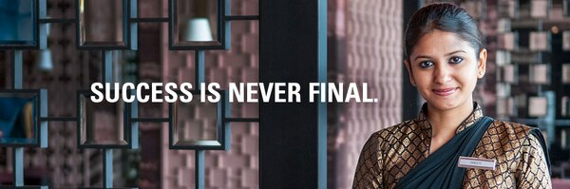

Our guiding principles shape who we are. The ideas that are most essential to us remain constant as we adapt and grow: putting people first, striving excellence, embracing change, behaving with integrity, and serving our world. Being a part of Marriott International entails being a part of a proud heritage and a vibrant culture.
We prioritise people. "Take care of your employees, and they will take care of your customers."
This is our founder's attitude, and it has helped to make Marriott International a terrific place to work for almost 85 years. Our people-first culture has garnered us prizes and recognition all around the world. It is in the company's DNA to provide chances for colleagues to grow and thrive.
We Strive for Excellence. Our commitment to the consumer is evident in all we do. Marriott's reputation for providing excellent customer service stems from J. Willard Marriott's original purpose for his company: "good cuisine and good service at a reasonable price." Every day, in every location throughout the world, we take delight in the details.
We Welcome Change Marriott's journey has always had an element of innovation. The Marriott family was instrumental in shaping the contemporary hotel business. With new brands, new worldwide locations, and new guest experiences, we're determined to constantly disrupt the status quo and anticipate our customers' shifting demands.
We act with honesty. What we do is just as important as how we do it.
We adhere to the highest ethical and legal standards. Our everyday business operations, personnel rules, supplier chain regulations, environmental initiatives and practises, and commitment to human rights and social responsibility are all part of this.
We Give Back to Our Community. Our "passion for service" helps to strengthen our organisation.
We contribute to the communities where we live and work. Marriott International is dedicated to five worldwide social issues: poverty alleviation, the environment, community workforce development, the well-being of children, and global diversity and inclusion.

2nd Blog

The infinite-edge pool, situated in Santorini, at the Mystique, a Luxury Collection hotel.

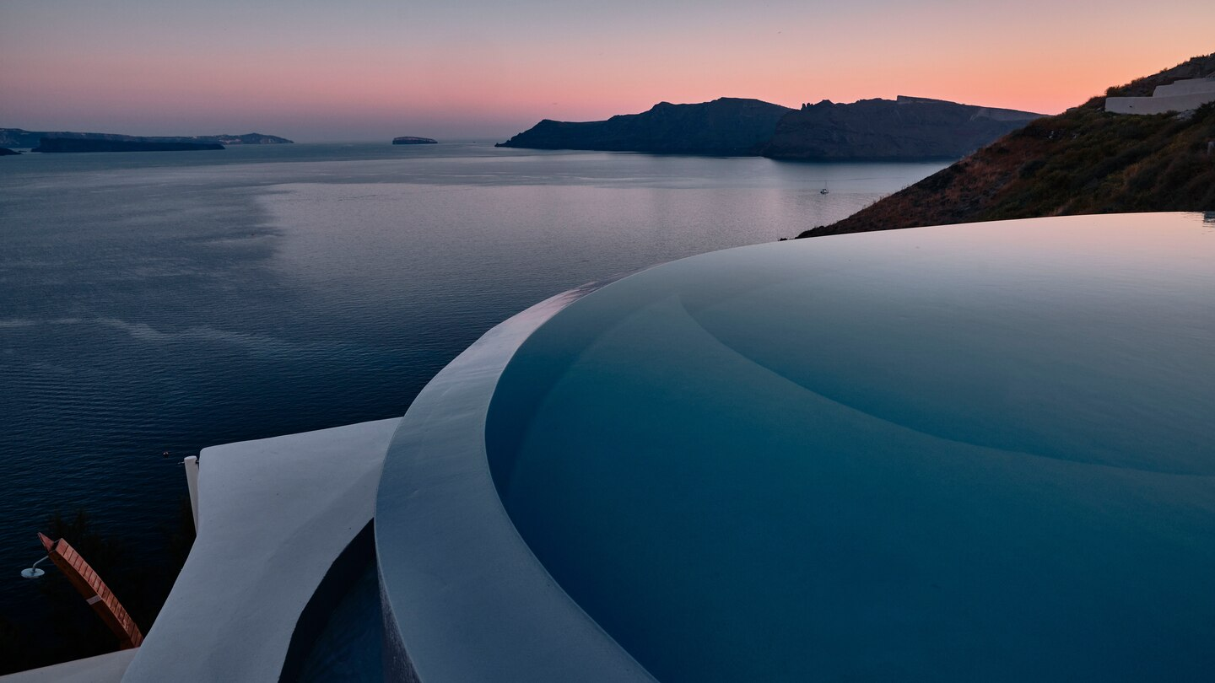

Mystique, a Luxury Collection Hotel, is built into the cliffs of the Caldera and overlooks the Aegean Sea, which surrounds the island of Santorini. The hotel was constructed in the Cycladic style, with smooth curves and sculpted arches merging with a subdued colour palette and light-enhancing areas. It is a favourite honeymoon and romantic vacation resort, oozing a carefree atmosphere and exclusive vibe while providing magnificently broad vistas. Mystique's 41 suites and villas, two swimming pools, the revitalising Elios Spa, and state-of-the-art gym are all connected by a network of cobbled pathways that allow panoramic sea views across to the active volcano that formed this amazing island. Charisma, which serves fresh Greek-inspired food in an outstanding setting, ASEA, which serves fresh sushi with a Mediterranean flair, and Captain's Lounge, which serves informal dining on the original site of a century-old mansion, cater to casual dining. From April until the end of October, MYSTIQUE emanates a carefree spirit, communicating an understated, exclusive air that is so indicative of the gorgeous surroundings, and is a favourite destination for honeymoons and romantic getaways..

33

3rd Blog

New opening-edge Pool
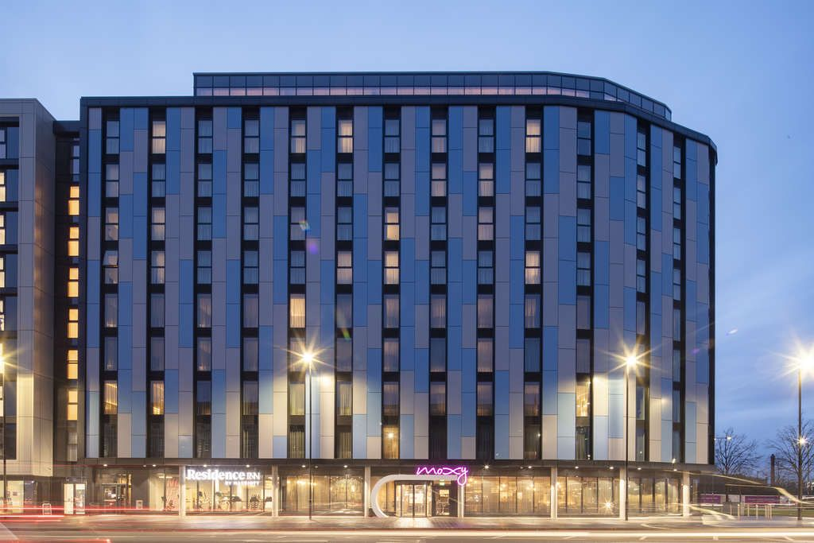

Slough's first double-decker hotel opened in February 2019, marking Marriott International's first integration of two hotel brands under one roof in the UK.
The Moxy Slough (www.moxyslough.com) occupies the bottom four levels and contains 152 guest rooms, including 28 twin rooms and eight accessible rooms. In recognition of the town's strong ties to the iconic Thunderbirds TV series, which was filmed on the neighbouring Slough Trading Estate, the hotel's modern décor includes unobtrusive pop-art wall graphics and signage honouring the Gerry & Sylvia Anderson puppet show and local tradition.
The Residence Inn by Marriott Slough (www.residenceinnslough.com) features 92 suites and is designed to provide longer-staying guests with a more home-from-home experience, with more living space and a fully-equipped kitchen. It is the first branded extended-stay resort in Slough and the surrounding area, and many of its ninth-floor rooms and social facilities provide views of the London skyline. While each hotel has its own entrance and reception, the dual-brand concept allows business and leisure clients to choose the location that best matches their travel needs while encouraging them to use both hotels' shared amenities. On the ninth floor, there are six conference rooms and four larger interconnecting event spaces, as well as a fully-equipped 24/7 fitness studio and a Residence Inn outdoor terrace. Guests may also choose between the Moxy Bar on the ground floor and the Residence Inn Bar & Lounge, both of which serve meals and drinks 24 hours a day, seven days a week.

4th Blog

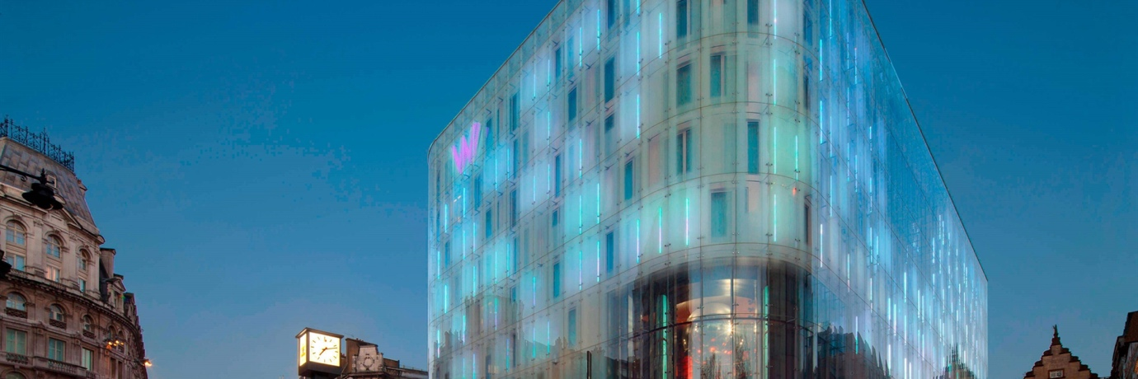

SOAK IT IN AND LIVE IT UP. WE'LL TAKE CARE OF THE REST.
This is the notification that all Marriott guests get.
We must be prepared to welcome the unexpected, which is what we have done in response to the COVID-19 outbreak.

As a member of Marriott International's family of brands, we have taken a multi-pronged approach to satisfying our "Commitment to Clean" standards for health and safety.

We've gone above and beyond to prepare for your stay, from improved cleanliness standards to expanded services and amenities.
Following a multi-million-pound refurbishment, W London is the first hotel in the UK to use the breakthrough DigiValet technology, which allows guests to customise their experience and offers each person with a unique mood, feel, and ambiance according to their preferences.
Each room features an in-room tablet, giving visitors total control over their experience. The colourful and user-friendly interface allows for more personalization of temperature, lighting, music, and entertainment options. The Digivalet technology also allows for a contactless stay and amenities like as breakfast pre-ordering, self-checkout, and housekeeping pre-booking. During a pandemic, one of the behaviours and tactics necessary to preserve social isolation.
Following a multi-million pound refurbishment, W London is the first hotel in the UK to utilise the cutting-edge DigiValet technology, which allows guests to customise their experience and offers each person with a unique mood, feel, and ambiance tailored to their preferences. Each room features an in-room tablet, giving visitors total control over their experience.
The colourful and easy-to-use interface enables for additional customization of temperature, lighting, music, and entertainment options. The Digivalet technology also allows for a contactless stay and amenities like as breakfast pre-ordering, self-checkout, and housekeeping pre-booking.
Other safeguards we are putting in place to keep you safe are as follows:
• Signage throughout the hotel advising guests to maintain a social distance.
• Screens are put in important public areas, such as reception desks and The Perception, and all staff members wear face masks when serving.
• Managing lift capacity.
• All staff must have their temperatures taken upon entering the hotel.

• Signage throughout the hotel advising guests to maintain a social distance.
• Screens are put in important public areas, such as reception desks and The Perception, and all staff members wear face masks when serving.
• Managing lift capacity.
• All staff must have their temperatures taken upon entering the hotel.

5th Blog
Marriott has launched a campaign “Fight for talent”.

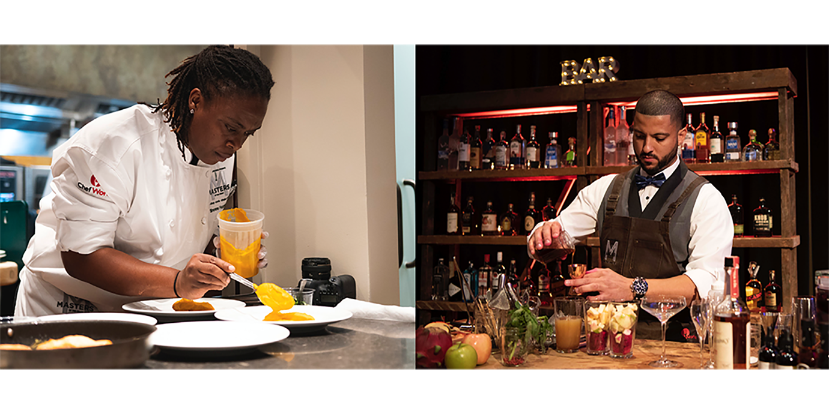
Tony Capuano, who took over when his predecessor Arne Sorenson died in February, stated that widespread layoffs have "rattled" workers' confidence in the travel and tourism industry, resulting in severe labour shortages.

Marriott International, the world's largest hotel operator, has approximately 10,000 vacancies across its 600 managed properties in the United States.
Marriott was forced to lay off tens of thousands of hotel employees and cut corporate employment by 17 percent in September of last year. Capuano, on the other hand, indicated that the company was now "actively and aggressively hiring," providing one-time incentives and bonuses, and focused on countries where demand had increasedMarriott owns and maintains over 7,300 properties worldwide. Executives throughout the industry have warned that labour shortages will force up wages as businesses battle for a limited supply of personnel. However, increasing salary alone, according to Dimitris Manikis, president of Wyndham Hotels Europe, Middle East, and Africa, would not entice staff to stay in the industry.

6th Blog

EMBRACE THE SEASON AND PLAN A SKI VACATION!
You can't go wrong with our fantastic – and ever-expanding – array of ski resorts from Colorado to California to Canada. Our hotels and resorts provide everything you need for a fantastic holiday, including beautiful mountain views, excellent accommodations, and outstanding dining and activities. Bring the whole family on a fun and adventurous ski holiday for less with Vacations by Marriott, and keep in mind that Vacations by Marriott is the only site where you can book a whole vacation with flights and earn Marriott BonvoyTM points!
One of the top destination for those who love to ski!
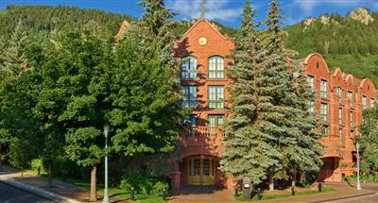

The St. Regis Aspen Resort
The St. Regis Aspen Resort is located at the base of Aspen Mountain, about a block away from the Cooper Avenue and Mill Street pedestrian malls, and two blocks away from the Silver Queen ski lift. The resort's Remède Spa provides massage therapy and body treatments for sore muscles, and the 179 guestrooms boast pillowtop mattresses, flat-screen TVs with DVD players, WiFi access for a fee, and nightly turndown service. The St. Regis Aspen Resort lies in the centre of the resort town, near the main gondola. After a hard day, the property's luxury spa and heated outdoor pool may draw you, but the in-room amenities may persuade you to snuggle into a plush robe, drink coffee, collapse into your pillow-top bed, or soak ski-weary muscles in the tub.

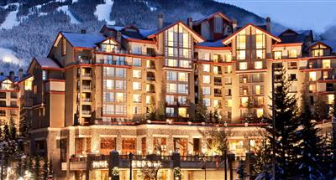

The Westin Resort & Spa, Whistler
WHISTLER, CANADA

The Westin Resort & Spa, Whistler is set slopeside, only minutes from the gondolas and the gorgeous Whistler Village, and offers travellers an unrivalled resort in Whistler, Canada. Our award-winning hotel has twice been named the #1 Ski Resort by Condé Nast Traveler. Enjoy a luxurious vacation in one of our 400 residentially styled rooms, which include facilities such as warming fireplaces, large soaking tubs, contemporary kitchenettes, and stunning mountain views. The Whistler Sliding Centre has previously hosted Olympic competitors, but it is now available to newcomers who wish to race down the track on a luge, bobsleigh, or skeleton.

7th Blog
Looking for some warm places for your holiday, here are some suggestions.

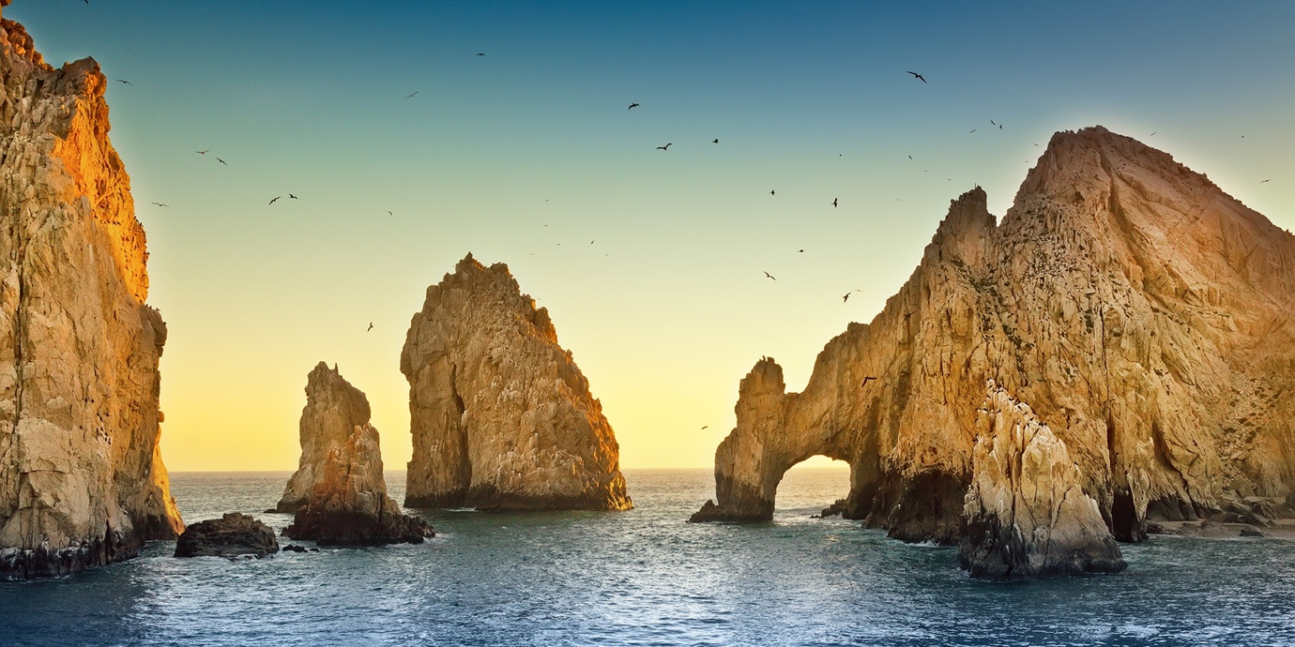

Cabo San Lucas, Mexico

Cabo San Lucas is a 2.5-hour trip from Los Angeles and offers both a convenient commute and unusual sights. While the 20-mile stretch between Cabo San Lucas and San Jose del Cabo is dotted with luxurious hotels where celebrities such as Jennifer Lopez, Cameron Diaz, and George Clooney have stayed.

If you're weary of laying on the beach, Wild Canyon ATVing will get your heart racing. With a personal guide and your own ATV, you'll ride through harsh desert landscapes and beaches that stretch all the way to the Sea of Cortez. Try Los Tres Gallos in town, an authentic Mexican restaurant off the beaten path of Cabo's strip that serves delicious pozole, mole enchiladas, and tamarind margaritas on an outdoor terrace.

Tenerife, Canary Islands, Spain
Beachgoers, take note: Tenerife, Spain's largest Canary Island, has 42 kilometres of gorgeous coastline (in black pebble and blonde varieties). The beaches of Alcala and Los Gigantes are two of the best on the island. Day trips to the crater-, volcano-, and petrified lava-filled environment of Teide National Park are also advised. Between exhilarating dives in the North Atlantic and travelling past the snow-capped heights of Mount Teide, sneak in a meal at the well-hidden Lucas Maes. Seasonal dishes such ravioli with chanterelles, truffles, and parmesan, as well as bluefin tuna wrapped in sweet potato puree, tomato chutney, soy and ginger vinaigrette, will be served in the restaurant's opulent surroundings.

Bibliography:
  - https://www.marriott.com/culture-and-values/core-values.mi
  - https://www.marriott.com/hotels/travel/jtrml-mystique-a-luxury-collection-hotel-santorini/
  - https://www.hospitalitynet.org/announcement/41005819/moxy-residence-inn-by-marriott-slough.html
  - https://whattoexpect.marriott.com/lonhw
  - https://www.ft.com/content/8acbe8d0-f1d0-4cb9-a15b-518a817455a4
  - https://www.vacationsbymarriott.com/travel-by-interest/ski-vacations
  - https://traveler.marriott.com/tips-and-trends/caught-winter-chill-check-11-warm-weather-getaways/

