Module: International Meetings Management for the Hotel Industry BMIH6007
Student: Anca Mihaela Marian
Student ID:2130340
Lecturer: Kathryn Flynn

TECHNOLOGY AND INNOVATION EVENT
VIRTUAL WELLNESS IN HOSPITALITY
LONDON
–
OLYMPIA EVENTS
INNOVATION AND TECHNOLOGY EVENT

VIRTUAL WELLNESS
The MICE industry includes a few factors such as meetings, incentives, conferences as well as exhibitions (tourismni, 2024).
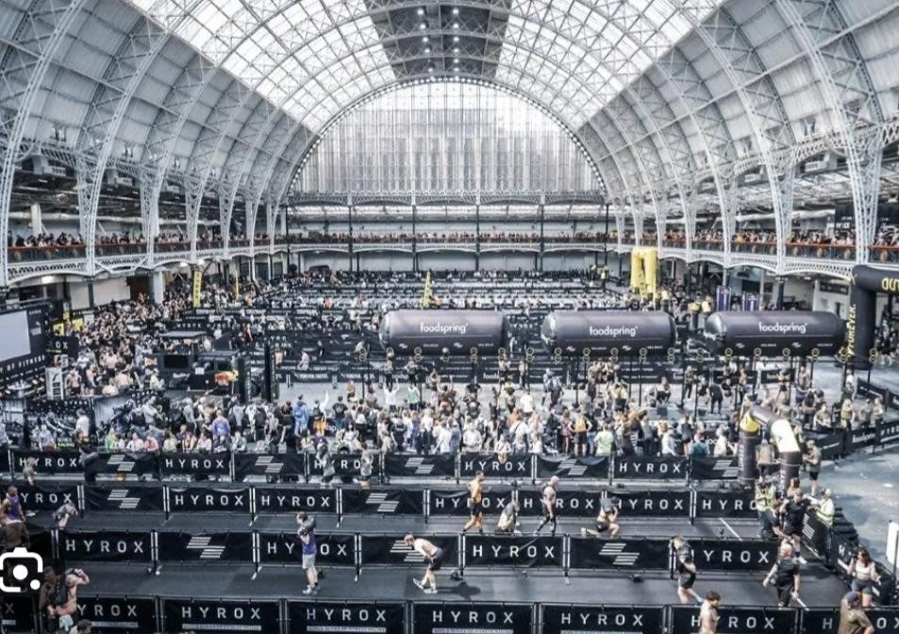
Annually the United Kingdom hosts a variety of events that not only garner significant media coverage but also bolster local economy. (Neves,2016)
The hospitality industry has reaped substantial benefits from advances in innovation and technology, dramatically enhancing both operational efficiency and customer
satisfaction. (Wolfe, 2023)
Integrating a virtual wellness system in the hospitality industry empowers hotels to offer personalised experiences and environmental adjustments thereby enhancing guest comfort, appealing to health-conscious guests and elevating industry standards in customer service and competition. (Karagiannis, 2024)
Anca Marian an enthusiast in wellbeing and fitness who works
within hospitality industry will present in London an event _{(Hyrox,2024)}
focused on Technology and Innovation in hospitality specifically discussing the role of virtual wellness.
The event is a social and managerial process by which individuals and groups will obtain what they need and want through creating and exchanging products and values with others. (Kotler et al 2008)

VIRTUAL WELLNESS
Wellbeing in hospitality industry is becoming increasingly popular (Global Wellness)
- Integrating Virtual Wellness in the hospitality marks a transformative approach.
- Hotels can personalise wellness offerings more effectively.
- Hotels can offer tailored services such as dietary recommendations, fitness programs and mental health support.
- AI systems can analyse past behaviour and patterns or current stress levels by wearable devices
- AI can facilitate real-time health monitoring and adjustments to guest environment - lightning, room temperature, scent and many more to optimise physical and emotional comfort

Market Factors
Technology and innovation can primarily offer virtually any blend of demographic, geographic or behaviouristic traits in the customer market (Ingram, 2024). Various market factors will be highlighted at the Innovation and Technology – Virtual Wellness Event at Olympia Events – London.
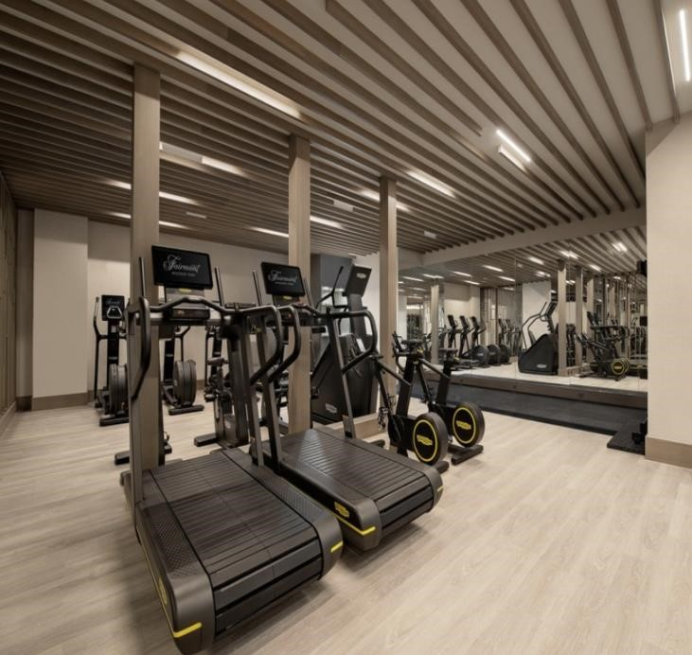
- Increasing demand for personalised experiences met by AI driven services (Levine, 2022)
- A significant shift in consumer behaviour towards wellness and health driving the demand for advanced technological solutions, particulary in facilitating virtual holistic wellness programs for health-conscious guests dedicated to maintaining their well-being while traveling (Escobar, 2024)
- Wellness orientated consumers that typically belong to middle upper-class demographics who prioritise experiences enhancing physical, mental and emotional health, or another key segment includes both business and leisure guests who seek wellness services focused on stress reduction and relaxation but also hotel guests interested in services that
promote self-development or improve physical condition. (PKF Hospitality, 2023)
(Sattar,2024)

Contd…
Currently, events of technology and innovation are driving success thoroughly even going far beyond that (Katz, 2021).
The demand for such events is growing as more people seek to integrate wellness into every aspect of their lives including leisure and travel. (Wellness Tourism, 2024)
This event enters a competitive landscape where traditional spas and wellness retreats have established strong footholds.
Additionally, tech companies or online and mobile apps offering virtual wellness pose competitions.

Operational Factors
Olympia Events can be considered as the venue where this event will take place as it is big enough to accommodate the attendee capacity. (bestvenues, 2024)
The location of the venue, the time of the year can significantly influence the attendees of the event which will take place after the Hyrox fitness race – on 8th May 2024 which means a possible increase in attendees than expected. The selected venue in central London is ideal for hosting large-scale events, offering ample space and being available on the required date without any scheduling conflicts.
Its strategic location in a major metropolitan area further supports logistical needs and accessibility, making it a top choice for significant gatherings that need both substantial capacity and specific timing

Contd…
Managing large-scale events requires a team with a broad range of skills, including organisational prowess for coordination and schedule management, clear communication abilities, technical knowledge of event-specific systems, and strong problem-solving capabilities to handle unforeseen issues. (Park and Jones, 2021).
Marketing also plays a pivotal role in the success of the event – and a dual approach that combines digital marketing tactics with traditional media outreach ensures extensive coverage and engagement with targeted consumers. (Novak, 2024)
Organising a technology and innovation event at London Olympia necessitates meticulous planning of essential resources such as catering services, adaptable lightning systems, sufficient parking facilities, and strategically arranged seating to ensure a seamless and engaging experience. (The home of inspirational events, 2024)
Hyrox’s full sponsorship of the event, following discussions with participant Anca, highlights their strategic commitment to promoting innovative wellness solutions in the hospitality industry.

SWOT ANALYSIS

Strengths
- Prestigious, central location at London Olympia with excellent transport links
- Innovative theme combining AI with wellness attracts a diverse audience of tech enthusiasts, health professionals, fitness lovers and the general public
- Potential to be a leader in the niche market by exploring new insights into health and fitness through virtual reality Weaknessess
- High costs associated with hosting an event at a renowned venue may exclude smaller stratups and independent developers
- Possible challenges in ensuring all attendees have the technical understanding necessary to fully engage with complex AI and wellness topics

Opportunities
- Partnering with major tech firms and health organisations could enhance credibility and attract media coverage
- Potential for creating ongoing collaborations or communities in hospitality focused on AI in wellness, extending the impact beyond the event
- Capitalising on increasing public interest in wellness through innovative technological approaches Threats
- Competition from other events focusing on similar themes could split potential audience
- Public scepticism about data privacy issues concerning AI may reduce participation among privacy-conscious individuals
- Sudden changes in regulatory frameworks regarding AI use in hospitality could affect content and engagement strategies.

PESTEL ANALYSIS
POLITICAL FACTORS
- Impact of UK’s regulatory environment on data protection and AI
- Potential effects of Brexit on international participation due to visa regulations and travel restrictions
ECONOMIC ASPECT
- Financial implications of hosting the event in London, including costs for venue hire and logistics
- Post pandemic economic conditions affecting sponsorships and attendance fees
SOCIAL ASPECT
- Increased public interest in health and technology integration
- Higher attendee expectations for health lifestyle form AI technologies showcased
TECHNOLOGICAL FACTORS
- Opportunity to display cutting-edge AI innovations attracting a tech-savy audience
- Enhancement of the event’s prestige through innovative technologies demonstrations
- ENVIRONMENTAL CONSIDERATIONS
- Implementation of sustainable practices like waste management and energy efficiency at Olympia
LEGAL ELEMENTS
- Compliance with local safety standards for events
- Adherence to intellectual property rights and GDPR for data handling

Financial Factors
Cash Income |  | Description | Amount
Lighting |  |  | £6800
Catering |  |  | £22,000
Land rent |  |  | £3,400
Parking Facilities |  |  | £5,200
Seating |  |  | £5000
Total: |  |  | £42400
Cash Expense |  |  | Amount
Stalls vendors (20-25) |  | Innovators and students | £40,000-£50,000 -(£2,000 per stall)
Visitor tickets (500-600) |  |  | £40,000 - £48,000 (per ticket  £80 )
Sponsorship |  | HYROX | £50,000
Mechandise (100-120) |  | Shirt, Cups, chocolates | 10000 – 12000  ( per merchandise bag 100)
Cross promotion of events (5-10) | other |  | £25,000 - £30,000 (per person  £5000 )
Total |  |  | £140,000 - £175,000
Profit |  |  | £97,600 -£132600

Conclusion
The above presentation was entirely based on the concept of a feasibility plan for an international meeting, and it has explained how the hospitality industry can be significantly transformed by the integration of advanced technologies.
The utilisation of artificial intelligence for personalising guest interactions allows hotels to offer customised services that enhance guest loyalty and increase revenue through targeted upselling.

References
- Escobar, M.C. (2024) 2024 Hospitality Revolution: Tech, sustainability, and personalization drive industry transformation, Hospitality Technology. Available at: https://hospitalitytech.com/2024-hospitality-revolution-techsustainability-and-personalization-drive-industry-transformation (Accessed: 04 May 2024).
- The home of inspirational events (2024) London Event & Exhibition Venue | Olympia Events. Available at: https://olympia.london/ (Accessed: 04 May 2024).
- Ingram, D. (2016) What target market does technology have?, Small Business - Chron.com. Available at: https://smallbusiness.chron.com/target-market-technology-have-13818.html (Accessed: 04 May 2024).
- Katz, M.L., (2021). Big Tech mergers: Innovation, competition for the market, and the acquisition of emerging competitors. Information Economics and Policy, 54,p.100883
- Karagiannis, M. (2024) Ai-driven wellness experiences for hotel guests, Medium. Available at:
https://medium.com/hotel-tech/ai-driven-wellness-experiences-for-hotel-guests-e38dc4f5f35a (Accessed: 04 May 2024).
 Levine, T. (2022) Council post: What does Today’s consumer want? personalized, seamless, omnichannel experiences, Forbes. Available at: https://www.forbes.com/sites/forbesbusinesscouncil/2022/03/11/what-does-todaysconsumer-want-personalized-seamless-omnichannel-experiences/?sh=195e4b221e1e (Accessed: 04 May 2024).
- Neves, M.F. (2016) Bowdin, G., allen, J., o’toole, W., harris, R., McDonnell, I. (2006). Events management., Academia.edu.available at:https://www.academia.edu/29403848/Bowdin_G_Allen_J_O_Toole_W_Harris_R_McDonnell_I_2006_Events_mana gement (Accessed: 05 May 2024).
- Novak, J. (2024) What is Digital Marketing? types, strategies & best practices, Forbes. Available at: https://www.forbes.com/advisor/business/what-is-digital-marketing/ (Accessed: 04 May 2024).

References
- Olympia (no date) London Tech Week 2024. Available at: https://londontechweek.com/venue (Accessed: 04 May 2024).
- Park, M. and Jones, T., (2021). Going virtual: The impact of Covid-19 on interships in tourism, events, and hospitality education. Journal of Hospitality &Tourism Education, 33(3),pp.176-193
- Sattar, J. (2024) The importance of wellness within the hotelier industry , The Importance of Wellness Within the Hotelier Industry . Available at: https://www.warmwelcomemagazine.com/healthandlifestyle/theimportance-of-wellness-within-the-hotelier-industry?format=amp (Accessed: 04 May 2024).
- The fitness competition for every body (2024) HYROX. Available at:https://hyrox.com/city/london/ (Accessed: 05 May 2024).
- The World of Wellness and Wellbeing in the Hospitality Industry: Articles & Publications: News (2023) PKF hospitality group. Available at: https://pkfhospitality.com/news/articles-publications/the-world-of-wellness-andwellbeing-in-the-hospitality-industry/ (Accessed: 04 May 2024).
- Wellness tourism (2024) Global Wellness Institute. Available at: https://globalwellnessinstitute.org/what-iswellness/what-is-wellness-tourism/ (Accessed: 04 May 2024).
- What is mice, business tourism or Business Events? (no date) Tourism NI - The Hub. Available at:
https://www.tourismni.com/business-guidance/sector/mice-travel-trade/mice-and-travel-trade-gettingstarted/what-is-
mice/#:~:text=MICE%20stands%20for%20Meetings%2C%20Incentives,Business%20Tourism%20or%20Busi ness%20Events (Accessed: 04 May 2024).
- Wolfe, A. (2023) Integration + digital engagement drive the hospitality industry’s transformation, Hospitality Technology. Available at: https://hospitalitytech.com/integration-digital-engagement-drive-hospitality-industrystransformation (Accessed: 04 May 2024).
- 2021 wellness tourism, spas, Thermal/Mineral Springs: The Global Wellness Economy: Looking beyond covid (2022) Global Wellness Institute. Available at: https://globalwellnessinstitute.org/wellness-tourism-spasmineral-thermal-springs-the-global-wellness-economy-looking-beyond-covid-2021/ (Accessed: 05 May 2024).

