University of Wales Trinity Saint David

Wales Institute of Science & Art



Analysis and Simulation of a Centrifugal Clutch
Stress Analysis and Dynamics (ACMA5010)

Joseph Carpanini
2211043
October 2024
Contents
2 Table of Figures ii
3 Introduction 1
4 Development of Centrifugal Friction Clutches 2
4.1 History 2
4.2 Design and Components 2
4.3 Choice of Materials 2
4.4 Typical Applications and Operating Conditions 3
4.5 Advantages of Centrifugal Clutches 3
5 Electromagnetic Clutches 4
6 Conclusion 5
7 Bibliography 6

Table of Figures

Figure 1 - (Crane, 2003) 2

Task A

Introduction
Clutch mechanisms in small motor equipment are essential for efficient power transmission and control. These systems enable the selective engagement and disengagement of power between the motor and driven components, ensuring smooth operation and enhanced performance.
In small motor applications, a variety of clutch types are utilized, each serving specific purposes. Centrifugal clutches, for example, automatically engage as engine speed increases, making them ideal for equipment like go-karts, lawnmowers, and chainsaws. Their simple design relies on centrifugal force to transmit power, offering a smooth transition from idle to operational speed without requiring manual intervention.
Another example is the permanent magnet bistable electromagnetic clutch, often used in in-wheel motor designs for electric vehicles (Yang & Gu, 2020). This clutch type provides a flexible connection between the motor and hub, reducing mechanical shock and electromagnetic interference, thereby enhancing overall system efficiency
In addition, innovative systems like the wedge-clutch-based actuation mechanism offer significant benefits by applying a large normal force on the clutch plates while requiring minimal motor torque (Yao et al., 2014). This self-reinforcement characteristic, while effective, requires careful control during engagement to ensure optimal driveline performance.
The evolution of centrifugal clutches has led to interesting developments and contradictions. While traditional designs relied on mechanical components, newer approaches have explored compliant mechanisms to reduce part count and increase manufacturability. For example, the floating-opposing-arm (FOA) centrifugal clutch consists of only two pieces yet performs all the functions of a centrifugal clutch (Crane et al., 2000). This design demonstrates a significant improvement in torque output compared to commercial one-piece compliant designs, showcasing the potential for simpler, more efficient clutches (Crane et al., 2004; Howell et al., 2001).

Development of Centrifugal Friction Clutches

History
The development process of centrifugal clutches has involved various advancements and innovations over time: Centrifugal clutches have evolved from traditional designs to more sophisticated and efficient models. Early designs included pivoted or expanding shoe clutches and dry plate clutches, which were commonly used in automotive transmissions (Tridgell, 1969). These designs allowed for automatic take-up and disengagement when changing gears, independent of rotational speed. Researchers have developed numerical models and simulation techniques to analyse and optimize centrifugal clutch performance. For instance, a model based on moment equilibrium and contact mechanics was created to estimate rotational speed, output torque, and contact pressure during clutch operation (Liu & Chiang, 2016). This approach reduces the need for physical prototypes and experimental costs. Interesting developments include the introduction of compliant centrifugal clutches, which offer cost and weight advantages in sensitive applications. The floating opposing arm (FOA) clutch design demonstrated high torque capacity compared to other configurations (Crane et al., 2004; Howell et al., 2001). This innovative design uses aggressive and non-aggressive contact surfaces in connected pairs to achieve high torque carrying capability while maintaining smooth starting and stability (Crane et al., 2000).

Design and Components
Centrifugal clutches are composed of a few key elements, including a clutch drum, friction shoes, and springs. At low engine speeds, the springs hold the shoes inside the drum. As the engine accelerates, centrifugal force pushes the shoes outward to make contact with the drum, transmitting torque. This simple mechanism is valued for its ease of use and minimal maintenance (BLM Automatic Clutch, 2024). The diagram of a typical centrifugal clutch highlights how centrifugal force allows the shoes to expand, engaging the clutch smoothly and efficiently (How Stuff Works, 2024).
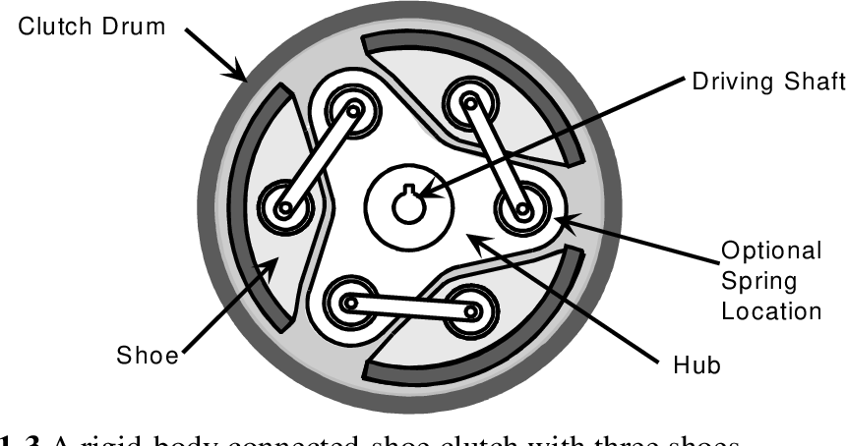
Figure 1 - (Crane, 2003)

Choice of Materials
Material selection for centrifugal clutches is critical to ensure durability and efficient operation. The shoes are often made from high-friction materials, such as carbon composites or steel alloys, to withstand constant engagement and disengagement cycles. The clutch drum, typically constructed from hardened steel or aluminium alloys, is designed to endure the friction and rotational forces generated during operation. These material choices enhance performance by ensuring that the clutch can endure varying operating conditions without premature wear or failure (Diaphragm Direct, 2016).

Typical Applications and Operating Conditions
Centrifugal clutches are primarily used in equipment that requires smooth and automatic engagement, such as chainsaws, go-karts, and lawnmowers. They excel in applications where automatic engagement and gradual power transfer are necessary. Common operating conditions include fluctuating temperatures, frequent stops and starts, and variable load conditions. To ensure longevity, some systems may integrate cooling mechanisms to manage the heat generated from friction during prolonged use (How Stuff Works, 2024). While centrifugal clutches have limitations in high-torque environments due to potential slippage, they remain widely used due to their simplicity and effectiveness in many small-scale motor applications (BLM Automatic Clutch, 2024).

Advantages of Centrifugal Clutches
Additionally, centrifugal clutches enhance safety by disengaging the driven shaft when the speed drops below a certain threshold, preventing accidental movement or overloading. This characteristic makes them ideal for small engines, such as those in go-karts, mopeds, and lawn equipment, where automatic engagement and disengagement at specific speeds improve performance and ease of use. Furthermore, the simplicity of centrifugal clutches contributes to lower maintenance requirements and a longer operational lifespan, as they have fewer moving parts than more complex clutch systems. (Testbook, 2023a)

Electromagnetic Clutches
Electromagnetic clutches are widely applied in modern automation systems within manufacturing processes due to their ability to rapidly and precisely control the engagement and disengagement of power transmission without physical contact. These clutches utilize electromagnetic fields to initiate engagement, allowing instantaneous and smooth transitions, essential in high-speed production environments. In applications such as conveyor systems, robotics, and assembly lines, electromagnetic clutches enhance efficiency by ensuring accurate timing and control over mechanical movements, minimizing downtime and optimizing synchronization across different stages of production (AspiringYouths, 2024).
One major application is in robotic arms, where precise control over gripping and rotational movements is essential. Electromagnetic clutches provide the necessary accuracy and quick response time for repetitive tasks that require consistent and reliable operation, improving the quality and speed of production (Martin, Steinberger, and Horn, 2014). Additionally, in high-speed machining and CNC (Computer Numerical Control) equipment, electromagnetic clutches allow for rapid tool changes and spindle control, which is critical for maintaining tight tolerances and high production rates. Furthermore, in automated packaging systems, these clutches enable precise stopping and starting actions to ensure that each product is positioned correctly, reducing errors and waste (Testbook, 2023b).
The contact-free nature of electromagnetic clutches also minimizes wear and tear, enhancing longevity and reducing the need for frequent maintenance, which is highly beneficial in reducing operational costs and extending the uptime of automated equipment (Hassan and Baghayipour, 2021). As automation technology advances, the role of electromagnetic clutches in manufacturing is likely to expand, offering new possibilities for increased production flexibility, speed, and reliability.

Conclusion
In conclusion, clutch mechanisms are essential in optimizing power transmission and control in various motor-driven and automated applications. Centrifugal clutches, known for their automatic engagement as engine speed increases, provide smooth operation, safety, and minimal maintenance, making them ideal for small engines in applications like chainsaws and go-karts. Recent innovations, such as the floating opposing arm (FOA) clutch, have simplified the design while enhancing torque capacity, demonstrating the potential for efficient, durable clutch mechanisms in small motor systems.
Electromagnetic clutches, with their contact-free operation and rapid response, are widely used in high-precision automation settings like robotics, CNC machinery, and packaging systems. Their ability to precisely control power engagement without physical wear significantly improves production accuracy and equipment lifespan. These clutches enhance productivity by ensuring seamless synchronization in high-speed manufacturing processes.
As technology advances, both centrifugal and electromagnetic clutches are poised to evolve further, meeting growing demands for efficient and reliable power transmission. By refining designs to improve durability, reduce maintenance, and boost performance, these mechanisms will continue to play a crucial role in enhancing the versatility and efficiency of small engines and automated systems alike.

Task B
- Given Data:
- Mass of each shoe, ms​=275g=0.275kg
- Spring stiffness k=7.5kN/m=7500N/m
- Coefficient of friction μ=0.35 (for the first scenario)
- Radius of the centre of mass of each shoe, r=95mm=0.095m
- Clearance to the outer drum 9mm=0.009m
- Wall thickness of the drum 4mm=0.004m

- What is the diameter of the outer drum?

Rdrum ​= 0.095 + 0.009 + (0.004 / 2) ​= 0.106m

Now, the diameter of the drum is:

Ddrum​ = 2 × 0.106 = 0.212m = 21.2cm

The diameter of the outer drum is 21.2 cm.

- Determine the engagement speed of the centrifugal clutch in RPM

Fspring​=7500×0.009=67.5N

Fcentrifugal​ = Fspring​
Fcentrifugal = 67.5

ω^2 = 67.5 / (m*r)​ = 67.5 / (0.275*0.095) = 2589.32
√2589.32 = 50.88 rad/s

RPM = 50.88 * (60/2π) = 485 RPM

The engagement speed of the centrifugal clutch is approximately 485 RPM.

- Calculate the radial force acting on the clutch face when the driving shaft is rotating at 550 RPM
First, convert the rotational speed to angular velocity ω\omegaω in radians per second:

ω=(2π×550) / 60 ​= 57.92rad/s

Now, calculate the centrifugal force Fc on one shoe:

Fc ​= 0.275 × 0.095 × 3354.24 = 86.87N

The radial force on one shoe is approximately 86.87 N. For all four shoes, the total radial force will be:

Ftotal​ = 4×0.35×86.87=121.62N

- Determine the torque transmitted to the driven shaft at 550 RPM

T= 121.62 × 0.095 = 11.55Nm

The torque transmitted at 550 RPM is 11.55 Nm.

- Calculate and plot the transmitted torque against driving shaft speed from 450 RPM to 700 RPM in increments of 25 RPM
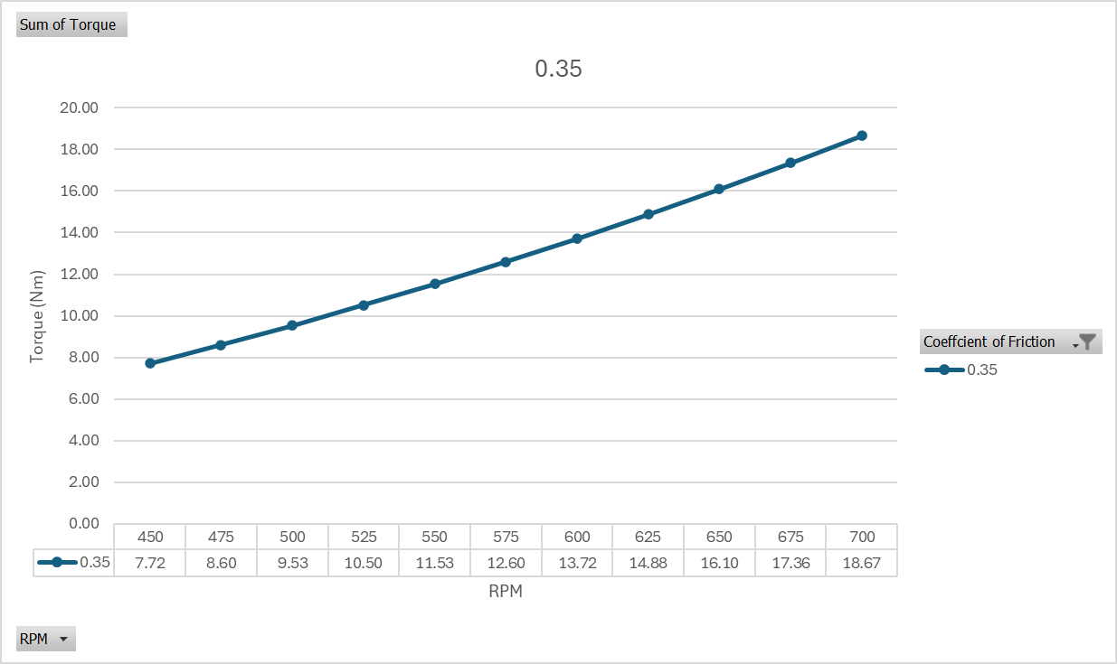

- Undertake the same analysis as in point 5 above but adopt a coefficient of friction of 0.3 and 0.4. Discuss the effect of changing the coefficient of friction of the shoe material on the torque transmitted when comparing the three values of coefficient of friction
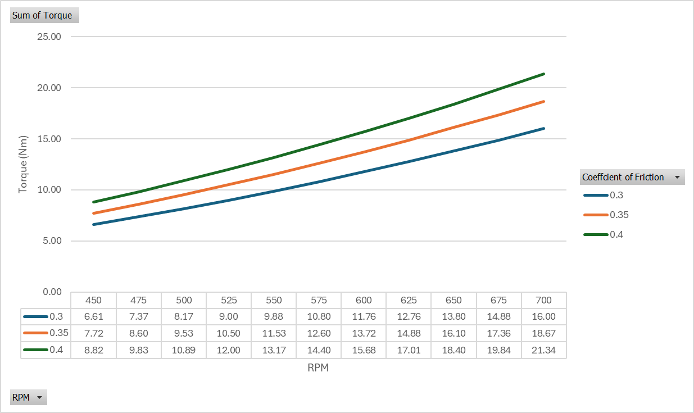
By comparing the three friction coefficients:

Increasing the coefficient of friction from 0.3 to 0.4 results in progressively higher torque transmitted at each RPM.
A higher friction coefficient means more torque at the same RPM, enabling stronger and possibly earlier engagement.
However, increasing μ could lead to faster wear of the shoe material and drum, so a balance must be struck based on the clutch’s performance requirements and durability considerations.
In conclusion, adjusting μ allows control over the clutch's engagement characteristics and torque output, with higher coefficients providing more torque but potentially at the cost of increased wear.

- For the maximum possible transmitted torque determined from either point 5 or 6 above, and given that the mass of the drum is 750 grams and can be considered as a solid disc, what is the angular acceleration of the drum to achieve the maximum possible torque?

Given Data
- Maximum transmitted torque: Tmax​ = 21.34 Nm
- Mass of the drum mdrum = 750 g = 0.75 kg
- Radius of the drum (calculated in question 1) Rdrum = 0.106m

Inertia = 21​ × 0.75kg × (0.106m)^2 = 0.00421 KGm^2

Angular Acceleration = 21.34 / 0.00421 ​= 5069.12 rad/s^2

The angular acceleration of the drum to achieve the maximum possible torque of 21.34 Nm is approximately 5069 rad/s^2.

- If the driven shaft had a diameter of 17.5 mm and a constant tangential braking force of 500 N was applied to the driven shaft, determine the maximum possible angular acceleration for the drum as given in point 7 above.

Given data
Tangential braking force, Fbrake​ = 500N
Diameter of the driven shaft, dshaft = 17.5mm = 0.0175m
Maximum transmitted torque (from question 7), Tmax=21.34 Nm
Moment of inertia of the drum I = 0.00421 kgm^2

Rshaft ​= 0.0175 / 2 ​=0.00875m
Tbrake = 500 × 0.00875 = 4.375 Nm

Tnet​ = 21.34 − 4.375 = 16.965Nm

Α = 16.965​ / 0.00421 = 4029.22 rad/s^2

The maximum possible angular acceleration of the drum, considering the braking force, is approximately 4029 rad/s².

Bibliography
AspiringYouths. (2024). Advantages and Disadvantages of Electromagnetic Clutch. [online] Available at: https://aspiringyouths.com/advantages-disadvantages/electromagnetic-clutch/ [Accessed 9 Nov. 2024].
BLM Automatic Clutch, 2024. The How and Why of Centrifugal Clutches. [online] Available at: https://www.centrifugalclutches.com.
Crane, N.B. (2003). Compliant Centrifugal Clutches: Design, Analysis, and Testing.
Crane, N.B., Howell, L.L., Magleby, S.P. and Weight, B.L. 2004. Compliant Floating-Opposing-Arm (FOA) Centrifugal Clutch. Journal of Mechanical Design 126(1), pp. 169–177. doi: 10.1115/1.1639378.
Diaphragm Direct, 2016. Centrifugal Clutches: How They Work. [online] Available at: https://www.diaphragmdirect.com/blogs/how-centrifugal-clutches-work.
Hassan, Mohammadi, Pirouz., Mohammadreza, Baghayipour. (2021). 2. Design and Analysis of a New Electrically Controllable Brushless Eddy-Current Clutch. Available from: 10.1109/ICEE52715.2021.9544501.
Howell, L.L., Crane, N.B. and Weight, B.L. 2001. Investigation of Compliant Centrifugal Clutch Designs. American Society of Mechanical Engineers. doi: 10.1115/detc2001/dac-21071.
How Stuff Works, 2024. How Centrifugal Clutches Are Used in Small Engines. [online] Available at: https://www.howstuffworks.com/centrifugal-clutches-engines.
Liu, C.H. and Chiang, Y.P. 2016. Analysis of the Sliding Contact Behavior of a Centrifugal Clutch. Key Engineering Materials 715, pp. 231–236. doi: 10.4028/www.scientific.net/kem.715.231.
Martin, Kirchengast., Martin, Steinberger., Martin, Horn. (2014). 4. Modeling and feedback linearization based control of an electromagnetic clutch actuator. Available from: 10.1109/CCA.2014.6981329.
Testbook. (2023a). Centrifugal Clutch- Diagram, Working, Advantages and Applications. [online] Available at: https://testbook.com/mechanical-engineering/centrifugal-clutch.
Testbook. (2023b). Electromagnetic Clutch: Diagram, Working, Advantages, and Uses. [online] Available at: https://testbook.com/mechanical-engineering/electromagnetic-clutch.
Tridgell, C.W. 1969. Paper 3. Centrifugal Clutches for Automotive Use. Proceedings of the Institution of Mechanical Engineers, Conference Proceedings 184(9), pp. 60–77. doi: 10.1243/pime_conf_1969_184_280_02.
Yang, F. and Gu, C. 2020. Power Supply System Design and Dynamic Analysis of a Permanent Magnet Bistable Electromagnetic Clutch for Wheel Motor Drive. IEEE Access 8, pp. 218161–218169. doi: 10.1109/access.2020.3041896.
Yao, J., Yin, C., Liu, F. and Chen, L. 2014. Experimental study on improvement in the shift quality for an automatic transmission using a motor-driven wedge clutch. Proceedings of the Institution of Mechanical Engineers, Part D: Journal of Automobile Engineering 228(6), pp. 663–673. doi: 10.1177/0954407013514397.

