

LOCATION: Swansea | LLEOLIAD: abertawe
LEVEL 4 | LEFEL 4
EXAMINATION PERIOD | CYFNOD ARHOLIADAU
January 2024 | 2024

MoCK EXAMINATION- Question PAPer

MODULE CODE: ACDA4006
Electrical and Electronic Principles

TIME: 2 HOURS
Maximum Marks : 100
answer Any 4 questions

Equipment or materials required – Calculator, Graph sheet,
Adnoddau neu ddefnyddiau sydd eu hangen - Cyfrifiannell

ANSWER ANY 4 QUESTIONS

Question 1 [25 Marks]
- For the circuit shown in fig:1 below,
- Calculate the total circuit resistance ( R_{T} ). [3 marks]
- Calculate the supply current ( I_{s}) [2 marks]
- Calculate the total power dissipated. [2 marks]
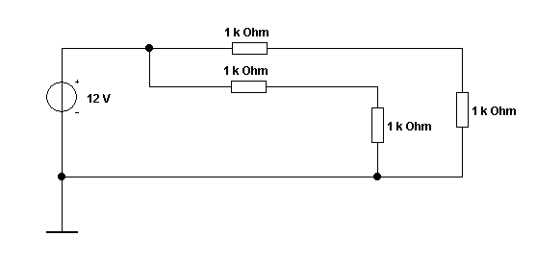
Fig:1
- An indicator light requires a $330Ω$ resistor to limit current. The voltage across the current limiting resistor is 3V. What is current flowing through the resistor? Also, calculate how the current change if a $200Ω$ resistor is used instead? [4 Marks]
- An oscilloscope display shows the below voltage waveform. The oscilloscope settings are shown in the box next to the waveform.
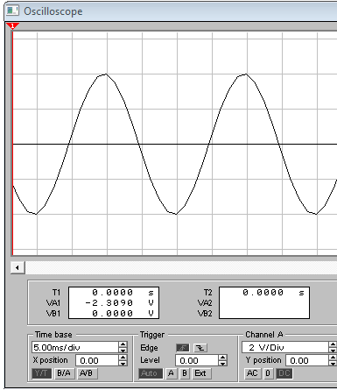
Oscilloscope settings:
2V/div
10ms/div

Fig:2
- Estimate the period of the waveform. [1 mark]
- From the estimated period, determine its frequency. [2 marks]
- Determine its peak-peak amplitude [2 marks]
- Determine the r.m.s. value of the waveform. [2 marks]

- Design an equivalent circuit with a single current source, for the circuit shown in fig.3, [3 Marks]
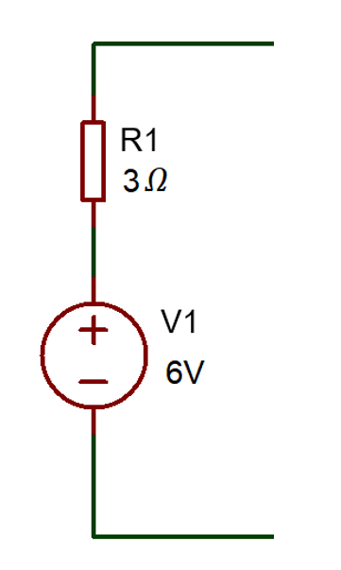
Fig: 3
- Differentiate Step- up Transformer and Step-Down Transformer (minimum of two differences) [4 Marks]
Question 2 [25 Marks]
- For the circuit shown in Fig. 4, calculate:
  - The total resistance. [3 Marks]
  - The total current if the battery voltage was 12V [2 Marks]
  - The total power dissipated by the circuit [2 Marks]
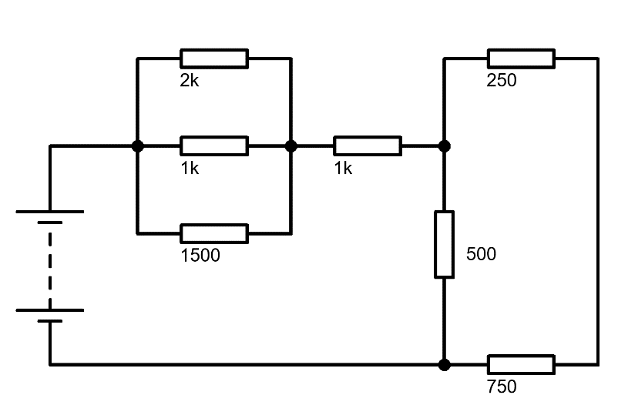
Fig: 4
- Three resistors ($R_{A} R_{B} and R_{c})$are connected in series to a 250V Voltage Source. Where, $R_{c}=50Ω, V_{B}=80V and$Total current = 2A. Calculate the following
- Voltage across $R_{A}$ [2 Marks]
- Voltage across $R_{C}$ [2 Marks]
- Resistance value of $R_{A}$ and $R_{B}$ [4 Marks]
- Explain the following terms:
- Resistance [2 Marks]
- Reactance [2 Marks]
- Impedance [2 Marks]
- List any four types of Transistors. [4 marks]
Question 3 [25 Marks]
- A certain power supply requires 25W of input power and produces an output power of 20W. Calculate its efficiency in percentage and the total power loss? [4 Marks]
- Determine the voltage across each resistor in the circuit shown in fig.5. [4 Marks]
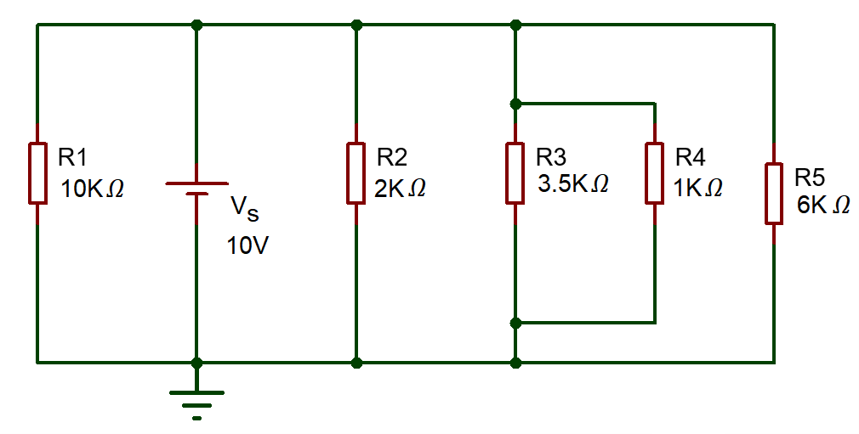
Fig.5
- Determine the current across each resistor in the circuit shown in fig.6, using mesh analysis (Kirchhoff’s Voltage Law) [17 Marks]
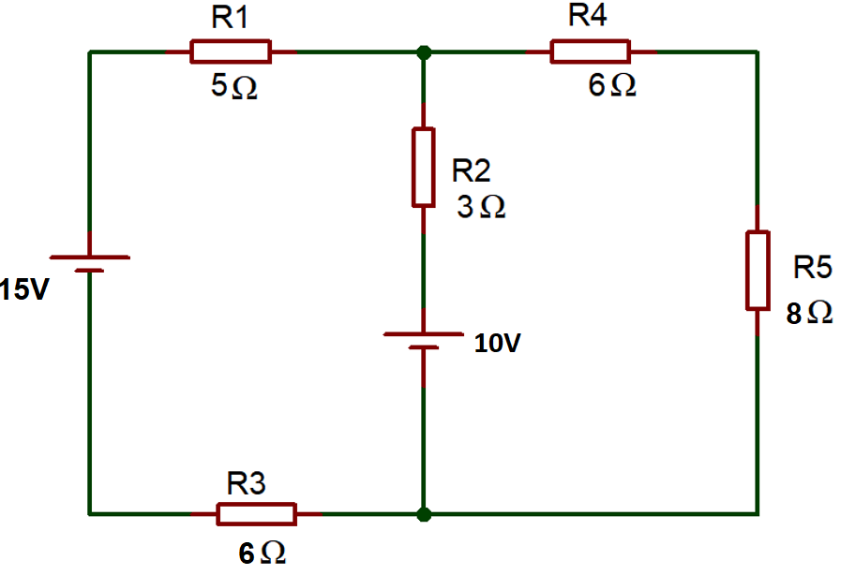
Fig.6
Question 4 [25 Marks]
- The alternating current is given by $i=40 sin314t$. Determine the following
- Maximum Value of current [1 Mark]
- RMS Value of Current [2 Marks]
- Frequency [2 Marks]
- What is the use of the circuit shown in fig.7? Describe the functions of each stage of the circuit with the necessary diagrams. [12 marks]
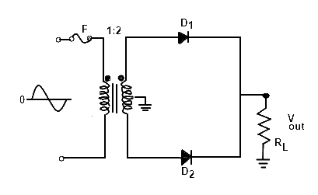
Fig.7
- For the circuit shown in fig 8:
- Calculate the total impedance [2 Marks]
- Calculate the circuit current and phase angle [3 Marks]
- Calculate the voltage drop across the resistor [1 Mark]
- Calculate the voltage drop across the inductor [1 Mark]
- Calculate the voltage drop across the capacitor [1 Mark]
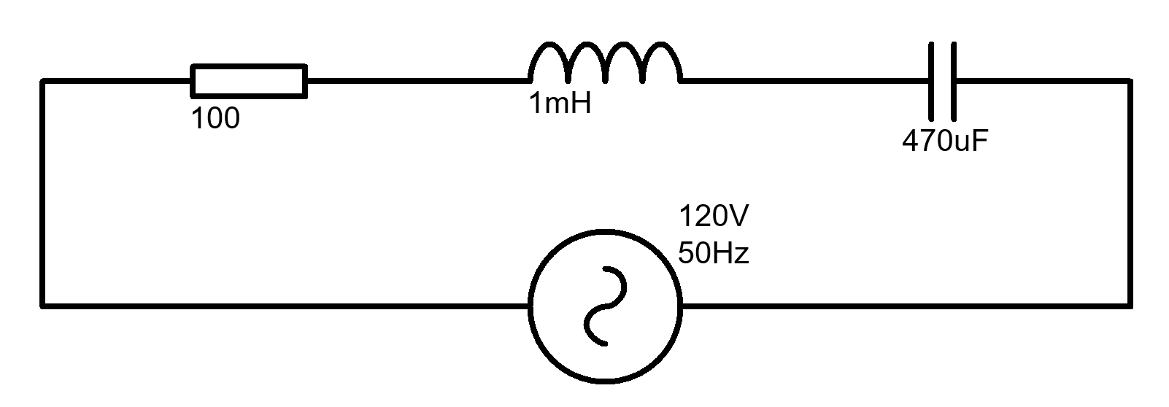
Fig.8
Question 5 [25 Marks]
- Describe the construction and working of PN Junction diode with the aid of necessary diagrams. [10 Marks]
- A 10 V Battery has an internal Resistance of 10Ω, Calculate the power dissipated by various load resistances given in the below table and complete the table. [10 Marks]
Load Resistance (Ω) | Load power (W)
5
10
15
20
25
- Plot a graph of the load Power against the load resistance,. [5 Marks]

Diwedd/End

