The appeal of creatures
Introduction
The purpose of this dissertation is to explore the design process for creatures within film and video games. The main focus being creatures based within the horror, fantasy and science fiction genres. Asking the question “What design features are addressed in practice making horror creatures appealing?” this is to help aid artists with their design of creatures and how adding meaning and certain aspects mainly being to appeal to the psychology of the viewer can help to capture the attention of their audience. To answer this research will be taken place to analyse methods of creature design. To begin with the attention will be on defining what a creature is and early examples of them within entertainment this will include literature and artists designs and representations within relevant mediums.
The word “creature” can be used to describe an imaginary or fantastical being. The focus for the dissertation will be more on villainous and hostile creatures, an example of popular creatures would be vampires (Dracula) beasts (King Kong) and monsters (Frankenstein’s monster).
The art of designing an appealing creature which captures the audience is a complex process and requires skill and attention to detail. There are many factors and thought process that must go into to design such as does the creature work within the world it is in, is it relatable and can the audience connect on an emotional level? A creature can be appealing in multiple ways, some tap into our more morbid side by being grotesque and horrifying in appearance, other may trigger our more emotional side by being able to relate and almost sympathize with it whether it be on a physical or emotional level.
Creatures have been a staple with film and gaming for many years dating as far back as the early 1900’s with the first being an early representation of Mary Shelley’s novel of Frankenstein’s monster titled Frankenstein. In 1910 there was a short film created by J. Searle Sawley where the design of Frankenstein was first portrayed on film with an accurate representation of the description taken from the novel. Frankenstein’s monster went on to become one of the icons of movie creatures within the monster genre.
So why do we find these creatures appealing? What draws us in to their twisted visuals and potentially dark intentions? Why would something that would typically be considered repulsive could also be considered attractive? What do they mean?
Before looking into what makes creatures appealing first the process of creating a creature will be explored to gain a further understanding as to what goes into creating a creature and what factors can be implemented to further amplify the appeal.
Creature Design
A creature can have a great impact in film and gaming and can sometimes play an incredibly important role within the story. The design of creature can also have a large impact on the audience perceive the story as a whole. During the design phase of creatures many aspects need to be considered such as whether it fits with the story being told and the character and personality given to it. Below are quotes by Professional creature’s designers Ken Barthelmey who worked on such films as the Maze Runner and Godzilla and Terryl Whitlatch who worked on the Star Wars movies as well as Men in Black.
“If you design a creature too 'cool' or fantastical, it will look unbelievable and silly. And vice versa. If you make a design too realistic, it will look boring. In order to make a good design I think it's important to have a good taste of realism and imagination. I love seeing an actual anatomy in a design, even if it's mechanical. Using reference photos from real animals is always a great help to accomplish that”. (Barthelmey, 2019)
As Barthelmey states above he includes this in his own work as seen in this design. This design presents real anatomy inspired by dogs even though the creature is otherworldly. This gives familiarity to the audience by resembling a common pet, this allows the audience to connect with the creature.
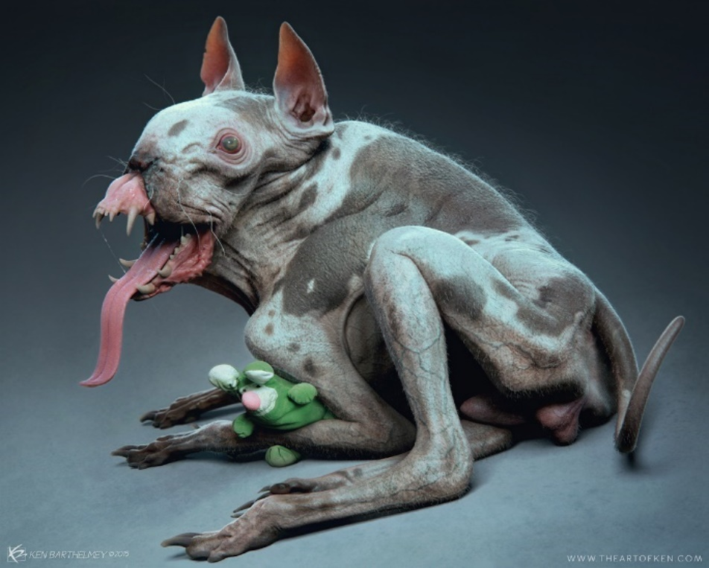

(Barthelmey, 2015)
Lots of people think they can just draw monsters out of thin air,” Whitlatch explained. “But any animal, imaginary or real, has to have some basis in reality. The more you know about anatomy, the more you know about the animal. If you can do animals, you can do any kind of creature.” She estimated 95% of her creatures are based at least in part on real animals. (Whitlatch, 2019)
Anatomy and realism are mentioned in both of these quotes, taking them into account, its important that when creating a creature, the anatomy does work especially in the eyes of the audience to add realism to it and make them believe that this could be real.
The process of creature design involved multiple stages that work like building blocks starting from very rough basic sketches finishing with a polished image. To begin with the creator must gain an understanding of the story and the role in which the creature needs to fill. Once the creator has an idea the next stage will be to gather references to help get a feel for the theme of what the creature will be, usually a mood board will be created which will contain a compilation of references of various designs and references. The next step will be creating the thumbnails. Thumbnails are small rough drawings that act as a kind of prototype which a creator can produce many of in a short amount of time to help with create ideas and variety and to get a sense of the shape of the creature. After producing thumbnails, the creator will then choose out of the selection the ones they deem suitable and start to refine them, this can be by strengthen the silhouette checking if there is believable anatomy. The next step would be to create variants of these refined designs to see what works best with the creature and which design could be considered the most appealing. After the most suitable one again is selected the design can be finalised in the form of concept art. Throughout these stages careful consideration needs to be taken in the creature. Does it fit the story and setting? Does it give off the desired impact.
In the context of horror what could be considered the main purpose of the creature is to invoke fear within the audience and to be dangerous in nature. This can be achieved through many means like incorporating a common phobia into the design or a physical trait which could cause us harm such as sharp teeth. An example of a strong creature design would be Pennywise the Clown from Stephen Kings IT. The design of pennywise can instantly produce a fear response from the audience especially those who suffer with a phobia to clowns. Pennywise also presents himself as an arachnid like being which also preys on arachnophobia, a common phobia among people.
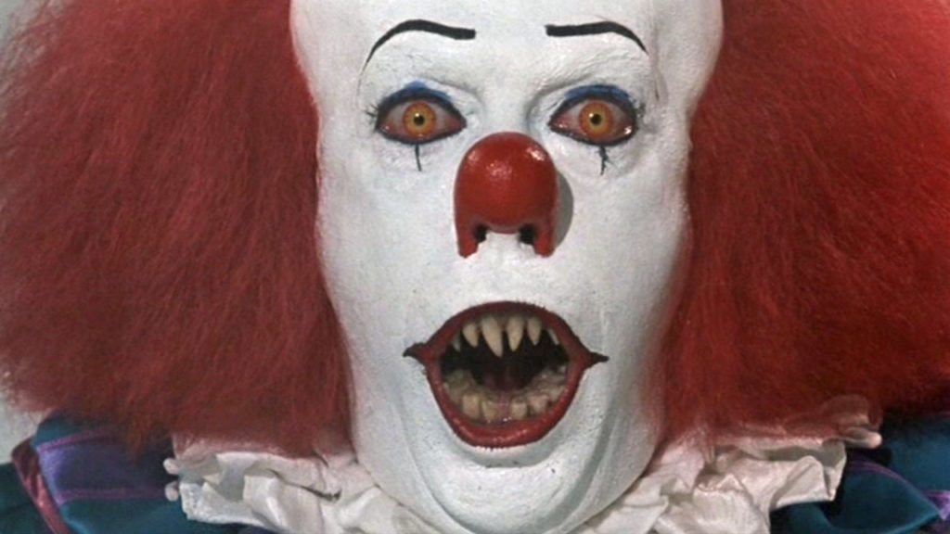
(Pennywise, 2019)
The creature can be targeted at a certain audience via their own culture and folklore, such as within Asian countries like China and Japan their folklore is based heavily around ghosts and spirits many are malicious in nature. Films like Ringu (The Ring) and Ju On (The Grudge) are well known films which use Asian superstition and culture to their advantage.
But what makes a creature design strong? According to Juho Lahti’s Thesis “Designing and animating a horror creature a good creature design” A creature should be able to indicate its story through its own appearance, this will invoke interest in the audience. This can be through physical traits or maybe an item on the creature which symbolises something from its past or former self.
Relatability
The appeal of relatability is linked to a psychological response primarily being empathy. This is where the person has the ability to put themselves in another’s perspective and situation. This can invoke an emotional response such as sympathy.
A key factor to make a strong creature design is relatability, and if the audience can connect or maybe put themselves in the creatures position. An example would be the creatures portrayed within the highly successful game Dead Space. Dead Space is a disturbing Sci-Fi horror game which contains a plethora of twisted and disturbing monsters. These are known as the Necromorphs which were humans that have been mutated due to a dark force that effecting both their physical and mental state, but despite their extreme transformation they still retain some physical human aspects.
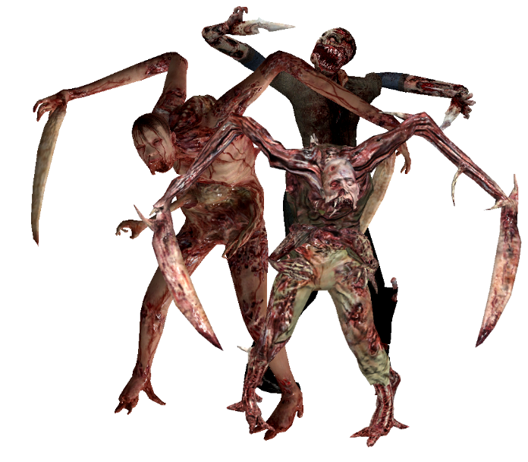
(Slasherimage, 2019)
Though they were horrifying in appearance, through all of the mess of bones and gore in their design there was one key factor, relatability. An interview with the designer of the Necromorphs Ben Wanat expresses that the creatures should be relatable in the sense that you can imagine the horrible transformations happening to yourself and the ones around you in an attempt to elicit fear within the player.
“The goal wasn’t to create things that were gross, but it was important players feel revulsion,” Dead Space 3’s ex-creative director Ben Wanat told me. “It was important that there was something chilling about them – enough glimmer of their former human self that you could fear the same thing happening to you.” (Wanat, 2018)
The protagonist of the game Isaac Clark is thrown into this isolated and hostile environment and witnesses the horror, bringing forth a reaction of fear in both the character and the player as Isaac is helplessly confronted by Necromorphs. Though you empathise with Isaac starting off as an everyday working man going to work, he is quickly thrown into an unexpected situation and we the player are able to witness and experience through playing what he is going through. Even though we can somewhat empathize with Isaac who is being mercilessly pursued and attacked by these terrifying creatures we can also empathize with the creatures as we can see that they were once human and can only imagine the torment that they are experiencing. They convey distress and pain through physical attributes and emotion for example before transforming they will be screaming in agony and pain and begging for it to stop before viciously deformed leaving little trace of their own person. The transformations could connect with People who have experienced trauma such as a broken limb or some form of body disfigurement, for example someone who has broken or dislocated a bone could find great discomfort but as well empathy for the characters enduring such a transformation which involves limbs to snap and protrude out of the body. Whilst creating the Necromorphs for first Dead Space game the design team stated that:
"We looked at human anatomy, the bones, sinews, organs, et cetera, and tried to think how they might be rearranged into something horrific. The more we made them look like normal people who went through something terrible, the deeper the emotional impact." (Magazine et al., 2019)
Yet even though these horrible things occur upon the characters within the game the audience are still drawn to them and still proceed to delve deeper into the world of Dead Space.
Many creatures like the Necromorphs and another example being zombies also rely on what is referred to as ‘Body horror’ to produce a response from the audience. “Mutations and Metamorphoses: Body Horror is Biological horror” by Ronald Allan Lopez Cruz states “that body horror refers to the manipulation and warping of the normal state of bodily form and function”. (Cruz. R, 2012) A prime example of body horror is the creature within John Carpenter’s “The Thing” (1987). The creature within The Thing is an alien which replicates its host by the process of assimilation. The alien lacks no visible true physical form that the audience see the but instead relies on taking the form of its host. This process is highly graphic with no regard for the potential host. Though the alien is not human it maintains throughout the film primarily a human like appearance. The transformations cause a similar response to the Necromorphs from Dead Space by seeing a person’s body snap and deform.
Zombies often referres to the undead, a person who has been resurrected. The zombie within games and films can have taken many forms over the years from slow moving decayed corpses seen in Night of the living dead to fast moving humans commonly referred to as infected such as the ones seen within the film 28 Days Later. The origin behind the zombie is caused mainly by a virus or infection in modern cinema. Though zombies have been in media for years popularity spiked with the series The Walking Dead. Since then there has been increase in zombies in pop culture spawning multiple films and series.
The zombie taps into so many areas whether it be from physical disgust and violent to even a commentary on today’s society and fears. The physical traits of a zombie typically fall under the category of body horror. Most depiction of them are that of decayed humans with heavy deformities to their flesh caused by the origin usually being a virus or infection.
Though the physical aspects of the common depiction of zombies is similar to that of say the Necromorphs, the representation of what the zombie’s can stand for within their story can spark great interest within the viewer. Director George A. Romero created of the famous Dead trilogy used the zombies within each of his films as a form of social commentary relevant to the time. His most famous film and a landmark in horror is Night of the Living Dead (1968) which defined the zombie genre. Form first glance this movie seems like what we would consider today as a typical zombie film, everyday people trying to survive against a horde of zombies whilst hiding in a location which will be their ultimate undoing. But if you look past that you can see that this film sociological commentary on the state of the world at that time. From paranoia and fear as well as the involvement with the Vietnam war to how people responded to race. Dawn of the Dead (1978) was the second film within the trilogy and was where using the zombies as social commentary was really noticeable. The setting for Dawn of the Dead was a shopping mall, and this was to really get across the point of the main theme of the film consumerism. The film follows four survivors that seek refuge in a shopping mall taking place after Night of the Living Dead. The film uses zombies to represent consumerism and materialist gratification as they mindlessly drawn back to the mall. A character within the film backs this up by stating “it’s not us they are after, it’s the place. They remember they want to be here”. At first glance the zombies could be considered the centrepiece of these movies but once you look deeper you can see that he implements certain behaviours within his creatures as a form of statement of culture which can connect with the audience especially audience members from the era that films are set in. a provoking thought is how these themes based in the dead series still remain today.
Tying into relatability would be the theory of uncanny valley. The uncanny valley theory is a feeling that we receive whilst looking at something humanoid but has features similar to ours but not quite realistic. This theory is prominent with androids and robots which are created to look human and are designed to look at realistic as possible, but we can instinctually tell that something is wrong. This can be shown in the form of an abnormal body feature such as disproportionately large eyes. This can invoke discomfort and revulsion within the audience.
Morbid curiosity
How can morbid curiosity be applied to creature design and appeal? Could a grotesque and morbid design draw out the audience’s curiosity?
Morbid curiosity can is usually can be loosely defined as our need to pursue and explore morbid media such as imagery or footage with the main theme being centred around death and violence but also themes containing natural threat such as predatory animals and social such as images of war. In the research article Choosing the negative: A behavioural demonstration of morbid Curiosity by Suzanne Oosterwijk describes it as a phenomenon where highly intense negative information causes curiosity within a person. This article explores morbid curiosity via controlled testing with the main focus being on a person’s behaviour. The general context of the testing carried out was to see what content the audience through imagery chose to view. The theme of the imagery ranged from highly negative to neutral and positive. The results from the test showed that negative imagery especially ones showing negative visuals in a social context were the most chosen and that a majority of the people tested deliberately subjected themselves to negative stimuli. It has also been theorised that people show a level of fascination and interest when presented with dark visuals compared to more pleasant ones.
As stated within the journal article “Must interesting things be pleasant? A test of competing appraisal structures” by Turner Jr. Samuel A and Silvia Paul Jr, an experiment was taken place to which imagery invoked more interest from the audience. Below is a passage taken from the article regarding their findings through the testing.
Within-person analyses found that (a) interest and pleasantness were essentially unrelated; (b) appraised novelty- complexity positively predicted interest, but negatively predicted pleasantness; and (c) disturbing pictures were highly interesting but unpleasant, whereas calming pictures were highly pleasant but uninteresting. The results thus strongly suggest that interesting things needn't be pleasant. Implications for in vivo (versus retrospective) tests of competing appraisal predictions are considered. (Turner S. Silvia P. 2006)
From the research and information gathered from the articles above, a link can be found between morbid, dark imagery and the audience, where being presented with morbid stimuli and more positive stimuli the audience was more likely to choose and show more interest in the morbid stimuli.
This information can be used in the process of designing creatures especially creatures designed for the horror genre as the appearance and physical traits can be used to elicit a response of fascination and interest within the viewer. Relating back to the studies, creatures that present visual gore or act in a violent manner could capture more of an audience’s interest and fascination compared to those that do not.
A passage from the article “Choosing the negative: A behavioural demonstration of morbid curiosity” reports that:
the urge to inform oneself about the details of a negative social situation may not only be driven by an information-seeking motivation, but potentially also by a motivation to experience empathy or sympathy for the people portrayed in the images (see for a similar point [50, 61]). Indeed, some studies on empathy have used stimuli with similar content as the negative social images used in the present studies (e.g., [37, 38, 62]). Moreover, people may experience a sense of moral responsibility to inform oneself about the reality of other people’s suffering [63]. The question how different motivations to empathize might influence people’s choice to expose themselves to the negative experiences of others is an important avenue for future research (see also [64]). (Suzanne Oosterwijk, 2017)
The passage above also states about empathising with the people portrayed within the image, this can be linked back to relatability and how we try and empathise with real people as well fictional such the previous mentioned creatures within games.
Instinct
Creatures having traits of predatory animals such as sharp teeth and claws which could resemble animals that are potential threats to humans. This would trigger an instinctual and sub conscious response of fight or flight within the body creating a surge of adrenaline with gives the viewer a rush. This can depend on the preferences of the viewer cause the viewer pleasure.
A socio-biologist E.O Wilson writes in Richard Ellis’ book: ‘Monsters of the Sea’:
“We are not just afraid of predators, we are transfixed by them, prone to weave stories and fables and chatter endlessly about them, because fascination creates preparedness, and preparedness- survival. In a deeply tribal sense- we love our monsters.” (Ellis, 2006)

An example of an iconic creature which preyed on our instinct and sub conscious would be the shark from the movie Jaws. Jaws was a book created by Peter Benchley and created for film by Steven Spielberg. The film is about a larger than average great white shark which preys on a small seaside town during the peak of the summer where there are many tourists. Jaws is an excellent example of how a relatively simple creature design can be made far more provoking to the audience due to the use of setting, atmosphere and similar to Pennywise the Clown using the audience’s phobias against them.
The shark within the film is designed after the great white shark but doesn’t rely so much on the visuals of the shark but more the atmosphere, environment and by concealing the shark until later into the film. This plays on our fear of the unknown by not revealing the shark but also our instincts towards the predatory animal with the great white being the apex predator of the sea. Jaws was so successful playing on the phobias and instincts of people that it created phobias that caused people to be fearful of water as they thought a shark would in the body of water.
Symbolism
Symbolism is a factor that can be found throughout many creature designs. This can be portrayed visually through physical attributes of the creature. Two example creators which are well known for use of heavy symbolism within their creature’s design are Team Silents lead creature designer Masahiro Ito who is responsible for the monster within the Silent Hill franchise and director and film maker Guillermo Del Toro who has created many well received movies such as Pan’s Labyrinth.

Symbolism within creatures can be a powerful tool that helps to define a creature with the use of certain traits that may indicate a trait about the creature; for example, a creature’s head may be shaped in a certain way to tell a story or to give information about it. An example of this is shown through the design of king Balor from the Hellboy franchise. The creature’s head is shaped in away to resemble a crown. Though the creature may not be wearing one, the head shape can indicate the presence of one which can symbolise royalty. Symbolism can be found throughout the designs of Del Toro’s creatures an example being the Pale Man from Pan’s Labyrinth.

(Guillermo Del Toro: 'I love monsters the way people worship holy images')

“The Pale Man, a demon with his eyes in the palms of his hands, is as terrifying in real life as he is in the movie. Only here you can casually study his ashen complexion and loose, sagging flesh (inspired by Del Toro’s own struggles with weight loss), without fear of reprisal”. (Del Toro, 2016)
As stated, the Pale man represents features such as the sagging skin with have symbolic meaning behind them, the skin being a result of weight loss which can cause sagging skin. This symbolism can help connect with the audience who have endured and experience this result.
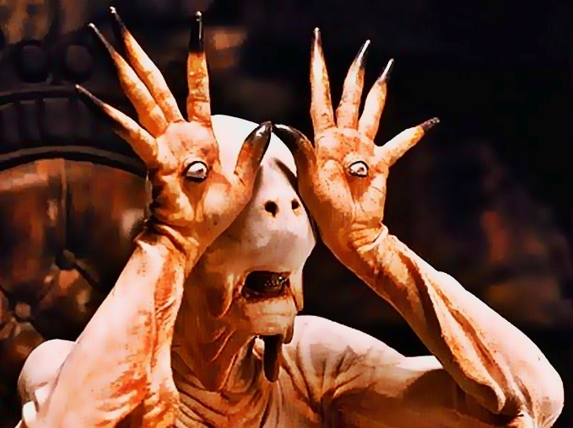
(TheScaryPaleManHD, 2019)
The Silent hill franchise has spawned many iconic creatures over their years of production with some being regarded as some of the most iconic in gaming. the creatures within the games are all well known for the symbolism that they portray, and the meanings behind them are usually the main focus for discussion for the fans. In Silent Hill you play as several different characters who are unwilling brought into the world of Silent Hill. Within this world they encounter creatures and twisted locations which all have personal meanings and represent something to that specific character.

There was large emphasis on the monsters within silent hill containing human aspects which were then deformed to make them more disturbing. Arguably one of the most iconic video games monsters was from Silent Hill 2 known as the Pyramid Head.

In the Game Silent Hill 2 you play a James Sunderland who is a man grieving over his deceased wife. Though the game implies that she died through terminal illness she was in fact killed by James who suffocated her with a pillow. Years later James receives a letter from his dead wife telling him to go to the town Silent hill. Within the town lies various creatures all symbolic to various aspects of James and his emotions. The creature design with the game really catches the attention of the players as the story unfolds you can relate them all to James. Referring back to the Pyramid Head, this was manifested to serve as James’s punisher for James guilt and desire to be punished over killing his wife but also, his darker side and emotions.
Visually the Pyramid Head is a large hulking male figure with a large red metal Pyramid covering his whole head. The most distinguishing feature being the pyramid represents an executioner’s hood but also the sharp points and angles suggest pain. The actions of the monster are to symbolic and relate to the main character, the monster twitches and jerks symbolising. Throughout the game James finds this monster killing other feminine monsters which symbolises the killing of his wife. The symbolism behind the monster caused great fascination from the audience both visually and through character as there are so many hidden meanings behind monster.
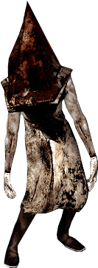
(PH Render.PNG, 2019)

Another popular monster present throughout Silent Hill 2 is the nurses. The nurses represent the characters anxiety and sexual frustration within James whilst his wife was in hospital. This is shown through the design of the nurse with their overall design aiming to be highly sexualised feminine figure wearing low cut revealing clothing. There were also hidden subtleties within the design such as a face of young child moulded into the nurses twisted face representing the child they will never have. This subtle feature can hit hard emotionally with same players who have gone through the same trauma

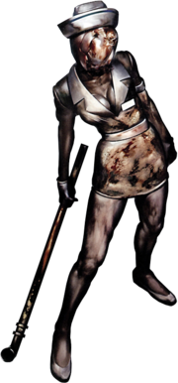
(Hellooo_Nurse!, 2019)
The use of symbolism portrayed through Masahiro Ito’s and Guillermo Del Toro’s monsters can greatly amplify the fascination and connection with the creatures.
Conclusion
The purpose of this dissertation was to explore and gain a better understanding of the thoughts and process that goes into designing and making a creature more appealing to the audience in the context of horror. The reason for this is to help with future creators of creatures by detailing aspects and themes to improve the overall design. Research into the creations of various well known and successful creature designers such as Guillermo Del Toro and Masahiro Ito were explored to gain a professional and experienced view and their own personal approach to the design process, this is to help creator take their own creatures to the next level. First the idea of creature design and its process was explored by looking into the overall process to familiarise the reader as well as a quote by two professional detailing what they feel are important aspects to consider and the theme of making the creature realistic by having believable anatomy. After researching into the to process its was very clear that use of psychology within the creatures played a crucial role whether it be triggering emotions or invoking fear in the audience to symbolism and meaning behind the design.
Relatability was a very prominent factor throughout the research to be considered with the idea that if a creature’s design resembles something human the audience can connect better with the creature through empathy. The example used was within the game Dead Space, the creatures within the game were physically pushed to the limits of human anatomy and visually grotesque but still showed some form of humanity which allowed the player to almost empathise with the creatures on a subconscious level with the feeling of I don’t want that to happen not me be invoked or relating to people who have experienced similar trauma to the creature an example being if the creature poses a broken limb someone can relate to experience. The idea of relatability can be seen throughout film and game history by the use of social commentary, applying meaning to a creature visually or personality wise can help the audience relate. The example used was the Night of the living Dead and Dawn of the dead by George Romero who used the creatures (Zombies) within his film as social commentary relating to the era.
The theory of morbid curiosity tied so much of the research together. Morbid curiosity was described as our need to view things that are deemed morbid ranging from natural threats such as dangerous animals and violent and macabre such as footage of death. Tests were carried to examine what topic ranging from negative to positive was likely to be viewed this was carried out by subjects choosing the imagery containing these themes that wanted to view or watch. Viewing of negative imagery mainly those containing social commentary or harm inflicted on a person were chosen producing a heighten sense of fascination within the subject. The final results amplified the idea of relatability with the subjects being more prone to view images containing negative social commentary and people in danger or who have been harmed. This was due to the subjects empathising with the people within the imagery.
Research was then done on our own primal instinct to explore how we react to things we perceive as threats and how a creature’s design can be used to invoke these instincts. The example used was the movie Jaws where the antagonist was a large great white shark which instantly triggered the audience’s primal response to a predator as well as large bodies of water. For designing creatures adding in threatening features such as sharp teeth and claws can produce and instinctual response from the viewer to be cautious of the creature.
The final topic covered was the use of symbolism behind creatures to peak interest and fascination from the viewer. The workings of Masahiro Ito and Guillermo Del Toro were used here as their creature designs are covered in symbolism. Del Toro’s pans labyrinth contained a monster known as the pale man which had symbolism woven into its physical attributes such as sagging skin resembling weight loss. Masahiro Ito created the monsters within the Silent hill games with all monsters being heavily symbolic and relating to a personal experience or problem that the character controlled by the player has gone through. The idea of keeping the creature human was applied to the creatures designed by both creators to once again help the audience relate and connect to the creatures creating an emotional response.
Throughout the topics researched the most common factor for designing creatures was relatability. All of the topic covered lead back to the audience being able to relate and empathise with the creature causing an emotional response and triggering our need to view negative imagery. By keeping a creature design grounded in reality and recognisable as human in some way as well as making it somewhat believable will create a greater response from the audience thus improving the design and reception of a monster.

Bibliography

Websites

Barthelmey, K. (2019). The Art of Ken Barthelmey - Creature Designer / Concept Artist / Illustrator. [online] Theartofken.com. Available at: https://theartofken.com/about-me [Accessed 25 Jan. 2019].

Power, T. (2019). Dead Space's Creator on Designing One of Gaming's Most Terrifying Enemies. [online] GameRevolution. Available at: https://www.gamerevolution.com/features/443251-dead-space-creative-director-necromorph-design#SdlQog74xeSHDAeS.99 [Accessed 25 Jan. 2019].

Magazine, W., Magazine, W., Horne, L., Allain, R., Muncy, J., Marshall, A., Gonzalez, R. and Lapowsky, I. (2019). Dead Space Game Designers Explore Some Really Gross Anatomy. [online] WIRED. Available at: https://www.wired.com/2010/12/pl-games-deadspace2-gallery/ [Accessed 25 Jan. 2019].

Riefe, J. (2019). Guillermo del Toro: 'I love monsters the way people worship holy images'. [online] the Guardian. Available at: https://www.theguardian.com/film/2016/aug/03/guillermo-del-toro-bleak-house-home-lacma-exhibit [Accessed 25 Jan. 2019].

Kaye, D. (2019). Firsts: the first film appearances of 10 classic monsters. [online] SYFY WIRE. Available at: https://www.syfy.com/syfywire/firsts-the-first-film-appearances-of-10-classic-monsters [Accessed 25 Jan. 2019].

Community.wacom.com. (2019). [online] Available at: https://community.wacom.com/inspiration/blog/2015/february/tips-on-getting-started-designing-creatures [Accessed 25 Jan. 2019].

Skillshare. (2019). Character Concept Art: From Initial Sketch to Final Design | Charlie Bowater | Skillshare. [online] Available at: https://www.skillshare.com/classes/Character-Concept-Art-From-Initial-Sketch-to-Final-Design/1310245862/project-guide [Accessed 25 Jan. 2019].

Silent Hill Wiki. (2019). Pyramid Head. [online] Available at: https://silenthill.fandom.com/wiki/Pyramid_Head [Accessed 25 Jan. 2019].

Articles
Loutzenhiser, S. (2019). THE DECAY OF MONSTERS: HORROR MOVIES THROUGHOUT HISTORY.
Loutzenhiser, S. (2019). [online] Scholarsbank.uoregon.edu. Available at: https://scholarsbank.uoregon.edu/xmlui/bitstream/handle/1794/20323/FINAL%20Thesis-Loutzenhiser.pdf?sequence=1&isAllowed=y [Accessed 25 Jan. 2019].
Oosterwijk, S. (2017). Choosing the negative: A behavioral demonstration of morbid curiosity. PLOS ONE, [online] 12(7), p.e0178399. Available at: https://journals.plos.org/plosone/article?id=10.1371/journal.pone.0178399.
Turner, S. and Silvia, P. (2006). Must interesting things be pleasant? A test of competing appraisal structures. Emotion, [online] 6(4), pp.670-674. Available at: https://psycnet.apa.org/doiLanding?doi=10.1037%2F1528-3542.6.4.670.
Curmi, A. (2005). [online] Sharkmans-world.eu. Available at: http://sharkmans-world.eu/research/lexi_thesis.pdf [Accessed 25 Jan. 2019].
Seyama, J. and Nagayama, R. (2007). The Uncanny Valley: Effect of Realism on the Impression of Artificial Human Faces. Presence: Teleoperators and Virtual Environments, [online] 16(4), pp.337-351. Available at: https://www.mitpressjournals.org/doi/abs/10.1162/pres.16.4.337.
Cruz, R. (2012). Mutations and Metamorphoses: Body Horror is Biological Horror. Journal of Popular Film and Television, [online] 40(4), pp.160-168. Available at: https://www.researchgate.net/publication/235990959_Mutations_and_Metamorphoses_Body_Horror_is_Biological_Horror.
Lahti, J. (2019). [online] Theseus.fi. Available at: https://www.theseus.fi/bitstream/handle/10024/149881/Lahti_Juho.pdf?sequence=1&isAllowed=y [Accessed 25 Jan.2019].
Sheldon, M. (2019). [online] Classicartfilms.com. Available at: http://www.classicartfilms.com/academicpapers/Historical-Cultural-Sociological-Themes-Zombie-Film.pdf [Accessed 25 Jan. 2019].

Books

Price, S. (2019). The Horror Film. [online] Google Books. Available at: https://books.google.co.uk/books?hl=en&lr=&id=a0ZgaAcKJ9sC&oi=fnd&pg=PA242&dq=Appeal+of+frankenstein&ots=d2fLKWcw2Q&sig=obvaQfZRFAKFnQIhIP10-lLurLU#v=onepage&q=Appeal%20of%20frankenstein&f=false [Accessed 25 Jan.2019].
Toro, G. (2013). Cabinet of curiosities. New York, NY.: Harper Design, pp.195, 197, 221.

Ellis, R. (2006). Monsters of the sea. Guilford, Conn.: Lyons Press.

Videos

YouTube. (2011). Making of Silent Hill 2 - HQ. [online] Available at: https://www.youtube.com/watch?v=E1VKvED76WQ [Accessed 25 Jan. 2019].

Images

PH Render.PNG. (2019). [image] Available at: https://silenthill.fandom.com/wiki/File:PH_render.png [Accessed 25 Jan. 2019].

Hellooo_Nurse!. (2019). [image] Available at: https://silenthill.fandom.com/wiki/File:Hellooo_nurse!.png [Accessed 25 Jan. 2019].

TheScaryPaleManHD. (2019). [image] Available at: https://villains.fandom.com/wiki/File:TheScaryPaleManHD.jpg [Accessed 25 Jan. 2019].

Slasherimage. (2019). [image] Available at: https://deadspace.fandom.com/wiki/File:Slasherimage.png [Accessed 25 Jan. 2019].

Pennywise. (2019). [image] Available at: https://horrorfreaknews.com/no-thats-not-tim-currys-real-hair-disproving-popular-myth [Accessed 25 Jan. 2019].
Barthelmey, K. (2015). PUPPY. [image] Available at: https://theartofken.com/gallery/creatures-12 [Accessed 25 Jan. 2019].

