Time to wake up: the justification of the global UN reform

The United Nations (UN) began to work, replacing the League of Nations on October 24, 1945. It was called the greatest hope for future peace because the UN was created primarily to support international peace and security. But in 2020, several nations are still reeling from wars and conflicts, and that is raising questions about the organization's effectiveness. Even though the UN remains the last resort in several issues, the most global challenges of our time suffer from unresolved issues. That is why it is time to discuss the global reform of the UN.

This policy brief is devoted to the main arguments and directions for reforming the UN to increase the effectiveness of the organization's response to modern challenges related to the security situation in the world.

Why the UN needs to be reformed: main arguments

1. From the beginning of its establishment, the United Nations was based on the realities of the world order that prevailed in the world at the time of the creation of this institution. Accordingly, the goals and functions of the organization, which were declared during the creation of the UN, corresponded to the then realities of the time – the world after World War II. Thus, a situation arises when the institution exists longer than the circumstances that necessitated its creation. Attempts to adapt the mechanisms of implementing changes to the challenges of modern times face such obstacles as the obsolescence of the organization's mechanisms and the inflexibility of its structures. The UN is not adapted to the post-truth era, hybrid wars, or any other large-scale wars outside of NATO countries.

2. The organizational structure of the UN and certain methods of its work are also subject to criticism. In general, the following are noted among the most common shortcomings. The General Assembly has lost it`s often unable to focus effectively on the most important issues on the agenda; the Commission on Human Rights suffers from a lack of legitimacy, which in particular negatively affects the general reputation of the UN; it is necessary to create a more professional and better-organized Secretariat, capable of coordinated actions as much as possible; the Security Council needs more authority, legitimacy and representation, etc. [8].

3. During the whole time of the work of the UN, the organization did not reach a high level of coordination with regional organizations. The lack of effective coordination with independent organizations in different countries has led in a global sense to a misunderstanding of the motivation and logic of the actions of one or another country, which is a consequence of a misunderstanding of the culture, history and characteristics of specific countries. In a more applied sense, this shortcoming is shown during the conduct of peacekeeping operations, the inconsistency of their actions and even the competition between regional influence groups and UN forces. [6]

4. Many researchers identify UN financing as one of the institution's main problems. Thus, the independence of the organization's initiatives is quite vulnerable due to the large difference in the amount of "assessed contributions" and their voluntary contributions to specific programs such as UNICEF. [6].

5. A related problem is the use of the right to veto by UN member states in the UN Security Council. The founders of the UN in the distant started from the hypothesis that no country that is a member of the Security Council will parasitize on the rights given to it. However, since 2014 (the annexation of the Crimean peninsula), the Russian Federation has refuted this hypothesis. Precisely because of the abuse of the rights granted by the UN, today we have the following situation: the smaller the amount of the state's annual contribution to various UN programs, the higher the frequency of using the right to veto in the Security Council. For example, since 1992, as of May 2022, Russia/USSR has used its veto 121 times, the US 82 times, the UK 29 times, China 17 times, and France 16 times. [4]

"From 1946 to 2022, the USSR, and then Russia, used the right to veto about 120 times. This is about the same as the right to veto used by all other permanent members of the UN Security Council. It is this right that is the blocking mechanism of collective security that led to complete paralysis of the UN", - said the former ambassador of Ukraine to the UN, diplomat Volodymyr Yelchenko. [10]

UN budget contributions by country, 2019 [7]
The visualization by howmach.net

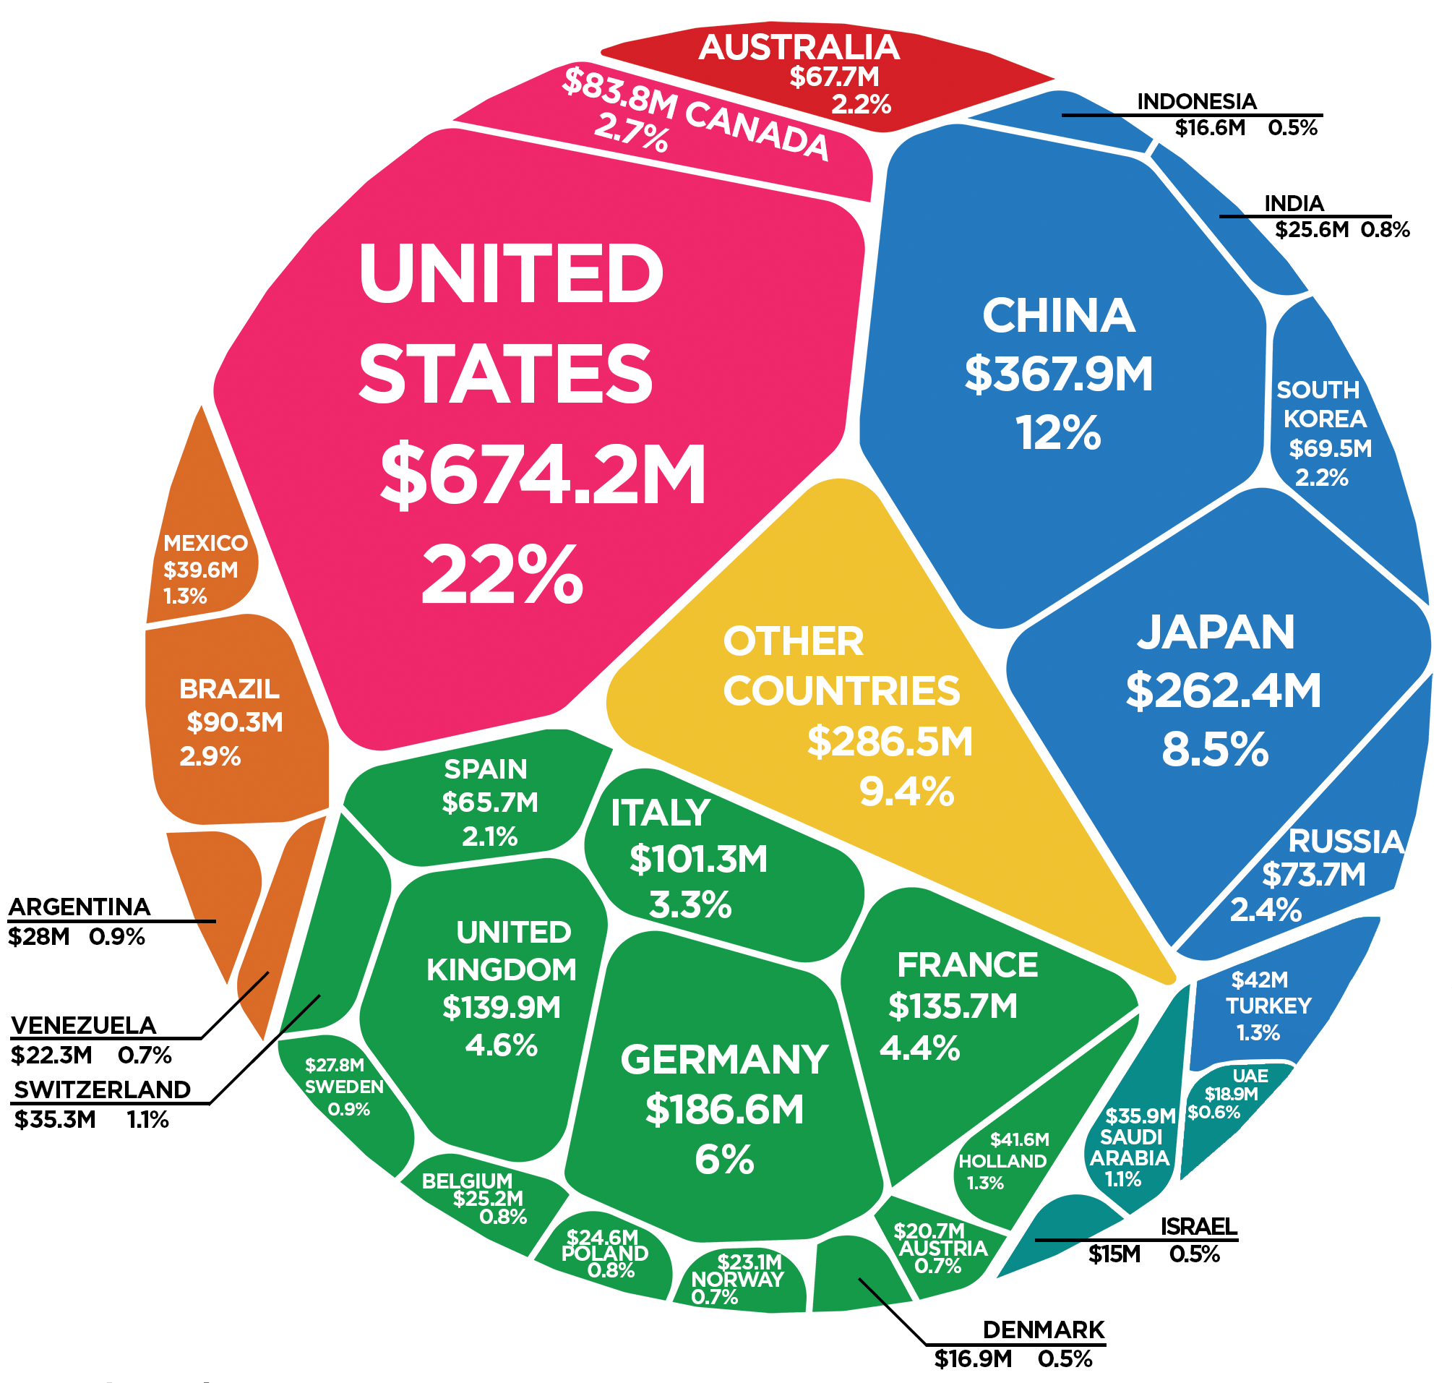

How to reform the UN: specific proposals

"We are faced with a dilemma:
which principles prevail - the protection of humanity (intervention)
or the protection of sovereignty and
territorial integrity (non-intervention)?" [1]

Kofi Annan, the seventh UN Secretary-General

The global reform of the UN should concern the structure of the organization, the decision-making mechanism, the institutional hierarchy within and the functions of the organization. Taking into account the problems mentioned above, we propose to divide the spheres of reforming the UN into 3 blocks, which indicate the most important directions of reforming the institution to improve the functioning of the UN in all spheres, and in particular - security issues.

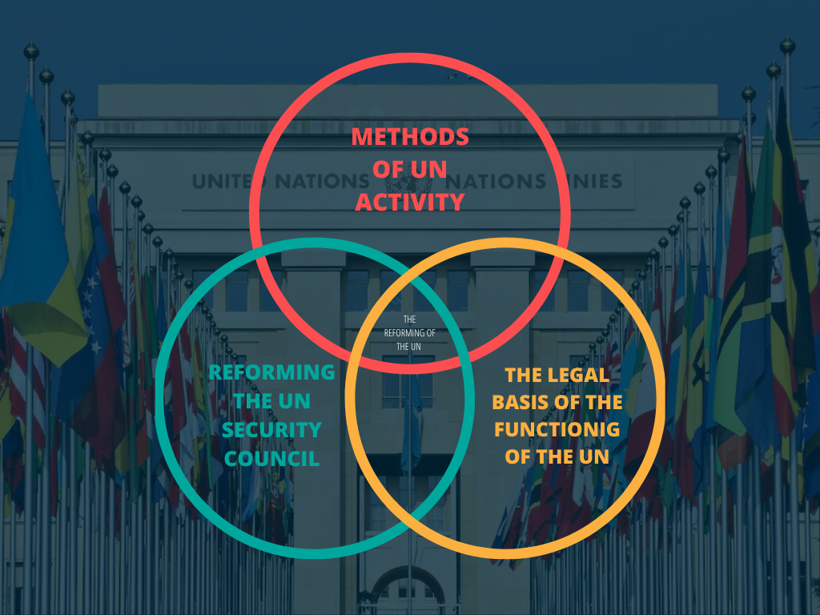

- Methods of UN activities

Cooperation with regional organizations (state or NGO)

As already mentioned above, the UN should review the network of its cooperation with representative organizations of other countries. These organizations can perform the function of observers of the organization's activities; would provide an opportunity to deepen the cooperation of specific countries with the UN in various fields: security, economic, humanitarian, environmental, etc.; could perform an educational function regarding the peculiarities of specific countries, their culture, peculiarities of the functioning of certain structures, etc. The sphere of responsibility of such organizations and the UN should be divided.

Peacekeeping activity and peacebuilding

The first goal and principle of the UN's work are:

«To maintain international peace and security, and to that end: to take effective collective measures for the prevention and removal of threats to the peace, and the suppression of acts of aggression or other breaches of the peace, and to bring about by peaceful means, and in conformity with the principles of justice and international law, adjustment or settlement of international disputes or situations which might lead to a breach of the peace». [2]

However, the events of 2022 (the beginning of the large-scale invasion of the Russian Federation on the territory of the sovereign country of Ukraine) and, as a result, the blackmailing of the world with nuclear weapons by Russia, put the security of the entire world into question.

Accordingly, the UN should review methods of countering unexpected global threats in the field of security. The principles of functioning in this field require to be more flexible, active and quick-reacting.

Another alternative is to create another body under the UN and give it the functions of rapid response to interstate conflicts and wars.

- Reforming the United Nations Security Council

According to the Charter, it is the Security Council that bears the primary responsibility for maintaining international peace and security. All member states must comply with the decision of the Council, which has the power to impose economic sanctions and can approve the use of military force. Protest according to critics from various countries, the number and composition of the Security Council are currently insufficiently representative, which undermines its credibility. The permanent members of the UN Security Council are the victors of the Second World War – Great Britain, China, France, the United States and Russia - with the right to veto any decision.

Thus, the balance of power in the Security Council does not allow to solve the issue without the influence of the political interests of individual players. This principle of work was laid based on the work of the UN at the very beginning, so the issue of reviewing the membership in the UN Security Council is urgent. That is why other conflicts in which permanent members of the UN Security Council were involved cannot be responded to, although the Council cannot do anything because of the politicization of this process. Therefore, the main consideration in this matter is the granting of representative status to this organization based on the widest possible consensus of the member states regarding the appropriateness of the organization and regional representation in it. [5]

Also, Russia's membership in the UN Security Council is a particularly relevant revision. The Russian Federation recognized itself as the legal successor of the USSR and thus automatically fell into compliance with the Security Council. In fact, after the collapse of the USSR, there was neither a vote nor a procedure by which it was recognized as occupying this seat. To date, it can be argued that the membership of the Russian Federation is legally unjustified, and therefore the main need is to hold a new vote on the members of the UN Security Council, taking into account all the challenges of the time. [3]

- The legal basis of the functioning of the UN

Reforms that affect changes in the field of security must be reflected in the UN Charter for the effective functioning of the innovation. The UN reform agenda should include the creation of a concept of intervention in response to conflicts.

The Charter should clearly define whether or not the UN has the right to intervene in intra-state and inter-state conflicts. If so – to clarify under what conditions, with what action algorithm and in what way. Therefore, it is necessary to clearly define the criteria for intervention and the possible use of force for regulation and the use of preventive strikes, etc.

The absence of such universally recognized norms undermines the authority of the UN and makes it more of a symbolic structure than the main organization for ensuring peace in the world.

References:
1.Annan, K.A. (2000) Global values: The United Nations and the rule of law in the 21st Century. Singapore: Institute of Southeast Asian Studies.
2.Chapter I: Purposes and principles (articles 1-2) (no date) United Nations. United Nations. Available at: https://www.un.org/en/about-us/un-charter/chapter-1 (Accessed: November 17, 2022).
3.Further escalation in the Russian Federation's ... - pace.coe.int (2022). Parliamentary Assembly. Available at: https://pace.coe.int/en/files/31390/html (Accessed: November 17, 2022).
4.General Assembly adopts landmark resolution aimed at holding five permanent Security Council members accountable for use of veto | UN press (April 26, 2022) United Nations. United Nations. Available at: https://press.un.org/en/2022/ga12417.doc.htm (Accessed: November 18, 2022).
5.Gould, M. and Rablen, M.D.R.D. (December 2016) Reform of the United Nations Security Council: Equity and efficiency. Available at: https://www.peio.me/wp-content/uploads/2016/12/UN314_10_2016.pdf (Accessed: November 15, 2022).
6.Person, Nigel, J. and Dower, W. (2016) Global citizenship: A critical introduction: Nigel Dower, John Willi, Taylor & Francis. Taylor & Francis. Available at: https://www.taylorfrancis.com/books/mono/10.4324/9781315023595/global-citizenship-nigel-dower-john-williams (Accessed: November 16, 2022).
7. United Nations / Committee on Contributions. United Nations. (no date) Available at: https://www.un.org/en/ga/contributions/honourroll_2019.shtml (Accessed: November 17, 2022).
8.United Nations a General Assembly - Office of the united nations high ... (December 2, 2004). Available at: https://www2.ohchr.org/english/bodies/hrcouncil/docs/gaA.59.565_En.pdf (Accessed: November 19, 2022).
9. Voting System Security Council (no date) United Nations. United Nations. Available at: https://www.un.org/securitycouncil/content/voting-system (Accessed: November 19, 2022).
10.Реформування ООН назріло -думки експертів (2022) UATV. Available at: https://uatv.ua/uk/reformuvannya-oon-nazrilo-nbsp-dumky-ekspertiv/ (Accessed: November 21, 2022).

