Assignment 1
By Krzysztof Matela
Introduction to Microcontrollers

Page index:

Page 2 ……………………………………………………………………………… What is MPLAB and what are its features?
Page 3 …………………………………………………………………………………………………… Errors within ‘count’ project
Page 4 ……………………………………………………………………………………………………………………….. Circuit diagram
Page 5 ……………………………………………………………………………………………………. Identifying the components
Page 12 …………………………………………………………………………………………………………………….. Reference Page

- What is MPLAB and what are its features?
MPLAB is a software that runs on a PC to develop applications for microchip microcontrollers and digital signal controllers ⁽¹⁾. Microcontrollers operate using mnemonic system which can be difficult for a person to understand. Main purpose of MPLAB is to translate text operations which are easily understandable for a person to numeric values that are understood by the device.
It contains a lot of features for programming, debugging, and developing microcontrollers.
Development:
When starting new project, MPLAB offers huge variety of templates for each individual microcontroller. Occasionally, when a PIC has unique feature as for example, interrupt peripheral, you can find example code on how to use it within.
Also, MPLAB has a window-based user interface which can be easily manipulated based on your personal preference that could make working with the software a lot easier.
Some of the configuration for each microcontroller are embedded within the code and MPLAB allows bypassing the code and use separate window which is easier to manipulate and contains the outcome description of that setting.
Debugging ⁽²⁾:
Debugging is the most vital aspect of development. This is how you find bugs within your code and make sure it is working as intended. MPLAB has a simulator embedded within which allow to virtualize the code. By using animate function, you can easily observe changes happening within variables and Special Function Registers (SFR’s) in the ‘Watch’ window.
When dealing with larger code, breakpoints are particularly useful. They will stop the program at a given line of code, skipping parts of code that you have already verified. Fallowing that with the animate and step over function, you can continue debugging the code.
Additionally, compiler function will automatically detect any errors and will prompt you accordingly. Within those errors messages there is always an information at what line of the code this error occurred and why.
MPLAB has a feature called ‘stimulus’ which is a great tool to simulate changes with the microcontroller ports which are happening outside of the device; i.e. a button press.
Programming:
This is where theory, or simulation, becomes reality. MPLAB has a programmer feature which can upload your code to the device. Naturally, software requires a hardware to do it. There are many devices available for this task going from legacy PicStart Plus Programmer, which requires COM port on your PC and external power source, to more recent devices like PicKit 3 which is powered by simple USB 2.0. It is worth mentioning that each of these must be properly selected in MPLAB programmer selection or else, the device will not be operating correctly and/or might sustain permanent damage.

- Errors within ‘count’ project
The ‘count’ project contains a lot of errors and I am tasked with identifying those errors and correct them.
Errors
With the use of compiler within MPLAB software I can see those errors clearly described as well as the line of code at which the error occurred.
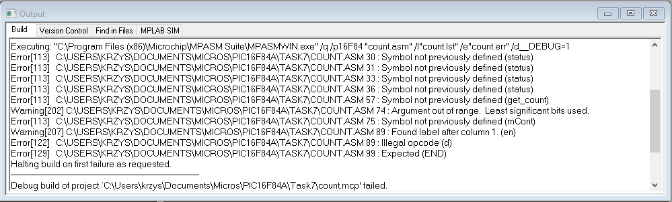
Correcting errors
First error that needs to be worked with is ‘Symbol not previously defined’. It is caused by the fact that variables are case sensitive. Where is ‘Status’ should be ‘status’. Same error can be found at the ‘goto’ command which is caused by main loop not being able to loop back. That’s because main loop label is written incorrectly where ‘get_counnt’ should be ‘get_count’. Last error of the same type is also a typo where ‘nCont’ should be ‘nCount’ within the subroutine.
Another error is described as ‘Argument out of range’ and it is caused by command that moves literal value to register being too big (exceed 8-bit range). Correction is as simple as replacing it with hexadecimal value of ‘0xff’.
Last errors are caused by ‘unexpected label’ and it is caused by ‘en d’ being read as a label. Replacing it with ‘end’ also has fixed one last error because program requires it to have a mark of the end of the program.
Testing the build.
To make sure errors have been corrected, it is best to run compiler and see if it has succeeded in the ‘Output’ window.
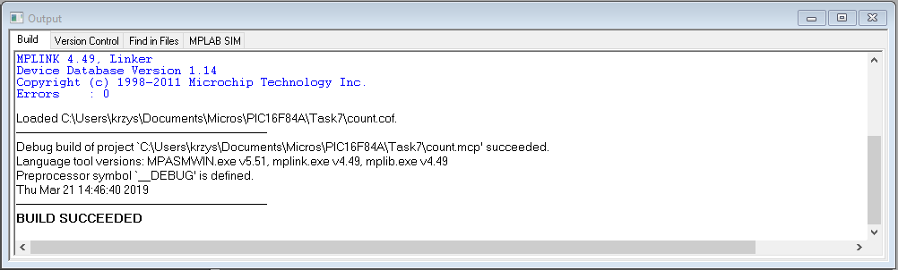
- Circuit diagram
This is a diagram for “HND/BENG PIC16F84 Assignment Board”.
All of the programs will run on this board and each of the components are identified and explained on the next page.

- Identifying the components
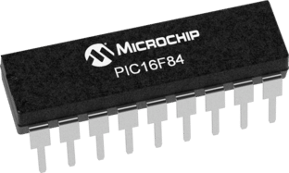
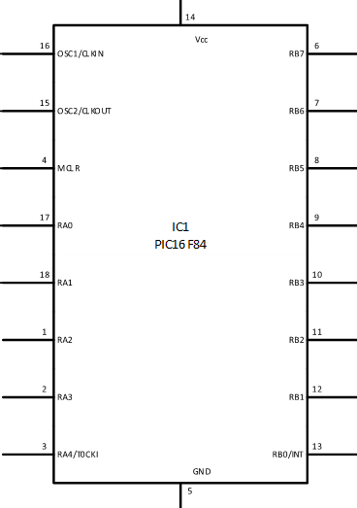
Microcontroller PIC16F84 - IC1 ⁽³⁾
As the name suggest, it is a tiny device that controls the operations within the circuit. Commonly referred as a brain of the device. Such microchips are a combination of several other integrated circuits.
PIC16f84A belongs to mid-range family of the PICmicro. The program memory contains 1024 instructions and because each 14-bit program memory is the same width as each instruction. The total device memory contains 68 bytes.
Within the PIC there are 13 I/O ports that can be user configured on a pin-to-pin basis. Some of those pins are multiplexed with other device functions like: External interrupt, Change on PORTB, timer0 clock input.

PIC16F84A pinout description
Pin name | PDIP, SOIC | I/O/P type | Buffer type | Description
OSC1/CLKIN | 16 | I | ST/CMOS | Oscillator crystal input/external clock source input
OSC2/CLKOUT | 15 | O | ------------ | Oscillator crystal output. Connects to crystal or resonator in Crystal Oscillator Mode
MCLR | 4 | I/P | ST | Master Clear (Reset) input/programming voltage input. This pin is an active low RESET to the device.
RA0  RA1  RA2  RA3  RA4/T0CKI | 17  18  1  2  3 | I/O  I/O  I/O  I/O  I/O | TTL  TTL  TTL  TTL  ST | PORTA is a bi-directional I/O port  Can also be selected to be the clock input to the TMR0 timer/counter. Output is open drain type.
RB0/INT  RB1  RB2  RB3  RB4  RB5  RB6  RB7 | 6  7  8  9  10  11  12  13 | I/O  I/O  I/O  I/O  I/O  I/O  I/O  I/O | TTL/ST  TTL  TTL  TTL  TTL  TTL  TTL/ST  TTLE/ST | PORTB is a bi-directional I/O port. PORTB can be programmed for internal weak pull-up on all inputs.  RB0/INT can also be selected as an external interrupt pin.  Interrupt-on-change pin.  Interrupt-on-change pin.  Interrupt-on-change pin. Serial programming clock  Interrupt-on-change pin. Serial programming clock
VSS | 5 | P | ------------ | Ground reference for logic and I/O pins.
VDD | 14 | P | ------------ | Positive supply for logic and I/O pins.
Legend: I = input O = Output I/O = input/Output P = Power
---- = Not used TTL = TTL input ST = Schmitt Trigger input
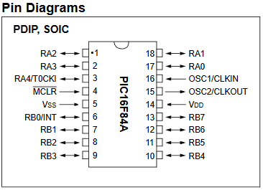
This is a pin diagram that is required to correctly connect all the peripherals.

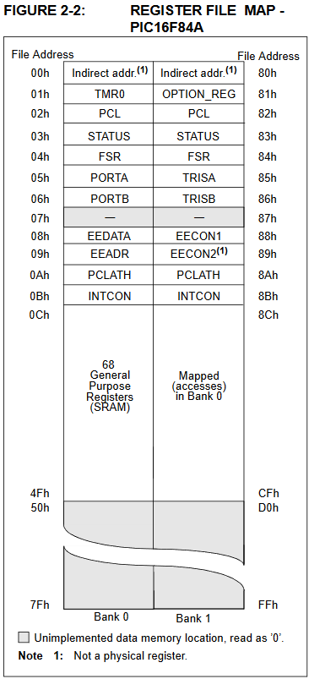
Memory Organisation
Memory is organised using two memory blocks inside the PIC. Each of those blocks can be accessed during the same operation cycle.
This memory is further broken down into the General-purpose RAM (GPR) and Special Function Registers (SFR). SFR’s are used to control core features of the device and peripherals modules features.
This data memory also contains the EEPROM data memory that is used when device requires need for operating system.
There is also a memory that contains 13-bit memory counter capable of addressing an 8k x 14 program memory space.
Portions of data memory are banked for both GPR and SFR areas. GPR area is banked in a way to allow greater than 116 bytes of data to be stored within RAM. The banked areas that are used for SFR’s are there for registers that control the peripheral functions. To operate properly, banking requires use of control bits for bank selection. These are located within the STATUS register. By clearing or setting RP1 and RP0 bits you can select appropriate bank.

Special function registers are used by CPU and peripheral functions to control device operations. Special function registers are classified into two sets: core and peripheral.
Addr | Name | Bits
Addr | Name | 7 | 6 | 5 | 4 | 3 | 2 | 1 | 0
Bank 0
00h | IDNF | Uses content of FSR to address Data Memory (not a physical register)
01h | TMR0 | 8-bit long, real-time clock/counter
02h | PCL | Low order 8 bits of program counter (PC)
03h | STATUS | IRP | RP1 | RP0 | TO | PD | Z | DC | C
04h | FSR | Indirect data memory address pointer 0
05h | PORTA | - | - | - | RA4/T0CKI | RA3 | RA2 | RA1 | RA0
06h | PORTB | RB7 | RB6 | RB5 | RB4 | RB3 | RB2 | RB1 | RB0/INT
07h | - | Unused memory location, read as ‘0’
08h | EEDATA | EEPROM Data Register
09h | EEADR | EEPROM Address Register
0Ah | PCLATH | - | - | - | Write for upper 5 bits of program counter (PC)
0Bh | INTCON | GIE | EEIE | T0IE | INTE | RBIE | T0IF | INTF | RBIF
Bank 1
80h | INDF | Uses content of FSR to address Data Memory (not a physical register)
81h | OPTION_REG | RBPU | INTEDG | T0CS | T0SE | PSA | PS2 | PS1 | PS0
82h | PCL | Low order 8 bits of program counter (PC)
83h | STATUS | IRP | RP1 | RP0 | TO | PD | Z | DC | C
84h | FSR | Indirect data memory address pointer 0
85h | TRISA | - | - | - | PORTA data direction registers
86h | TRISB | PORTB data direction registers
87h | - | Unused memory location, read as ‘0’
88h | EECON1 | - | - | - | EEIF | WRERR | WREN | WR | RD
89h | EECON2 | EEPROM control register 2 (not a physical register)
0Ah | PCLATH | - | - | - | Write for upper 5 bits of program counter (PC)
0Bh | INTCON | GIE | EEIE | T0IE | INTE | RBIE | T0IF | INTF | RBIF

INDF – it is not a physical register, with the use FSR as a pointer it allows indirect addressing.
TMR0 – This register contains the 8-bit wide result of the timer/clock.
PCL & PCLATH – this is a program counter register used by program to fetch instructions from.
STATUS – This register is used to control arithmetic status and allows selection of banks.
FSR – this is an indirect memory address; used along with INDF register for indirect addressing.
PORTA & TRISA – both registers are 5-bit wide, TRISA is used to configure corresponding bits of PORTA to be either input or output. While PORTA is used to read and write current status of bits (I/O).
PORTB & TRISB – similar to PORTA functions with the difference of being 8-bit wide.
EEDATA, EEADR, EECON1 & EECON2 – those are used to read and write EEPROM memory with each not being directly mapped.
INTCON – This register is used to enable interrupt control bits used by peripherals.
OPTION_Reg – this register is used to enable and configure external timer functions.

Instructions
Each PIC has instructions which are used to manipulate the device and these are called mnemonic operations. These operations can operate on either a single bit or a whole byte at the time.
Mnemonic instruction | Descriptions
Byte-Oriented file register operations
ADDWF | Add W-reg and file | Add W to the register and store in register or W (selectable)
ANDWF | And W-reg with file | Register is AND’ed with W and stored in register
CLRF | Clear file | Load register with zero’s
CLRW | Clear W-reg | Load W with zeros
COMF | Complement file | Content of register is complemented and stored in register or W (selectable)
DECF | Decrement file | Decrements register with 1 as default
DECFSZ | Decrement file, skip if zero | Decrements register and skip next command if zero
INCF | Increment file | Increments register with 1 as default
INCFSZ | Increment file, skip if zero | Increments register and skip next command if zero
IORWF | Inclusive or W-reg with file | Content of the W are OR’ed with register and placed in register or W
MOVF | Move file | Move value from one register to another register
MOVWF | Move W-reg to file | Move W to the register
NOP | No operation | Do nothing for a single cycle
RLF | Rotate left file through Carry | Move content of register one bit to the left
RRF | Rotate right file through Carry | Move content of register one bit to the right
SUBWF | Subtract W-reg from file | Subtract register from W
SWAPF | Swap nibbles in file | ‘1’ is changed to ‘0’ and ‘0’ is changed to ‘1’
XORWF | Exclusive or W-reg with file | Content of the W are XOR’ed with register and placed in register or W
Bit-oriented file register operations
BCF | Bit clear file | Clear single bit down with remaining bits unchanged
BSF | Bit set file | Set single bit up with remaining bits unchanged
BTFSC | Bit test file, skip if clear | Test single bit and skip next command if clear
BTFSS | Bit test file, skip if set | Test single bit and skip next command if set
Literal and control operations
ADDLW | Add literal to W-reg | The content of W is added to the literal and placed in W
ANDLW | And literal with W-reg | W is AND’ed with literal and result is placed in W
CALL | Call subroutine | Go to subroutine with option to return available
CLRWDT | Clear Watchdog timer | Clears WDT register and resets prescalers (bits TO and PD are set)
GOTO | Go to address | Jumps code directly to the labelled address
IORLW | Inclusive or literal with W-reg | Content of the W are OR’ed with literal and placed in W
MOVLW | Move literal to W-reg | Load up W with literal
RETFIE | Return from interrupt | Return from interrupt subroutine
RETLW | Return with literal in W-reg | Return from call instruction with W loaded with literal
RETURN | Return from subroutine | Return from call instruction
SLEEP | Go into standby mode (sleep) | Go into low power consumption mode
SUBLW | Subtract W from literal | Subtract literal from W
XORLW | Exclusive or literal with W-reg | Content of the W are XOR’ed with literal and placed in W

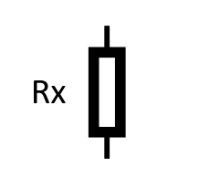
Resistor and resistor ladder - IC2
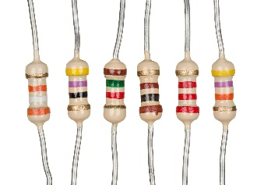
Resistors are probably the most vital components within the circuit. It allows limiting the flow of current for the purpose of providing other components with just the right amplitude.
They work by using materials which have a variety of different conductivity. Those materials include: carbon composition, carbon film, thick metal film and more ⁽⁴⁾.
Choosing the right resistors is crucial for any circuit. If any of the components will have too high current flowing, they might sustain everlasting damage and if the current is too low, they might not be operating at all.
Within this circuit, there’s also an IC that is a combination of series of resistors with each distinguish pin on one side applying resistance while load is connected to the other side of an IC. Imagine resistors stacked one on top of another with each have its own pair of pins embedded within a chassis.

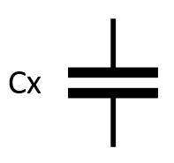
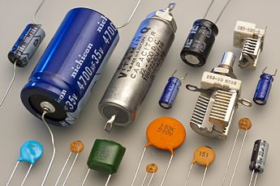
Capacitors
Capacitor are like tiny batteries but instead of holding a charge using chemicals, they store it using two plates isolated from each other. It works on principle that when a current is applied to both plates, the positive plate becomes charged up with electrons that are attracted to negative plate but due to isolation, they can’t get through. In other words, the charge has been trapped inside.
There two purposes for capacitors within this circuit. Two capacitors are connected to voltage regulator that aids the stability of the voltage. Other two capacitors are connected to crystal oscillator to stabilize resonation frequency of an oscillator.

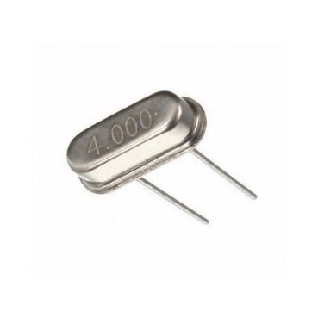
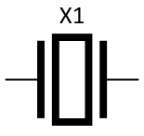
Crystal Oscillator
It is an electronic device resonates at a specific frequency when a current is applied through it. It is used to provide precise clock signal for other electronic devices. This quartz crystal requires 2 additional capacitors to stabilize the frequency clock.
It works by applying current to a non-conductive material that causes it to slightly bend and as it returns to its original shape it produces some current of its own.
Oscillators can be made from quartz crystals (either natural or synthetic) or ceramic which have a pair of capacitors already integrated.
This particular crystal will operate at frequency of 4MHz giving the equal clock to the microchip.


Sounder
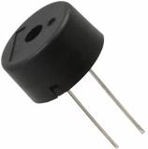
As the name suggest, sounder is producing a noise when a current is applied to it. When switching power on or off the sounder will produce a high-pitched tone with the exact frequency that is applied to it.
These types of piezo sounders are most commonly used in alarm circuits and can generate sound frequency between 2 to 4kHz ⁽⁵⁾.

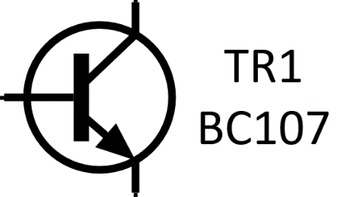
Transistor
Transistor can be easily compared to a switch but instead of mechanical trigger transistor registers current flow in 1 pin and allow current through the device. Due to its material properties it can only allow a current to flow in one direction.
Inside the transistors, you can find 3 different semi-conductive materials. Charing up the semi-conductive material in the middle with electrons allow electric connection between two remaining materials.
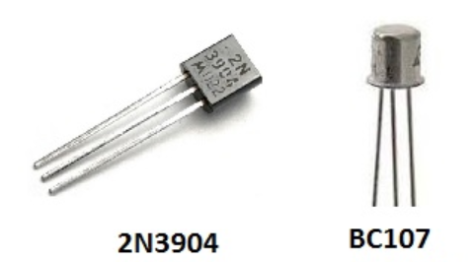
Within this particular project, the microcontroller will determine the transistor to be either switched on or off while being connected to the piezo sounder and allow current to flow through that component. It is required for this project because piezo requires higher amplitude that microchip cannot generate. Therefore, speaker is directly connected to the power supply to receive the right voltage.
This transistor is called bipolar and named because current must go through two different materials. Bipolar transistor be made up of either PNP or an NPN sandwich structure.

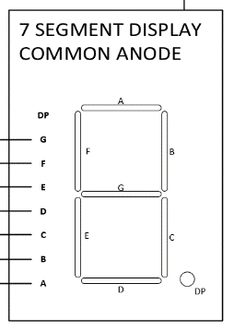
7 segment display
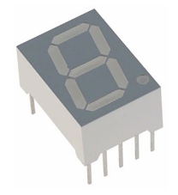
This is a numeric display which can display series of numbers (and few letters) by lighting up individual LED’s. Those LED’s are all connected to the same power source with each having their separate ground. This setup is named common anode while if connections would be reversed, it would be common cathode with each LED having the same ground connection. By controlling which segment is connected to ground, you can control the display.

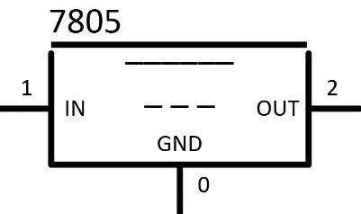
Voltage Regulator - IC3
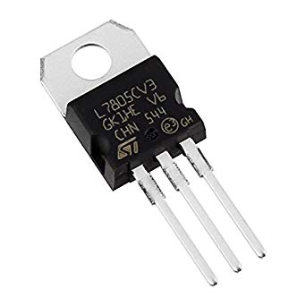
This tiny integrated circuit that is responsible controlling the voltage at exactly 5 volts. It is required by the rest of the circuit because applying voltage that is too high would cause permanent damage to it. This IC due to fact that there is high current flowing through it will generate a lot of heat as it operates. Therefore, it possesses a heatsink on top to drive that heat away.

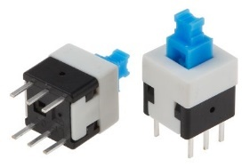
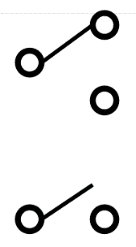
Switches
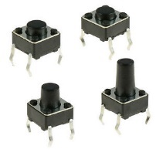
There are two types of switches within the circuit and they both operate using mechanical functions. Spring lock switch is used to connect power supply to the device by locking the connections together. The other switch is more of a simple button that will only allow the current through while pressed.

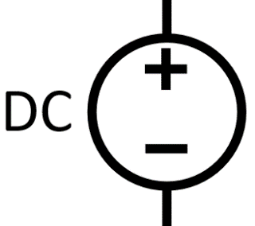
Power source

Every electric or electronic device requires power source to run. This circuit will operate using either 9V battery or 9-12V AC-DC adapter. The input cannot be higher than 12V because voltage regulator IC will not be able to handle current this big.

Reference page
- Brief introduction on microcontrollers by Microcontrollers, URL: https://www.microchip.com/mplab
- Using MPLAB v8.92 by John Young, section 7, URL: https://moodle.uwtsd.ac.uk/mod/resource/view.php?id=19012
- All information, and diagrams comes from PIC16F84A datasheet by Microchip url: https://ww1.microchip.com/downloads/en/devicedoc/35007b.pdf
- Resistor guide, URL: http://www.resistorguide.com/materials/
- Explanation by Nisha Shukla, Executive Engineer at Havells India, URL: https://www.quora.com/How-do-piezoelectric-buzzers-work

