Academic Skills

ENHANCING ACADEMIC GROWTH THROUGH REFLECTIVE PRACTICE
Federico Marta
2327151
LCLM4001
Academic Skills
Tim Hopkins

1. Introduction 3
2.1 Note-taking Skills 4
2.2 Summarizing Skills 5
2.3 Reflection Skills 6
3. Conclusion 7
References 8
3.1 Appendix…………………………………………………………………………………………..9
3.2 Appendix…………………………………………………………………………………………..10
3.3 Appendix…………………………………………………………………………………………….11

1. Introduction
As a reflective report, this piece will take a look at the development of academic skills throughout this module, focusing on note-taking, summarizing, and reflection. In trying to organize this reflection, I have selected Gibbs' Reflective Cycle, which seems very systematic because it guides through six stages: description, feelings, evaluation, analysis, conclusion, and action plan. This model is ideal in the sense that it will prompt deeper thoughts about experiences to help understand both successes and difficulties encountered. This reflection is based on evidence from tasks and activities undertaken within the module, which demonstrate how these skills were practised and honed. Through the analysis of this progress, the areas I seek to be able to isolate which require greater work are the strategies moving forward for academic success. Sources which I have researched, in terms of relevant content, are referenced using the Harvard referencing system to underline the reflection.

2. Reflection Topics

2.1 Note-taking Skills
During this module, I could work on improving my note-taking skills by taking useful notes, especially during lectures and reading sessions. Among the most influential experiences to be remembered in this module is when early in the module, I attended a lecture that was pretty fast a lecturer who has spoken pretty fast and thorough whose speech, I had to come to the realization I could not capture almost all the important points that were being reinforced. It initially left me overwhelmed and worried about missing important information. After passing that feeling of slight frustration, I soon started realizing that proper note-taking would instead increase my comprehension and retention of material better.
In retrospect, through the consideration using Gibbs' Reflective Cycle, I found my way of notetaking to be less effective at the outset. I wrote very much, but it was unorganized and thus became an uphill task to get back and review. According to Markkanen et al., (2020) realization can make us understand about the root cause of the problem, which was my trying to transcribe information instead of processing and summarizing it.
On the road to improvement, I resorted to the more practical route of adopting the Cornell note-taking method. It involved breaking down my notes into columns regarding key points, details, and summary notes (Adeani et al., 2020). Such a structured format would be of real help in putting down cohesively what I am thinking of and helping review the material with more manageable ease. Moreover, I began to listen more actively to understand concepts rather than taking verbatim.
I will improve my note-taking by continuing to enhance my diagram and mind-mapping to aid understanding. I am also making it a practice to revisit the notes shortly after the lectures to help me emphasize what is learned and also notice any gaps left. My note-taking skills have increased a great deal from this experience, enabling me to be much more confident in handling information effectively throughout my academic sojourn.

2.2 Summarizing Skills
Skills of summarizing learned in this module were stretched to their limits mostly during reading assignments done for preparing group discussions. One notable experience was when I had to summarize a long academic article. I found the process challenging because I did not know how to summarize without losing critical information. I felt desperate about how to pull out the main ideas while still developing the main essence of the content.
Using Gibbs' Reflective Cycle, I judged my initial attempt to be fairly ineffectual. Even though I could pick out the salient points in a piece of information, my summaries were too long, which could contradict the purpose of summarizing. My lack of confidence in attributing information as primary or secondary led to summaries resembling condensed versions rather than summaries.
Through reflection and analysis, I could find the root of the problem: my personally developed prioritization of every detail, not to miss something that might create false information. To solve this problem, I used a more systematic approach by identifying at first the main thesis of the article, and then breaking down what was said into supporting arguments (Tawanwongsri and Phenwan, 2019). This helped me to stay focused on core ideas, not getting lost in the specifics. I also learned to summarize, yet comprehensively, so that the essence of the material was realized without its being burdened by unnecessary details.
In the future, I shall continue to work on my summarizing skills through this approach and seek feedback from colleagues and tutors. I also want to ensure that enough time is allowed for me to go over the summaries concerning clarity and brevity. The experience taught me the importance of effective summarizing not only in academic work but in every context where one communicates and one needs to be effective. By developing this skill, I have become more confident in my ability to handle enormous information and be concise in its presentation.

2.3 Reflection Skills
To reflect on this experience, I will use Gibbs' Reflective Cycle, 1988. Description The first stage in this cycle is to describe the activity that I had undertaken When I was required to reflect upon my academic progress. Feelings My feelings toward reflection at this point were uneasy and not want to do it because it was an area I had never experienced. Moving now onto the Evaluation stage, I felt that the exercise on reflection was extremely useful. Despite the initial discomfort, it provided me with valuable insights into how I was processing my learning, and it pointed out areas where I had gained ground and also those where more work needed to be done. According to Ardian et al., (2019), reflective skills are essential for enhancing personal skills or developing any new skills.
During the analysis stage, I considered what had caused my initial difficulty in reflecting. For me, structured reflection was very new, I did not have experience in it, so organizing my thoughts and feelings into words was hard. Another point that held me back was the fear of looking stupid or realizing where I needed to improve. As time went on, however, after reflecting more and more, I became comfortable enough with the process, and the benefits became glaring regarding how my self-awareness and academic growth were increased.
For the Conclusion step, I acknowledged that developing reflection skills is a continuous process requiring practice and dedication (Bassot, 2024). To that end, I have made a conscious effort to create time for regular self-reflection immediately after completing academic tasks. I kept prompts and guiding questions to help in reflect on my learning.
In the Action Plan stage, I would make reflection a part of my routine for both academic and personal development purposes. I will retain Gibbs' Reflective Cycle throughout as a framework to enforce a systematic and constructive approach towards the tasks at hand. Such ongoing practice will let me keep a reflective mindset; this supports continuous growth at both an academic and personal level (Ezezika and Johnston, 2023).

3. Conclusion
The activities reflected upon in this report have been highly influential on my behaviour and influenced my academic and personal growth. Note-taking, summarizing, and reflection have made me a much more organized, analytical, and self-aware person. These skills have not only built up acumen for the respective subjects at college but also boosted my confidence in dealing with tasks efficiently. In the future, I will certainly be applying these skills incessantly both as a learner and in professional scenarios to ensure improvements and adaptability. This reflective practice is therefore going to guide me in my actions whenever I have a challenge, more clearly and with a lot of purpose.

References
Adeani, I.S., Febriani, R.B. and Syafryadin, S., 2020. Using GIBBS’reflective cycle in making reflections of literary analysis. Indonesian EFL Journal, 6(2), pp.139-148.
Ardian, P., Hariyati, R.T.S. and Afifah, E., 2019. Correlation between implementation case reflection discussion based on the Graham Gibbs Cycle and nurses’ critical thinking skills. Enfermeria Clinica, 29, pp.588-593.
Bassot, B., 2024. The reflective journal. Bloomsbury Publishing.
Ezezika, O. and Johnston, N., 2023. Development and implementation of a reflective writing assignment for undergraduate students in a large public health biology course. Pedagogy in Health Promotion, 9(2), pp.101-115.
Markkanen, P., Välimäki, M., Anttila, M. and Kuuskorpi, M., 2020. A reflective cycle: Understanding challenging situations in a school setting. Educational Research, 62(1), pp.46-62.
Tawanwongsri, W. and Phenwan, T., 2019. Reflective and feedback performances on Thai medical students’ patient history-taking skills. BMC medical education, 19, pp.1-8.

3.1 Appendices
Appendix 1: in class notes

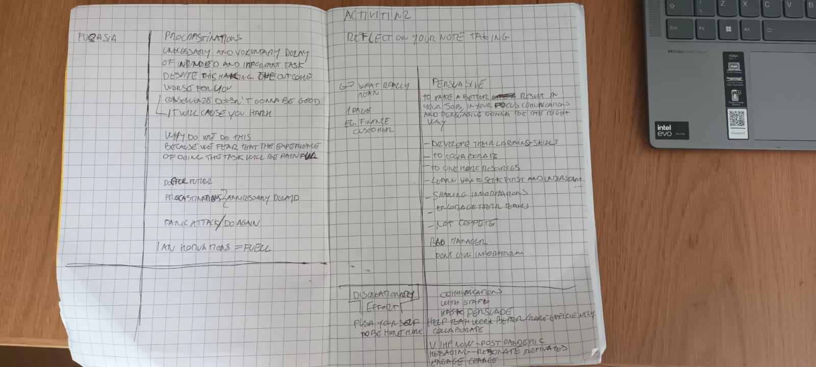

Appendix 2

