ACCB4017 – SOFTWARE DEVELOPMENT

ASSESSMENT 1

DESISLAVA ALYOSHEVA PALIKAROVA
ID NUMBER: 2020966

BSC CLOUD COMPUTING
25/08/2021

RENUGA JAYAKUMAR

CONTENT

- INTRODUCTION
- PART A (UNDERSTANDING)
- A1. Explain the different types of control structures in programming. Explain in detail how selection control structure has been handled using If..elif structure in Python with suitable example/s.
- A2. With reference to repetition, compare and contrast the different types of loops in Python. Explain ‘for’ loop in detail with all the options. Use appropriate example/s to support your answer.
- A3.Define list. Explain how lists are different from normal variables. Include how to access the element of the list in your answer.
- Part B (Implementation)
Exercise 1:
Exercise 2:
Exercise 3:
Exercise 4:
- Conclusion
- Reference

- INTRODUCTION

In nowadays as we know the computer industry is developed to a very high level and a very distributed. With the using and participation of all consumer, saving the time of the human and enriching there knowledge. The knowledge of programing and computer environments help us in development and even saves a lot of time for people to write, calculate, draw and many other things. Programing language is quite widespread and diverse. The programing languages is usually split into the two components of syntax and semantics. They are made an investigation of several aspects of control structure of programing languages, which achieves better control over the program and thus also simplifies understanding and facilitates the program for correct and accurate execution. The same is with programing language in python. [1]

- PART A (UNDERSTANDING)

- A1. Explain the different types of control structures in programming. Explain in detail how selection control structure has been handled using If..elif structure in Python with suitable example/s.
Control structure in programing language is only the way to specify flow of control in program. When stand-alone modules called logic or control structure are used, each algorithm and program will more clearly and understood. The control flow in Python program is regulated by conditional statements, loops and functions. There are three types of control structure:
- Sequential Logic – This is also called default mode. This type of control structure are set of statements whose execution process happens in a sequence but if the logic in the statement broken in any line that mean the code execute will also be break.
- Selection Logic – This type of control is also knowing decision or branching control statement. The selection type of control give away the program to test several condition and execute the code on which condition is true. Some of that instruction are: simply if; if-else; nested-if; if-elif.
- Repetition Logic – This type of control is for repeating multiply times of code. We have two repetition statement in python (for loop and while loop).In python we use mainly for loop for repeating variable to the end of range we give in the program. In while loop the program start with statement and followed by a condition, that result is executed answer true or false.

The difference between this three control structures give the users choice to choose basic statement or if-else or repeating list that depend of what variable needed to input the program then can use the type of control for receiving the correct output.
In python programing the user use if-elif control structure that structure is for decision making. This syntax the program will execute the statement if only expression of test is true. If expression is false the statement will be not executed. [2]
For example:
num=10
if num>10:
print("num greater than 10")
elif num==10:
print ("num is 10")
elif num<10:
print("num is less than 10")

Screenshot of output: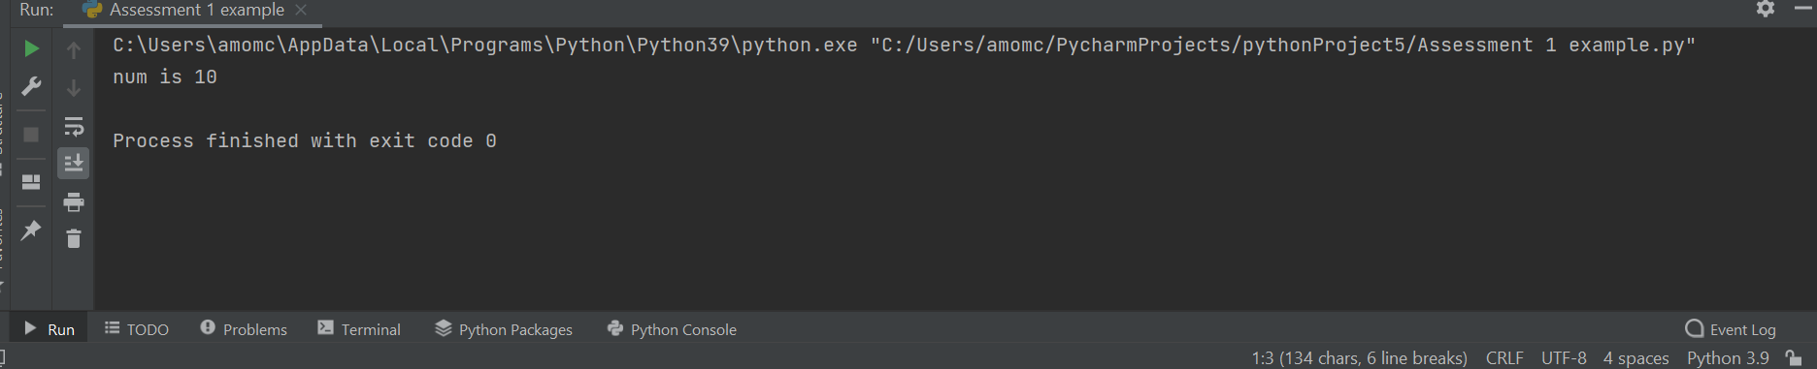 [3]
- A2. With reference to repetition, compare and contrast the different types of loops in Python. Explain ‘for’ loop in detail with all the options. Use appropriate example/s to support your answer.

- Repetition – is one of type of control structures in programing language. The user using this command when have to repeating numbers or other things. Repetition also calling looping which meaning repeating multi times. In Python knowing three type of repetition: while loop; for loop; nested loop.

- While loop – that command is similar to an ‘if’ statement if condition of statement is true, but while loop will continue repeating code execute as long condition is true.

- Nested loop – in that control structure you can put any type of loop inside of any other type of loop. Python programing language give allow to use one loop in another loop.

- For loop – that type can used when the user have to give the command of the program and have block of codes and need to repeat fixed number of times. For loop can also use for list, tuple or dictionary. Contrast the ‘for loop’ with the ‘while loop’ used when the condition needs to be checked each iteration or repeat block of code forever.

Example ‘for loop’:
n = int(input("enter the number"))
for i in range(3, n, 3):
print(i)

Screenshot of output:

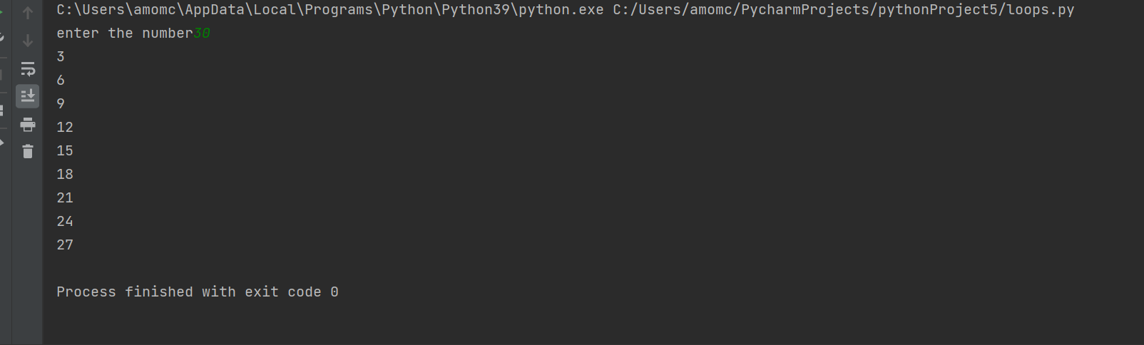 [4]

5. A3.Define list. Explain how lists are different from normal variables. Include how to access the element of the list in your answer.

The programming languages is very popular and useful. The so-called command in python ‘list’ is from repetition or more precisely ‘for loop’ control structure. List is like container, ordered collection of values. The values which make a list called elements or items. The list is similar to strings but with the different between, expect that the elements of list can be any type. List and string and other collection that order they are items is called sequences. The easy way and basic to use a list when putting commas between the elements and close them in square brackets. As we know a list is collection of variables that’s mean in group but the normal variables is isolated. The list can collect multiple data into a single variables. For example a= [2, b, c, 4]: so a is a single variables which collect multiple data in square brackets 2, b, c, 4.

a = [2, 'b', 'c', 4]
print(a)

Screenshot of output:

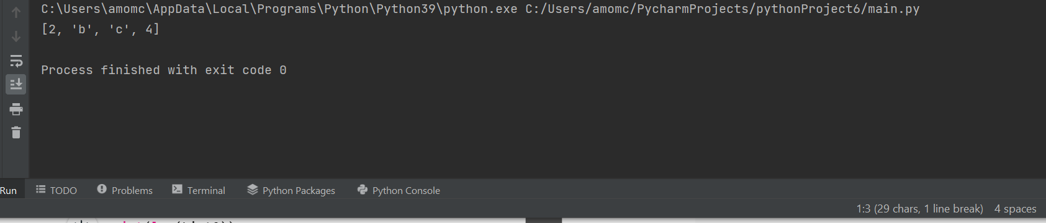

6. Part B (Implementation)
Exercise 1:
Show how variables can contain different types of values by using three variables to hold a customer name, price of a product and quantity. Also, try to find out the total price of the order. Write a program to allow the user to input these values and then display them on the screen. The variables should be appropriately typed for the data required.
- Logical stage:
- User need to enter the name
- Also price of the product
- And quantity
- User also need to enter the total price of the order
- Calculate the total price

- Code of the program:

name = input("enter your Name")
price = int(input("price of a product"))
quantity = int(input("enter the quantity"))
result = (price*quantity)
print(result)

- Testing: Screenshot of output

Normal value in range
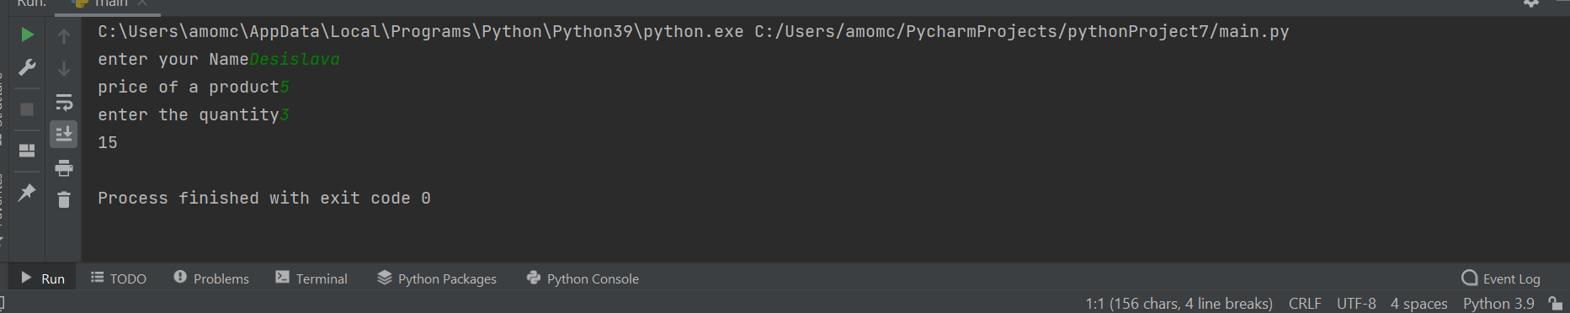

The program work properly with normal value in range.

Testing with 0 price if user make a mistake:

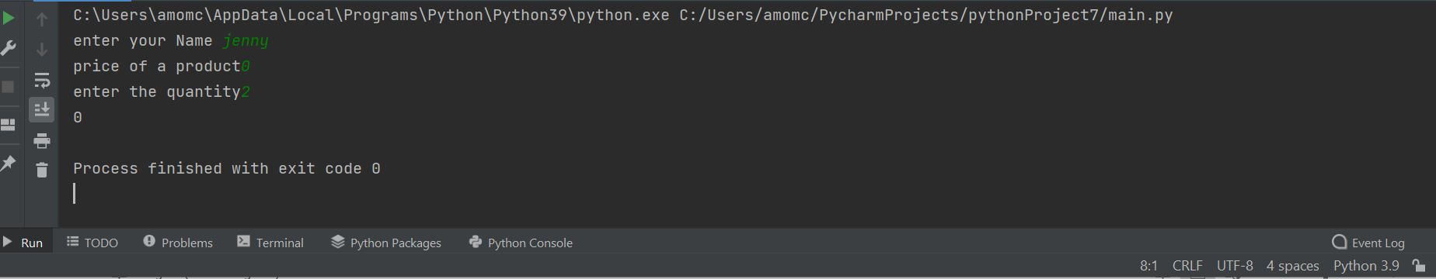

The program also work properly when user enter 0 price of product, because the program set with correct control structures.

Exercise 2:

Design and construct a program to allow the user to enter the radii to calculate the shaded area.

Figure1

R1
R2

Formula for the area of the circle: $A=πr^{2}$
Hint: Calculate the area of inner circle using the radius R1 and calculate the area of outer circle using the radius R2. Calculate the shaded region by finding the difference between the radiuses.

- Logical stage:
- The user need to start with entering the constant of pi which is 3.14159 for this solution.
- Then need to input radius for one circle
- Next radius for another circle
- After that have to find area1 for first circle with formula
- Then area2 for second circle with formula
- when from area 2 minus area1
- And then print the result
- Code of the program:
CONSTANT_PI = 3.14159
R1 = float(input("enter R1 of the circle"))
R2 = float(input("enter R2 of the circle"))
Area1 = CONSTANT_PI * R1**2
Area2 = CONSTANT_PI * R2**2
Area = Area2 - Area1
print(Area)

- Testing: Screenshot of output
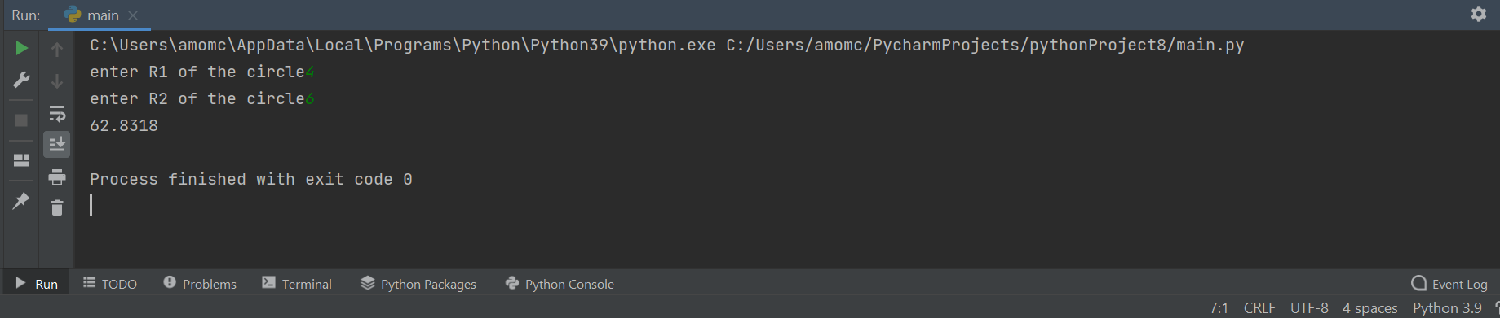
The program work properly. From first execute I found some syntax error like space didn’t leave after the = and after fixed is fine. The other error which I found is when I try to run the program whit decimal fraction because instead of ‘float’ I was put ‘int’ then I change and everything work perfectly.

- Testing: Screenshot of output:

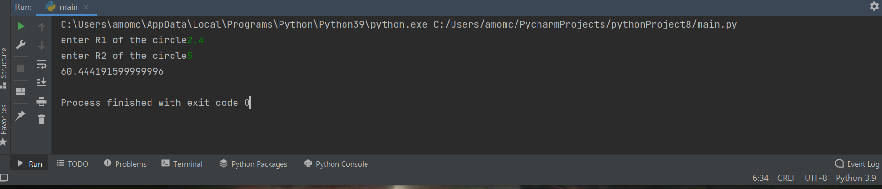
Output with decimal number and whole number with the some code.

- Testing: Screenshot of output:
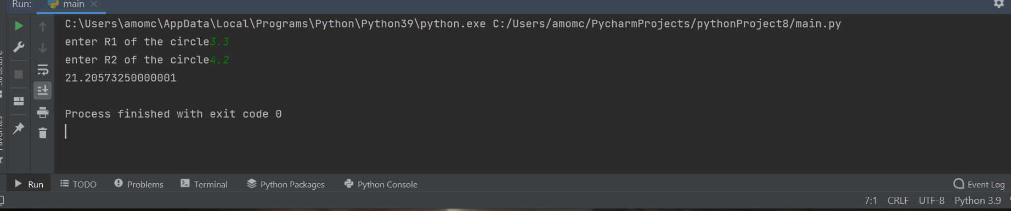
This is screenshot of execute the same program with only decimal number, it’s also work fine.

Exercise 3:

Write a program that allows the user to enter the names of five staff members working in IT
department into an array/list and their monthly salary of the staff member into a second array/list.
When all the staff names and their salaries have been entered, print them on the screen, then
calculate total how much money in total the IT department requires to spend on employees’ salary
every month. Finally, help the department to check how much total money they need if 10%
increase on overall salary.

Your output might look something like this:
Enter staff name :
Mariana
Enter salary :
1200.00
Staff details entered:
Paul 1300.00
Susan 1250.00
James 1300.00
Rossie 1350.00
Alan 1400.00
Total salary amount is : 6600.00
Total salary amount with 10% increase: 7260.00

- Logical stage:
- The user need to make list with name
- Another list with salary
- After that need to input the name of the staff
- And then salary of the staff
- After that have to use for loop for how many people of staff and append the name entered and also the salary
- User need to print the staff details
- After that need to use another for loop for print the name and salary
- After that to give the program to calculate the salary
- Then need to print total of salary for a month
- And also calculate the money if 10% increase on overall salary
- On the end to show total salary amount with 10% increase
- For the salary to be show for example 1200.00 user need to use format formula also for total salary amount and for increase total salary

- Code of the program:
name = []
salary = []
for i in range(5):
name_1 = input("enter staff name")
salary_1 = float(input("enter staff salary"))
name.append(name_1)
salary.append(salary_1)
print('staff details')
for i in range(5):
print(name[i], '{:.2f}'.format(salary[i]))
totalSalary = sum(salary)
print('Total salary amount is: ','{:.2f}'.format(totalSalary))
increaseSalary = totalSalary*1.1
print('Total salary amount with 10% increase: ','{:.2f}'.format( increaseSalary))

- Testing: Screenshot of output
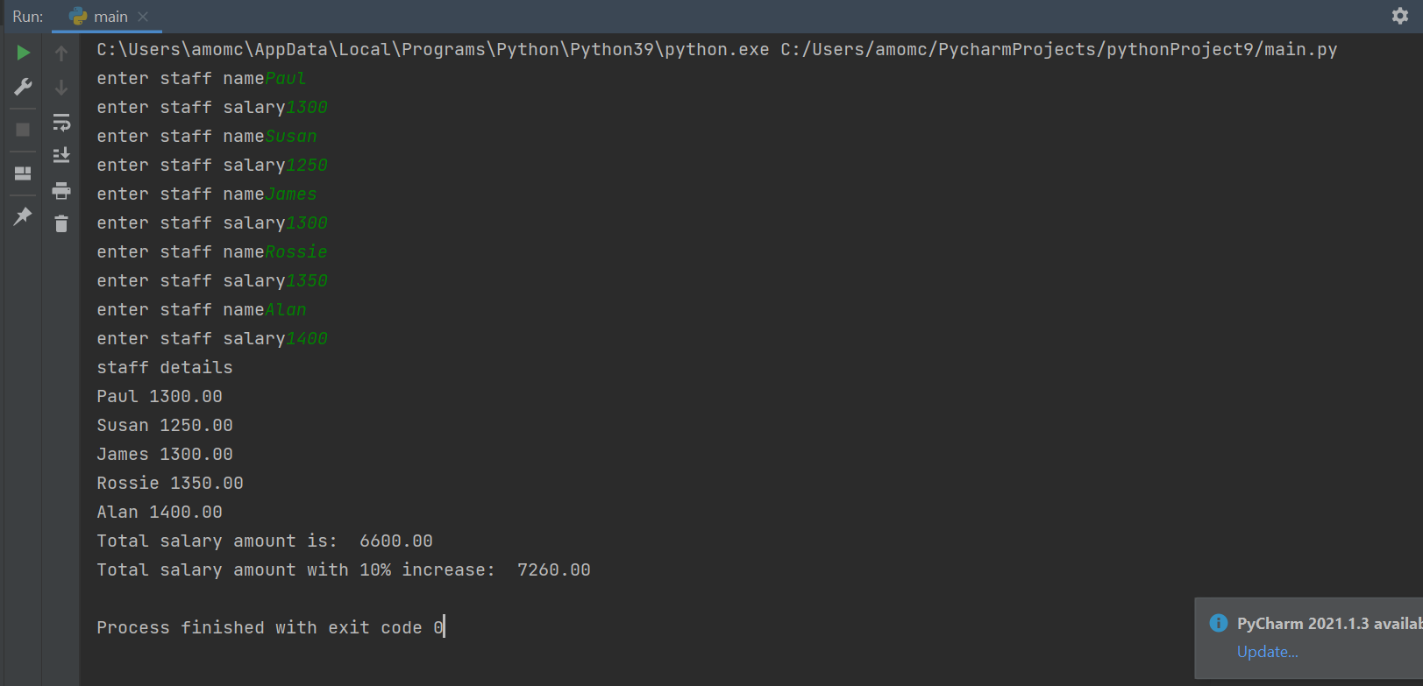

The code work properly and correct.

Exercise 4:
Spinning game
Develop a spin game which requires three random numbers ranging from 0 to 9 chosen each time the
player asks to take another go. Use python user-defined function to find the score of each spin.
The value of 9 will be treated as the “Jackpot” symbol.
The scoring will be as follows:
• Any combination of two of the same numbers will pay a bonus of 5 points e.g.
7 5 7
8 8 9
6 5 5, etc.
• Any three of the same numbers (excluding nines) will pay a bonus of 15 points e.g.
7 7 7
8 8 8
5 5 5
• Any combination of two nines will pay a jackpot of 200 e.g.
5 9 9
9 8 9
9 9 6, etc.
• Three nines pay out the big jackpot of 2000 points.
The points the player has accumulated should be displayed and the player should be asked if they wish to
make another spin or quit. It could look something like this:
Spin? Yes
5 6 7
You lose, your points are 0
Spin? Yes
7 7 6
You win, your points are 5
Spin? Yes
9 9 9
You win, your points are 200

- Logical stage:
- For this solution of exercise user need to use import random library
- Then have to input go for yes or no in spinning game
- After that have to use while loop for variables of the numbers from 0 to 9
- And then to check any of the solution of the combination given in the assessment brief
- Any combination of two of the same numbers will pay a bonus 5 points
- Any tree of the some numbers(excluding nines) will pay a bonus of 15
- Any combination of two nines will pay a jackpot of 200
- Three nines pay out the big jackpot of 2000

- Code of the program:
- import random
go = input('yes or no')
total = 0
while go == 'yes':
a = random.randint(0, 9)
b = random.randint(0, 9)
c = random.randint(0, 9)
print(a, b, c)
if a == b and a == c and b == c and a == 9:
total = total+2000
print('You win, your points are', total)
if a == b and a == c and b == c and a != 9:
total = total + 15
print('You win, your points are', total)
if a == b and a == 9 or b == c and b == 9 or a == c and a == 9:
total = total + 200
print('You win, your points are', total)
if a == b and a != 9 or b == c and b != 9 or a == c and a != 9:
total = total + 5
print('You win, your points are', total)
if a != b and b != c and c != a:
print('You lose, your points are', total)
go = input('yes or no')

- Testing: Screenshot of output

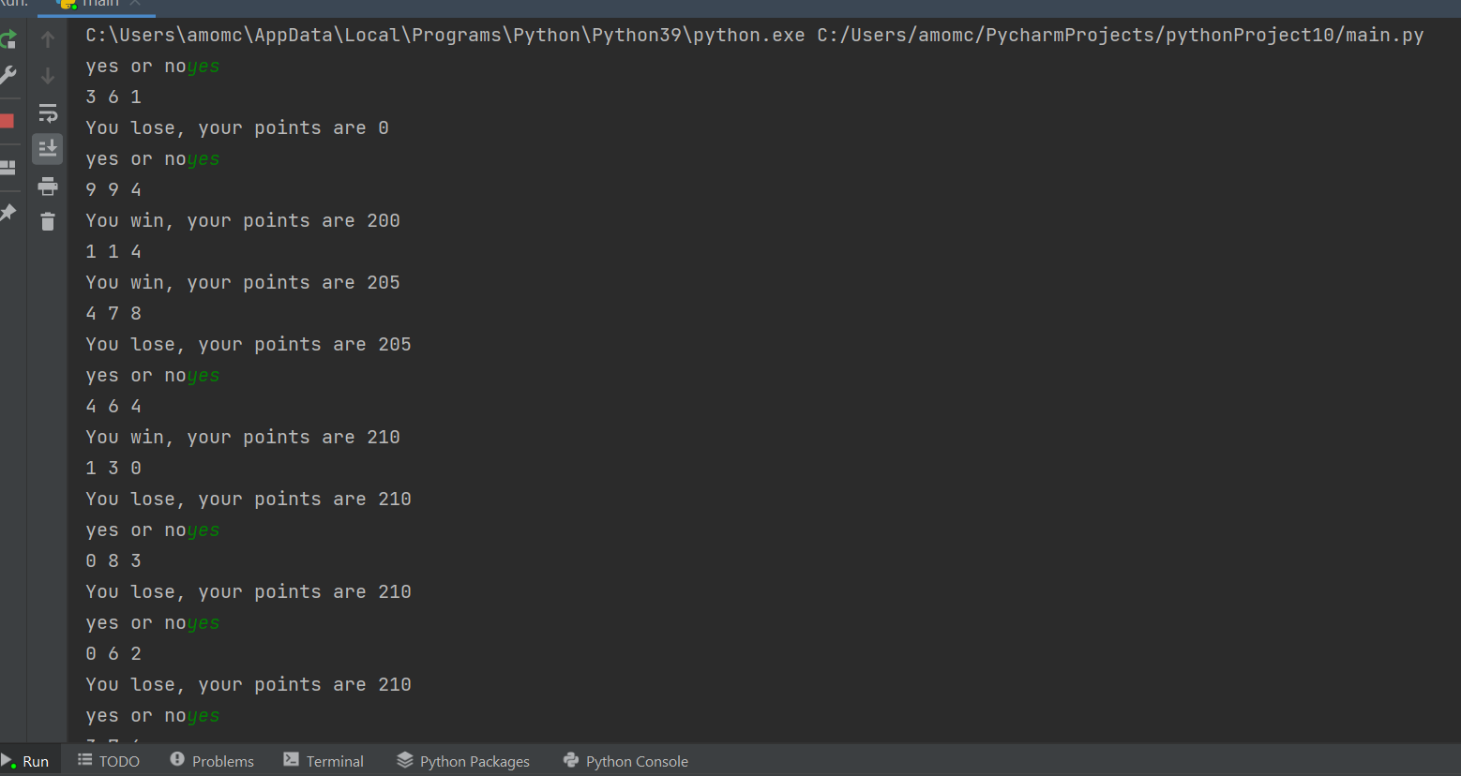

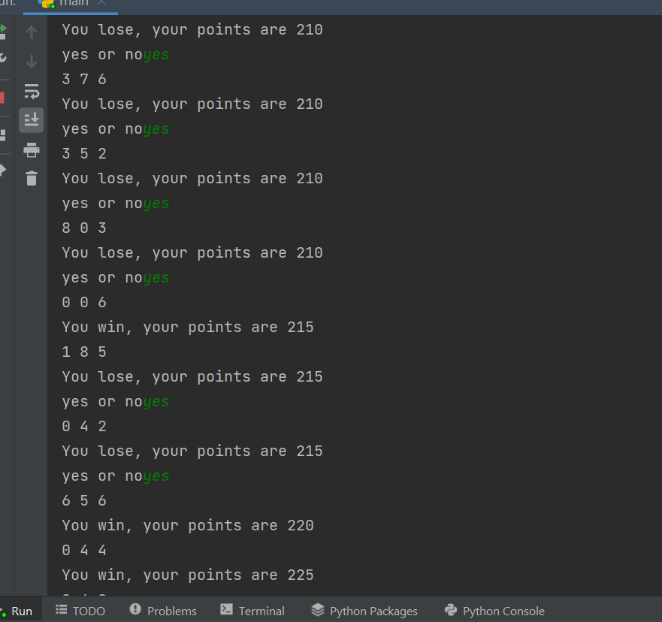

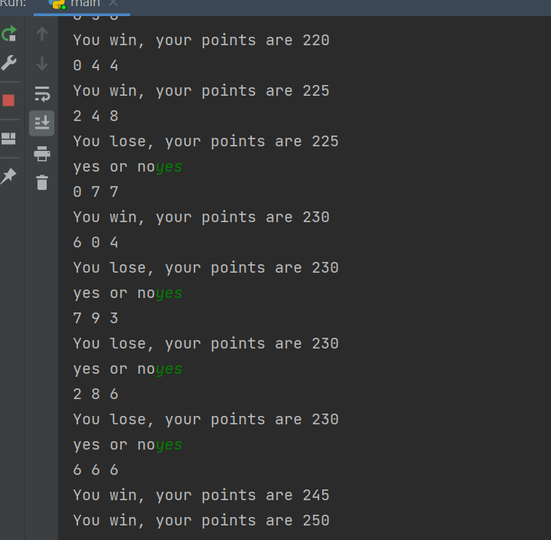

Whit the testing we see the program work correct.

- Conclusion:
Python programing is very interesting and also very useful in any industrial in nowadays. The practise is the way to develop the knowledge because when make some mistake and error with the code then find the corrected them, that is the way to understand more and more in this programing language.

- Reference:

[1] | D. A. Fisher, “Control Structures For Programming Languages,” in Control Structures For Programming Languages , Pennsylvania, 1970, 1970.
[2] | S. Jain, “Control Structures in Programming Languages,” GeeksforGeeks, 16 january 2020. [Online]. Available: https://www.geeksforgeeks.org/control-structures-in-programming-languages/. [Accessed 20 august 2021].
[3] | B. Koushik, “What are control flow statements in Python?,” https://www.educative.io, 2021. [Online]. Available: https://www.educative.io/edpresso/what-are-control-flow-statements-in-python. [Accessed 19 August 2021].
[4] | https://www.javatpoint.com/, “Python Loops,” https://www.javatpoint.com/, 2021. [Online]. Available: https://www.javatpoint.com/python-loops. [Accessed 21 August 2021].

