
CPD and Placement Portfolio
Owen Penton-Voak


 | 07935511690  Owenspv@outlook.com
  Opv | Owen penton-voak

Professional summary

Availability; Monday to Friday and Weekends.
I can work effectively as part of a team or under my own initiative and follow instructions well. I have good people skills when helping others, and I can sort problems quickly and get jobs done efficiently. I am enthusiastic about my work and use exceptional communication and relationship-building abilities to grow and expand my knowledge. Using extensive industry experience to offer expert knowledge to customers. I am resourceful and can creatively solve problems with exceptional time management skills.

I am very aware of safety issues that may arise in the workplace. In my previous line of work as an outdoor activity instructor, there were many dangers. Taking this into account, I can be aware of these issues and provide a safe, motivational, and educational session to anyone under my supervision. I am driven by knowledge and achievement, and I look to succeed in any task or challenge I’ve been given and strive to achieve.
Skills

- Technical Skills | - Marketing/Sales
- Adaptability | - Digital Literacy
- Strong Leadership Abilities | - Knowledgeable in Special Educational Needs
- Knowledge of Educational games | - Ability to work outdoors
- Knowledgeable in education practices
Experience

Occasional Sports Assistant, May 3rd 2024- On Going
- Office and Practical based working, setting up events and liaison between management and clients.
- Sports Camp- Leading sports activities with the public (30 children)
- Camp Cynefin- Leading outdoor based activities, creating fun and engaging sessions that incorporated a ‘sense of place’, e.g Nature Walk, Den Building, Fire Lighting and Bug Hunting.
- Lifeguarding
- International liaison
Activity Instructor, Haven, February 13th 2023-4th September
- Key Activity Instructor, leading activities for all ages, aiding all departments when needed.
- Key holder
- Rifles and Archery Instructor, including activititots, performing bushcraft skills and outdoor activities.
- Maintenance around the sight.

Outdoor Activity Instructor/Group Leader, PGL, June 14th 2021-15th November 2021/ 10th February 2022- 14th November 2022
- In house training on multiple ropes activities (Trapeze, outdoor/indoor climbing wall, Jacob's ladder), Training on all seasonal ground base activities that were used at the centre.
- Taking children on excursions to Alton

Outdoor education Instructor (Apprenticeship), JCA, Jan 2019 ‐ Jul 2020, Shrewsbury
- Being responsible for a group of children, young adults, and adults during their stay at the residential site teaching and delivering sessions such as Rock Climbing, Abseiling, Archery, Fencing, Team building exercises and much more.
- Time keeping was essential to this role having to arrive early to sessions to set up and complete risk assessments for the activity.
- Making sure guests were accommodated for and looked after during their stay and had everything they needed throughout the week, consistently liaising with the teachers to always offer support and assistance.
- Being a proud representative of the company displaying company values and always following company procedures.
- Completing Apprenticeship work on time and to the best of my ability.
Education

NVQ Level 3, Outdoor Instructing June 2020
Shrewsbury College
A First4Sport NVQ Level 3 qualification with Shrewsbury College earned whilst working for JCA.
Other qualifications earned whilst working for JCA include;
GB qualified Orienteering
GB qualified Fencing Instructor
NPLQ Level 3 Lifeguarding
Functional Skills, English level 2 June 2020

Lincoln college
NVQ level 3 Sport Coaching, Fitness, Performance- PP June 2018
June 2014
St Georges Academy
GCSE And BTEC
Physical Education- A
Maths- C
English- D
Spanish- F
Product Design- D
Geography- D
Science- Environmental Land Based Studies- D
Public Services level 2- Distinction

Certifications/Hard Skills

- Level 2 English (GCSE GRADE C EQUIVALENT)
- Rifles Qualifications
- Archery GB
- GB Orienteering
- GB Fencing Instructor
- NPLQ Level Lifeguard
- NVQ Level 3 Outdoor Instructor
- Cardiopulmonary Resuscitation and First Aid
- AED
- Outdoor First Aid Level 3
- RLSS Water Safety and Management
- Bushcraft Level 1
References

References available upon request.

S.W.O.T Using Appendix’s

As a seasoned outdoor instructor and sports coach, I possess a robust skill set that includes solid outdoor leadership, effective communication, and proficiency in risk management. My ability to engage participants and foster teamwork sets the environment for effective learning and adventure. I understand the necessity of ongoing continued professional development to stay competitive and effective.
With this understanding, I have identified specific training and development goals. I will attend workshops focused on advanced technical skills related to outdoor maintenance and usage within the next six months. Additionally, my marketing skills and sales require development; this will lead me to enlist in a targeted marketing course in the next three months. Lastly, to further improve my digital literacy skills, I will focus on attending online courses that target digital coaching and communication over the next four months. The initial goal is to find a placement that will allow me to complete and implement my goals simultaneously. Training and praxis will be the most efficient way of achieving my goals and further improving them beyond my targeted level.

Personal Statement

I am a dedicated outdoor instructor with over 15 years of experience in the industry. I am adept at developing a positive and safe environment for participants of all levels. My ability to work effectively as part of a team and my capability to excel independently enable me to adapt to various situations while delivering high-quality instruction. I possess strong problem-solving skills, allowing me to tackle challenges swiftly and efficiently, ensuring that all tasks are completed efficiently and to a high standard.

My background encompasses various activities ranging from rifle shooting to leading climbing wall activities. I have attended weekly practical sessions for the past year, including coasteering, coastal and indoor climbing, hill and mountain walking, and water safety and rescue. My broad experience has allowed me to increase the complexity of my qualifications and experience portfolio. My future goal, with my varied qualifications, will propel my ambition to create an outdoor environment that promotes adventure and learning; I also believe I can create an environment that will alleviate stress and anxiety in a population that struggles each day.

My exceptional communication and interpersonal relationship-building abilities enable me to connect with clients and participants, creating a supportive and motivational atmosphere. I pride myself on being resourceful and solving problems creatively, which is crucial in outdoor environments where conditions such as risk can change rapidly. I’m excited to help others grow and learn in the great outdoors. With my wealth of knowledge, I strive to enrich their experiences and make them long-lasting, concrete experiences.

My highest priority is safety, especially during outdoor activities with inherent risks. I know the hazards and risks involved and am committed to implementing effective risk management strategies. By putting safety first, I can offer educational and engaging sessions that empower participants to challenge themselves while feeling secure.

Driven by a passion for knowledge and achievement, I continuously seek opportunities to expand my skills and expertise. I strive to excel in every task or challenge, ensuring I meet and exceed expectations. I aim to provide participants with valuable insights and guidance, enriching their outdoor experiences and fostering a lifelong appreciation for nature. With a commitment to excellence, I aim to contribute positively to any team or organization, inspiring others to reach their full potential in outdoor activities.

Evaluating the gaps in my skill set, I identified that my IT and marketing skills are insufficient for my progress in other areas. My immediate goal is to advance these specific skills in my own time to enhance my capabilities within the working environment. I can develop these skills by attending workshops that teach these individual skills. I will also participate in continual CPD throughout my outdoor educational journey to extend my intrinsic and experiential learning.

Word Count- 1254
Appendix’s
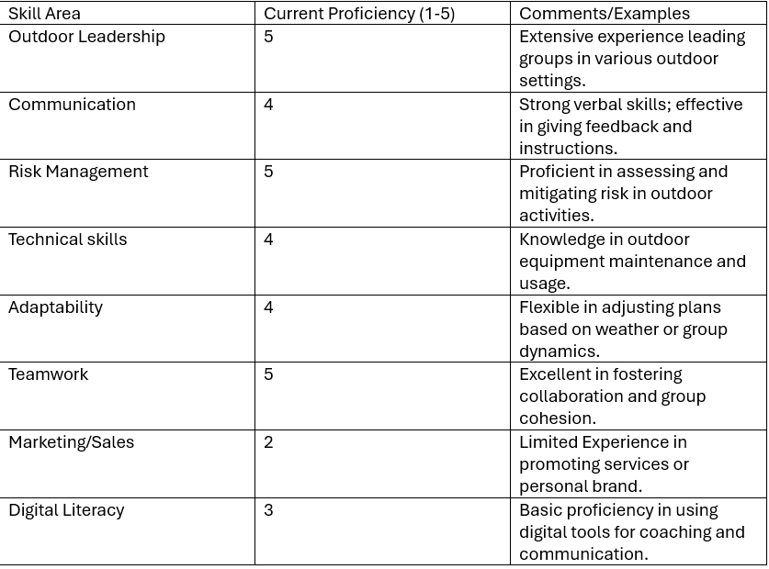

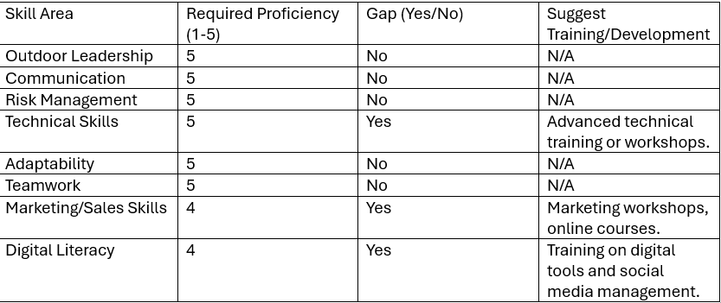

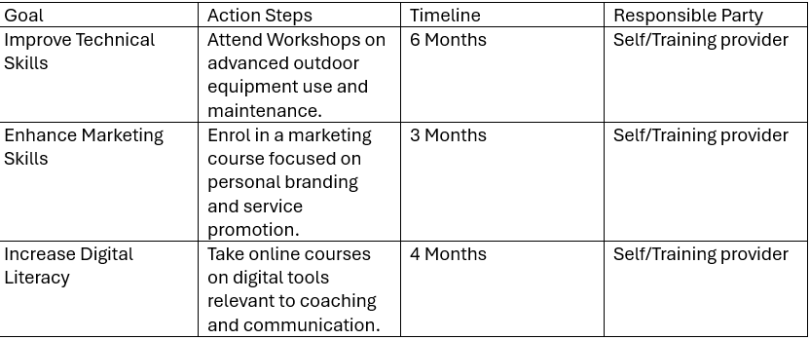

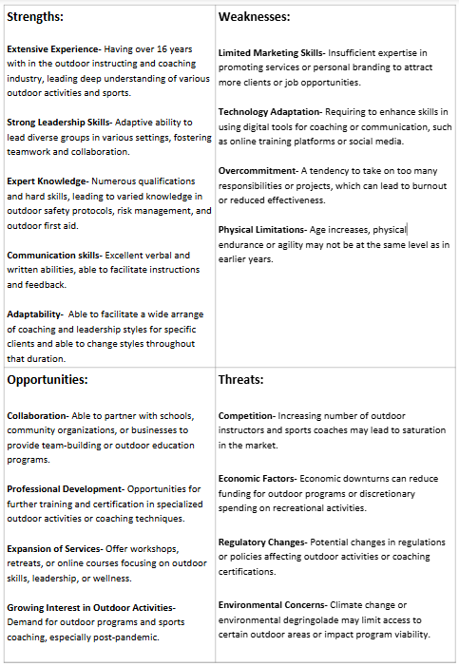

Reference list

Gottlieb, M., Promes, S.B. and Coates, W.C. (2021). A guide to creating a high‐quality curriculum vitae. AEM Education and Training, 5(4). doi: https://doi.org/10.1002/aet2.10717.

Gurel, E. (2017). SWOT analysis: a Theoretical Review. Journal of International Social Research, 10(51), pp.994–1006. doi: http://dx.doi.org/10.17719/jisr.2017.1832.

IOL (2024). Job Listing. [online] Outdoor-learning.org. Available at: https://www.outdoor-learning.org/workforce/job-listing.html.

Jones, D., Pittman, J.R. and Manning, K.D. (2022). Ten Steps for Writing an Exceptional Personal Statement. Journal of Graduate Medical Education, 14(5), pp.522–525. doi: https://doi.org/10.4300/jgme-d-22-00331.1.

Rikala, P., Braun, G., Järvinen, M., Stahre, J. and Hämäläinen, R. (2024). Understanding and measuring skill gaps in Industry 4.0 — A review. Technological Forecasting and Social Change, 201, pp.123206–123206. doi: https://doi.org/10.1016/j.techfore.2024.123206.

