The Future of Hospitality industry and is it Profitable to be green.

Student name: Mihaela Anton
Student number: 2122259
Module name: Sustainable Hospitality & Tourism Management
Module number: BMIH5006
Lecturer name: Ruth Taylor Davies

Contents
1.INTRODUCTION 3
2.MAIN BODY 3
Profitability in been green. 3
CSR 3
Customers Driven 5
Hospitality truly green 7
Recommendations 7
Financial resiliency 8
Greenwashing 8
Doxey Irridex Model 8
Butler’s Model 10
Examples of green hospitality 11
3.CONCLUSION 11
4.REFERENCES: 12

1.INTRODUCTION
This report is about the future of hospitality and the profitability for the organizations to be green as Milton Friedman stated “The social responsibility of an organization is to increase profits” in the 1950. The report will also analyse if this is relevant in our days and if in a business the finance comes first and if it is the business responsibility for being sustainable environmentally or is consumers driven. Furthermore, the report will research on Elkington’s triple bottom line analyse the impact of sustainability with Doxey’s Irridex model and Butler’s life cycle model.

2.MAIN BODY

Profitability in been green.
Green practices are gaining popularity among scholars and practitioners in the hospitality industry. A green practice is an approach that adds value to a business plan that involves environmental conservation. In hospitality industry, green practices are old (Buckely, 2012) and are implemented from more initiatives like financial values (Tzschentke et al.,2004), investors relations (Chan and Hawkins,2010) and consumers demands (Martinez and Bosque, 2013). Green practices at the start were implemented as a way to do economy (Hsieh, 2012), later to become a way to benefit market advantages in increase relationship with investors (Esparon et al.,2014).
To become environmentally friendly, leaders in their organisations changed their organisational structure, culture they also modify their product and service.
Natixis investment managers suggest that four from five investors are trying to find investments that are in line with their values. In the last ten years, the green ecosystem has become more structured and more ESG products have developed. In 2006 the United Nation introduced the ESG criteria and Principles for responsible investment (UNPRI).
A study from Oxford University highlights a connection between economic performance and sustainability practices. The sources showed that businesses with strong sustainability practices have better operational running which is reflected in cash flow. Furthermore, according to Clark et al. (2015), eighty percent of the papers they analysed demonstrated the beneficial effects of sustainability practices on investment performance.

CSR
Corporate social responsibility is a business concept for companies to help incorporate in their business operations and interaction with investors social and environmental concerns. The CSR help companies achieve and maintain the triple-bottom-line approach.
The main key issues are:
- Conscientious sourcing.
- Conviction of investors.
- Working conditions and labour standards.
- Community and employee relations.
- Right of humans.
- Societal justice.
- Balance of genders.
- Good governance.
- Measures taken against corruption.
CSR implemented in a business correctly can drive help in achieving:
- Competitive advantages.
- Increase profit.
- Cost savings.
- Good quality.
- Increase productivity.
- Improve brand.
- Good human resource base.
- Increase customer loyalty.
- Good reputation.
- Good decision making.
(UNIDO, 2023).
Milton Friedman opinion is that the businessman’s are actually just enumerating about the CSR criteria, but nobody really takes them seriously. He is saying about them that they are “unwitting puppets”, and they are using CSR to increase their profits.
Profitability allows organisations to reinvest in their operations, create employment opportunities, and contribute to economic growth. However, the notion of profit has evolved over time to include a more holistic perspective, considering both financial and non-financial aspects.
CSR is not used just to increase profit as it also increases the customer loyalty. When in this days allot of people know about the sustainability and it is in fact a trend.
In the current climate sustainability not just to increase travellers that grown in focus for environment, but government regulation too. In Europe large companies are required to report their sustainability practices initiatives from 2024 onwards.
From economic sustainability perspective, technology can reduce operational costs and help become productive. Technology evolved rapidly in recent years and take as further into a scientific fiction like future faster (EHL insights, 2019).
Implementing software will allow employees to devote more time to other business-related tasks if the sustainability aims is to increase financial performance. Smart hotels rooms are one of the goal that helps to reduce carbon footprint. The guest has access to the smart thermostats for temperature control and on the other part saving cost on utility bill. Reduce plastic waste by implementing water dispenser replacing water bottle. The dispensers can nowadays be bubbly or flavoured drink. Work with local suppliers in order to contribute more with community and save carbon miles. This helps reduce costs, help in differentiation from competitors, attract guests, build relationships with customers, enhance brand as keeping the CSR keys in concept as well.
Financial asset and the organisation size are the most significant internal element. Rahman et al (2012) suggest that big organisations engage in green practices for the reason that they have financial strength. On the other part, Park et al. (2018) advise that another important internal element is managerial commitment. Geographic location is an important factor that can affect to implement green practices. Rich nations and areas are apparently adopting green practices at a higher rate, accordingly to Bohdanowics (2006).
Communication with investors and mainly with customers highlight marketing-related operation. The goal is to change investor’s favourable perceptions of the adoption of environmentally friendly practices (Han et al.,2011).
Burns and Cowlishaw (2014), suggest that a big hospitality industry is using the indirect communication such as websites to communicate with their customers regarding green methods. On the other part, small and medium organisations are using direct communication with their customers and also with their communities by directly acquisition of local supplies and support environmental protection (Leslie, 2007).

Customers Driven
Customers stay intent in green hotels it was like an advantage between the clients, society, and business owners. It is hard to understand customers drive and factors influencing their choices. It can be a correlation between perceived behavioural control, moral obligation, and environmental awareness. The next image it will show how the people are getting more conscious about the environment. 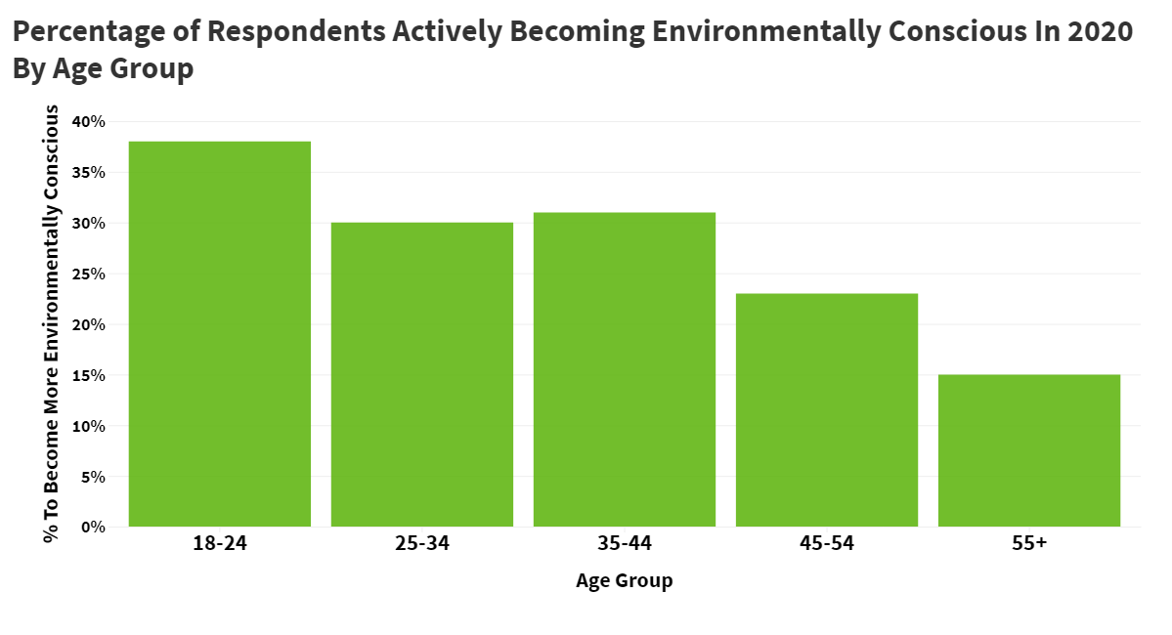

And in the next image from Statista, it is shown the people that intend to choose to stay at a green accommodation.
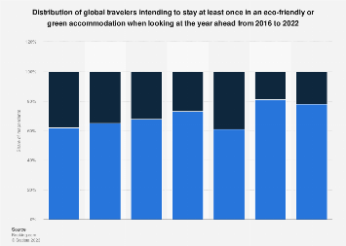

Statista.com

Hospitality truly green

Sustainability it starts now to be a necessity for the future generations and not just a trend. Hospitality sector has particular difficulties in reaching total environmental sustainability from allot of points. However, implementing green technologies and practices can result in significant advantages. For examples:
- Energy supply should be renewable.
- Operate fresh and grey-water management systems.
- Organisations should hire people locally.
- Furniture can be recycled.
- Automatic key cards for power switch of when customer leaves the room.
- All packaging must be recyclable and reusable.
- Food that remains to be donated.
- Decrease emissions of dioxide carbon.
- Change to LED lights.
- Built garden for kitchen supply.
- Scraps and peelings give for composed.
Booking.com suggests that people agreed on a survey that everyone should start to do sustainable travel choice for the future generations to help conserve the planet.

Recommendations
• Collaboration: To exchange best practises, combine resources, and promote change as a group, companies should work with suppliers, colleagues in the industry, and local communities.
• Innovation: welcome new ideas and make research and development investments to find new methods and technologies that have a smaller negative impact on the environment.
• Education: To promote an environmentally conscious and responsible culture within organisations, teach and train staff members about sustainable practises.
• Reporting and transparency: enhance reporting procedures to clearly inform stakeholders of the strides made towards attaining sustainability.
• Regulatory compliance: collaborate closely with the government to guarantee adherence to environmental laws and to advance legislative structures that encourage environmentally friendly behaviour.

Financial resiliency
Is essential to keeping up environmental projects. Enterprises have to find a middle ground between investing in long-term growth and profitability. Thoroughly assessing the advantages and disadvantages of both immediate expenses and future gains is crucial. Doxey and Buttler's life cycle model, among other financial forecasting models, can assist businesses in making well-informed decisions about sustainability investments.

Greenwashing
It is a tactic used by some organizations to make people believe that they are protecting the environment and actually they are not. This is correlated to a number of conditions such as packaging, transporting and ingredients.
An example for greenwash is Fiji water that are using greenwashing method by illustrating a green image but in fact they use plastic bottles with single use and pollute transportation.
Greenwashes is a concern in hotel industry along with hotel customers. Some organizations publish only the positive information, neglecting to publish the negative information as well (Lyon and Maxwell,2011).

Doxey Irridex Model
It is a model that illustrates how the locals shift from having positive to negative attitudes such us euphoria, apathy, irritation, antagonism, and final level. The model considers a linear change in residents’ attitude when tourism continue to grow (Cheung and Li, 2019).

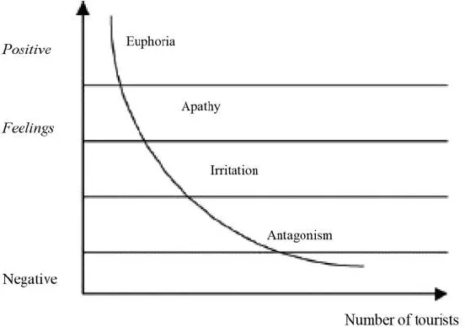
(tourismteacher.com)

Euphoria is developed when initial tourist is greeted. At this point the tourists are not in a big number, and they are respecting the residents and destination.
Apathy is the second attitude. In this point the host are seeing the tourists as a source of income and appear when tourism grows.
Irritation appears when the disputes grow between the residents and tourists. The tourist number is overlimit. The host at this point intolerant and the tourists are considered exploiters.
Final stage is the last attitude and is when the destination is ended and not anymore attractive or the host are closing for recovering.
Smith (1989) suggest that the host stress increases with the number of guests.
Tourism is a good factor for economy, but this can easily change to negative impacts as: overcrowding, price increasing, pollution and bad environment and this can change the attitudes of people.

Butler’s Model
Butler Model as well as Doxey Irridex model is a theory that describe the stages of the tourism destinations development. It is like a road map that help understand the development and growth over time.
There are six stages:
- Exploration
- Involvement
- Development
- Consolidation
- Stagnation
- Decline

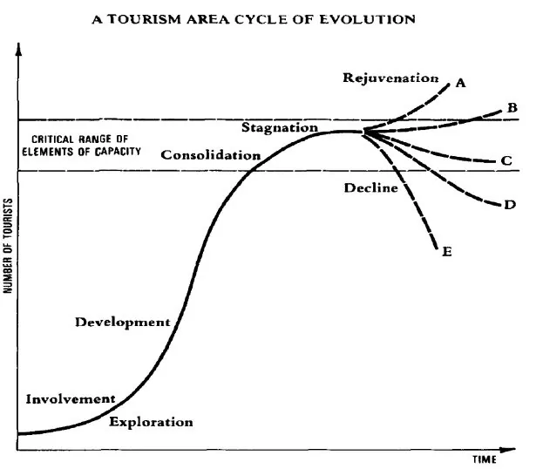
(adorngeo.com)

Exploration is the start. This is when the tourists start visiting and the infrastructure start to develop.
Development is the stage when experiences start rapid grow and become popular.
Consolidation is when the destination has a good instal and attract a good flow of tourists.
Stagnation starts when the destination may have challenges and experience a problem in growth.
Decline is when destination lose the tourists interest and the number of tourists start decreasing.

Examples of green hospitality

Tahiti's Eco Resort “The Brando”, which has a very pleasant culture and recycles everything, is one excellent example. Boats are kept far away so as not to harm the coral reef, and they use solar panels for electricity. They use special machinery to compost all food waste, and all water used for drinking and air conditioning comes from the ocean.
Bambu Indah in Bali is another excellent example, as they use natural resources like bamboo, water from the ground, energy from the sun, and food cultivated in their garden.
Organisations in both of the given examples are ecologically conscious and innovative for a sustainable future.

3.CONCLUSION

This report analysed the profitability in hospitality industry to be green. Achieving a balance between environmental sustainability and profitability is crucial for the future of hospitality. Long-term success increasingly depends on implementing green practises, even if financial returns are still important. Hospitality companies can take up green initiatives as a way to fulfil their social responsibility, as consumers' demands and moral values align with these goals. The industry can move towards greater environmental sustainability without sacrificing profitability by putting future recommendations into practise, working together, and investing in innovation. By combining the Doxey and Butler models, it is also possible to create a comprehensive strategy that addresses the social, environmental, and economic aspects of sustainable tourism.

4.REFERENCES:
Burns, P.M. and Cowlishaw, C., 2014. Climate change discourses: How UK airlines communicate their case to the public. Journal of Sustainable Tourism, 22(5), pp.750-767.
Buckley, R., 2012. Sustainable tourism: Research and reality. Annals of tourism research, 39(2), pp.528-546.
Chan, E.S. and Hawkins, R., 2010. Attitude towards EMSs in an international hotel: An exploratory case study. International Journal of Hospitality Management, 29(4), pp.641-651.
Clark, G.L., Feiner, A. and Viehs, M., 2015. From the stockholder to the stakeholder: How sustainability can drive financial outperformance. Available at SSRN 2508281.
Cheung, K.S. and Li, L.H., 2019. Understanding visitor–resident relations in overtourism: Developing resilience for sustainable tourism. Journal of Sustainable Tourism, 27(8), pp.1197-1216.
Dief, M.E. and Font, X., 2010. The determinants of hotels' marketing managers' green marketing behaviour. Journal of sustainable tourism, 18(2), pp.157-174.
Esparon, M., Gyuris, E. and Stoeckl, N., 2014. Does ECO certification deliver benefits? An empirical investigation of visitors’ perceptions of the importance of ECO certification's attributes and of operators’ performance. Journal of Sustainable Tourism, 22(1), pp.148-169.
Friedman, M., 2007. The social responsibility of business is to increase its profits. In Corporate ethics and corporate governance (pp. 173-178). Berlin, Heidelberg: springer berlin heidelberg.
Han, H., Hsu, L.T.J., Lee, J.S. and Sheu, C., 2011. Are lodging customers ready to go green? An examination of attitudes, demographics, and eco-friendly intentions. International journal of hospitality management, 30(2), pp.345-355.Hsieh, Y.C., 2012. Hotel companies' environmental policies and practices: a content analysis of their web pages. International journal of contemporary hospitality management, 24(1), pp.97-121.
https://www.im.natixis.com/fr/recherche/esg-investing-survey-insights-report (Accessed on 01 November 2023).
https://hospitalityinsights.ehl.edu/tech-trends-hospitality-industry-2019 (Accessed on 3 November 2023).
https://globalnews.booking.com/bookingcoms-2021-sustainable-travel-report-affirms-potential-watershed-moment-for-industry-and-consumers/ (Accessed on 3 November 2023).
https://tourismteacher.com/doxeys-irritation-index/ (Accessed on 5 November 2023 image).
http://www.adorngeo.com/butlers-model.html (Accessed on 5 November 2023 image).
https://www.bambuindah.com/ (Accessed on 5 November 2023)
https://thebrando.com/ (Accessed on 5 November 2023)
Leslie, D., 2007. The missing component in the ‘greening’of tourism: the environmental performance of the self-catering accommodation sector. International Journal of Hospitality Management, 26(2), pp.310-322.
Lyon, T.P. and Maxwell, J.W., 2011. Greenwash: Corporate environmental disclosure under threat of audit. Journal of economics & management strategy, 20(1), pp.3-41.
Martínez, P. and Del Bosque, I.R., 2013. CSR and customer loyalty: The roles of trust, customer identification with the company and satisfaction. International journal of hospitality management, 35, pp.89-99.
Park, S.Y., Lee, C.K. and Kim, H., 2018. The influence of corporate social responsibility on travel company employees. International Journal of Contemporary Hospitality Management, 30(1), pp.178-196.
Rahman, I., Reynolds, D. and Svaren, S., 2012. How “green” are North American hotels? An exploration of low-cost adoption practices. International journal of hospitality management, 31(3), pp.720-727.
Smith, V.L. ed., 2012. Hosts and guests: The anthropology of tourism. University of Pennsylvania Press.
Tzschentke, N., Kirk, D. and Lynch, P.A., 2004. Reasons for going green in serviced accommodation establishments. International journal of contemporary hospitality management, 16(2), pp.116-124.

