Iridian
Game Design Document By Samuel Riley 1807467
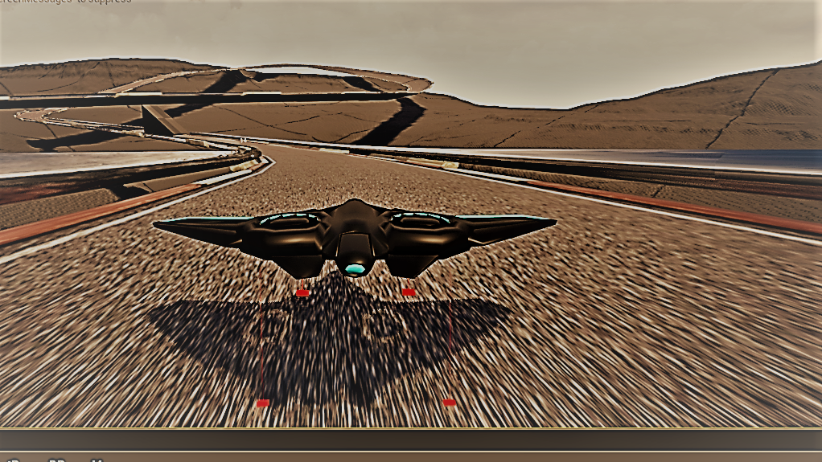

Prepared by:

www.ironbellystudios.com

Table of Contents
OVERVIEWOVERVIEWTalk GAMEPLAY 3
Target Platform / Minimum Hardware: 3
Visual Style 3
Audio Style 3
Starting Out 4
Game start – Main Menu – Character Selection/Creation 4
Game Start and Intro 4
In-Game HUD & Menus 4
Multiplayer (If Applicable) 4
UI 5
Main Menu 5
Player Customization / Store 5
Game setup Screen 5
In-Game Options Menu 5
In-Game HUD 5
Game Over Screen 5
Level Selection 5
Level Types: 6
Full Level List 6
Gamplay 6
Mechanics 6
Controls 6
Modes 6
WINNING THE MATCH 7
Score 7
Currency 7
Challenges of importance 7
Missions and Achievements 7
Assets 7
Characters 7
Weapons 7
Equipment and Upgrades 7
Environmental 8
Audio 8
Back Story 8
CINEMATICS 8

Revision Notes

OVERVIEWOVERVIEWTalk GAMEPLAY
Iridian is a highspeed anti-gravity racing game with the opportunity to eliminate your opponent using projectile weapons.
Iridian is set in the future where humans have gone deep into space and set up mining colonies on alien planets. The mining corporations set up the racing leagues to keep their workers entertained. and keep them from rebelling. For many winning the races is the only chance they will ever have to make a better future.
Race against AI ships or other humans. You can compete in the racing league or just play a single race.
Events are held at various locations currently occupied and controlled by the mining corps. these include.
Desert moons’ alien worlds and large asteroids.

Target Platform / Minimum Hardware:

MINIMUM:

Requires a 64-bit processor and operating system

OS: Windows 7

Processor: i3 2.6Ghz

Memory: 4 GB RAM

Graphics: GTX 560 or equivalent

DirectX: Version 11

Storage: 6 GB available space

RECOMMENDED:

Requires a 64-bit processor and operating system

OS: Windows 10

Processor: i5 2.6Ghz

Memory: 8 GB RAM

Graphics: GTX 960 or equivalent

DirectX: Version 11

Storage: 6 GB available space


Visual Style
Simple low poly art style. Desert environment with canyons to race through.
Art style will be similar to the triangulated style you see a lot with VR/Indie games but with less visible triangle’s and smoother mesh normals.

Reference image for skybox (http://planewave.com/ngc-6960-veil-nebula-19/)
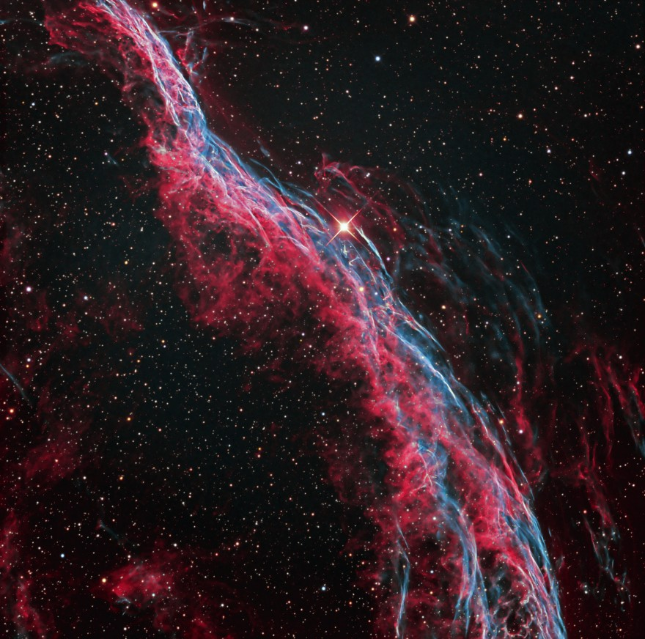
Morphite-android. I like the Rock shapes
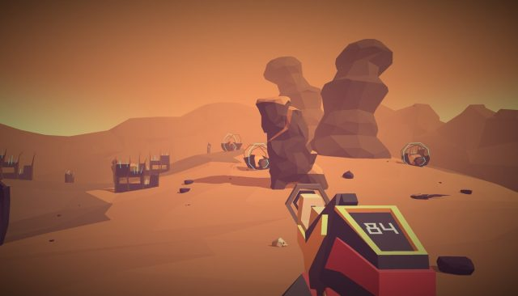Reference image Death Valley (Artists-Drive-Death-Valley-Featured-Image)
I like the color and depth of this image
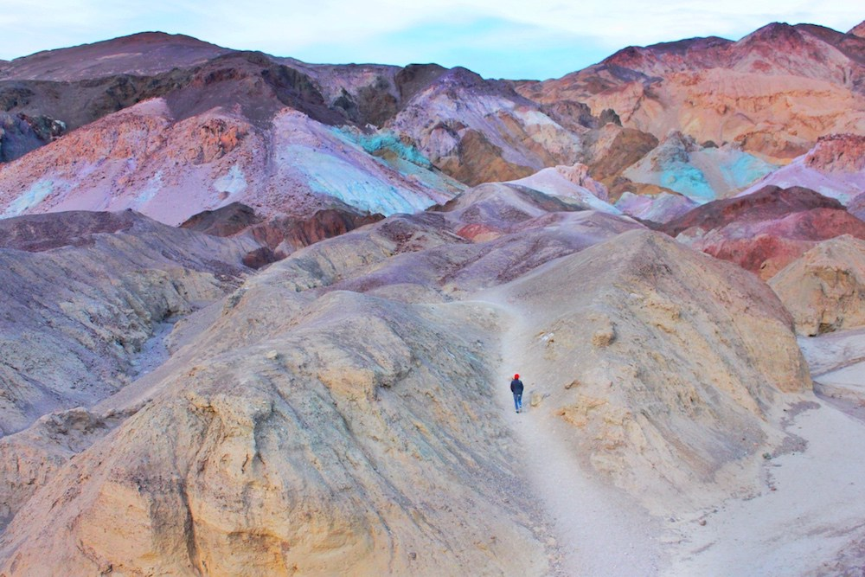

Reference Art. Star wars episode one
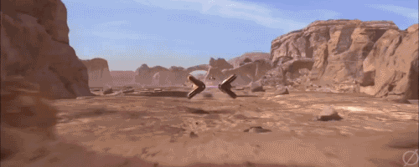

I like the rock formation shapes in this image
Concept art. Created Using world creator 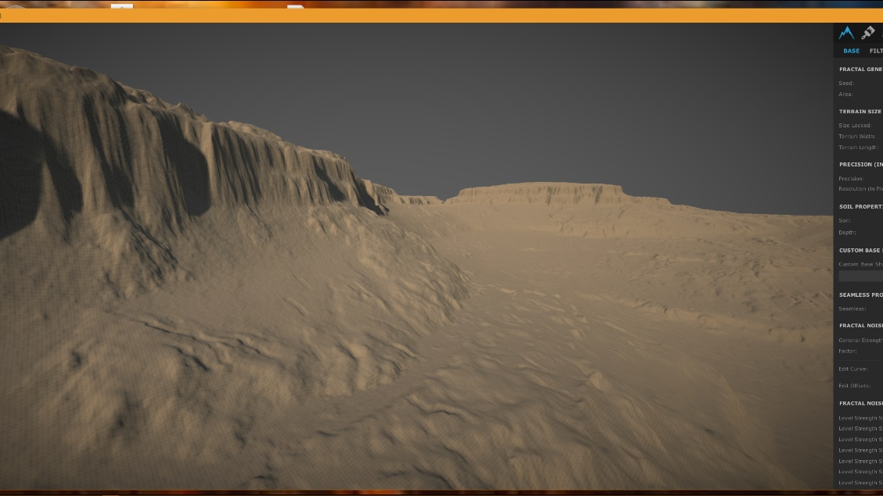
Track reference Art (Redout) I like the style of the track and the translucent look.
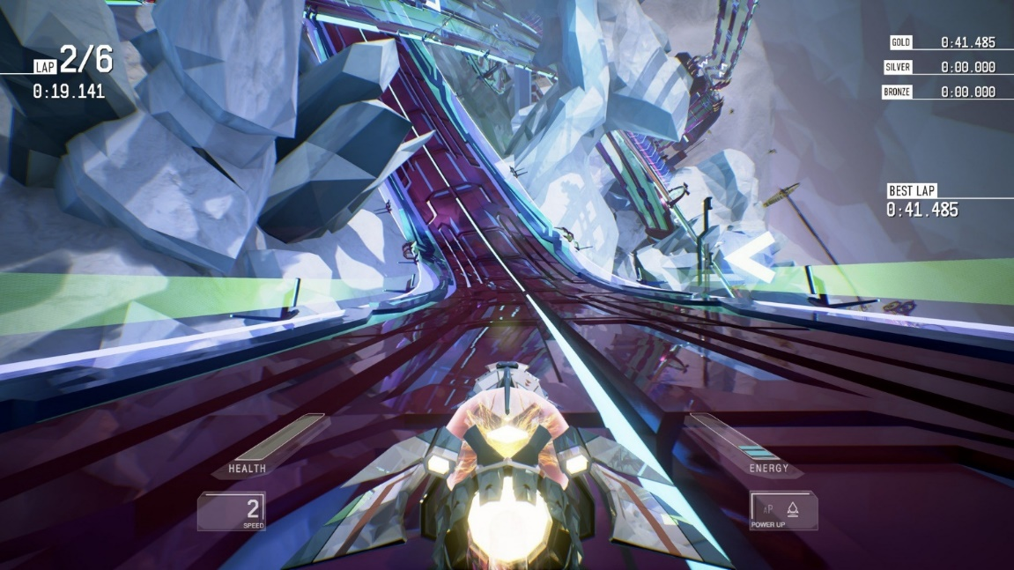

Witch Race. I like the shape and style of the cliffs and the stone arc.
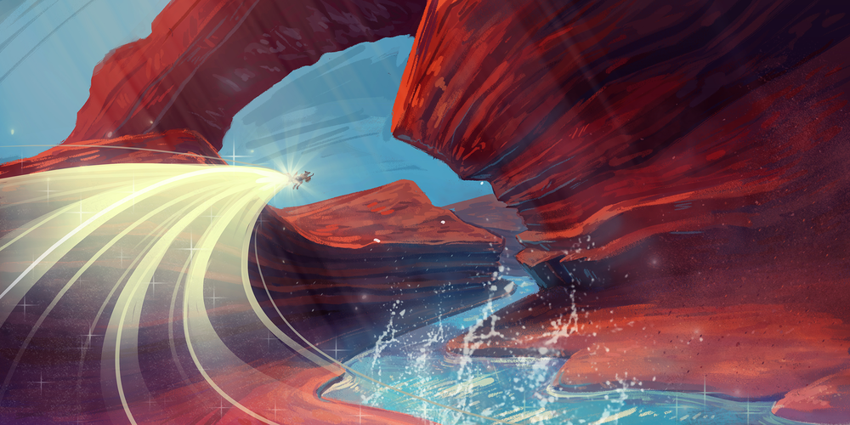

Audio Style

Drum and bass/fast pasted dance music.

Noisia & The Upbeats - Dead Limit

Noisia - Block Control VIP
Black Sun Empire & Concord Dawn - The Sun (Evol Intent Remix)

B-complex ft Jan Werich - Past Lessons For The Future
Audio effects style
Sci fi lasers
Ship engines will be discreet electric motor/air escaping.
Example (wipeout 2097)

Sci fi Cinematic weapons
Example (Rogue One: A Star Wars Story - Space & Aerial Battle of Scarif)

Starting Out

Game start – Main Menu – Character Selection/Creation
While the game is loading. Our company logo and the ue4 logo will be displayed.
The first menu has 3 options single player multi player and settings.
After choosing either single or multi player you will get the option to select a ship.
There is no option to modify ships or upgrade weapons.
Options are selected by moving the analog controller and pressing the A button.
B button takes you back to the previous menu. If using a computer keyboard the arrow keys are used to navigate and enter is used to select your desired option. Esc takes you back to the previous menu.

Game Start and Intro

After choosing a ship the player gets the option to play either a single or multi player race.
As a single player you will be able to race in a league or a single race.
When competing in a league Player’s will have to get 3rd place or better to move on to the next race.
Tracks are unlocked by playing the league. Once a track has been unlocked it can be played as a single race.
Multi player is either via LAN or steam.
Maximum 4 players.
For LAN you will have the choice to either host a game or join a game.
Players will vote on which track to race on before each race starts.

In-Game HUD & Menus
The HUD will display the players race position’ the number of racers in total. The ships current speed and engine force. Your current weapon a mini map and the amount of boost’s left.
Pressing start (controller) or Esc(keyboard) will pause the game and bring up the in-game menu.
In the in-game menu you will be able to adjust the audio effects and music volume’ display resolution and shadow/detail quality. Their will also be an option to go back to the main menu.

Multiplayer (If Applicable)
Multi player will have a maximum of 4 players.
Players will be paired at random. Once 2 or more players have joined a party, they will be able to vote on which track they would like to play and start a race.
the in-game menu will allow you to adjust the audio effects and music volume’ display resolution and shadow/detail quality. And leave the race by going back to the main menu. While in multi-player mode this will not pause the game.
Upon finishing your final position and the position of all the other racers will be displayed.
Your best lap and race time will be added to the leader board and you will be returned to match making.

UI

Main Menu
The main menu’s will be wire frame text box’s over the top of dulled out images of the tracks and ships from the game.
Options are selected by moving the analog controller and pressing the A button.
B button takes you back to the previous menu.
If using a computer keyboard the arrow keys or mouse are used to navigate and enter or left mouse click is used to select your desired option. Esc takes you back to the previous menu.
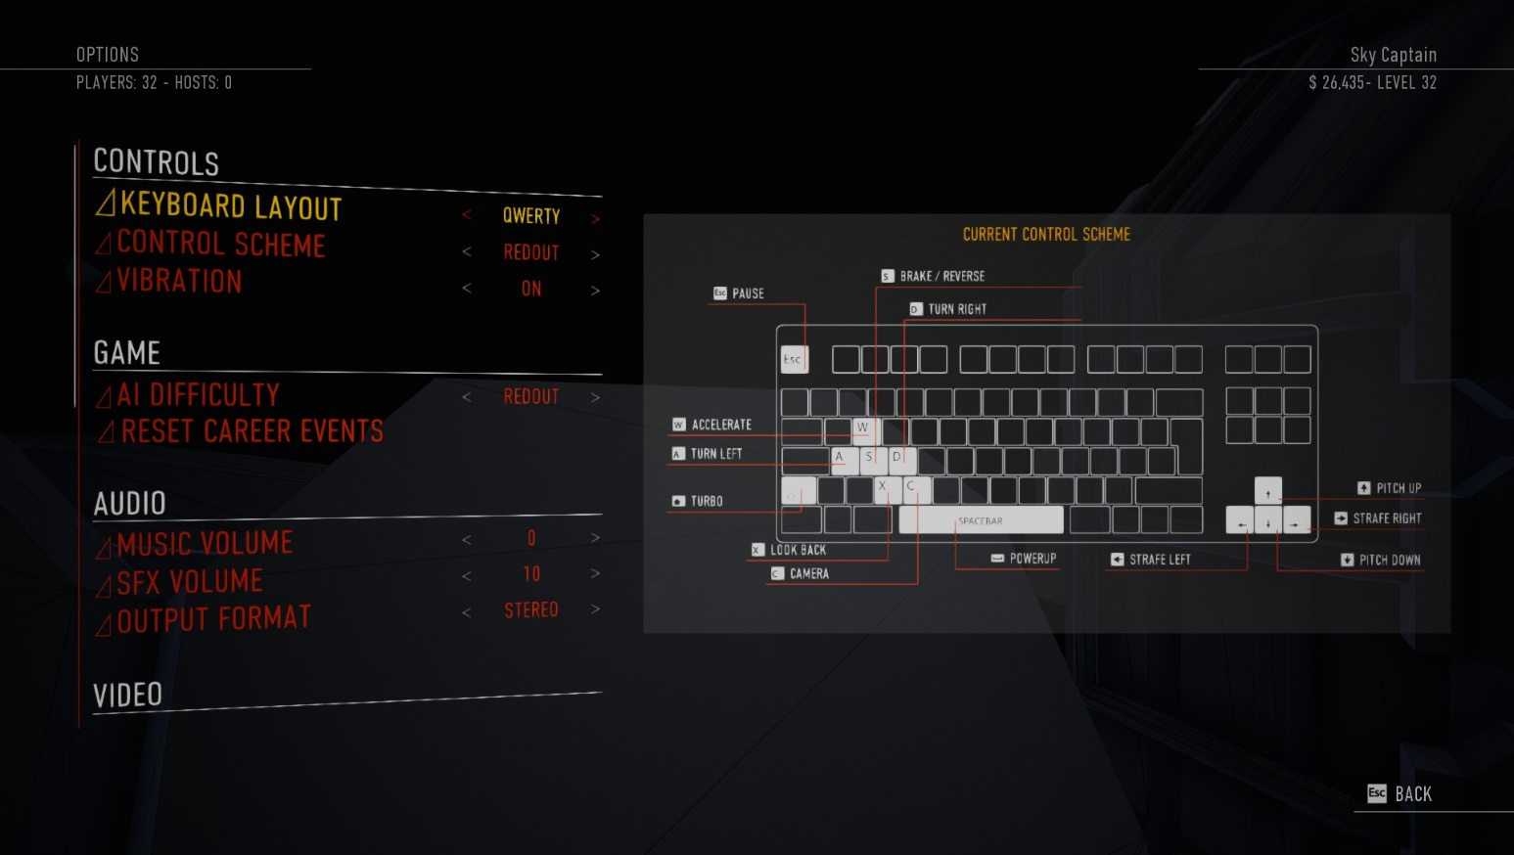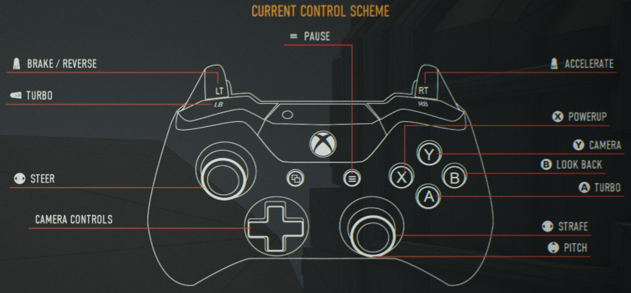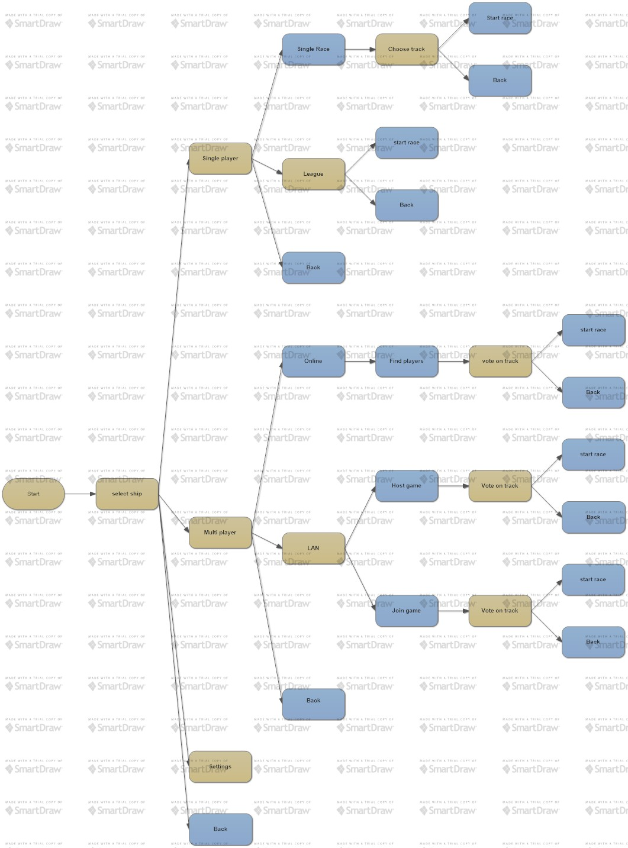

Player Customization / Store
Ships will not be customizable

Game setup Screen
Game setup is as short as possible with a maximum of six screens before the player gets to start a race. 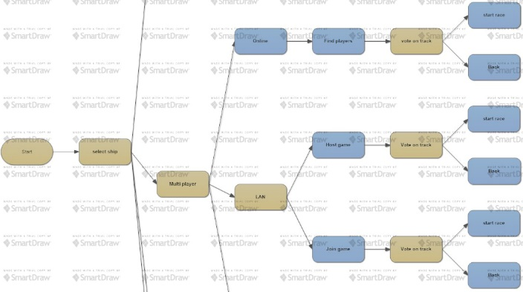 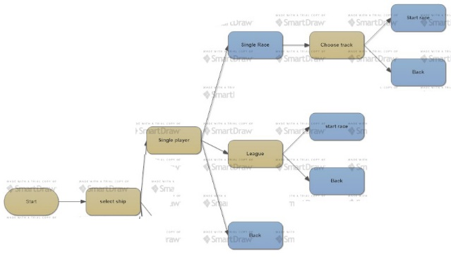

In-Game Options Menu
The only in-game options will be to adjust audio and sound effects volume.
Adjust resolution and shadow quality.
Quit to main menu.
This menu will be accessed by pressing start or Esc.

In-Game HUD
The HUD will display the players race position the number of racers in total. The ships current speed and engine force. Your current weapon a mini map and the amount of boost’s left will also be displayed.
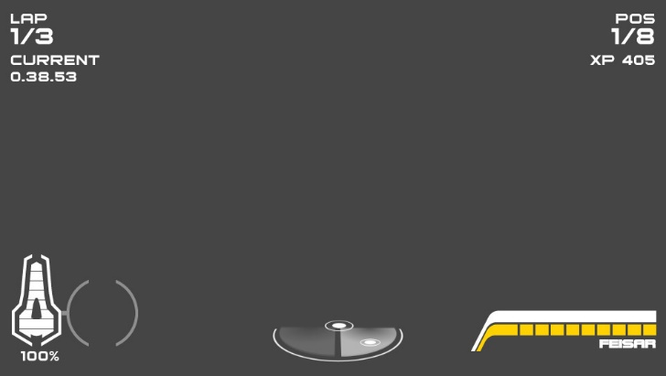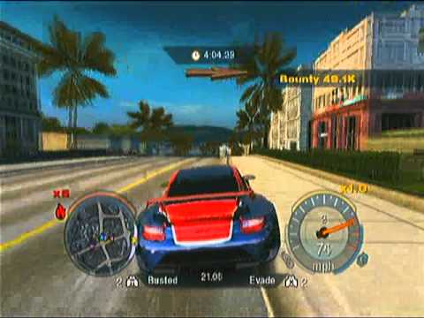

Game Over Screen
Your finishing position and that of your fellow racers will be displayed.
Your fastest lap and race times will be added to the leader board.

Level Selection
Level’s will be unlocked by playing the racing league. Once a level has been unlocked in the league players will be able to play it in single race mode. When you start a new profile only the first track is available.

Level Types:
There will be 3 level types. The first level type will be about speed and getting used to the ship’s controls. it will also have more boost and fewer weapon pickups.
The second level type will be more about weapons. it will also have a higher number of difficult turns and fewer boost pickups.
In the third level use of airbrakes will be essential as corner difficulty and frequency will be increased.

Full Level List
Iridian 09
Track 01
Track 02
Track 03
Death canyon
Track 01
Track 02
Track 03
The Asteroid mines
Track 01
Track 02
Track 03

Gamplay
After selecting a ship and choosing a game-mode and track you can start a race.
The objective of the race is to win. You can do this by trying to get to the finish as quickly as possible or by slowing down or eliminating other racers with the use of weapons. weapons are picked up along the way. You may choose to pick up boosts instead of weapons.
Boosts will be placed mainly along the apex race line whereas weapons will not be.
If your apex line is blocked by another ship you may go for a weapon instead of a boost
The game is based around making the player feel adrenalin and a sense of achievement.
The track is the only part of the environment players can interact with. If you come off the track, you will be recovered back onto it.
Staying alive and finishing first are the main challenges. Players are rewarded by the unlocking of ships and tracks.
There is no cooperative game type. up to four players can play against each other in single race mode. league race is only single player

Mechanics
The tracks are divided into checkpoints you must reach the checkpoints within a certain timeframe.
Ships will be able to strafe a small amount.
When the ship is in the air i.e. going over a ramp you will be able to adjust the pitch of the ship to either gain or reduce height.
Players will start with 100 health. Health can be picked up along the way.
There will be rockets, homing missiles, and mines. Each will remove 30 health.
If health is under 20 all weapons pickups will be substituted for health.

Controls
Right trigger is accelerator and left trigger is brake/reverse.
Left joystick to turn and pitch. Pitch only works while in the air.
Right joystick strafe.
Left and right bumpers are air brakes.
A button is fire weapon.
B button to use boost.
Start button pause’s the game if in single player mode. and brings up the in-game menu
If playing multi-player, the start button just brings up the in-game menu.

Modes
Single race
League race
Multi player race
Battle mode?

WINNING THE MATCH
In a single race. you must cross the finish line in first position to win.
In a league race. you must finish in 3rd position or higher to continue to the next race.

Score
Score is determined by your final race position

Currency
No money

Challenges of importance
Once you have unlocked a track by playing the league you can race on it in a single race mode.

Missions and Achievements
You Can Complete the league and get either gold silver or bronze by getting at least 1st 2nd or 3rd place in every race.

Assets
Modular track for spline-based system.
Raceway/Track tris 300-500 tris, 2k texture
Side barriers 500-700 tris, 2k texture
Signage 200-500 tris, 512 textures
Boost pads 200-500 tris, 512 textures
Health pickup 200-500 tris, 512 textures
Mine 200-500 tris, 512 textures
Ship 6k tris max, 2k texture
all the ships will have the same skeletal mesh. The skeletal mesh will have one socket for each of the two wing flaps.
Flaps will be connected to the sockets. the flaps will be animated so as they tilt when the ship corners or the air brakes are applied.
The ships will be modeled UV Mapped and animated using Maya. Texturing will be done in substance painter.

Desert assets.
Two to three large cliff assets to block out large areas. 2k-4k tris, 2k tile-able textures.
Two to three medium rock formations to break up the larger areas and add layering. 1-2k tris, 2k tile-able textures.
Two to three smaller boulders to add around base of rock formations for more break up and layering. 500-1k tris, 1k tile-able textures.
Two to three small/medium rocks for scattering using the foliage painting system to add variation to open areas. 100-200 tris, 1k tile-able textures.

Texture scale will be controlled using UE4 LOD Bias in Mip gen settings to get consistent texel density.

Characters
Ships will be in two classes. One class will have higher speed and less maneuverability
And one class will have more maneuverability and less speed.
All ships will have the same skeletal mesh which will have animation for steering/airbrake flaps on the wings.
Sounds needed
Engine sound
Ship turning sound
Health low warning
Missile locked on

Weapons
Homing missile/rocket:
-30 health
Rocket (will be reskinned for rocket)
Particle effects for booster and explosion
Roaring Sound when being fired.
Bang/explosion when it hits its target.
The same Particle and audio effects will be used for rockets and homing missiles.
Mine:
-30 health
A click sounds when you drop a mine
Audio and particle effects will be reused from homing missile.

Equipment and Upgrades
Ships are not upgradeable

Environmental

landscape
The landscape will be a 2k-4k height map made in world creator.
heat maps will be exported and used in ue4 to layer multiple materials together using a master material to make erosion/cliff/sediment layers and even path layers if required.

sky sphere
the sky sphere will be created using Spacescape.
it will be a 4k single dds cube map.

Audio
There will be an audio track/FMod sound asset for each race-track
And an FMod sound asset for the main UI.
A discreet bleep will be used to let the player know they have selected an option.
The sound track will be available as a separate DLC.

Back Story
Earth has run out of resource’s and mankind has spread out across space in search of metals and other minerals essential to are survival.

CINEMATICS
When a race is started a cinematic will show the race track from the sky. the camera will then zoom in behind the start line showing your starting position.

