Changing attitudes towards disabled people  The Welsh Government released in 2018 a consultation: Action on disability: the right to independent living. This looked at suggestions and opinions from disabled people on what they wanted in order to live an independent, life Welsh Government (2018). This has led to the Welsh Government making changes to the final version of Action on Disability: The Right to Independent Living and Action Plan.  The Laws and Legislation that have been put into place have empowered disabled people in many ways.  - They have enabled people with a disability to be included as part of society as equals Humanity and Inclusion (2019).  - Children with a disabilities are able to attend mainstream schools where possible depending on the needs of the child Contact (2019).  - There is an International Day of Persons with Disabilities, in order to promote awareness of disabilities and to highlight the issues that disabled face on a daily basis Humanity and Inclusion (2019).  Prejudices and negative messages about disabilities can affect the choices that people living with these issues make and without the right support can have a negative impact on their lives Anti Defamation League (2017).  As you have read the way able bodied people see people with disabilities has changed dramatically over the years. Discrimination towards people with a disability in the UK seem to be diminishing. However, the prejudice that remains could be extremely harmful to the goal that disabled people are seem and respected as equal member of society Deal (2006)  Useful Websites  www.scope.org.uk  www.Anti-bullyingallliance.org.uk  www.disabiliytnewsservice.com  https://www.gov.uk/browse/disabilities  4 |  |  | Disablism  What is Disablism?  Disablism is a word used to describe prejudice and discrimination towards people that have a disability Scope (2019). It is “Discriminatory, oppressive, abusive behaviour arising from the belief that disabled people are inferior to others” (Miller et al, 2004).  Negative attitudes based on prejudice or stereotype can stop disabled people from having equal opportunities. This is sometimes referred to as disablism. (Scope, 2019,2)  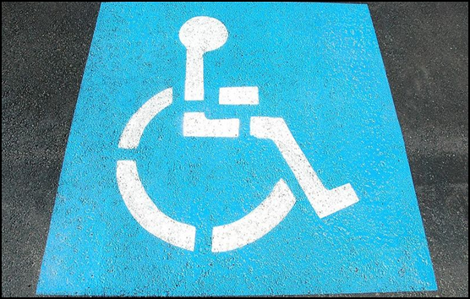  “Persons with disabilities should be guaranteed equal opportunity through the elimination of all socially determined barriers, be they physical, financial, social or psychological, which exclude or restrict full participation in society” (Yee, no date).  1
Legislation and law’s effecting people with a disability  Historically a person with a disability impairment was not treated in the same way as a normal healthy person. It wasn’t until 1601 when the laws and legislations started to change and look at disabilities in a more favourable way. All previous legislation was consolidated, and The Poor Law was introduced. This law made financial provision for a person dependant on charity and this Law included people with disabilities Moorhouse (no date): The Health Foundation (2019): NHS (2013). The Poor Law Amendment Act 1834 was amended. This law was a step backward regarding the care of a person that was disabled or mentally impaired because if they were unable to survive ‘the workhouse test’ (National Health Service (NHS), 2013) it resulted in them being forced into institutions The National Archives (2019).  There were numerous acts put into to place over the years, but it wasn’t until 1944 that The Disabled Persons Employment Act was introduced to help those that needed to work in order to survive but had a disability. The Act required an employer with more than 20 employees to have ensure that at least 3 percent of their staff have a disability Crawshore (2016): NHS (2013). Then in 1970 The Chronically Sick and Disabled Persons Act was introduced. This was the first Law in world recognised disabled people and gave them rights. This was the start of Local Authorities being made accountable to ensure they provided disabled people with adequate housing, health care and assistance NHS (2013).  In 1995 the Disability Discrimination Act was introduced, this made it illegal to discriminate against a disabled person in all areas, such as employment, services and it meant that providers had to make changes to allow disabled people to gain access to their services NHS (2013): RNIB (no date).  The next big change was in 2010 when the UK Government ratifies the United Nations Convention on the Rights of People with Disabilities. This applied to all disabled person in the UK, at the time there were 12 million people living with a disability. Also, in 2010, The Equality Act 2010 was passed by Parliament which made it illegal to discriminate direct and indirectly against a person with a disability, Social Care Institute for excellence (2010): NHS (2013).  3 |  |  | What are the different theories of disability?  The Medical Model of Disability - Historically doctors have seen the disability as the problem The Alliance for Inclusive Education (2019). Instead of looking at what the person needs, the medical model looks at what is wrong with the person Scope (2019)2. This view of people with a disability can lead to people losing control of their lives by not getting a choice and others having low expectation of them Scope (2019)2. This type of view leads to disablism.  The Social Model of Disability - In the 1980s the view of disability changed, and a different perspective was developed. The social model states that it is society itself that is causing the person to be disabled. |t describes people as being disabled by the environment around them through the barriers in society, and not the disability itself Scope (2019). That society needs to change in order to take into account the persons requirements The Alliance for Inclusive Education (2019): Reeve, D. (2015)  Statistics  ♦ Over two thirds of young disabled people believe they can’t join in with friends (Miller ,Gillinson & Huber, 2006).  ♦ One in four people with a disability say that negative attitudes from other travellers prevent them from using public transport The Telegraph ( 2018).  ♦ There are approximately 300,000 disabled people living in unsuitable housing Siddique (2014).  ♦ Only 19% of disabled people of working age are in employment in the UK, Parliament (2019).  There are currently 13.9 million disabled people in the UK (Scope, no date: The Department for Work and Pensions, 2018)  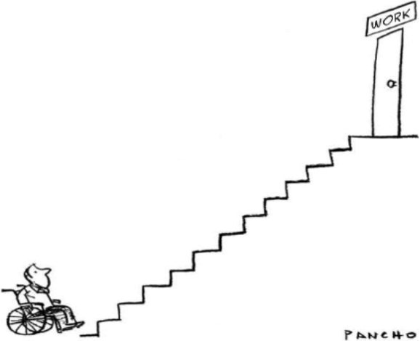  45% are people of pensionable age  19% are adults of working age  8% are children  2  Council of Europe, 2017)
Rationale  The front page of the leaflet has the word disablism in large bold print in order to be eye catching, along with a well know picture representing disabilities. The description of disablism is on the front so that people reading it can clearly see the what information will be contained in the leaflet. There are also a couple of quotes in relation to disablism to maintain the readers interest.  The second page talks about some of the theories in relation to disabilities and how it effects not only the people living with disabilities but also the people around them. It then goes on to point out to the reader some relevant statistics of how many people living in the UK have a disability. It also has statistics of how people’s opinions and judgements can impact on how they live their lives as well as statistics on the struggle disabled people have to get suitable housing. It also contains a picture highlighting a problem a disabled person may face and how society allows this to happen, as if a ramp was installed there would be no barriers.  1 |  |  |  | The third page goes into depth how disabled people have been looked at by able bodied people through the ages. It highlights that until the middle of the twentieth century, people with a disability were considered a nuisance, as less important. It highlights some of the current relevant legislation in relation to people living with a disability and shows how attitudes and law have changed in order to protect their rights.  The fourth and final page looks at how far the UK has come regarding how disabled people treated and viewed by others. It shows that they are now valued members of society. However, the closing paragraph highlights that not all discrimination has been stamped out and that the prejudice that remains could potentially be harmful to future efforts for change.  2

