Appendix - A
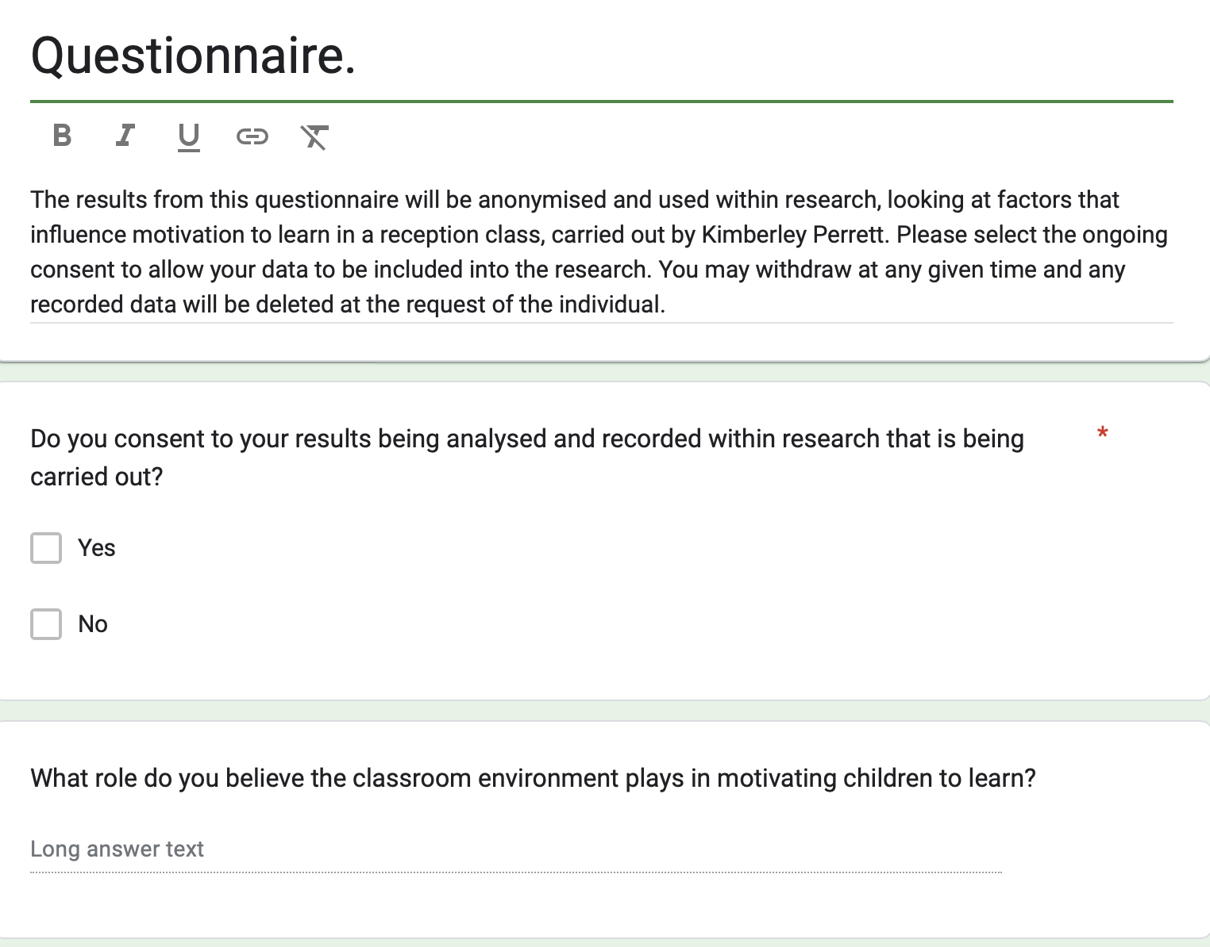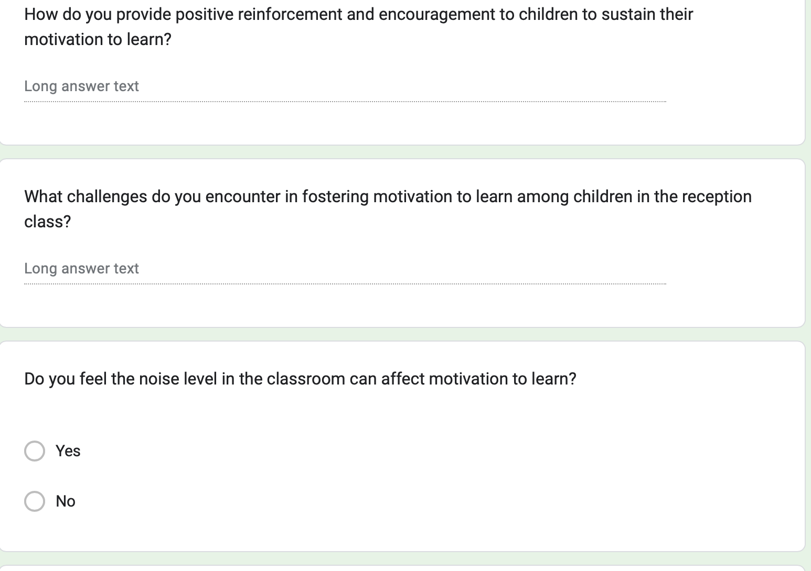
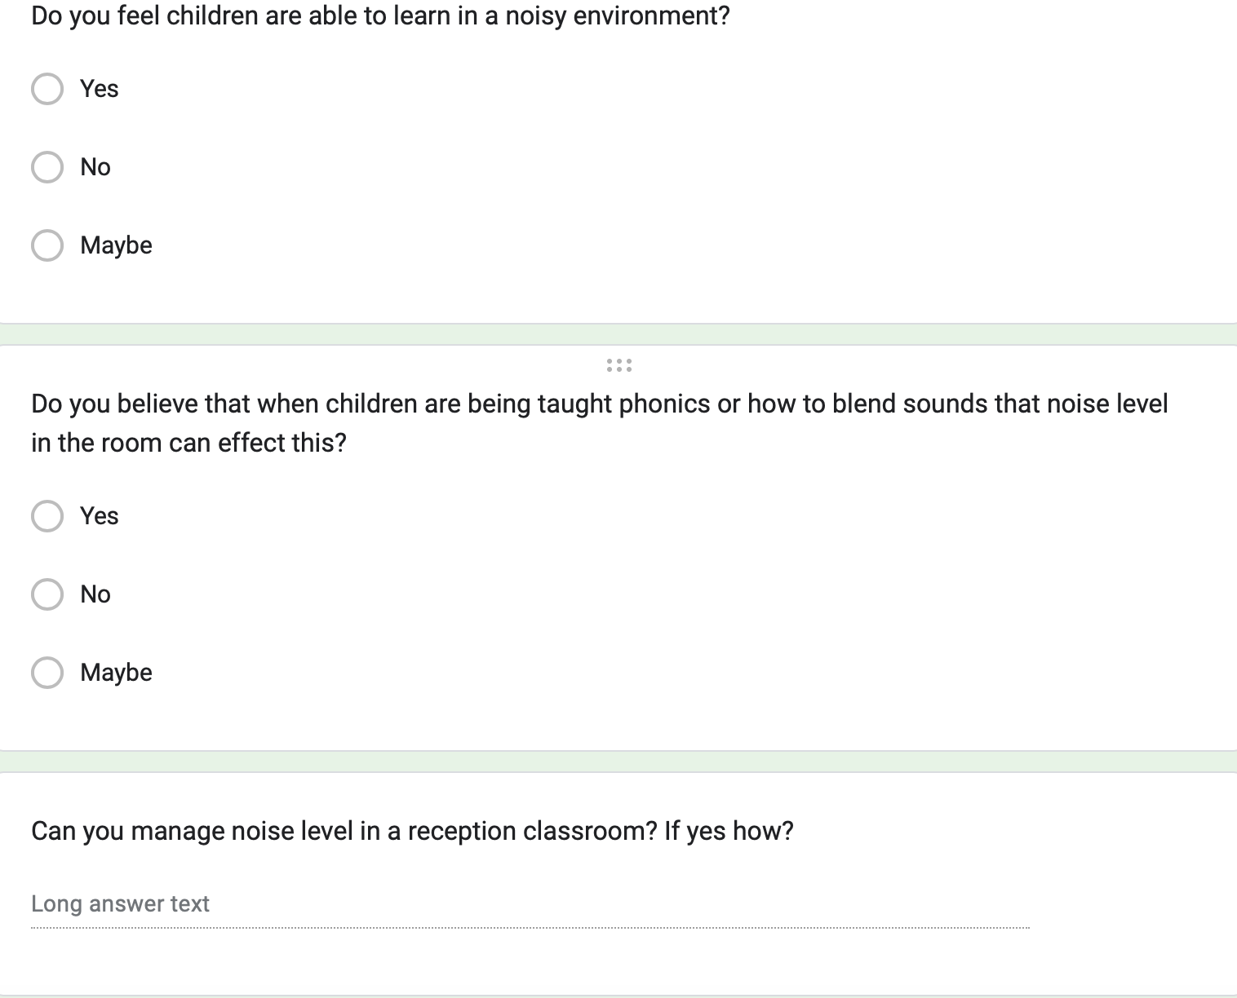
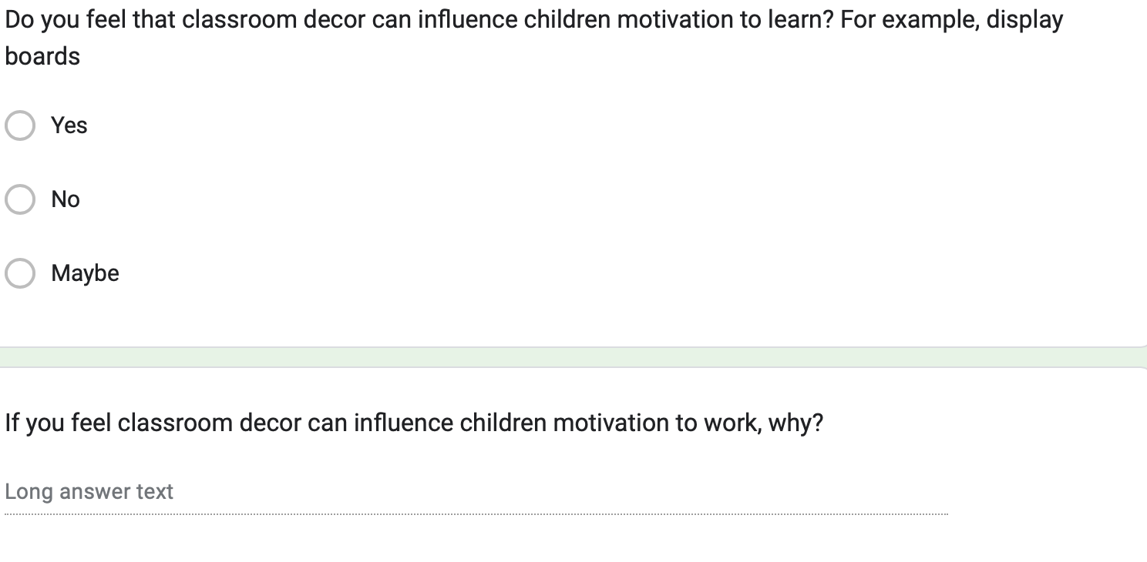

Appendix B
Interview questions for the children that took place during the morning session in the library.
- What do you like about your classroom?
- When do you think the classroom is loud?
- When do you think the classroom is quiet?
- Are there any times when the classroom is too noisy?
- Do you ever get distracted by noise?
- Are there any rules in the classroom about noise?
- Can you think of any time when it’s important for the classroom to be quiet?
- What do you think the teacher can do to help the noise in the classroom?
- How do you think the display boards help us with our learning?
- What do you like about the display boards in our classroom?
- Do you think the display boards make our classroom look more inviting?
- How do you feel when the teacher gives you a sticker?
- What kinds of things do you do to earn stickers from your teacher?
- Do you think getting stickers makes you want to work harder?
- When you are allowed to use the outdoor area during class time how does that make you feel?
- Do you think the classroom is quitter or louder when you are allowed to play outside?
- Are the rules the same in school during the week?

Appendix C - Observation schedule

Observation | Date and Time
Narrative observation focusing on factors that influence children motivation to learn. | 15th April 2024. 9:15am.
Observation using Leuven scale, focusing on children’s involvement in learning. | 17th April 2024, 1:30pm.
Narrative observation focusing on factors that influence children motivation to learn. | 18th April 2024, 9:15 am.
Observation using Leuven scale, focusing on children’s well-being. | 19th April 2024, 11:00 am.

Appendix D- Letter to parents about the research.
Dear parent/Guardian,
Your child has been invited to take part in a research study. To help you understand what the research is about and why it’s being done and what it will involve, please take some time to read the following information. Carefully.
Who I am and what is this research all about?
My name is Kimberley Perrett, and I am a student teacher currently completing my PGCE, for me to complete this I need to undertake a research project within a reception class. The aim is to identify factors that influence children’s motivation to learn.
What will taking part involve?
I will be collecting data on this through observing the children in the classroom, carrying out semi- structured interviews in the library during school time, that will take around 10 minutes to complete. A copy of the interview questions will be available if requested.
Does my child have to take part?
You are free to decide whether your child is involved in this research. If you do not want your child to be involved, please let your class teacher know. Additionally, on the days when data is being collected, it will be made clear to the children that their consent can be withdrawn at any time, furthermore their ongoing assent will be approved from each child prior to collecting any data.
Will taking part be confidential?
I will not ask for or retain any personal data pertaining to a pupil within the research. Consent will be handled via the school and so children’s personal information will not be held by myself. The only data collected will be through observations or interviews with the children.
What will happen to the research?
The results of this study will be collated, analysed, and presented in an academic written assignment that will contribute to the accreditation of my PGCE.
Thank you for taking the time in reading this information sheet about this research study. If you have any further questions or you would like to meet me, I will be present at the gate during drop off or collection.
Kind regards.

Appendix E- Ethics Form.
APPLICATION FOR ETHICAL APPROVAL

RESEARCH STUDENTS
This form is to be completed by the student within SIX months for full-time students and TWELVE months for part time students, after the commencement of the research degree or following progression to Part Two of your course.

Once complete, submit this form via the MyTSD Doctoral College Portal at (https://mytsd.uwtsd.ac.uk).

This document is also available in Welsh.

RESEARCH STAFF ONLY
All communications relating to this application during its processing must be in writing and emailed to pgresearch@uwtsd.ac.uk , with the title ‘Ethical Approval’ followed by your name.

STUDENTS ON UNDERGRADUATE OR TAUGHT MASTERS PROGRAMMES should submit this form (and receive the outcome) via systems explained to you by the supervisor/module leader.

In order for research to result in benefit and minimise risk of harm, it must be conducted ethically. A researcher may not be covered by the University’s insurance if ethical approval has not been obtained prior to commencement.

The University follows the OECD Frascati manual definition of research activity: “creative work undertaken on a systematic basis in order to increase the stock of knowledge, including knowledge of man, culture and society, and the use of this stock of knowledge to devise new applications”. As such this covers activities undertaken by members of staff, postgraduate research students, and both taught postgraduate and undergraduate students working on dissertations/projects.

The individual undertaking the research activity is known as the “principal researcher”.

Ethical approval is not required for routine audits, performance reviews, quality assurance studies, testing within normal educational requirements, and literary or artistic criticism.

Please read the notes for guidance before completing ALL sections of the form.

This form must be completed and approved prior to undertaking any research activity. Please see Checklist for details of process for different categories of application.

SECTION A: About You (Principal Researcher)
1 | Full Name: |  | Kimberley Perrett
2 | Tick all boxes that apply: |  | Member of staff: | ☐ | Honorary research fellow: | ☐
 | Undergraduate Student | ☐ | Taught Postgraduate Student | ☒ | Postgraduate Research Student | ☐

3 | Institute/Academic Discipline/Centre: | University of Wales Trinty Saint Davids
4 | Campus: | Swansea Campus
5 | E-mail address: | 2300401@student.uwtsd.ac.uk
6 | Contact Telephone Number: | 07930716113
 | For students:
7 | Student Number: | 2300401
8 | Programme of Study: | Post Graduate Certificate in Education with Qualified Teaching Status in Primary Education.
9 | Director of Studies/Supervisor: | Jo Bamsey.

SECTION B: Approval for Research Activity
1 | Has the research activity received approval in principle?  (please check the Guidance Notes as to the appropriate approval process for different levels of research by different categories of individual) |  | YES | ☒ | NO | ☐
 |  |  |  |  | Date
2 | If Yes, please indicate source of approval (and date where known): Approval in principle must be obtained from the relevant source prior to seeking ethical approval | Research Degrees Committee |  | ☐
2 |  | Institute Research Committee |  | ☐
2 |  | Other Jo Bamsey |  | ☒ | 14/03/24

SECTION C: Internal and External Ethical Guidance Materials
 | Please list the core ethical guidance documents that have been referred to during the completion of this form (including any discipline-specific codes of research ethics, location-specific codes of research ethics, and also any specific ethical guidance relating to the proposed methodology). Please tick to confirm that your research proposal adheres to these codes and guidelines. You may add rows to this table if needed.
1 | UWTSD Research Ethics & Integrity Code of Practice | ☒
2 | UWTSD Research Data Management Policy | ☒
3 | BERA 2018. | ☒

SECTION D: External Collaborative Research Activity
If there are external collaborators then you should gain consent from the contact persons to share their personal data with the university. If there are no external collaborators then leave this section blank and continue to section E.
1 | Institution
2 | Contact person name
3 | Contact person e-mail address
4 | Is your research externally funded? |  | YES | ☐ | NO |  | ☐
5 | Are you in receipt of a KESS scholarship? |  | YES | ☐ | NO |  | ☐
6 | Are you specifically employed to undertake this research in either a paid or voluntary capacity? | Voluntary | YES | ☐ | NO | ☐
7 |  | Employed | YES | ☐ | NO | ☐
8 | Is the research being undertaken within an existing UWTSD Athrofa Professional Learning Partnership (APLP)? | If YES then the permission question below does not need to be answered. | YES | ☐ | NO |  | ☐
9 | Has permission to undertake the research has been provided by the partner organisation? | (If YES attach copy)  If NO the application cannot continue | YES | ☐ | NO |  | ☐

Where research activity is carried out in collaboration with an external organisation
10 | Does this organisation have its own ethics approval system? | YES | ☐ | NO | ☐
 | If Yes, please attach a copy of any final approval (or interim approval) from the organisation (this may be a copy of an email if appropriate).

SECTION E: Details of Research Activity
1 | Indicative title: | What are the factors that influence children motivation to learn in a reception class.
2 | Proposed start date: | 14.03.24 | Proposed end date: | July 31st 2024
Introduction to the Research (maximum 300 words per section)
Ensure that you write for a Non-Specialist Audience when outlining your response to the points below:
- Purpose of Research Activity
- Proposed Research Question
- Aims of Research Activity
- Objectives of Research Activity
Demonstrate, briefly, how Existing Research has informed the proposed activity and explain
- What the research activity will add to the body of knowledge
- How it addresses an area of importance.
3 | Purpose of Research Activity  To find out factors that influence children's motivation to learn in a reception class, this could be positive or negative influences.  The findings of my research will allow me to develop as a teacher and have an impact on my future teaching profession by understanding of the factors that influence learning.  (this box should expand as you type)
4 | Research Question  What are the factors that influence motivation to learn in a reception class?  (this box should expand as you type)
5 | Aims of Research Activity  The aim of this research is to improve my understanding of the learners view of factors that influence their ability to learn. Furthermore, exploring the perceptions of the teaching staff.  (this box should expand as you type)
6 | Objectives of Research Activity  - I will be exploring relevant literature on the proposed question to gain a wealth of perspectives and enhance my knowledge to carry out the research effectively.  - I will be selecting a representative sample of participants with support from my mentor to enable a diverse approach to take place.  - I will be using a variety of research methodology to collect data from a diverse group.  - I will analyse the data and consider the limitations to my research.  (this box should expand as you type)
Proposed methods (maximum 600 words)
Provide a brief summary of all the methods that may be used in the research activity, making it clear what specific techniques may be used. If methods other than those listed in this section are deemed appropriate later, additional ethical approval for those methods will be needed. You do not need to justify the methods here, but should instead describe how you intend to collect the data necessary for you to complete your project.
7 | I will be carrying out observations with participants knowledge, to gain an understanding on how the classroom works daily and identify barriers and motivations to learning. I will consider the Hawthorne effect during this. I will undertake the interviews in familiar surrounds in the school library so that participants feel at ease, I will be do this during the first lesson of the day to minimises disruptions, I will carry out observation during my teaching, but will also carry out observations of other teachers over a period.  I will be using digital questionnaires for the staff that will be anonymised, they will be given at the end of the day. They will contain open and closed ended questions to gain the perceptions of teaching staff to consider their opinions whilst carrying out my research. They will have the opportunity to not answer all questions if they do not want to share their opinion. They work with the children daily and know the children and the environment best. This perception of teachers will enhance the validity of my research.  I will be carrying out interviews in public places such as the library, with children individually or at the end of lessons I am teaching in the classroom with others present.  This allows the children to have a voice and enable me to gain their perspectives. I will consider the child’s feelings and offer a range of ongoing mental health and wellbeing assessments, to ensure that their mental health and wellbeing is paramount. I will do this by providing happy and sad faces, I will remind them that they do not have to answer every question and complete check ins during the interviews. I will record these interviews so I can engage with the children fully and ensure I am collecting reliable data and analyse verbatim. All data will be anonymised, participants will be coded to protect identity. The interviews will consist of a variety of pre-planned questions to explore the research area.  Adult participants must give consent to participate and will have the right to withdraw. Parental consent must be given for children aged under 18 years; however, children must also provide assent during the research.  (this box should expand as you type)
Location of research activity
Identify all locations where research activity will take place.
8 | A reception classroom in a primary school in the South Wales area.  (this box should expand as you type)
Research activity outside of the UK
If research activity will take place overseas, you are responsible for ensuring that local ethical considerations are complied with and that the relevant permissions are sought. Specify any local guidelines (e.g. from local professional associations/learned societies/universities) that exist and whether these involve any ethical stipulations beyond those usual in the UK (provide details of any licenses or permissions required). Also specify whether there are any specific ethical issues raised by the local context in which the research activity is taking place, for example, particular cultural and/or legal sensitivities or vulnerabilities of participants. If you live in the country where you will do the research then please state this.
9 | (this box should expand as you type)

10 | Use of documentation not in the public domain: Are any documents NOT publicly available? | NO | ☒
10 |  | YES | ☐
11 | If Yes, please provide details here of how you will gain access to specific documentation that is not in the public domain and that this is in accordance with the current data protection law of the country in question and that of England and Wales.  (this box should expand as you type)

 | Does your research relate to one or more of the seven aims of the Well-being of Future Generations (Wales) Act 2015? | YES | NO
12 | A prosperous Wales | ☒ | ☐
13 | A resilient Wales | ☒ | ☐
14 | A healthier Wales | ☒ | ☐
15 | A more equal Wales | ☒ | ☐
16 | A Wales of cohesive communities | ☐ | ☒
17 | A Wales of vibrant culture and thriving Welsh language | ☐ | ☒
18 | A globally responsible Wales | ☐ | ☒
19 | If YES to any of the above, please give details:
Researching factors that influence children's learning directly corressponds to the seven wellbeing goals by addressing various facets crucial for holistic development. Firstly, understanding cognitive and socio-emotional factors affecting learning contributes to the goal of "good mental health." By identifying effective teaching methods and supportive environments, it promotes "quality education" and "positive relationships." Moreover, investigating socio-economic influences on learning aligns with the goals of "adequate standard of living" and "economic security." Additionally, recognising and accommodating diverse learning styles fosters "inclusion and participation" while promoting "physical health" through active engagement in learning activities. Overall, such research endeavours strive to optimise children's learning experiences, thereby nurturing their overall wellbeing across multiple domains.

(this box should expand as you type)

SECTION F: Scope of Research Activity
 | Will the research activity include: | YES | NO
1 | Use of a questionnaire or similar research instrument? | ☒ | ☐
2 | Use of interviews? | ☒ | ☐
3 | Use of focus groups? | ☒ | ☐
4 | Use of participant diaries? | ☐ | ☒
5 | Use of video or audio recording? | ☒ | ☐
6 | Use of computer-generated log files? | ☐ | ☒
7 | Participant observation with their knowledge? | ☒ | ☐
8 | Participant observation without their knowledge? | ☐ | ☒
9 | Access to personal or confidential information without the participants’ specific consent? | ☐ | ☒
10 | Administration of any questions, test stimuli, presentation that may be experienced as physically, mentally or emotionally harmful / offensive? | ☐ | ☒
11 | Performance of any acts which may cause embarrassment or affect self-esteem? | ☐ | ☒
12 | Investigation of participants involved in illegal activities? | ☐ | ☒
13 | Use of procedures that involve deception? | ☐ | ☒
14 | Administration of any substance, agent or placebo? | ☐ | ☒
15 | Working with live vertebrate animals? | ☐ | ☒
16 | Procedures that may have a negative impact on the environment? | ☐ | ☒
17 | Other primary data collection methods. Please indicate the type of data collection method(s) below. | ☐ | ☒
 | Details of any other primary data collection method:  (this box should expand as you type) | ☐ | ☒
If NO to every question, then the research activity is (ethically) low risk and may be exempt from some of the following sections (please refer to Guidance Notes).

If YES to any question, then no research activity should be undertaken until full ethical approval has been obtained.

SECTION G: Intended Participants
If there are no participants then do not complete this section, but go directly to section H.

 | Who are the intended participants: | YES | NO
1 | Students or staff at the University? | ☐ | ☒
2 | Adults (over the age of 18 and competent to give consent)? | ☒ | ☐
3 | Vulnerable adults? | ☐ | ☒
4 | Children and Young People under the age of 18? (Consent from Parent, Carer or Guardian will be required) | ☒ | ☐
5 | Prisoners? | ☐ | ☒
6 | Young offenders? | ☐ | ☒
7 | Those who could be considered to have a particularly dependent relationship with the investigator or a gatekeeper? | ☐ | ☒
8 | People engaged in illegal activities? | ☐ | ☒
9 | Others. Please indicate the participants below, and specifically any group who may be unable to give consent. | ☐ | ☒
 | Details of any other participant groups:  (this box should expand as you type) | ☐ | ☒

Participant numbers and source
Provide an estimate of the expected number of participants. How will you identify participants and how will they be recruited?
10 | How many participants are expected? | There will be approximately 15 children of mix gender aged 4-5.  There will be 2 teachers participating in the research.  There will be three learning support assistants participating in the research.  (this box should expand as you type)
11 | Who will the participants be? | There will be children aged 4-5 in a reception class.  Two teachers who job share their role.  Three Learning Support Assistants that work in the class.  (this box should expand as you type)
12 | How will you identify the participants? | I will be working with staffing with in the class of focus in the research.  I will be collaborating with staff to identify the children to participate in the research.  I will be emailing parents to introduce the research being carried out and to gain consent.  (this box should expand as you type)

 | Information for participants: | YES | NO | N/A
13 | Will you describe the main research procedures to participants in advance, so that they are informed about what to expect? | ☒ | ☐ | ☐
14 | Will you tell participants that their participation is voluntary? | ☒ | ☐ | ☐
15 | Will you obtain written consent for participation? | ☒ | ☐ | ☐
16 | Will you explain to participants that refusal to participate in the research will not affect their treatment or education (if relevant)? | ☒ | ☐ | ☐
17 | If the research is observational, will you ask participants for their consent to being observed? | ☒ | ☐ | ☐
18 | Will you tell participants that they may withdraw from the research at any time and for any reason? | ☒ | ☐ | ☐
19 | With questionnaires, will you give participants the option of omitting questions they do not want to answer? | ☒ | ☐ | ☐
20 | Will you tell participants that their data will be treated with full confidentiality and that, if published, it will not be identifiable as theirs? | ☒ | ☐ | ☐
21 | Will you debrief participants at the end of their participation, in a way appropriate to the type of research undertaken? | ☒ | ☐ | ☐
22 | If NO to any of above questions, please give an explanation
 | (this box should expand as you type)

 | Information for participants: | YES | NO | N/A
24 | Will participants be paid? | ☐ | ☒ | ☐
25 | Is specialist electrical or other equipment to be used with participants? | ☐ | ☒ | ☐
26 | Are there any financial or other interests to the investigator or University arising from this study? | ☐ | ☒ | ☐
27 | Will the research activity involve deliberately misleading participants in any way, or the partial or full concealment of the specific study aims? | ☐ | ☒ | ☐
28 | If YES to any question, please provide full details
 | (this box should expand as you type)

SECTION H: Anticipated Risks

Outline any anticipated risks that may adversely affect any of the participants, the researchers and/or the University, and the steps that will be taken to address them.

If you have completed a full risk assessment (for example as required by a laboratory, or external research collaborator) you may append that to this form.
1 | Full risk assessment completed and appended? |  | Yes | ☐
1 |  |  | No | ☒
2 | Risks to participants  For example: sector-specific health & safety, emotional distress, financial disclosure, physical harm, transfer of personal data, sensitive organisational information
 | Risk to participants:  - Emotional distress.  - Disturbance of relationships.  (this box should expand as you type) | How you will mitigate the risk to participants:  - I will ensure access to appropriate support should this become evident and reconsider the approach being taken.  - Work collaboratively with gatekeepers in exploring any issues that may arise in the interviews which may cause distress to the young people taking part in the research.  - I will be clear with the young people regarding the conduct of the interviews, the area to the covered, and their rights to stop the interview or withdraw from it at any time.  - I will consult with staff, parents/guardians, to gain an understanding of personal circumstances of the young people participating in the research to ensure that the interviews are conducted in a sensitive way, and that the interview subject matter does not cause distress.  - I will ensure clarity with all young people and staff regarding the aims and focus of the research.  - I will minimise disturbance of day-to-day activities within the provision due to the research project.  - I will ensure confidentiality and anonymity of those participating in the research at all times.  - I will ensure appropriate and secure storage of data. Reassure participants that the information that they provide will not be disclosed without their consent.  - I will ensure interviews are conducted in a suitably confidential environment.  (this box should expand as you type)
3 | If research activity may include sensitive, embarrassing or upsetting topics (e.g. sexual activity, drug use) or issues likely to disclose information requiring further action (e.g. criminal activity), give details of the procedures to deal with these issues, including any support/advice (e.g. helpline numbers) to be offered to participants. Note that where applicable, consent procedures should make it clear that if something potentially or actually illegal is discovered in the course of a project, it may need to be disclosed to the proper authorities
 | (this box should expand as you type)
4 | Risks to the investigator  For example: personal health & safety, physical harm, emotional distress, risk of accusation of harm/impropriety, conflict of interest
 | Risk to the investigator:  1) Allegations while conducting interviews  2) Concerns of coercion  3)Participants may wish to withdraw.  4) A confidentiality breach due to data being released accidently  (this box should expand as you type) | How you will mitigate the risk to the investigator:  - I will ensure access to a suitable space that secures the confidentiality of the of the participant contributions, whilst also being visible to other colleagues.  - It will be made explicit that participants are free to disengage and that in that event, this will not impact on assessment or outcomes of their programme of study.  - In the case of withdrawal from the student group, discussions would be conducted with the remaining participants and new participants will be recruited, if necessary, who will be fully briefed, and whose informed consent will be sought. For the case of a withdrawal from the staff group, a nominee will be sought in the relevant department/specialism.  - The research will be stored on the UWTSD cloud and any recordings, data or transcript will be password protected in electronic folders on UWTSD systems and subject to university protocols. However, GDPR statements will be included in any participant information and consent and that the researcher has completed training on GDPR and will ensure that all records are kept in secure cloud locations as a precaution and not on any hard drive.  (this box should expand as you type)
5 | University/institutional risks  For example: adverse publicity, financial loss, data protection
 | Risk to the University:  Reputational damage.  (this box should expand as you type) | How you will mitigate the risk to the University:  Ensure adherence to the UWTSD code of ethics and research standards and commonly agreed standards of good practice.  Ensure compliance with data storage regulations and university guidelines and security procedures.  Ensure that research methodology is robust and that methods are appropriate.  Adhere to the UWTSD code of conduct (and also the EWC code of conduct if you are a teacher).  Establish clarity regarding procedures on reporting of disclosures in field work settings.  Work with partners to promote a comprehensive understanding regard the nature of the research in order to avoid misunderstandings and manage expectations.  (this box should expand as you type)
6 | Environmental risks  For example: accidental spillage of pollutants, damage to local ecosystems
 | Risk to the environment:  Carbon footprint.  (this box should expand as you type) | How you will mitigate the risk to environment:  This research activity will mostly use electronic systems reducing the need for bleached paper and need for travel.  (this box should expand as you type)

 | Disclosure and Barring Service
 | If the research activity involves children or vulnerable adults, a Disclosure and Barring Service (DBS) certificate must be obtained before any contact with such participants. | YES | NO | N/A
7 | Does your research require you to hold a current DBS Certificate? | ☒ | ☐ | ☐
8 | If YES, please give the certificate number. If the certificate number is not available please write “Pending”; in this case any ethical approval will be subject to providing the appropriate certificate number.

SECTION I: Feedback, Consent and Confidentiality

1 | Feedback  What de-briefing and feedback will be provided to participants, how will this be done and when?
On request I will be able to share the headline findings from my research.

(this box should expand as you type)
2 | Informed consent  Describe the arrangements to inform potential participants, before providing consent, of what is involved in participating. Describe the arrangements for participants to provide full consent before data collection begins. If gaining consent in this way is inappropriate, explain how consent will be obtained and recorded in accordance with prevailing data protection legislation.
I will be sharing information on the research on the communication platform in the school and ask for consent.

I will maintain ascent throughout using visuals of happy and sad faces to see if they want to continue.
(this box should expand as you type)
3 | Confidentiality / Anonymity  Set out how anonymity of participants and confidentiality will be ensured in any outputs. If anonymity is not being offered, explain why this is the case.
I will maintain confidentiality throughout the research project by not providing any identifiable reference in my work in line with the BERA.

(this box should expand as you type)

SECTION J: Data Protection and Storage

 | Does the research activity involve personal data (as defined by the General Data Protection Regulation 2016 “GDPR” and the Data Protection Act 2018 “DPA”)? | YES | NO
1 | “Personal data” means any information relating to an identified or identifiable natural person (‘data subject’). An identifiable natural person is one who can be identified, directly or indirectly, in particular by reference to an identifier such as a name, an identification number, location data, an online identifier or to one or more factors specific to the physical, physiological, genetic, mental, economic, cultural or social identity of that natural person. Any video or audio recordings of participants is considered to be personal data. | ☐ | X
 | If YES, provide a description of the data and explain why this data needs to be collected:
2 | (this box should expand as you type)
 | Does it involve special category data (as defined by the GDPR)? | YES | NO
3 | “Special category data” means sensitive personal data consisting of information as to the data subjects’ –  (a) racial or ethnic origin,  (b) political opinions,  (c ) religious beliefs or other beliefs of a similar nature,  (d) membership of a trade union (within the meaning of the Trade Union and Labour Relations (Consolidation) Act 1992),  (e) physical or mental health or condition,  (f) sexual life,  (g) genetics,  (h) biometric data (as used for ID purposes), | ☐ | X
 | If YES, provide a description of the special category data and explain why this data needs to be collected:
4 | (this box should expand as you type)

 | Will data from the research activity (collected data, drafts of the thesis, or materials for publication) be stored in any of the following ways? | YES | NO
5 | Manual files (i.e. in paper form)? | ☐ | ☒
6 | University computers? | ☐ | ☒
7 | Private company computers? | ☐ | ☒
8 | Home or other personal computers? | ☒ | ☐
9 | Laptop computers/ CDs/ Portable disk-drives/ memory sticks? | ☐ | ☒
10 | “Cloud” storage or websites? | ☐ | ☒
11 | Other – specify: | ☐ | ☒
12 | For all stored data, explain the measures in place to ensure the security of the data collected, data confidentiality, including details of backup procedures, password protection, encryption, anonymisation and pseudonymisation:
The data will be stored on a personal laptop and will be protected by fingerprint ID.

(this box should expand as you type)

 | Data Protection
 | Will the research activity involve any of the following activities: | YES | NO
13 | Electronic transfer of data in any form? | ☐ | ☒
14 | Sharing of data with others at the University outside of the immediate research team? | ☐ | ☒
15 | Sharing of data with other organisations? | ☐ | ☒
16 | Export of data outside the UK or importing of data from outside the UK? | ☐ | ☒
17 | Use of personal addresses, postcodes, faxes, emails or telephone numbers? | ☐ | ☒
18 | Publication of data that might allow identification of individuals? | ☐ | ☒
19 | Use of data management system? | ☐ | ☒
20 | Data archiving? | ☐ | ☒
21 | If YES to any question, please provide full details, explaining how this will be conducted in accordance with the GDPR and Data Protection Act (2018) (and any international equivalents, where appropriate):
 | (this box should expand as you type)
22 | List all who will have access to the data generated by the research activity:
 | (this box should expand as you type)
23 | List who will have control of, and act as custodian(s) for, data generated by the research activity:
 | (this box should expand as you type)
24 | Give details of data storage arrangements, including security measures in place to protect the data, where data will be stored, how long for, and in what form. Will data be archived – if so how and if not why not.
 | (this box should expand as you type)
25 | Please indicate if your data will be stored in the UWTSD Research Data Repository (see https://researchdata.uwtsd.ac.uk/ ). If so please explain. (Most relevant to academic staff)
 | (this box should expand as you type)
26 | Confirm that you have read the UWTSD guidance on data management (see https://www.uwtsd.ac.uk/library/research-data-management/) | YES | ☒
27 | Confirm that you are aware that you need to keep all data until after your research has completed or the end of your funding | YES | ☒

SECTION K: Declaration
The information which I have provided is correct and complete to the best of my knowledge. I have attempted to identify any risks and issues related to the research activity and acknowledge my obligations and the rights of the participants.

In submitting this application I hereby confirm that I undertake to ensure that the above named research activity will meet the University’s Research Ethics and Integrity Code of Practice which is published on the website: https://www.uwtsd.ac.uk/research/research-ethics/
1 | Signature of applicant: | K.Perrett | Date:  15.03.24

For STUDENT Submissions:
2 | Director of Studies/Supervisor: | Jo Bamsey | Date:  15.03.24
3 | Signature: | J.Bamsey | Date:  15.03.24

For STAFF Submissions:
4 | Academic Director/ Assistant Dean: |  | Date:
5 | Signature: |  | Date:

Checklist: Please complete the checklist below to ensure that you have completed the form according to the guidelines and attached any required documentation:
☒ | I have read the guidance notes supplied before completing the form.
☒ | I have completed ALL RELEVANT sections of the form in full.
☒ | I confirm that the research activity has received approval in principle
☐ | I have attached a copy of final/interim approval from external organisation (where appropriate)
☐ | I have attached a full risk assessment (where appropriate) ONLY TICK IF YOU HAVE ATTACHED A FULL RISK ASSESSMENT
☒ | I understand that it is my responsibility to ensure that the above named research activity will meet the University’s Research Ethics and Integrity Code of Practice.
☒ | I understand that before commencing data collection all documents aimed at respondents (including information sheets, consent forms, questionnaires, interview schedules etc.) must be confirmed by the DoS/Supervisor, module tutor or Academic Director.

RESEARCH STUDENTS ONLY
Once complete, submit this form via the MyTSD Doctoral College Portal at (https://mytsd.uwtsd.ac.uk).

RESEARCH STAFF ONLY
All communications relating to this application during its processing must be in writing and emailed to pgresearch@uwtsd.ac.uk , with the title ‘Ethical Approval’ followed by your name.

STUDENTS ON UNDERGRADUATE OR TAUGHT MASTERS PROGRAMMES should submit this form (and receive the outcome) via systems explained to you by the supervisor/module leader.

