
CUlture and context of tesco
Rina Begum Miah 1812757

July 10, 2020
university of trinity st david

Executive summary

To summarise, the researcher demonstrated Tesco organisation culture and its three external factors which is affecting Tesco at the moment by using pestle analysis tool. Cultural web analysis was used to highlight the positive element which have been contributed to Tesco’s success. Furthermore, an analysis of Tesco ethical stance, including ethical, unethical behaviour and an analysis of Tesco’s employees who is likely to perform better reference to Tesco’s values. The researcher provided two recommendations for Tesco to enhance in the area of its organisation culture and ethical behaviour.

Contents list

• Executive Summary
• Content
• 1.0 Introduction ............................................................................. 3
• 2.0 Findings .................................................................................... 4-11
2.1 Tesco background
2.1.1 Pestle analysis
2.1.2 Three factors currently affecting Tesco
2.1.3 Organisational culture
2.1.4 Cultural web
2.1.5 Organisation Ethics
2.1.6 Tesco’s ethical stance
2.1.7 Tesco ethical/unethical behaviour in the organisation
2.1.8 Corporate Responsibility (CR)
2.1.9 Value
2.2 Employees performance in reference to Tesco’s values
• 3.0 Conclusion ............................................................................... 12
• 4.0 Recommendations .................................................................. 13
• 5.0 References .............................................................................. 14-16

1.0 Introduction

The report has been requested by the regional manager of Tesco on the 15/06/2020. The purpose of this report is to present Tesco’s workplace culture, which have contributed to its success and its impact on Tesco’s efficiency. The consultant of Tesco has been requested to write a 3500- word report to identify, using pestle analysis tool, the three important factors currently affecting Tesco and an analysis using culture web, Tesco’s ethical stance including ethical/unethical behaviour and Tesco’s employees skills, knowledge and behaviour of working well by aligning with Tesco’s values. Tesco has many problems with its ethics and culture. The sources that have been used for the report are articles and websites. The dates of submission is 10/07/2020.

2.0 Findings

2.1 Tesco background

Tesco supermarket grocery chain started in 1919. Jack Cohen is the founder of Tesco. The first store was opened in the East End of London. Tesco is one of the largest supermarket chains in the United Kingdom (Telegraph,2020). Tesco places its employees in a culture of respect and trust is essential to the success of its organisation. The heart of Tesco organisation is its customers, employees, communities and what is important to Tesco and attempting to improve these factors (Tesco-careers, 2020). Tesco created the most successful loyalty programme, which is its Clubcard scheme launched in 1995, currently holds 19 million customers (The Guardian, 2019). Tesco employs an estimated 460,000 employees internationally, including greater than 300,000 in the United Kingdom (BBC News,2018).

2.1.1 Pestle analysis

Francis Aguilar is the founder of Pestle analysis framework. The Pestle analysis describes a frame of macro-environmental elements that are used in the environmental scanning component of strategic management. The framework is made up of six factors which are Political, Economic, Social, Technology, Legal and Environment (CIPD, 2020).

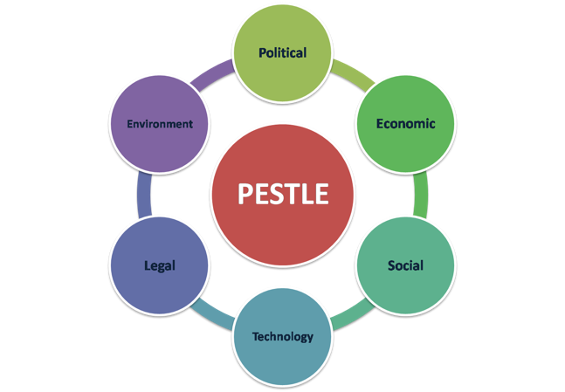

2.1.2 Three factors currently affecting Tesco

The researcher had analysed using pestle analysis tool as it assists one in understanding the market of the organisation and position in business better, plan strategically, and manage market research existing and new markets. The framework of the pestle analysis supports strategic thinking and helps one assess how one’s strategy adapts into the environment (Groupmap, 2020). Three factors which is political, social and economic currently affected Tesco due to the Covid-19, (Political) the government ordered UK to initiate lockdown. (Economic) According to Zoe Wood of the Guardian article (2020), one factor is that Tesco had been financially affected by this crisis. To explain, as a result of Tesco’s 50,000 employees taking sick off on full pay and Tesco sales increasing by 30% as customers stockpiled. (Social) Tesco was forced to hire 45,000 new employees to operate its stores and online services this resulted in extra operating cost on top of that Tesco paid 10% bonuses for the time employees worked throughout the crisis. This leads to increased it wages bill by £415 million to £580 million. One other factor is that new rules and guidelines had to be made on the Tesco’s Clubcard loyalty scheme which is that Tesco had planned to extend the expiration date on its Clubcard vouchers, to provide its customers more time to use the vouchers. Furthermore, Tesco additionally given members of the Clubcard scheme one point for every £1 spent in-store and every £2 spent on fuel (Coventry telegraph, 2020). Another factor is that 28% of Tesco’s customers no longer visiting whilst in lockdown this is due to supporting of small local business during the pandemic (Bristol post, 2020).

2.1.3 Organisational culture

Buchanan and Huczynski (2017) stated that,

“Organisational culture is the shared values, beliefs and norms which influence the way employees think, feel and act towards others inside and outside the organisation”

Organisation culture is important due to the fact that it will lead employees to work as a team to meet the organisations and one’s own personal requirement additionally it can enhance the performance of the organisation in many sectors (Small business, 2020).

2.1.4 Cultural web

Cultural web supplies a system for changing and recognising the organisation’s culture. The culture web was founded by Gerry Johnson and Kevin Scholes in the year 1992 (OPM,2020). The culture web is composed of six elements which are: stories & myths, symbols, power structures, organisational structures, control system and rituals & routines.

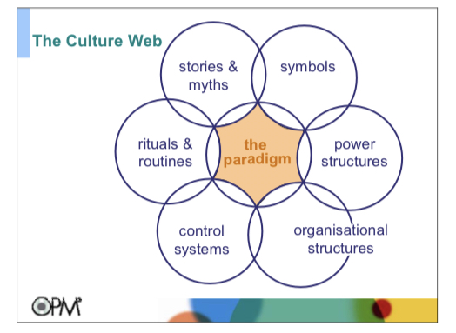

When cultural web is applied, it can reveal cultural assumptions, practices and proceed to aligning factors of an organisation with another and with organisations strategy (Mindtool, 2020).

For example, this is how cultural web is applied to the United Kingdom largest supermarket store Tesco.

Stories – which is the past issue or what people have discussed about outside and inside the organisation. What and who the organisation selects to immortalise give great deal about what it values and perceives as a great behaviour. To explain, According to The Grocer article (2018), the world’s largest professional analyst, Monteyne of the European food retail reported that with evidence from the analysis that Tesco’s average shopping basket is cheaper than its competitors Aldi and Lidl average shopping basket. In addition to this Tesco has won several awards from The Grocer of year.
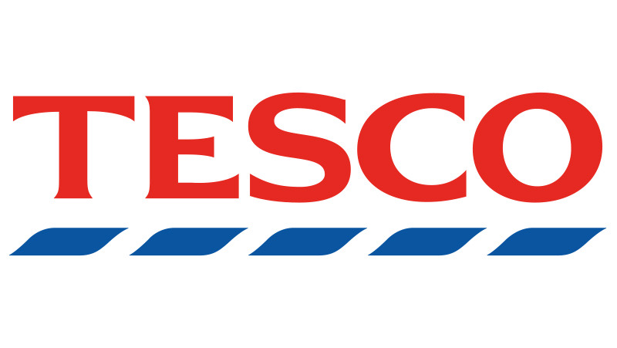
Symbols - the sight of representing of the organisation including the formal or informal dress code and how excellent condition the offices are and the logo of the organisation holds. To explain, “The current version of the emblem introduced in 1995 sports a bright red word-mark with a blue horizontal bar placed under each letter”. Tesco’s logo is extracted from the British flag – red is to show happiness and prosperity; blue is to show Tesco is trust worthiness and excellence. This reassure Tesco’s customers will receive a warm welcome (Rodger, J. 2020).
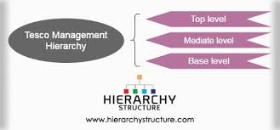

Organisational structure – this incorporate the structure interpreted by the organisation guide and unrecognised rules of control and authority that indicated where contributions are most appreciated. To explain, Tesco take place of a tall hierarchical structure. At the top level of the hierarchical structure is the executive board leaded by the CEO of Tesco who are the head of all administrative employees and holds all important decisions. Additionally, there are more people on the board including the Chief Finance Officer, Chairman, Chief Executive Officer and other Non-Executive Directors. There are 9 members of an executive committee that leads dissimilar departments who only make important decisions and supervisory functions. They operate at the external front and represent Tesco in the international market. Furthermore, there is a mediate level that is responsible between the ground employees and the board of directors. These consist of numerous act assistants and managers under them. The managers and assistants cooperate the responsibility of the other two levels and perform roles such as Marketing and Advertising, Funds, Human Resource Management and Personal relations. Moreover, situated at the base level is the top managerial position which is held by a regional manager. This person takes important decisions of Tesco stores located in the region one is in. the region of manager regularly reports to the mediator level executives. Below this position are store managers who maintain the stores and employees. Assistants and team leaders are below the position of store manager and work in the three divided department in Tesco such as personal section, non-food trading section and food trading section. Employees working at this level are directly in contact with customers on a daily basis (Hierarchy structure, 2020)

Power structures – this could include one or more senior executives, even a department or an entire group of executives. These people have the power to operate, decisions and strategic direction. To explain, Tesco power structures is the executives board leaders who are the CEO of Tesco who takes all important decision overall (Tesco – careers,2020).

Control systems – the processes by which the organisation is controlled. Control systems can involve reward, quality system and financial system. In addition, it includes the procedure by which they are recorded and dispensed within the organisation. To explain, Tesco’s long-term awards, Tesco holds once a year an award ceremony to its recognised employees and celebrities the hard work employees had done for Tesco’s customers (Our Tesco, 2020).

Rituals and Routines – the everyday actions and behaviour of people which indicates acceptance. This controls what is valued and what is expected to happen in a given situation. To explain, Tesco provides high quality products at a lower price for its customers. Tesco delivers excellent services to its customers to ensure they become long term and loyal customers. Tesco offers its customers loyalty club card scheme and rewards them by using it in every purchase made (Tesco PLC, 2020).

The researcher has identified using cultural web analysis that Tesco is a successful organisation do to the fact that it won many awards and that Tesco values its employees and customers.

2.1.5 Organisation Ethics

According to Suttle of the article Small business (2019), Organisation ethics are vital guidelines by which the organisation function on the authority of reference for organisation. These are best shown through compassion, integrity, acts of fairness, responsibility and honour. This is the key for organisations to ensure that all employees acknowledge these ethics. The greatest procedure to communicate organisational ethics is to train employees on the organisation’s rules.

2.1.6 Tesco’s ethical stance

Tesco’s ethical stance is Tesco’s ethical trading programme which is a core element of Tesco assuring to trade its products responsibly. Tesco operates by its four pillars which is set on the ethical trading programme. Tesco believes that this is the correct procedure to act on.
The first pillars are that Tesco ensure that it select the right suppliers who shares Tesco values and maintains it. Tesco ‘Values’ is collocated three key themes which are ‘Set Strong Standards’, communicate our values’ and ‘Approve New Suppliers’.
Tesco Values main priority is its customers, how Tesco can ensure to meet customers needs and how Tesco work with others. The development of Tesco’s ethical trading programme began in 1998 since then Tesco had worked beyond its expectations that these values are reflected in all location of Tesco’s ethics. One of Tesco’s core value is “treat people how we like to be treated” this includes Tesco employees as well as its customers and suppliers. Tesco regards setting strong standards is the main aspect of its ethical trading programme. In addition, Tesco confirms that its organisation will only collaborate with suppliers who comply with its values and ethical trading initiative (ETI).
Tesco’s potential new suppliers are assessed before being registered to supply in order to make sure they acknowledge Tesco’s standards and are able to fulfil them. Tesco will not collaborate with suppliers who are identified to have issues and problems that are not able to be solved at the stage of assessment.

The second pillar is monitoring. This helps Tesco to identify problems in the supply chain in which the suppliers and Tesco must prioritise ‘assessing risk’ and ‘audit and report accurately’. All suppliers of Tesco are subject to a risk-assessment in relation to the ethical standards prior to supplying starts. Ethical audits are managed by following the guidelines of SEDEX Members Ethical Trade Audit (SMETA).

The third pillar is improvement. This is of great importance as the process of monitoring does not drive improvement that is sustainable in the longer term, only identify issues that is required of more attention.

The final pillar is transparency. This is indispensable to maintain both stakeholders and customers trust in Tesco organisation and allow productive collaboration and convergence with other civil society, retailer and suppliers.

2.1.7 Tesco ethical/unethical behaviour in the organisation

According to Tesco CEO Dave Lewis (2015), Tesco’s code of business conduct is the way to Tesco’s ethics. It provides a protective layer of support, procedures and training to ensure Tesco acts upon the law and regulations. Tesco uses its values for guidance as Tesco believes this is the best way to result in correct outcomes for Tesco’s success. Tesco’s code of conduct presents the employees minimum expectations. It provides in-depth information of any risks which might occur. Dave Lewis has put forward that the code of business conduct has 21 guides of problems and who to contact for assistance regarding these issues. According to Business Benchmark (2020), Tesco has achieved success in its Animal welfare (BBFFAW). To elucidate, since the report of Animal welfare began in 2012, Tesco has progressed from tier 4 to tier 2 in this current year. Upon reaching tier 2, Tesco successfully overcame its competitor the Germany grocery chain Aldi which was founded in 1961 by the Albrecht family (Aldi, 2020).

Despite Dave Lewis’ claim about the code of business conduct, unfortunately, according to the Guardian (2015), Tesco’s suppliers assert that Tesco does not follow its code of business conduct. To explain, Tesco suppliers are complaining about the five issues of unreasonable charges for customer complaints, Tesco changing contract terms, demands for a capital contribution for marketing costs, long delays in payments and no compensation was distributed to suppliers when Tesco made mistakes in acquiring the number of products they required. YouGov’s data shows that Tesco does not fully follow its code of business conduct as the results on the survey shows that 66% of Tesco’s suppliers claim Tesco does follow its code of business conduct however 34% of Tesco’s suppliers claim that Tesco hardly or never follows its code of business conduct. As a result, Tesco is one of the least complying with code of business conduct supermarket in the UK. One of Tesco’s rival supermarket brand Aldi is placed on the first of YouGov’s data due to the fact Aldi is greatly compliant with its code of business conduct and works closer with its suppliers to offer its customers products that are low in price. In addition to this, Aldi has a long-term and loyal relationship with its suppliers therefore this allows Aldi to balance demand and supply more efficiently (Futurelearn, 2020). According to Indeed (2020), on the Tesco review section, 3900 current and former employees of Tesco rated the culture of Tesco at a mediocre score of 3.4/5. To explain, on one hand, many employees claim that Tesco is a great place to work, gives a range of benefits, provides a good pension scheme and offers a satisfactory lifestyle balance however on the other hand, most employees argue that there is a lack of work life balance, Tesco’s culture encourages selfishness, Tesco is too focused on customers, low wages, management employees have to complete work of other employees due to lack of staff and training programmes are non-existent. It is apparent that Tesco seem not to comply with its code of business conduct in relation to employees as it is evident that Tesco does not provide the full range of elements to employees.

2.1.8 Corporate Responsibility (CR)

“A responsible organisation conducts business ethically and takes account of its economic, social and environmental impact” (CIPD, 2020).

Corporate responsibility (CR) also known as CSR Corporate social Responsibility which is regarding the long-term sustainability of an organisation. The central point of it is that it seeks to add worth to an organisation’s activities by making sure they have a positive impact on economy, society and environment. CR initiatives fall into four main areas which are market place, environment, community and workplace. To explain, this is how Tesco incorporate Corporate Responsibility into its organisation (CIPD, 2020).

Economic: Tesco trades and transfers products through its network of stores and operations, Tesco interconnect with many people on a day to day. Tesco follows its values by treating “people how they want to be treated” in addition Tesco strongly believes in human rights. Tesco also ensures that those employees in the supply chain are protected.

Social: Tesco strives for its employees’ well-being and health to be stable, both mentally and physically, while at work and home. Tesco collaborates with Health Charity Partners to develop a health programme.

Environmental: Tesco supports and promotes sustainable and healthy products and agricultural systems – that make effective use of production, diminish waste and supply nutrition for employees and customers as it is greatly fundamental to the organisation. This clearly substantiates that Tesco care for their employees and customers wellbeing (Tesco PLC, 2020).

2.1.9 Values

“The principles that help you to decide what is right and wrong, and how to act in various situations” (Cambridge.org, 2020).

According to Barrett values centre (2020), values are important due to the fact that it helps one to develop and grow. It encourages one to make future experiences. Organisation values is a reflection of the organisation’s operation in the world. The values included in an organisation are teamwork, growth, financial, strategic alliances and productivity. Individual values are a reflection of how one is presented in life and one’s specific needs- what one views as important for one’s interest and the principles one lives by. Individual values comprise of humility, creativity, personal fulfilment and enthusiasm. Values are greatly important simply because they are stable long-standing beliefs with regards to what is significantly important to an individual.

2.2 Employees performance in reference to Tesco’s values

Tesco’s three core values are “No one tries harder for customers”, “we treat people how they like to be treated” and “we believe every little help can make a big difference”. Tesco’s mission statement is “To be the champion for customers” and vision is “To be the most highly valued business by the customers we serve, the communities in which we operate, our loyal and committed colleagues and of course, our stakeholders” (Tesco PLC, 2020). Tesco’s values, mission and vision are the overall expression of the organisation and to inspire and motivate its employees and stakeholders. Tesco acknowledges that taking care of its employees in a culture of trust and respect is advantageous to Tesco’s success. Tesco believes in its value “Every little help makes a big difference” and acts upon it by ensuring the customers, employees and communities it serves have a little better every day. Tesco ensures that it can make a big difference to issues that matter to employees, customers, communities and in wider society. To restore transparency and trust in the organisation, Tesco contributes to substantial global initiatives and covers the small operations it does every day. Tesco believes that its values are the most important part of its culture since they began it a decade ago which is significantly supportive of Tesco’s growth and success. Tesco make sure that its employees understands what is important and how the organisation works together as a team and that the customer are the central focus of Tesco (Tesco PLC, 2020). On one hand, Tesco offers numerous support and benefits such as Tesco pension scheme and life assurance, employees club card and long service awards to its employees during their developmental stage to show that Tesco appreciates the hard work on the other hand, according to Indeed (2020), Tesco employees want as a result of working hard for customers is the package of benefits, satisfactory pay and a good work life balance. This will result in Tesco requiring employees to work hard for customers in which employees will be communicating, understanding and performing in a good manner for Tesco (Our Tesco, 2020).

3.0 Conclusion

The researcher has identified and evaluated that Tesco has an organisation culture that promotes its employees to work at a higher level for its customers in order to continue its growth and success. The researcher used the pestle analysis tool and discovered that there are three factors that are indisputably affecting Tesco at the moment. The factors of political, social and economic has changed the processes and actions of Tesco and the way it interacts with employees, customers, stakeholders and its market. Furthermore, by using the cultural web, the researcher has identified the six elements of Tesco. Upon identification, the cultural web revealed Tesco’s cultural practices and assumptions. In addition, Tesco’s ethical stance is its ethical trading programme which is based on its four pillars. For Tesco’s ethical and unethical behaviour in the organisation, Tesco follows its code of business conduct to a certain extent however it should apply to improve its relationship with employees and suppliers. It is evident that Tesco does have corporate responsibility (CR) and its positive effects on environment, economic and social factors have been evaluated. There is evidence to suggest that Tesco follows its values and its employees’ values align with it. These values have resulted in the success of Tesco.

4.0 Recommendations

To further improve Tesco’s culture in the ethical side, Tesco should aim to observe its competitor Aldi’s practice with its suppliers and replicate this action in order to improve its relationship with its own suppliers. In addition to this, Tesco will be required to completely follow its code of business conduct to ensure its suppliers needs are satisfied, this will require Tesco to work increasingly closer with its suppliers (Future Learn, 2020).

To further enhance it’s organisation culture, Tesco must employ more qualified people as most departments of Tesco stores are lacking employees, implement new training programmes that will provide consequential information that employees can use to help with their assigned position, and regular checkups on employees to ensure they are mentally and psychologically well (Harvard Business Review, 2020).

5.0 Reference list

Amp.theguardian.com (2020) Tesco Clubcard Plus: is the new £8-a-month deal worth it? | Money | The Guardian [Online] Available at: https://amp.theguardian.com/money/2019/nov/01/tesco-clubcard-plus-deal-supermarket-loyalty-scheme (Accessed on 17/06/2020)

Amp.theguardian.com (2020) Tesco defends £635m dividend pay-out after coronavirus tax break | Tesco | The Guardian [Online] Available at: https://amp.theguardian.com/business/2020/apr/08/tesco-sales-up-30-per-cent-because-of-pre-lockdown-stockpiling-coronavirus (Accessed on 17/06/2020)

Amp.theguardian.com (2020) Tesco suppliers say retailer worst at following grocery code of practice | Tesco | The Guardian [Online] Available at: https://amp.theguardian.com/business/2015/jun/22/tesco-suppliers-say-retailer-worst-at-following-grocery-code-of-practice (Accessed on 13/6/2020)

Barrett Value Centre (2020) Personal Values Assessment (PVA) – Barrett Values Centre [Online] Available at https://www.valuescentre.com/tools-assessments/pva/ (Accessed on 24/6/2020)

Barrett Values Centre (2020) Why Values are Important - Barrett Values Centre [Online] Available at: https://www.valuescentre.com/values-are-important/ (Accessed on 24/6/2020)

Bbfaw.com (2020) BBFAW | Benchmark [Online] Available at: https://www.bbfaw.com/benchmark/ (Accessed on 24/6/2020)

BBC News (2020) Tesco to cut 1,700 shop floor jobs [Online] Available at: https://www.bbc.co.uk/news/amp/business-42779698 (Accessed on 17/06/2020)

Birmingham mail (2020) Roger, J. This is why supermarket logos are certain colours [Online] Available at: https://www.birminghammail.co.uk/whats-on/shopping/supermarket-logos-certain-colours-12772238 (Accessed on 28/5/2020)

Bristol Post (2020) More people ditch Tesco than any other supermarket in lockdown [Online] Available at: https://www.bristolpost.co.uk/whats-on/shopping/tesco-sainburys-asda-lidl-4116561.amp (Accessed on 17/06/2020)

CIPD (2020) Information on Corporate Responsibility | CIPD [Online] Available at: https://www.cipd.co.uk/knowledge/strategy/corporate-responsibility (Accessed on 24/6/2020)

CIPD (2020) Information on Corporate Responsibility | CIPD [Online] Available at: https://www.cipd.co.uk/knowledge/strategy/corporate-responsibility (Accessed on 24/06/2020)

Coventry Telegraph (2020) Changes announced affecting Tesco, Asda, Aldi and Lidl shoppers [Online] Available at: https://www.coventrytelegraph.net/whats-on/shopping/changes-announced-affecting-tesco-asda-18337574.amp (Accessed on 17/06/2020)

Corporate.aldi.us (2020) ALDI History | ALDI US [Online] Available at: https://corporate.aldi.us/en/aldi-history/ (Accessed on 13/6/2020)

Future Learn (2020) Why are Aldi and Lidl currently so successful? [Online] Available at: https://www.futurelearn.com/courses/supply-chains/0/steps/23702 (Accessed on 13/6/2020)

Google.co.uk (2020) VALUES | meaning in the Cambridge English Dictionary [Online] Available at: https://www.google.co.uk/amp/s/dictionary.cambridge.org/amp/english/values (Accessed on 27/06/2020)

Group Map (2020) Collaborative Brainstorming and Decision Making, PESTLE Analysis, PESTLE Analysis Template – Group Map [Online] Available at: https://www.groupmap.com/map-templates/pestle-analysis/ (Accessed on 30/6/2020)

Harvard Business Review (2020) 7 ways to improve employee development programs [Online] Available at: https://hbr.org/amp/2015/07/7-ways-to-improve-employee-development-programs (Accessed on 30/6/2020)

Hierarchy Structure (2020) Tesco Management Hierarchy | Tesco Organisational Structure [Online] Available at: https://www.hierarchystructure.com/tesco-management-hierarchy/amp/ (Accessed on 28/5/2020)

Indeed.co.uk (2020) Working at Tesco: 13,707 Reviews | Indeed.co.uk [Online] Available at: https://www.indeed.co.uk/cmp/Tesco/reviews (Accessed on 27/06/2020)

Mindtools.com (2020) The cultural web: Aligning your organisation’s culture with strategy [Online] Available at https://www.mindtools.com/pages/article/newSTR_90.htm (Accessed on 28/5/2020)
OPM (2020) Understanding culture and change [Online] Available at: https://moodle.uwtsd.ac.uk/pluginfile.php/292615/mod_resource/content/1/Cultural-Web-Questions.pdf (Accessed on 28/5/2020)
Our Tesco (2020) Ethical Trading - Our Tesco [Online] Available at: https://www.ourtesco.ie/working-at-tesco/people-policies/legal-policies/code-of-business-conduct/trading-fairly/ethical-trading/ (19/06/2020)

Our Tesco (2020) What you can expect from us [Online] Available at: https://www.ourtesco.com/your-benefits/what-you-can-expect-from-us/ (Accessed on 20/6/2020)

Small Business - Chron.com (2020) Example of Organizational Ethics [Online] Available at: https://smallbusiness.chron.com/example-organizational-ethics-36755.html (19/06/2020)

Tesco-careers.com (2020) Culture | Tesco Careers [Online] Available at: https://www.tesco-careers.com/explore-our-world/our-culture/ (Accessed on 17/06/2020)

Tesco-careers.com Stores – Management | Tesco Careers [Online] Available at: https://www.tesco-careers.com/stores-and-distribution/management-colleagues/stores/ (Accessed on 28/5/2020)
Tesco PLC (2020) Healthier products [Online] Available at: https://www.tescoplc.com/sustainability/product/health-and-diets/healthier-products/ (Accessed on 18/06/2020)

Tesco PLC (2020) Core Purpose and Values [Online] Available at: https://www.tescoplc.com/about/how-we-do-business/core-purpose-and-values/ (Accessed on 20/6/2020)

Tescoplc.com (2020) Code of business conduct [Online] Available at: https://www.tescoplc.com/media/1143/code_of_business_conduct_2015.pdf (Accessed on 8/6/2020)

The Telegraph (2020) A history of Tesco: The rise of Britain's biggest supermarket [Online] Available at: https://www.telegraph.co.uk/finance/markets/2788089/A-history-of-Tesco-The-rise-of-Britains-biggest-supermarket.html (Accessed on 17/06/2020)

The Grocer (2020) Can Tesco convince consumers it’s cheaper than Aldi and Lidl [Online] Available at: https://www.thegrocer.co.uk/prices-and-promotions/can-tesco-convince-consumers-its-cheaper-than-aldi-and-lidl/572624.article (Accessed on 28/5/2020)

1000logos.net (2020) Tesco logo and symbol, meaning, history, PNG [Online] Available at: https://1000logos.net/tesco-logo/ (Accessed on 24/6/2020)

