The Analysis of Intercultural Business Communication

Xin Wang
1704354
Managing Internationally
SBUS6115
Contents
Executive Summary
- Introduction
  - Cross Culture
  - Hofstede's Cultural Dimensions Theory
- Examples and Analysis
  - Negotiation and Decision Making
  - Communication Preferences
  - Management
  - Leadership and Motivation
- Conclusion and Recommendation
References and Bibliography

Executive Summary
The trend of economic globalization and the increasing frequency of international business activities have demonstrated the importance of multicultural understanding and cross-cultural communication ability. Cross cultural awareness and communication are equivalent to economic benefits.
It’s not enough to have strong economic strength, well-developed professional skills and excellent management if an enterprise wants to make its products occupy a place in the international market. Having a deep understanding of partner’s culture is seen as more necessary.
In this report, enterprises that entered different cultures are researched and evaluated with academic models and theories, so as to find how cultural variation effects their negotiation and decision making, communication preferences, management, leadership and motivation.

- Introduction
1.1 Cross Culture Communication
There are no foreign lands, only the traveller is foreign (Stevenson, R. L.).
Nowadays we hear more and more about big topics like globalization, economic integration and new technologies for communication. Big distances between different countries do not play a big role any more. Today we are able to communicate with anyone we like to, no matter what countries they live in.
Thinking about companies who are selling their products into global market. However, the arising importance of cross-culture communication is also associated with barriers and misunderstanding. Since a person’s background culture-the way of life he was brought up in-will affect his approach to every decision, learning more about other countries’ values, beliefs and ideologies becomes increasingly important (Bannon, G. and Mattock, J.). In this report, Hofstede’s cultural dimensions theory model is used to analyse examples about negotiation styles, communication preferences, management styles, leadership styles of different countries. In this way, to discover the real cause behind cross culture communication failure.
1.2 Hofstede's Cultural Dimensions Theory
Geert Hofstede’s research in the area of culture and management is known worldwide. It is not only frequently quoted in cross-cultural research, but also used in prescriptive works on dealing with other cultures. Hofstede used the results of his research to produce a comparison between cultures on four and eventually five dimensions (Browaeys, M. and Price, R.):
Power Distance | Attitudes to authority, the distance between individuals in a hierarchy.
Uncertainty Avoidance | The degree of tolerance for uncertainty or instability.
Individualism VS Collectivism | Independence and interdependence, the loyalty towards oneself and towards a group.
Masculinity VS Feminine orientation | Importance of work goals（earnings, advancement）compared with personal goals(co-operation, relationships)
Long-term VS Short-term Orientation | Fostering virtues related to the past and present or virtues related to the future.

2.0 Examples and Analysis
2.1Negotiation and Decision Making
Here is a case:
The Chinese& Canadian Dispute
A major Canadian industrialist signed a property deal with a Chinese businessman, with whom he had hitherto enjoyed a long and mutually profitable association.
At first, everything went smoothly. Three months later, the Chinese began suffering losses in his core business, and began withdrawing funds from the property investment. The Canadian decided to take action and sent his legal advisor on a fact-finding mission since he was tied up with other work. However, the Canadian did not call his Chinese partner and told him about this. The Chinese was surprised to receive a lawyer's phone call from the airport, he had to confirm all the matters with the Canadian. Even he got the confirmation, he was still reluctant to talk with the lawyer.
The Chinese was proud of his status as an independent and successful entrepreneur. He was used to dealing only with persons of the same status， and was not prepared to negotiate on equal terms with a “servant.”
Therefore, he responded by delaying and finally refusing to meet him.
After three days the Canadian industrialist wrote the letter to put an end to this property deal as soon as the lawyer came back (Mead, R., 2000).
Contradictions:
The fuse was the Chinese partner withdrawing funds without consulting with his partner. After finding this issue, the Canadian tried to send lawyers to solve the problem without prior notice. This move made the Chinese partner unhappy and refused to negotiate, which eventually led to the bankruptcy of the project.
Analysis of causes:
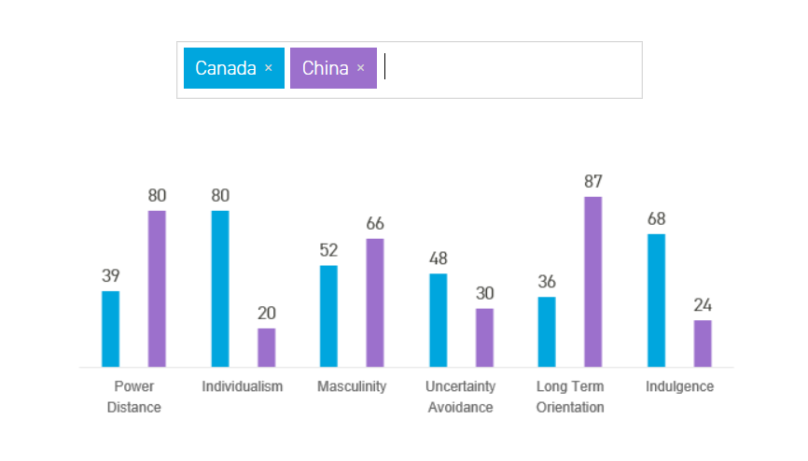
(Hofstede Insights, 2018)
With a score of 39 on power distance dimension, Canadian culture is marked by interdependence among its inhabitants and there is value placed on egalitarianism. However, China scores 80 in this dimension- a society that believes that inequalities amongst people are acceptable.
In China, people are more familiar with the hierarchical system of power inequality. In Canada, people advocate equality of power. The concept of hierarchy is indifferent. So, the Chinese feel neglected when the Canadian sent his lawyer (lower class) instead of negotiating in person. To the Canadian, this kind of uncooperative behaviour was seen as unilateral breach and finally led to the termination of the contract.
On the other hand, in Chinese culture, mianzi (face) and guanxi (interpersonal networks) are seen to be indicative of characteristically sociocultural phenomena (Kaynak, E., Wong, Y. H. and Leung, T, 2013). The Chinese in this case believed that the two sides had established good relations in the past successful cooperation, which is the reason for him withdrawing money from the project without any consultation.
Whereas Western cultures are primarily rule-based, they trust the system. It is believed that this issue should be solved through legal approach.
2.2 Communication Preferences
Here is a case:
What if an American manager highly praises Japanese worker in Public Workplaces?
American: Mr. Sugimoto, I have noticed that you are doing an excellent job on the assembly line. I hope that the other workers notice how it should be done. Japanese: (He is uneasy). Praise is not necessary. I am only doing my job. (He hopes other Japanese workers do not hear).
American: You are the finest, most excellent, dedicated worker we have ever had at the Jones Corporation.
Japanese:（He blushes and nods his head several times, and keeps working.）
American: Well, are you going to say “thank you” Mr. Sugimoto, or just remain silent?
Japanese: Excuse me, Mr. Jones… May I take leave for five minutes？
American: Sure. (He is annoyed and watches Sugimoto exit). I can’t believe how rude some Japanese workers are. They seem to be disturbed by praise and don’t answer you…just silent（Xu, X., 2001）.
Contradictions:
Mr. Jones thought that praising Mr. Sugimoto in front of all workers was the affirmation and approval of his work. But he only thought based on American individualism, had no idea of Japanese view of the relationship between individuals and collectives. Therefore, the result is counterproductive.
Analysis of causes:
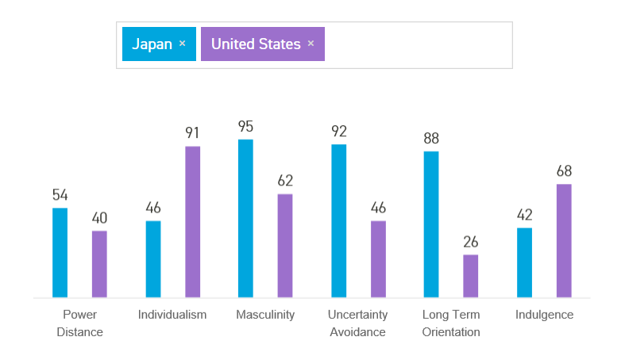
(Hofstede Insights, 2018)
Among universal cultural categories specifically related to communication. Hall’s concept of “High-context” vs. “low-context” is the most popular one (Hall, E. T., 1989). According to Hall, messages exchanged in a high-context culture carry implicit meanings with more information than the actually spoken parts, while in low-context cultures, the messages have a clear meaning, with nothing implied beyond the words used.
Hofstede (1991) also refers to Hall’s concept of context and concludes that high individualism is very often connected to low-context communication, whereas collectivism very often is connected to high context communication. 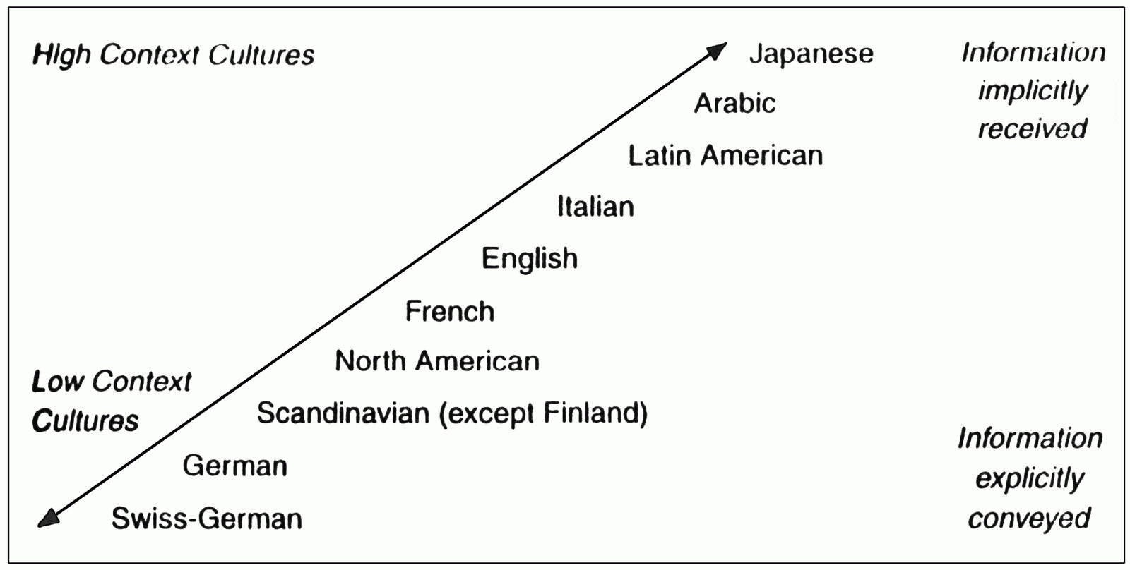
The United States scores 91 on the individualism dimension, ranks first in the 53 countries, while Japan ranks 22. This means that the United States emphases individualism, while Japan pays more attention to the collective. The failure of communication had a lot to do with the different communication preferences between two countries.
It is a typical American way for superiors to praise subordinates for their outstanding performance. American employees who are praised often say "thank you" for an answer. So Mr. Jones thought that Mr. Sugimoto should also accept praise in this way.
The United States is a low-context country and prefer the direct way of communicating style. Mr. Jones kept asking when Mr. Sugimoto looked uneasy. When he asked to leave, Mr. Jones thought it was impolite to leave without any answer.
However, Japan is a typical country of collectivism. The members of one group are likely to keep relatively consistent pace and never highlight individual performance. So being praised in front of colleagues embarrassed Mr Sugimoto very much and did not give Mr. Jones any reply. He felt that Mr. Jones separated him from group and made him lose face.
According to Hall’s concept of “High-context” vs. “low-context”, Japan is a typical high-context country. People are euphemistic, do not express their dissatisfaction in public and depend more on non-verbal communication. Just like Mr. Sugimoto, he kept silence to show his dissatisfaction with unwilling praise.
2.3 Management
Here is a case:
The Resignation of American CEO in a Swedish-American Company
Pharmacia &Upjohn Inc., the merged Swedish-American pharmaceuticals company. This $ 7 billion-a-year company has been buffeted by business culture problems since it was born in 1995 as a trans-Atlantic merger of equals．
The conflicts culminated in the resignation of the group’s American chief executive, John Zabriskie. Indeed, Pharmacia& Upjohn has suffered enough clashes of management culture, style and approach to make a case study of what American executives should not do when they come to Europe.
The American managers from Kalamazoo could not begin to comprehend how their European counterparts could take off the entire month of August for vacation.
Mr. Zabriskie, when he took over the merged group, ran into immediate trouble with European managers. As one senior Pharmacia& Upjohn executive said, “Zabriskie was charging hard, aiming high, keen on numerical accountability. He had this ‘we’ll take every hill approach. The Europeans were closer to their people, seeking more feedback from the troops，and were not used to the American business culture (The New York Times, 2018). ”
Later the company had Fred Hassan in May 1997 as chief executive officer to rescue them. He is a master of change and widely regarded for his ability to turn around struggling companies. This American based Pakistani took a lot of methods to find out the conflict between two cultures in this company. “To align and motivate employees to work together, we respect the local culture and combine it with the American way of approaching business. Besides, corporate management structure is changed a lot. This helped us get rid of a few ‘culture resisters’.” Then he took a few steps to help reinvent through corporate culture and make the company became a high-performance competitor (Harvard Business Review, 2018).
Contradictions:
Although both sides belong to western culture, there are many differences between American culture and Swedish culture. Such as different management, decision-making and problem-solving styles. American managers who take the American mode directly into the company will encounter great obstacles.
Analysis of cause: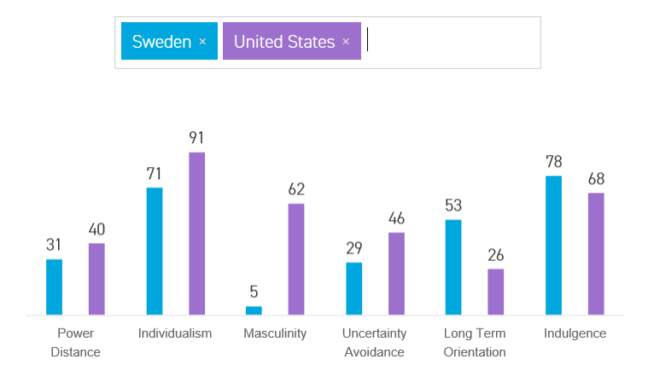
- The United States scores normative on the fifth dimension with a low score of 26. While Sweden gets an intermediate score of 53.
Mr. Zabriskie, influenced by American short-term oriented culture, pays more attention on making quick decisions and getting profits in the shortest time.
Compared with American, Swedes are more likely to consider all possible hidden problems and make an important decision only when the solution is the best option in terms of cost and efficiency.
- The score of the US on Masculinity is high at 62, while Sweden scores 5 on this dimension and is therefore a Feminine society.
Masculinity culture stresses more on competition and performance. Material wealth are thought to define masculine success (Keith, T, 2017). According to Morgan, G. (1997), the American companies and their managers adopt competitive individualism, pre-set goals, clear roles and a reward system.
Feminity culture stress on co-operation. The relationship between employees and subordinates is very important for Swedes. When completing a task, maintaining harmony is the first goal. They never sacrifice their relationship to achieve desired goals.
- The United States scores as an Indulgent (68) society on the sixth dimension. Furthermore, a high score of 78 in this dimension indicates that Swedish culture is one of Indulgence.
Americans work hard and thus play hard because they really do not have much time away from work (Naylor, L. L., 1998). Therefore, Americans regard time as money and compete against time to accomplish everything.
Swedes are more likely to enjoy life. They advocate to enjoy life as much as possible within a limited time. In their opinion, this is not a waste of time, but to put themselves better into work.
Analysis of solutions:
It is important to respect the local culture and to combine it with the American way of approaching business.
American managers should strengthen the localization of his management style and respect the values and lifestyle of Swedish employees. Combine the advantages of both sides’ management culture is important when formulate a management system. The company can take the method of holding regular general meeting to listen employees' opinions and exchange ideas with each other.
2.4 Leadership and Motivation
Here is a case:
Pay-for-performance in Italy
At the summing-up meeting of Commodore Corp. Representatives from various international branches began to introduce the implementation of pay-for-performance incentive mechanism in their region. It had been three years since the system was first introduced. “In general, we could detect a link between the use of this system and computer sales.” Mr. Johnson said, “we are strongly convinced that we need to introduce this system worldwide.”
Then the Italian representative, Mr. Gialli, began describing his experience with the system. In his country, the pay-for-performance experiment did much better than he had expected during the first three months. But the following three months were disastrous. Sales were dramatically lower for the salesperson who had performed the best during the previous period. “After many discussions,” he continued, “I finally discovered what was happening. The salesperson who received the bonus for the previous period felt guilty in front of the others and tried extremely hard the next quarter not to earn a bonus.”
After rethinking and adjusting, the company decides that the Italian market should be divided into nine regions for the next year. All sales representatives with one region should be allowed to allocate the bonus earned in their region either to individual performers or to share it equally (Mann, J. W., 1965).
Contradictions:
Mr. Johnson believes that, “pay-for-performance excitation mechanism will be effective in all countries around the world. This system will enhance the enthusiasm of staff and the sales performance of every company.” But his view is based on highly individualism and low uncertainty avoidance culture of America. He did not know that Italians are more collectivist and uncertainty-avoiding compared to America (Hofstede, G., 2001), which is the reason for the failure of the system experiment in Italy.
Analysis of causes:
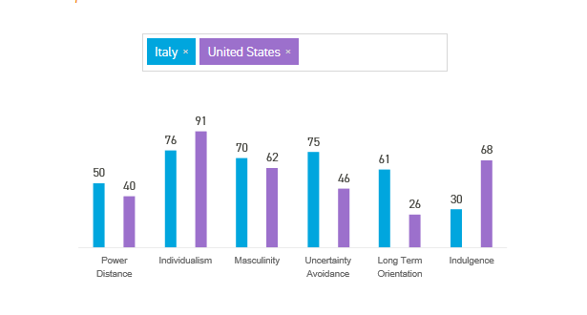
- The United States scores 91 on the individualism dimension, ranks first in the 53 countries. While Italy scores 76 on this dimension, ranks seventh. Compared to the United States, Italian society is a higher-context, more collectivist society (Gannon, M. J., 2016).
In an individualistic country like the United States, people encourage competition rather than cooperation, praise individual efforts and achievements. Individual wealth is regarded as a symbol of success. As a new incentive mechanism, pay-for-performance is adopted and seen as a great success in the United States-effectively improve the enthusiasm of staff and performance of companies (Brown and Heywood, 2002).
In Italy-a relatively collectivist country, people pay attention to family and social relations. They have emotional attachment to community. Compared to U.S.A, the culture emphasizes relatively more on harmony, cooperation and mutual benefit. In the case, after pay-for-performance system was implemented in Italy, it achieved better results than expected in the first three months but suffered great loss in the following three months. The salesperson who received the bonus for the previous period felt guilty in front of the others and tried not to earn a bonus next time. They feel guilty because their culture emphasizes collaboration rather than individual performance. Only a few people get bonuses, this expand the distance between them and other colleagues as well as create inequality. So that the team is no longer in harmony.
- The US scores below average, with a low score of 46, on the Uncertainty Avoidance dimension. Consequently, they take things as they come and tolerate of new things. That’s why pay-for-performance is adopted and successful as well.
At 75 Italy has a high score on Uncertainty Avoidance which means that as a nation Italians thinks uncertainty is threatening and resist changes. Sudden changes in compensation system may put a lot of stress on them and cause the failure of this mechanism.
Analysis of solution:
The company later decided to adopt a more flexible incentive system in the Italian branch: let the salesperson who got the bonus decide whether the individual receive the prize or to share. This approach not only satisfied the local people's psychological appeal but also promoted the sales of the company to some extent.

3.0 Conclusion and Recommendation
- Through research, we found the reason why it is difficult for both sides to reach consensus is as follows:
In general, the failures of transnational corporations are due to the neglect of cultural differences. Both parties of the cooperation participate in the operation and negotiation with their own values, beliefs and thinking methods. So, they have different understandings or opposite views on decisions. Therefore, cultural cooperation has become an important content of contemporary business cooperation and an inevitable requirement for companies to enter global market.
- To allow the two parties to communicate smoothly and achieve a win-win situation, communication suggestions are proposed as follows:
- Communicate more, try to understand each other’s culture, way of thinking.
Learn to see the problem through your business partner’s eyes. So as to understand their management style.
- Face up to cultural differences and seek common ground while reserving differences. Learn to balance mutual benefits and get competitive advantage from a multicultural perspective.

References
Bannon, G. and Mattock, J. (2003). Cross-cultural communication. London: Kogan Page, p.5.
Browaeys, M. and Price, R. (2008). Understanding cross-cultural management. Harlow, England: Financial Times/Prentice Hall, pp.32-45.
Brown, M. and Heywood, J. (2002). Paying for Performance：An International Comparison. Armonk, N.Y.: M.E. Sharpe, pp.17-26.
Gannon, M. and Pillai, R. (2016). Understanding global cultures. Los Angeles [u.a.]: SAGE.
Hall, E. (1989). Beyond culture. New York [u.a.]: Doubleday.
Harvard Business Review. (2018). Reinvent Your Company Through Culture. [online] Available at: https://hbr.org/2013/06/reinvent-your-company-through [Accessed 8 May 2018].
Hofstede Insights. (2018). Country Comparison - Hofstede Insights. [online] Available at: https://www.hofstede-insights.com/country-comparison/japan,the-usa/ [Accessed 8 May 2018].
Hofstede Insights. (2018). Country Comparison - Hofstede Insights. [online] Available at: https://www.hofstede-insights.com/country-comparison/sweden,the-usa/ [Accessed 8 May 2018].
Hofstede Insights. (2018). Country Comparison - Hofstede Insights. [online] Available at: https://www.hofstede-insights.com/country-comparison/canada,china/ [Accessed 7 May 2018].
Hofstede Insights. (2018). Country Comparison - Hofstede Insights. [online] Available at: https://www.hofstede-insights.com/country-comparison/italy,the-usa/ [Accessed 8 May 2018].
Hofstede, G. (1991). Cultures and organizations. London: McGraw-Hill.
Hofstede, G. (2001). Culture's consequences. Thousand Oaks, Calif.: Sage, p.243.
Kaynak, E., Wong, Y. and Leung, T. (2013). Guanxi. Hoboken: Taylor and Francis, p.36.
Keith, T. (2017). Masculinities in contemporary American culture. Taylor & Francis, p.16.
Mann, J. (1965). The group and the individual. Johannesburg: Witwatersrand University Press.
Mead, R. (2000). Cases and projects in international management. Oxford: Blackwell Business.
Morgan, G. (1997). Images of organization. Thousand Oaks, Calif.: Sage Publications.
Naylor, L. (1998). American culture. Westport, Conn. [u.a.]: Bergin & Garvey, p.113.
STEVENSON, R. (2018). TREASURE ISLAND. [S.l.]: PALAZZO EDITIONS LTD.
Tribune, A. (2018). A Case of Corporate Culture Shock in the Global Arena. [online] Nytimes.com. Available at: https://www.nytimes.com/1997/04/23/news/a-case-of-corporate-culture-shock-in-the-global-arena.html [Accessed 8 May 2018].
Xu, X. (2001). Business Communication. Beijing: Foreign language teaching and research press, p.35.

