INDIVIDUAL BLOG
By Sanya Suneja
Student id: 2234449

Submission date: 28TH July 2023
Module name and number: Marketing Fundamentals, LCBB4004
Words: 2429
Lecturer name: Tushara Balendran
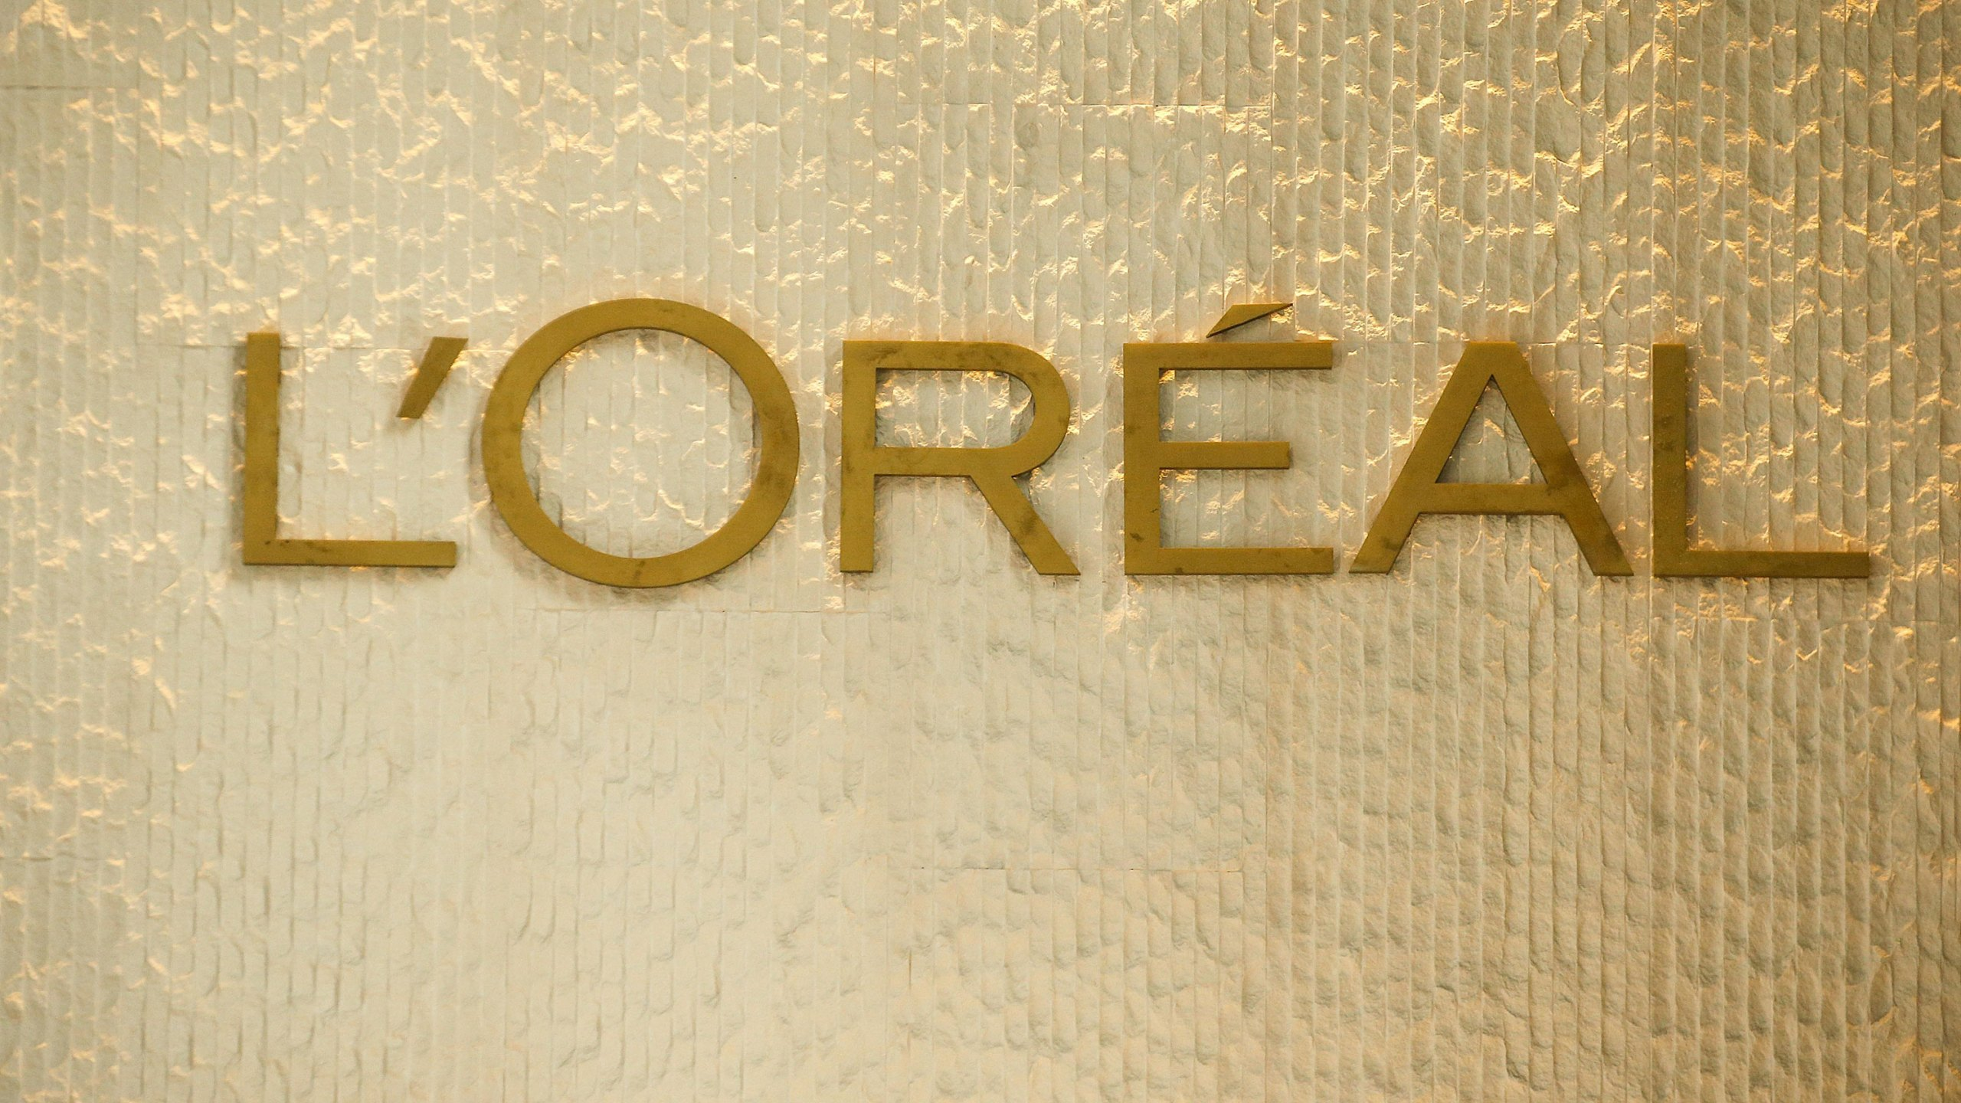
L’ORÉAL BLOG
FOUNDER AND HISTORY OF L’ORÉAL:
L’ORÉAL GROUPE was founded by a young chemist named Eugène Schuller in 1909. He had an ideal entrepreneurial spirit towards the idea of making the first hair dye formulation and selling it to the Persian hairdressers. Thus, the first link of the founder continues to be an important aspect of the company’s DNA.

1957-1983
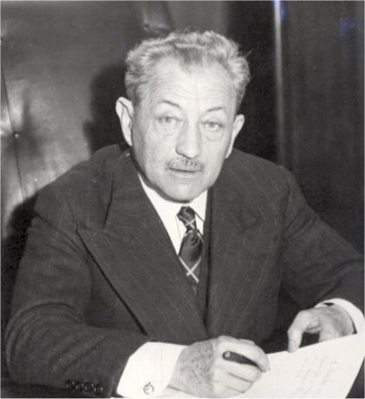
The provocation of Chairman François Dalle led to international expansion of the company; resulted in development of “Le Grand L’ORÉAL”. As the company was in a developing phase of strategic brand acquisition and growth, thus the motto of the company during the period was “Savoir Sai sir ce commence” which in literal meaning translated to embracing new (L’ORÉAL groupe,n.d.).

Eugène Schuller

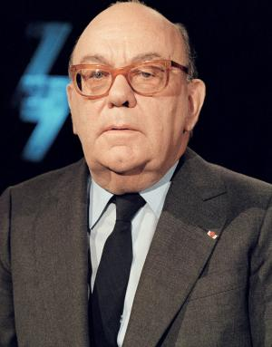

Motto: “Savoir Sai sir ce commence”
François Dalle

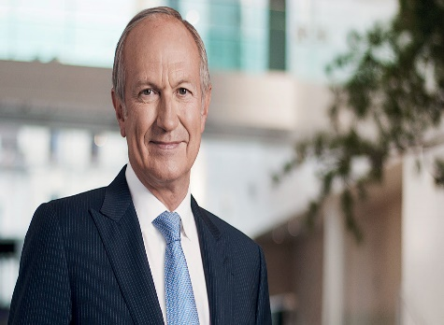
2006- Today
With Jean Paul Agon at the helm as a Chief Executive Office, the company commits to universalization and “Beauty for all” as a mission. L’ORÉAL continues with new variation of cosmetic needs along with taking suitable initiatives that are socially, environmentally, and digitally responsible for suitable development (Loreal Groupe, n.d.).

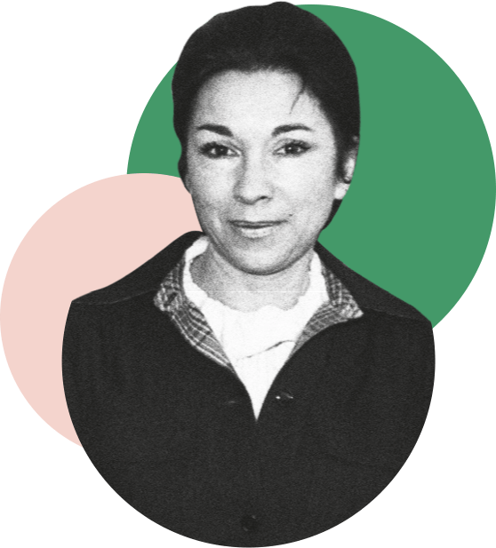
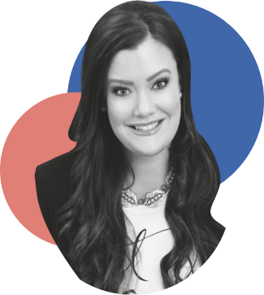
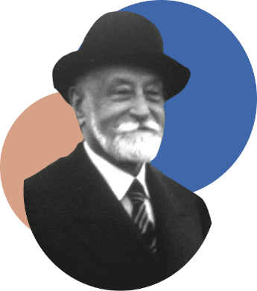
VISIONARIES:

JEANINE MARISSAL
JAMIE KERN LIMA
ARMAND PETITJEAN
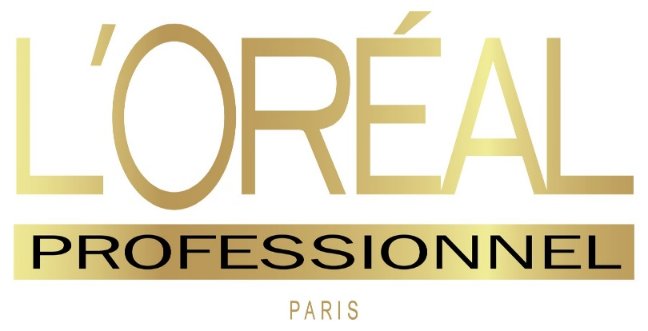
Our mission, vision & logo
MISSION

We commit ourselves to the path of universalization and create “BEAUTY FOR ALL”.
As we have entered the 21st century, we consider inclusivity and diversity our agenda for growth. We assimilate diverse cosmetic needs worldwide while keeping quality, efficacy, safety, and responsibility in mind (Loreal Groupe, n.d.).
VISION

LOGO
The logo of the company is a verbal sign, indicating the name of the company: Loreal. It is derived from an ancient Greek word ωραίος meaning “beauty”. It has been also inspired by the first hair dye created by our founder Eugene Schuller: L’Auréale (loreal groupe , n.d.).

The vision statement of our company is “CREATE BEAUTY THAT MOVES THE WORLD”
We have a goal to provide everyone “best of beauty” concerning the satisfaction of all beauty needs. We aim to be recognized as a leading beauty company. The motto to influence future of beauty by utilization of science and technology which is inspired by nature. (LOREAL GROUPE, n.d.).

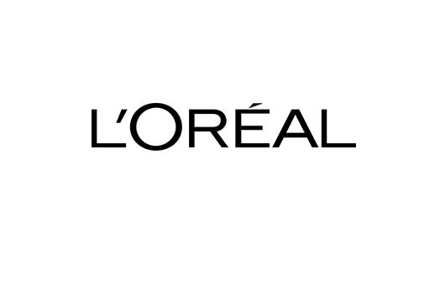
SEGMENTATION OF L’ORÉAL:
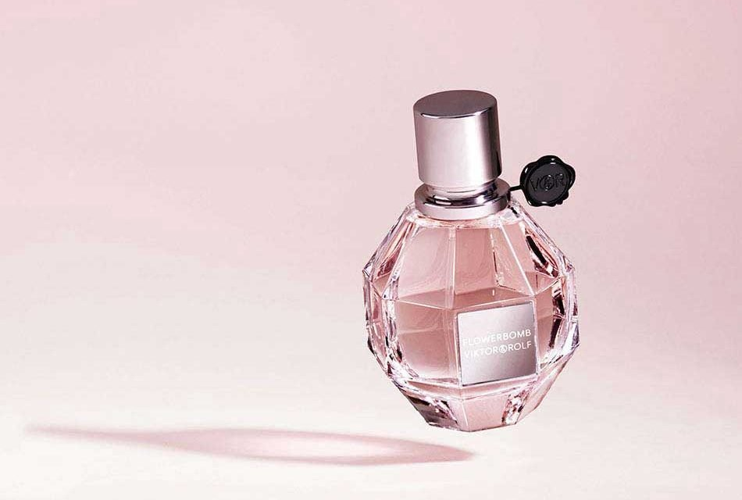
“Market segmentation is a decision-making tool for the marketing manager in the crucial task of selecting a target market for a given product and designing an appropriate marketing mix.” (Dolnicar, S. 2018, p.1)

DEMOGRAPHIC:
Loreal has a diverse range of products for various age groups, races, genders. They target people by making products for children, men, and women. There are 5 divisions of consumer product which targets mass market which are as follows: Loreal Paris, Garnier, Maybelline New York, Nyx professional makeup, and Stylenanda. The subdivision of Dark and lovely has suitable products for different complexions, this represents ethnicity factor. (Loreal Groupe, 2019)
Luxury edition of loreal products favors the income segmentation. It offers the best and most unique range of products for a group of people who like sustainable and high-quality products. Moreover, there is a special edition for professionals having products for professional use which determines niche market such as salon shampoos, and hair color. (Loreal Groupe, n.d)
Loreal produces products mostly for women although men products are targeted in niche market. Men products are available on outlets such as Superdrug, Amazon, and Boots and are specially made for hair, body, and a classified set of skincare. (Loreal men expert, n.d) Division of Loreal Groupe, Loreal Paris offers products for kids such as gentle shampoos. (Loreal Paris, n.d)

GEOGRAPHIC:
“Dividing the market in nations, reifons,counties, states, cities and even neighborhood is called geographic segmentation” (Kotler and armstrong, 2019)
The beauty brand is available in 3 main geographic zones: Western Europe, North America, and New Markets: Asia Pacific, Latin America, Eastern Europe and Africa, Middle East. It is overall spread in 150 countries (2019) having diverse consumers all around the world. (Loreal Finance, 2020)
PYSCHOGRAPHIC:
The professional and luxury range are high end whereas consumer division products are generally middle class. These social classes are divided based on interest and lifestyle. Loreal attracts different personalities and behaviors of customers such as people who like to shop from retail consumer purchasing in duty free shops. (Loreal,2019)
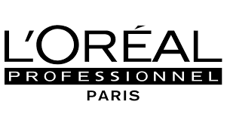

TARGETING:
“Targeting is a marketing strategy followed by the process of segmentation for specifying the customers.” (Marketing fundamentals, 2023)
The targeting strategy used by loreal is differentiation marketing. It means Loreal focuses differently on each group for the marketing mix strategy. Owning more than 35 brands internationally and currently focusing on four divisions which are Loreal luxe, professional products, dermatological beauty, and consumer products.
Loreal focuses on all the products specifically targeting mass market and niche market as well. For instance, loreal luxe is mostly bought by upper division of people for flaunting their persona, consumer products are targets mass market that is the middle division and professional products are utilized by professional beauty people. (Loreal group, n.d)

ADVANTAGES OF L'ORÉAL
SEGMENTATION:
1. By focusing on the demographic factors, Loreal has focused on the needs and wants of the customers.
2. The global availability of the brand enables quick distribution.
3. It promotes niche market which classifies the needs of small groups of people.
DISADVANTAGES OF L'ORÉAL
SEGMENATION:
1. The cost of production is high due to maintenance of sustainability.
2. The cost of production is high due to maintenance of sustainability.
3. It requires a heavy investment for promotion and distribution worldwide.
4. Due to the division of products the production process is costly.

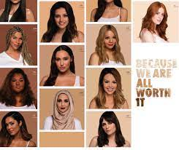
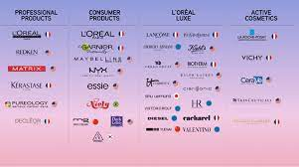
Loreal adapts universalization as their strategy also said as “Glocalisation”. It is opted to focus on the differences between people’s lifestyle, desire, and needs. This will fulfill the needs of the consumers all around the world. (Loreal Finance, 2021)

POSITIONING
“Positioning is the act of designing company’s offering and image to occupy a distinctive place in minds of the target market.” (Kotler. P, 2009)
ADVANTAGES OF TARGETING DISADVANTAGES OF TARGETING
1. It helps in reaching right customer at the right time. 1. High cost for collecting requirements of people.
2. It can lead to increase in profits. 2. Targeting different people requires time to perceive their insights.
3. It integrates pricing strategy thus, gives a passage 3. High risk of competition regarding prices (Harappa,2022).
for future research (Talukdar, D., 2015).

MARKETING MIX
“Analyzing, Planning, controlling and, implementing is engaged by the company to control the 4 P’s for having a good marketing strategy and mix” (Kotler, 2019)
1. PRODUCT
Four main divisions:
L’ORÉAL luxe: “Yves Saint Laurent, Armani, Kiehl's Since 1851, Helena Rubinstein, Biotherm ,Shu Uemura ,IT Cosmetics” and many more (L’ORÉAL Groupe,n.d)
Consumer Products: “L'Oréal Paris Garnier, Maybelline New York ,NYX Professional Makeup , and Stylenanda” (L’ORÉAL Groupe, n.d)
Professional products: “ L'Oréal Professional Paris, Kérastase Redken, Matrix Pureology, and Pulp Riot” (L’ORÉAL Groupe,n.d)
Dermatological products: “La Roche-Posay ,Vichy ,CeraVe , SkinCeuticals , and Skinbetter Science” (L’ORÉAL Groupe,n.d)
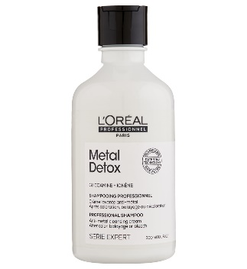
All the products are designed with the evolving needs of the consumers. These are classified for upper class and middle class both to satisfy the needs to emphasize product innovation and quality.
Anti-Metal Cleansing Cream Shampoo: L’ORÉAL Paris Professional product
Features: keeps the color intact, gives two times more shiny hair, and makes the hair stronger
Size and packaging: 1500ml and 300ml in a bottle packaging
Ingredients: GLICOAMINE and Ionène (L’ORÉAL Partner shop, n.d)
Variety of similar products: Beautiful silver hair grey shampoo
Price: 300 ml: £ 19⁵⁰
1500ml: £ 35⁹⁸ ⁽Amazon, 2022)
2. PRICE: L’ORÉAL uses a Premium pricing strategy.
“Premium price strategy is setting high prices for products other than the competitors in the market in order to position itself as premium brand.” (Allsopp, J. ,2005)
L’ORÉAL has a luxury division in which they offer luxury products with high end value. They earn profits from this division as they sell it in cosmetic stores, supermarkets and in their own outlets. They use a value-based pricing strategy, this is the reason customers pay high prices as compared to the competitors. (MBA Skool,2021)
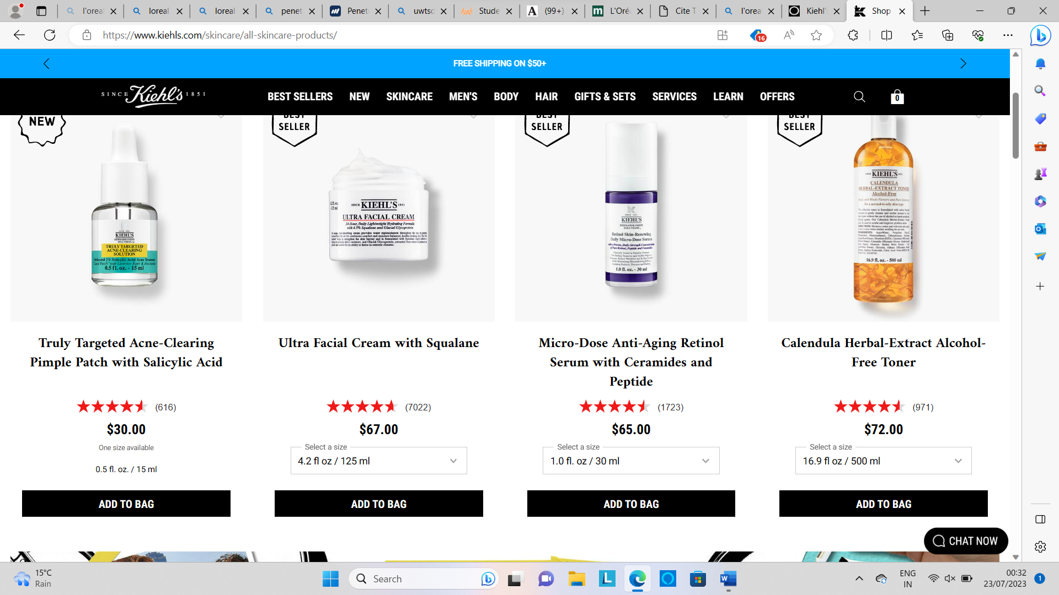
One of the brands from luxury division Kiehl’s since 1851 prices skincare premium products starting from 30 pounds. (Keihl’s since 1851,2023)
image source: Shop Skincare & Face Products - Gentle & Effective Skincare - Kiehl's (kiehls.com)

3.PLACE:
“Place marketing takes the market of places as a basis – places where the supply of different places meets the demand for them” (Vanova, et.al,2017).
L’ORÉAL uses both direct and indirect distribution channels.
There is dispatch of over 6 billion products every year which sums up 2 orders per second to 8 different distribution channels.
The direct distribution goes to salons, mass market, makeovers, and professionals to meet the needs and wants of the consumers.
L’ORÉAL also has fulfilment factories which is an “augmented distribution center” specialized for customization of product deliveries. The location for one of these factories is Suzhou, China.
Indirect Distribution is through wholesalers and retailers and some examples of stores selling the products are Superdrug and Boots.
The sales increased from 15% to 23% from 2019 by the end of 2020, which is during the pandemic. The reason behind the success was digital marketing which made it easier for the consumer from ordering to receiving deliveries (L’ORÉAL Groupe, n.d).
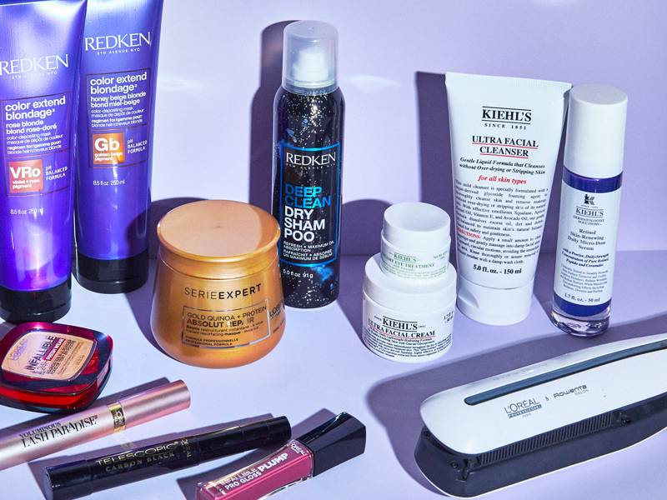
According to reports L’ORÉAL is leading in 3 main geographical zones:
1. WESTERN EUROPE
2. NORTH AMERICA AND THE NEW MARKETS: ASIA PACIFIC, LATIN AMERICA, EASTERN EUROPE AND, AFRICA
3. MIDDLE EAST
According to 2019 annual reports, it is present in 150 countries (L’ORÉAL finance, n.d)

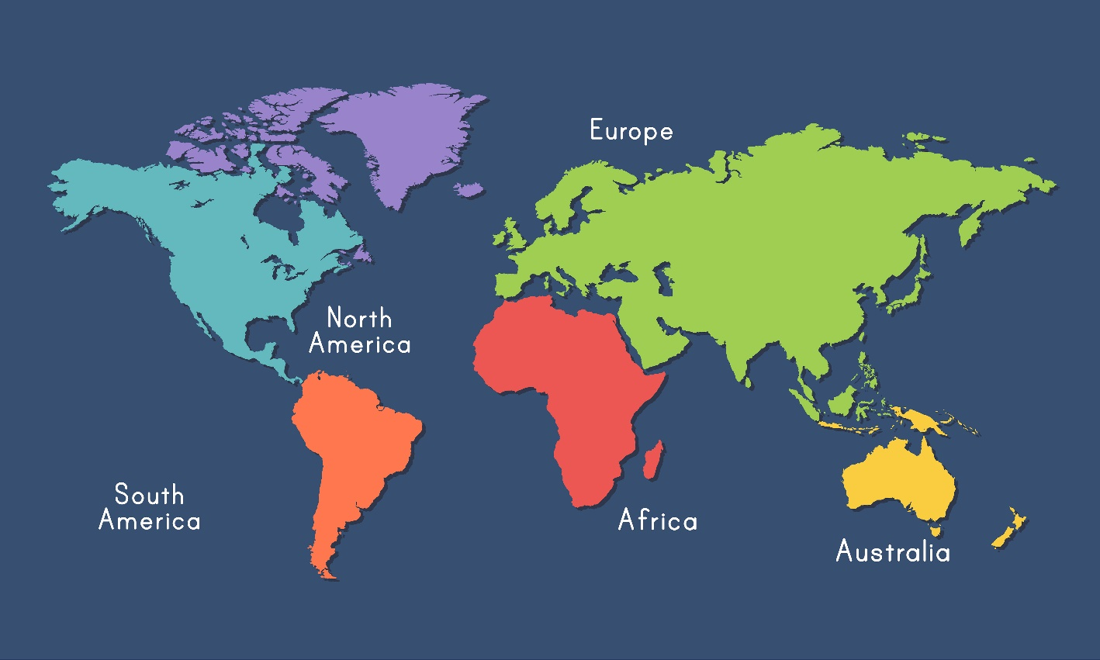
ASIA PACIFIC
EASTERN EUROPE
WESTERN EUROPE

AFRICA
MIDDLE EAST
NORTH AMERICA
LATIN AMERICA

WORLD MAP SHOWING DISTRIBUTION OF L’ORÉAL

4. Promotion:
ADVERSTISING: “Advertising attracts consumers and make a relationship with them by commuting their value” (Kotler and Armstrong, 2019)
L’ORÉAL uses various celebrities for advertising and promoting their products. For example: the new launch of “Total repair 5” was advertised by global ambassador Aishwarya Rai Bachchan and actress Sobhita Dhulipala who has worked in “Made in Heaven” (Exchange 4 Media, 2019)
You tube link for 5 total repair advertisement: (115) L'Oreal Paris Total Repair 5 | Win Over Damaged Hair | Aishwarya Rai & Sobhita Dhulipala - English - YouTube
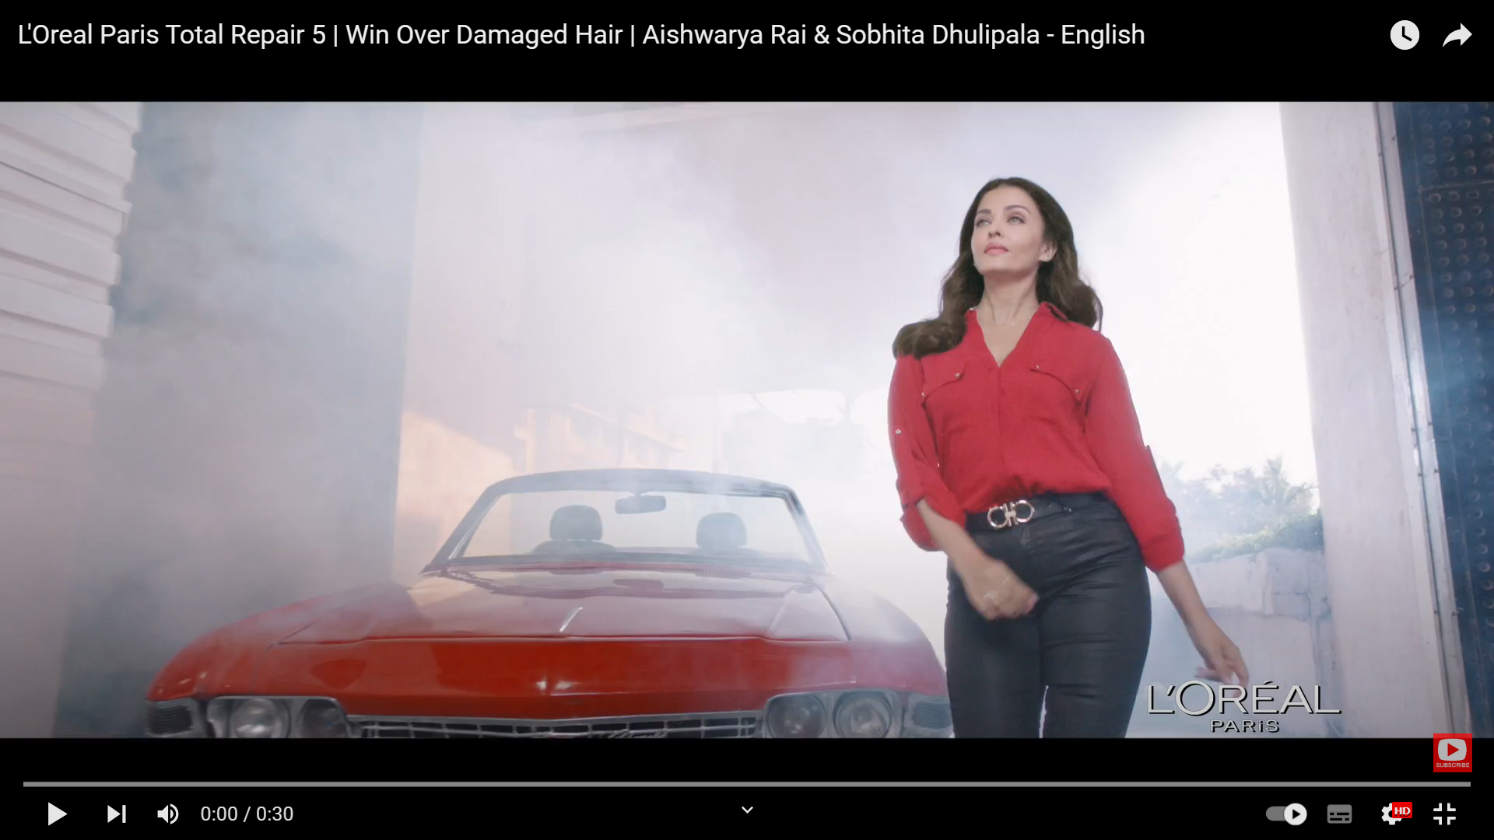
SALES PROMOTION:
“The short-term incentives to encourage the customer to purchase is called sales promotion” (Kotler, P. et. al., 2019)
L’ORÉAL gives discounts and free samples to salons to increase the rate of growth of a product (Shastri,2020)
SOCIAL MEDIA MARKETING: To engage more customers, social media extends opportunity in the market (Kotler, P. et. al., 2019)
It uses different social media platforms to promote products and ideas about their new campaigns. This engages the interest of youth and new consumers.
The social media platforms and their links are as follows (L’ORÉAL Groupe, n.d):
1. INSTAGRAM : L'Oréal Groupe (@L’ORÉALgroupe) • Instagram photos and videos
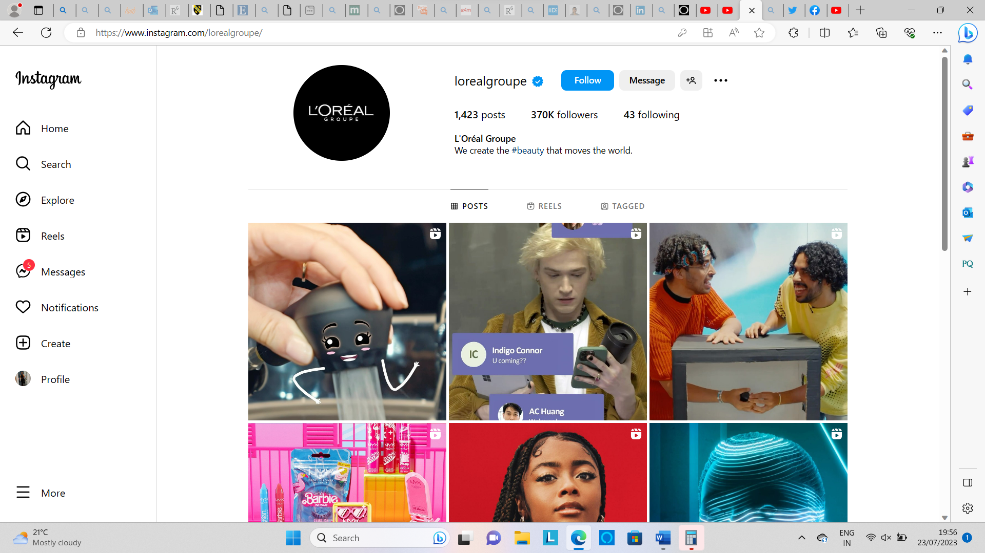

2. FACEBOOK LINK: L'Oréal Professionnel | Facebook 3. TWITTER: L'Oréal Groupe (@L’ORÉALGroupe) / Twitter
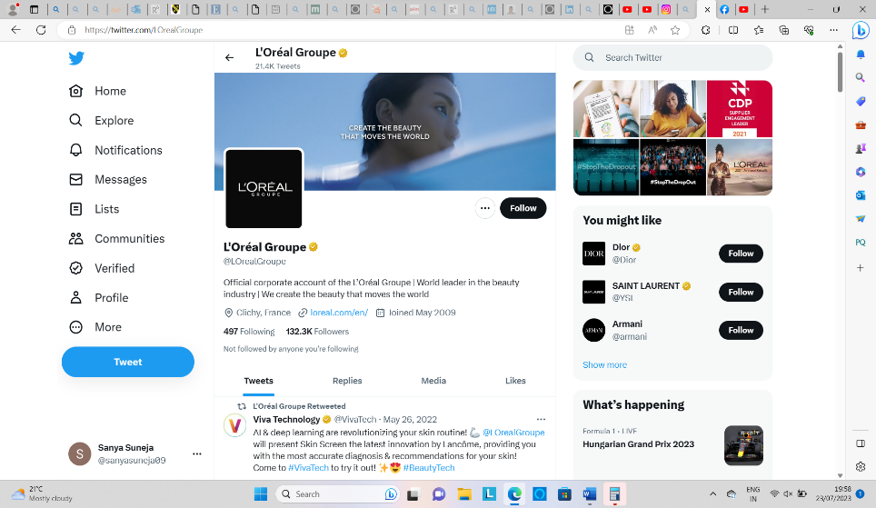
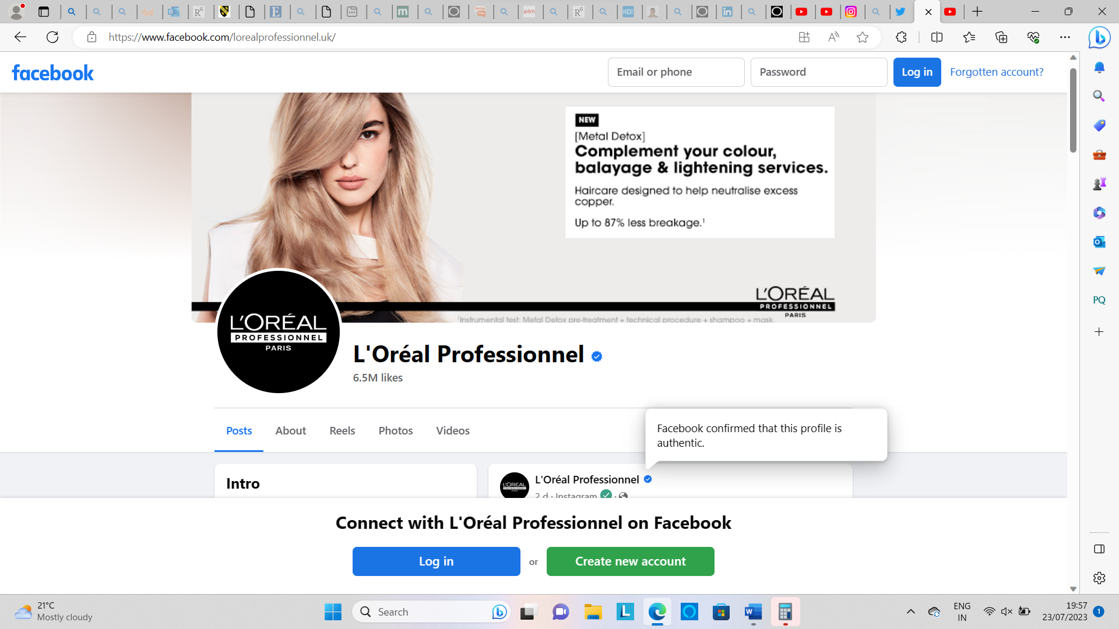
4. YOU TUBE: (115) L'Oréal Groupe - YouTube 5. LINKEDIN: L'Oréal | LinkedIn
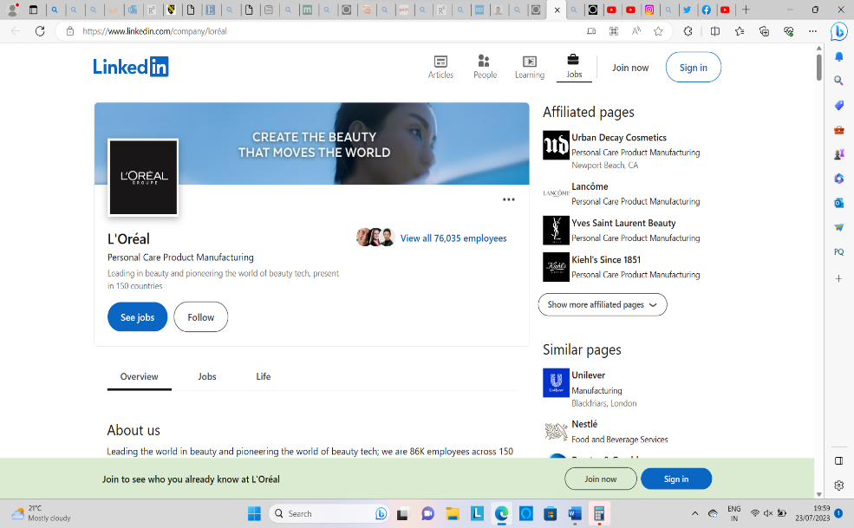
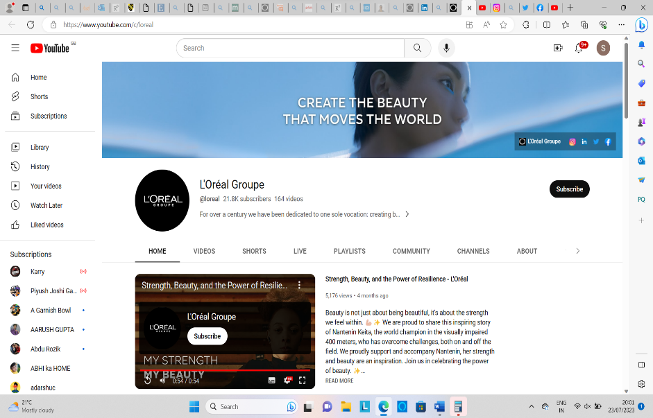

REFERENCES:
Allsopp, J. (2005) 'Premium Pricing: Understanding the value of Premium', Journal of Revenue and pricing management, vol 4(2), pp.185-194. Available at: (99+) Premium pricing | Anna Roman - Academia.edu
Amazon (2022) L’ORÉAL Professional Paris. Available at: https://www.amazon.co.uk/Professionnel-Anti-Metal-Cleansing-Lightening-Glicoamine/dp/B07BCCRWVT/ref=sr_1_5?crid=5S2J9EZIRWRT&keywords=anti+metal+shampoo&qid=1689097754&sprefix=anti+metal+%2Caps%2C101&sr=8-5 (Accessed: July11, 2023).
Dolnicar, S. (2018) Marketing Segmentation analysis understanding it, doing it and making it. Singapore: Austrian Science Fund (FWF).
Exchange 4 media (2019) L’ORÉAL Paris launches new campaign with Aishwarya Rai Bachchan and Sobhita Dhulipala. Available at: L’Oréal Paris launches new campaign with Aishwarya Rai Bachchan and Sobhita Dhulipala - Exchange4media(Accessed: 23 July 2023).
Harappa (2022) Differentiated marketing strategy: meaning, examples and strategy. Available at: Differentiated Marketing Strategy: Meaning, Examples and Strategy - Harappa (Accessed: 22 JULY 2023).
Keilh's since 1851 (2023) Skincare and face products. Available at: Shop Skincare & Face Products - Gentle & Effective Skincare - Kiehl's - Page 3 (kiehls.com) (Accessed: 23 july 2023).
Kotler, P. (2009) Marketing Management. England: Publisher. Pearson Publications Limited.
Kotler, P. et. al. (2019) Principles of Marketing. Edition: 17. United Kingdom: Pearson Education Limited. p.24
Kotler, P. et. al. (2019) Principles of Marketing. Edition: 17. United Kingdom: Pearson Education Limited. p.450
Kotler, P. et. al. (2019) Principles of Marketing. Edition: 17. United Kingdom: Pearson Education Limited. p.480
Kotler, P. et. al. (2019) Principles of Marketing. Edition: 17. United Kingdom: Pearson Education Limited. p.49
Kotler, P. et. al. (2019) Principles of Marketing. Edition: 17. United Kingdom: Pearson Education Limited. p.200
L’ORÉAL (2019) Consumer Product Division. Available at: https://www.L’ORÉAL.com/en/consumer-products-division/(Accessed: 7th July' 2023).
L’ORÉAL finance (2019) L’ORÉAL Worldwide. Available at: L'Oréal Finance : L'Oréal worldwide (L’ORÉAL-finance.com) (Accessed: 23 july,2023).
L’ORÉAL Finance (2020) L’ORÉAL Worldwide. Available at: https://www.L’ORÉAL-finance.com/eng/other/L’ORÉAL-worldwide#:~:text=Present%20in%20150%20countries%20in,and%20men%20around%20the%20world.(Accessed: July 7th, 2023).
L’ORÉAL finance (2021) L’ORÉAL 2021 Annual Report. Available at: https://www.L’ORÉAL-finance.com/en/annual-report-2021/strategy/#:~:text=L%E2%80%99Or%C3%A9al%20relies%20on%20a%20single%20strategy%E2%80%94Glocalisation%E2%80%94meaning%20the%20globalisation,is%20more%20relevant%20than%20ever%2C%20timeless%20and%20evolutionary. (Accessed: July 11,2023).
L’ORÉAL Groupe (n.d) Our global brands portfolio. Available at: https://www.L’ORÉAL.com/en/our-global-brands-portfolio/ (Accessed: july 11, 2023).
L’ORÉAL Groupe (n.d) How supply chain evolves to meet our consumer's demand. Available at: Interview: How Supply Chain Evolves to Meet Our Consumers’ Demands (L’ORÉAL.com) (Accessed: 23 July, 2023).
L’ORÉAL Groupe (n.d) L’ORÉAL Luxe Division. Available at: https://www.L’ORÉAL.com/en/L’ORÉAL-luxe/ (Accessed: July 7th, 2023).
L’ORÉAL Groupe (n.d) Mediaroom. Available at: L'Oréal Finance :Mediaroom - L'Oréal (L’ORÉAL.com) (Accessed: 23 july,2023).
L’ORÉAL Groupe (n.d.) Consumer Products Division. Available at: https://www.L’ORÉAL.com/en/consumer-products-division/ (Accessed: 11thJuly,2023).
L’ORÉAL Groupe (n.d.) Create the beauty that moves the world. Available at: L'Oréal Group : Our Purpose (L’ORÉAL.com)(Accessed: 23 July 2023).
L’ORÉAL Groupe (n.d.) Dermatological Beauty Division. Available at: https://www.L’ORÉAL.com/en/division-beaute-dermatologique/(Accessed: 11thJuly,2023).
L’ORÉAL Groupe (n.d.) L’ORÉAL Luxe Division. Available at: https://www.L’ORÉAL.com/en/L’ORÉAL-luxe/ (Accessed: 11thJuly,2023).
L’ORÉAL Groupe (n.d.) Our History. Available at: L'Oréal's history: the adventure of beauty (L’ORÉAL.com) (Accessed: 23 July 2023)
L’ORÉAL Groupe (n.d.) Professional Products Division. Available at: https://www.L’ORÉAL.com/en/professional-products-division/(Accessed: 11thJuly,2023).
L’ORÉAL men expert (n.d) Hair, Body, and Skin care for men. Available at: https://www.L’ORÉAL-paris.co.uk/men/ (Accessed: July 7th, 2023).
L’ORÉAL Paris (n.d) L’ORÉAL Kids. Available at: https://www.L’ORÉAL-paris.co.uk/hair-care/L’ORÉAL-kids(Accessed: July 7th, 2023).
L’ORÉAL Partner shop (n.d.) METAL DETOX ANTI-METAL CLEANSING CREAM SHAMPOO. Available at: https://uk.L’ORÉALpartnershop.com/en/metal-detox-anti-metal-cleansing-cream-shampoo/GB30160668.html
(Accessed: 11thJuly,2023).
Marketing Fundamentals, (2023) 'Targeting', Segmentation, targeting and positioning. Available at: https://moodle.uwtsd.ac.uk/course/view.php?id=3813 (11July 2023).
MBA skool (2021) L’ORÉAL Marketing strategy & marketing mix (4PS). Available at: L'Oréal Marketing Strategy & Marketing Mix (4Ps) | MBA Skool (Accessed: 23 July 2023).
Shastri, A. (2020) L’ORÉAL Digital Marketing Case study. Available at: L'Oréal Marketing Strategy - Top Cosmetic Brand | IIDE (Accessed: 23 July 2023).
Talukdar, D. (2015) 'Optimal Targeting for advertisement for new products with multiple consumer segments', International Journal of in marketing, Issue-3, Vol.32, pp. 263-271. Available at: Optimal targeting of advertisement for new products with multiple consumer segments - ScienceDirect (uwtsd.ac.uk)
Vanova, A., et.al. (2017) 'Place Marketing', ISBN: 978-80-557-1312-0, p-22. Available at:(PDF) Place marketing (researchgate.net)

