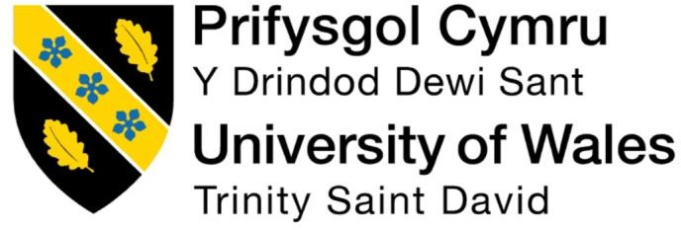

Programme: Master of Business Administration
Module: Human Capital Management
Module code: LCMB7023
Assignment Title: Assessment component 1: Individual report
THE INFLUENCE OF NATIONAL AND INTERNATIONAL LABOUR MARKETS ON HRM AND IHRM STRATEGIES
Lecturer: Ejike Udeogu (Birmingham)
Student name: Harshil Bharatkumar Desai
Student ID number: 2504765
Word count: 2647
Submission date: 17/10/2025
Table of Contents

Introduction 3
1. Technological advancements are reshaping the labour markets 3
Figure 1: EY.ai Workforce of Ernst & Young 5
2 Influence of demographic and geopolitical factors on the employment market 6
Figure 2: Innovation at Tesco for better customer service 7
3 Strategic HRM’s use for addressing skill gaps and talent shortages 8
4. Reflective report 9
Figure 3: Gibbs reflective Cycle 9
Conclusion 11
References 12

Introduction.
The employment market is referred to as the supply and demand for labour (employees) on the basis of factors, such as job availability, skills required, economic conditions, and policies guiding employment levels. The report is mainly based on the context of HRM and IHRM strategies and their influence on the global labour market. In this context, it is to be understood that Human Resource Management (HRM) refers to managing employees within the boundary of a single country, and, therefore, deals with domestic regulations and culture. On the contrary, IHRM (International Human Resource Management) is all about managing human resources across national borders. This, therefore, requires consideration of diverse cultures, multiple legal compliances, and complex global factors.

1. Technological advancements are reshaping the labour markets.
The context of technological advancements through AI (Artificial Intelligence), Automation, and digital platforms are majorly contributing in the changes in labour markets, with a focus on varied HR functions. In terms of HRM, the national boundaries develop a need for more dynamic resourcing models. As stated by Vrontis et al., (2023), this further depicts the need for human working, alongside AI and other technological tools, in contrast to being replaced, thereby developing a potential for human-AI/robotics collaboration. In the international HRM or IHRM context, the pressure is further enhanced through contexts like allowing technological readiness, regulatory alignments and even selecting talents from wider talent pools across the globe. As an example, Unilever can be considered regarding how large UK-based companies use AI in HR. It is found to have adapted gamified cognitive assessments and video interviews through HireVue for their screening of candidates, which further contributed to reducing hiring time by 75% (Staniszewska and Galindo, 2024). There needs to be further understanding of the company’s use of FLEX Experiences, which is an AI-based internal talent marketplace, supporting to exploration of cross-functional assignments and enhancing mobility (Unilever, 2020). These digital transformations not only enhance efficiency, but can also develop ethical and even cultural challenges. For example, the algorithm bias in AI recruitment tools like HI revue can reproduce potential inequalities if not managed properly. Furthermore, the major support on automation can risk the reduction of human touch for HR decision-making, potentially affecting trust and even engagement of employees (David et al., 2025).
On the other hand, Shell Plc has also focused on digital transformation widely through considering the adaptation of various advanced technologies like AI, and Block chain. In this context, the use of AR & VR has raised the foremost need for effective operational alignments. Furthermore, with a focus on human-robotics collaboration concept, Shell also focused on utilizing robotics to not only support their human resources but also conduct tasks that cannot be possible with people (Shell, 2021). While in the retail context, companies like Tesco have also modernized their HR operations. Another concrete UK example is that the company has invested in advanced HR analytics, workforce scheduling algorithms, and digital engagement tools for its 330,000 colleagues in the UK and abroad (Cipd, 2024). Furthermore, Tesco’s partnership with Manna, trialling drone delivery services in Ireland (Oranmore and Balbriggan) to enable customers to receive grocery orders within minutes. This initiative positions Tesco as a leader in sustainable and rapid delivery innovation (Tesco PLC, 2024).
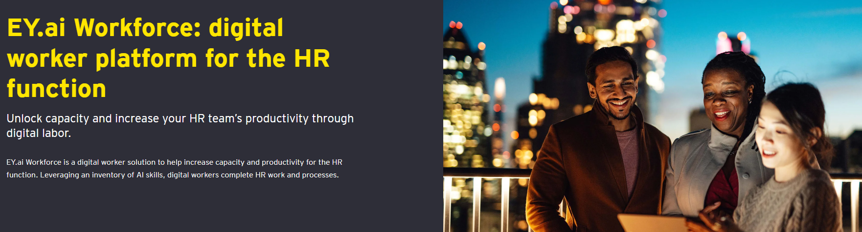
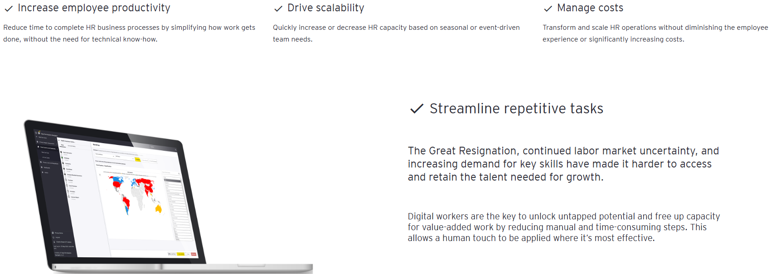

Figure 1: EY.ai Workforce of Ernst & Young
(Source: Ey, 2025)
Not only has this but the London-based consulting firm, Ernst & Young (EY), also relied on the use of AI in their HR operations. As shown in figure 1, it has introduced EY.ai Workforce, which is a platform powered through AI for providing digital workers with the training of particular skills for completing diverse HR tasks and practices (Ey, 2025). EY has also launched a global AI Assurance Framework for more than 130,000 professionals, guiding the ethical and compliant use of AI in financial reporting and risk management. To further strengthen digital audit capabilities, EY is aligning around 9,000 Technology Risk professionals with its Assurance division, expanding expertise in IT risk and data governance (EY, 2024). Although technology enhances global HRM integration, it forces HR leaders to critically balance their efficiency with transparency, inclusivity and proper fairness. These findings are further aligned with the AMO (Ability-motivation-opportunity) model, which showcases that HR strategies need to enhance employee abilities through sustainable motivation, which in this is through technology engagement, training and developing opportunities through flexible digital systems (Al-Shahwani, 2020). Effective level of IHRM is based on aligning the AI-focused efficiency with human capital developments, in the contemporary time. For instance, talent strategy needs to be more forward looking with HR monitoring, which tasks can be automated, and even re-skill or redeploy employees based on it. As per the views of Eubanks (2025), HR operating models need to become more digital through AI assistance, and self-service should be utilized in contrast of traditional legacy systems. Thus, while technology is changing the HR approaches and labour markets, its complete impact is further enhanced through demographic shifts and geopolitical developments, further changing the global talent context.

2. Influence of demographic and geopolitical factors on the employment market.
Demographic shifts and the context of geopolitical factors are raising their influence on changing the employment markets in various manners that needs to be considered. Among these, the trend of population ageing is vital as in the UK and other developed economies, the proportion of older workers is rising due to the fact that people are living longer and birth rates have declined. A recent report has shed light on how a major portion of individuals in the UK are working regardless of reaching their retirement age of 65 years (Lewissilkin, 2025). In this context, the findings of Portes and Springford (2023) reveals the need to consider the post-Brexit situation, which resulted in a reduction of net migration from the EU. However, policy changes like Brexit have increased domestic employment, besides developing long-term contradictory aspects like tight labour supplies. These have increased business costs like in terms of R&D and lowered the potential of innovation in key industries, thereby hindering the potential for growth (Do et al., 2025).
Employment rates in the UK vary sharply by ethnic group. For example, in 2022, those of Pakistani/Bangladeshi origin had an employment rate of 61%, as compared to 76% average for all groups. Unemployment among minority ethnic individuals has also risen more steeply than among white counterparts. To be more precise, in between April and June 2024, the minority ethnic unemployment rate was approximately 8.0%, compared with 3.3% for people of white ethnic background (a gap of 4.6%) (Gov.uk, 2023). The fact here is that young professionals can have diverse values in relation to the work-life balance approaches, remote or hybrid working (Ljungkvist and Moore, 2023). The context of ‘War for talent’ has become to be not only for organizational level, but also has become to be a competition among countries (Faugoo, 2024). Nationalism, changing immigration laws, as identified above in the Brexit context, have developed various uncertainties, especially impacting workers, adding costs, and developing potential time issues. On that note, several renowned companies have been investing for creating new jobs in the UK market. For example, Unilever has made a £80 million investment in a new fragrance facility at Port Sunlight, expanding its R&D and innovation capabilities (Unilever, 2025). In addition, Shell UK plans to invest £20-25 billion over the next decade in low- and zero-carbon energy systems, including offshore wind, hydrogen, electric mobility, and carbon capture, aligning with net-zero goals (Russell, 2022). As shown in figure 2, Tesco is also experimenting with innovations like drone delivery (with Manna), AI in product development (with Turing), Urban Fulfilment Centres (Tesco, 2025).
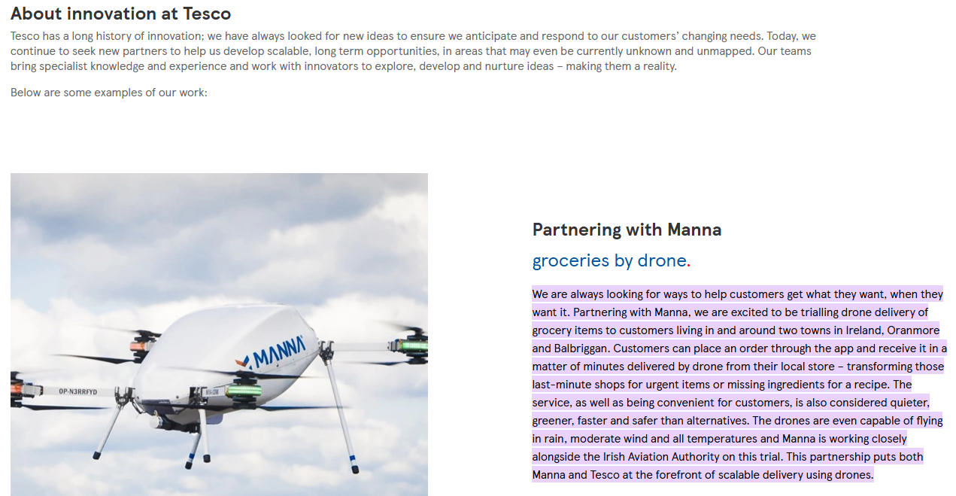

Figure 2: Innovation at Tesco for better customer service
(Source: Tesco, 2025)
It is critically identified that geopolitical level volatility allows the HR to act not only as reactive individual, but also as a strategic individual. Thus, the anticipation of policy risks and even workforce mobility issues, in contrast of just responding only after each disruption (Rodriguez and Hasan, 2025). Furthermore, geopolitical issues like supply chain disruptions, regulatory barriers, and new sanctions can also develop a major uncertain situation for HR and their functions (Kanike, 2023). In this context, the demographics and geopolitical factors can, however, develop challenges for HR professionals, which are as follows:
- Policy and regulatory issues: managing diverse laws of international markets and immigration rules will require in-depth analysis and anticipation capabilities for any changes or disruptions.
- Talent supply: ensuring the enough workers with skills are available in the rapidly reducing domestic labour market and stricter immigration.
- Employee expectations: As per Rahman (2025), the adaptation of diverse generational workforce can be a major complex barrier for HR managers, as it is not a one-size-fits-all approach and can often result in causing miscommunication, internal conflicts, and even turnover, if not managed correctly.
These demographics, along with geopolitical changes, contribute towards enhancing skill gaps and talent shortages, which need strategic HRM approaches for ensuring the complete company adaptability and workforce resilience.

3. Strategic HRM’s use for addressing skill gaps and talent shortages
International organizations and even in the UK are facing various talent shortages in diverse critical sectors like hospitality, healthcare, and technology. The context of strategic HRM can offer various potential approaches that can address these gaps. Yet these will further require more up skilling of employees, flexibility, and inclusive strategies. These initiatives can be aligned with Strategic Workforce Planning principles, which are focused on anticipating future skills needs and aligning HR practices with long-term company goals for competitive advantages (Mckinsey, 2025).
Investments in early and ongoing talent contexts: In this approach, the example of Unilever can be utilized, as it has introduced a leadership development programme, named Future Leaders Programme that can develop future leaders and technical experts. As stated by Karatas (2021), such a leadership program includes exposing the individuals to various aspects like human resources, business, and technology.
Technological use and adaptation: Being the most central and common beneficial approach for companies, this approach can contribute positively to increasing productivity and even create opportunities for higher productivity efficiency. This will potentially allow the existing workforce to gain more, and any shortages will have a lesser level of damaging impacts on the companies. For example, in the healthcare context, analytics and various other advanced tools can support workforce planning and patient care with a particular focus on scheduling (Youn et al., 2022).
Working partnerships: companies can ensure collaborating or developing partnerships with educational companies, and government to support and align their curricula with the real needs of the current labour market. In this context, companies in the technological or healthcare sectors can collaborate with various technical colleges or universities to further offer the graduates with skills that will meet their employment needs (Tereshchenko et al., 2024). These can further allow the students to gain potential hand-on experiences for learning the sector-specific needs.
Reskilling and up skilling: Up skilling or reskilling of staff can allow them to adapt to changes in the market more efficiently. In this context, Kıcır (2024) has found it essential for organisations to focus on providing offers of quiet hiring, which will allow existing employees to take various new responsibilities and even reduce the dependency on external recruitments.

4. Reflective report
In this reflective section, the Gibbs reflective Cycle is followed, which includes stages of descriptions, feelings, evaluation, analysis, conclusion and action plan. Use of this model allowed structuring own reflection critically and connect experiences with future improvement approaches.
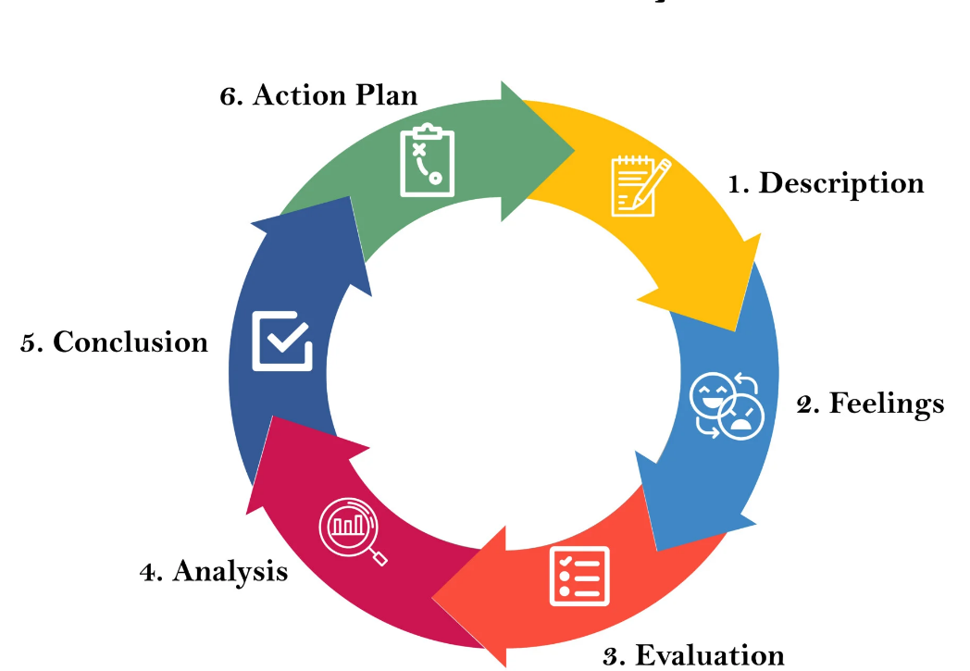

Figure 3: Gibbs reflective Cycle
(Source: McLeod, 2025)
To begin with, I felt confident utilizing digital tools which makes it one of my major strengths is in technological usage. As I am used to working in a critical environment with significant digital collaboration tools like Slack, and Microsoft Teams, I have been able to utilize these platforms more effectively to communicate and coordinate across various time zones. Evaluating this experience, I was able to consider how various new technologies can be applicable to academic and professional contexts. The analysis of these experiences further allowed me to consider various improvement actions. In reflecting on my own experience, I felt that I was a confident individual while expressing understanding in both speaking and written forms in English. In terms of evaluation, in a recent virtual collaboration of this term with peers from the UK and India, I was facing issues in analysing the indirect feedback and diverse communication approaches. Although, I was later able to ask more clarifying questions and even listen actively. Analysing it, made me understand that in an international context, communication is not limited only to language proficiency, as it also includes intercultural sensitivity and even empathy. From that day, as enhancement actions, I started to research and understand the context of international communication theories like Hofstede’s cultural dimensions to properly develop an understanding of how culture influences communication and even workplace approaches. I further aim to engage in more international communication opportunities to further enhance my skills.
Reflecting on my experience of teamwork, I felt that I tend to have much better performances in collaborative approaches, especially if the tasks are properly defined. While evaluating my most recent academic projects, I was provided the role of facilitator, which also ensured the fact that deadlines were properly met. Although it is decisive to consider that I have further noticed that I can often face hesitations for delegation of tasks when I am liable for the complete quality of work outcomes. This is majorly due to the overwhelming pressure for responsibilities and can impact the inputs of others, eventually increasing my work pressure. Thus, to improve this area, I am focused on practicing a more distributed leadership style. As per Youngs and Evans (2021), this will allow others to even take initiatives and share my workload to gain more beneficial results.
In reflecting on my leadership context, I have felt that I aim to lead through collaboration in contrast to authority, which is focused on engagement and inclusion. The evaluation showcased that during my leadership in a student group, I ensured that everyone’s opinions were considered and also ensured to encourage them for a more constructive level of feedback. Yet, I have also identified that I can be majorly cautious in decision-making processes. In case of international working environments, adaptability and rapid decision-making are required (Fakhri et al., 2021). Finally, reflecting on my self-directed learning context, I felt that it has become my key support for professional growth. Evaluating this experience showcased me that, I have developed a potential habit for setting various goals for learning and tracking progress while seeking feedback from seniors and others. In this term, I utilized reflective journaling for the monitoring of my academic and personal level developments. It showcased that this approach ensures my ability to effectively learn, which is a vital skill in the current global labour marketplace. Although, I face issues in often setting too ambitious learning targets, which can lead to my burnout. Thus, to overcome this, as future enhancement actions, I am planning to adopt more selective SMART goals, ensuring that each of the targets is specific, measurable, achievable, relevant, and time-bound.

Conclusion.
This above report has shed light on the complete national and international labour markets and their influence on HRM and IHRM processes. The report has showcased how technological advancements like AI, automation, and robotics are changing the complete labour market and HR practices with the support of examples from a variety of renowned companies in the UK, namely EY, Shell, Tesco, and Unilever. Additionally, there need to have a global consistency with local adaptation in multinational companies with the support of AI and HR, although a flexibility to local labour laws and cultural norms is also important. The study also analysed the influence of demographic like diverse generation gaps, and geopolitical like changes in regulations and sanctions can influence and develop major issues for HR managers.

References
Al-Shahwani, T.M., (2020) Impact of AMO enhancing human resource management practices on sustainable competitive advantage in insurance companies in Qatar. Management Science Letters, 10(8), pp.1827-1834.https://pdfs.semanticscholar.org/e4eb/ebee79064c0a37ea6d10802bd37a936ce8f4.pdf
Cipd. (2024). ‘Transforming the HR operating model: Tesco’ CIPD. Available at: https://www.cipd.org/en/knowledge/case-studies/operating-model-tesco (Accessed on 01 October 2025).
David, O., Hookers, A. and Day, J., (2025) Artificial Intelligence for Human Resource Management: Recruitment, Retention, and Performance.https://www.researchgate.net/profile/Blessing-Idowu/publication/396179996_Artificial_Intelligence_for_Human_Resource_Management_Recruitment_Retention_and_Performance_Author/links/68e08556ffdca73694b54e97/Artificial-Intelligence-for-Human-Resource-Management-Recruitment-Retention-and-Performance-Author.pdf
Do, H., Duong, K.T., Huynh, L.D.T. and Vu, N.T., (2025) The Real Effects of Brexit on Labor Demand: Evidence from Firm-level Data. Available at SSRN 5257575.https://papers.ssrn.com/sol3/Delivery.cfm?abstractid=5257575
Eubanks, B., (2025) ‘Artificial intelligence for HR: Use AI to support and develop a successful workforce’. Kogan Page Publishers. Available at: https://books.google.com/books?hl=en&lr=&id=Wf2AEQAAQBAJ&oi=fnd&pg=PP1&dq=HR+operating+models+need+to+become+more+digital+through+AI+assistance&ots=fMCGC8HxoC&sig=iV7yQ04cngu0Wp-hc95iOmHmn84
EY. (2024, May). ‘EY Assurance releases new technology capabilities, strengthening confidence and trust’ EY. Available at: https://www.ey.com/en_gl/newsroom/2024/05/ey-asurance-releases-new-technology-capabilities-strengthening-confidence-and-trust (Accessed on 25 September 2025).
Ey. (2025). ‘EY.ai Workforce: digital worker platform for the HR function’ EY. Available at: https://www.ey.com/en_uk/services/workforce/ey-ai-workforce-digital-worker-platform-hr-function#:~:text=Unlock%20capacity%20and%20increase%20your,complete%20HR%20work%20and%20processes. (Accessed on 30 September 2025).
Fakhri, M., SYARIFUDDIN, S., WINARNO, A., NURNIDA, I. and HANUM, S., (2021) ‘Democratic leadership practice to construct clan organizational culture in family companies’ the journal of Asian finance, economics and business, 8(1), pp.803-811. Available at: https://doi.org/10.13106/jafeb.2021.vol8.no1.803
Faugoo, D., (2024). ‘Talent management for achievement of organizational supremacy: The case of reputed global multinationals that have achieved unparalleled success through superior talent management’ International Journal of Business and Technology Management, 6(3), pp.753-764. Available at: https://www.researchgate.net/publication/382909567_Talent_Management_for_Achievement_of_Organizational_Supremacy_The_Case_of_Reputed_Global_Multinationals_That_Have_Achieved_Unparalleled_Success_Through_Superior_Talent_Management
Gov.uk. (2023, November 28). ‘Employment’ GOV.UK. Available at: https://www.ethnicity-facts-figures.service.gov.uk/work-pay-and-benefits/employment/employment/latest/ (Accessed on 01 October 2025).
Kanike, U.K., (2023) ‘Factors disrupting supply chain management in manufacturing industries’ Journal of Supply Chain Management Science, 4(1-2), pp.1-24. Available at: https://doi.org/10.18757/jscms.2023.6986
Karatas, B., (2021) ‘The project of development of human resource management system for a chosen company'. Available at: https://digilib.k.utb.cz/bitstream/handle/10563/47414/karatas_2021_dp.pdf?sequence=-1
Kıcır, G.K., (2024) ‘The New Silence Trend for Businesses: Quiet Hiring’ İşletme Bilimi Dergisi, 12(3), pp.359-369. Available at: https://dergipark.org.tr/en/download/article-file/4100804
Lewissilkin, (2025) ‘Changing demographics and ageing workforces in the UK’. Available at: https://www.lewissilkin.com/our-thinking/future-of-work-hub/insights/2025/05/19/changing-demographics-and-ageing-workforces (Accessed on 02 October 2025).
Ljungkvist, H. and Moore, M., (2023) ‘the challenges of achieving work-life balance in the digital age: A study of young professionals: Exploring the impact of new ways of working on early career adults’. Available at: https://www.diva-portal.org/smash/get/diva2:1769245/FULLTEXT02
Mckinsey, (2025). The critical role of strategic workforce planning in the age of AI. Available at: https://www.mckinsey.com/capabilities/people-and-organizational-performance/our-insights/the-critical-role-of-strategic-workforce-planning-in-the-age-of-ai
McLeod, S., (2025) Gibbs Reflective Cycle. Available at: https://www.simplypsychology.org/gibbs-reflective-cycle.html
Portes, J. and Springford, J., (2023) ‘The impact of the post-Brexit migration system on the UK labour market’ Contemporary Social Science, 18(2), pp.132-149. Available at: https://doi.org/10.1080/21582041.2023.2192516
Rahman, M.M., (2025) ‘Generational Diversity and Inclusion: HRM Challenges and Opportunities in Multigenerational Workforces’. Available at: http://dx.doi.org/10.2139/ssrn.5330092
Rodriguez, R. V. and Hasan, S., (2025) Talent in the age of global disruptions: Building resilient workforce for an uncertain world. Available at: https://hr.economictimes.indiatimes.com/news/trends/leadership/talent-in-the-age-of-global-disruption-building-resilient-workforce-for-an-uncertain-world/121950940#:~:text=A%20global%20HR%20leader%20navigating,changes%20will%20affect%20people%20strategy.

Russell, T. (2022). ‘Shell UK unveils £20 billion low carbon investment plans’. Available at: https://www.4coffshore.com/news/shell-uk-unveils-a320-billion-low-carbon-investment-plans-nid25263.html#:~:text=By:%20Tom%20Russell,in%20various%20stages%20of%20development. (Accessed on 23 September 2025).
Shell, (2021) ‘THE ROAD TRAVELLED SO FAR TO ground surveillance robots’, shell. Available at: https://www.shell.com/what-we-do/digitalisation/robotics/_jcr_content/root/main/section/simple/call_to_action/links/item0.stream/1650125467488/f902d0fe13e308df3ac7c92269231ae9d3131d04/the-road-travelled-so-far-to-ground-surveillance-robots-mulder.pdf
Staniszewska, Z. and Galindo, G., (2024) ‘The Future of Leadership in the Era of AI: Do we Still need’ ESCP Business School Impact Paper. Available at: https://papers.ssrn.com/sol3/Delivery.cfm?abstractid=5457537
Tereshchenko, E., Salmela, E., Melkko, E., Phang, S.K. and Happonen, A., (2024) ‘Emerging best strategies and capabilities for university–industry cooperation: opportunities for MSMEs and universities to improve collaboration. A literature review 2000–2023’ Journal of Innovation and Entrepreneurship, 13(1), p.28. Available at: https://doi.org/10.1186/s13731-024-00386-4
Tesco PLC. (2024) ‘Tesco agrees largest UK corporate PPA for solar power in landmark infrastructure project’, Tesco. Available at: https://www.tescoplc.com/tesco-agrees-largest-uk-corporate-ppa-for-solar-power-in-landmark-infrastructure-project/ (Accessed on 04 October 2025).
Tesco. (2025) ‘Find out more – innovation’, Tesco PLC. Available at: https://www.tescoplc.com/innovation/find-out-more (Accessed on 25 September 2025).
Unilever, (2020). ‘An exciting new normal for flexible working’, Unilever. Available at: https://www.unilever.com/news/news-search/2020/an-exciting-new-normal-for-flexible-working/ (Accessed on 28 September 2025).

Unilever, (2025). ‘What’s behind the doors of our world-leading fragrance house?’, Unilever. Available at: https://www.unilever.com/news/news-search/2025/whats-behind-the-doors-of-our-worldleading-fragrance-house/#:~:text=Published:%2019%20May%202025,product%20formulation%20and%20consumer%20preference. (Accessed on 04 October 2025).
Vrontis, D., Christofi, M., Pereira, V., Tarba, S., Makrides, A. and Trichina, E., (2023) ‘Artificial intelligence, robotics, advanced technologies and human resource management: a systematic review’ Artificial intelligence and international HRM, pp.172-201. Available at: https://doi.org/10.1080/09585192.2020.1871398
Youn, S., Geismar, H.N. and Pinedo, M., (2022) ‘Planning and scheduling in healthcare for better care coordination: Current understanding, trending topics, and future opportunities’ Production and Operations Management, 31(12), pp.4407-4423. Available at: https://doi.org/10.1111/poms.13867
Youngs, H. and Evans, L., (2021) ‘Distributed leadership’ Understanding educational leadership: Critical perspectives and approaches, 203. Available at: https://books.google.com/books?hl=en&lr=&id=dSQXEAAAQBAJ&oi=fnd&pg=PA203&dq=+distributed+leadership+style.+for+business&ots=Ioiv8qwVrM&sig=HfByDO7EkvDRPE6nSlb7R7PvvJA

