STUDENT NAME: SALIMA BEGUM
STUDENT I.D: 2128697
MODULE: BMHP5003
LECTURER: GILLIAN WEAVER

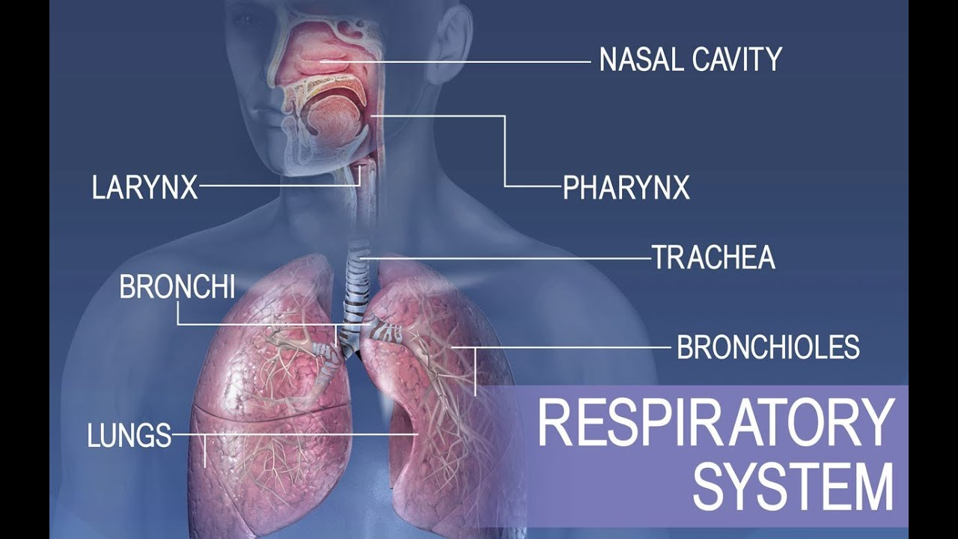

INTRODUCTION

Respiratory system is built up of different organs and tissues, these help with your breathing. These include airways, your lungs and the blood vessels. They together help in absorbing oxygen from the air to work your organs. Oxygen is moved throughout your body to clean out waste like carbon dioxide.

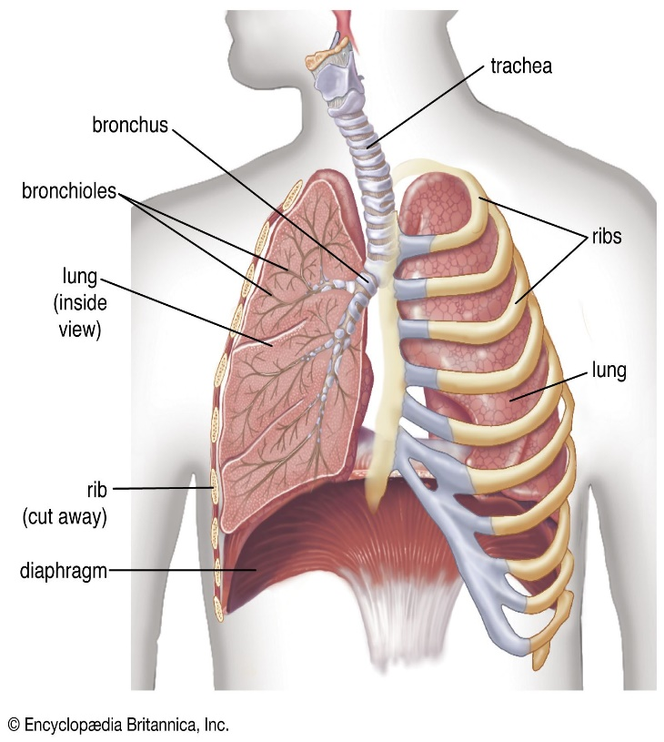
The system helps you to talk and smell.
Oxygen delivery in your body through cells
Removal of waste gases like carbon dioxide when exhaled
Airways are protected from harmful substances
(Cleveland clinic)

The different parts that work together in helping breathing is through the mouth and nose, your sinuses, pharynx i.e the throat, trachea, bronchial tubes, lungs. From the lungs oxygen is transmitted to the other organs around your body.

The Function and Anatomy/Physiology of the Respiratory System

There are different components of the respiratory system which help in keeping the system clear and breathing. The components are
- Mouth and Nose – openings help in pulling air in and out the body, into the system
- Sinuses – these help the hollow openings in between bones in the head which control temperatures and humidness in the air inhaled in
- Pharynx – This is the tube that passes air that from mouth and nose to the trachea. ( windpipe)
- Trachea – This is the road that connects the throat and lungs
- Bronchial tubes – placed at the bottom of your windpipe which connects to lungs
- Lungs – Two of the organs which helps remove of oxygen in air and passes into blood
Then from the lungs, to bloodstream oxygen is passed to other organs and tissues. Muscles and bones help in moving air around the body like the
- Diaphragm – this helps to pull the air in and push out of the lungs
- Ribs – these bones protect the lungs and heart
The other components which also help are
- Alveoli little air sacs within the lungs where exchange of oxygen and carbon dioxide happens
- Bronchioles little tree like branches the bronchial tubes which go towards the alveoli
- Capillaries the vessels within the alveoli wall which moves oxygen and carbon dioxide
- Lung lobes parts of lung consists of three on right side and two on the left side
- Pleura this is the thin sacs which surrounds each of the lung and separate the chest wall.( Cleveland clinic, Britannica.com)
Conditions that can affect the system include allergies, asthma, infection, like pneumonia, bronchitis, diseases like copd, lung cancer etc.

Body functions and relationship between anatomy and physiology
Anatomy of the respiratory system divides the upper organs outside thorax, ( nose, pharynx, and larynx). The lower respiratory organ in the thorax, include the trachea, bronchi, bronchioles, alveolar duct and alveoli.
Breathing in
The contraction of the diaphragm is moved downwards so the intercostal muscles will contract and move ribs up and outwards. Thus will increase the chest size and air pressure decreased which will suck air to the lungs.
Breathing out
Diaphragm will then relax to its domed shape. When the muscles relax ribs move in and down under their weight. Thus will decrease the chest size and air pressure increases to the chest so air is forced out of the lungs. (bbc, bitesize).
Air breathed in | Air breathed out
21% oxygen | 16% oxygen
0.03% carbon dioxide | 4% carbon dioxide

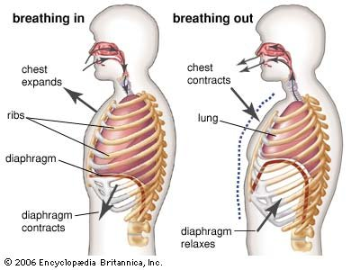This image shows how the chest expands when breathing in and how the chest contracts when breathing out. The lung is very important in the functioning of breathing.
The exchange of gas is the main function of the respiratory system, to get 02 from atmosphere and to remove c02 from the blood. 02 is a necessity for the metabolism c02 is the waste. C02 is inhaled in minor quantities so c02 which passes out is made in the body. While the c02 is plays in the acid base balance it needs to go out of the body, through levels of ventilation.( The learning global). The airways will carry air to alveoli which is the exchange part of lung, and the chest is responsible for the air going out of lungs, the pump. Respiratory system is between upper and lower airways, extended to the larynx, lower from the larynx to bronchiole and alveoli. Lungs is connected to thoracic cage, which includes the ribs, sternum, thoracic, vertebrae, and diaphragm and the intercostal muscles. (Stocks,Alison,Hislop, 2002). Understanding the volume, lung compliances, ventilation perfusion and bronchomotor is essential. So normal requirements should be about 4-8 ml/kg. body mechanism has to be kept as extra ventilation in the form of reserve volume which is capacity breath 4-5 L in average to 70kg individually. (Patwa,Shah 2015).

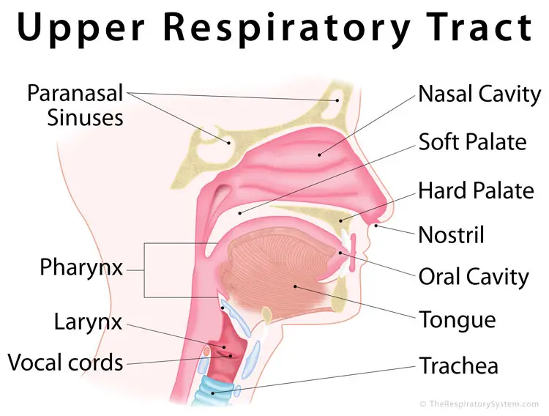
The images show the upper and lower respiratory tract and how they work.
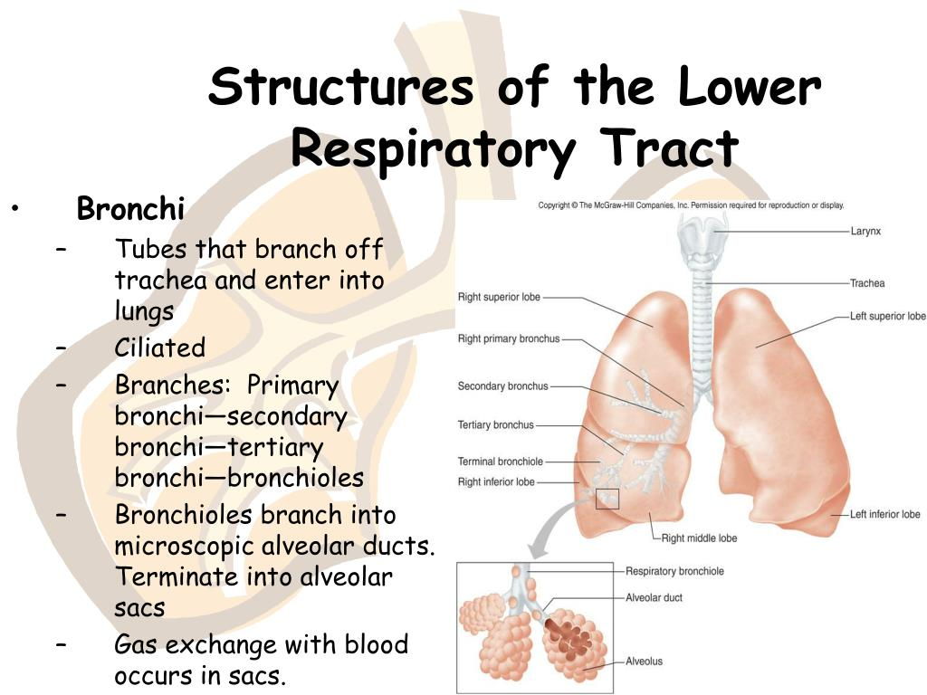

Body functions
- the air goes in the body warms as it goes through mouth and lungs
- then goes to trachea
- trachea divides into two bronchi and goes into both lungs
- then they make small tubes called bronchioles, air passes through them
- at the end air goes through millions of alveoli where the main exchange happens
Breathing
This is where air is passes in and out of lungs
The two important structures of breathing is the diaphragm and intercostal muscles
Diaphragm muscles divide chest from other parts of body
Intercostal muscles are mainly in between ribs and control the movement

Asthma and respiratory system and how healthcare helps
The NHS has put into plan for the longer term which is the next 10 years, is to identify respiratory diseases as the main priority. To make improvements with investing in treatments and supporting people with respiratory diseases. Respiratory affects one in five and is the third main cause of death within England comes after lung cancer, pneumonia, copd, they are the bigger causes of death. With hospital admissions risen three times higher and during the winter it’s a bigger factor to affect the NHS. The estimated economic outcome for asthma and copd in NHS is about 3 billion to 1.9 billion, overall all the lung diseases UK cost annually 11 billion. (NHS.England.UK).
Asthma a long term condition affecting airways, which air is carried from tubes in and out the lungs. There are about 4.5 million people within the UK who receive treatment. There are many different types of asthma. ( Imperial college healthcare). The following are conditions and treatments
- Adult onset of asthma
- Severity of asthma
- Difficulty in treating of asthma
- Breathing pattern
- Vocal cord dysfunction
The diagnostic tests
- Peak flow
- Tests for lung function
- Histamine tests
- X-rays
- Ct scans
- Echodiogram
- Bloods
- Skin pricks
The NHS will do reviews, physiotherapy, speech therapy, pulmonary rehabilitation. The chronic condition comes with episodes of wheezing, coughing, breathlessness, chest tightness. There are two types of asthma intermittent and persistent. Intermittent comes and goes whereas persistent is most of the times symptoms could vary like mild, moderate or severe and healthcare will class you on the severity of how many times you have it. And conditions like allergy, environmental, genetics and infections could play a major part in it.
Healthcare will make a personal action plan, accounting your medication, monitor conditions, your inhalers, peak flow to check your level. Action to prevent symptoms, asthma attacks, if it is getting worse what steps to take. They will always review in 3 months or call you earlier if you have had bad cases with your asthma.

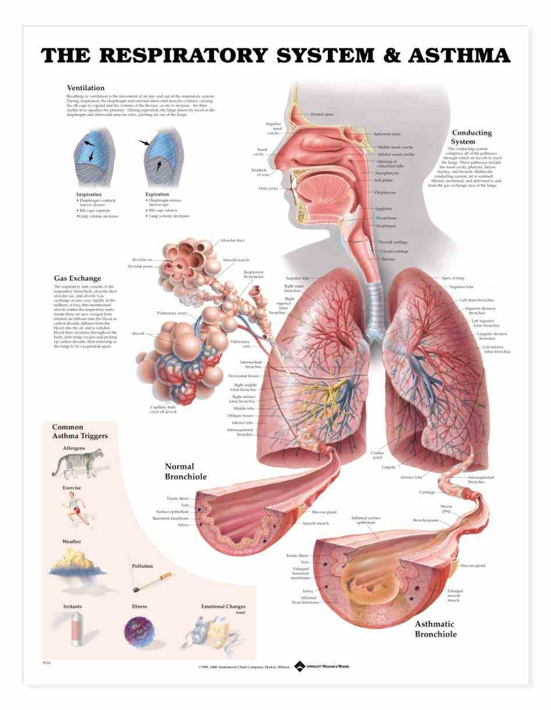
The relationship between respiratory and asthma

Conclusion
The respiratory system plays a huge part in our body system and function. it is the reason for our living and breathing. Many factors affect it. It affects everyone differently, but we have to live with it in our lives.

References

https://clevelandclinic.org>body
https://www.bbc.co.uk/bitesize/guides/ztkr82p/revision/1
https://www.britannica.com/science/human-respiratory-system
https://www.england.nhs.uk>respiratory
https://www.imperial.nhs.uk>asthma
Patwa A, Shah.Anatomy and physiology of respiratory system relevant to anaesthesia.Indian J Anaesth. 2015 sep;59(9):533-41.doi: 10.4103/0019-5049.165849.PMID26556911;PMCID:PMc4613399.
Quirt J,Hildebrand KJ.Mazza J, Noya F,Kim H. Asthma. Allergy Asthma Clin Immunol. 2018 sep 12;14(suppl 2):50. Doi:10.1186/s13223-018-0279-0. PMID:30275843;PMCID:PMC6157154.
Stokes,J.and Hislop, A.A. 2002. Structure and function of the respiratory system. “Drug delivery to the lung (2002): 47-104

